

9B21M073

Sagrada FamÍlia: Managing a Masterpiece[1]

Esther Chew and Cindy Lu wrote this case under the supervision of Professor Ning Su solely to provide material for class discussion. The authors do not intend to illustrate either effective or ineffective handling of a managerial situation. The authors may have disguised certain names and other identifying information to protect confidentiality.

This publication may not be transmitted, photocopied, digitized, or otherwise reproduced in any form or by any means without the permission of the copyright holder. Reproduction of this material is not covered under authorization by any reproduction rights organization. To order copies or request permission to reproduce materials, contact Ivey Publishing, Ivey Business School, Western University, London, Ontario, Canada, N6G 0N1; (t) 519.661.3208; (e) cases@ivey.ca; www.iveycases.com. Our goal is to publish materials of the highest quality; submit any errata to publishcases@ivey.ca. i1v2e5y5pubs

Copyright © 2021, Ivey Business School Foundation Version: 2021-07-26

The closure of the Basílica de la Sagrada Família (Sagrada Família) on March 13, 2020, due to the coronavirus outbreak left a question around whether the anticipated 2026 construction completion deadline for the basilica was still achievable. Although COVID-19 made it uncertain as to when both construction and tourism would resume, the pandemic was just one of many obstacles that the basilica had faced in its time. From the tragic death of the basilica’s leading architect to the Spanish Civil War, the Sagrada Família in Barcelona, Spain, had been under construction for 138 years and was one of the longest-running architectural projects ever undertaken.[2]

The global pandemic presented yet another challenge to meeting the project’s deadline. Would the construction of the basilica be delayed again? In a typical year, over three million visitors from around the world came to admire Antoni Gaudí’s unfinished masterpiece, providing the main source of funding for the basilica.[3] As the magnificent towering structure stood empty, the construction team had to determine how to proceed with the project to ensure its long-term recognition while also honouring Gaudí’s legacy.

The Sagrada Família History

Located on the Carrer de Mallorca in Barcelona, Spain, the Sagrada Família was originally set to be an average church.[4] However, when Gaudí took over as designer and architect, he wanted to build something grander and proposed building a cathedral instead, drawing inspiration from the Barcelona Cathedral floor plans. After a few decades of construction, the Sagrada Família, originally designated as a cathedral, was officially declared a basilica by Pope Benedict XVI in 2010, given the absence of a bishop’s home.[5]

Construction plans for the Sagrada Família indicated that it would reach 172 metres in height at the tallest spire or tower. When completed, the basilica would have 18 towers, each representing a different person of biblical significance: the 12 apostles, the four evangelists, the Virgin Mary, and Jesus Christ.[6]

Furthermore, the Sagrada Família would incorporate three facades (architectural elements that portrayed a scene on the exterior of a building): the Nativity (see Exhibit 1), depicting the birth of Jesus Christ; the Passion (see Exhibit 2), depicting His death on the cross for the sins of humanity; and the Glory, depicting Him sitting in heaven, at the right hand of God.

Clearly, the unfinished basilica was beautiful to behold, and its size, stature, and allure alone were enough to draw a crowd. It was a work of art combining Gothic and curvilinear art nouveau architecture.[7] However, the greatest reason why it attracted millions of visitors each year was arguably the architect himself⎯Gaudí.

Architect Background

Gaudí was born in 1852 in Reus, Catalonia. He spent most of his childhood years observing nature in Reus, which would become a significant inspiration for his work. In primary school, he excelled in geometry and arithmetic, and he later received a traditional religious education in the humanities.[8] Gaudí eventually moved to Barcelona, Catalonia’s capital and centre of culture, to attend the Provincial School of Architecture.[9]

After completing his degree, Gaudí’s professional reputation quickly took off as he worked on large projects commissioned by the bourgeoisie, including Casa Calvet, Casa Batlló, and Casa Milà.[10] Throughout his life, Gaudí remained a deeply religious man and drew inspiration from the Bible. He also enjoyed experimenting with scale models, testing the shapes and structures that would later be used in his constructions.[11] Gaudí remained one of the most iconic figures of Catalan culture and international architecture. By 2005, seven of his works had been declared World Heritage Sites by the United Nations Educational, Scientific, and Cultural Organization.[12]

Timeline of Construction

The Beginning

The Sagrada Família was a source of inspiration for bookseller Josep María Bocabella, a devout man who, in 1866, founded the Asociación Espiritual de Devotos de San José (the Asociación). This entity collaborated in the dissemination and promotion of Catholicism during the time of the Industrial Revolution.[13]

In 1881, the Asociación gained enough donations to purchase a 12,800-metre-square plot of land for a price of 172,000 pesetas (€1,034[14]) to build the basilica. Construction began on the feast day of Saint Joseph in 1882 (see Exhibit 3). In 1883, Gaudí took the place of the Sagrada Família’s original architect, Francisco de Paula del Villar, a year after construction began, due to a difference in opinion between del Villar and the project board.[15]

Early Construction

While Gaudí worked on the basilica, he was also involved in other projects, including the Casa Vicens, a house in Barcelona later converted to a museum. From 1883 to 1914, Gaudí worked on 18 other projects while also dedicating his time to the Sagrada Família.[16]

During the same time frame, the Chapel of Saint Joseph in the crypt was completed, and the basilica started hosting masses.[17]

Gaudí’s Death

Nicknamed “God’s architect,” Gaudí stated that his client was not in a hurry, indicating that he was not concerned about the time that it was taking to build the Sagrada Família.[18] In 1914, Gaudí threw himself further into his work and moved his workshop inside the Sagrada Família.[19] He never married, nor had children, instead focusing solely on his work and on Catholicism. During his later life, Gaudí became even more religious, attending mass and praying each day.[20]

Gaudí spent the last 12 years of his life devoted to the basilica. He died on June 10, 1926, when he was run over by a tram.[21] When Gaudí passed away, the basilica was only 25 per cent complete.[22] On June 12, he was buried in the crypt of the Sagrada Família, where his body has remained since. After Gaudí’s death, his assistant Domènec Sugrañes took over management of the project.[23]

The Spanish Civil War

From 1936 to 1939, the Spanish Civil War took over the country, including the city of Barcelona. During the unrest, many important monuments and buildings in the city were set on fire, including the Sagrada Família.[24]

The damage resulting from these fires was disastrous. All of the original plans that Gaudí had created, stored in the crypt of the basilica, were burned. His plaster models were smashed.From then on, architects and designers tried piecing together the project plans using photographs and designs that had been published in newspapers and journals.[25] Without those printed copies, it was unlikely that Gaudí’s original plans could have been carried out to the extent that they were.

Unfortunately, the basilica endured many other minor acts of vandalism throughout the course of its construction and had to adjust accordingly.

The Twenty-First Century

In the years since Gaudí’s death, nine different architects had taken on the project and tried to follow Gaudí’s original vision of the Sagrada Família as closely as possible. However, many of the architects and designers involved with the project eventually walked away because of the project’s massive scope and the lack of detailed plans available.[26]

The current chief architect and site manager for the Sagrada Família was Barcelona-born Jordi Faulí, who assumed control in 2012. Faulí first began working on the project in 1990 as a junior architect led by Jordi Bonet. In 2009, Faulí completed his doctoral thesis on the Sagrada Família’s design.[27]

Shortly after his appointment as chief architect, Faulí surprised many when he declared the project’s overall architectural form would be completed around 2026, 100 years after Gaudí’s death, provided circumstances allowed construction to follow the current pace. Faulí and the project team, which was made of up more than 300 workers, had managed to achieve an accelerated pace by establishing a firmer idea of the project scope and by leveraging technology to make that pace possible.[28]

Cultural Significance

When construction of the Sagrada Família first began, there was no way of knowing that it would remain incomplete 138 years later. At the same time, perhaps no one could have predicted that it would become one of the top-visited tourist attractions in the country.[29] For the city of Barcelona itself, the Sagrada Família represented heritage, art, and national pride. One of the construction workers on the project commented, “Si Dios quiere, nosotros somos la generación que vamos acabar el templo” (God willing, we will be the generation that finishes the church).[30]

In 2019, over 9.47 million tourists visited Barcelona.[31] And even though the Sagrada Família was not complete, over three million tourists visited the basilica every year.[32] For many visitors, it was likely that even seeing the semi-completed basilica was worth the trip to Spain. Gaudí’s legacy was world renown, and tourists were the driving force behind the basilica, as visitor fees funded the project. It was estimated that the construction of the Sagrada Família cost around €25 million every year, all of this collected from donations and tourist dollars.[33]

Construction Roadblocks

Over decades of construction, an array of materials and methods had been used on the Sagrada Família. Its long history offered a unique look at how the scope of the project and the system behind it had progressed over the last century. In addition to the change in architects working on the project were other challenges to the basilica’s construction.

During Gaudí’s lifetime, the basilica’s bell towers were made from Montjuïc sandstone in Barcelona; however, in current times the stone could only be sourced from demolished buildings, as the quarries in the region had been exhausted, and extraction had been shut down years earlier.[34] According to David Puig, an architect in the Projects Department at the Sagrada Família, it was for this reason that “extensive research was done to find materials similar in character and properties. Several stones have been identified that meet similar properties of durability, resistance and colour. The solution is a combination of several stones that emulate the original closely.”[35]

In recent years, the construction team had relied on prefabrication to increase speed and reduce risk. The prefabricated units were built in Gaià, 80 kilometres from Barcelona, before being shipped to the site and assembled there.[36] As Puig explained, “This is a process of changing from completely handmade production, which was done with the abundant skilled labour that existed at the time of Gaudí, to an increasingly industrialized form of production. There are two reasons for this change⎯there are fewer skilled workers and the adjustment to the industrialized world makes it possible to increase the production rate.” Additionally, physical modelling was still a crucial part of the design process, as it had been for Gaudí, and the models used by the current team leveraged computer-aided design software.[37]

The development of new materials had also had an effect on the basilica’s construction over time. Materials that were not available during Gaudí’s time—such as high-strength concrete, stainless steel, engineered wood, light metal, and various types of mortar—had since been used. Furthermore, modern buildings had to adhere to different safety and performance standards compared to those of the early twentieth century. Despite roadblocks to its construction, the Sagrada Família had continued to adapt over time to changing circumstances while meeting modern requirements around evacuation procedures, protection, and performance.[38]

Technology

Since its commencement in 1882, the construction of the Sagrada Família had been influenced by significant technological advancements. Gaudí himself was already ahead of his time when he began designing and using three-dimensional (3-D) model mock-ups before beginning construction; present-day designers continued to leverage and adopt this method.[39]

In 2001, 3-D printing was introduced to the project to speed up the design and prototyping processes. Prior to the introduction of 3-D printing, handmade prototypes were created before anything new was built to scale. The 3-D printer printed material similar to plaster, which allowed designers to mould and make slight modifications, if necessary. It took about 12 hours to print an entire model, and they were modular, meaning that the designers could swap certain pieces individually as they changed the designs.[40]

The use of 3-D modelling had become a staple in the project, as it both allowed for precise design and reduced cost. Structural problems that would have daunted previous builders were eliminated, as the design went directly from the model to a robotic arm, and the materials were then cut precisely to shape and size. The ability to model the building also reduced construction time: historically, decorative details had to be cut by skilled craftsman, but now they could be completed by fast-moving computer-numerical-control cutters working from digital patterns.[41]

In 2013, a time-lapse projection of the Sagrada Família was published to show how the construction would unfold over the next 13 years. The video, which used aerial photography and sophisticated digital imaging, depicted the definitive vision of the future basilica. Through the culmination of years of archival research to determine Gaudí’s intentions, the team was able to sufficiently produce a virtual model. This also allowed the Construction Board of the Sagrada Família Foundation to make tough decisions about what could and could not be done, thereby refining the project scope.[42]

Another technological advancement leveraged by the basilica’s Technology Department was virtual reality.[43] Sagrada Família’s chief information officer, Fernando Villa, explained, “Virtual reality enables us to see the designs scaled to their actual size, with the textures and materials required whilst allowing us to make changes with minimal impact on cost and time. This saves us time and money without constructing mock-ups.”[44]

Agile Project Management

Agile project management emphasized the journey or process to a project’s completion, as reflected in the management of the Sagrada Família’s construction. It was an iterative approach that focused on incorporating feedback; required flexibility; and broke down large projects into smaller, more manageable tasks tackled in short iterations or sprints.[45] This enabled teams to easily adapt to change and to ensure fast work delivery when faced with chaos or uncertainty. The agile methodology also allowed teams to re-evaluate the work they were completing and make adjustments as the work and landscape changed.[46]

While working on the Sagrada Família, Gaudí had taken an iterative approach to his work. First, he would sketch an independent element of the basilica and then prototype his sketch using clay, which was extremely cheap and allowed for last-minute adjustments. He then proceeded to model his design with durable materials such as gypsum to add greater detail. In between stages in the process, he incorporated validation steps by making multiple models and selecting the most durable one as the final concept.[47] Each iteration for Gaudí represented a higher level of mastery. His successors continued his legacy using the models, schemas, and designs he had left behind.

The Sagrada Família could be described as a project with no end, and a complicated design that had led to various construction challenges. However, it was also a breathtaking piece of art that could be admired for hours. Despite having taken over a century to build and still incomplete, the Sagrada Família’s unfinished form added to its charm, as each visit to the structure could provide a unique experience and continued to draw millions of visitors every year. Comparatively, most projects were typically in development for years before being released to the end-user and were often met with little to no demand once released.[48]

Agile project management was about prototyping, iterating, and learning how to incorporate obstacles, instead of avoiding them. The Sagrada Família project was an example of continuous delivery and of satisfying the customer throughout the project’s life cycle.

COVID-19

COVID-19 was severely affecting the Sagrada Família’s tentative completion dates. The uncertainty around how long the quarantine conditions would last added an extra layer of unpredictability for reassessing timelines.

On March 11, 2020, the Construction Board of the Sagrada Família Foundation announced a halt in both construction of and visits to the basilica.[49] Understandably, this was done to ensure the protection of workers and tourists alike.

In the midst of the pandemic in 2020, over the Easter weekend, a time when normally over 20,000 people visited the basilica for the illumination of the Passion facade, the basilica showed footage of the previous year’s celebration. Over 60,000 people tuned in to watch this online.[50]

On June 7, 2020, the basilica announced a phased reopening, starting with Phase One⎯the “Tribute Phase.”[51] The Sagrada Família opened in early July to front-line workers, in an effort to celebrate and appreciate them for fighting and working to prevent COVID-19.

Phase Two, “Barcelona Time,” allowed for Barcelona residents to enjoy visiting the basilica free of charge over multiple weeks. Finally, the basilica announced that on July 25, 2020, it would reopen to all visitors, with extra safety precautions in place to minimize the risk of contracting or spreading the virus.[52]

Additionally, the Sagrada Família’s virus mitigation plans included transitioning from paper booklets and pamphlets to an entirely digital model for tours and masses, as well as offering a virtual tour on its website, for people to enjoy the basilica from the comfort of their homes.[53]

The Future of The Sagrada Família

As the construction completion deadline approached, controversy was growing around the question of whether the Sagrada Família should actually be finished. Some said the basilica’s perpetual state of construction was central to its charm. Others argued that the building’s current form incorporated less than half of Gaudí’s original design, with many of his detailed plans having been destroyed during the Spanish Civil War.[54]

However, the Sagrada Família represented artistic and cultural significance unlike any other building. Despite construction obstacles, the basilica⎯whether complete or incomplete⎯accomplished its purpose as a beautiful work of art celebrating the Christian faith.[55] Numerous opportunities and challenges laid ahead for the Sagrada Família. How could the Sagrada Família continue to attract its yearly visitors and ensure enough funding to complete the project on schedule? How could Faulí honour Gaudí’s legacy while also satisfying stakeholders’ interests in the project?

EXHIBIT 1: THE SAGRADA FAMÍLIA NATIVITY Facade, 2020

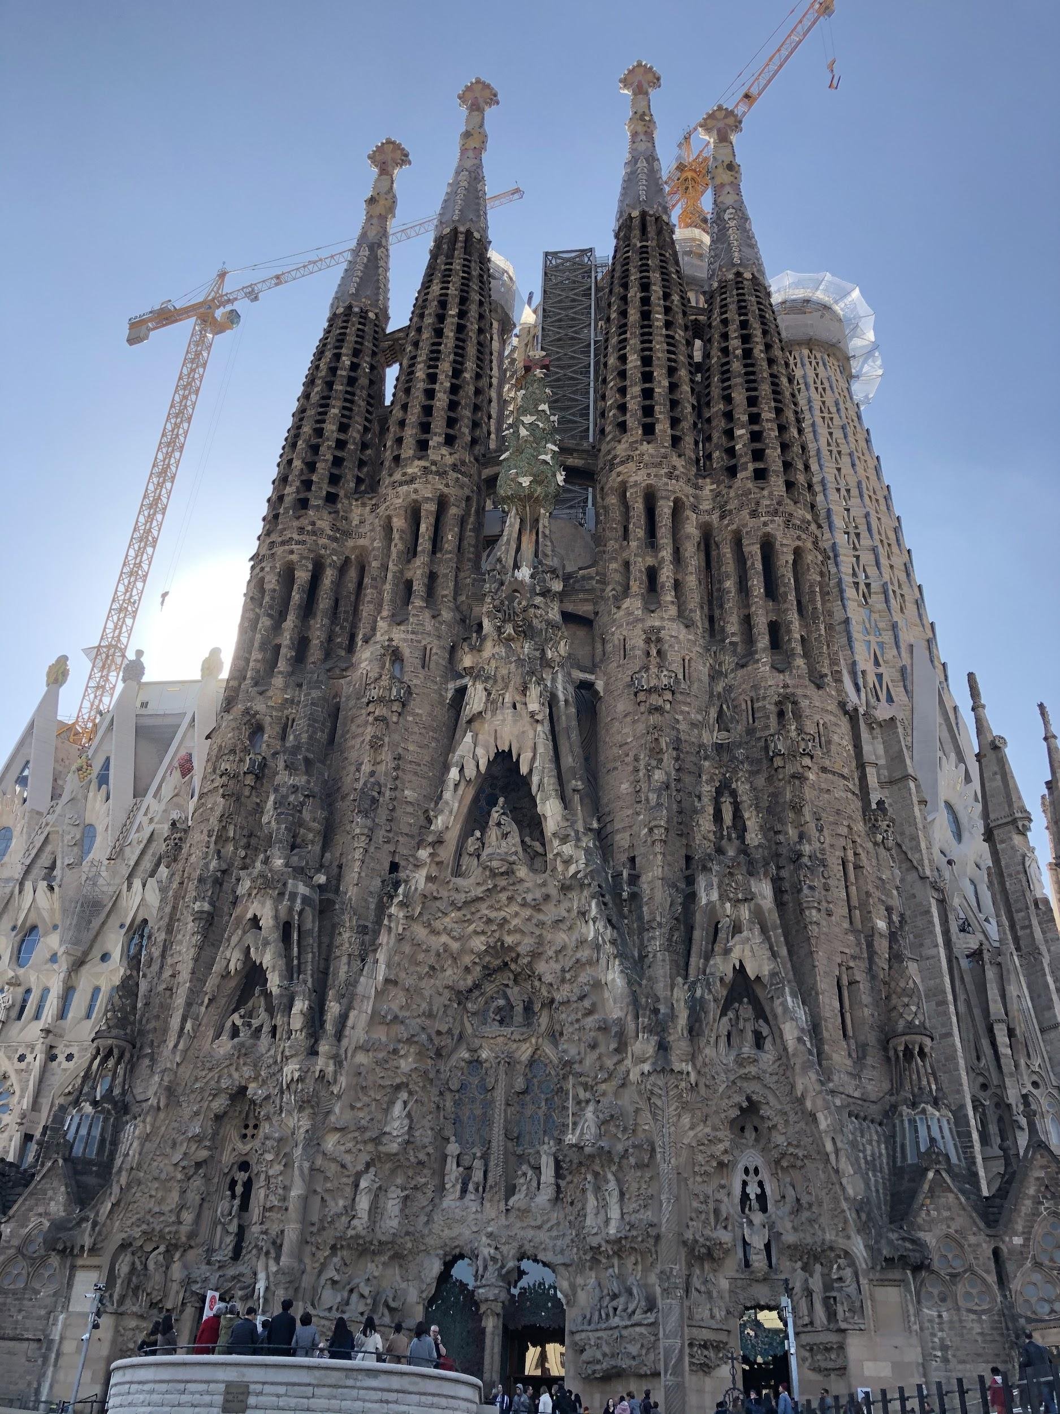

Source: Cindy Lu.

EXHIBIT 2: THE SAGRADA FAMÍLIA PASSION Facade, 2020

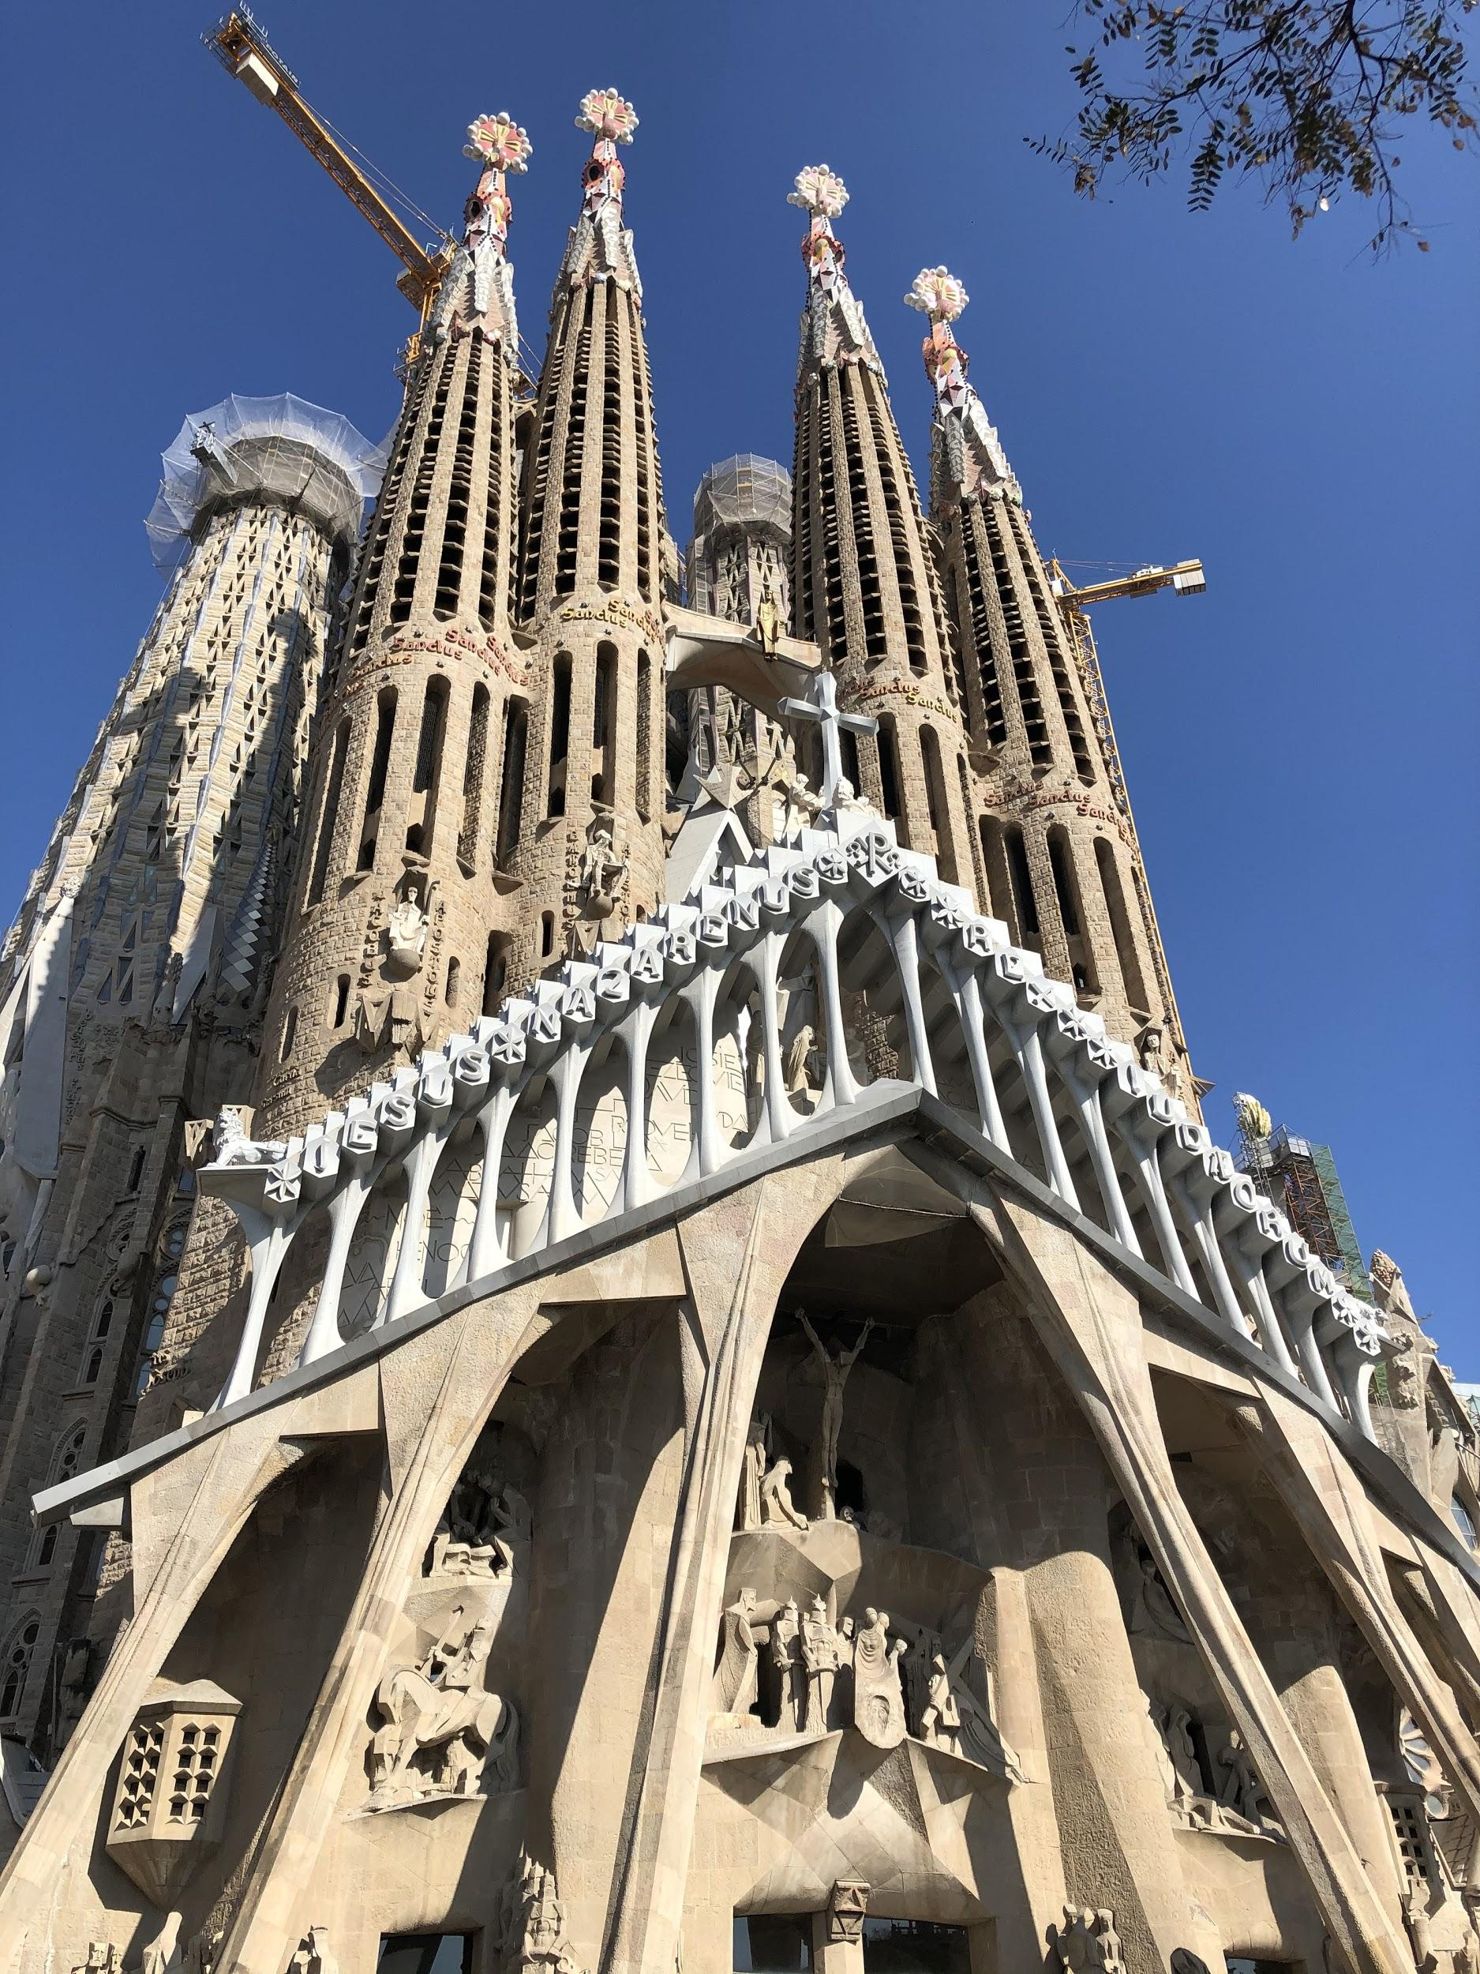

Source: Cindy Lu.

EXHIBIT 3: PROJECT TIMELINE OF THE SAGRADA FAMÍLIA

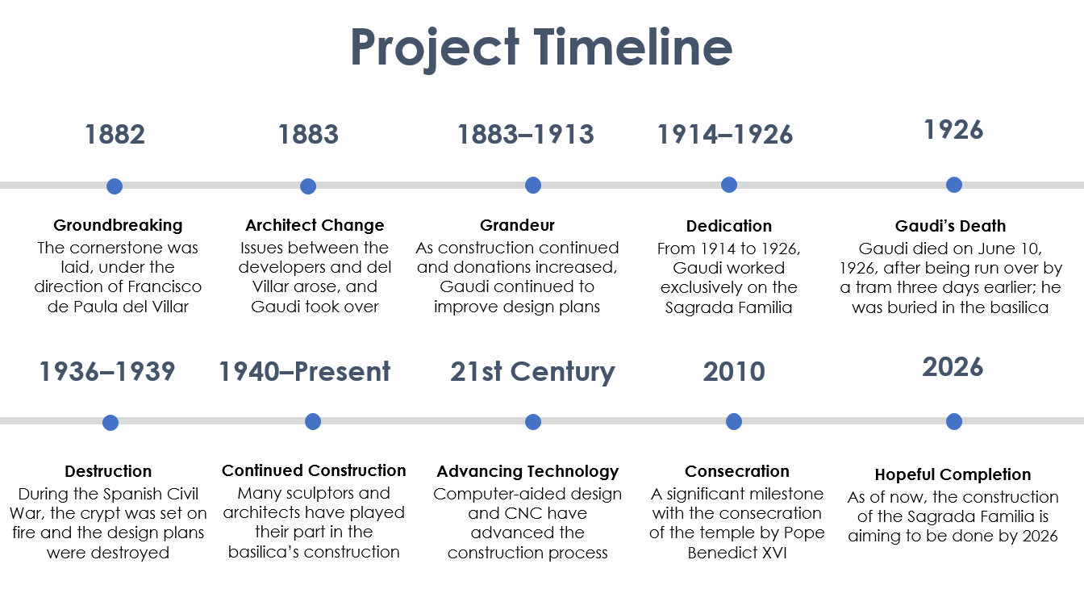

Note: CNC = computer numerical control.

Source: Created by Esther Chew, based on “History of the Temple,” Sagrada Família, accessed March 28, 2020, https://sagradafamilia.org/en/history-of-the-temple.

ENDNOTES

1. This case has been written on the basis of published sources only. Consequently, the interpretation and perspectives presented in this case are not necessarily those of anyone involved in the construction of the Sagrada Família.
2. “History of the Basílica,” Sagrada Família, accessed June 18, 2020, https://sagradafamilia.org/en/history-of-the-temple.
3. “La Sagrada Familia: 15 Amazing Facts You Need to Know,” Culture Trip, accessed December 17, 2020, https://theculturetrip.com/europe/spain/articles/15-amazing-facts-you-need-to-know-about-la-sagrada-familia/.
4. “Map Sagrada Família Location in Relation to the Nearest Metro Underground Stops,” Tourist Guide Barcelona, accessed December 17, 2020, https://www.barcelona-tourist-guide.com/en/maps/attractions/gaudi-sagrada-familia.html.
5. “History of the Basílica,” op. cit.
6. “La Sagrada Familia: 15 Amazing Facts You Need to Know,” op. cit.
7. “Sagrada Familia,” Architectuul, accessed December 17, 2020, http://architectuul.com/architecture/sagrada-familia.
8. “Antoni Gaudi,” Sagrada Família, accessed July 3, 2020, <https://sagradafamilia.org/en/antoni-gaudi>.
9. Stephanie Przybylek, “Antoni Gaudi: Buildings, Architecture & Style,” Study.com, May 31, 2016, accessed July 2, 2020, study.com/academy/lesson/antoni-gaudi-buildings-architecture-style.html.
10. Ibid.
11. Ibid.
12. Ibid.
13. “The Sagrada Familia,” Gaudí and Barcelona Club, accessed June 14, 2020, [www.gaudiclub.com/ingles/i_vida/i_sagr.html](http://www.gaudiclub.com/ingles/i_vida/i_sagr.html).
14. € = EUR = euro; €1 = US$1.1028 on March 31, 2020.
15. “The Sagrada Familia,” op. cit.
16. “Works of Antoni Gaudi,” United Nations Educational, Scientific and Cultural Organization, accessed May 9, 2021, https://whc.unesco.org/en/list/320/.
17. “History of the Basílica,” op. cit.
18. Suzanne Raga, “Gaudí’s Accidental Death: Why the Great Architect Was Mistaken for a Beggar,” Mental Floss, February 11, 2016, accessed June 27, 2020, <https://www.mentalfloss.com/article/72482/gaudis-accidental-death-why-great-architect-was-mistaken-beggar>.
19. Ibid.
20. Ibid.
21. Ibid.
22. BD + C Staff, “Gaudi's Sagrada Familia to be Completed in 2026,” *Building Design + Construction*, March 3, 2015, accessed December 17, 2020, https://www.bdcnetwork.com/gaudis-sagrada-familia-be-completed-2026.
23. “Antoni Gaudi,” op. cit.
24. Ibid.
25. Ibid.
26. BD + C Staff, op. cit.
27. Ian Volner, “A Completion Date for Sagrada Familia, Helped by Technology,” *Architect*, January 23, 2014, accessed June 27, 2020, <https://www.architectmagazine.com/technology/a-completion-date-for-sagrada-familia-helped-by-technology_o>.
28. Ibid.
29. Barbara Rogers, “15 Top-Rated Tourist Attractions in Spain,” PlanetWare, accessed July 2, 2020, <https://www.planetware.com/tourist-attractions/spain-e.htm>.
30. “Inside La Sagrada Familia: Barcelona’s Unfinished Masterpiece | TIME,” YouTube video, 5:29, posted by “TIME,” June 28, 2019, accessed November 23, 2020, <https://www.youtube.com/watch?v=_di-VI-iKC0>.
31. Fernando Forte, “Tourist Numbers in Barcelona’s Hotels 1990-2019,” Statista, November 5, 2020, accessed November 23, 2020, <https://www.statista.com/statistics/452060/number-of-tourists-in-barcelona-spain/>.
32. “La Sagrada Família by Antoni Gaudí - Barcelona Photo Guide,” Tourist Guide Barcelona, accessed July 2, 2020, <https://www.barcelona-tourist-guide.com/en/albums-en/gaudi-sagrada-familia/index.html#:~:text=The%20Sagrada%20Fam%C3%ADlia%20is%20the,original%20and%20ambitious%20modern%20buildings.>
33. “La Sagrada Familia: 15 Amazing Facts You Need to Know,” op. cit.
34. “Material Marvels: Basilica de la Sagrada Familia,” Institute of Materials, Minerals & Mining, accessed December 17, 2020, <https://www.iom3.org/materials-world-magazine/feature/2017/jul/03/material-marvels-basilica-de-la-sagrada-familia>.
35. Ibid.
36. Ibid.
37. Ibid.
38. Ibid.
39. Geraldine Chua, “Antoni Gaudi’s Sagrada Familia Has Been Using 3D Printing for 14 Years,” *Architecture & Design*, accessed February 1, 2021, https://www.architectureanddesign.com.au/news/antoni-gaudi-s-sagrada-familia-has-been-using-3d-p#.
40. Rory Stott, “Construction of Sagrada Família Accelerated by 3-D Printing Technology,” ArchDaily, March 25, 2015, accessed July 11, 2020, <https://www.archdaily.com/613197/construction-of-sagrada-familia-accelerated-by-3-d-printing-technology>.
41. Volner, op. cit.
42. Ibid.
43. “How Technology is Accelerating Construction at Gaudí’s Sagrada Familia,” Techerati, March 29, 2016, accessed June 8, 2020, <https://techerati.com/the-stack-archive/world/2016/03/29/how-technology-is-accelerating-construction-at-gaudis-sagrada-familia/>.
44. Ibid.
45. Christina Torode, “Agile Project Management,” TechTarget, accessed February 1, 2021, https://searchcio.techtarget.com/definition/Agile-project-management.
46. Ibid.
47. Yuliia Pieskova, “Agile Lessons from Gaudí and the Sagrada Familia - Part II,” Agility for All, July 22, 2020, accessed November 22, 2020, <https://www.agilityforall.com/blog-post/agile-lessons-from-sagrada-familia>.
48. Ibid.
49. “Junta Agrees to Stop Works and Visits to the Basilica,” Sagrada Família, March 11, 2020, accessed November 20, 2020, <https://sagradafamilia.org/en/-/la-sagrada-familia-redueix-l-aforament-per-reforcar-les-mesures-de-prevencio-enfront-del-covid-19?redirect=%2Fen%2Fnews%3F_com_liferay_asset_publisher_web_portlet_AssetPublisherPortlet_INSTANCE_2yfH8wNJ7HD2_cur%3D3%26_com_liferay_asset_publisher_web_portlet_AssetPublisherPortlet_INSTANCE_2yfH8wNJ7HD2_delta%3D6%26p_p_id%3Dcom_liferay_asset_publisher_web_portlet_AssetPublisherPortlet_INSTANCE_2yfH8wNJ7HD2%26p_p_lifecycle%3D0%26p_p_mode%3Dview%26p_p_state%3Dnormal%26p_r_p_resetCur%3Dfalse>.
50. “Sagrada Família Lit Up in Red in Recognition of All the Work by Càritas during the Covid-19 Healthcare Crisis,” Sagrada Família, May 5, 2020, accessed July 25, 2020, <https://sagradafamilia.org/en/-/la-sagrada-familia-s-il-lumina-de-vermell-en-reconeixement-de-la-tasca-de-caritas-durant-la-crisi-sanitaria-per-la-covid-19?redirect=%2Fen%2Fnews%3F_com_liferay_asset_publisher_web_portlet_AssetPublisherPortlet_INSTANCE_2yfH8wNJ7HD2_cur%3D3%26_com_liferay_asset_publisher_web_portlet_AssetPublisherPortlet_INSTANCE_2yfH8wNJ7HD2_delta%3D6%26p_p_id%3Dcom_liferay_asset_publisher_web_portlet_AssetPublisherPortlet_INSTANCE_2yfH8wNJ7HD2%26p_p_lifecycle%3D0%26p_p_mode%3Dview%26p_p_state%3Dnormal%26p_r_p_resetCur%3Dfalse>.
51. “Sagrada Família to Reopen on 4 July with Tribute to Barcelona Residents,” Sagrada Família, June 7, 2020, accessed February 1, 2021, https://sagradafamilia.org/en/-/la-sagrada-familia-obrira-les-portes-el-4-de-juliol-i-converteix-la-reobertura-en-un-reconeixement-a-la-ciutadania-de-barcelona.
52. Ibid.
53. “Sagrada Família Moves to Digital Readings Booklets, Reducing Use of Paper and Minimising Risk of Spreading Virus,” Sagrada Família, July 24, 2020, accessed February 1, 2021, https://sagradafamilia.org/en/-/la-sagrada-familia-aposta-pels-llibrets-de-lectura-digitals-redueix-l-us-de-paper-i-minimitza-el-risc-de-contagi.
54. Katharine Schwab, “Gaudí’s Basilica: Almost Finished After 132 Years,” *The Atlantic*, November 23, 2015, accessed February 1, 2021, https://www.theatlantic.com/entertainment/archive/2015/11/sagrada-familia-reaches-its-final-stage-of-construction/413476/.
55. Austen Ivereigh, “Why Gaudí's Sagrada Família is a Cathedral for Our Times,” *The Guardian*, November 16, 2010, accessed February 1, 2021, https://www.theguardian.com/commentisfree/belief/2010/nov/16/gaudi-sagrada-familia-cathedral-for-our-times.