

9B21M074

Aritzia: Managing Growth DURING a Global Pandemic[1]

Alina Salemohamed and Liam Johnson wrote this case under the supervision of Professor Dominic Lim solely to provide material for class discussion. The authors do not intend to illustrate either effective or ineffective handling of a managerial situation. The authors may have disguised certain names and other identifying information to protect confidentiality.

This publication may not be transmitted, photocopied, digitized, or otherwise reproduced in any form or by any means without the permission of the copyright holder. Reproduction of this material is not covered under authorization by any reproduction rights organization. To order copies or request permission to reproduce materials, contact Ivey Publishing, Ivey Business School, Western University, London, Ontario, Canada, N6G 0N1; (t) 519.661.3208; (e) cases@ivey.ca; www.iveycases.com. Our goal is to publish materials of the highest quality; submit any errata to publishcases@ivey.ca. i1v2e5y5pubs

Copyright © 2021, Ivey Business School Foundation Version: 2021-08-23

It was May 28, 2020, and Aritzia Inc. (Aritzia) had just released its annual report for fiscal year (FY) 2020 earlier that morning. The women’s fashion retailer was experiencing unprecedented and challenging times due to the COVID-19 pandemic, which was upending the traditional ways that consumers shopped. Aritzia had grown into a reputable brand with a strong presence across North America, but in March 2020, the company had been forced to temporarily close all 96 of its boutique retail stores, thereby cutting into the main driver of its strong historical growth and shifting all of its sales volume to its e-commerce website. The website mitigated the sales hit to a certain extent, but while Aritzia had taken many steps to augment and optimize both consumers’ shopping experience and its internal operations, it remained unclear whether that trend would continue. The company was slowly and cautiously reopening its boutiques in accordance with the guidelines provided by the federal, provincial, and municipal authorities, but uncertainties regarding the pandemic and the future of retail remained. Aritzia needed to avoid any risk to its brand by treating safety as a priority for both customers and its nearly 3,500 employees.[2] Chief executive officer (CEO) Brian Hill and the executive team needed to participate in the quarterly (Q4) earnings call that same day,[3] and it was highly likely that the analysts would ask questions about how Aritzia was going to adapt in order to mitigate any risks and maintain its growth trajectory in the face of the pandemic.[4]

HISTORY OF ARITZIA

The Hill Family and Brian Hill

In 1945, John Hill purchased Kerrisdale Dry Goods, which was located in Marpole, British Columbia. John’s son, James Hill, worked with his father part time while studying at the University of British Columbia[5] and then took over the business,[6] eventually purchasing a second location in Kerrisdale, British Columbia. James and his brother, Forbes Hill, renamed the storeHill’s of Kerrisdale in 1960 and focused on retail goods. Brian Hill grew up working alongside his father James at the company. Thus, he was familiar with the retail industry from a young age, having worked with merchandise, sorted hangers, washed windows, and performed other tasks.[7] After finishing high school, Hill attended Queen’s University in Kingston, Ontario,[8] before returning to Vancouver.

The Creation of Aritzia

Hill spotted a gap in the Vancouver market with regard to high-quality, fashionable clothing, specifically within the teen and young adult segment.[9] Sensing an opportunity in relation to young women who had “significant disposable income but didn’t want disposable clothes,”[10] Hill opened the first Aritzia location in the Oakridge Centre in 1984.[11] It was an apparel retail store focusing on the segment located between the junior and luxury markets[12] for women between the ages of 15 and 30.[13]

Hill initially intended to source designs from external manufacturers, but after realizing that none of the available options met his high expectations, he decided to establish a vertically integrated collection of in-house clothing lines. Aritzia launched the Babaton, TNA, and Talula labels during the late 1990s, and then in the early 2000s, it launched Wilfred, Community, and more (see Exhibit 1).[14] Each brand was treated as its own independent label, with its own vision and a dedicated in-house design team. The products included a broad assortment of t-shirts, sweaters, dresses, denim, jackets, coats, pants, accessories, and intimates made from high-quality fabrics.[15] This vertically integrated, innovative design process served as a key differentiator for Aritzia.[16]

To produce the in-house clothing lines and maintain its strong vertically integrated platform, Aritzia contracted with a diverse group of independent third-party mills, manufacturers, and trim suppliers.[17] These sources, which were located primarily in China, Japan, Italy, South Korea, and France, allowed the in-house production team to purchase raw materials at fair prices.[18] The finished goods were then sourced from manufacturers based in China, Vietnam, India, Romania, Sri Lanka, and Cambodia.[19] All of the suppliers offered high-quality materials and produced the products in a timely manner.[20] The production planning was performed at the beginning of each season to ensure that there was sufficient time to process the orders and maintain flexibility if any changes were made to the product strategy. In addition to these direct supplier relationships, Aritzia had dedicated design and manufacturing teams to ensure that all products were delivered on time and were of a high quality.[21]

To complement its own product offerings, Aritzia partnered with third-party brands such as Citizens of Humanity and Agolde in an effort to diversify its offering and gain more traction at its locations. Additionally, Aritzia entered into partnerships with certain brands, such as Levi’s, to offer exclusive products to customers in Aritzia stores.[22] While the company did sell external brands, its in-house brands generally accounted for over 90 per cent of the company’s revenue.[23] Aritzia’s multi-brand portfolio (see Exhibit 2), vertically integrated business model, and unique product mix allowed the company to keep pace with constantly evolving fashion trends, while its in-house design and manufacturing teams allowed the company to pivot quickly as well as to capitalize on shifting trends.

Culture and Stores

A typical Aritzia store, known as a boutique, ranged from 3,000 to 8,000 square feet (ft2) and averaged approximately 6,000 ft2, although the flagship stores were more than double that size.[24] All of the stores were leased and located in high-performing malls or shopping streets.[25] Each brick-and-mortar location had its own unique design, which integrated fashion, art, magazines, and curated music to create a distinctive environment for customers[26] (see Exhibit 3). The store ambience was also transferred to the fitting rooms, where customers could use communal mirrors to view potential purchases. Aritzia further focused on customer service by offering product recommendations and styling advice from well-trained store representatives known as style advisors. If customers wanted even more assistance, there was also the option to book personal shopping appointments for one-on-one styling advice.[27] It was clear that Aritzia believed in differentiating itself through a unique and seamless shopping experience as well as building customer loyalty through its high-quality products, engaging retail environment, and well-trained staff.[28] After opening the first boutique in 1984, Hill opened four more locations across Vancouver. Between 1984 and 2000, he continued to expand the company across Canada,[29] and by the end of 2000, Hill had opened nine Aritzia boutiques.[30] Despite Aritzia’s success, Hill continually sought to improve operations, and it seemed that there were many opportunities for the company to grow moving forward.[31]

Growth

By 2005, Aritzia was earning roughly $100 million in annual revenue from the 18 stores it operated across Canada.[32] The company had opened the first standalone store for one of its in-house brands, TNA, in Vancouver, which saw tremendous success. Hill seemingly had bigger plans for Aritzia and looked to expand outside of Canada, with a goal of creating 8–12 new stores annually and generating $170 million in revenue during the following year.[33] Aritzia partnered with Boston-based private equity firm Berkshire Partners,[34] which invested $87 million[35] in exchange for 63 per cent[36] ownership. Hill considered this transaction to be an opportunity to continue expansion through the injection of both capital and valuable experience that would allow Aritzia to go on the offensive.[37]

In 2007, just months before the recession, Aritzia opened its first US retail locations in Seattle, Washington and Santa Clara, California.[38] Despite the economic challenges, the two stores experienced much success, and Aritzia remained focused on continuing its expansion into the United States. With help from Hill’s friend and Lululemon Athletica founder Chip Wilson, Aritzia was able to obtain prime US retail space that became available throughout 2008.[39] Given the significant role boutiques played in promoting the Aritzia culture and brand to customers, store selection was key to the company’s marketing strategy. As such, the company was very selective when it came to new locations.[40]

In 2009, capitalizing on the increasing number of working women and their growing economic power, Aritzia stepped up its expansion, opening stores more rapidly than ever before. As the economic recovery accelerated in North America, the company continued to expand its physical presence, opening flagship stores in New York in 2011 and Montreal in 2015, in addition to expanding its Vancouver flagship store in 2016. By March 2013, the company had a total of 54 brick-and-mortar locations across Canada and the United States[41] (see Exhibit 4).

To further expedite company growth and capitalize on its increasing digital capabilities, Aritzia launched its e-commerce platform in November 2012.[42] Aritzia.com served customers in both Canada and the United States, and it was designed to offer an integrated experience and platform so that customers could enjoy the same level of service as they did in-store.[43] The e-commerce business had its own customer care team, most of whom were former sales associates who provided recommendations and styling advice in its boutiques.[44] The online orders were supported and sent through Aritzia’s three distribution centres and an internal warehouse management system.[45] The orders were shipped to consumers by independent third-party companies, which were also used to ship merchandise to stores and other distribution centres as needed.[46] Each order was wrapped in Aritzia’s unique packaging to ensure that the items arrived in the same state in which they were in before leaving the distribution centre.[47]

In 2016, with the company’s growth showing no signs of slowing, Aritzia filed to go public on the Toronto Stock Exchange,[48] with the goal of doubling its 2016 revenue and opening 20–30 new stores by 2021.[49] On October 3, 2016, the company completed its initial public offering (IPO) of subordinate voting shares for a total of $460 Million.[50] Aritzia now had 79 brick-and-mortar locations (19 in the United States and 60 in Canada).[51] By March 2019, the company was earning approximately $1,600 sales per square foot (see Exhibit 5), which was a very competitive figure when compared with to other major retailers in North America. Aritzia’s performance was strong and its continued growth was promising, and on March 8, 2019, the company repurchased over 6.3 million shares from shareholders, including those of Berkshire Partners, as the firm officially exited its investor position.[52] By March 2020, Aritzia had 67 stores across Canada and 29 stores in the United States, and it had plans to open six more stores per year within North America.[53] The company posted $981 million in revenue for the FY 2020—up 12 per cent compared with 2019—with a 39 per cent gross margin and 9.3 per cent profit margin, both very healthy figures when compared with the industry situation (see Exhibit 6). Aritzia was averaging $1,703 sales per square foot,[54] and it was on track for e-commerce to account for approximately 25 per cent of its revenue by 2021.[55]

NORTH AMERICAN APPAREL RETAIL INDUSTRY

The apparel retail industry in North America was a diverse market involving players ranging from discount retailers to high-end luxury brands. During the late 1990s and early 2000s, customer preferences changed dramatically, with consumers looking for affordable clothing to wear for just one season. Pioneered in Europe by brands such as Zara and H&M, the idea of “fast fashion” soon made its way to North America, being implemented in the early 2000s by well-known brands such as Urban Outfitters and Gap. Fast fashion allowed consumers to have access to trendy clothes at reasonable prices, only to replace them the following year as new fashion trends emerged.[56]

Throughout the 2000s, fashion trends also began to shift toward loud and flashy styles. As Christina Brinkley, who covered fashion for the *Wall Street Journal*, recalled, “People were dripping in gold. There was bling on clothing, jewelry, accessories.”[57] However, this all changed when the recession hit in 2007. Millions of people lost their jobs and large retailers were hit hard, first by the large downturn in consumer spending and then by the growing lack of trust in “corporate America.” Wealthy consumers continued to shop for luxury brands, but there was a dramatic pushback on the part of the average consumer against items with noticeable logos. Subtle clothing designs began to garner more respect, and the associated drop in demand for bold styles caused some well-known retailers such as Barneys and Neiman Marcus to slash prices.[58] Direct-to-consumer (DTC) lifestyle brands such as Everlane and Reformation began to appear, with a focus on a simple aesthetic, value, transparency, and honesty, all without a retail markup.[59] As a result, older brands began to stock up on basic styled clothing and encouraged customers to buy fewer but better-quality items. Just like that, the landscape changed.[60]

A concurrent development concerned the increasing influence of women within the economy. As the economy began to recover in 2009, women’s involvement in the workforce and their contribution to consumer spending began to grow substantially,[61] accounting for roughly $20 trillion in annual spending worldwide.[62] The growing influence of women opened up a new category of consumers. In addition, womenswear apparel retailers offered a variety of price and style options, although a gap in terms of the quality of items remained.[63] If brands could offer better quality, there was room for new leaders to emerge and capitalize on the growing opportunity.

In 2010, information technology and digital capabilities continued to develop, and e-commerce began to gain significant traction for many big-name retailers. Between 2010 and 2018, the US e-commerce channel grew from $165.4 billion to $517.4 billion.[64] Online shopping offered numerous benefits to consumers, including convenience, online discounts, accessibility, easy payment processing, and favorable return policies.[65] Brands were beginning to innovate and find new ways to sell to customers online, such as subscription services and the growing popularity of DTC models,[66] and consumers were also turning to online platforms to browse selections prior to purchasing from physical retail stores.[67] As a result, major retailers across North America shuttered hundreds of brick-and-mortar locations in an effort to remain profitable.[68] Due to the diverse selection of affordable products available online, some retailers resorted to deep discounting in an attempt to drive sales.[69] Despite these changes, many believed that the personalized customer experience associated with brick-and-mortal retail could not be fully replicated online. Thus, some industry experts speculated that the in-person retail channel was not disappearing, but rather changing into a customer service and community-based experience for brands that could properly execute it.[70]

By 2020, the North American apparel retail industry was relatively mature, having grown at an annualized rate of roughly 2.6 per cent since 2014 to reach a total market size of $387.4 billion in 2018[71] (see Exhibit 7). The United States dominated the region, generating nearly 90 per cent of the total value, although Canada and Mexico had been experiencing higher growth in recent years (3.1 per cent and 6.9 per cent, respectively), hitting values of $23.4 billion and $16.1 billion, respectively.[72] Both apparel and the wider retail industry were heavily tied to the macroeconomic conditions, as consumer confidence drove consumer and household spending. Prior to 2020, the gross domestic product (GDP) growth in the United States had been showing an upward trend on a regular basis, with consumer confidence following a similar trend. Canada, however, had experienced slowing growth in 2015 and 2016 due to volatile commodity prices and increased borrowing costs. Yet, this trend was slowly turning around, and by 2017 the more positive and stable macroeconomic environment in Canada suggested opportunities for growth in the coming years.[73]

Among the many apparel retail categories, womenswear was the largest segment, accounting for approximately 52 per cent of the industry size.[74] This category appeared to be growing faster than the clothing retail market as a whole, showing a compound annual growth rate (CAGR) of about five per cent from 2014–2019.[75] The key players in this space included brands such as Aritzia, Zara, H&M, Lululemon, Club Monaco, and Reformation,[76] in addition to larger retailers such as Hudson’s Bay Company, Holt Renfrew, Simons, and Nordstrom.[77] These companies competed on price and needed to continuously manufacture products that were in line with current and upcoming trends. The other key success factors included the supply chain, inventory management, and marketing and advertising strategies.[78] Increasing levels of disposable income combined with the increasing prevalence of social media as a marketing tool, as well as moves by brands to attract and retain celebrity endorsements, led to increased demand for premium apparel.[79] As a result, brands began to break down their own luxury segments into different categories at multiple price levels, including luxury, everyday luxury, mid-market, and fast fashion, in order to address fashion-conscious customers.[80]

IMPACT OF THE COVID-19 PANDEMIC ON RETAIL

In January 2020, the World Health Organization (WHO) began to report on a cluster of mysterious and fatal pneumonia-like cases in the city of Wuhan in Hubei Province, China.[81] After initial scientific research and genome sequencing with reference to other respiratory diseases, the infection was classified as a novel coronavirus (2019-nCoV), which was termed COVID-19. The virus was found to spread through respiratory droplets or small particles when an infected person coughed, sneezed, spoke, or breathed.[82] Certain characteristics specific to COVID-19, such as the asymptomatic infection spread and varying timelines of symptoms following exposure, led to the exponential growth of cases, and COVID-19 spread to every corner of the world in a matter of weeks. On March 11, 2020, the WHO officially declared COVID-19 to be a global pandemic, and by May 1, 2020, it had infected over 3.5 million people worldwide.[83]

The approaches to containing COVID-19 varied by country, but at the highest level, many Western countries implemented similar strategies – restrict movement and contact by introducing lockdowns and halting international travel to slow the spread of the virus. In Canada, health officials from some provinces recommended the immediate cancellation of large gatherings and also strongly urged against non-essential travel while implementing 14-day quarantine restrictions for those who did travel internationally.[84] Multiple provinces declared states of emergencies as the federal government completely closed Canada’s borders to the rest of the world. In the United States, the approach was similar, although mixed signals and limited guidance from the federal government left many states scrambling.[85] In light of increasing calls for social distancing and restrictions on movement, retail companies were forced to close both brick-and-mortar retail stores and corporate offices to help reduce the spread of the virus.

By April 2020, it looked as though the crisis would have a devastating impact on the retail industry. Initial estimates showed that revenue could drop between 27 per cent and 30 per cent in 2020 due to store closures and the shift to e-commerce.[86] The pandemic not only led to the closure of in-person retail channels, but also disrupted global supply chains, a considerable problem given the extent to which North American apparel companies relied on partners in countries such as China and India for textile manufacturing and fashion production.[87] A study by McKinsey & Company estimated that 75 per cent of publicly traded apparel and fashion companies in North America would see negative earnings before interest, taxes, depreciation, and amortization (EBITDA) levels coupled with potentially unmanageable levels of debt.[88] It appeared that balance sheet and cash management would become extremely critical for incumbents.

IMPACT ON ARITZIA AND INITIAL RESPONSE

As was the case for the entire industry, Aritzia proved to be highly susceptible to the pandemic. The company faced significant challenges to its business model, meaning that it would need to adapt quickly to maintain its growth.

Boutique Retail Stores

While a large part of Aritzia’s competitive advantage and value proposition stemmed from its unique brand portfolio, the execution of its strategy relied heavily on its boutiques, which contributed 77 per cent of Aritzia’s sales prior to the pandemic.[89] The company’s product strategy was driven by merchandising techniques in its physical stores as well as by the ability to create consistent yet unique touchpoints with customers. As COVID-19 began to spread across North America, Aritzia experienced a material decline in sales during the first two weeks of March. This was followed by the temporary closure of all 96 of its boutiques, which would almost certainly result in further financial harm.[90] On May 7, after weeks of closures, Aritzia began to pursue the phased reopening of its boutiques based on an established list of criteria for each one, including local public health guidelines, the status of the shopping centres in which the boutiques were located, and Aritzia’s own preparedness for opening each location.[91] The company had planned to reopen 30 of its 96 boutiques by the end of the month, and depending on the location, each store was bound to follow some combination of safety protocols, such as limited capacity, mask mandates, frequent cleaning, and physical distancing requirements for customers and staff.[92] Uncertainty regarding the pandemic remained, while concerns with regard to a second wave led to questions about how long stores would be able to stay open. Aritzia had never permanently closed a boutique in its 36-year history.[93] Would the pandemic put an end to Aritzia’s streak?

Not only did Aritzia have to mitigate the financial losses from its existing stores, the company also had ambitions to continue its expansion. Aritzia had grown consistently, going from 85 stores in the FY 2018, to 91 stores in the FY 2019 and 96 stores after FY 2020. In the FY 2021, Aritzia had anticipated the opening of another five to six boutiques and two exclusive pop-ups.[94] Aritzia’s boutiques had been the main source of its sales growth and were highly profitable. In addition, with much of the retail industry in financial distress, new retail opportunities offering favourable financial terms continued to present themselves. Hill even hinted about an expansion into China “at some point in the future.”[95] However, a continued physical expansion would require significant capital investment that might be better spent on mitigation strategies while uncertainties remained and the fashion industry continued the broad shift toward omnichannel and e-commerce strategies. The year-over-year comparable sales growth, which sat at 7.6 per cent in 2020 vs. 9.8 per cent in 2019,[96] as well as the projected new store openings, were sure to be vital metrics from the perspectives of shareholders and investors. Hill and his team needed to quickly decide what was best for Aritzia with regard to its physical retail channel as well as what the company was going to communicate to investors.

E-commerce Growth

The public health concerns stemming from the pandemic and the corresponding closure of non-essential businesses did wonders for Aritzia’s e-commerce business. Aritzia was quick to take advantage of the opportunity, as the company worked to adjust its product, marketing, and operational strategies to drive e-commerce sales.[97] Having recognized the shift toward e-commerce in recent years, Aritzia had been continuously building its digital capabilities, and the company appeared well-positioned to capitalize on the growing channel.[98] In early 2020, Aritzia launched the Clientele Application(App), a digital selling tool used by style advisors across the company’s boutique network to connect with customers. Through the app, the style advisors could view client profiles and purchase histories, contact clients, and curate customized looks to share with clients and so drive customers to the website.[99]

Aritzia’s e-commerce efforts were supported by the company’s recent investments in distribution. In mid-2018, Aritzia had relocated its Vancouver-based distribution centre to a larger facility, and in quarter two (Q2) of 2020, the company finalized the expansion of third-party distribution centres in Mississauga, Ontario and Columbus, Ohio.[100] In total, the investments added 177,000 square feet of space, representing an 80 per cent increase over previous distribution capabilities.[101] These three facilities supported the e-commerce and retail operations, but would they be able to sustain the long-term volume if the e-commerce boom continued while the physical retail stores reopened? Some retail brands were also exploring the possibility of curbside pickup, which allowed customers to place orders online or over the phone and then pick up the products outside the store once available.[102] Such a move could alleviate some of the centralized logistical efforts, as individual retail stores could act as small distribution centres. Opening for curbside pickup could also mitigate some of the stores’ sales declines; however, it would come at the cost of additional wages and overheads by requiring workers to return to the stores. Would such costs be offset by increased sales? Should Aritzia be one of the apparel retailers to put the strategy to the test?

Aritzia’s e-commerce strategies appeared to be working, with the company reporting a 150 per cent jump in e-commerce revenue through the end of May 2020 when compared with one year previously.[103] Additionally, Aritzia had quickly adjusted its merchandise strategy to capitalize on the change in fashion demands from consumers who were now working from home. However, it remained unclear whether the e-commerce experience could fully replicate the value of shopping in one of Aritzia’s boutiques. Was the continued investment in digital capabilities and the launch of the Clientele app a temporary fix until Aritzia could fully and safely re-open its boutiques, or was e-commerce the new driver of growth? If the latter was true, what did Aritzia need to do to continue to improve the Clientele App and replicate its value proposition in the online world? How would Aritzia’s new distribution setup support its operations? Were there additional strategies that could be pursued, either temporarily or in the long term, that would optimize these processes?

Community, Employees, Culture, and Morale

One of Aritzia’s key value propositions involved providing the best experience for its consumers and maintaining a strong culture within both the Aritzia and local communities. When the pandemic loomed over North America, Aritzia released statements (see Exhibit 8) on its website and social media channels recognizing the impact that COVID-19 would have on the community and shared plans to keep employees safe and financially secure.[104] Aritzia launched the Community Relief Fund and the Heroes at Heart Campaign to show support for employees and healthcare workers.

Community Relief Fund: Given the magnitude of the COVID-19 pandemic, many retailers were forced to lay off employees as brick-and-mortar locations were unable to remain open. Aritzia, however, was able to keep all of its staff employed. On April 4, 2020, the company released a statement saying that all sales for the day would go directly to the Community Relief Fund, which would help keep its workers secure.[105] As of May 2020, the company had paid out $20 million in salaries to non-working employees in the Aritzia community.[106]

Community Care Program – Heroes at Heart: In early May 2020, Aritzia suspended many of the company’s marketing initiatives and launched the $20 million Community Care Program. This initiative gifted a relief package consisting of two T-shirts and two pairs of leggings to 150,000 female doctors, healthcare aides, nurses, and other frontline workers who were playing critical roles in fighting the COVID-19 pandemic.[107] Additionally, the company made an initial donation of community sponsor packages to 100,000 frontline workers in Canada and the United States, which had a retail value of over $10 million.[108]

While the two community programs were great short-term initiatives, it was important to consider the sustainability of each program if the pandemic lasted longer than expected. The stores began a phased reopening on May 7, although some stores were still unable to open due to their locations.[109] It was also important to consider the possibility of the stores being forced to close again. Would there be enough funding to continue to support Aritzia’s employees? What else should Aritzia do to support its community?

Company Morale and Culture: Aritzia also needed to find a way to maintain its culture. The company was committed to supporting numerous organizations that helped women and girls, such as Dress for Success,[110] but could it do more? Aritzia’s employees, especially the style advisors, represented a strong asset for the organization and, therefore, it was important that they felt supported during the pandemic. How could Aritzia keep them engaged while they were not physically connected? Part of Aritzia’s culture also stemmed from the company’s loyal customers. What else could Aritzia do to show customers it was working hard to support the community? How could the company continue to maintain its strong culture during this crisis?

Cash Management and Financial Support

To help weather the decline in demand and the dramatic changes to the retail landscape, Aritzia implemented several cash management initiatives (see Exhibit 9). These initiatives included drawing down $100 million from its revolving credit facility; suspending all share repurchase programs; re-evaluating and optimizing inventory levels; mitigating ongoing operating costs through supplier, vendor, and landlord management; extending payment terms where possible; and temporarily reducing executive compensation by 25 per cent.[111] Additionally, the federal governments in both Canada and the United States were quick to introduce support programs for businesses and individuals significantly affected by the pandemic. In Canada, Aritzia qualified for the Canada Emergency Wage Subsidy (CEWS) program,[112] a COVID-19 relief program that paid a portion of employee wages.[113] Similarly, in the United States, Congress passed the Coronavirus Aid, Relief, and Economic Security Act (CARES Act) on March 27.[114] Part of the CARES Act allowed for the expensing of leasehold improvements retroactive to 2017 as well as the carry back of operating losses in prior years, resulting in over $7 million of short-term tax benefits for Aritzia.[115] The steps taken to manage its cash along with the government support programs provided Aritzia with some temporary financial relief, but such initiatives were not sustainable in the long term, and the company had to determine what its next steps would be.

Moving Forward

By 2020, it was clear that Aritzia had experienced tremendous growth. After originating in Vancouver, the company had expanded across North America, gone public, and built a strong brand in the eyes of both loyal customers and employees. However, COVID-19 represented one of the most challenging crises that Aritzia had faced during its 36-year history, as the pandemic interrupted Aritzia’s connection with its customers, which harmed the company’s value proposition. The company bought itself some time through cash management initiatives and government support programs, although such resources would not last forever and it was unclear what strategies should be pursued going forward. All 96 boutiques had temporarily closed, although a gradual reopening of the economy was on the horizon and Aritzia had to determine how to cautiously reopen its stores while keeping the safety of customers and employees a top priority. In addition, Aritzia had enjoyed significant success through its e-commerce site and digital capabilities. Would this be the new key growth channel for the company? Or would it be a temporary solution for waiting out the pandemic, only to return to a focus on a physical presence once the risks of the pandemic were in the past? If the company’s focus shifted to e-commerce, how could Aritzia optimize its solutions to match its unique in-person customer experience? If the company remained focused on its physical presence without knowing how long the impacts of the pandemic would last, what else could Aritzia do to maintain its healthy growth? Additionally, how could Aritzia continue to support both its employees and the wider community while maintaining the financial health of its business? How could Aritzia maintain the culture and morale that the company had spent years fostering? Many of these questions were on the minds of analysts and shareholders given the recent volatility in the stock market due to the pandemic (see Exhibit 10), meaning that Aritzia’s executive team would need to develop a strategy fast.

The authors would like to acknowledge the support of the Pierre L. Morrissette Institute for Entrepreneurship, Ivey Business School.

Exhibit 1: Timeline of Key Events

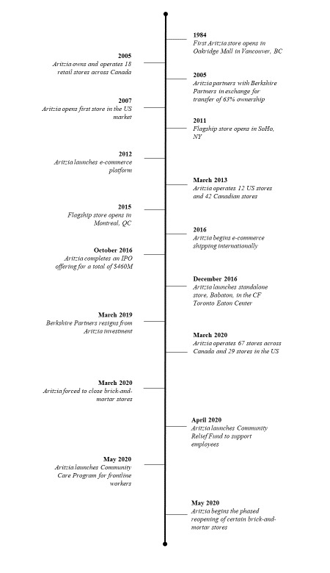

Exhibit 1 (continued)

Source: Aritzia, *Annual Information Form: Fiscal Year Ended February 26, 2017*, May 10, 2017, accessed February 1 2021, https://s21.q4cdn.com/489771965/files/doc_financials/2017/2017-AIF.pdf; Aritzia, *Annual Information Form: Fiscal Year Ended February 25, 2018*, May 10, 2018, accessed February 1 2021, https://s21.q4cdn.com/489771965/files/doc_financials/2018/Annual/2018-AIF.pdf; Aritzia, *Annual Information Form: Fiscal Year Ended March 1, 2020*, May 28, 2020, accessed February 12, 2020, <https://s21.q4cdn.com/489771965/files/doc_financials/2020/ar/Aritzia-AIF-2020-SEDAR.pdf>; Marina Strauss, “Aritzia Eyes Growth,” *Globe and Mail*, December 20, 2005, accessed February 6, 2021, www.theglobeandmail.com/report-on-business/aritzia-eyes-growth/article1132529/; Susan Hollis, “2008 Entrepreneur of the Year: Brian Hill,” BCBusiness, October 9, 2008, accessed January 28, 2021, www.bcbusiness.ca/2008-entrepreneur-of-the-year-brian-hill; Caitlin Kelly, “Aritzia, Canadian Fashion Retailer, Files IPO,” Forbes, August 22, 2016, accessed February 5, 2021, www.forbes.com/sites/caitlinkelly/2016/08/22/aritzia-canadian-fashion-retailer-files-ipo/; Nicole Gibillini, “‘They Know What They’re Good at’: How Aritzia Is Bucking the Retail Trend,” *BNN Bloomberg*, February 14, 2020, accessed February 7, 2021, www.bnnbloomberg.ca/they-know-what-they-re-good-at-how-aritzia-is-bucking-the-retail-trend-1.1390530; “A NOTE ON COVID-19,” Aritzia, accessed February 10, 2021, www.aritzia.com/en/aritzia/covid-19.html#covid-letter_anch; Aritzia, *Annual Report 2020*, May 28, 2020, accessed February 15, 2021, https://s21.q4cdn.com/489771965/files/doc_financials/2020/ar/Aritzia_Annual_Report_2020_Final.pdf.

Exhibit 2: Aritzia Brand Portfolio

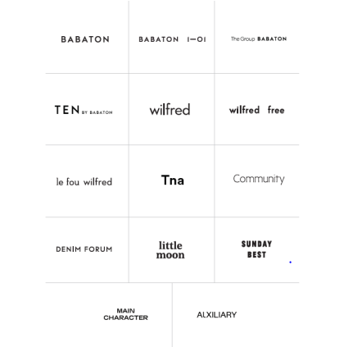

Source: Aritzia, *Annual Information Form: Fiscal Year Ended March 1, 2020*, May 28, 2020, accessed February 12, 2020, <https://s21.q4cdn.com/489771965/files/doc_financials/2020/ar/Aritzia-AIF-2020-SEDAR.pdf>. Used with permission.

Exhibit 3: Aritzia Store Layout

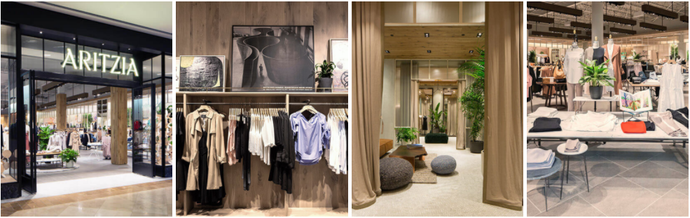

Source: Aritzia, *Annual Report 2020*, May 28, 2020, accessed February 14, 2021, https://s21.q4cdn.com/489771965/files/doc_financials/2020/ar/Aritzia_Annual_Report_2020_Final.pdf. Used with permission.

Exhibit 4: Aritzia Boutique Retail Store Growth

Source: Aritzia, *Annual Information Form: Fiscal Year Ended March 1, 2020*, May 28, 2020, accessed February 12, 2020, <https://s21.q4cdn.com/489771965/files/doc_financials/2020/ar/Aritzia-AIF-2020-SEDAR.pdf>. Used with permission.

Exhibit 5: Sales Per Square Foot – Apparel Retail

**August 2018**

| **Retailer** | **Average Sales/SqFt** |
| --- | --- |
|  |  |
| Aritzia* | $ 1,423 |
| Lululemon | $ 1,491 |
| Gap | $ 321 |
| Urban Outfitters | $ 294 |
| TJ Maxx/Marshalls | $ 448 |
|  |  |

**\***Aritzia was calculated on the basis of the fiscal 2018 revenue number ($743 Million / (87 stores * 6000 average square feet).

**March 2019**

| **Retailer** | **Average Sales/SqFt** |
| --- | --- |
|  |  |
| Aritzia* | $ 1,601 |
| [116]Lululemon | $ 1,657 |
|  |  |

**\***Aritzia was calculated on the basis of the fiscal 2019 revenue number ($874 Million / (91 stores * 6000 average square feet).

Source: “Average Square Footage and Retail Sales per Square Foot Across Major Brands,” Camoin Associates, October 31, 2018, accessed February 17, 2021, www.camoinassociates.com/average-square-footage-and-retail-sales-square-foot-across-major-brands; Aritzia, *Annual Information Form: Fiscal Year Ended March 1, 2020*, May 28, 2020, accessed February 12, 2020, <https://s21.q4cdn.com/489771965/files/doc_financials/2020/ar/Aritzia-AIF-2020-SEDAR.pdf>.

Exhibit 6: Aritzia Financial Statements

| **INCOME STATEMENT** | **2020\*** | **2019** | **2018** |
| --- | --- | --- | --- |
|  |  |  |  |
| **Net revenue** | 980,589 | 874,296 | 743,267 |
| **Cost of goods sold** | 600,199 | 531,383 | 447,776 |
|  |  |  |  |
| **Gross profit** | **380,390** | **342,913** | **295,491** |
|  |  |  |  |
| **Operating expenses** |  |  |  |
| Selling, general, and administration | 243,778 | 215,297 | 183,857 |
| Stock-based compensation expense | 7,790 | 11,540 | 17,240 |
|  |  |  |  |
| **Income from operations** | 128,822 | 116,076 | 94,394 |
| Finance expense | 4,556 | 4,821 | 5,221 |
| Other expense (income) | -2,185 | -395 | 1,890 |
|  |  |  |  |
| **Income (loss) before income taxes** | **126,451** | **111,650** | **87,283** |
| Income tax expenses (recovery) | 35,631 | 32,922 | 30,190 |
|  |  |  |  |
| **Net income (loss)** | **90,820** | **78,728** | **57,093** |

| **BALANCE SHEET** | **2020** | **2019** | **2018** |
| --- | --- | --- | --- |
| **Assets** |  |  |  |
| Cash and cash equivalents | 117,750 | 100,897 | 112,475 |
| Accounts receivable | 6,555 | 4,355 | 2,413 |
| Inventory | 94,034 | 112,183 | 78,833 |
| Other current assets | 13,037 | 18,422 | 17,733 |
| **Total current assets** | **231,376** | **235,857** | **211,454** |
|  |  |  |  |
| Property and equipment | 184,637 | 167,593 | 135,672 |
| Intangible assets | 63,867 | 64,427 | 61,387 |
| Goodwill | 151,682 | 151,682 | 151,682 |
| Right-of-use assets | 380,360 | 0 | 0 |
| Other assets | 24,793 | 9,815 | 8,181 |
|  |  |  |  |
| **Total assets** | **1,036,715** | **629,374** | **568,376** |
| **Liabilities** |  |  |  |
| Accounts payable and accrued liabilities | 57,715 | 62,736 | 67,292 |
| Other current liabilities | 96,128 | 27,875 | 38,435 |
| **Total current liabilities** | **153,843** | **90,611** | **105,727** |
|  |  |  |  |
| Lease liabilities | 447,087 | 0 | 0 |
| Long-term debt | 74,740 | 74,624 | 99,460 |
| Other liabilities | 28,980 | 89,830 | 77,488 |
|  |  |  |  |
| **Total liabilities** | **704,650** | **255,065** | **282,675** |
|  |  |  |  |
| **Shareholders’ equity** | **332,065** | **374,309** | **285,701** |
|  |  |  |  |
| **Total liabilities and shareholder equity** | **1,036,715** | **629,374** | **568,376** |

**Exhibit note:** FY 2020 has been normalized to adjust for the impact of IFRS16. IFRS 16 specifies how an IFRS reporter will recognize, measure, present and disclose leases. The standard provides a single lessee accounting model, requiring lessees to recognize assets and liabilities for all leases unless the lease term is 12 months or less or the underlying asset has a low value. IFRS 16 applies to annual reporting periods beginning on or after 1 January 2019. As such, Aritzia was required to change its lease reporting standards from this point onwards. However, Aritzia was not required to restate historical figures. To ensure consistency in the financial statements, the case writers have adjusted FY 2020 to match financial reporting practices from prior years (note that both styles have been disclosed in the Aritzia annual report).

Source: Aritzia, *Annual Report 2020*, May 28, 2020, accessed February 14, 2021, <https://s21.q4cdn.com/489771965/files/doc_financials/2020/ar/Aritzia_Annual_Report_2020_Final.pdf>.

Exhibit 7: Industry Figures

**A.** North American Apparel Retail Size

|  |  |  |  |  |  |
| --- | --- | --- | --- | --- | --- |
| **Industry ($ bn)** | **2014** | **2015** | **2016** | **2017** | **2018** |
| Market Size | 349.1 | 358.7 | 365.8 | 374.8 | 387.4 |
| % Growth |  | 2.7% | 2.0% | 2.5% | 3.4% |

**B.** Category Segmentation

|  |  |  |
| --- | --- | --- |
| **Segment Size 2018 ($ bn)** | **Value** | **%** |
|  |  |  |
| Womenswear | 201.7 | 52% |
| Menswear | 120.9 | 31% |
| Childrenswear | 64.9 | 17% |
|  |  |  |
| **Total** | **387.5** | **100%** |

**C.** Geographic Segmentation

| **Sales by Region 2018 ($ bn)** | **Value** | **%** |
| --- | --- | --- |
|  |  |  |
| United States | 348.0 | 90% |
| Canada | 23.4 | 6% |
| Mexico | 16.1 | 4% |
|  |  |  |
| **Total** | **387.5** | **100%** |

**D.** Market Distribution

| **Market Distribution 2018 ($ bn)** | **Share** |
| --- | --- |
|  |  |
| Clothing, footwear, and accessories | 43.8% |
| Department stores | 13.8% |
| Online pureplay | 8.2% |
| Hypermarkets, supermarkets, and hard discounters | 3.8% |
| Other | 30.3% |
|  |  |
| **Total** | **100%** |

Source: “Apparel Retail in North America,” MarketLine, February 2020, https://store.marketline.com/report/ohip2721--apparel-retail-in-north-america-2/.

Exhibit 8: Community Statements on COVID-19

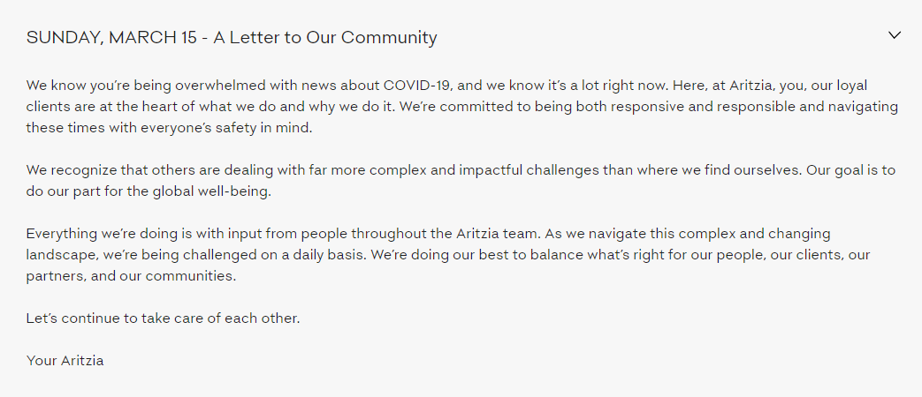

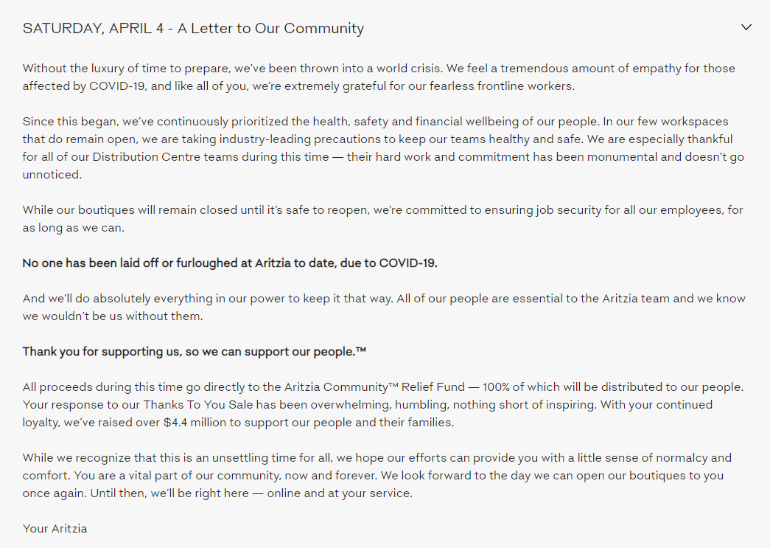

Exhibit 8: Community statements on covid-19 (continued)

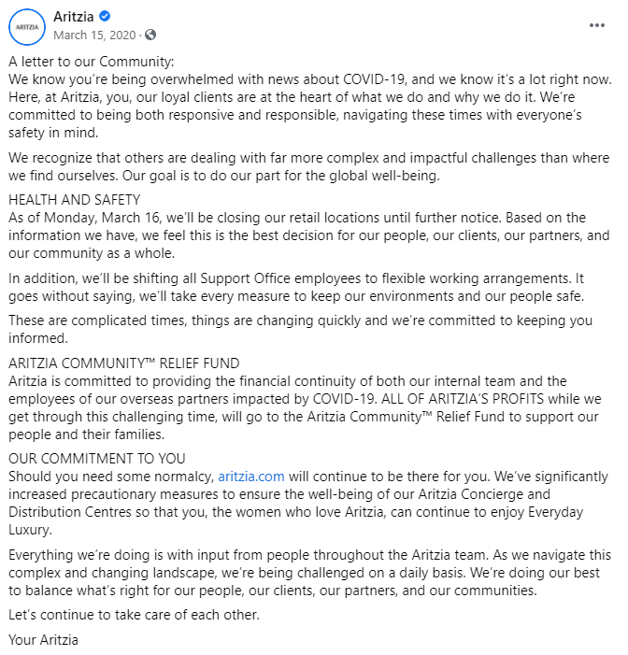

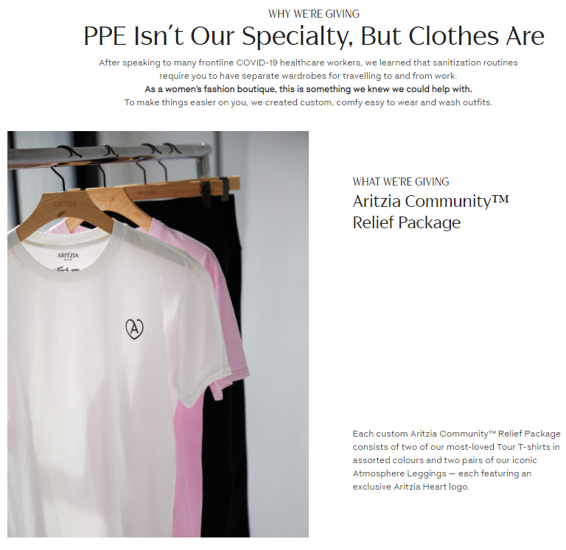

Source: “A NOTE ON COVID-19,” Aritzia, accessed February 9, 2021, www.aritzia.com/en/aritzia/covid-19.html#covid-letter_anch; “A letter to our Community: We know you’re being overwhelmed with news about COVID-19,” accessed February 19, 2021, www.facebook.com/aritzia/posts/a-letter-to-our-communitywe-know-youre-being-overwhelmed-with-news-about-covid-1/10156611624256653/; “Heroes at Heart: Aritzia CA,” Aritzia, accessed February 18, 2021, www.aritzia.com/en/aritzia/community-care-program/heroes-at-heart.html. Used with permission.

Exhibit 9: COVID-19 Update

COVID-19 Update

Since the outbreak of COVID-19, our priorities have been the well-being of our people, clients and supporting the community while safeguarding the long-term financial strength of our business. On March 16, 2020, we temporarily closed all of our 96 retail boutiques in Canada and the United States and immediately focused our efforts on driving revenue through aritzia.com. Concurrently, we took swift action to enhance our short-term liquidity and protect our cash position. These measures included:

* Drawing down $100.0 million from our revolving credit facility (“Revolving Credit Facility”) to enhance our short-term liquidity;
* Suspending share repurchases under our NCIB;
* Leveraging applicable government business support programs for COVID-19;
* Delaying capital expenditures related to boutique construction;
* Accelerating infrastructure investments related to eCommerce and omni-channel projects;
* Reducing and/or eliminating any outstanding Spring/Summer orders to optimize inventory levels;
* Driving cost reductions by minimizing non-essential operating costs and ongoing negotiations with suppliers, vendors, and landlords for concessions;
* Extending payment terms where possible; and
* Temporarily reducing compensation for the senior leadership team by 25% and the forfeiture by the Board of Directors of the cash portion of their fees.

During the temporary boutique closure period, we saw favourable response to our beautifully designed Spring/Summer product and strategic sales events through our eCommerce channel. eCommerce revenue growth since our boutique closures has been in excess of 150% compared to last year. Operating under stringent health and safety protocols and the support of nearly 575 retail and support office employees, our Distribution Centres and Concierge teams effectively managed the surge in eCommerce volumes while maintaining delivery times to meet or exceed clients’ expectations. To-date, we have not laid off or furloughed any of our employees due to COVID-19. We will, however, pursue a right-sizing of our infrastructure once clarity on a new normal emerges.

On May 7, 2020, we began the phased reopening of our retail boutiques. We have established a list of criteria to determine the timing of boutique reopenings, taking into consideration the guidance of local authorities, the reopening status of shopping centres, and our readiness. As part of the reopening plan, we have implemented extensive health and safety measures designed to protect our people and clients. We expect to have reopened approximately 30 of our 96 boutiques by May 31, 2020 and are actively preparing for the reopening of the remainder of our retail boutiques as conditions permit in the coming weeks. While initial results from the reopening process are encouraging in light of the current environment, we expect an extended ramp to a new normal.

Source: Aritzia, *Annual Report 2020*, May 28, 2020, accessed February 14, 2021, <https://s21.q4cdn.com/489771965/files/doc_financials/2020/ar/Aritzia_Annual_Report_2020_Final.pdf>. Used with permission.

Exhibit 10: Aritzia Share Price History (ATZ.TO)

Source: “ARITZIA INC (ATZ.TO) Stock Historical Prices & Data,” Yahoo! Finance, accessed February 19, 2021, https://finance.yahoo.com/quote/ATZ.TO/history?p=ATZ.TO.

endnotes

1. This case has been written on the basis of published sources only. Consequently, the interpretations and perspectives presented in the case are not necessarily those of Aritzia or any of its employees.
2. Aritzia, *Annual Information Form: Fiscal Year Ended March 1, 2020*, May 28, 2020, accessed February 1, 2021, <https://s21.q4cdn.com/489771965/files/doc_financials/2020/ar/Aritzia-AIF-2020-SEDAR.pdf>.
3. Aritzia, *Q4 2020 Earnings Call Transcript*, May 28, 2020, accessed February 15, 2021, https://s21.q4cdn.com/489771965/files/doc_downloads/2020/10/ATZ-4Q20-Transcript.pdf.
4. Ibid.
5. Legacy, “Obituary Search - Find Your Loved One's Life Stories,” Legacy.com, accessed February 19, 2021, accessed February 4, 2021, www.legacy.com/search.
6. Ibid.
7. Susan Hollis, “2008 Entrepreneur of the Year: Brian Hill,” BCBusiness, October 9, 2008, accessed January 28, 2021, www.bcbusiness.ca/2008-entrepreneur-of-the-year-brian-hill.
8. Ibid.
9. Ibid.
10. Imran Amed, “CEO Talk: Brian Hill, Chief Executive Officer, Aritzia,” The Business of Fashion, August 25, 2009, accessed February 5, 2021, www.businessoffashion.com/articles/news-analysis/ceo-talk-brian-hill-chief-executive-officer-aritzia.
11. Susan Hollis, op. cit.
12. Ibid.
13. Ibid.
14. Aritzia, *Annual Information Form: Fiscal Year Ended February 26, 2017*, May 10, 2017, accessed February 1 2021, https://s21.q4cdn.com/489771965/files/doc_financials/2017/2017-AIF.pdf.
15. Aritzia, *Annual Information Form: Fiscal Year Ended February 25, 2018*, May 10, 2018, accessed February 1 2021, https://s21.q4cdn.com/489771965/files/doc_financials/2018/Annual/2018-AIF.pdf.
16. Ibid.
17. Aritzia, *Annual Information Form: Fiscal Year Ended February 26, 2017*, op. cit.
18. Aritzia, *Annual Information Form: Fiscal Year Ended March 1, 2020*, op. cit.
19. Ibid.
20. Aritzia, *Annual Information Form: Fiscal Year Ended February 26, 2017*, op. cit.
21. Ibid.
22. Kari Hamanaka, “Aritzia Collaborates with Levi's for Exclusive Collection,” *WWD*, November 17, 2017, accessed February 17, 2021, https://wwd.com/fashion-news/fashion-scoops/aritzia-levis-launch-collection-11052392-11052392/.
23. Imran Amed, op. cit.
24. Aritzia, *Annual Information Form: Fiscal Year Ended February 25, 2018*, op. cit.
25. Ibid.
26. “Our Story,” Aritzia, accessed February 6, 2021, www.aritzia.com/en/aritzia/about-aritzia/about-us.html.
27. Ibid.
28. Aritzia, *Annual Information Form: Fiscal Year Ended February 25, 2018*, op. cit.
29. Susan Hollis, op. cit.
30. Karen Von Hahn, David Roberts, and Julie Ovenell-Carter, “Store-War Survivors Aritzia,” *Globe and Mail*, September 29, 2000, accessed February 2, 2021 www.theglobeandmail.com/life/store-war-survivors-aritzia/article770100/.
31. Ibid.
32. Marina Strauss, “Aritzia Eyes Growth,” *Globe and Mail*, December 20, 2005, accessed February 6, 2021, www.theglobeandmail.com/report-on-business/aritzia-eyes-growth/article1132529/.
33. Susan Hollis, op. cit.
34. Marina Strauss, “Aritzia Eyes Growth,” op. cit.
35. Genevieve Scarano, “Aritzia Files for IPO on Toronto Stock Exchange,” *Sourcing Journal*, August 18, 2016, accessed February 2 2021, https://sourcingjournal.com/topics/business-news/aritzia-files-for-ipo-on-toronto-stock-exchange-gs-51798/.
36. Susan Hollis, op. cit.
37. Ibid.
38. Caitlin Kelly, “Aritzia, Canadian Fashion Retailer, Files IPO,” Forbes, August 22, 2016, accessed February 5, 2021, www.forbes.com/sites/caitlinkelly/2016/08/22/aritzia-canadian-fashion-retailer-files-ipo/.
39. Marina Strauss, “Recession Opens U.S. Mall Doors for Aritzia,” *Globe and Mail*, June 28, 2010, accessed February 6, 2021, www.theglobeandmail.com/report-on-business/recession-opens-us-mall-doors-for-aritzia/article1379440/.
40. Ibid.
41. Aritzia, *Annual Information Form: Fiscal Year Ended February 26, 2017*, op. cit.
42. Aritzia, *Annual Information Form: Fiscal Year Ended February 25, 2018*, op. cit.
43. Ibid.
44. Ibid.
45. Ibid.
46. Ibid.
47. Ibid.
48. Ibid.
49. The Canadian Press, “Aritzia to Raise $400M in Canada's Largest IPO of the Year, despite Subordinate Shares - BNN Bloomberg,” *BNN Bloomberg*, September 27, 2016, accessed February 10, 2021, www.bnnbloomberg.ca/aritzia-to-raise-400m-in-canada-s-largest-ipo-of-the-year-despite-subordinate-shares-1.574587.
50. Aritzia, *Annual Information Form: Fiscal Year Ended February 25, 2018*, op. cit.
51. Ibid.
52. Aritzia, *Aritzia Completes $330 Million Secondary Offering of Subordinate Voting Shares and Concurrent Share Repurchase of $107 Million Subordinate Voting Shares and Multiple Voting Shares*, accessed February 19, 2021, accessed February 4, 2021, https://investors.aritzia.com/investor-news/press-release-details/2019/Aritzia-Completes-330-Million-Secondary-Offering-of-Subordinate-Voting-Shares-and-Concurrent-Share-Repurchase-of-107-Million-Subordinate-Voting-Shares-and-Multiple-Voting-Shares/default.aspx.
53. Nicole Gibillini, “'They Know What They're Good at': How Aritzia Is Bucking the Retail Trend,” *BNN Bloomberg*, February 14, 2020, accessed February 7, 2021, www.bnnbloomberg.ca/they-know-what-they-re-good-at-how-aritzia-is-bucking-the-retail-trend-1.1390530.
54. Calculated based on the fiscal 2020 revenue number ($981 Million / (96 stores * 6000 average square feet); Aritzia, *Annual Information Form: Fiscal Year Ended March 1, 2020*, op. cit.
55. Nicole Gibillini, op. cit.
56. Ibid.
57. Eliza Brooke, “How the Great Recession Influenced a Decade of Design,” *Vox*, December 27, 2018, accessed February 9, 2021, www.vox.com/the-goods/2018/12/27/18156431/recession-fashion-design-minimalism.
58. Ibid.
59. Ibid.
60. Ibid.
61. Michael Silverstein and Kate Sayre, “The Female Economy,” *Harvard Business Review*, July 16, 2015, accessed February 9, 2021, https://hbr.org/2009/09/the-female-economy.
62. Ibid.
63. Ibid.
64. Sam Greenspan, “The 2010s ECommerce and Online Shopping Decade in Review,” Jilt, May 15, 2020, accessed February 9, 2021, https://jilt.com/blog/decade-ecommerce-2010s/.
65. Ibid.
66. Ibid.
67. Martin Schofield, “How Retail Has Changed in the Last Decade: The Evolution from 2010 to 2020,” Retail247, October 3, 2020, accessed February 9, 2021, https://retail247.com/how-retail-has-changed-in-the-last-decade-the-evolution-from-2010-to-2020/.
68. Ibid.
69. Ibid.
70. Robyn Turk, “Brick and Mortar Still Has a Future, According to Retailers,” FashionUnited, September 9, 2020, accessed February 4, 2021, https://fashionunited.com/news/retail/brick-and-mortar-still-has-a-future-according-to-retailers/2018110624425.
71. “Apparel Retail in North America,” MarketLine, February, 2020, https://store.marketline.com/report/ohip2721--apparel-retail-in-north-america-2/.
72. Ibid.
73. Ibid.
74. Ibid.
75. “Global Women Apparel Market (2020 to 2025) - Industry Trends, Share, Size, Growth, Opportunity and Forecast - ResearchAndMarkets.com,” Business Wire, September 23, 2020, accessed February 4, 2021, www.businesswire.com/news/home/20200923005753/en/Global-Women-Apparel-Market-2020-to-2025---Industry-Trends-Share-Size-Growth-Opportunity-and-Forecast---ResearchAndMarkets.com.
76. “Aritzia”, Owler, 2020, accessed February 3, 2021,www.owler.com/company/aritzia.
77. “Hudson’s Bay Company”, Owler, 2020, accessed February 3, 2021, [www.owler.com/company/hbc](https://www.owler.com/company/hbc).
78. M.T. Wroblewski, “Important Factors of Competition in the Clothing Market,” Chron.com, December 19, 2018, accessed February 3, 2021, https://smallbusiness.chron.com/important-factors-competition-clothing-market-81643.html.
79. “Apparel Retail in North America,” op. cit.
80. Ibid.
81. “Coronavirus Disease (COVID-19) - Events as They Happen,” World Health Organization, accessed January 25, 2021, www.who.int/emergencies/diseases/novel-coronavirus-2019/events-as-they-happen.
82. “Coronavirus Disease 2019 (COVID-19),” Centers for Disease Control and Prevention, accessed January 25, 2021, www.cdc.gov/coronavirus/2019-ncov/index.html.
83. “Estimated Disease Burden of COVID-19,” Centers for Disease Control and Prevention, accessed January 25, 2021, www.cdc.gov/coronavirus/2019-ncov/cases-updates/burden.html.
84. “COVID-19: A Timeline of Canada's First-Wave Response,” *CMAJ News*, June 12, 2020, accessed January 25, 2021, https://cmajnews.com/2020/06/12/coronavirus-1095847/.
85. “Timeline of the Coronavirus Pandemic and U.S. Response,” Just Security, November 17, 2020, accessed January 25, 2021, www.justsecurity.org/69650/timeline-of-the-coronavirus-pandemic-and-u-s-response/.
86. “Time for Change: How to use the crisis to make fashion sourcing more agile and sustainable,” McKinsey & Company, May 2020, accessed February 14, 2021, www.mckinsey.com/~/media/McKinsey/Industries/Retail/Our%20Insights/Time%20for%20change%20How%20to%20use%20the%20crisis%20to%20make%20fashion%20sourcing%20more%20agile%20and%20sustainable/Time-for-change-How-to-use-the-crisis-to-make-fashion-sourcing-more-agile-and-sustainable.pdf.
87. “Textile and Garment Supply Chains in Times of COVID-19: Challenges for Developing Countries,” UNCTAD, May 29, 2020, https://unctad.org/news/textile-and-garment-supply-chains-times-covid-19-challenges-developing-countries.
88. Colleen Baum et al., “Perspectives for North America's Fashion Industry in a Time of Crisis,” McKinsey & Company, May 7, 2020, accessed February 14, 2021, www.mckinsey.com/industries/retail/our-insights/perspectives-for-north-americas-fashion-industry-in-a-time-of-crisis.
89. Aritzia, *Annual Report 2020*, May 28, 2020, accessed February 15, 2021, <https://s21.q4cdn.com/489771965/files/doc_financials/2020/ar/Aritzia_Annual_Report_2020_Final.pdf>.
90. Ibid.
91. Ibid.
92. Ibid.
93. Ibid.
94. Aritzia, “Aritzia Reports Financial Results for First Quarter Ended May 31, 2020,” Cision Canada, July 9, 2020, accessed Feb 2, 2021, www.newswire.ca/news-releases/aritzia-reports-financial-results-for-first-quarter-ended-may-31-2020-862557692.html.
95. “How One Canadian Boutique Is Trying to Beat the Retail Slump,” The Business of Fashion, July 26, 2019, accessed February 5, 2021, www.businessoffashion.com/articles/retail/the-boutique-chain-defying-americas-retail-slump.
96. Aritzia, *Annual Report 2020*, op. cit.
97. Ibid.
98. Ibid.
99. The Canadian Press, “Aritzia Online Revenue Surged 150% in Latest Quarter,” *BNN Bloomberg*, May 29, 2020, accessed February 5, 2021, www.bnnbloomberg.ca/aritzia-online-revenue-surged-150-in-latest-quarter-1.1442603.
100. Aritzia, *Annual Report 2020*, op. cit.
101. Ibid.
102. “Ontario Retail Stores Open for Curbside Pickup and Delivery,” Ontario Newsroom, May 11, 2020, accessed February 19, 2021, https://news.ontario.ca/en/release/56916/ontario-retail-stores-open-for-curbside-pickup-and-delivery.
103. Aritzia, *Annual Report 2020*, op. cit.
104. “A NOTE ON COVID-19,” Aritzia, accessed February 10, 2021, www.aritzia.com/en/aritzia/covid-19.html#covid-letter_anch.
105. Ibid.
106. Aritzia, *Annual Report 2020*, op. cit.
107. “A NOTE ON COVID-19,” op. cit.
108. Ibid.
109. Aritzia, *Annual Report 2020*, op. cit.
110. “COMMUNITY,” Aritzia, accessed February 9, 2021, www.aritzia.com/en/aritzia/corporate-responsibility/sustainability-communities.html.
111. Aritzia, *Annual Report 2020*, op. cit.
112. Aritzia, *Condensed Interim Consolidated Financial Statements*, May 31 2020, accessed February 17, 2021, https://s21.q4cdn.com/489771965/files/doc_financials/2021/Q1/Aritzia-Inc.-Q1-2021-FS.pdf
113. “Canadian Emergency Wage Subsidy (CEWS),” Government of Canada, February 14, 2021, accessed February 2, 2021, www.canada.ca/en/revenue-agency/services/subsidy/emergency-wage-subsidy.html.
114. “H.R.748 - CARES Act, 116th Congress (2019-2020),” Congress.gov, accessed February 18, 2021, www.congress.gov/bill/116th-congress/house-bill/748.
115. Aritzia, *Annual Report 2020*, op. cit.
116.