

9B21N007

GFL ENVIRONMENTAL INC.’S INITIAL PUBLIC OFFERING[1]

Steve Foerster, Craig Dunbar, and Felipe Restrepo wrote this case solely to provide material for class discussion. The authors do not intend to illustrate either effective or ineffective handling of a managerial situation. The authors may have disguised certain names and other identifying information to protect confidentiality.

This publication may not be transmitted, photocopied, digitized, or otherwise reproduced in any form or by any means without the permission of the copyright holder. Reproduction of this material is not covered under authorization by any reproduction rights organization. To order copies or request permission to reproduce materials, contact Ivey Publishing, Ivey Business School, Western University, London, Ontario, Canada, N6G 0N1; (t) 519.661.3208; (e) cases@ivey.ca; www.iveycases.com. Our goal is to publish materials of the highest quality; submit any errata to publishcases@ivey.ca. i1v2e5y5pubs

Copyright © 2021, Ivey Business School Foundation Version: 2021-06-25

In early November 2019, the management and main underwriters of GFL Environmental Inc. (GFL) were participating in roadshow presentations in advance of the company’s initial public offering. GFL was a leading North American provider of various environmental solutions, including solid waste management, liquid waste management, and infrastructure development services.[2] The roadshows were providing institutional investors with an opportunity to hear GFL explain why these investors should invest in its IPO, and were also allowing potential investors to access key company executives who were eager to discuss GFL’s prospects.

GFL was seeking a share price of US$20.00 to US$24.00, which meant that the IPO could potentially raise as much as US$2.4 billion, making it one of the largest ever IPOs for a Canadian company.[3] However, potential investors needed to assess the company’s prospects and arrive at their own independent valuation to support a buy or no buy recommendation. The investors’ analysis would include assessments of the general economic conditions and the waste management industry as well as of the perceived strengths and weaknesses of GFL in particular. Investors would also need to examine GFL’s valuation relative to its peers. An investment would only be considered if the IPO price didn’t exceed the perceived fair value.

**THE WASTE MANAGEMENT INDUSTRY**

The waste management industry provided services related to the collection, transportation, treatment, recycling, and disposal of both liquid and solid waste products. The industry was fundamentally driven by population and consumption growth, as the demand for waste management services was largely a function of the waste produced by households and companies. After having grown at a compound annual growth rate (CAGR) of around 2.9 per cent since 2012 in the North American market, the industry generated revenues of approximately US$158 billion in 2018 (US$17 billion in Canada and US$141 billion in the United States).[4] From 2018 to 2023, the industry was expected to grow at a CAGR of 2.7 per cent, reaching a total annual revenue of US$180 billion.[5]

Although the waste management industry was considered to be relatively stable and recession proof, the adoption of more stringent regulatory frameworks intended to reduce the negative externalities associated with waste production were expected to affect its efficiency and growth. The industry was also characterized by high capital needs in order to achieve economies of scale, market fragmentation, and consolidation into just a few strong players.[6]

Competition within the industry came mostly from public and private waste management companies, companies that handled their own waste management operations, as well as from municipalities and regional authorities.[7] In Ontario, some 60 per cent of the landfill capacity was owned by the public sector, whereas only 20 per cent of the landfill capacity in the United States was publicly owned.[8] The municipalities and regional authorities were often able to offer lower direct prices by subsidizing their costs through tax revenues and by providing tax exemptions.[9] However, these government entities generally did not provide substantial waste disposal or collection services for large commercial and industrial companies.[10]

There were three main segments within the waste management industry, namely solid waste management, infrastructure and soil remediation, and liquid waste management. The solid waste management segment, which generated North American revenues of US$73 billion in 2018, involved the collection, transportation, and disposal of solid waste for industrial and municipal clients.[11] The service contracts tended to be longer term (3–10 years, with renewal options) and the pricing was linked to the volumes of waste managed (with some ability to adjust as costs changed).[12] While the waste volume generation per capita in North America had peaked in 2012 and then began to decline slightly due to recycling and other initiatives, the revenue had continued to grow by around two per cent per year.[13] The segment was highly fragmented (in 2018, the top five firms in Canada and the United States controlled 31 per cent and 48 per cent of the market, respectively), although it had been steadily consolidating over time.[14] The threat of new entrants was considered low due to the geographical, regulatory, environmental, and capital costs associated with the industry.[15] The three largest solid waste competitors in Canada, that is, Waste Management, Waste Connections of Canada, and GFL, accounted for 13 per cent, 12 per cent, and 11 per cent of segment revenues, respectively. In addition to Waste Management, Inc. (the largest firm in the industry in the United States by market capitalization) and Waste Connections, Inc. (the third largest firm), rounding out the top three competitors in the United States was Republic Services, Inc. (the second largest firm).

Waste Management, Inc. originally incorporated in Oklahoma in 1987, and it provided waste management services to residential, commercial, industrial, and municipal customers in Canada and the United States.[16] In 2018, Waste Management, Inc. generated revenues of US$14.9 billion and a net income of US$1.95 billion, which represented increases of three per cent and 12.9 per cent, respectively, relative to the previous year.[17] Republic Services, Inc., which originated as Republic Industries in 1981, was headquartered in Phoenix, Arizona.[18] In 2018, Republic Services, Inc. generated revenues of US$10 billion and a net income of US$1.28 billion, which both remained virtually unchanged relative to 2017.[19] Waste Connections, Inc. was founded in 1997 in California, and it also provided various waste management services in North America.[20] In 2018, Waste Connections, Inc. generated revenues of US$4.9 billion and a net income of US$547 million, which represented increases of 6.3 per cent and 11.1 per cent, respectively, relative to 2017.[21]

The infrastructure and soil remediation segment provided services associated with the decontamination of waste-contaminated soils, and it generated revenues of US$49 billion in North America in 2018.[22] The segment was highly specialized and included only a few significant competitors.[23] Service providers had to obtain government permits, which was a time-consuming process.[24] A key driver in relation to the segment was construction and infrastructure development.[25] The segment was highly fragmented (in 2018, the top five firms in Canada and the United States controlled 14 per cent and eight per cent of the market, respectively).[26] GFL’s top competitors in this regard were Aecon Group Inc. and Keller Group plc.

The liquid waste segment, which generated revenues of US$42 billion in 2018, involved the collection, transportation, and disposal of liquid waste, mainly from industrial and commercial customers.[27] The segment was highly regulated, with industry participants being required to have various permits and being subject to operational supervision.[28] The segment was also highly fragmented (in 2018, the top five firms in Canada and the United States controlled 33 per cent and six per cent of the market, respectively).[29] GFL’s largest publicly traded competitors in the liquid waste segment were Clean Harbors, Inc. (through the Safety-Kleen division) and Heritage-Crystal Clean, Inc.

The solid waste management, infrastructure and soil remediation, and liquid waste segments within the waste management industry were expected to generate annual North American revenues of US$82 billion, US$56 billion, and US$42 billion, respectively, by 2023.[30]

**GFL COMPANY BACKGROUND**

Patrick Dovigi, a one-time hockey prospect (a goalie, who was drafted 41st overall in the 1997 National Hockey League draft by the Edmonton Oilers) founded GFL in 2007, despite having only two-and-a-half years of experience in the environmental services industry.[31] GFL stood for Green For Life, and the company was known for its distinctive lime green trucks. As part of his initial business plan, Dovigi saw opportunities in relation to two fundamental aspects of the industry.[32] First, he believed that there was significant fragmentation within the Canadian market. Indeed, according to Statistics Canada, there were 1,700 companies in the Canadian waste management industry in 2010.[33] Dovigi believed that an opportunity existed in terms of consolidating many small players, which would allow a company to achieve the volume necessary to compete with the larger players.[34] Second, Dovigi believed that an opportunity still existed with regard to offering bundled services, which would allow commercial customers in particular to take care of both their liquid and solid waste needs. Dovigi’s business plan and passion for the industry convinced Genuity Capital, the private equity division of Cannacord Genuity, and the first firm that provided equity financing for GFL.[35]

Backed by private equity capital, GFL acquired nearly a dozen companies during its first few years of operation.[36] The company’s rapid growth led to the raising of more capital. In 2010, Roark Capital Group, a US-based private equity firm, invested $105 million in the company, while in 2013, GFL raised debt capital for CAD$200 million in the form of five-year unsecured notes. [37]

By 2019, GFL had grown to become the fourth largest environmental services company in North America, operating all across Canada (primarily in Western Canada, Southern Ontario, and Quebec) as well as within 23 states in the United States (primarily in the South East).[38] With a workforce of approximately 11,500 employees, the company provided services to 135,000 commercial and industrial customers as well as to more than four million households.[39] The company’s largest source of revenue in 2018 was solid waste services (77 per cent of its revenues), followed by infrastructure and soil remediation (15 per cent) and liquid waste services (nine per cent).[40] Geographically, 54 per cent of the company’s revenues were generated in Canada, with the remaining 46 per cent coming from the United States.

GFL believed that its solid and liquid waste management operations were relatively predictable, in large part due to the contractual nature of the two segments. In fact, the company explained the recurring nature of its revenues as follows:

Our municipal solid waste customer relationships are supported by contracts with initial terms of three to 10 years, with one to five year renewal terms at the option of the municipality, and typically contain annual consumer price index (“CPI”) and periodic fuel adjustments. Similarly, our solid waste contracts with commercial and industrial customers typically have three to five year terms with automatic renewals, volume-based pricing and CPI, fuel and other adjustments.[41]

**ECONOMIC CONDITIONS**

The global real gross domestic product (GDP) was expected to increase by three per cent in 2019,[42] which was below the long-term average (since 1961) of 3.5 per cent.[43] The weakening of global manufacturing activity coupled with rising trade and political tensions had increased uncertainty regarding the strength of the global economy, affecting business confidence, investment, and international trade.[44] In Canada and the United States—as in most developed countries—economic growth in 2019 was expected to be lower (1.5 per cent and 2.3 per cent, respectively).[45] The growth prospects in Canada were lower than those in the United States, in part due to the larger impact that declining oil prices were having on the Canadian economy. Exhibit 1 summarizes selected historical economic data concerning both Canada and the United States, from where GFL derived almost equal shares of its revenues.

Consistent with the weaker economic environment and after almost three years of increases, the Bank of Canada had maintained its policy interest rate (or overnight rate) at 1.75 per cent throughout 2019.[46] In the United States, the Federal Reserve had lowered its reference rate (or federal funds rate) from 2.5 per cent in August 2019 to 1.5 per cent in early November 2019, the first series of reductions since 2008.[47] Against this backdrop, yields on 10-year government bonds had declined to below two per cent in both countries. In turn, the equity markets had accumulated sizable price increases since the beginning of 2019. Indeed, by early November 2019, Canada’s S&P/TSX[48] composite index had increased by 15.1 per cent, while the S&P 500 index in the United States had appreciated by 21 per cent.[49] Going forward, the economic conditions were expected to remain moderately weak yet non-recessionary in 2020, with the prospect of a modest growth increase in 2021 and beyond.[50]

**THE IPO PROCESS[51]**

Going public through an IPO was a time-intensive process that took several months to complete, and it required significant effort on the part of a firm’s top management team. The process typically began after approval by the firm’s board of directors. The board played a key role in selecting the required IPO advisors, including an accounting firm, which would be responsible for auditing the company’s financials and ensuring all regulatory requirements were met, and a law firm that specialized in securities law. Another key set of advisors was the syndicate of underwriters. Typically, a firm selected an investment bank to serve as the “lead manager” in relation to the offering through a series of interviews referred to as the “bake-off” (in recent years, IPOs have included multiple lead managers). The issuing firm and its lead manager then selected other investment banks to support the selling of shares to investors and take on different roles, including the “book runner” (the institution tracking investor orders) and the “co-manager.” Together, the IPO syndicate of investment banks led most of the major activities throughout the IPO process, including due diligence (work to reasonably support all statements made by the firm during the process), the preparation of regulatory and selling documents, the organization and management of the roadshow (a series of meeting with investors in the final few weeks leading up to the offering), deal structuring, and pricing. The IPO syndicate was compensated via the “gross spread,” which was typically stated as a percentage of the offering price (in a typical mid-sized US IPO, the investment banks were paid seven per cent of the offering price for each share sold).[52]

**GFL’S PLANNED IPO[53]**

On July 19, 2019, GFL registered a preliminary prospectus for an IPO of subordinate voting shares with the United States Securities and Exchange Commission (SEC), and it intended to dual list the shares on the New York Stock Exchange (NYSE) and the Toronto Stock Exchange (TSX). The firm had appointed BMO Capital Markets and Goldman Sachs & Co. LLC as the joint lead managers for the offering. The other investment banks selected to be part of the syndicate included J.P. Morgan, RBC Capital Markets, and Scotiabank.

According to a subsequent prospectus filed on October 23, 2019, between the fiscal year 2016 and the Pro Forma 2018, GFL’s revenues grew from CAD$934 million to CAD$2,699 million, its net loss increased from CAD$152 million to CAD$611 million, and its adjusted earnings before interest, taxes, depreciation, and amortization (EBITDA) grew from CAD$201 million to CAD$659 million.[54] Since 2007, the firm had completed over 100 acquisitions, generally at an average adjusted EBITDA multiple of seven. Its growth strategies included generating strong and stable organic revenue growth, executing strategic and accretive acquisitions, and driving operating cost efficiencies. Its major investors included BC Partners, a leading international private equity firm; Ontario Teachers, a globally active investor that administered the Ontario Teachers’ Pension Plan; and Patrick Dovigi, GFL’s founder, chairman, president, and chief executive officer, who had led the firm since its inception in 2007. The senior management team had an average of 18 years of environmental services experience. The firm had a decentralized operating structure, with business oversight being assigned to regional business leaders. The IPO prospectus highlighted GFL’s long-term focus on environmental responsibility and sustainability, noting its aim of becoming a recognized leader in terms of driving sustainable solutions within the industry.

The proposed offering was for 87,572,500 subordinate voting shares. Existing shareholders would sell 1,038,636 shares, while 86,533,864 new shares would be created.[55] The subordinate shares issued as part of the IPO would have one vote per share, while the remaining multiple voting shares held by other investors would have 10 votes per share. Further, GFL was expected to grant the underwriters a 30-day option to purchase up to an additional 13,135,875 subordinate voting shares to cover any overallotments. GFL was approved for listing on both the NYSE and the TSX.

According to Bloomberg, the proposed IPO would be the largest in Canada since PrairieSky Royalty Ltd.’s US$1.53 billion offering in 2014.[56] It would also be by far the largest IPO announced in Canada during 2019, being much larger than Mercer Park Brand Acquisition’s US$402.5 million offering announced in April. The proceeds from the IPO were intended to repay certain debts. GFL expected to use the net proceeds to redeem all of its 5.375 per cent senior notes due in 2023 (US$535 million), US$160 million of its seven per cent senior notes due in 2026, and US$240 million of its senior 8.5 per cent notes due in 2027. Any remaining net proceeds would be used for general corporate purposes, including acquisitions. The prospectus noted that GFL had not recently paid dividends and that it did not anticipate paying any dividends for the foreseeable future.

The IPO prospectus noted a number of risk factors concerning GFL’s business. First, it noted that the firm was subject to substantial regulation that could change over time, thereby exposing the firm to increased costs. Liabilities in connection with environmental matters or a failure to comply with regulations were also possible. Although the firm reported good success in terms of renewing contracts, non-renewal was still a risk, as 34 per cent of GFL’s solid waste contracts in 2018 came from municipal contracts. Moreover, while the firm’s significant experience as an acquirer was recognized as a strength, its ongoing integration risks were highlighted.

**GFL’S VALUATION**

Recent income statements (Exhibit 2), balance sheets (Exhibit 3), cash flow statements (Exhibit 4), and financial ratios (Exhibit 5) were available for evaluation by potential investors. GFL’s statements were in CADs, although the IPO was being priced in USDs because it was being listed jointly in Canada and the United States. After analyzing this financial information, investors would need to estimate the intrinsic value of GFL’s equity. They would need to determine whether it fell within the proposed IPO price range, which valuations methods would be most appropriate, and they would have to estimate the value in CADs and convert the estimate into a USD intrinsic per share price. The most common valuation approaches were the discounted cash flow (DCF) method and various relative valuation approaches, including the price-to-earnings (P/E) and enterprise value (EV)-to-EBITDA multiples, based on a comparable firm analysis. For example, “comparable” firm information is presented in Exhibit 6, but it would be important for potential investors to determine whether the list of firms was too broad or not.

The DCF approach involved estimating the future free cash flows, discounting those free cash flows at an appropriate discount rate, and then subtracting the value of debt and other items to arrive at an estimate of the intrinsic value of the firm’s equity. The number of shares outstanding before the IPO was 215.6 million, while the post-IPO number of shares was expected to increase to 302.1 million. The free cash flows to the firm were the cash available to equity and debt holders after accounting for taxes, capital expenditures, and working capital needs. The free cash flows were estimated as the operating profit or earnings before interest and taxes (EBIT), as adjusted for taxes, adding back non-cash items such as depreciation and amortization, then subtracting the capital expenditures as well as the changes in working capital.

It was expected that the IPO would occur later in the year. Taking December 31, 2019 as a specific example, investors would have to make a number of base-case assumptions for the DCF analysis.

Potential base-case assumptions

* A target capital structure for GFL of 40 per cent debt and 60 per cent equity since the IPO proceeds were in part targeted toward paying down debt.
* GFL would pay no taxes in 2020 and 2021, given the recent negative net income.
* A steady-state tax rate for GFL of 25 per cent.
* A market risk premium of five per cent.
* A credit rating of BBB+ would appropriately measure GFL’s credit risk, despite the company not having a credit rating.
* GFL’s revenue would be CAD$4 billion in 2020, with an increase of six percent, five percent, four percent, and three percent in each of the subsequent four years, respectively, through to 2024.
* An EBITDA margin of 24 per cent.
* GFL’s depreciation would be CAD$400 million in 2020, with an increase of CAD$20 million in each of the subsequent four years.
* GFL’s capital expenditure would be CAD$400 in 2020, with an increase of CAD$25 million in each of the subsequent four years.
* GFL’s increase in working capital would be CAD$5 million in 2020, with an increase of CAD$1 million in each of the subsequent four years.
* GFL’s growth in free cash flows would be two per cent per year beyond 2024.

Taking these assumptions into account, an investor would also need to review the most recent balance sheet (as of June 30, 2019) to determine GFL’s current amount of interest-bearing debt (including leases) less cash. It could be important to consider the impact of GFL increasing its EBITDA margin by 0.5 percent to one per cent, since the base assumption of a 24 per cent margin was comparatively lower than GFL’s major solid waste management peers (albeit it was higher than GFL’s smaller peers).

**TO INVEST OR NOT**

After completing an assessment of the intrinsic value of GFL’s equity based on various valuation techniques and on the pre-IPO number of shares outstanding, it could be determined whether the anticipated IPO price was in the US$20.00 to US$24.00 range and, therefore, if it was a fair price to pay. This determination would need to be balanced against a qualitative assessment, and it would need to be ensured that all modelling assumptions were grounded. If the price range was deemed too high, an investor could assess what price would make for a fair investment, since it was possible that the actual IPO price might be adjusted beyond the preliminary range, or if the price dropped after the listing, it might subsequently be an attractive investment. What changes might GFL’s management make in order to enhance the firm’s value? What questions should investors ask GFL’s management and the underwriting team at the roadshow? The road show attendance would be an incredible opportunity one wouldn’t want to waste.

Exhibit 1: HISTORICAL ECONOMIC CONDITIONS



Note: GDP = gross domestic product; USD = United States dollar; CAD = Canadian dollar.

Source: GDP growth and inflation data from 2012–2018 were obtained from “World Bank Open Data,” The World Bank, accessed April 20, 2020, https://data.worldbank.org/; data for 2019 were preliminary (p) estimates obtained from Trading Economics, September 15, 2019, accessed April 20, 2020, tradingeconomics.com; population data were obtained from “Population Data,” United Nations Department of Economic and Social Affairs, accessed April 20, 2020, https://population.un.org/wpp/Download/Standard/Population/; government bond and USD/CAD exchange rate data as of December 31 each year, except for 2019, were obtained from “FRED Economic Data,” Federal Reserve Bank of St. Louis, September 15, 2019, accessed April 20, 2020, https://fred.stlouisfed.org/.

Exhibit 2: GFL INCOME STATEMENTS For Years Ending December 31 or 6-Months Ending June 30 (CAD millions)

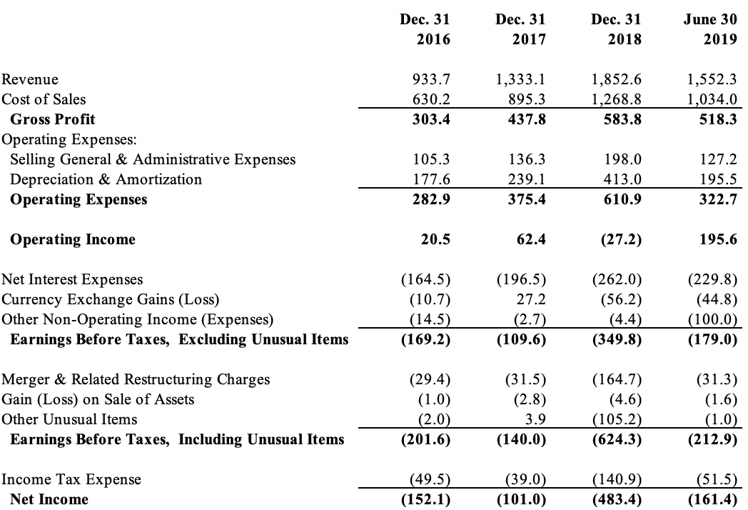

Note: CAD = Canadian dollar.

Source: “GFL Environmental Inc. Amendment No. 5 to Form F-1,” United States Securities and Exchange Commission, November 1, 2019, accessed April 20, 2020, www.sec.gov/Archives/edgar/data/1780232/000104746919006024/a2239933zf-1a.htm.

Exhibit 3: GFL BALANCE SHEETS As of December 31 or June 30 (CAD millions)

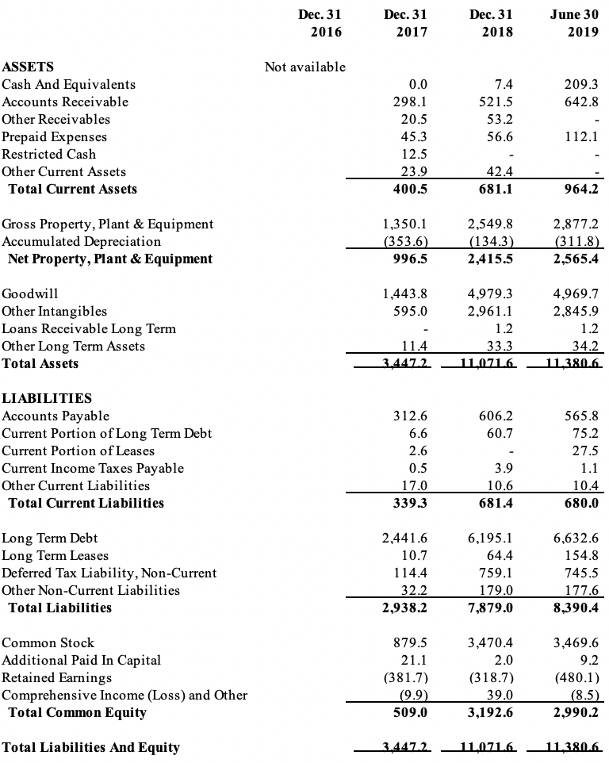

Note: CAD = Canadian dollar.

Source: “GFL Environmental Inc. Amendment No. 5 to Form F-1,” United States Securities and Exchange Commission, November 1, 2019, accessed April 20, 2020, www.sec.gov/Archives/edgar/data/1780232/000104746919006024/a2239933zf-1a.htm.

Exhibit 4: CASH FLOW STATEMENTS For Years Ending December 31 or 6-Months Ending June 30 (CAD millions)

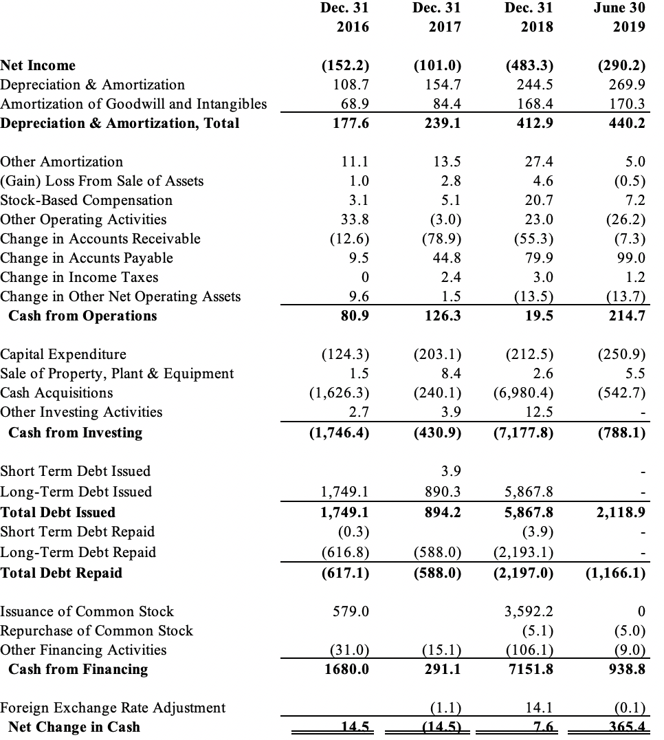

Note: Canadian dollar.

Source: “GFL Environmental Inc. Amendment No. 5 to Form F-1,” United States Securities and Exchange Commission, November 1, 2019, accessed April 20, 2020, www.sec.gov/Archives/edgar/data/1780232/000104746919006024/a2239933zf-1a.htm.

Exhibit 5: GFL KEY FINANCIAL RATIOS



Note: EBIT = earnings before interest and taxes; EBITDA = earnings before interest, taxes, depreciation, and amortization; N/A = not applicable; N/M = not meaningful.

Source: Authors’ estimates.

Exhibit 6: FINANCIAL INFORMATION concerning COMPARABLE FIRMs

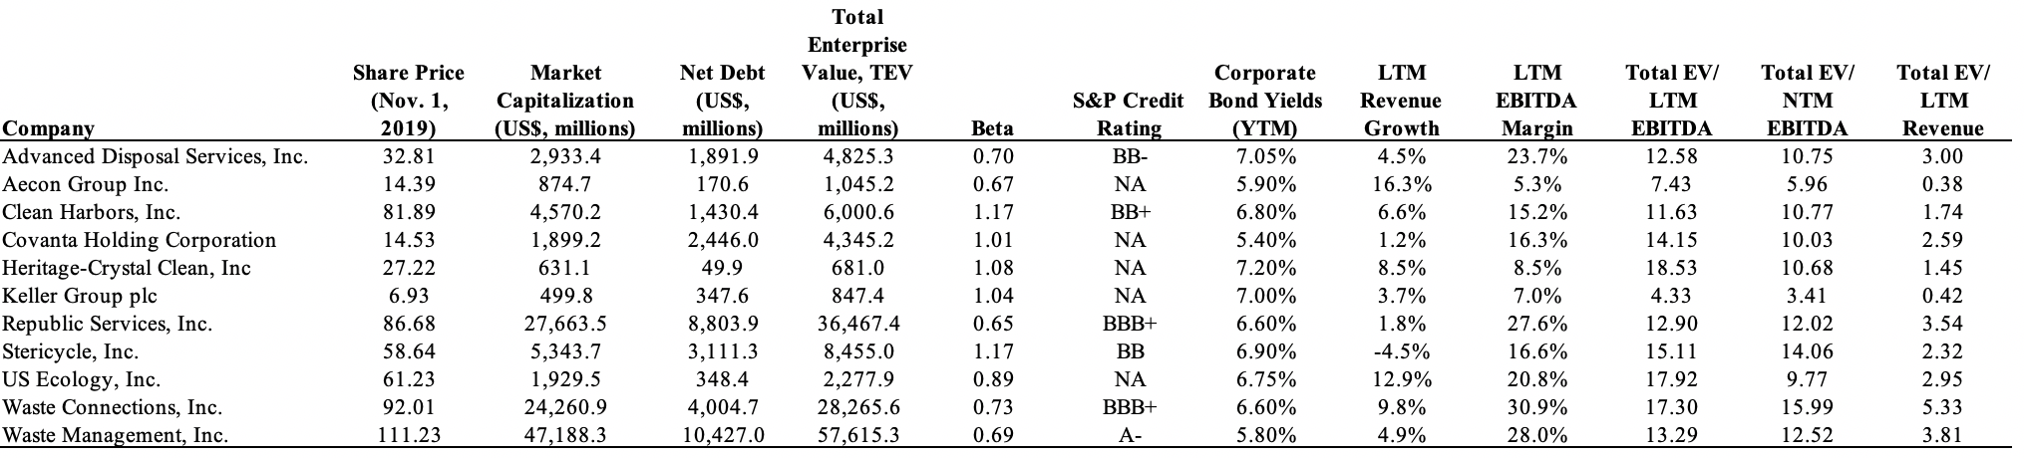



Note: N/A = not applicable; LTM = last twelve months; NTM = next twelve months. Net Debt is equal to Debt minus Cash.

Source: S&P Capital IQ and authors’ estimates.

ENDNOTES

1. This case has been written on the basis of published sources only. Consequently, the interpretations and perspectives presented in the case are not necessarily those of GFL Environmental Inc. or any of its employees.
2. About Us,” GFL Environmental, accessed February 13, 2020, http://gflenv.com/about-us/.
3. “GFL Environmental Inc. Amendment No. 5 to Form F-1,” United States Securities and Exchange Commission, November 1, 2019, accessed April 20, 2020, www.sec.gov/Archives/edgar/data/1780232/000104746919006024/a2239933zf-1a.htm.
4. Ibid.
5. Ibid.
6. Ibid.
7. Waste Management, Inc. Annual Report 2005,” United States Securities and Exchange Commission, December 31, 2005, accessed May 26, 2021, https://www.sec.gov/Archives/edgar/data/823768/000095012906001649/h32785e10vk.htm
8. “GFL Environmental,” BMO Capital Markets, March 31, 2020, accessed September 9, 2020, https://researchglobal0.bmocapitalmarkets.com/research/06708805-6b6a-41de-85e3-347a66b3cafc.
9. Ibid.
10. Ibid.
11. “GFL Environmental Inc. Amendment No. 5 to Form F-1,” op. cit.
12. “GFL Environmental,” BMO Capital Markets, op. cit.
13. Ibid.
14. “GFL Environmental,” J.P. Morgan, March 30, 2020, Mergent Investext, accessed September 9, 2020.
15. “GFL Environmental Inc. Amendment No. 5 to Form F-1,” op. cit.
16. “Waste Management, Inc. Long Business Description,” S&P Capital IQ, accessed October 15, 2020.
17. “Waste Management, Inc. Income Statement,” S&P Capital IQ, accessed October 15, 2020.
18. “Republic Services, Inc. Long Business Description,” S&P Capital IQ, accessed October 15, 2020.
19. “Republic Services, Inc. Income Statement,” S&P Capital IQ, accessed October 15, 2020.
20. “Waste Connections, Inc. Long Business Description,” S&P Capital IQ, accessed October 15, 2020.
21. “Waste Connections, Inc. Income Statement,” S&P Capital IQ, accessed October 15, 2020.
22. “GFL Environmental,” J.P. Morgan, March 30, 2020, accessed September 9, 2020.
23. Ibid.
24. Ibid.
25. Ibid.
26. Ibid.
27. Ibid.
28. Ibid.
29. Ibid.
30. “GFL Environmental Inc. Amendment No. 5 to Form F-1,” op. cit.
31. Shannon Kari, “Business is picking up at garbage upstart Green for Life,” *Globe and Mail*, February 3, 2015, accessed April 20, 2020, www.theglobeandmail.com/report-on-business/rob-magazine/business-is-picking-up-at-garbage-upstart-green-for-life/article22759312/.
32. Ibid.
33. Statistics Canada, “Waste Management Industry Survey: Business and Government Sectors, 2010”, accessed May 26, 2021, https://www150.statcan.gc.ca/n1/pub/16f0023x/16f0023x2013001-eng.pdf
34. Ibid.
35. Ibid.
36. Ibid.
37. Ibid. In 2013, the USD/CAD exchange rate was close to 1.00.
38. “GFL Environmental Inc. Amendment No. 5 to Form F-1,” op. cit.
39. “Corporate Overview” GFL Environmental, accessed April 20, 2020, https://investors.gflenv.com/English/home/default.aspx.
40. “GFL Environmental Inc. Amendment No. 5 to Form F-1,” op. cit.
41. Ibid.
42. “World Economic Outlook, October 2019: Global Manufacturing Downturn, Rising Trade Barriers,” International Monetary Fund, October 2019, accessed September 15, 2020, www.imf.org/en/Publications/WEO/Issues/2019/10/01/world-economic-outlook-october-2019.
43. “World GDP Growth Rate 1961-2021,” macrotrends, accessed September 17, 2020, www.macrotrends.net/countries/WLD/world/gdp-growth-rate.
44. Ibid.
45. “World Economic Outlook, October 2019: Global Manufacturing Downturn, Rising Trade Barriers,” op. cit.
46. “Policy Interest Rate,” Bank of Canada, accessed October 15, 2020, www.bankofcanada.ca/core-functions/monetary-policy/key-interest-rate/.
47. “Effective Federal Funds Rate,” Federal Reserve Bank of New York, accessed October 15, 2020, https://apps.newyorkfed.org/markets/autorates/fed%20funds.
48. S&P/TSX = Standard and Poor’s Toronto Stock Exchange.
49. “Trending Tickers,” Yahoo!Finance, accessed October 15, 2020, https://ca.finance.yahoo.com/quote/.
50. “World GDP Growth Rate 1961-2021,” op. cit.
51. “Roadmap for an IPO: A guide to going public,” PriceWaterhouseCoopers, November 2011, accessed March 6, 2020, www.pwc.com/us/en/deals/publications/assets/pwc-roadmap-to-an-ipo.pdf.
52. Robert J. Jackson Jr., Commissioner, U.S. Securities and Exchange Commission, “The Middle-Market IPO Tax,” speech dated April 25, 2018, Cleveland, Ohio, https://www.sec.gov/news/speech/jackson-middle-market-ipo-tax
53. “GFL Environmental Inc. Amendment No. 5 to Form F-1,” op. cit.
54. The unaudited Pro Forma 2018 results assumed any acquisitions that took place during 2018 occurred on January 1, 2018 (rather than on the actual acquisition dates), which meant that they differed from the actual results as presented in Exhibit 3.
55. Ibid.
56. “GPL Environmental files for IPO said to raise about US$1.5 billion,” *BNN Bloomberg*, July 22, 2019, accessed February 13, 2020, www.bnnbloomberg.ca/gfl-environmental-files-for-ipo-said-to-raise-about-1-5-billion-1.1289911.