SHAF Project

Safe, Healthy, Active, and Flexible

Ahmed Abdulkareem

Todd Harlow

Hai Dang Hoang

Than Tien Troung

Supervised by

Mark Faust

Table of Contents

Need 3

Objective 3

Alternatives 3

Example Use-Case 4

Requirements 5

Physical Design Flow 6

Need

* 45 million American adults had a gym membership in 2015
* There was a 35% increase in exercise related injuries in 2015
* Without any form of feedback, many people fall short of the maximum benefit of their chosen exercise

A need exists for a system that prevents injury and maximizes results for any person performing exercises for general fitness or for rehabilitation. Ideally, such a system would provide feedback informing the user of the correctness and the effectiveness of their prescribed exercises.

Objective

To design and prototype a wearable device that can effectively support a user’s workout by allowing them to select their targeted muscle group and a corresponding exercise. Our device will provide users examples of the chosen exercise, count correct repetitions, and accurately alert them when they should stop the exercise. The device should be safe, easy to use, and portable.

Alternatives

Possible alternatives to our solution include:

* Personal Trainer
* Workout Videos
* Workout Buddy
* Flex Belt
* “Beast” Sensor
* “Fitbit Flex”

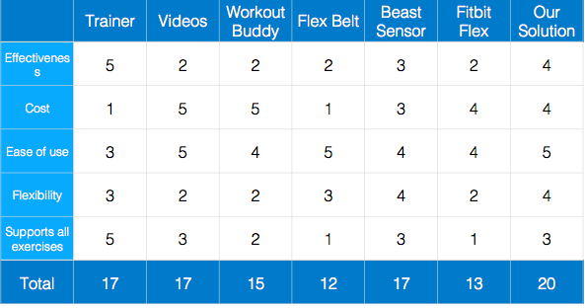

*A subjective selection matrix of the alternatives and our solution using a*

*1 to 5 scale with 5 being best.*

Example Use-Case

|  |  |
| --- | --- |
| **Use-Case** | Muscle: bicep Goal: strength Exercise: bicep curl |
| **Actors** | User, barbell(s), SHAF wearable device, smart device |
| **Description** | A user employs the SHAF device in conjunction with a smart device running SHAF software to assist in a strength-building bicep exercise. |
| **Steps** | 1. User dons the SHAF wearable on the left or right upper-arm 2. User syncs the wearable with SHAF software running on a smart device 3. User selects “bicep” as desired muscle to be exercised 4. User selects “strength” as desired goal for exercise outcome 5. Smart device presents user with “bicep curl” as an exercise to achieve selected goal with selected muscle 6. User has the option to watch a short animation/video demonstrating a correct bicep curl 7. Smart device directs user to perform calibration 8. Smart device informs user of the number of sets and the number of repetitions per set to perform 9. Smart device alerts user to begin an exercise set 10. User begins to perform exercise reps 11. Smart device alerts user when they are nearing the end of the current set of reps 12. Smart device informs user when they are finished with the set 13. User stops performing exercise reps 14. Smart device provides a countdown for user to rest 15. Repeat steps 9 through 14 until total number of sets is complete 16. Smart device locally stores data from exercise 17. Smart device prompts the user to place wearable on opposing arm and restart the process from step 7 |
| **Variations** | 1. User could choose to not watch exercise demonstration video, skipping step 6 2. User could finish a set early by not completing prescribed number of reps, jumping to step 13 3. User could choose to stop exercising in step 17, or choose another muscle and/or exercise |
| **Issues** | 1. Weight of barbell. Current use-case has no method for prescribing the weight of barbell to use in exercise 2. Calibration method. Current use-case does not detail the calibration in step 7 |

Requirements

|  |  |  |
| --- | --- | --- |
| **Marketing Requirements** | **Engineering Requirements** | **Justification** |
| 1,2,3,4,6,7 | The device should be able to adhere to program described in the “bicep, strength, bicep curl” use-case. | This use-case serves as an over-arching test of the goals of the SHAF project. |
| 1 | >90% of users of the device should express greater confidence in the correctness of their exercises compared to not using the device. | To justify the purchase of the device, it should make the majority of user's workouts better. |
| 2 | The device should have a >98% success rate in detecting correct repetitions of the chosen exercise. | A main feature of the device is detecting correct repetitions. >98% success is a good baseline for an advertised feature. |
| 3 | The device should have a >98% success rate in detecting the third-from-last repetition of a set of a given exercise as recommended by a certified trainer. | A main feature of the device is to mimic a personal trainer coaching the user through the difficult last couple of repetitions of an exercise to maximize benefit. |
| 4 | The device should provide audio and visual cues for exercise instructions. | Simultaneously providing audio and visual cues increases the flexibility of the device. |
| 5 | The device should cost no more than $200. | The average price for top wearable fitness devices in 2016 is $160, and our device aims to deliver the "trainer experience" which costs considerably more over time. |
| 6 | It should take a user less than two minutes to go from start to exercising. | Excessive complication to a user's workout will be a major detraction. |
| 6 | The wearable garment device should weigh less than 8 ounces. | Excessive weight will detract from the user’s exercise experience. |
| 6 | The device should not encumber the user nor interfere with any prescribed exercise. | It would be counterintuitive for the device to detract from any exercise it is claiming to enhance. |
| 7 | The device should be able to sync with an Intel Atom powered smart device for user interfacing. | The Intel Atom powers the next generation of user devices and provides the utmost in power and flexibility. |
| 8 | The device should never tell a user to perform additional reps when a certified trainer would not. | It would be counterproductive to have a personal training device that injures a user. |
| 8 | The device should unambiguously alert the user when any muscle group being sensed is completely fatigued. | Same as above |
| **Marketing Requirements**  1. The device should enhance the user's workout.  2. The device should be able to detect correct exercise repetitions.  3. The device should be able to detect when targeted muscles are fatigued.  4. The device should provide simultaneous audio and visual usage cues.  5. The device should have low cost.  6. The device should be easy to use.  7. The device should easily integrate with existing consumer technologies.  8. The device should not endanger the user in any way. | | |

Physical Design Flow

