Chapter I
THE PROBLEM

1.1 Introduction
¶
¶
The introduction of new technology has changed the way colleges and universities operate, especially in the handling of academic work and research. These projects are a compulsory requirement to demonstrate the student’s ability to apply creative thinking to solve real-world problems. But for many institutions, systems are not yet up to date or organized, and student work is often kept in paper files or scattered across different apps. Without a central repository it is difficult to track progress, to find similar research, or to see that topics are not being recovered.
¶
¶
Studies have shown that many of these problems are caused by the absence of a unified system. Manual monitoring has been associated with administrative delays and lack of proper communication between students and advisors (Lando & Wambua, 2025). Similarly, (Huang, 2025) found that colleges find it difficult to communicate their findings to external partners because they lack formal technology transfer procedures. Some systems help to structure data to perform office tasks, for example, the one built by (Liu et al., 2021), but usually do not allow the real-world use of research. (Hailitik et al., 2025) further found that progress tracking often fails because schools don’t have real data or clear plans to get students to finish on time.
¶
¶
The research imperative for this study was established after observing that at the University of Science and Technology of Southern Philippines (USTP) – Jasaan Campus, many student inventions are underutilized because there is no formal way to connect them with industry or community partners. Currently, advisors and staff often update records by hand through unorganized channels, which leads to confusion and delays in project development. This study aims to solve these problems by proposing a single, tech-based tool to make research management easier and more transparent.
¶
¶
The proposed system offers several advantages over existing manual methods by providing a centralized digital home for all research project data. It includes real-time progress tracking through goals and timelines, allowing advisors to provide structured feedback and generate automatic reports. Most importantly, the system features a "technology transfer" section designed to match student projects with the right partners and track how these inventions are used in the real world. To ensure its effectiveness, the system will be evaluated using ISO/IEC 25010 quality standards to check its functional suitability, performance efficiency, usability, reliability, and security. Furthermore, the evaluation will employ User Acceptance Testing (UAT) and the System Usability Scale (SUS) to clearly measure user satisfaction, workflow integration, and overall ease of use in order to ensure that the platform is useful and intuitive for its intended users.
¶
¶
1.2 Conceptual Framework
¶
¶
This study utilizes an Input-Process-Output (IPO) framework to develop an integrated management system that simplifies academic research through centralized inventory, progress monitoring, and technology transfer modules. The process illustrates how project data and user information are transformed into organized, reliable outputs that enhance institutional oversight and facilitate the real-world application of research.
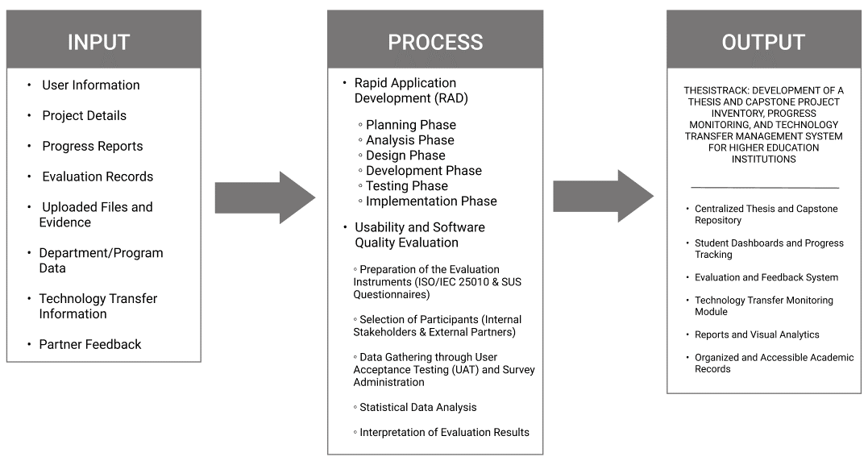
Figure 1.1. Input-Process-Output Diagram
¶
¶
INPUT
¶
¶
The input layer gathers all necessary raw data, institutional parameters, and stakeholder feedback required to drive the management, tracking, and evaluation operations within the system.
¶
¶
- User Information: Includes the profile details, institutional roles, and credentials of students, advisers, panel members, administrators, and external stakeholders used for secure access, role-based permissions, and identification.
- Project Details: Contains metadata regarding the thesis or capstone project, including titles, project abstracts, designated timelines, and group member composition.
- Progress Reports: Records iterative updates on project development, milestone achievements, and submission timelines.
- Evaluation Records: Includes structured qualitative feedback, matrix scores, and formal assessment results from advisers and panel members.
- Uploaded Files and Evidence: Consists of digital documentation and artifacts, such as research proposals, final manuscripts, source code links, and supporting evidence files.
- Department/Program Data: Provides organizational information, academic program classifications, and institutional operations data used for reporting and alignment.
- Technology Transfer Information: Contains licensing data, project marketability profiles, and intellectual property indicators related to system deployment.
- Partner Feedback: Includes evaluative responses, system recommendations, and utilization data from external industry partners regarding project scalability.
¶
¶
PROCESS
¶
¶
The process layer represents the software engineering methodology and the scientific evaluation framework responsible for transforming the gathered inputs into a functional web application. As illustrated in figure 1.1, this layer is divided into two operational phases:
¶
¶
- Rapid Application Development (RAD)
- ¶
- ¶
This phase governs the iterative software engineering lifecycle used to design, build, and deploy the application environment.
¶
¶
- Planning Phase: Identifying existing institutional delays in thesis management, defining systemic boundaries, and scoping initial requirements from stakeholders.
- Analysis Phase: Examining collected data flows, user needs, and institutional policies to establish detailed system specifications.
- Design Phase: Modeling the underlying software architecture, database structures, entity relationships, and user interface layouts.
- Development Phase: Executing full-stack programming to build core system logic and integrate functional modules.
- Testing Phase: Conducting technical code verification, error corrections, and system optimization to ensure application stability.
- Implementation Phase: Deploying the polished system environment within the research department for active, real-world user interaction.
¶
¶
- Usability and Software Quality Evaluation
- ¶
- ¶
This phase represents the empirical research methodology used to evaluate the deployed system against standardized software engineering benchmarks.
¶
¶
- Preparation of the Evaluation Instruments (ISO/IEC 25010 & SUS Questionnaires): Formatting and configuring the standardized evaluation instruments to measure system quality characteristics and system usability.
- Selection of Participants (Internal Stakeholders & External Partners): Stratifying and selecting evaluators from all target end-user populations, including students, faculty, administration, and external partners.
- Data Gathering through User Acceptance Testing (UAT) and Survey Administration: Conducting hands-on testing sessions where users navigate the live application and submit quantitative and qualitative feedback.
- Statistical Data Analysis: Aggregating and computing the collected survey metrics to determine precise usability scores and quality ratings.
Interpretation of Evaluation Results: Analyzing data findings to draw conclusions regarding system efficacy, operational readiness, and future improvement plans.
¶
¶
OUTPUT
¶
¶
The output layer presents the final concrete deliverables, fully integrated application features, and empirical research findings generated after processing the inputs through the development lifecycle.
¶
¶
- Centralized Thesis and Capstone Repository: An organized, searchable, and secure digital archive for preserving and accessing institutional academic outputs.
- Student Dashboards and Progress Tracking: Interactive interfaces providing real-time visual monitoring of milestone developments and timeline compliance.
- Evaluation and Feedback System: A structured communication engine facilitating digitized rubric scoring, panel assessments, and feedback loops.
- Technology Transfer Monitoring Module: A specialized tracking engine for managing project deployment, industry collaborations, and technology utilization.
- Reports and Visual Analytics: Data-driven reporting tools that generate actionable insights and compliance analytics for institutional decision-making.
- Organized and Accessible Academic Records: A systematic management layer that optimizes the accessibility, data integrity, and retrieval of historical project data.
- ¶
- ¶
1.3 Statement of the Problem
¶
¶
General Problem
¶
¶
Higher education institutions struggle with decentralized research management and inconsistent progress monitoring due to underutilized digital tools (Hailitik et al., 2025). Furthermore, a lack of structured technology transfer and weak industry ties prevent academic discoveries from reaching real-world application, particularly in Philippine state universities (Goncharenko, 2021; Sarita, 2025). Therefore, this study addresses the urgent need for a centralized system to bridge the gap between academic output and industry utilization.
¶
¶
Specific Problems
¶
¶
1. How can a centralized digital inventory repository be developed to address the absence of organized management for thesis and capstone project outputs?
2. What processes must be implemented to establish an efficient system for monitoring the progress of ongoing research and development projects?
3. In what way can a technology transfer module be designed to overcome the limited mechanisms for facilitating partnerships between academic institutions and industry or community stakeholders?
4. How can interactive dashboards and automated reporting features be structured to mitigate the difficulty in tracking research, extension activities, and collaborations?
5. What is the level of software quality of the developed system based on ISO/IEC 25010 standards in terms of functionality, usability, reliability, performance efficiency, and security?
¶
¶
1.4 Objectives of the Study
¶
¶
To design and develop an integrated system for inventory, progress monitoring, and technology transfer of thesis and capstone project outputs in higher education institutions.
¶
¶
Specific Objectives
¶
¶
- To develop a digital inventory repository for thesis and capstone projects
- To implement a progress monitoring system for ongoing research and development
- To create a technology transfer module linking academic outputs to industry and community partners
- To provide dashboards and reports for research, extension, and industry collaboration
- To evaluate the system using ISO/IEC 25010 quality standards
- ¶
- ¶
1.5 Significance of the Study
¶
¶
The significance of the study will be useful to the following:
¶
¶
- Students: This study is important for students because provides a centralized platform for them to manage their final projects, allowing for easier document submission, milestone tracking, and timely feedback from advisors. It reduces confusion and delays by maintaining organized records and offers a technology transfer section to showcase their work to external partners for possible real-world application.
- Advisers: Faculty advisers are included to evaluate how the platform supports day-to-day monitoring of student progress, milestone tracking, and research supervision. Their feedback will help determine whether the system reduces manual tracking and improves the overall advising workflow throughout the project lifecycle.
- Panel Members: Panel members are included to examine how centralized access to archived manuscripts, project histories, and evaluation rubrics affects the efficiency of formal assessments. Their input will help determine the system’s effectiveness during key academic processes such as proposal presentations and final defenses.
- Department Chairs: The study provides department chairs with detailed reports on student progress, completion rates, and overall project performance. This data assists in identifying academic trends or delays, facilitating better departmental management and program improvement.
- Library Personnel: The system serves as an organized digital repository that simplifies the archiving and retrieval of completed thesis and capstone projects. By providing a centralized home for final manuscripts and metadata, it helps library staff manage academic records more efficiently and ensures that research outputs are easily accessible for future reference.
- Research Head: For the research head, the system serves as a primary core for storing and managing institutional research, making it easier to track and report on activities necessary for school ratings. The technology transfer module specifically helps the research head connect academic projects with outside partners to enhance the institution's societal impact.
- Industry Partners: Businesses, government offices, and community groups gain an efficient way to discover student projects that offer solutions to specific problems. This collaboration helps transform academic research into real-world products or services that benefit the local economy and community.
- System Admin: This study is useful for system administrators because it provides an integrated platform for high-level management of the system's technical operations. It supports user account management, role-based access control, system maintenance, and notification management. The study enables administrators to preserve the reliability, security, and integrity of the digital infrastructure more effectively.
- Future Researchers: The study acts as a foundation for developing or improving systems related to project management and technology transfer. The research design, results, and methodologies serve as a guide for future updates and contribute to the fields of information systems and educational technology.
- ¶
- ¶
1.6. Scope and Limitations of the Study
¶
¶
1.6.1 Scope of the Study
¶
¶
This study focuses on the design and development of a Thesis and Capstone Project Inventory, Progress Monitoring, and Technology Transfer Management System for Higher Education Institutions, specifically intended for use at the University of Science and Technology of Southern Philippines – Jasaan Campus. The system aims to simplify research management by providing a centralized platform to organize and store final projects, including titles, abstracts, author names, and supporting digital files. It incorporates a progress tracking feature that allows students, advisors, and administrative staff to monitor project development through established milestones and timelines, ensuring timely completion of academic requirements.
¶
¶
The system is designed to support multiple user roles including students, advisors, staff, and external partners each with specific access levels and functional tasks. Key features include structured file uploading, organized data storage, and a search function for easy document retrieval. To assist in institutional oversight and decision-making, the platform also provides dashboards and reports that offer visual summaries and data-driven insights into research performance.
¶
¶
Additionally, the study includes a dedicated technology transfer module to bridge the gap between academic innovation and real-world application by connecting school projects with businesses, government offices, and community organizations. This module facilitates partner matching, tracks project utilization, and monitors the societal impact of research outputs. The system is developed as a web-based application and will be evaluated using the ISO/IEC 25010 quality standards to verify its functional suitability, usability, reliability, and performance efficiency.
¶
¶
    - Limitations of the Study
- ¶
- ¶
Despite its intended contributions, this study is subject to several limitations. The system is developed specifically for the University of Science and Technology of Southern Philippines – Jasaan Campus and is not currently intended for use by other institutions. Consequently, its features are tailored to the specific administrative rules and workflows of the Jasaan campus.
¶
¶
The system does not incorporate Artificial Intelligence (AI) functionalities, such as automated recommendations, predictive analytics, plagiarism detection, or AI-based monitoring tools. Instead, all system operations rely on manual user input, predefined task sequences, and human evaluation. This focus ensures the study remains centered on the core functional architecture of the management system rather than advanced automation technologies.
¶
¶
Furthermore, while the platform includes a technology transfer module, it cannot guarantee that external partners will officially launch or adopt the projects, as such outcomes depend on external factors beyond the system's control. The scope of management is strictly limited to student thesis and capstone projects and does not extend to faculty research, academic journals, or projects funded by external organizations.
¶
¶
In terms of technical features, the system does not facilitate student consultations or offer advanced real-time communication tools like live chat or video conferencing, as the primary focus is strictly on organization, milestone tracking, and reporting. The reliability of the generated results depends entirely on the accuracy and completeness of the data entered by users. Additionally, integration with third-party platforms such as Google Scholar or Scopus may be limited due to technical and resource constraints.
¶
¶
Lastly, while basic security measures are implemented, the system may not be protected against all advanced cybersecurity risks. The evaluation is limited to specific ISO/IEC 25010 standards and short-term user testing, rather than a long-term assessment of how the system performs over an extended period or on a very large scale.

1.7 Definition of Terms
¶
¶
To ensure clarity and a shared understanding of the concepts discussed in this study, the following terms are operationally defined based on their specific use within the proposed system:
¶
¶
Adviser and Panel Member: Faculty users assigned to supervise project workflows, provide structured feedback on milestone submissions, and utilize the system to calculate and record final defense grades.
¶
¶
Capstone Project and Thesis: In the context of this study, this refers to the mandatory final academic research outputs produced by students that are systematically uploaded, monitored, evaluated, and archived within the platform.
¶
¶
Department Chair: The academic leaders responsible for monitoring student progress, reviewing departmental analytics, and managing the technology transfer module by matching high-impact projects to industry needs and tracking deployment impact.
¶
¶
Digital Inventory Repository: The centralized, web-based storage component of the system designed for the organized archiving, indexing, and retrieval of approved manuscripts, metadata, and supporting digital files.
¶
¶
Digital Rubric: The automated, structured grading tool integrated into the system that panel members use to evaluate student outputs and automatically calculate final defense scores.
¶
¶
Industry Partner: External stakeholders—including businesses, government offices, and community organizations—who are granted specific system access to browse high-impact student research, submit implementation requests, and provide feedback on deployed projects.
¶
¶
ISO/IEC 25010: The standard software quality evaluation framework utilized in this study to quantitatively assess the developed system based on its functional suitability, usability, reliability, and performance efficiency.
¶
¶
Library Personnel: The designated staff responsible for auditing, validating, and permanently archiving the finalized thesis manuscripts and indexing them for the system's search module.
¶
¶
Next.js and React: The core front-end web development frameworks utilized to build the system's responsive user interface and stakeholder dashboards.
¶
¶
Prisma ORM: The database access layer that facilitates efficient and structured communication between the system's application logic and the database storage.
¶
¶
Progress Monitoring: The active tracking feature within the platform that allows students, faculty, and administrators to oversee ongoing project development through predefined milestones, document submissions, and structured real-time feedback.
¶
¶
Rapid Application Development (RAD): The iterative software engineering methodology adopted in this study, which focuses on quick prototyping and continuous user feedback to efficiently build and test the system's core modules.
¶
¶
Research Head: The administrative user with institutional oversight, utilizing a centralized dashboard to monitor project milestones, review departmental analytics, and oversee technology transfer metrics.
¶
¶
Supabase (PostgreSQL): The primary cloud-based backend and database service used for the secure, systematic storage of institutional project records, user information, and manuscript files.
¶
¶
System Admin: The user role responsible for the high-level management of the platform’s technical operations, including user account creation, role-based access control, and system maintenance.
¶
¶
System Usability Scale (SUS) and User Acceptance Testing (UAT): The supplementary evaluation metrics employed to formally measure the platform's practical workflow integration, user satisfaction, and overall ease of use among its intended stakeholders.
¶
¶
Technology Transfer: The systematic process facilitated by the system’s dedicated module that bridges the gap between academic innovation and real-world application by matching finalized student projects with appropriate external partners.

Chapter II
REVIEW OF RELATED LITERATURE
¶
¶
¶
¶
This chapter presents the review of related literature and studies relevant to the research. It examines foreign and local sources on research repositories, project management, academic monitoring, and technology transfer. The review identifies key developments, existing limitations, and research gaps, providing the foundation for developing a more integrated and effective solution.
¶
¶
2.1 Research Repository and Inventory Systems
¶
¶
Research repository and inventory systems are essential in higher education because they preserve academic outputs and make institutional knowledge easier to retrieve, verify, and reuse. For thesis and capstone projects, repository systems serve not only as storage locations but also as evidence of student learning, departmental productivity, and institutional research direction. The common problem addressed by the studies in this area is the continued dependence of many institutions on hardbound manuscripts, scattered digital files, and manual recordkeeping practices. These approaches make retrieval slow, expose documents to physical damage or loss, and limit the ability of students, faculty, and administrators to trace previous works. The reviewed studies therefore share a common objective: to improve the organization, accessibility, and protection of academic records through digital systems.
¶
¶
Perante et al. (2024) directly addressed this issue by designing and developing a thesis and capstone project manuscript archiving management system for Eastern Visayas State University Ormoc Campus. The study was motivated by the limitations of traditional hardbound storage, particularly the difficulty of preserving, searching, and retrieving completed manuscripts. Using system development approaches associated with Agile and Rapid Application Development, the researchers created a web-based digital archive intended to support faster access to student research outputs. The results showed that digital archiving can improve the preservation and accessibility of thesis and capstone manuscripts. This study is significant because it demonstrates how a local higher education institution can shift from physical archives to a more organized digital environment. However, its main limitation is that it treats the manuscript largely as a completed record. It does not deeply address what happens before archiving, such as proposal submission, adviser feedback, progress tracking, revision history, defense evaluation, or post-completion technology transfer.
¶
¶
The focus on improving records is also reflected in the work of Reyes et al. (2024), who assessed the efficiency of computerized student record management systems in higher education institutions. While their study was not limited to thesis or capstone manuscripts, it supports the argument that academic institutions need reliable computerized systems to reduce duplication, improve data accuracy, and strengthen long-term record integrity. Their study proposed a computerized management model that could improve administrative efficiency and user interaction. Compared with Perante et al. (2024), Reyes et al. (2024) approached the issue at a broader institutional records level rather than at a thesis-specific level. This broader scope is useful because it highlights the importance of structured data management, but it also reveals a limitation: general student record systems do not fully capture the milestone-driven nature of thesis and capstone projects, where documents pass through proposal, revision, defense, approval, archiving, and possible utilization stages.
¶
¶
Liu et al. (2021) expanded the discussion from basic archiving to scientific research project management by designing and applying a science and technology project management information system for educational institutes. Their study analyzed user needs, business requirements, system feasibility, and system-level design, then developed a layered architecture to support secure and consistent research management. Its contribution lies in showing that research-related information systems must be designed with attention to data consistency, information security, and institutional workflow. In relation to the previous studies, Liu et al. (2021) offered a more technically structured approach than ordinary repository systems. However, the system was designed mainly for scientific research project administration and institutional research office tasks. It does not specifically address the student-centered supervision process of thesis and capstone projects, where advisers, panels, students, department chairs, library personnel, and external partners may need different access levels and workflow responsibilities.
¶
¶
The institutional repository perspective is further supported by Safdar (2021), who examined the experience of Library and Information Science professionals in Pakistan in creating institutional repositories using DSpace. The study explored success factors, implementation problems, and possible solutions through multiple phases, including literature review and professional experience-based investigation. Safdar (2021) emphasized that institutional repositories are valuable because they support academic communication, research preservation, and access to scholarly outputs. This strengthens the repository argument made by Perante et al. (2024), but it also introduces an important operational issue: successful implementation depends on staff knowledge, technical capacity, training, and institutional support. Thus, even when a repository platform is available, it may not function effectively if users are not prepared to maintain it. For the current study, this finding is important because a repository should not only be technically functional; it should also be aligned with the roles and actual abilities of the users who will operate it.
¶
¶
Doromal and Soberano (2023) presented a more specialized repository system through their Capstone Archiving Management System with Citation and Reference Generator. Their objective was to help students electronically access, search, and use capstone studies while also supporting citation and reference generation. The study involved user acceptance testing among students, faculty, library personnel, and other users familiar with capstone activities. The results showed strong agreement in usefulness, ease of use, and computer system usability, indicating that users found the system helpful and practical. Compared with Safdar (2021), who focused on institutional repository implementation using DSpace, Doromal and Soberano (2023) designed a system closer to student capstone needs. However, despite its usefulness, the system still centers on archiving and reference support. It does not provide a complete active project management process, such as milestone monitoring, adviser review, defense tracking, or technology transfer follow-up.
¶
¶
Batoon et al. (2022) moved repository development a step further by integrating plagiarism checking and prescriptive analytics into THESISQUO, a research management system for thesis studies. The study aimed to provide an online repository while also addressing the problem of plagiarism and limited research guidance. Its evaluation using ISO/IEC 25010 showed that the system was positively rated in relevant quality characteristics. This study differs from the earlier archive-centered systems because it attempts to add analytical functions to the repository environment. However, its limitation remains similar: the system is stronger in storing, checking, and analyzing documents than in managing the full thesis or capstone lifecycle. It does not fully integrate day-to-day adviser supervision, milestone-based progress monitoring, department-level reporting, library archiving approval, and structured industry or community partner engagement.
¶
¶
2.2 Monitoring and Evaluation in Academic Systems
¶
¶
Monitoring and evaluation systems are important because thesis and capstone projects depend on continuous supervision, timely feedback, milestone completion, and decision-making by advisers, panels, and administrators. While repository systems solve the problem of storing completed outputs, they do not automatically solve delays, weak communication, inconsistent adviser feedback, or lack of follow-up during project development. The studies in this section therefore address a different but related problem: how institutions can track academic progress, identify students or projects at risk, and improve the quality of supervision and evaluation. This section builds on the previous discussion by showing that an effective thesis and capstone management system must support both archiving and active monitoring.
¶
¶
Lando and Wambua (2025) examined digital solutions for graduate supervision and provided a critical analysis of thesis management systems. Their work was motivated by supervision challenges such as delayed feedback, weak communication, stagnation of graduate students, and administrative bottlenecks. The objective of the study was to analyze how thesis management systems can improve graduate supervision by organizing supervisor-student interactions and providing clearer oversight. Their discussion showed that digital thesis management systems can strengthen transparency and reduce delays when supervision tasks are supported by structured workflows. This study is closely related to the current research because it confirms that supervision is not only a communication issue but also a management issue. However, its limitation is that it mainly focuses on the graduate supervision relationship and does not fully incorporate repository archiving, library validation, departmental dashboards, or technology transfer process.
¶
¶
Qazdar et al. (2023) approached monitoring from the perspective of learning analytics. Their study proposed student performance indicators based on data generated within Learning Management Systems to support continuous monitoring. The researchers used a case study involving a Web Technologies course on an e-campus platform, transforming student interactions and academic activities into indicators that could help faculty identify underperforming students, project progress, and anticipate academic risk. This study supports the findings of Lando and Wambua (2025) by showing that monitoring becomes more useful when student activity is translated into meaningful indicators. However, Qazdar et al. (2023) focused on course-based learning analytics rather than thesis or capstone project development. A regular course usually follows a predictable class structure, while thesis and capstone projects involve proposal approval, chapter submissions, prototype development, defense scheduling, revisions, final manuscript compliance, and archiving. Therefore, while learning analytics offers useful monitoring principles, these principles must be adapted to the unique workflow of research project management.
¶
¶
Regla and Ballera (2023) extended the monitoring discussion to the institutional research productivity level. Their study aimed to design a research data collection system, apply Natural Language Processing techniques to support retrieval and monitoring of research productivity, and generate visualizations and analytics from institutional research data. The study shows how digital systems can help higher education institutions organize research outputs and convert stored information into useful analytics for decision-making. Compared with Qazdar et al. (2023), who focused on individual student progress within an LMS, Regla and Ballera (2023) focused more on institutional research productivity and reporting. This is valuable for administrators because it supports strategic planning and visibility of research performance. Nevertheless, its limitation for the present study is that it monitors productivity at a broader institutional level rather than managing the detailed, project-level activities of students and advisers. It does not fully address how individual thesis groups move from one milestone to another or how adviser feedback and evaluation records are handled during project development.
¶
¶
The need for meaningful follow-up is emphasized by Hailitik et al. (2025), who analyzed the effectiveness of academic monitoring and evaluation on the length of study at Nusa Cendana University. Using a qualitative case study approach, the researchers gathered data through in-depth interviews, participant observation, and documentation studies. Their results showed that academic monitoring and evaluation were not fully effective in influencing timely student completion because of minimal academic guidance, weak follow-up on evaluation results, suboptimal use of academic information systems, and limited intervention for delayed students. This finding strengthens the argument that monitoring cannot be reduced to the existence of a system alone. Even when academic information systems are present, they must be actively used to support follow-up, intervention, and accountable decision-making. For the current study, this means that progress monitoring should not simply display status updates; it should create a clearer workflow for submissions, adviser review, milestone tracking, notifications, and reports.
¶
¶
Simard (2021) contributed another important perspective by examining the implementation of project management principles in a capstone design course. The study focused on practices such as scheduling, reporting, communication, and structured project organization. Its findings showed that applying project management practices can improve capstone outcomes because students become more guided in planning and completing their work. This study relates closely to Hailitik et al. (2025) because both point to the importance of structure and follow-through. However, Simard (2021) concentrated more on pedagogical project management practices than on a dedicated software platform that can automate, document, and institutionalize these practices. This creates a practical gap: project management principles may improve capstone performance, but without a system that records milestones, stores submissions, tracks evaluations, and generates reports, implementation may still depend heavily on individual advisers and manual coordination.
¶
¶
2.3 Innovation, Technology Transfer, and Research Advancement Systems
¶
¶
Innovation and technology transfer are important extensions of thesis and capstone management because student research is not only an academic requirement but may also contain practical solutions for institutional, community, or industry problems. A project that is properly monitored and archived can still remain underutilized if there is no system for identifying its potential users, recording partner interest, tracking implementation, or reporting its impact. The studies in this section therefore address the problem of connecting academic outputs with broader research advancement and real-world application. This section continues the flow of the review by moving from storage and monitoring toward the final stage of the research lifecycle: utilization, collaboration, and innovation development.
¶
¶
Chio et al. (2022) developed ThesisIT, a web-based university thesis management portal with a defense scheduling system. The study was designed to make the thesis cycle easier to follow and complete, particularly by automating oral defense scheduling. The researchers implemented automated scheduling using a genetic algorithm and evaluated the system through usability testing. The results indicated that the system improved administrative efficiency and supported document management and defense scheduling. This study is relevant because it demonstrates how a specific bottleneck in thesis administration, such as scheduling, can be addressed through a digital system. In relation to the monitoring studies discussed earlier, ThesisIT shows the value of automation in reducing delays during the defense stage. However, its limitation is that it focuses mainly on the thesis cycle up to defense-related processes. It does not fully extend to post-defense archiving, technology transfer monitoring, or partner engagement after the project has been completed.
¶
¶
Goncharenko (2021) shifted the discussion from thesis administration to the broader university innovation ecosystem. The study proposed a conceptual model of a hackathon ecosystem for technology transfer in a higher education institution. Its objective was to promote collaboration, public visibility, creativity, and the movement of university-generated ideas toward practical application. Unlike Chio et al. (2022), which presented a functional thesis portal, Goncharenko (2021) offered a conceptual ecosystem model centered on innovation events and collaboration. This study is useful because it shows that technology transfer is not merely a database function; it also requires interaction among students, mentors, institutions, and external stakeholders. However, the study remains largely conceptual and does not provide a working software platform for tracking research outputs, monitoring partner interest, or documenting implementation outcomes over time.
¶
¶
Huang (2025) further examined technology transfer in higher education by focusing on how data-driven collaboration and institutional processes can strengthen research innovation. The study used survey and workshop-based insights to propose a flexible implementation plan for technology transfer in higher education. This connects with Goncharenko (2021) because both studies recognize that innovation requires structured collaboration between the university and external actors. Huang (2025), however, places stronger attention on data-informed teamwork and implementation planning. Its limitation is that it remains focused on strategy and process improvement rather than on a specific technical platform that links research inventory, progress monitoring, partner matching, and utilization tracking. Thus, while it provides important guidance on how higher education institutions can think about technology transfer, it does not fully solve the system-level problem of managing student research outputs from development to adoption.
¶
¶
Palavesm and Joorel (2022) discussed Research Information Management Systems through the implementation of IRINS in Indian higher education institutions. Their study described challenges in setting up research information management, including identifying nodal officers, collecting faculty profile information, retrieving scholarly communication activities from internal and external sources, and providing training to institutional personnel. This study is significant because it shows that research advancement requires organized data infrastructure and trained personnel. Compared with Huang (2025), which emphasized technology transfer planning, Palavesm and Joorel (2022) focused on institutional research information management and visibility. However, IRINS and similar research information systems are generally designed for faculty research profiles, scholarly outputs, and institutional productivity. They are not primarily designed for managing student thesis and capstone projects at the granular level of submissions, adviser reviews, defense outcomes, final repository approval, and partner matching.
¶
¶
Sarita (2025) provided a Philippine-specific view of technology transfer in state universities and colleges. The study examined the technology transfer landscape in Philippine SUCs, particularly in the Davao Region and Davao Oriental State University, and highlighted barriers such as weak industry linkages, bureaucratic inefficiencies, limited institutional capacity, regulatory constraints, and inadequate funding. This study is particularly important for the current research because it situates technology transfer within the Philippine higher education context. It supports the idea that student and institutional research outputs may fail to reach practical users not because they lack value, but because universities often lack dedicated processes, personnel, resources, and industry connections to move research toward application. However, while Sarita (2025) provides a strong policy and ecosystem-based analysis, it does not present a software system that can operationalize technology transfer at the level of project records, partner browsing, implementation requests, feedback, and impact tracking.
¶
¶
Across these innovation and technology transfer studies, previous researchers have already accomplished important work in three areas. First, they have shown that specific administrative problems in thesis management, such as defense scheduling and document handling, can be improved through web-based systems. Second, they have established that innovation requires structured collaboration between universities and external stakeholders, not only internal academic evaluation. Third, they have demonstrated that research information management systems can increase visibility, organization, and institutional reporting. These accomplishments provide a strong foundation for the present study because they show that digital tools and institutional processes can make academic research more organized and more useful.
¶
¶
Despite these accomplishments, common gaps remain across the reviewed studies. Many systems are fragmented, focusing only on one stage of the research lifecycle. Repository systems preserve completed outputs but often neglect active supervision and progress tracking. Monitoring systems improve oversight but usually do not connect their data to final archiving or technology transfer. Technology transfer studies explain the importance of innovation ecosystems and industry linkages, but many remain conceptual or policy-oriented and do not provide an integrated project-level software tool. In addition, research information management systems often focus on faculty publications and institutional productivity rather than student thesis and capstone projects. These limitations show that the problem is not simply the absence of digital tools, but the absence of a unified workflow that connects project inventory, milestone monitoring, evaluation, archiving, reporting, and partner engagement.
¶
¶
The current study is justified by these gaps because it proposes a system that treats thesis and capstone projects as a complete lifecycle rather than as isolated records. The proposed Thesis and Capstone Project Inventory, Progress Monitoring, and Technology Transfer Management System intends to integrate repository management with progress monitoring, adviser and panel evaluation, dashboard reporting, and technology transfer tracking. By doing so, it addresses the storage limitations identified in repository systems, the follow-up weaknesses identified in monitoring studies, and the lack of operational tools identified in technology transfer literature. The system does not claim to guarantee external adoption of student projects, since industry acceptance depends on factors beyond the software itself. However, it can provide the institutional mechanism needed to make projects visible, organized, traceable, and easier to connect with potential partners.
¶
¶
The reviewed literature presents a clear progression in the development of academic research management systems, beginning with digital repository and inventory platforms, expanding into monitoring and evaluation systems, and eventually progressing toward innovation and technology transfer initiatives. Studies on repository and inventory systems demonstrate that digital archiving greatly improves document accessibility, long-term preservation, and institutional record management. Over time, these systems have evolved from simple storage platforms into more advanced solutions that incorporate search functions, citation support, plagiarism detection, analytics, and secure data handling. Despite these developments, most repository systems still focus primarily on storing completed outputs rather than supporting research projects throughout their entire academic and administrative lifecycle. As a result, an important gap remains in managing research activities while projects are still in progress, not only after they have been completed.
¶
¶
Furthermore, studies on monitoring and evaluation systems emphasize that academic progress and project completion improve when supervision, analytics, performance indicators, and project management practices are systematically organized. Existing literature shows that learning analytics can help identify students at risk of delays, productivity monitoring systems can support institutional reporting, and structured project management approaches can strengthen coordination in capstone courses. Although these systems contribute significantly to improving academic oversight, many were designed for specific purposes such as supervision management, course monitoring, institutional productivity analysis, or instructional support. Because of this, they often fail to provide a unified environment capable of handling the full thesis and capstone workflow from proposal development to final completion. In addition, even effective monitoring becomes limited when completed projects remain archived without opportunities for practical application or external collaboration.
¶
¶
This limitation naturally leads to the growing importance of innovation and technology transfer systems, which aim to connect academic research with industry, government agencies, and community stakeholders. The reviewed studies emphasize the value of collaboration, commercialization, innovation ecosystems, and institutional partnerships in increasing the real-world impact of student research. However, many of these initiatives remain conceptual, policy-oriented, or focused mainly on institutional-level innovation management rather than providing practical systems that integrate repository management, progress monitoring, and technology transfer into a single platform. Consequently, although repository systems preserve knowledge, monitoring systems guide project completion, and technology transfer initiatives promote practical utilization, these functions are still commonly implemented as separate processes. The present study addresses this gap by proposing an integrated web-based platform that combines repository management, progress monitoring, evaluation support, and technology transfer into a unified system specifically designed for thesis and capstone management in higher education institutions, particularly within the USTP Jasaan Campus
¶
¶
Table 2.1 Comparison of Related Studies
¶
¶
Study / Author(Year) | Document Repository | Milestone Tracking | Email Alerts | Role-Based Access Control | Digital Rubrics Grading | Defense Scheduling | Industry Partner Portal | Mobile Access Layout | Cross-Dept Analytics
Design and develop a thesis and capstone project manuscript archiving…  Perante et al. (2024) |  | × | × | × | × | × | × | × | ×
Digital solutions for graduate supervision: A critical analysis of thesis…  Lando & Wambua (2025) | × | Conceptual | × | × | × | × | × | × | ×
Technology transfer in higher education  Huang (2025) | × | × | × | × | × | × | Conceptual | × | ×
Design and application of science and technology Project management…  Liu et al. (2021) |  | × | × | × | × | × | × |  | ×
The effectiveness of academic monitoring and Evaluation…  Hailitik et al. (2025) | × | Conceptual | × | × | × | × | × | × | ×
ThesisIT: Web-based university thesis management portal with a defense scheduling system  Chio et al. (2022) |  | × | × | × | × |  | × | × | ×
ThesisTrack: Development of a Thesis and Capstone Project Inventory, Progress Monitoring, and Technology Transfer Management System for Higher Education Institutions
Proposed System
¶
¶
The comparative analysis presented in Table 2.1 highlights clear functional gaps between existing studies and the administrative requirements of university research management. The systems developed by Perante et al. (2024) and Liu et al. (2021) successfully implemented structured digital repositories for storing and managing research documents. However, these platforms primarily serve as document archives and do not support continuous research progress tracking or automated notifications while student research is still in progress. Similarly, the ThesisIT system developed by Chio et al. (2022) improved the scheduling of thesis defense activities but was limited to the pre-defense stage. It does not provide features for long-term document version control, institutional analytics, or technology transfer management.
¶
¶
In contrast, the studies conducted by Lando and Wambua (2025) and Huang (2025) emphasize the growing need for real-time research monitoring and structured technology transfer processes within higher education institutions. However, these studies remain conceptual and do not present functional software systems or practical implementation frameworks to support their recommendations.
¶
¶
The proposed ThesisTrack platform addresses these limitations by integrating all major research management processes into a single web-based application accessible through both desktop and mobile devices. The system provides secure role-based access control, interactive milestone tracking with automated email notifications, a dedicated technology transfer module that connects completed student projects with potential industry partners, and institutional analytics to support accreditation and administrative decision-making. By combining these features into one platform, ThesisTrack offers a comprehensive and centralized solution for managing the entire university research lifecycle.
Chapter III
RESEARCH METHODOLOGY
¶
¶
¶
¶
This chapter details the research methodology employed to facilitate the systematic development and accurate evaluation of the proposed system. It outlines the foundational research design, the phased development approach, and the specific data collection methods utilized to capture both technical and user-centric requirements. Furthermore, this section discusses the comprehensive procedures for gathering data from institutional and external stakeholders, alongside the statistical and thematic frameworks used to analyze the results and ensure the system's overall efficacy.
¶
¶
3.1 Research Design
¶
¶
This study will use a Descriptive-Developmental Research Design to address the operational challenges in the institution’s research process. The descriptive part is used to identify and describe the needs of the stakeholders and to evaluate the technical quality of the developed system. The developmental part focuses on the planning, design, development, and creation of the integrated management platform. The study is carried out in two connected phases to ensure that the system is both effective and suitable for institutional use.
¶
¶
Phase 1 focuses on System Development, which integrates the descriptive and developmental workflows. This phase begins with the descriptive assessment and gathering of system requirements from students, advisers, administrators, and industry partners to map out actual user workflows and institutional constraints. Guided by these descriptive parameters, the developmental process takes place to architect, program, and build the six core modules: the Student Module, Adviser Module, Institutional Admin Module, System Admin Module, Industry Partner Module, and the Technology Transfer Module. Following development, the research transitions into Phase 2, System Evaluation, which utilizes a descriptive approach to formally measure and document the performance metrics of the application. This assessment is quantitatively grounded in the ISO/IEC 25010 quality standards, specifically evaluating functional suitability, performance efficiency, usability, reliability, and security. Additionally, the study will deploy the System Usability Scale (SUS) and User Acceptance Testing (UAT) instruments to describe the platform's workflow integration and overall institutional acceptability.
¶
¶
3.1.1 Functional Requirements
¶
¶
The functional requirements define the core features and operations that the ThesisTrack platform shall provide to support research management and collaboration among its stakeholders. These requirements describe the specific functions the system must perform to meet user and institutional needs.
¶
¶
- Multi-Role Authentication: The system shall authenticate seven stakeholder roles: Students, Advisers/Panel Members, Department Chairs, Research Heads, System Administrators, Library Staff, and Industry Partners.
- Role-Based Access Control: The system shall restrict access to dashboards, modules, and system functions based on the authenticated user's role and permissions.
- Document Upload and Management: The system shall allow students to upload, manage, and update research proposals, manuscripts, certificates, and supporting documents.
- Research Data Management: The system shall store and manage user information, project records, evaluation results, milestones, and technology transfer data.
- Milestone Progress Tracking: The system shall monitor research progress by recording milestones and displaying the current status of each project.
- Digital Evaluation: The system shall enable panel members to evaluate research using digital rubrics and automatically calculate final scores.
- Automated Notifications: The system shall send notifications for account verification, milestone deadlines, defense schedules, and other important research activities.
- Library Validation and Archiving: The system shall enable library personnel to review, approve, archive, and maintain completed research manuscripts in the institutional repository.
- Technology Transfer Management: The system shall facilitate the matching of completed student projects with industry needs to support technology transfer initiatives.
- Industry Collaboration: The system shall allow industry partners to browse eligible research projects and submit collaboration or implementation requests to the appropriate academic office.
- ¶
- ¶
3.1.2 Non-Functional Requirements
- ¶
- ¶
The non-functional requirements define the quality attributes and operational standards that the ThesisTrack platform shall satisfy to ensure reliable, secure, efficient, and user-friendly system performance.
- ¶
- ¶
- Security: The system shall protect user accounts and research data through secure authentication, encrypted communication, and controlled user access.
- Performance: The system shall provide fast response times during data retrieval, document uploads, progress tracking, and report generation.
- Reliability: The system shall maintain stable operation and ensure data integrity during normal usage and concurrent access by multiple users.
- Usability: The system shall provide an intuitive and responsive interface that is easy to learn and use across desktop and mobile devices.
- Compatibility: The system shall function properly on modern web browsers and support access from various screen sizes and devices.
- Maintainability: The system shall be designed with a modular architecture that allows future updates, feature enhancements, and maintenance with minimal disruption.
- Scalability: The system shall support increasing numbers of users, research records, and institutional data without significant degradation in performance.
- Data Availability: The system shall ensure that authorized users can access research records and system services whenever needed, subject to scheduled maintenance.
- Quality Compliance: The system shall be developed in accordance with the quality characteristics defined in ISO/IEC 25010, including functional suitability, reliability, usability, security, performance efficiency, maintainability, and compatibility.

3.2 System Development Life Cycle
¶
¶
This section presents the development methodology that will be used in designing, building, and evaluating the ThesisTrack platform. Consistent with the developmental research design, the system will follow an iterative and collaborative approach that emphasizes rapid prototyping and continuous improvement to ensure alignment with user and institutional requirements.
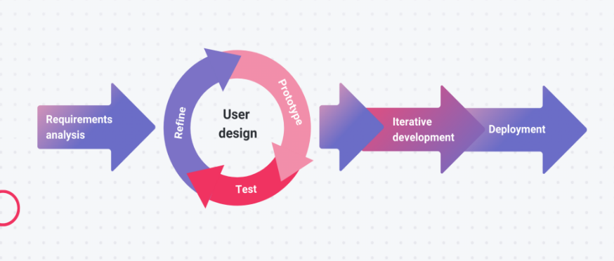
Figure 3.1 RAD Model for System Design
¶
¶
Figure 3.1 illustrates the system development methodology adopted in this study. To support the developmental research design, the researchers will utilize the Rapid Application Development (RAD) model. This approach emphasizes iterative prototyping and continuous user feedback, allowing the researchers to refine system features efficiently and ensure the final product aligns with user requirements within a short development cycle.
¶
¶
The development process will follow multiple phases:
¶
¶
- Planning – The researchers will identify existing problems in thesis management and define system objectives. Initial requirements will be collected from students, advisers, and school leaders. The team will also engage external stakeholders, such as industry partners, to ensure the system effectively supports technology transfer.
- Analysis – Collected data will be examined to determine detailed system requirements. Researchers will analyze user needs and process flows to ensure the design aligns with institutional operations.
- Design – The system architecture, database structure, and user interface will be created. Technical diagrams, including system flows and database designs, will be prepared to guide development.
- Development – The system will be built using appropriate front-end, back-end, and database tools. Core features, such as the project inventory and technology transfer modules, will be integrated to make the system functional.
- Testing – Once development is finished, the application will undergo rigorous testing to identify and correct errors or inconsistencies. Feedback will be used to check performance and implement necessary improvements.
- Implementation – After testing and polishing the system, the final version will be prepared for launch and introduced to selected users within the research department. Users will interact with the system in real-life situations to provide further performance feedback.
- Evaluation – The finished application will be assessed by users to measure functionality, ease of use, and overall performance based on ISO/IEC 25010 standards. Results will be gathered through standardized survey questionnaires and direct observations to adjust the system.
¶
¶
3.3 System Design Procedure
¶
¶
The system design procedure explains how gathered institutional requirements are translated into technical blueprints for the ThesisTrack application. It ensures that functional requirements are properly converted into system design for backend development. This process is divided into four sequential phases that define how data flows, how users interact with the system, and how security is applied across the six core modules.
¶
¶
- Architectural Design: The process starts by converting academic monitoring requirements into a high-level system design. This defines how the user interface, server, and database interact, and establishes the structure of the six core modules to support smooth thesis timeline monitoring.
- Process Modeling: Structured Analysis is used to map how research files move through institutional workflows. A Context Diagram is first created to define the boundary between external entities such as students, faculty advisers, library personnel, and industry partners and the ThesisTrack system. This is then expanded into more detailed Data Flow Diagram to show how data moves, changes, and is stored in the database. This includes uploaded manuscripts, milestone evaluations, and tracking data across the six modules.
- UML Modeling: This phase defines system behavior and user permissions using Unified Modeling Language (UML). Use Case Diagrams establish role-based access, Sequence Diagrams show step-by-step processes such as milestone uploads, and Activity Diagrams illustrate approval and rejection workflows.
- Algorithmic Design: This stage focuses on detailed coding logic and system quality. Flowcharts are used to design backend processes, especially the Technology Transfer matching engine, ensuring that reliability, performance, and security meet ISO/IEC 25010 standards.
¶

3.4 System Architecture
¶
¶
¶
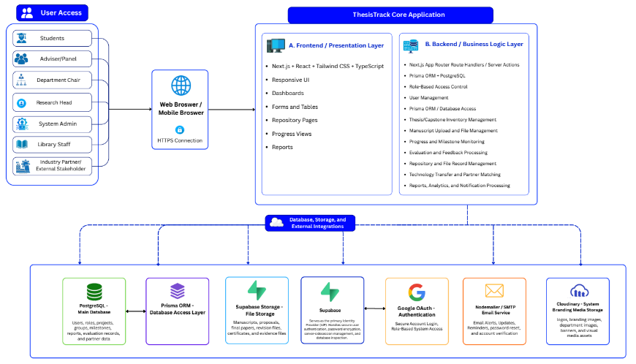
Figure 3.2 System Architecture of ThesisTrack
¶
¶
Figure 3.2 illustrates the overall architecture of the ThesisTrack system, showing how users interact with the application and how data flows through its major components. The architecture is organized into several layers that work together to support thesis and capstone project management, repository services, monitoring, and reporting functions.
¶
¶
- User Access Layer – Consists of the different stakeholders who utilize the system, including Students, Advisers/Panels, Department Chairs, Research Heads, System Administrators, Library Staff, and Industry Partners/External Stakeholders. Each user is granted access according to their assigned roles and responsibilities.
- Web Browser Layer – Serves as the primary access point to the system. Users interact with ThesisTrack through a web browser, while secure HTTPS communication ensures the protection of data transmitted between users and the application.
- Frontend / Presentation Layer – Provides the user interface of the system, including dashboards, forms, tables, repository pages, progress monitoring views, and reports. This layer enables users to perform system functions through an organized and responsive interface.
- Backend / Business Logic Layer – Handles the core processing of the system. It manages user accounts, role-based access control, thesis and capstone inventory records, manuscript submissions, progress monitoring, evaluation processing, technology transfer activities, and report generation.
- Database and Storage Components – Responsible for storing and managing system data. PostgreSQL serves as the primary database, while Prisma ORM facilitates database access and communication between the application and stored records.
- External Integration Services – Includes Supabase for file storage and backend services, Google OAuth for secure user authentication, Nodemailer SMTP for email notifications, and Cloudinary for storing images and other media assets used by the system.
- Data Flow and System Integration – Demonstrates how information is exchanged between the presentation layer, business logic layer, database, and external services to ensure efficient processing, secure data management, and reliable system operation.
- ¶
- ¶
The architecture provides a scalable and integrated framework that supports the core functionalities of the ThesisTrack platform while maintaining data security, accessibility, and system performance.
¶

¶3.5 Context Diagram
¶
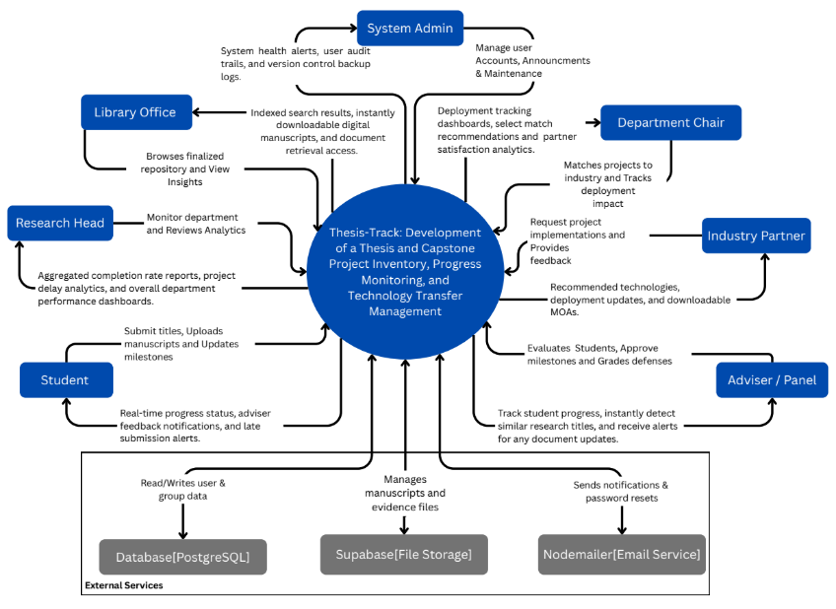
¶
Figure 3.3 Context Diagram of the ThesisTrack System
¶
¶
Figure 3.3 shows the system as a single process and its interactions with various external entities and supporting services. The diagram presents the flow of information between the system and its primary stakeholders, including Students, Advisers/Panels, Department Chairs, Library Office personnel, Research Head, Industry Partners, and System Administrators. Through these interactions, the system facilitates the submission of research documents, monitoring of project progress, evaluation of student outputs, management of repository records, and coordination of technology transfer activities.
¶
¶
Figure 3.3 also shows how ThesisTrack exchanges data with external services to support its operations. PostgreSQL serves as the primary database for storing user accounts, project records, and system information, while Supabase File Storage manages manuscripts, supporting documents, and evidence files. In addition, the Nodemailer Email Service enables the delivery of notifications, alerts, account verification messages, and password reset requests. Overall, the context diagram provides a high-level view of the system boundary and demonstrates how ThesisTrack communicates with users and external services to support thesis and capstone project inventory, progress monitoring, and technology transfer management.
¶
¶
3.6 Data Flow Diagram
¶
¶
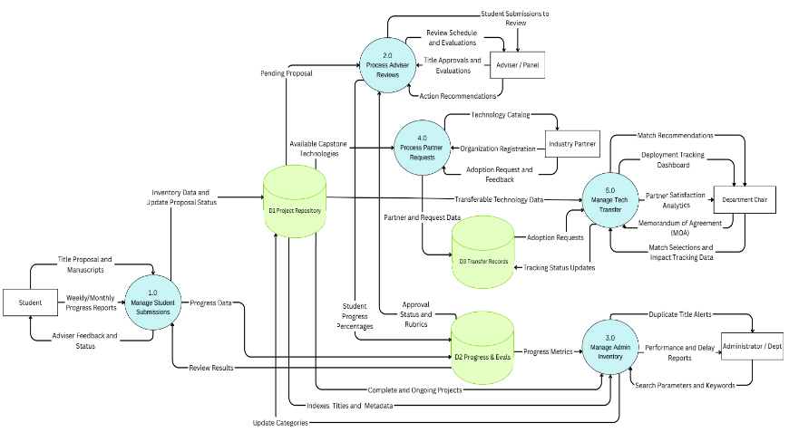
Figure 3.4 Data Flow Diagram of the ThesisTrack System
¶
¶
Figure 3.4 illustrates the Data Flow Diagram (DFD) of the ThesisTrack System, showing how data is exchanged among users, system processes, and data repositories. The diagram presents the major operational activities involved in managing thesis and capstone projects, from proposal submission and evaluation to inventory management and technology transfer.
¶
¶
- Manage Student Submissions (1.0) – Receives title proposals, manuscripts, and progress reports from students and records them within the system for further review and monitoring.
- Process Adviser Reviews (2.0) – Enables advisers and panel members to evaluate submissions, provide recommendations, approve titles, and assess student progress based on established criteria.
- Manage Admin Inventory (3.0) – Supports administrative functions such as repository maintenance, title verification, metadata management, duplicate checking, and generation of monitoring reports.
- Process Partner Requests (4.0) – Handles requests from industry partners, including technology inquiries, organization registration, adoption requests, and feedback submission.
- Manage Technology Transfer (5.0) – Facilitates the matching of completed capstone technologies with industry partners, tracks adoption activities, and monitors technology deployment outcomes.
- Project Repository (D1) – Serves as the central storage for project records, proposal information, repository metadata, and project status updates.
- Progress and Evaluation Records (D2) – Stores student progress reports, evaluation results, approval statuses, assessment rubrics, and performance indicators.
- Transfer Records (D3) – Maintains data related to technology transfer activities, partner requests, deployment records, and adoption tracking information.
- External Entities – Include Students, Advisers/Panels, Industry Partners, Department Chairs, and Administrators who interact with the system by submitting, reviewing, monitoring, and utilizing project information.
- ¶
- ¶
The diagram demonstrates how ThesisTrack integrates academic project management, repository administration, progress monitoring, evaluation processes, and technology transfer activities into a unified system that supports efficient information flow and decision-making among stakeholders.
¶
¶
3.7 Flowchart
¶
¶
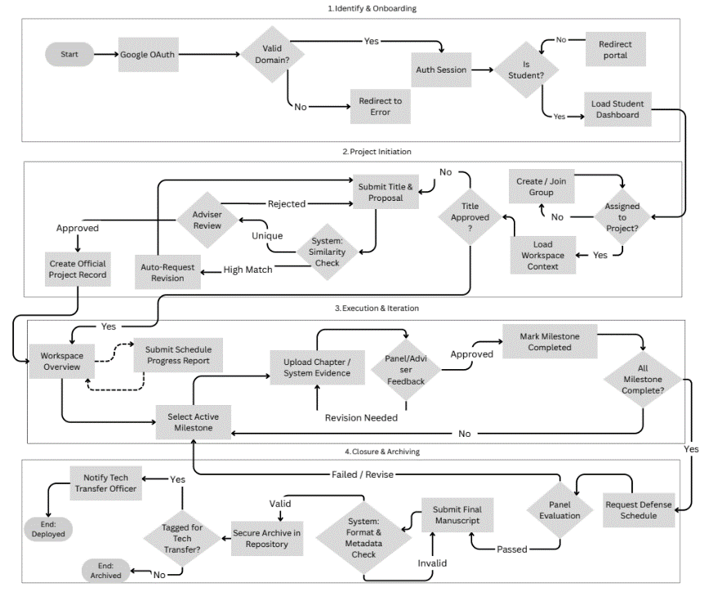
Figure 3.5 Student Research Process Flow
¶
¶
Figure 3.5 illustrates the student flowchart within the student module, outlining the operational logic, decision points, and sequential processes followed by student researchers. The diagram maps the progression of student activities from account verification and project initialization to research development, review processes, defense evaluation, and final repository submission. It presents key decision paths, including authentication validation, manuscript similarity checking, faculty review cycles, metadata verification, and technology transfer screening. This flowchart provides a structured representation of the processes that guide students throughout the research lifecycle and support document management from project initiation to graduation clearance.
¶
¶
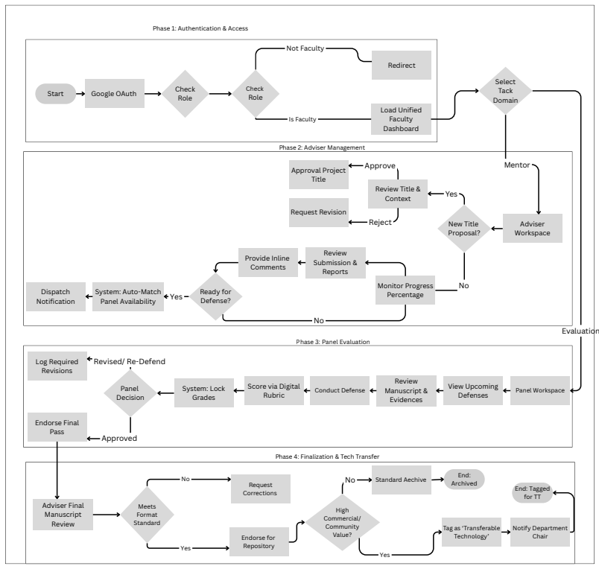
Figure 3.6 Faculty Module Workflow
¶
¶
Figure 3.6 illustrates the faculty workflow within the faculty module, outlining the operational logic, decision points, and sequential processes performed by advisers and panel members. The diagram maps faculty activities from authentication and project supervision to defense evaluation and technology transfer review. It presents key decision paths, including role verification, title approval and revision cycles, progress monitoring, panel assignment, rubric-based evaluation, post-defense verification, and intellectual property assessment. This flowchart provides a structured representation of the processes that support faculty supervision, evaluation, and approval of student research throughout the system.
¶
¶
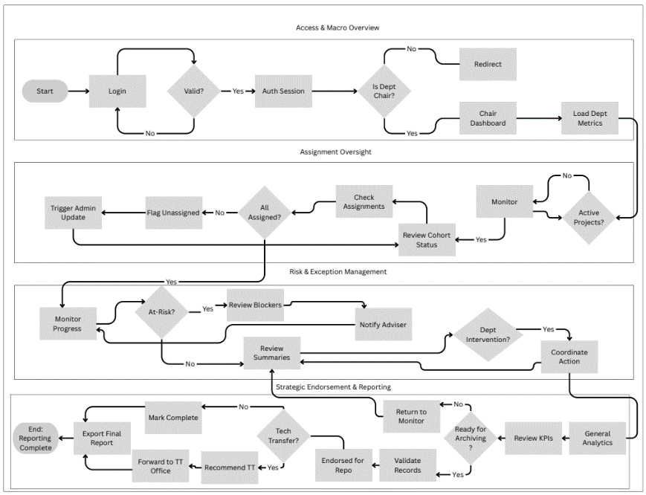
Figure 3.7 Department Chair Monitoring and Research Oversight Workflow
¶
¶
Figure 3.7 illustrates the workflow of the Department Chair within the ThesisTrack system for overseeing thesis and capstone activities at the departmental level. The process includes authentication, assignment monitoring, project oversight, risk and exception management, progress evaluation, report generation, and technology transfer endorsement. The diagram highlights how department chairs monitor academic performance, coordinate interventions, review research analytics, and support institutional reporting and archiving activities.
¶
¶
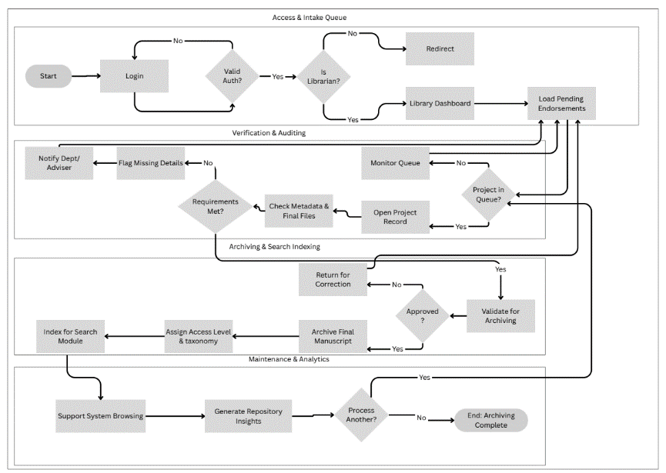
Figure 3.8 Library Repository Validation and Archiving Workflow
¶
¶
Figure 3.8 illustrates the workflow of the Library Personnel within the ThesisTrack system for validating, organizing, and archiving finalized thesis and capstone manuscripts. The process includes authentication, review of pending endorsements, metadata and file verification, repository validation, manuscript archiving, taxonomy assignment, and search indexing. The diagram also highlights how library personnel manage repository maintenance and generate repository insights to support organized institutional record management.
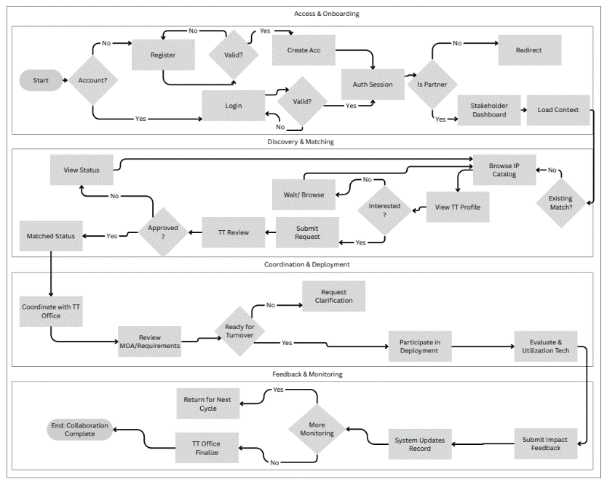
Figure 3.9 Industry Partner Collaboration and Technology Transfer Workflow
¶
¶
Figure 3.9 illustrates the workflow of industry partners within the ThesisTrack system for engaging with academic research and technology transfer activities. The process includes stakeholder registration, project discovery and matching, submission of collaboration requests, coordination with the technology transfer office, deployment participation, and impact feedback monitoring. The diagram highlights how external partners interact with the platform to evaluate, utilize, and support thesis and capstone projects for real-world application and collaboration opportunities.
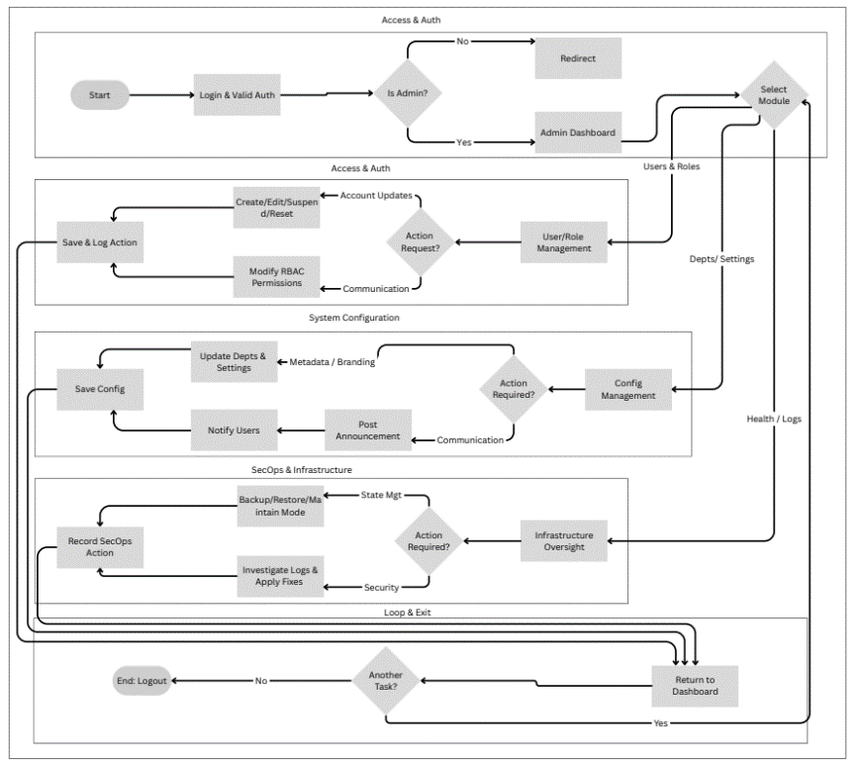
Figure 3.10 System Administration and Platform Management Workflow
¶
¶
Figure 3.10 illustrates the workflow of the System Administrator within the ThesisTrack platform for managing system operations, user access, and technical maintenance. The process includes authentication, user and role management, configuration of departmental settings, announcement handling, security monitoring, backup and maintenance operations, and infrastructure oversight. The diagram highlights how the administrator ensures the stability, security, and continuous operation of the system across all institutional modules and user roles.
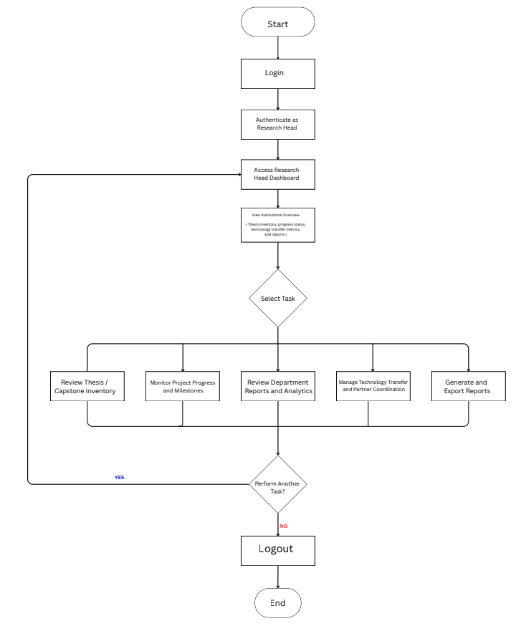Figure 3.11 Research Head Institutional Monitoring and Technology Transfer Workflow
¶
¶
Figure 3.11 illustrates the workflow of the Research Head within the ThesisTrack system for overseeing institutional research activities and technology transfer operations. The process includes authentication, access to the research management dashboard, monitoring thesis and capstone inventories, reviewing departmental analytics, tracking project progress, coordinating with external partners, and generating institutional reports. The diagram highlights how the Research Head manages centralized oversight and supports research utilization and decision-making within the institution.
¶
¶
3.8 Object Modeling
¶
¶
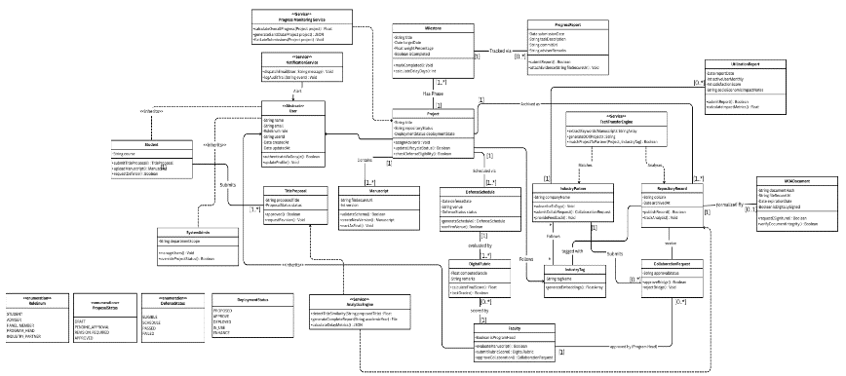
Figure 3.12 Object Modeling of ThesisTrack
¶
¶
Figure 3.12 illustrates the object modeling class diagram, providing a static structural representation of the platform’s data domain, entities, and backend logic. The diagram defines the object-oriented architecture and database relationships that govern the system. It maps core entity classes, including user role inheritance structures (Student, Faculty, SystemAdmin), Project, Milestone, DefenseSchedule, and RepositoryRecord, along with service components such as the Progress Monitoring Service, Analytics Engine, and Technology Transfer Engine. By specifying class attributes, data types, methods, and multiplicity constraints, this diagram establishes the relational structure and data integrity required to support system-wide tracking, evaluation, and collaboration processes.
¶
¶
3.9 Use Case Diagram
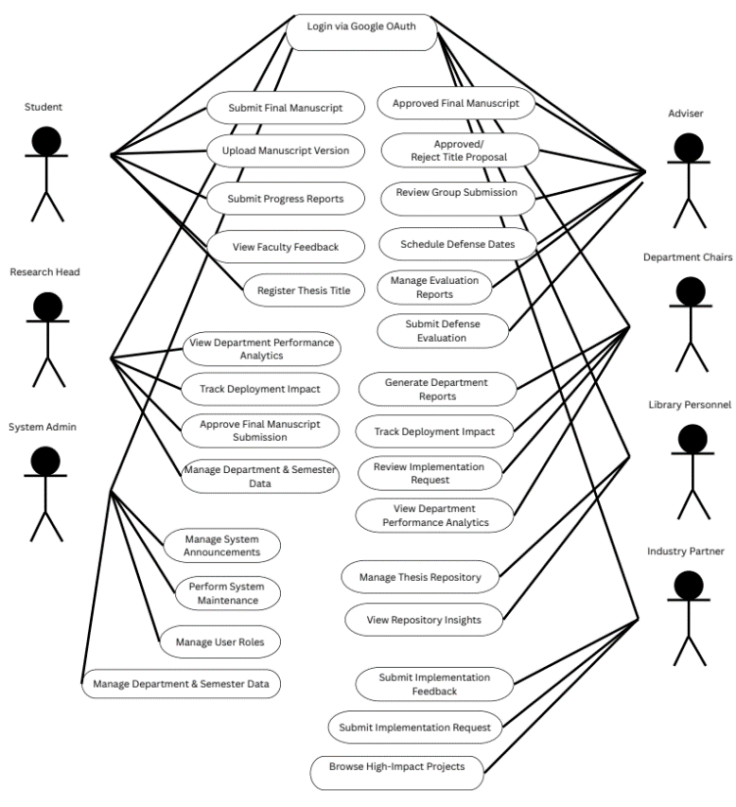
Figure 3.13 Use Case Diagram of ThesisTrack
¶
¶
Figure 3.13 illustrates the use case diagram, mapping the functional interactions between the system’s user roles and core features. The diagram serves as a structural overview of the system architecture, outlining how different actors such as Students, Advisers, Department Chairs, Research Heads, Library Personnel, Industry Partners, and System Administrators interact with specific modules of the application. It defines role-based access boundaries and data flow pathways across the platform, covering the full thesis lifecycle from title registration and academic evaluation to repository publication and technology transfer activities.
¶
¶
3.10 Sequence Diagram
¶
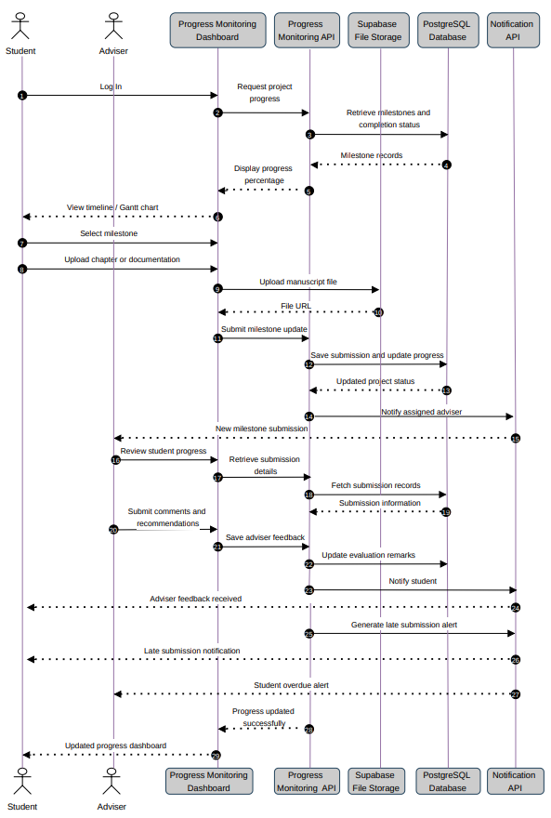
¶
Figure 3.14 Progress Monitoring Sequence Diagram
¶
¶
Figure 3.14 illustrates the progress monitoring sequence diagram, outlining the step-by-step runtime interactions and data flow between user actors, system components, and backend repositories. The diagram maps the dynamic workflow of student research milestone submission, validation, and review processes. It shows the chronological exchange of messages among key entities, including the Student, Adviser, Progress Monitoring Dashboard, Progress Monitoring API, Supabase File Storage, PostgreSQL Database, and Notification API. This diagram defines the sequence of backend operations, database transactions, file storage handling, and automated notifications required to support synchronized academic progress tracking across the system.
¶
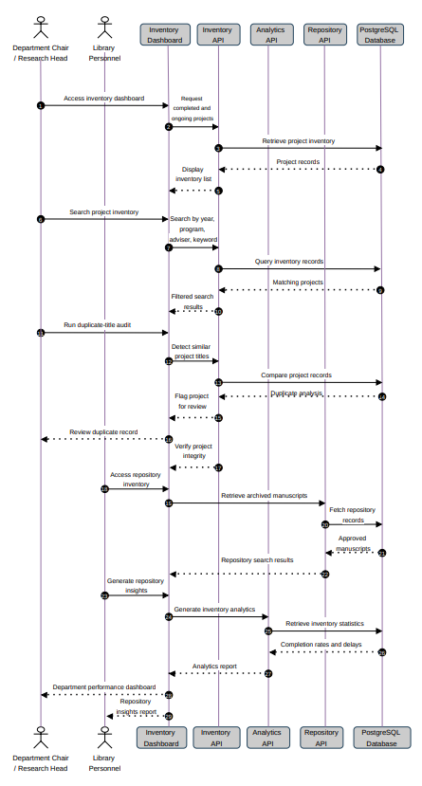
¶
Figure 3.15 Thesis & Capstone Inventory Sequence Diagram
¶
¶
Figure 3.15 illustrates the thesis/capstone inventory sequence diagram, outlining the step-by-step runtime interactions and data flow between user actors, system interfaces, and backend components. The diagram maps the lifecycle of how archived and ongoing research records are managed, searched, and checked for duplicate titles. It shows the chronological exchange of messages among key entities, including the Department Chair/Research Head, Library Personnel, Inventory Dashboard, Inventory API, Analytics API, Repository API, and PostgreSQL Database. This diagram defines the operational sequence for managing institutional research records and generating analytical insights.
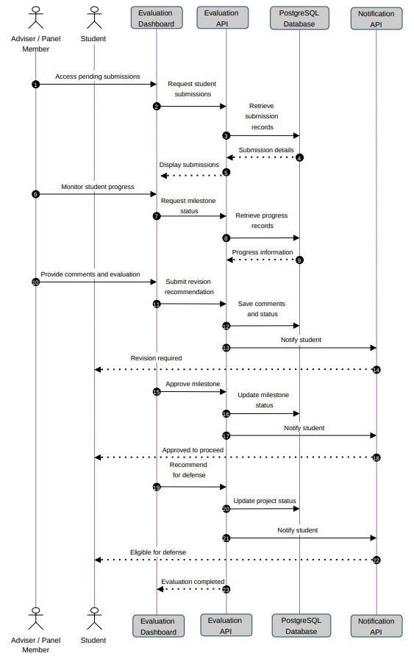
Figure 3.16 - Evaluation Sequence Diagram
¶
¶
Figure 3.16 illustrates the evaluation sequence diagram, outlining the step-by-step runtime interactions and data flow between user actors, system interfaces, and backend components. The diagram maps the lifecycle of how student capstone submissions are assessed, graded, and processed through revision or approval workflows by faculty reviewers. It shows the chronological exchange of messages among key entities, including the Adviser/Panel Member, Student, Evaluation Dashboard, Evaluation API, PostgreSQL Database, and Notification API. This diagram defines the operational sequence for coordinating defense eligibility, managing evaluation records, and automating feedback delivery within the system.
3.11 Activity Diagram
¶
¶
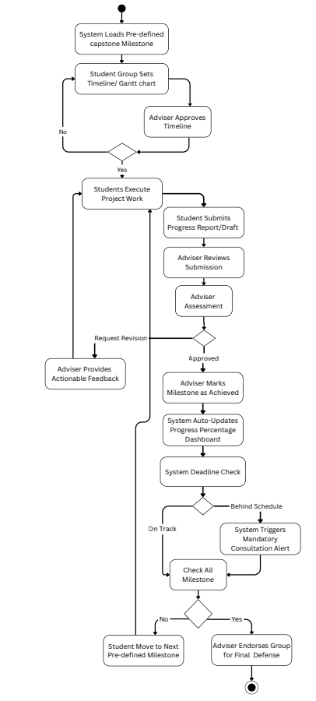
Figure 3.17 Progress Monitoring Activity Diagram
¶
¶
Figure 3.17 illustrates the workflow for the progress monitoring module of the ThesisTrack system. It shows the sequence of activities involved in tracking student milestones, beginning with artifact submission and automated validation. Valid submissions are forwarded for adviser review and progress tracking, while invalid submissions are returned for correction. The process also includes activity logging and dashboard updates, concluding with either milestone advancement upon approval or revision upon rejection until final project completion and archival.
¶
¶
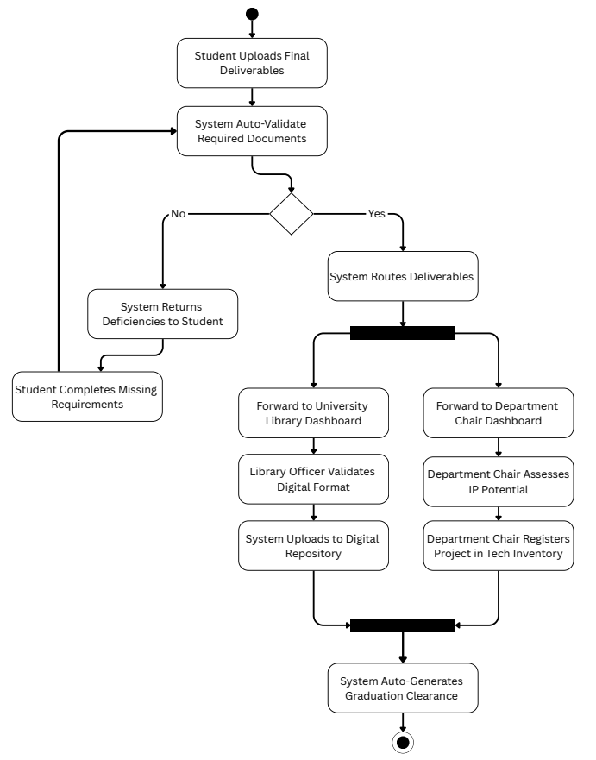
Figure 3.18 Thesis & Capstone Inventory Activity Diagram
¶
¶
Figure 3.18 illustrates the workflow for the thesis and capstone inventory module of the ThesisTrack system. It depicts the process of recording research projects in the repository, beginning with metadata entry and validation. The workflow includes duplicate checking, repository indexing, and archival storage, ensuring that research records are properly validated, organized, and made accessible within the system before final publication.
¶
¶
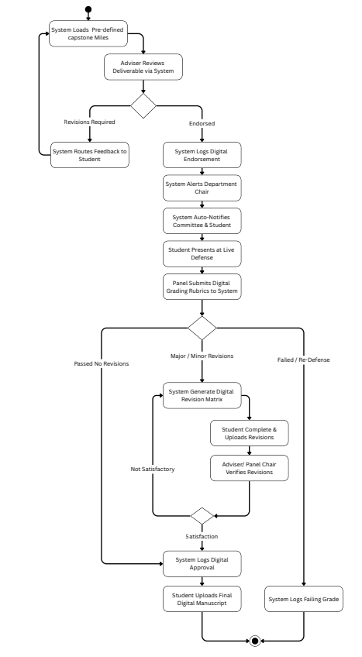
Figure 3.19 Evaluation Activity Diagram
¶
¶
Figure 3.19 illustrates the workflow for the oral defense evaluation module of the ThesisTrack system. It shows the process of conducting and recording defense evaluations, beginning with rubric access and score entry by faculty panel members. The workflow includes validation of evaluation inputs, automatic score computation, grade consolidation, and database recording. It also updates monitoring dashboards and notifies students of evaluation results before advancing the group's status within the research lifecycle.
¶
¶
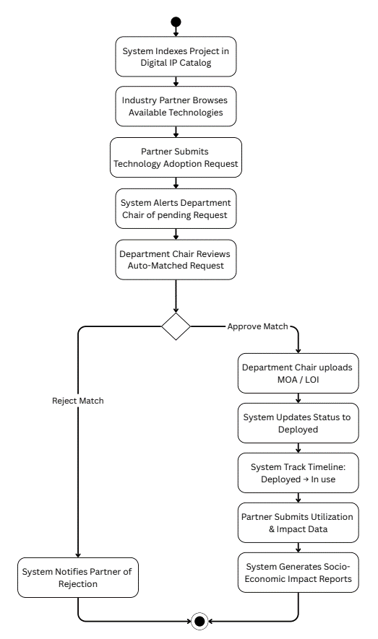
Figure 3.20 Technology Transfer Activity Diagram
¶
¶
Figure 3.20 illustrates the workflow for the technology transfer and external collaboration module of the ThesisTrack system. It depicts the process of matching research projects with potential industry partners, evaluating compatibility requirements, and initiating collaboration activities. The workflow includes stakeholder notifications, agreement recording, impact tracking updates, and formal approval procedures, concluding once collaboration records are finalized and confirmations are issued to all involved parties.
¶
¶
3.12 Entity-Relationship-Diagram (ERD)
¶
¶
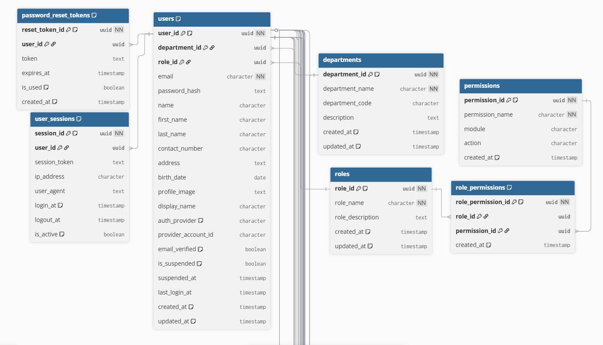
Figure 3.21 ThesisTrack Entity-Relationship-Diagram (A)
¶
¶
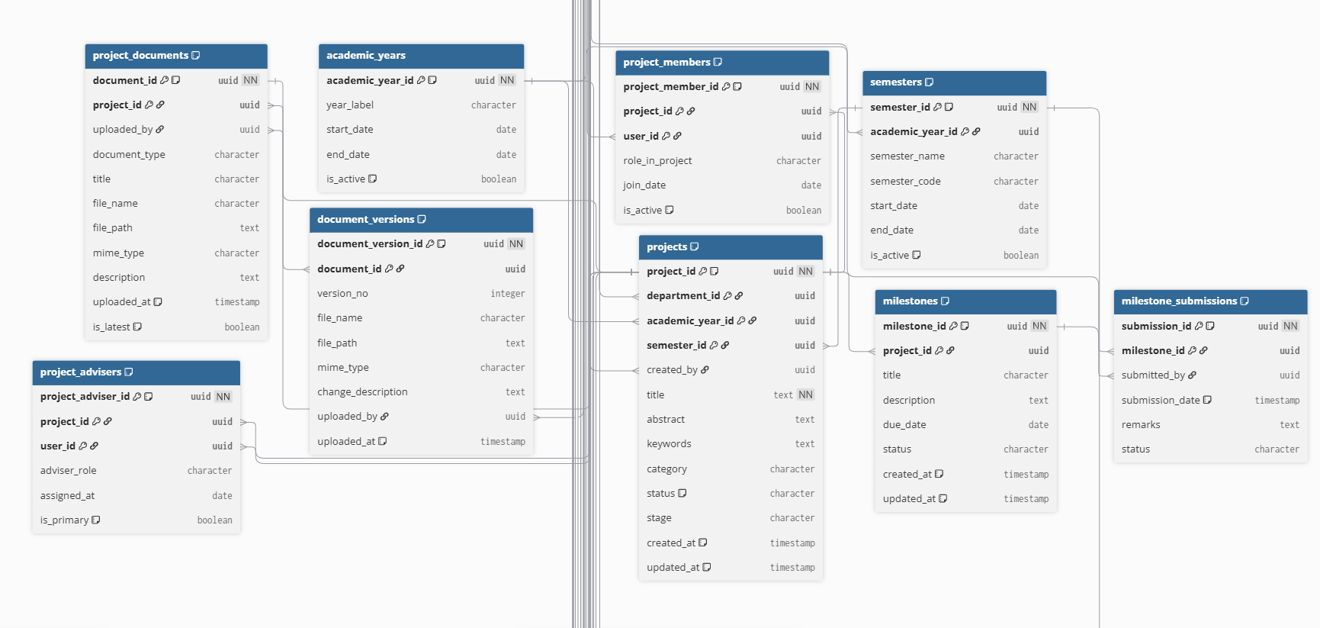
Figure 3.22 ThesisTrack Entity-Relationship-Diagram (B)
¶
¶
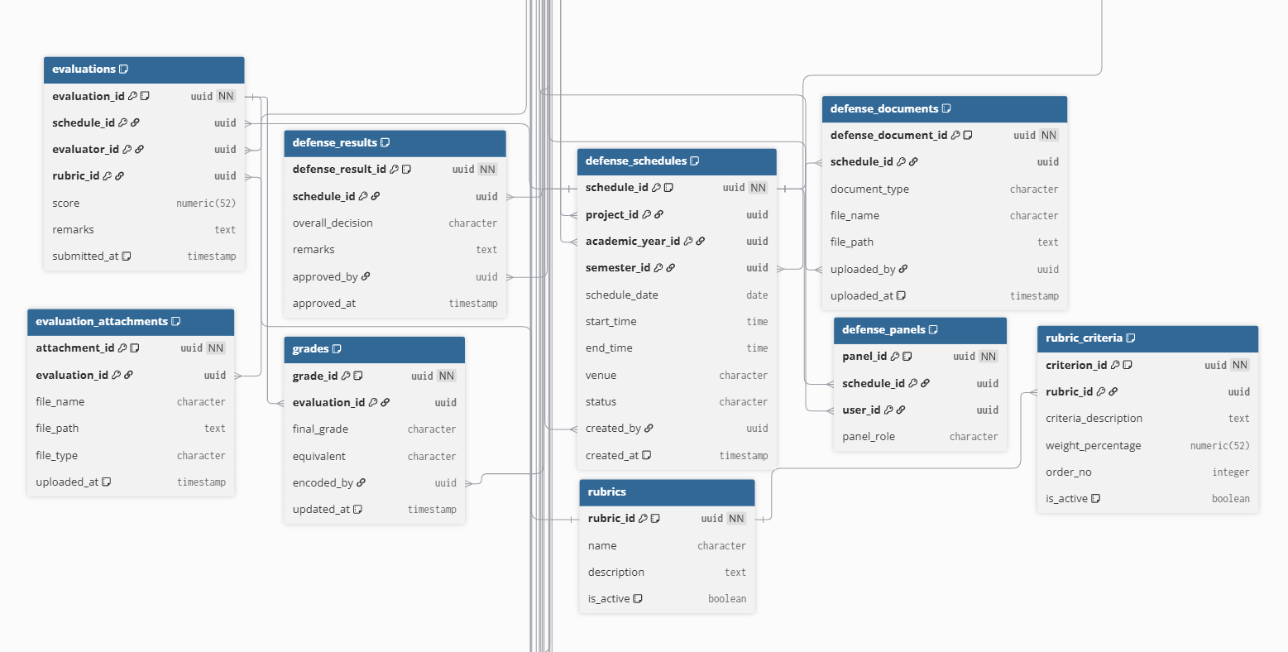
Figure 3.23 ThesisTrack Entity-Relationship-Diagram (C)
¶
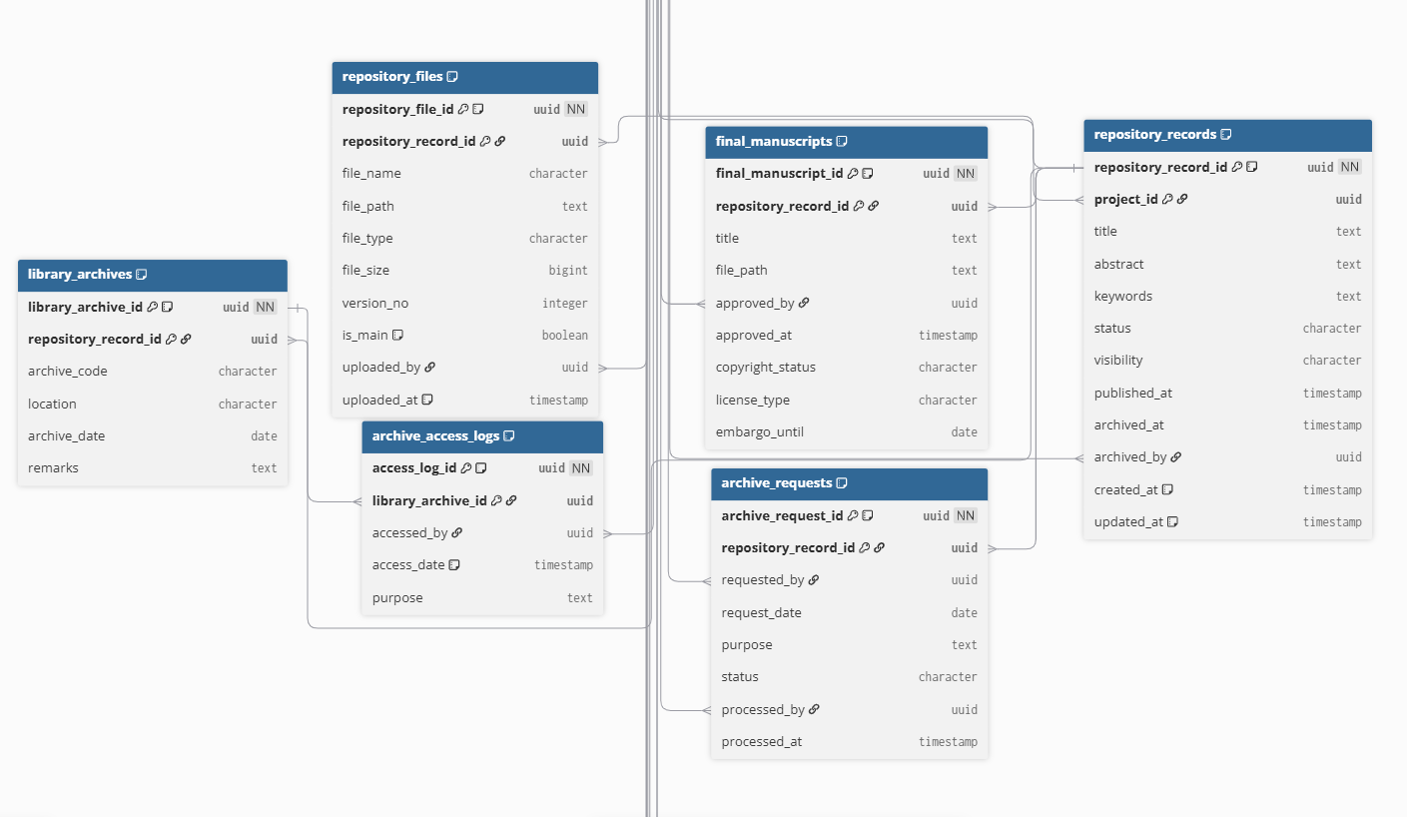
Figure 3.24 ThesisTrack Entity-Relationship-Diagram (D)
¶
¶
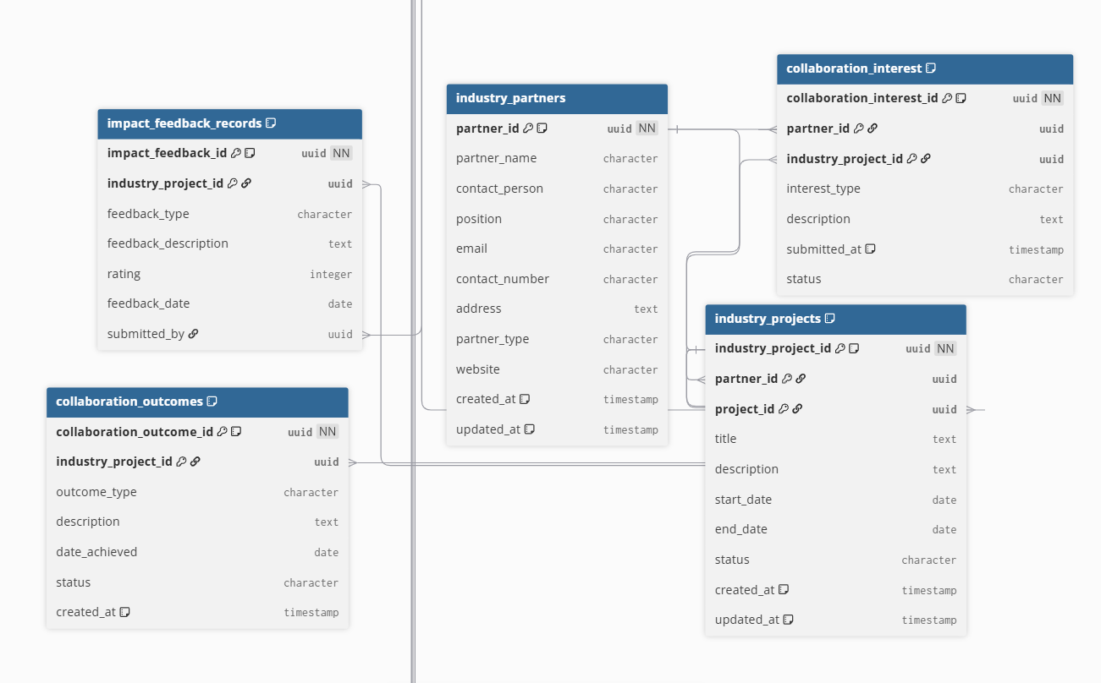
Figure 3.25 ThesisTrack Entity-Relationship-Diagram (E)
¶
¶
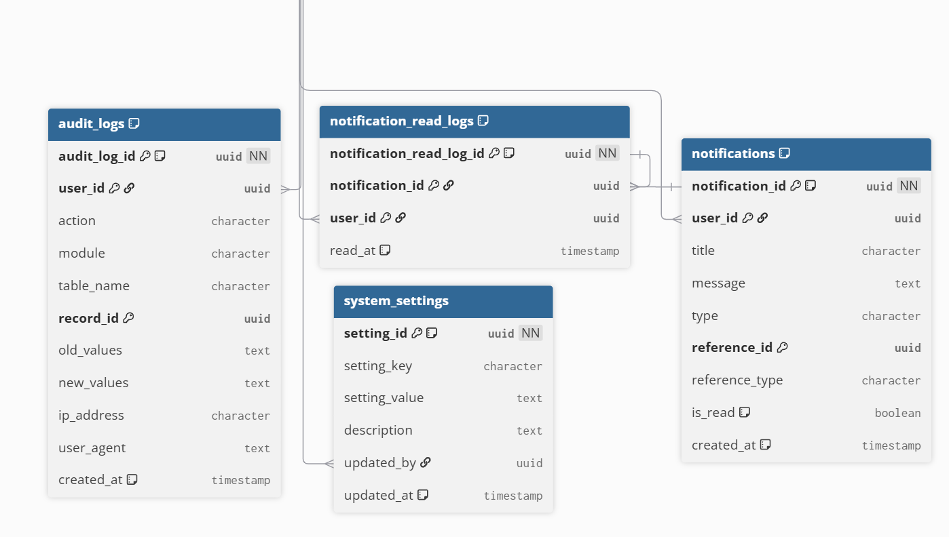
Figure 3.26 ThesisTrack Entity-Relationship-Diagram (F)
¶
¶
- Entities: Entities represent the core components of the thesistrack system. Key entities include users and departments, with projects as the central academic records. Projects are linked to milestones, submissions, and defense schedules to track progress. Roles and permissions manage access control, while rubrics and evaluation criteria handle assessment. Outputs are stored in library archives, and industry partners support external collaboration and application.
- Attributes: Attributes define the data fields of each entity, including identifiers, authentication details, and academic metadata such as project titles, descriptions, status, academic year, and semester. They also include progress data like milestone names, deadlines, submission status, and document versions. Evaluation data covers rubric components, scores, and computed results, while foreign keys ensure proper relationships among entities.
- Relationships: Relationships describe interactions among system entities. A department can have multiple users, while projects involve multiple users depending on roles. Each project contains multiple milestones, generating submissions and versioned documents. Defense schedules link projects to evaluators through panel assignments, producing assessment records. Completed projects are archived as single records, and industry partners engage with projects through collaboration interests for potential implementation or commercialization.
- ¶
- ¶
3.13 Data Dictionary
¶
¶
Table 3.1 Users Table
¶
Table 3.1 stores information and records related to users within the ThesisTrack system.
¶
Field Name | Data Type | Constraints | Description
user_id | BIGINT | PK, AI | Unique identifier for the user record
department_id | BIGINT | FK | References the department record
role_id | VARCHAR | FK | References the role record
email | VARCHAR | UQ, NN | Stores the email
password_hash | VARCHAR | NN | Stores the password hash
name | VARCHAR | NN | Stores the name
first_name | VARCHAR | NN | Stores the first name
last_name | VARCHAR | NN | Stores the last name
contact_number | VARCHAR | NN | Stores the contact number
address | VARCHAR | NN | Stores the address
birth_date | DATE | NN | Stores the birth date
profile_image | VARCHAR | NN | Stores the profile image
display_name | VARCHAR | NN | Stores the display name
auth_provider | VARCHAR | NN | Stores the auth provider
provider_account_id | VARCHAR | NN | Stores the provider account id
email_verified | VARCHAR | UQ, NN | Stores the email verified
is_suspended | BOOLEAN | NN | Indicates whether the record is suspended
suspended_at | TIMESTAMP | NN | Stores the suspended at
last_login_at | TIMESTAMP | NN | Stores the last login at
created_at | TIMESTAMP | NN | Stores the created at
updated_at | DATE | NN | Stores the updated at
¶
¶
Table 3.2 Department Table
¶
Table 3.2 stores information and records related to departments within the ThesisTrack system.
¶
Field Name | Data Type | Constraints | Description
department_id | BIGINT | PK, AI | Unique identifier for the department record
department_name | VARCHAR | NN | Stores the department name
department_code | VARCHAR | NN | Stores the department code
description | TEXT | NN | Stores the description
created_at | TIMESTAMP | NN | Stores the created at
updated_at | DATE | NN | Stores the updated at

Table 3.3 Roles Table
¶
Table 3.3 stores information and records related to roles within the ThesisTrack system.

Field Name | Data Type | Constraints | Description
role_id | VARCHAR | PK, AI | Unique identifier for the role record
role_name | VARCHAR | NN | Stores the role name
role_description | VARCHAR | NN | Stores the role description
created_at | TIMESTAMP | NN | Stores the created at
updated_at | DATE | NN | Stores the updated at
¶
¶
Table 3.4 Permissions Table
¶
Table 3.4 stores information and records related to permissions within the ThesisTrack system.
¶
Field Name | Data Type | Constraints | Description
permission_id | BIGINT | PK, AI | Unique identifier for the permission record
permission_name | VARCHAR | NN | Stores the permission name
module | VARCHAR | NN | Stores the module
action | VARCHAR | NN | Stores the action
created_at | TIMESTAMP | NN | Stores the created at
¶
¶
Table 3.5 Role Permissions Table
¶
Table 3.5 stores information and records related to role permissions within the ThesisTrack system.
¶
Field Name | Data Type | Constraints | Description
role_permission_id | VARCHAR | PK, AI | Unique identifier for the role_permission record
role_id | VARCHAR | FK | References the role record
permission_id | BIGINT | FK | References the permission record
created_at | TIMESTAMP | NN | Stores the created at
¶
¶

Table 3.6 Years Table
¶
Table 3.6 stores information and records related to academic years within the ThesisTrack system.
¶
Field Name | Data Type | Constraints | Description
academic_year_id | BIGINT | PK, AI | Unique identifier for the academic_year record
year_label | VARCHAR | NN | Stores the year label
start_date | DATE | NN | Stores the start date
end_date | DATE | NN | Stores the end date
is_active | BOOLEAN | NN | Indicates whether the record is active
¶
¶
Table 3.7 Semesters Table
¶
Table 3.7 stores information and records related to semesters within
the ThesisTrack system.
¶
Field Name | Data Type | Constraints | Description
semester_id | BIGINT | PK, AI | Unique identifier for the semester record
academic_year_id | BIGINT | FK | References the academic_year record
semester_name | VARCHAR | NN | Stores the semester name
semester_code | VARCHAR | NN | Stores the semester code
start_date | DATE | NN | Stores the start date
end_date | DATE | NN | Stores the end date
is_active | BOOLEAN | NN | Indicates whether the record is active

Table 3.8 User Session

Table 3.8 stores information and records related to user
sessions within the ThesisTrack system.

Field Name | Data Type | Constraints | Description
session_id | BIGINT | PK, AI | Unique identifier for the session record
user_id | BIGINT | FK | References the user record
session_token | VARCHAR | NN | Stores the session token
ip_address | VARCHAR | NN | Stores the ip address
user_agent | VARCHAR | NN | Stores the user agent
login_at | TIMESTAMP | NN | Stores the login at
logout_at | TIMESTAMP | NN | Stores the logout at
is_active | BOOLEAN | NN | Indicates whether the record is active

Table 3.9 Password Reset Token Table

Table 3.9 stores information and records related to password reset tokens within the ThesisTrack system.

Field Name | Data Type | Constraints | Description
reset_token_id | VARCHAR | PK, AI | Unique identifier for the reset_token record
user_id | BIGINT | FK | References the user record
token | VARCHAR | NN | Stores the token
expires_at | TIMESTAMP | NN | Stores the expires at
is_used | BOOLEAN | NN | Indicates whether the record is used
created_at | TIMESTAMP | NN | Stores the created at

Table 3.10 Projects Table

Table 3.10 stores information and records related to projects within the ThesisTrack system.

Field Name | Data Type | Constraints | Description
project_id | BIGINT | PK, AI | Unique identifier for the project record
department_id | BIGINT | FK | References the department record
academic_year_id | BIGINT | FK | References the academic_year record
semester_id | BIGINT | FK | References the semester record
created_by | BIGINT | FK | References the users record
title | VARCHAR | NN | Stores the title
abstract | TEXT | NN | Stores the abstract
keywords | TEXT | NN | Stores the keywords
category | VARCHAR | NN | Stores the category
status | VARCHAR | NN | Stores the status
stage | VARCHAR | NN | Stores the stage
created_at | TIMESTAMP | NN | Stores the created at
updated_at | DATE | NN | Stores the updated at

Table 3.11 Project Members Table

Table 3.11 stores information and records related to project members within the ThesisTrack system.

Field Name | Data Type | Constraints | Description
project_member_id | BIGINT | PK, AI | Unique identifier for the project_member record
project_id | BIGINT | FK | References the project record
user_id | BIGINT | FK | References the user record
role_in_project | VARCHAR | NN | Stores the role in project
join_date | DATE | NN | Stores the join date
is_active | BOOLEAN | NN | Indicates whether the record is active

Table 3.12 Project Advisers Table

Table 3.12 stores information and records related to project advisers within the ThesisTrack system.

Field Name | Data Type | Constraints | Description
project_adviser_id | BIGINT | PK, AI | Unique identifier for the project_adviser record
project_id | BIGINT | FK | References the project record
user_id | BIGINT | FK | References the user record
adviser_role | VARCHAR | NN | Stores the adviser role
assigned_at | TIMESTAMP | NN | Stores the assigned at
is_primary | BOOLEAN | NN | Indicates whether the record is primary

Table 3.13 Milestone Table

Table 3.13 stores information and records related to milestones within the ThesisTrack system.

Field Name | Data Type | Constraints | Description
milestone_id | BIGINT | PK, AI | Unique identifier for the milestone record
project_id | BIGINT | FK | References the project record
title | VARCHAR | NN | Stores the title
description | TEXT | NN | Stores the description
due_date | DATE | NN | Stores the due date
status | VARCHAR | NN | Stores the status
created_at | TIMESTAMP | NN | Stores the created at
updated_at | DATE | NN | Stores the updated at

Table 3.14 Milestone Submissions Table

Table 3.14 stores information and records related to milestones within the ThesisTrack system.

Field Name | Data Type | Constraints | Description
submission_id | BIGINT | PK, AI | Unique identifier for the submission record
milestone_id | BIGINT | FK | References the milestone record
submitted_by | BIGINT | FK | References the users record
submission_date | DATE | NN | Stores the submission date
remarks | TEXT | NN | Stores the remarks
status | VARCHAR | NN | Stores the status

Table 3.15 Project Documents Table

Table 3.15 stores information and records related to project documents within the ThesisTrack system.

Field Name | Data Type | Constraints | Description
document_id | BIGINT | PK, AI | Unique identifier for the document record
project_id | BIGINT | FK | References the project record
uploaded_by | BIGINT | FK | References the users record
document_type | VARCHAR | NN | Stores the document type
title | VARCHAR | NN | Stores the title
file_name | VARCHAR | NN | Stores the file name
file_path | VARCHAR | NN | Stores the file path
mime_type | VARCHAR | NN | Stores the mime type
description | TEXT | NN | Stores the description
uploaded_at | TIMESTAMP | NN | Stores the uploaded at
is_latest | BOOLEAN | NN | Indicates whether the record is latest

Table 3.16 Document Versions Table

Table 3.16 stores information and records related to document versions
within the ThesisTrack system.

Field Name | Data Type | Constraints | Description
document_version_id | BIGINT | PK, AI | Unique identifier for the document_version record
document_id | BIGINT | FK | References the document record
version_no | INT | NN | Stores the version no
file_name | VARCHAR | NN | Stores the file name
file_path | VARCHAR | NN | Stores the file path
mime_type | VARCHAR | NN | Stores the mime type
change_description | TEXT | NN | Stores the change description
uploaded_by | BIGINT | FK | References the users record
uploaded_at | TIMESTAMP | NN | Stores the uploaded at

Table 3.17 Defense Schedules Table

Table 3.17 stores information and records related to defense schedules within the ThesisTrack system.

Field Name | Data Type | Constraints | Description
schedule_id | BIGINT | PK, AI | Unique identifier for the schedule record
project_id | BIGINT | FK | References the project record
academic_year_id | BIGINT | FK | References the academic_year record
semester_id | BIGINT | FK | References the semester record
schedule_date | DATE | NN | Stores the schedule date
start_time | TIMESTAMP | NN | Stores the start time
end_time | TIMESTAMP | NN | Stores the end time
venue | VARCHAR | NN | Stores the venue
status | VARCHAR | NN | Stores the status
created_by | BIGINT | FK | References the users record
created_at | TIMESTAMP | NN | Stores the created at

Table 3.18 Defense Panels Table

Table 3.18 stores information and records related to defense panels within the ThesisTrack system.

Field Name | Data Type | Constraints | Description
panel_id | BIGINT | PK, AI | Unique identifier for the panel record
schedule_id | BIGINT | FK | References the schedule record
user_id | BIGINT | FK | References the user record
panel_role | VARCHAR | NN | Stores the panel role

Table 3.19 Rubrics Table

Table 3.19 stores information and records related to rubrics within the ThesisTrack system.

Field Name | Data Type | Constraints | Description
rubric_id | BIGINT | PK, AI | Unique identifier for the rubric record
name | VARCHAR | NN | Stores the name
description | TEXT | NN | Stores the description
is_active | BOOLEAN | NN | Indicates whether the record is active

Table 3.20 Rubric Criteria Table

Table 3.20 stores information and records related to rubric criteria within the ThesisTrack system.

Field Name | Data Type | Constraints | Description
criterion_id | BIGINT | PK, AI | Unique identifier for the criterion record
rubric_id | BIGINT | FK | References the rubric record
criteria_description | TEXT | NN | Stores the criteria description
weight_percentage | DECIMAL | NN | Stores the weight percentage
order_no | INT | NN | Stores the order no
is_active | BOOLEAN | NN | Indicates whether the record is active

Table 3.21 Evaluations Table

Table 3.21 stores information and records related to evaluations within the ThesisTrack system.

Field Name | Data Type | Constraints | Description
evaluation_id | BIGINT | PK, AI | Unique identifier for the evaluation record
schedule_id | BIGINT | FK | References the schedule record
evaluator_id | BIGINT | FK | References the evaluator record
rubric_id | BIGINT | FK | References the rubric record
score | DECIMAL | NN | Stores the score
remarks | TEXT | NN | Stores the remarks
submitted_at | TIMESTAMP | NN | Stores the submitted at

Table 3.22 Evaluation Attachments Table

Table 3.22 stores information and records related to evaluation attachments within the ThesisTrack system.

Field Name | Data Type | Constraints | Description
attachment_id | BIGINT | PK, AI | Unique identifier for the attachment record
evaluation_id | BIGINT | FK | References the evaluation record
file_name | VARCHAR | NN | Stores the file name
file_path | VARCHAR | NN | Stores the file path
file_type | VARCHAR | NN | Stores the file type
uploaded_at | TIMESTAMP | NN | Stores the uploaded at

Table 3.23 Defense Results Table

Table 3.23 stores information and records related to defense results within the ThesisTrack system.

Field Name | Data Type | Constraints | Description
defense_result_id | BIGINT | PK, AI | Unique identifier for the defense_result record
schedule_id | BIGINT | FK | References the schedule record
overall_decision | VARCHAR | NN | Stores the overall decision
remarks | TEXT | NN | Stores the remarks
approved_by | BIGINT | FK | References the users record
approved_at | TIMESTAMP | NN | Stores the approved at
Table 3.24 Defense Documents Table

Table 3.24 stores information and records related to defense documents within the ThesisTrack system.

Field Name | Data Type | Constraints | Description
defense_document_id | BIGINT | PK, AI | Unique identifier for the defense_document record
schedule_id | BIGINT | FK | References the schedule record
document_type | VARCHAR | NN | Stores the document type
file_name | VARCHAR | NN | Stores the file name
file_path | VARCHAR | NN | Stores the file path
uploaded_by | BIGINT | FK | References the users record
uploaded_at | TIMESTAMP | NN | Stores the uploaded at

Table 3.25 Repository Files Table

Table 3.25 stores information and records related to repository files within the ThesisTrack system.

Field Name | Data Type | Constraints | Description
repository_file_id | BIGINT | PK, AI | Unique identifier for the repository_file record
repository_record_id | BIGINT | FK | References the repository_record record
file_name | VARCHAR | NN | Stores the file name
file_path | VARCHAR | NN | Stores the file path
file_type | VARCHAR | NN | Stores the file type
file_size | INT | NN | Stores the file size
version_no | INT | NN | Stores the version no
is_main | BOOLEAN | NN | Indicates whether the record is main
uploaded_by | BIGINT | FK | References the users record
uploaded_at | TIMESTAMP | NN | Stores the uploaded at

Table 3.26 Final Manuscript Table

Table 3.26 stores information and records related to final manuscripts within the ThesisTrack system.

Field Name | Data Type | Constraints | Description
final_manuscript_id | BIGINT | PK, AI | Unique identifier for the final_manuscript record
repository_record_id | BIGINT | FK | References the repository_record record
title | VARCHAR | NN | Stores the title
file_path | VARCHAR | NN | Stores the file path
approved_by | BIGINT | FK | References the users record
approved_at | TIMESTAMP | NN | Stores the approved at
copyright_status | VARCHAR | NN | Stores the copyright status
license_type | VARCHAR | NN | Stores the license type
embargo_until | VARCHAR | NN | Stores the embargo until

Table 3.27 Library Archives Table

Table 3.27 stores information and records related to library archives within the ThesisTrack system.

Field Name | Data Type | Constraints | Description
library_archive_id | BIGINT | PK, AI | Unique identifier for the library_archive record
repository_record_id | BIGINT | FK | References the repository_record record
archive_code | VARCHAR | NN | Stores the archive code
location | VARCHAR | NN | Stores the location
archive_date | DATE | NN | Stores the archive date
remarks | TEXT | NN | Stores the remarks

Table 3.28 Archive Access Logs Table

Table 3.28 stores information and records related to archive access logs within the ThesisTrack system.

Field Name | Data Type | Constraints | Description
access_log_id | BIGINT | PK, AI | Unique identifier for the access_log record
library_archive_id | BIGINT | FK | References the library_archive record
accessed_by | BIGINT | FK | References the users record
access_date | DATE | NN | Stores the access date
purpose | VARCHAR | NN | Stores the purpose
Table 3.29 Archive Requests Table

Table 3.29 stores information and records related to archive requests within the ThesisTrack system.

Field Name | Data Type | Constraints | Description
archive_request_id | BIGINT | PK, AI | Unique identifier for the archive_request record
repository_record_id | BIGINT | FK | References the repository_record record
requested_by | BIGINT | FK | References the users record
request_date | DATE | NN | Stores the request date
purpose | VARCHAR | NN | Stores the purpose
status | VARCHAR | NN | Stores the status
processed_by | BIGINT | FK | References the users record
processed_at | TIMESTAMP | NN | Stores the processed at

Table 3.30 Industry Partners Table

Table 3.30 stores information and records related to industry partners within the ThesisTrack system.

Field Name | Data Type | Constraints | Description
partner_id | BIGINT | PK, AI | Unique identifier for the partner record
partner_name | VARCHAR | NN | Stores the partner name
contact_person | VARCHAR | NN | Stores the contact person
position | VARCHAR | NN | Stores the position
email | VARCHAR | UQ, NN | Stores the email
contact_number | VARCHAR | NN | Stores the contact number
address | VARCHAR | NN | Stores the address
partner_type | VARCHAR | NN | Stores the partner type
website | VARCHAR | NN | Stores the website
created_at | TIMESTAMP | NN | Stores the created at
updated_at | DATE | NN | Stores the updated at

Table 3.31 Industry Projects Table

Table 3.31 stores information and records related to industry projects within the ThesisTrack system.

Field Name | Data Type | Constraints | Description
industry_project_id | BIGINT | PK, AI | Unique identifier for the industry_project record
partner_id | BIGINT | FK | References the partner record
project_id | BIGINT | FK | References the project record
title | VARCHAR | NN | Stores the title
description | TEXT | NN | Stores the description
start_date | DATE | NN | Stores the start date
end_date | DATE | NN | Stores the end date
status | VARCHAR | NN | Stores the status
created_at | TIMESTAMP | NN | Stores the created at
updated_at | DATE | NN | Stores the updated at

Table 3.32 Collaboration Interest Table

Table 3.32 stores information and records related to collaboration interest within the ThesisTrack system.

Field Name | Data Type | Constraints | Description
collaboration_interest_id | BIGINT | PK, AI | Unique identifier for the collaboration_interest record
partner_id | BIGINT | FK | References the partner record
industry_project_id | BIGINT | FK | References the industry_project record
interest_type | VARCHAR | NN | Stores the interest type
description | TEXT | NN | Stores the description
submitted_at | TIMESTAMP | NN | Stores the submitted at
status | VARCHAR | NN | Stores the status

Table 3.33 Collaboration Outcomes Table

Table 3.33 stores information and records related to collaboration outcomes within the ThesisTrack system.

Field Name | Data Type | Constraints | Description
collaboration_outcome_id | BIGINT | PK, AI | Unique identifier for the collaboration_outcome record
industry_project_id | BIGINT | FK | References the industry_project record
outcome_type | VARCHAR | NN | Stores the outcome type
description | TEXT | NN | Stores the description
date_achieved | DATE | NN | Stores the date achieved
status | VARCHAR | NN | Stores the status
created_at | TIMESTAMP | NN | Stores the created at

Table 3.34 Impact Feedback Records

Table 3.34 stores information and records related to impact feedback
records within the ThesisTrack system.

Field Name | Data Type | Constraints | Description
impact_feedback_id | BIGINT | PK, AI | Unique identifier for the impact_feedback record
industry_project_id | BIGINT | FK | References the industry_project record
feedback_type | VARCHAR | NN | Stores the feedback type
feedback_description | TEXT | NN | Stores the feedback description
rating | DECIMAL | NN | Stores the rating
feedback_date | DATE | NN | Stores the feedback date
submitted_by | BIGINT | FK | References the users record
¶
3.14 User Interface

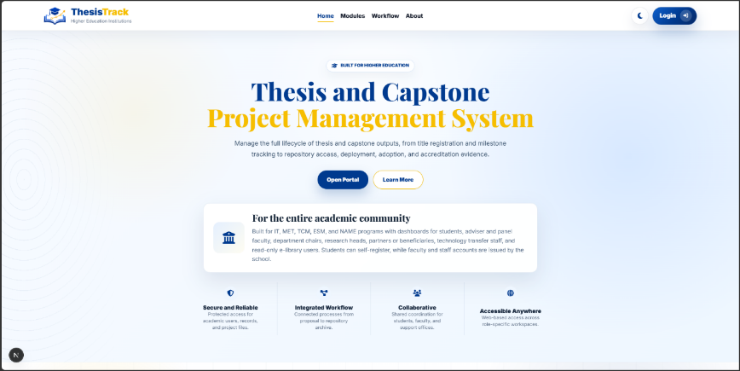
Figure 3.27 Landing Page

Figure 3.27 illustrates the official landing page of the ThesisTrack web application. It serves as the main entry point, providing users with navigation options, authentication access, a brief overview of the platform, and highlight of its key features for academic project management.

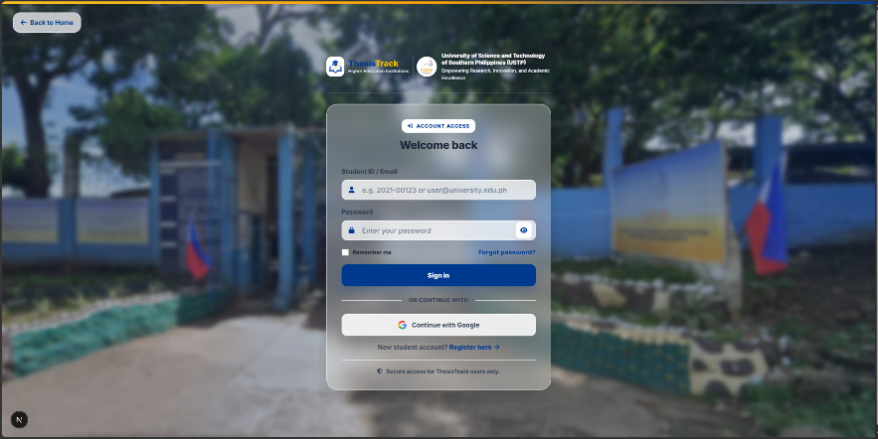
Figure 3.28 Log In Interface

Figure 3.28 illustrates the login interface of the ThesisTrack web application. It serves as the primary access point for registered users, featuring a login form for authentication and options for account registration and password recovery. The interface supports secure access and directs users to appropriate system functions based on their assigned roles.

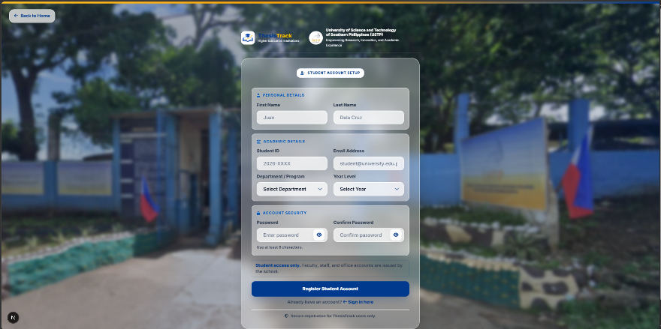
Figure 3.29 Register Student Account Interface

Figure 3.29 illustrates the student registration interface of the ThesisTrack web application. It allows student researchers to create accounts by providing personal information, academic program details, and login credentials, enabling access to the platform’s academic project management features.
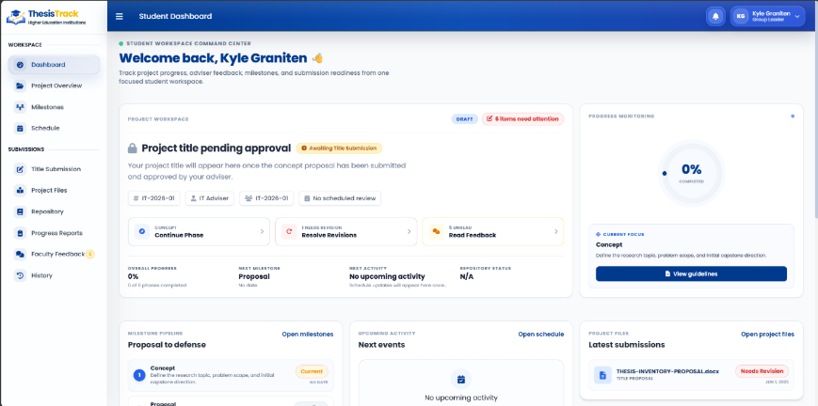
Figure 3.30 Student: Dashboard

Figure 3.30 illustrates the student dashboard of the ThesisTrack web application. It serves as the central workspace where students can monitor project progress, view status updates and notifications, and access key modules such as Groups, Advisers, Proposals, Defenses, and Repositories.

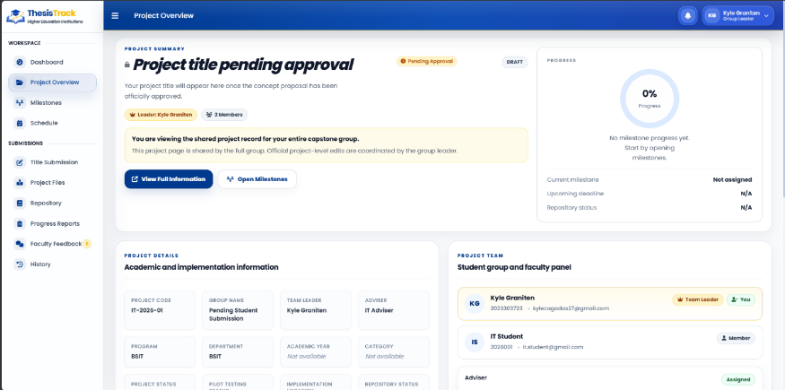
Figure 3.31 Student: Project Overview

Figure 3.31 illustrates the project overview interface of the ThesisTrack web application. It provides students with a centralized view of their research project, displaying project details, group information, assigned advisers, and progress milestones to support effective project monitoring.

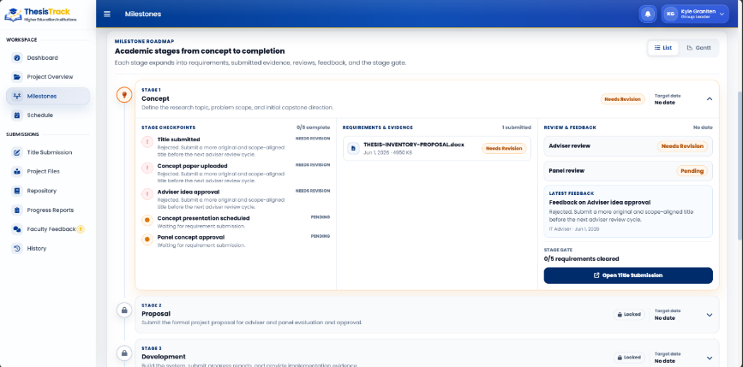
Figure 3.32 Student: Milestone

Figure 3.32 illustrates the milestone tracking interface of the ThesisTrack web application. It allows students to monitor project progress across key stages, view milestone statuses and submission dates, and manage required document submissions throughout the research process.

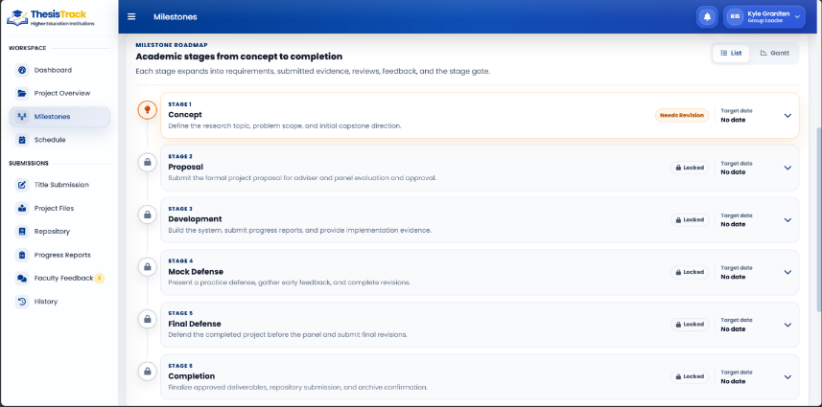
Figure 3.33 Student: Milestone Academic List
Figure 3.33 illustrates the milestone academic list interface of the ThesisTrack web application. It presents the major research phases, their corresponding statuses, and related requirements, allowing students to track progress and manage project activities throughout the research process.

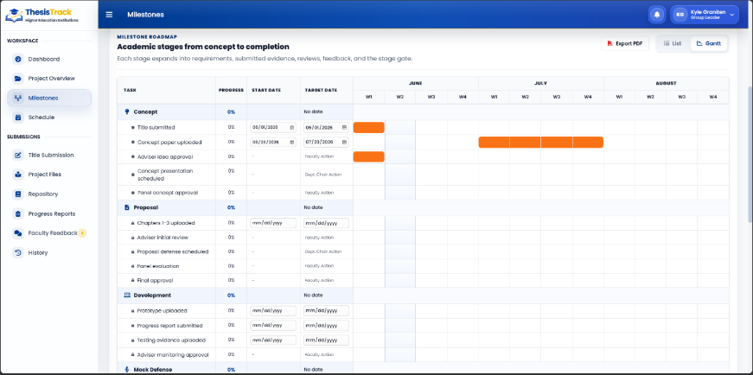
Figure 3.34 Student: Milestone Academic Gantt Stages

Figure 3.34 illustrates the milestone Gantt chart interface of the ThesisTrack web application. It provides a timeline-based view of project milestones, allowing students to monitor schedules, track progress, and compare project activities with designated deadlines throughout the research process.

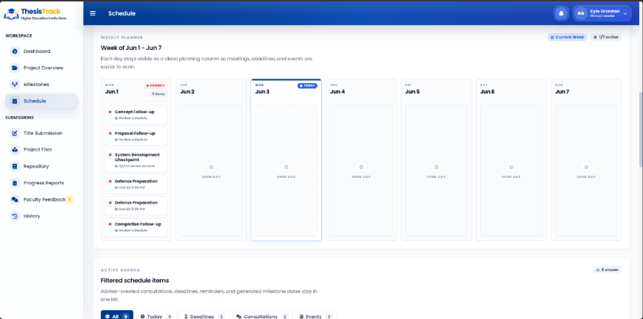
Figure 3.35 Student Schedule

Figure 3.35 illustrates the student defense scheduling interface of the ThesisTrack web application. It provides a calendar-based view of scheduled defense sessions, panelist availability, and upcoming evaluation timelines, allowing students to monitor and prepare for their assigned defense schedules.

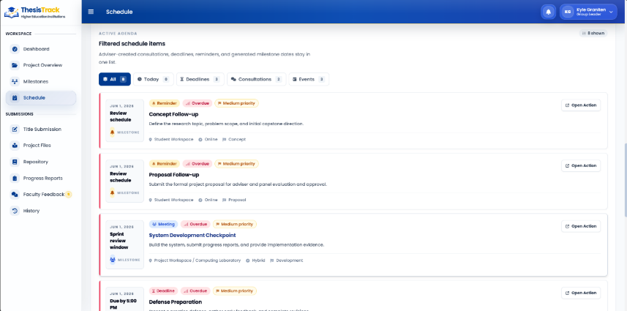
Figure 3.36 Student Filtered Schedule

Figure 3.36 illustrates the filtered schedule interface of the ThesisTrack web application. It allows students to view relevant schedules based on selected criteria such as program, academic year, and event type, helping them monitor important research-related activities and deadlines.

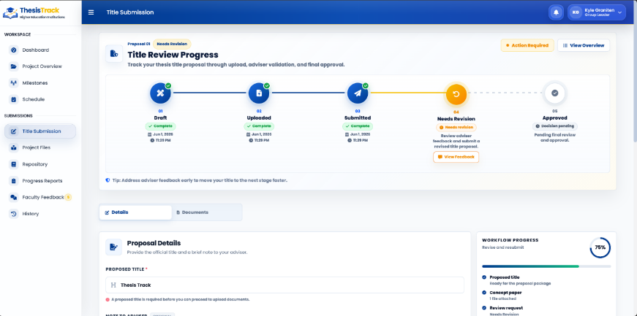
Figure 3.37 Student: Title Submission

Figure 3.37 illustrates the title submission interface of the ThesisTrack web application. It allows students to submit research titles, upload required documents, monitor approval statuses, and review adviser feedback throughout the title approval process.

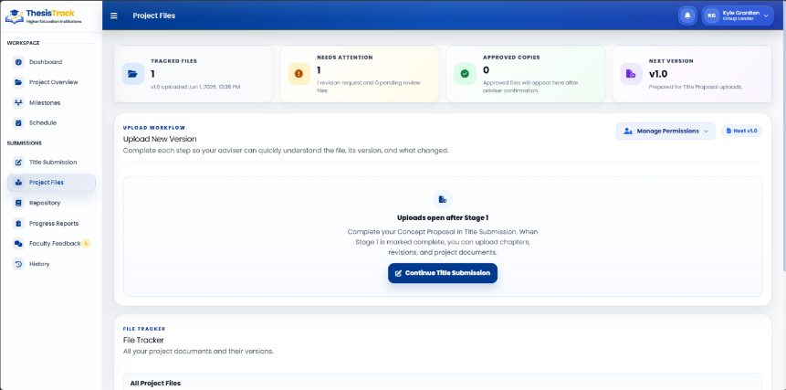
Figure 3.38 Student: Project Files A.
Figure 3.38 illustrates the project files management interface of the ThesisTrack web application. It enables students to upload, organize, and manage research documents, track file versions and revisions, and monitor the status of submitted project files throughout the research process.

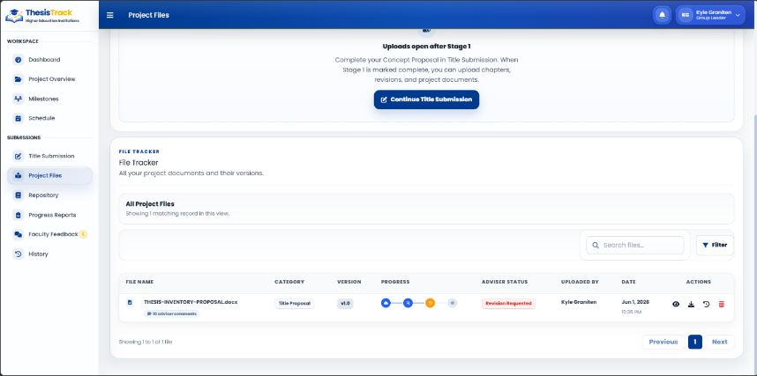
Figure 3.39 Student: Project Files B. File Tracker

Figure 3.39 illustrates the project files version tracker interface of the ThesisTrack web application. It provides a structured record of submitted documents, allowing students to track file versions, review submission history, and manage project documentation throughout the research process.

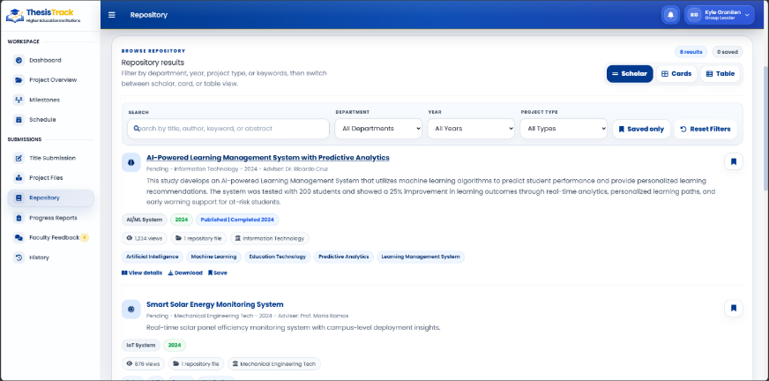
Figure 3.40 Student: Repository

Figure 3.40 illustrates the repository interface of the ThesisTrack web application. It allows students to search, filter, view, and download archived research projects, providing access to previous studies and institutional research outputs for reference and literature review purposes.

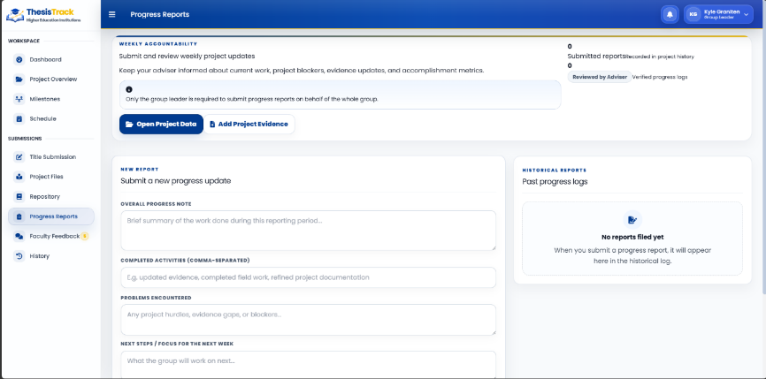
Figure 3.41 Student: Progress Reports

Figure 3.41 illustrates the progress reports interface of the ThesisTrack web application. It allows research groups to submit project updates, monitor reporting history, and track project progress, supporting regular communication and monitoring between students and advisers.

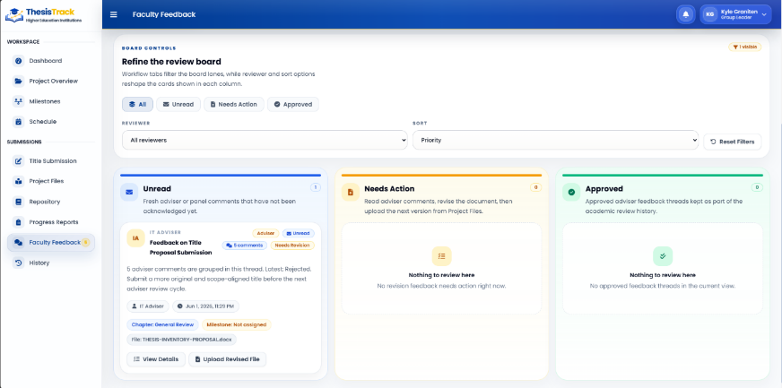
Figure 3.42 – Student: Faculty Feedback

Figure 3.42 illustrates the feedback management interface of the ThesisTrack web application. It allows students to view adviser and panel feedback, monitor review statuses, and manage document revisions throughout the research process.

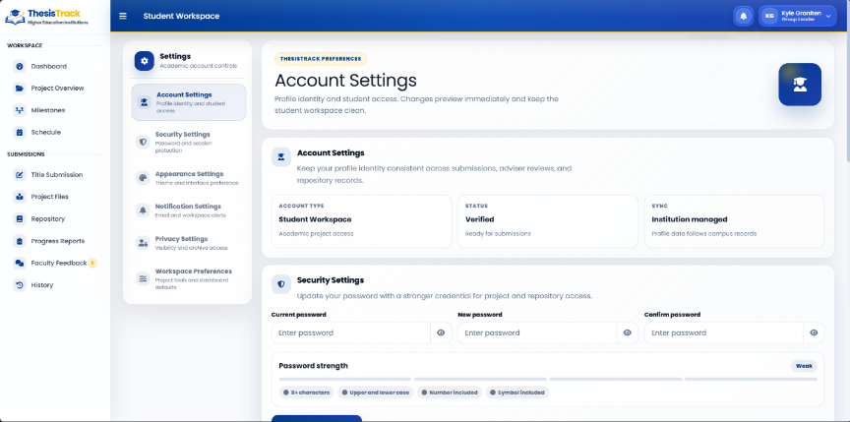
Figure 3.43 – Student: Account Settings A
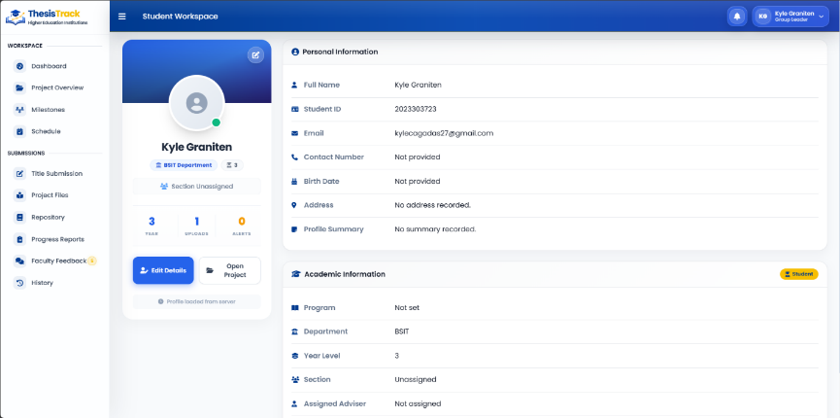
Figure 3.44 – Student Account Settings B

Figures 3.43 and 3.44 illustrate the account management interface of the ThesisTrack web application. It allows students to manage profile information, update account settings, and maintain security while displaying personal and academic details such as department and year level.

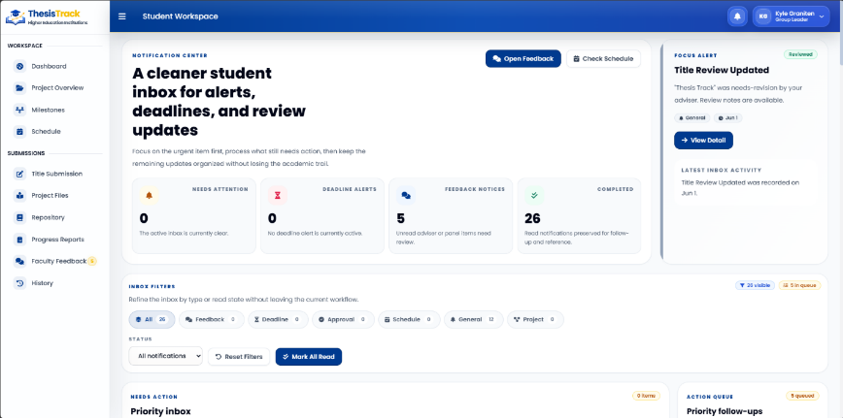
Figure 3.45 – Student: Notification

Figure 3.45 illustrates the notification center interface of the ThesisTrack web application. It allows students to view and organize system updates, deadlines, approvals, schedules, and adviser or panel feedback, helping them stay informed about important project-related activities.

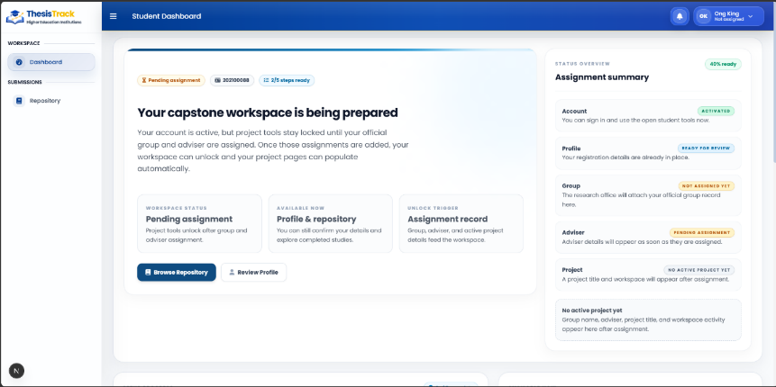
Figure 3.46 – Student: New Account Dashboard (Limited Access)

Figure 3.46 illustrates the limited-access student dashboard of the ThesisTrack web application. It restricts core module access for unassigned accounts while displaying onboarding requirements such as group assignment and adviser linkage, along with a progress tracker for completing setup.

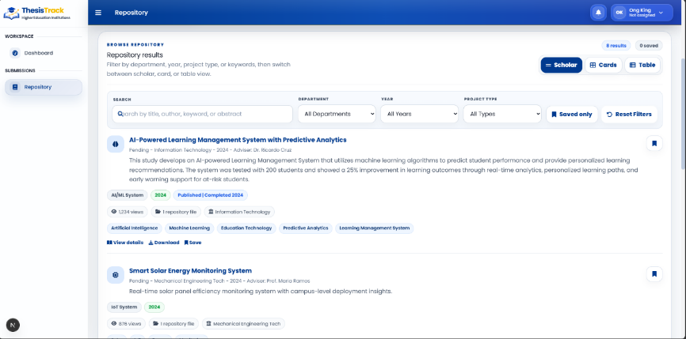
Figure 3.47 – Student: Repository (Access View)
Figure 3.47 illustrates the repository access interface for newly registered student accounts in the ThesisTrack web application. It allows limited access to the Dashboard and Repository modules while enabling users to search, filter, and view archived institutional research in different layouts such as Scholar, Cards, and Table formats.

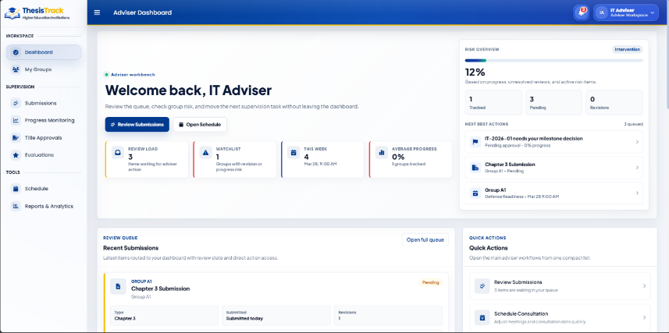
Figure 3.48 – Adviser Dashboard

Figure 3.48 illustrates the adviser dashboard interface of the ThesisTrack web application. It serves as the main workspace for faculty advisers to monitor assigned research groups, view workload summaries, track submissions and defense schedules, and manage supervision tasks through organized navigation and status updates.
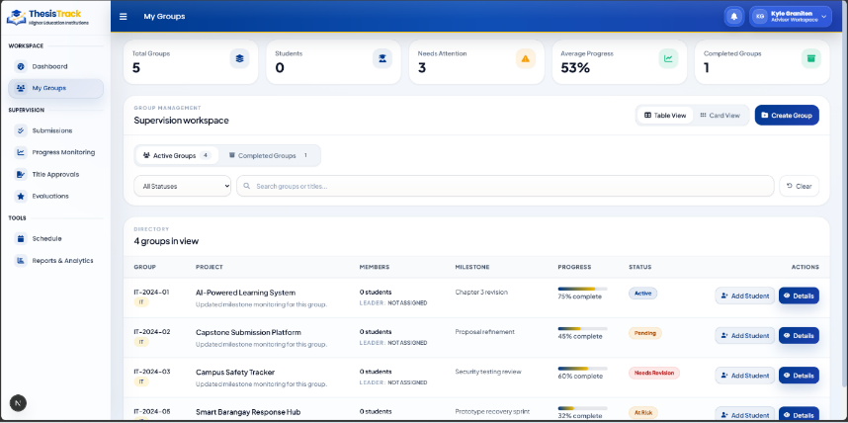Figure 3.49 – Adviser: Groups

Figure 3.49 illustrates the active group supervision interface of the ThesisTrack web application. It enables faculty advisers to monitor assigned research groups, view progress summaries, and access detailed group information including project status, members, and completion stage, with tools for search, filtering, and management.

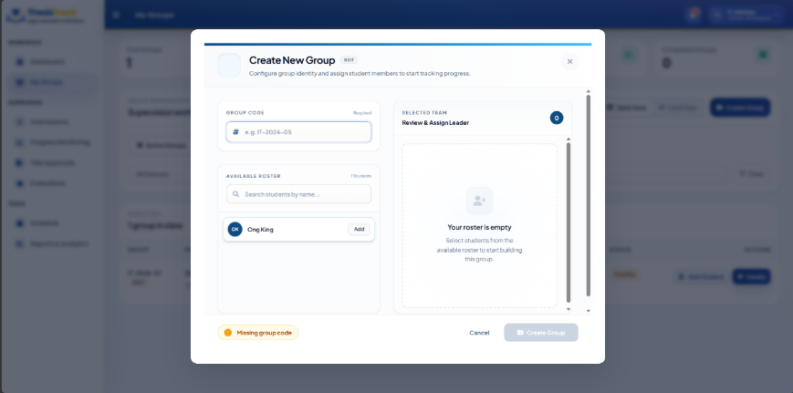
Figure 3.50 – Adviser: Create New Group

Figure 3.50 illustrates the group creation modal interface of the ThesisTrack web application. It allows faculty advisers to create research groups by entering a group code, selecting students, and assigning roles such as group leader, ensuring proper validation before submission.

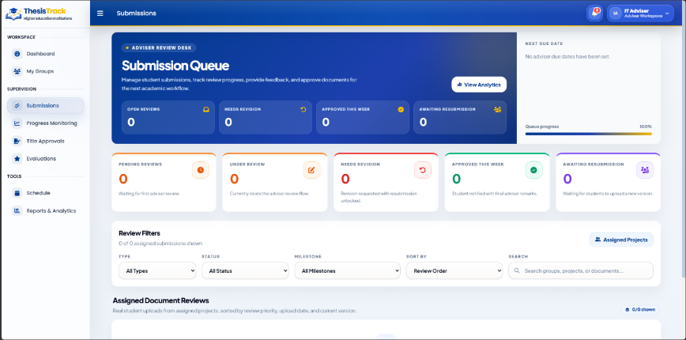
Figure 3.51 – Adviser: Submissions

Figure 3.51 illustrates the adviser submissions management interface of the ThesisTrack web application. It allows faculty advisers to review and manage student document submissions through categorized statuses, with tools for filtering, searching, and tracking feedback across different research stages.

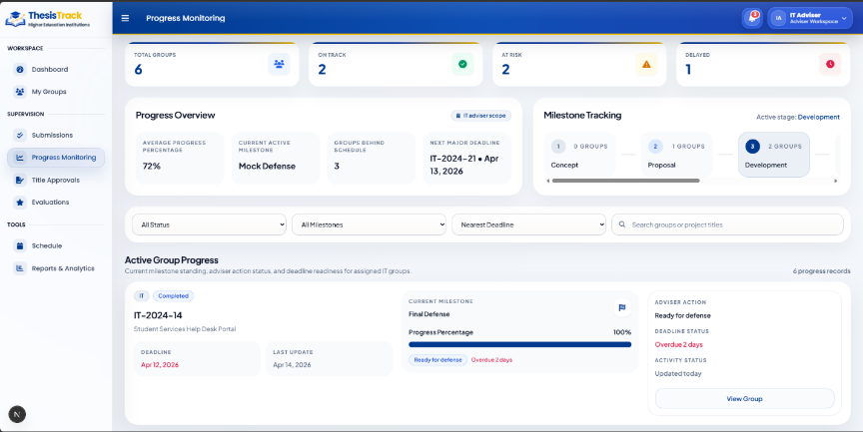
Figure 3.52 – Adviser: Progress Monitoring
Figure 3.52 illustrates the adviser progress monitoring interface of the ThesisTrack web application. It provides an overview of assigned research groups, showing progress metrics, milestone stages, completion rates, and deadlines to help advisers monitor performance and identify groups that need intervention.

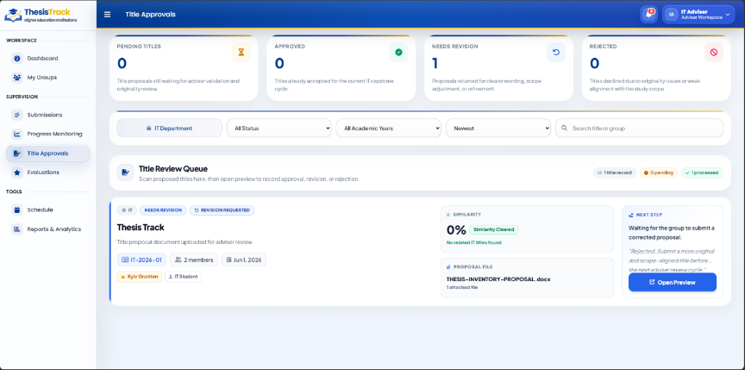
Figure 3.53 – Adviser: Title Approval

Figure 3.53 illustrates the adviser title approval interface of the ThesisTrack web application. It allows faculty advisers to review and manage research title proposals through categorized statuses, view submission details, and request revisions, ensuring efficient evaluation and approval of proposed titles.
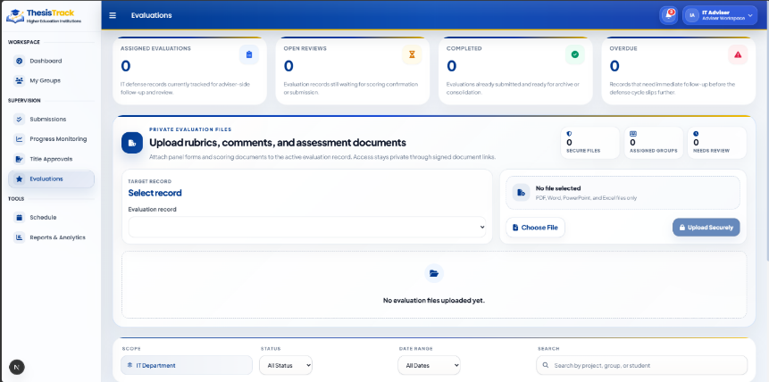
Figure 3.54 – Adviser: Evaluations

Figure 3.54 illustrates the adviser evaluations interface of the ThesisTrack web application. It allows faculty advisers to manage and review student defense evaluations, view submission details and rubrics, and track evaluation status across different review stages for efficient assessment of research defenses.

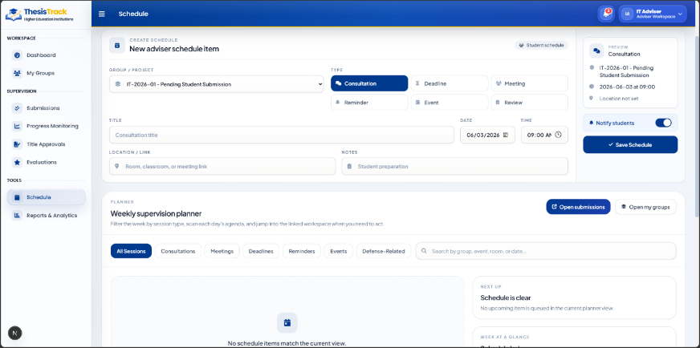
Figure 3.55 – Adviser: Schedule

Figure 3.55 illustrates the adviser schedule management interface of the ThesisTrack web application. It provides a weekly calendar view for organizing and tracking consultations, milestones, and defense schedules, helping advisers manage and coordinate academic supervision activities efficiently.

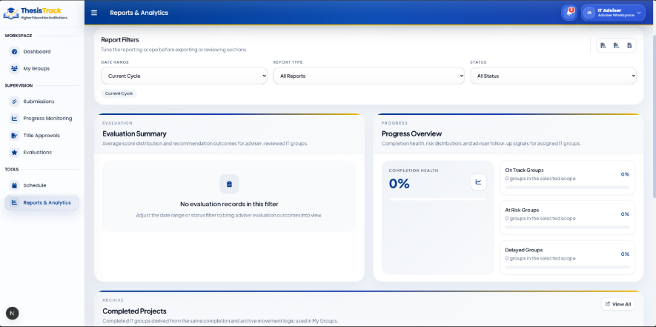
Figure 3.56 – Adviser: Reports & Analytics

Figure 3.56 illustrates the reports and analytics interface of the ThesisTrack web application for advisers. It provides an overview of supervision performance and group progress, showing key metrics and detailed group evaluation data to help advisers monitor research activities and track overall project status.

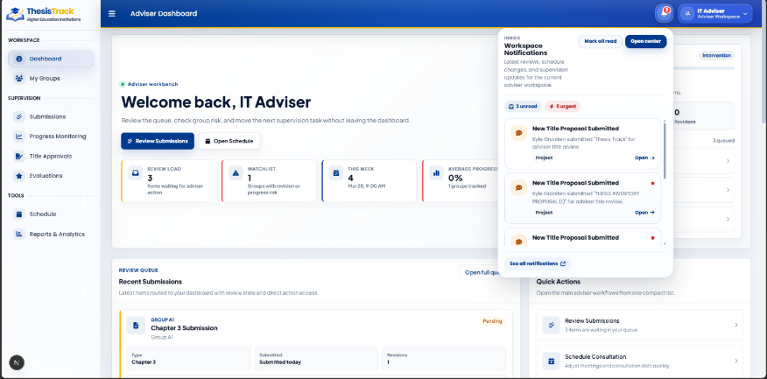
Figure 3.57 – Adviser: Notification
Figure 3.57 illustrates the notification button feature of the ThesisTrack web application for advisers. It provides quick access to categorized system alerts such as action requirements, deadline updates, submission notifications, and archived records, enabling advisers to monitor and manage student activities in real time.

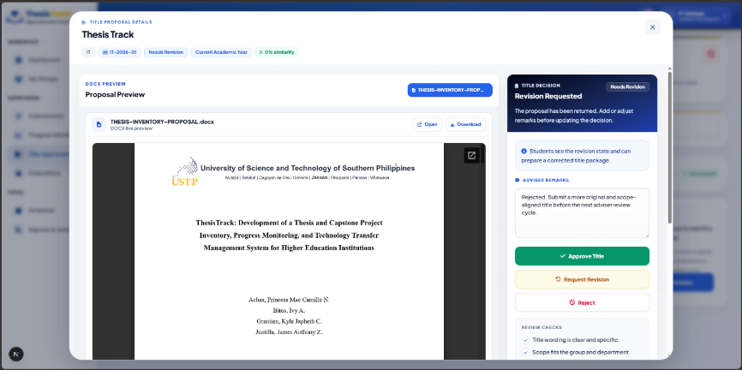
Figure 3.58 – Adviser: Title Proposal Preview

Figure 3.58 illustrates the title proposal detail and preview modal of the ThesisTrack web application. It displays the selected group’s research title, abstract, and concept paper link, and provides options for advisers to approve, request revisions, or reject the proposal during the evaluation process.

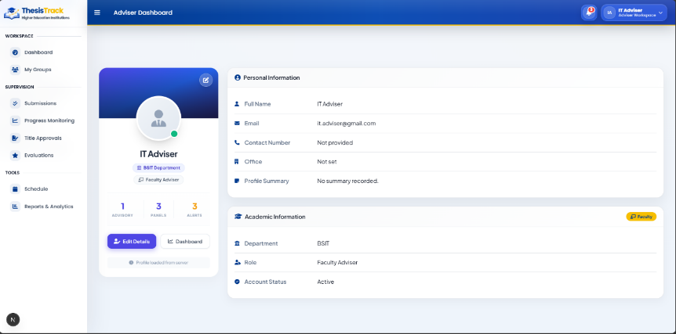
Figure 3.59 – Adviser: Account Settings

Figure 3.59 illustrates the account settings interface for advisers in the ThesisTrack web application. It allows faculty members to update profile information, manage passwords, and maintain institutional details such as faculty ID, department, and official email address securely.

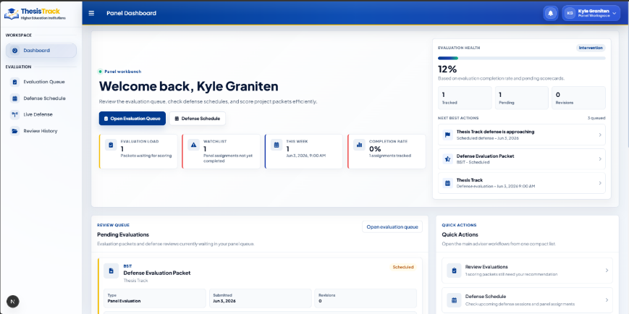
Figure 3.60 – Panel Mode: Dashboard

Figure 3.60 illustrates the panel mode dashboard of ThesisTrack, which serves as the main workspace for faculty panelists. It provides an overview of assigned evaluations, including pending reviews, completed assessments, and upcoming defense schedules, helping panel members manage and organize their evaluation tasks efficiently.

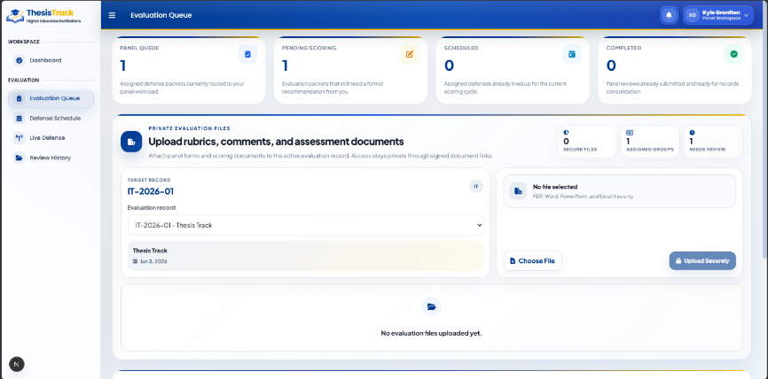
Figure 3.61 – Panel Mode: Evaluation Queue

Figure 3.361 illustrates the panel mode evaluation queue interface of ThesisTrack, which organizes upcoming and completed oral defense assignments for faculty panelists. It displays evaluation summaries and a structured list of defense sessions with key details such as group codes, titles, schedules, and access to grading rubrics.

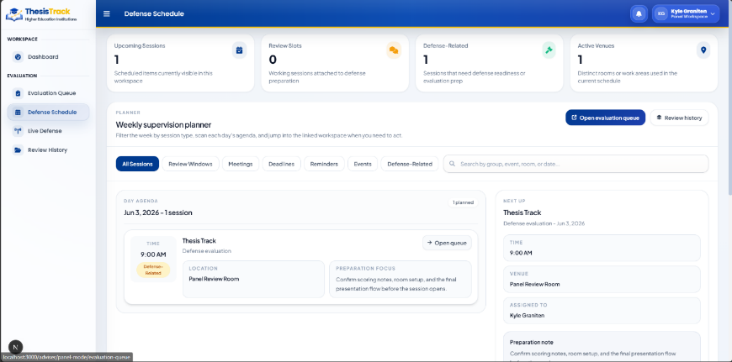
Figure 3.62 – Panel Mode: Defense Schedule
Figure 3.62 illustrates the panel mode defense schedule interface of ThesisTrack, which provides faculty panelists with a weekly calendar view of upcoming defense assignments. It displays evaluation schedules, venues, and assigned groups in chronological order, along with tools for filtering and managing commitments efficiently.

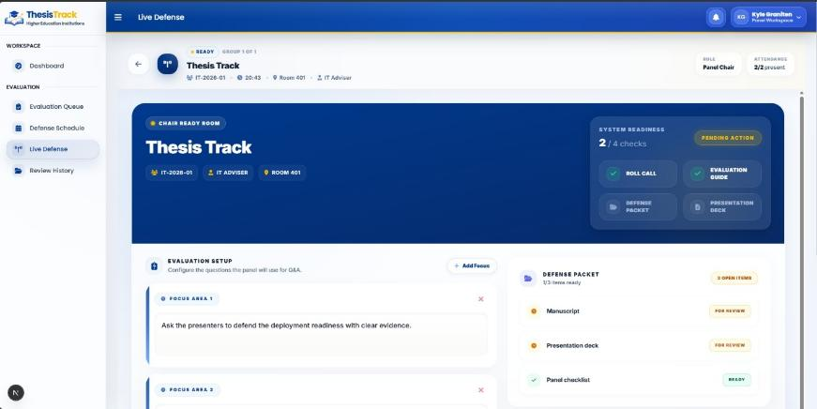
Figure 3.63 – Panel Mode: Live Defense

Figure 3.63 illustrates the panel mode live defense grading interface of ThesisTrack, designed for faculty panelists to evaluate students during oral defense sessions. It provides a rubric-based grading sheet alongside session details, group information, and feedback tools to support structured and real-time evaluation during defense proceedings.
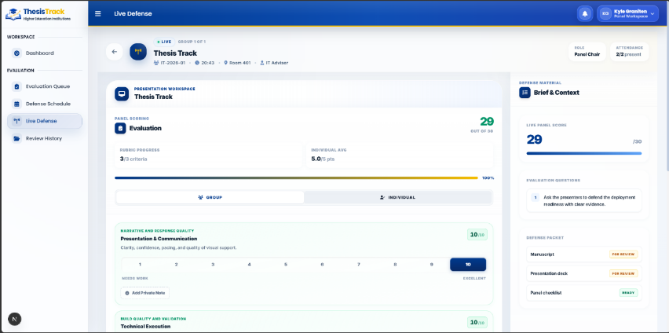
Figure 3.64 Panel Mode: Live Defense Evaluation (A)

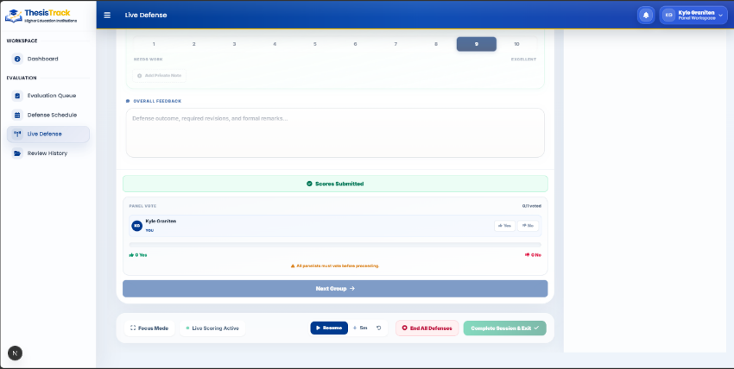
Figure 3.65 Panel Mode: Live Defense Evaluation (B)

Figures 3.64 and 3.65 present the live defense evaluation interface in panel mode, which supports real-time grading of student defenses through a structured, multi-step evaluation system. Figure 3.64 shows the initialization stage with group and student details, while Figure 3.65 focuses on scoring, rubric-based evaluation, and feedback entry with automated score computation.
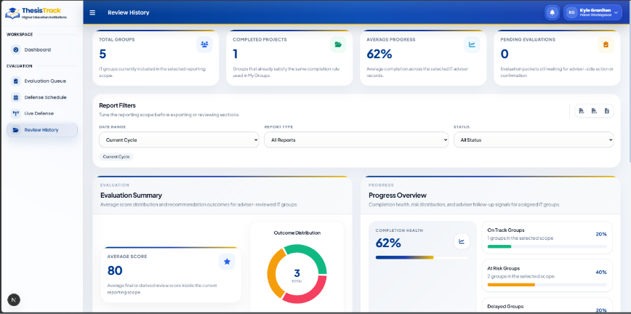
Figure 3.66 – Panel Mode: Review History

Figure 3.366 illustrates the review history interface in panel mode, which provides faculty panelists with a record of past evaluation and grading activities. It displays summary indicators and a structured table of historical assessments, including group details, scores, and timestamps, with options to review rubrics and submitted documents.

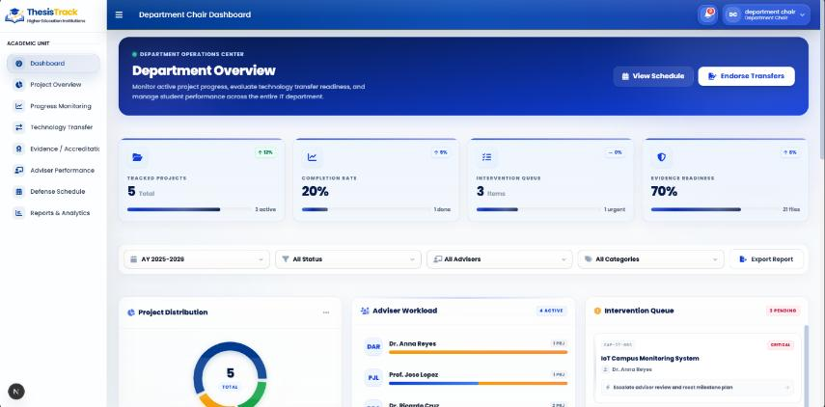Figure 3.67 – Department Chairman: Dashboard

Figure 3.67 illustrates the department chairman dashboard interface, which serves as a centralized workspace for monitoring departmental research activities. It displays key metrics, progress summaries, and task queues to help track student groups, adviser assignments, and research completion status across the department.

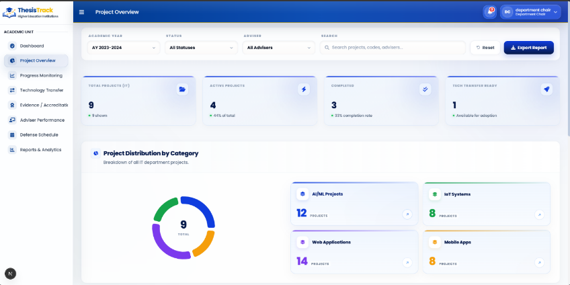
Figure 3.68 – Department Chairman: Project Overview A

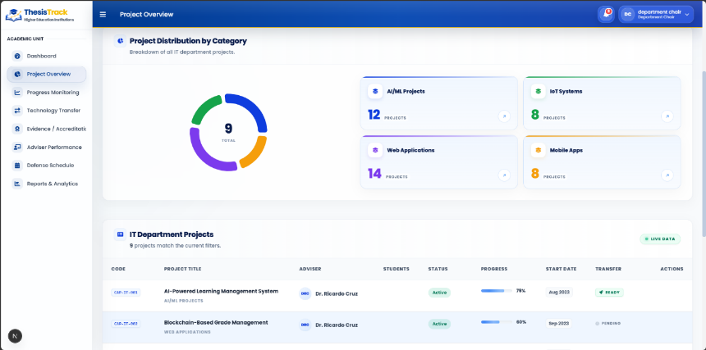
Figure 3.69 – Department Chairman: Project Overview B

Figures 3.68 and 3.69 illustrate the project overview workspace within the department chairman module of ThesisTrack. Figure 3.68 shows summary analytics and management controls for monitoring project statuses, while Figure 3.69 presents a detailed list of research groups with their members, advisers, milestones, and progress indicators, supporting comprehensive departmental oversight.

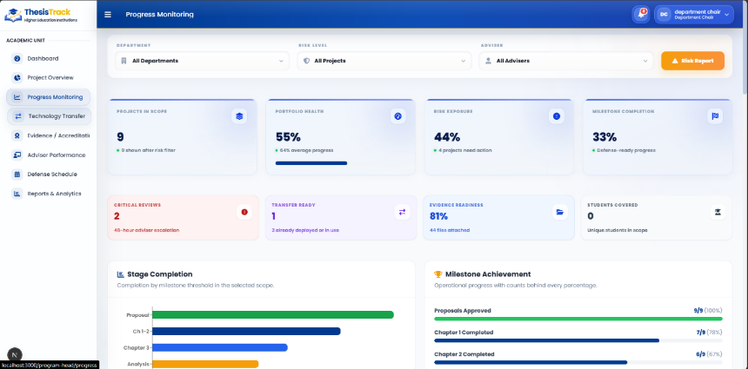
Figure 3.70 – Department Chairman: Progress Monitoring

Figure 3.70 illustrates the progress monitoring interface within the department chairman module, providing an overview of research group performance through key metrics, milestone tracking, and individual group status cards to support departmental oversight and timely project completion.

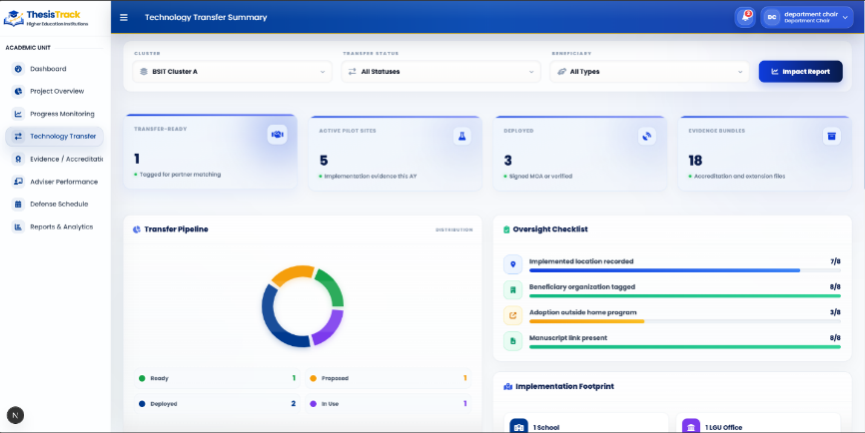
Figure 3.71 – Department Chairman: Technology Transfer
Figure 3.71 illustrates the technology transfer management interface within the department chairman module, which monitors research outputs with potential for commercialization. It provides key indicators and a detailed project directory showing commercialization status, project details, and related administrative actions to support technology transfer tracking and management.

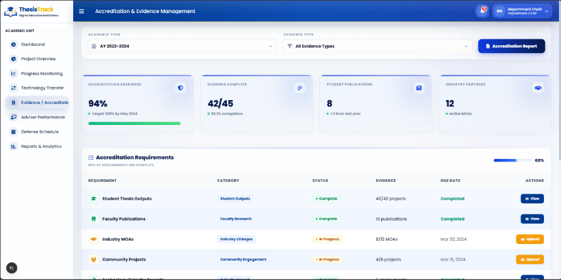
Figure 3.72 – Department Chairman: Evidence & Accrediation

Figure 3.72 illustrates the evidence and accreditation interface within the department chairman module, which supports document verification and compliance tracking for research outputs. It displays summary indicators and a structured directory of submissions with verification status and supporting records for accreditation purposes.
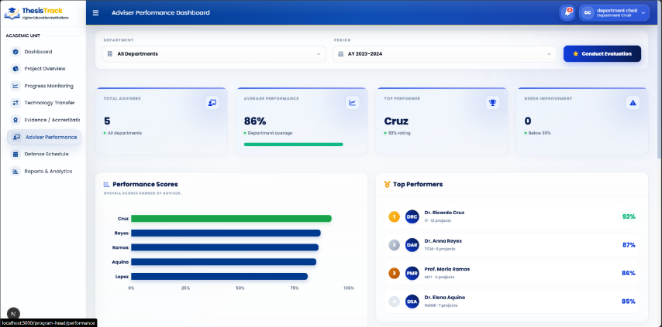
Figure 3.73 – Department Chairman: Adviser Performance

Figure 3.73 illustrates the adviser performance dashboard within the department chairman module, which monitors faculty advising workloads and research group progress. It displays key performance indicators and a searchable adviser directory with supervision details and progress metrics to support evaluation and management of advising activities.

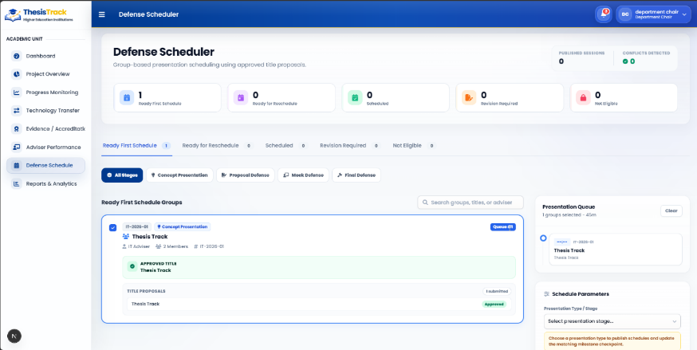
Figure 3.74 – Department Chairman: Defense Schedule

Figure 3.74 illustrates the defense schedule management interface within the department chairman module, which organizes and monitors departmental defense activities using a weekly calendar. It displays scheduled defenses with details such as time, venue, research groups, and panel members, along with tools for scheduling and filtering.

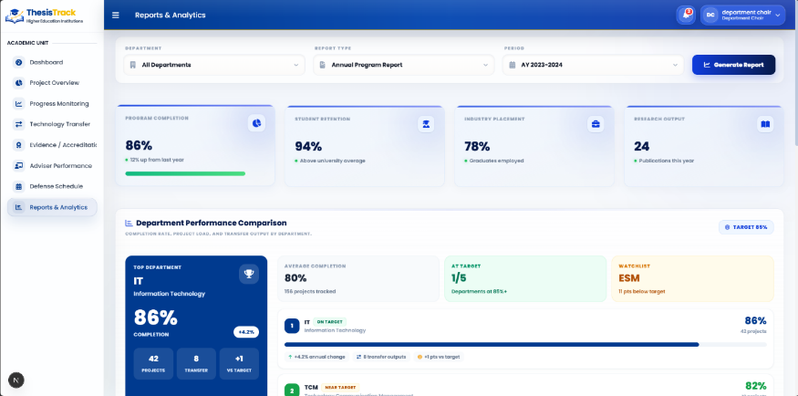
Figure 3.75 – Department Chairman: Reports & Analytics

Figure 3.75 illustrates the reports and analytics interface within the department chairman module, which provides an overview of departmental research performance and adviser workload. It includes key summary metrics and a detailed table of research group data to support monitoring, evaluation, and report generation for administrative decision-making.

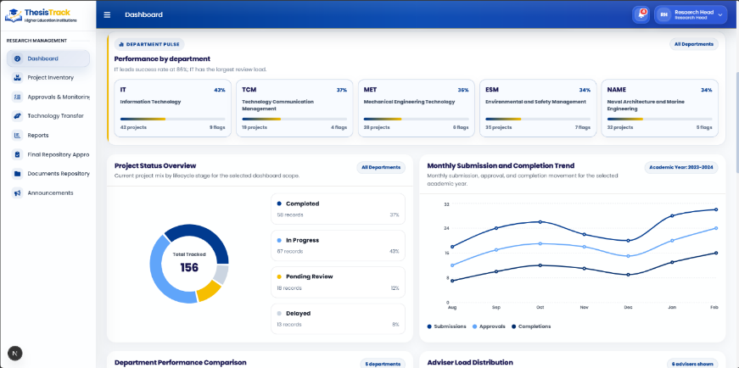
Figure 3.76 – Research Head: Dashboard

Figure 3.76 illustrates the research head dashboard interface, which serves as a centralized workspace for monitoring institutional research activities. It displays key performance indicators, search and filtering tools, and a repository table of research records to support oversight of project progress, outputs, and documentation.

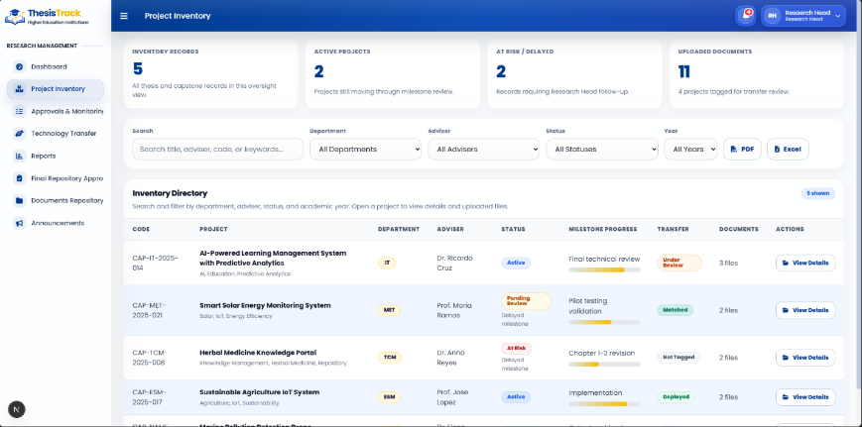
Figure 3.77 – Research Head: Project Inventory

Figure 3.77 illustrates the university-wide project inventory registry within the research head module, which supports institutional research tracking and repository management. It displays summary indicators and a centralized repository of research records with filtering tools, enabling administrators to monitor projects, access documentation, and oversee institutional research outputs.

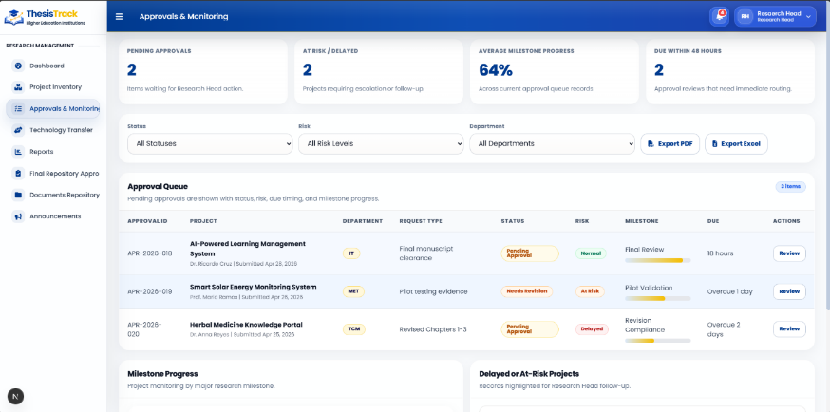
Figure 3.78 – Research Head: Approval & Monitoring

Figure 3.78 illustrates the approval and monitoring interface within the research head module, which supports institutional review and validation of research outputs. It displays key approval indicators and a centralized table of research records, enabling administrators to monitor compliance, verify submissions, and manage approval processes efficiently.

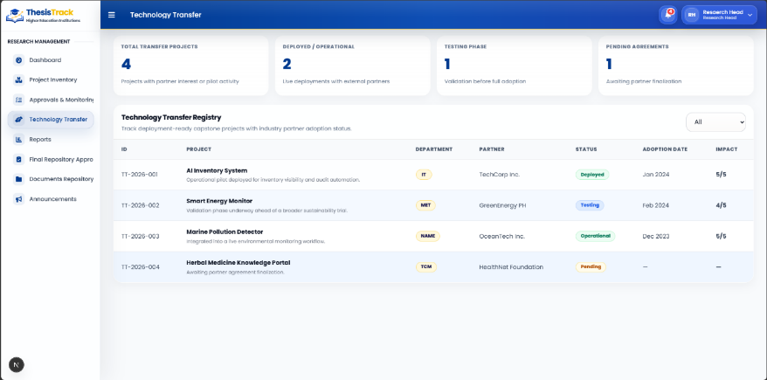
Figure 3.79 – Research Head: Technology Transfer

Figure 3.79 illustrates the technology transfer management interface within the research head module, which monitors institutional intellectual property and research commercialization activities. It displays key indicators and a searchable project directory to support tracking of commercialization efforts, patents, and research implementation status across the institution.

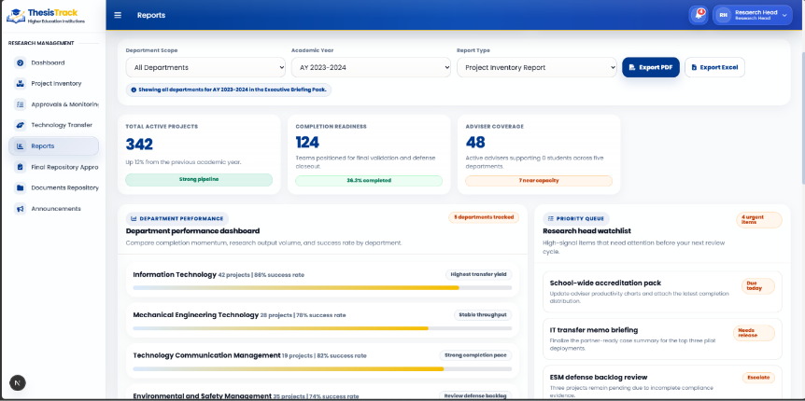
Figure 3.80 Research Head: Reports

Figure 3.80 illustrates the reports generation and analytics interface within the research head module, which supports institutional reporting and research performance evaluation. It provides summary indicators, export functionality, and a detailed table of project and milestone data to help administrators generate reports and analyze institutional research outcomes.

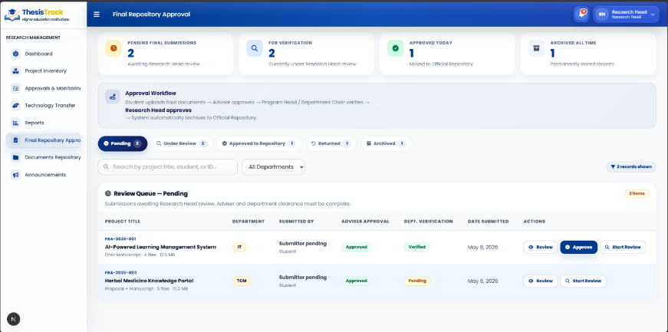
Figure 3.81 Research Head: Final Repository Approval

Figure 3.81 illustrates the final repository approval window within the research head module, which allows institutional validation of completed research projects before publication. It displays key project details and provides options to approve or cancel the submission for inclusion in the institutional repository.

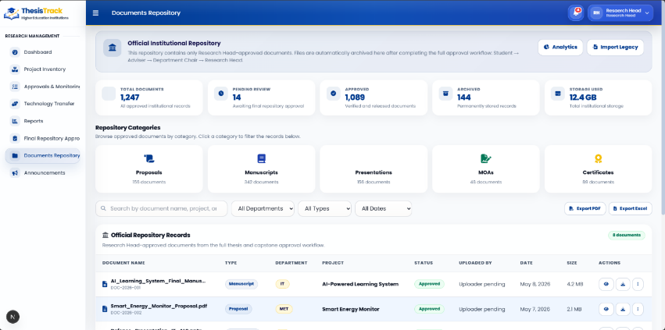
Figure 3.82 – Research Head: Documents Repository

Figure 3.82 illustrates the documents repository interface within the research head module, which supports institutional archiving and management of research documents. It provides search and filtering tools and a structured table of submitted files for efficient retrieval and organization of research manuscripts.

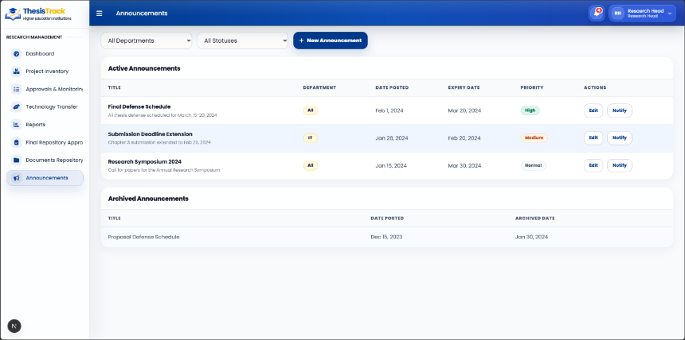
Figure 3.83 – Research Head: Announcements

Figure 3.83 illustrates the announcements management interface within the research head module, which allows administrators to create and manage institutional announcements. It includes tools for publishing updates and a list of existing announcements with key details such as category, date, and engagement metrics to support effective communication across the institution.

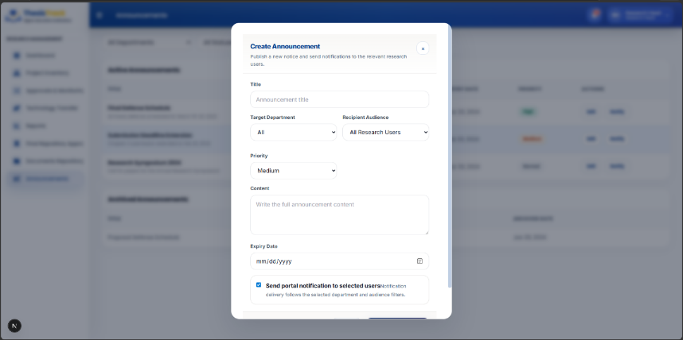
Figure 3.84 – Research Head: Create Announcement

Figure 3.84 illustrates the announcement creation window within the research head module, which allows administrators to compose and publish institutional announcements. It provides fields for the title, message content, and recipient selection, along with options to publish or cancel, enabling efficient distribution of targeted updates across the system.

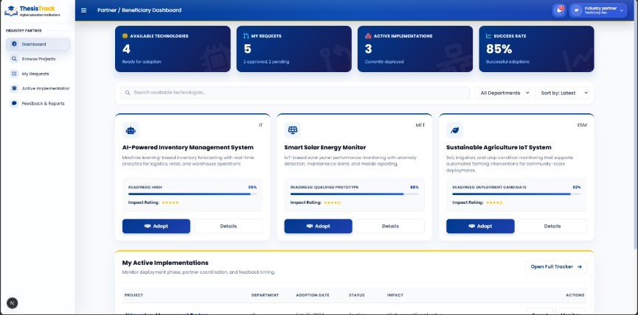
Figure 3.85 – Technology Transfer: Dashboard

Figure 3.85 illustrates the technology transfer officer dashboard interface, which supports the management of research commercialization, intellectual property, and industry collaborations. It displays key performance indicators and a structured project directory to help officers monitor research outputs and coordinate commercialization activities efficiently.

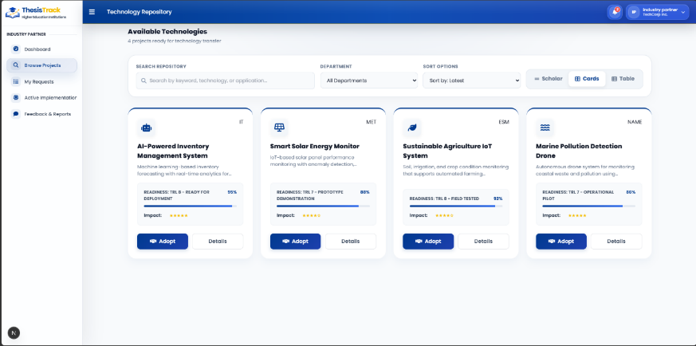
Figure 3.86 – Technology Transfer: Browse Projects

Figure 3.86 illustrates the project browsing registry within the technology transfer officer module, which supports the review and management of research outputs with commercialization potential. It provides filtering and search tools and a structured project directory to help officers evaluate projects, monitor commercialization progress, and identify collaboration opportunities.

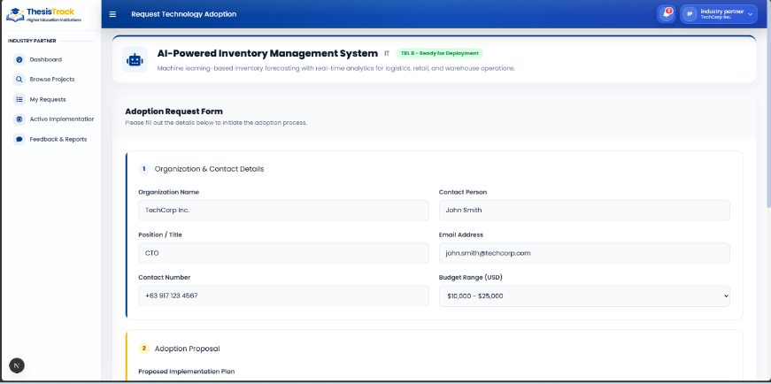
Figure 3.87 – Technology Transfer: Adoption Form

Figure 3.87 illustrates the technology transfer adoption and partner assignment form within the technology transfer officer module, which allows officers to assign industry partners and define commercialization pathways for completed research projects. It includes project details, input fields, and action controls to support documentation and management of technology transfer activities.
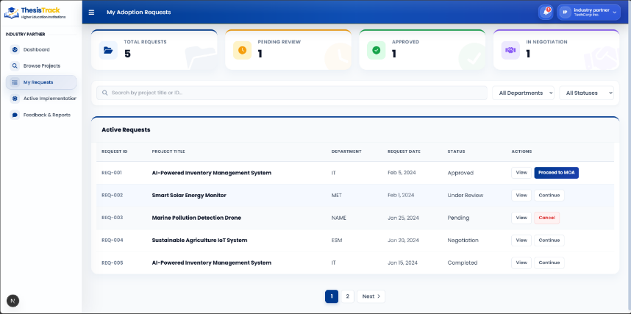
Figure 3.88 – Technology Transfer: Requests

Figure 3.88 illustrates the incoming partnership requests ledger within the technology transfer officer module, which manages external collaboration proposals. It displays a structured list of partnership requests with key details and status indicators, allowing officers to review, accept, or reject applications for research commercialization and industry collaboration.

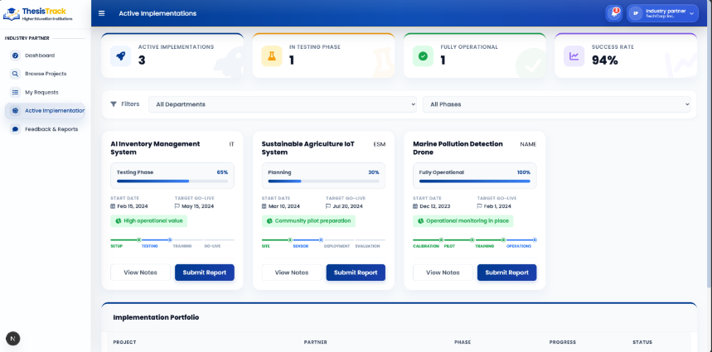
Figure 3.89 – Technology Transfer: Active Implementation

Figure 89 illustrates the active implementation monitoring interface within the technology transfer officer module, which tracks research projects undergoing commercialization or industry adoption. It displays key performance indicators and a structured table of ongoing implementations to help officers monitor progress and manage technology transfer activities.

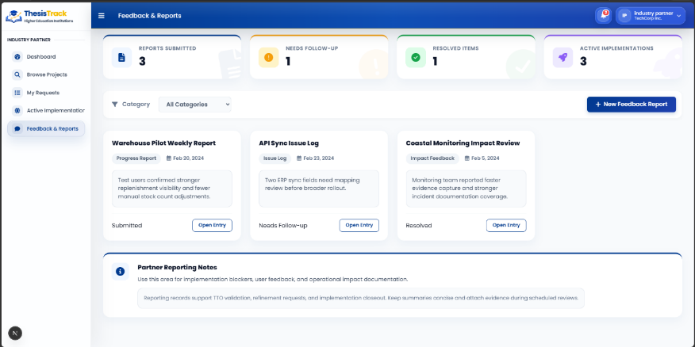
Figure 3.90 – Technology Transfer: Feedback & Reports

Figure 3.90 illustrates the feedback and reporting interface within the technology transfer officer module, which evaluates the outcomes of commercialized research projects. It displays key performance indicators and a structured table of project feedback and commercialization records to support assessment, reporting, and continuous improvement of technology transfer activities.

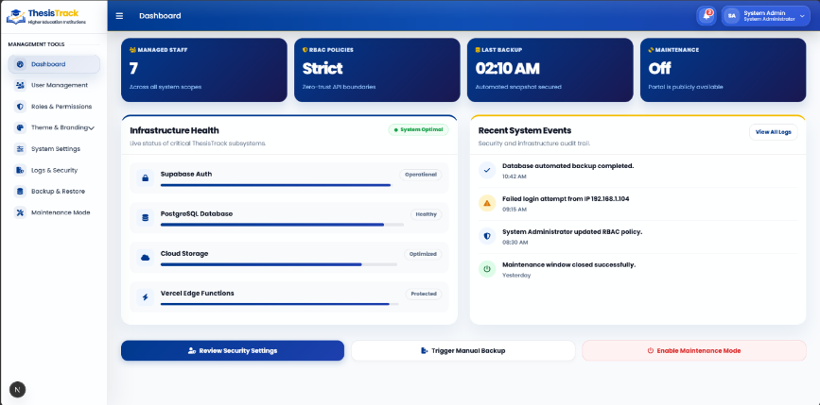
Figure 3.91 – System Admin: Dashboard

Figure 3.91 illustrates the system administrator dashboard, which serves as a central control interface for managing user access, system performance, and platform operations. It displays key system metrics and provides administrative tools for monitoring accounts, security, and overall system stability.

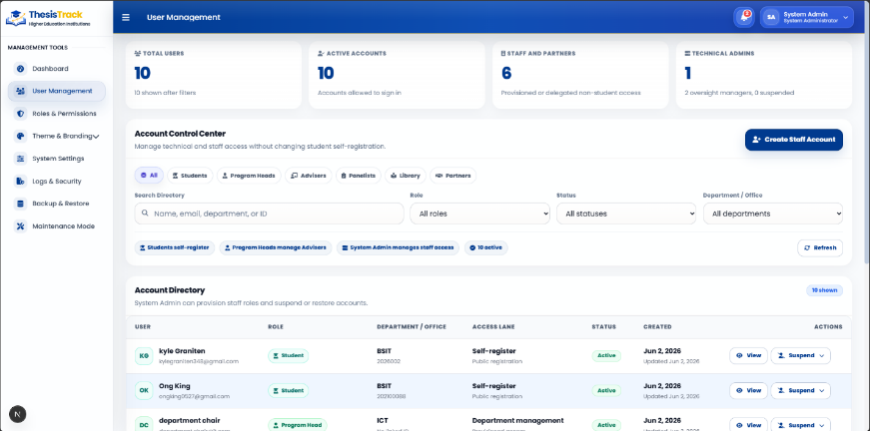
Figure 3.92 – System Admin: User Management

Figure 3.92 illustrates the user management interface within the system administrator module, which supports role-based account control and access management. It displays user statistics and a structured table of account details, allowing administrators to manage permissions, verify accounts, and maintain secure system access.

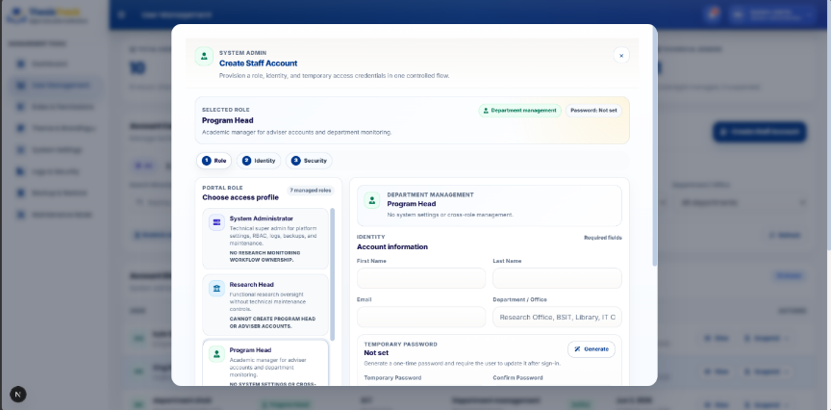
Figure 3.93 – System Admin: Create Staff Account

Figure 3.93 illustrates the staff account creation window within the system administrator module, which allows administrators to create and configure staff accounts. It includes input fields for personal and institutional details, role assignment, and controls to save or cancel the account creation process, supporting secure user provisioning within the system.

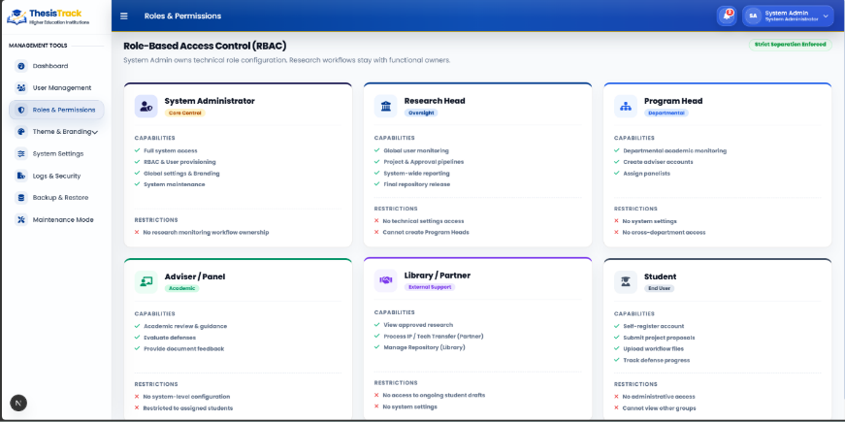
Figure 3.94 – System Admin: Roles & Permissions

Figure 3.94 illustrates the roles and permissions configuration dashboard within the system administrator module, which manages role-based access control across the platform. It maps user roles to their permissions and system access levels, allowing administrators to review, adjust, and audit access configurations securely.

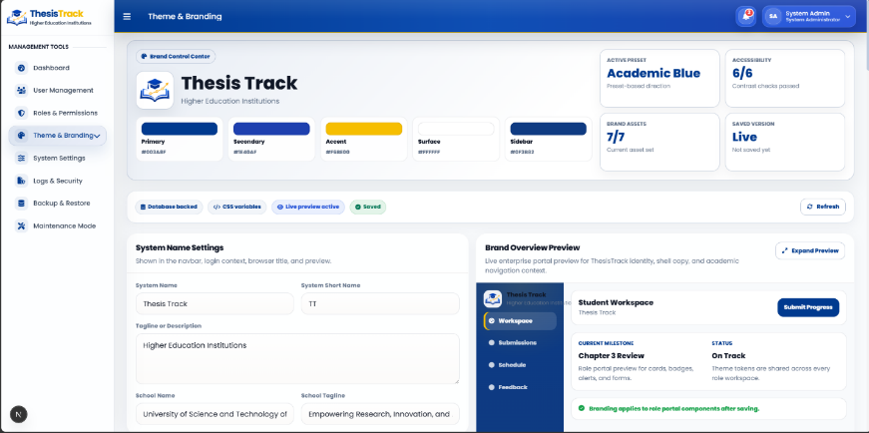
Figure 3.95 – System Admin: Theme & Branding
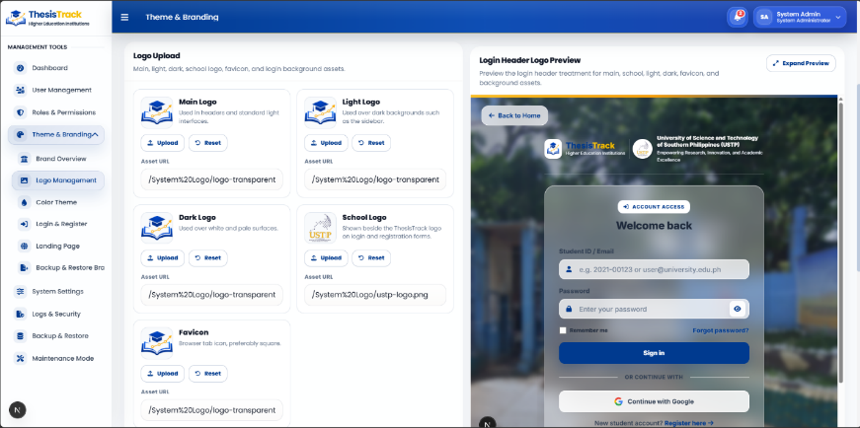
Figure 3.96 – System Admin: Theme & Branding Logo Upload

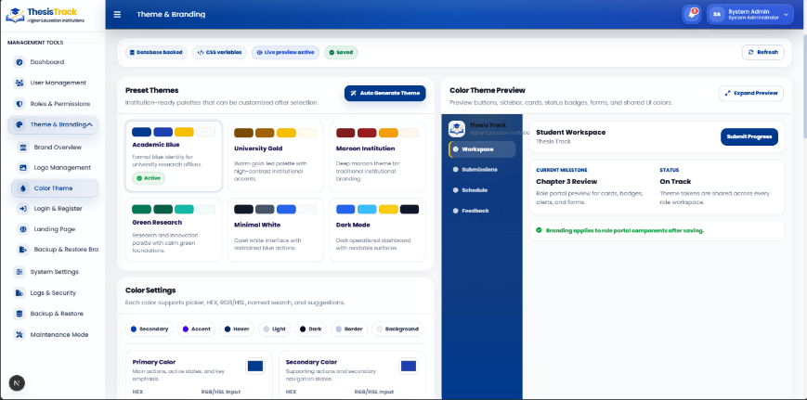
Figure 3.97 – System Admin: Theme & Branding Color Theme
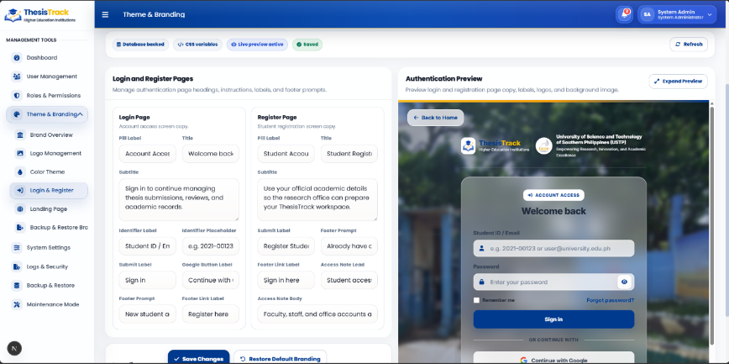
Figure 3.98 – System Admin: Theme & Branding Login & Register

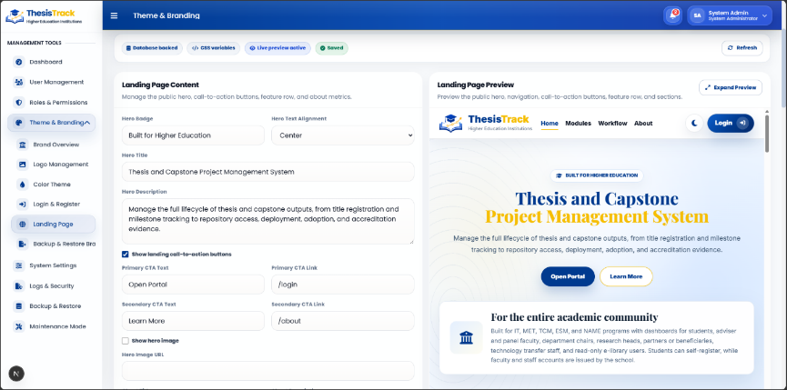
Figure 3.99 – System Admin: Theme & Branding Landing Page Content

The Theme & Branding suite within the system administrator module of the ThesisTrack web application provides a centralized interface for configuring the platform’s visual identity in line with institutional branding guidelines, without altering the core system. It uses a dual-pane layout with configuration controls on the left and a real-time preview on the right.
• System Asset and Identity Management (Figures 3.95 & 3.96): Figure 3.95 manages core brand settings such as platform name, color palette, and institutional identity, while Figure 3.96 handles logo and asset uploads with support for multiple logo variants and live previews.
• Color Palette Optimization (Figure 3.97): This module allows customization of system-wide color schemes, assigning colors to UI components and supporting accessibility-aware contrast checks.
• Gateway Authentication Copy (Figure 3.98): This interface enables editing of login and registration page content with real-time preview.
• Public Landing Page Editor (Figure 3.99): This module manages the public-facing landing page, including banners, text content, and visual elements that define the system’s first user experience.

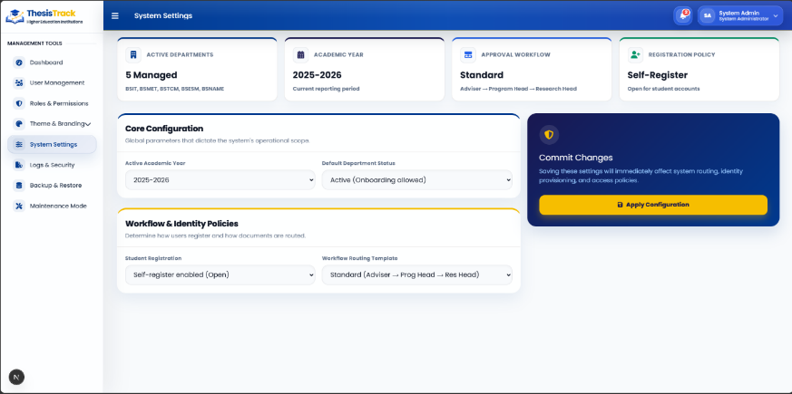
Figure 3.100 – System Admin: System Settings

Figure 3.100 illustrates the system settings interface within the system administrator module, which allows administrators to configure global system parameters and institutional policies. It provides centralized controls for managing academic timelines, registration settings, and workflow configurations to ensure system operations align with institutional requirements.
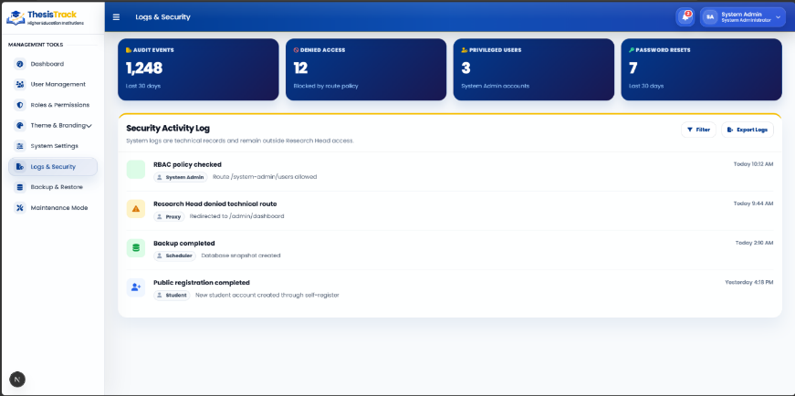
Figure 3.101 – System Admin: Logs & Security

Figure 3.101 illustrates the logs and security interface within the system administrator module, which serves as a centralized audit and monitoring dashboard. It tracks system activity, security events, and access logs, allowing administrators to review actions, ensure compliance, and export records for institutional auditing purposes.

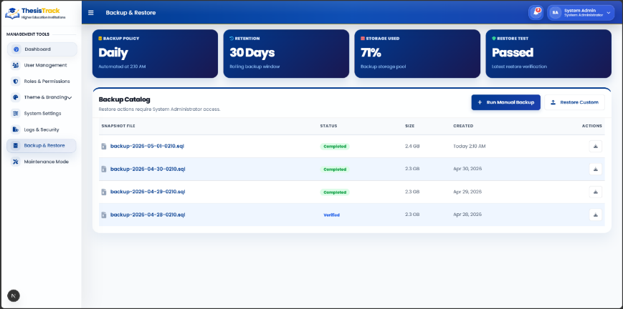
Figure 3.102 – System Admin: Backup & Restore

Figure 3.102 illustrates the backup and restore interface within the system administrator module, which supports database backup scheduling, storage monitoring, and system recovery operations. It allows administrators to create, manage, and restore backups to ensure data integrity and system resilience.

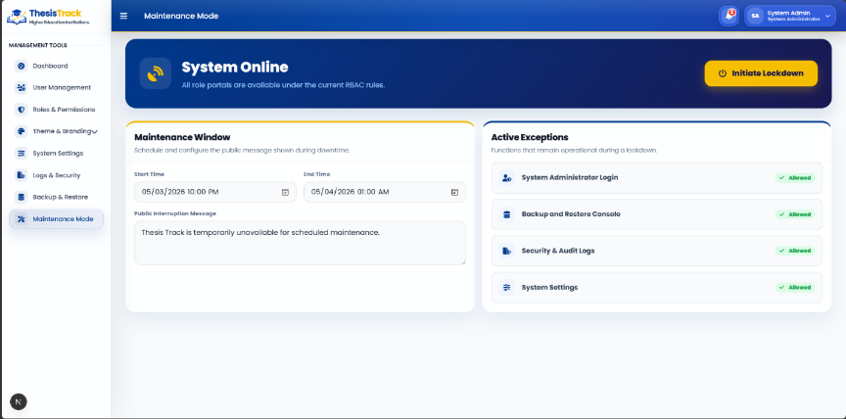
Figure 3.103 – System Admin: Maintenance Mode (System Online)

Figure 3.103 illustrates the maintenance mode interface within the system administrator module, which allows administrators to manage system downtime and configure maintenance settings. It supports controlled activation of maintenance mode and custom user notifications to ensure coordinated system updates without disrupting platform integrity.
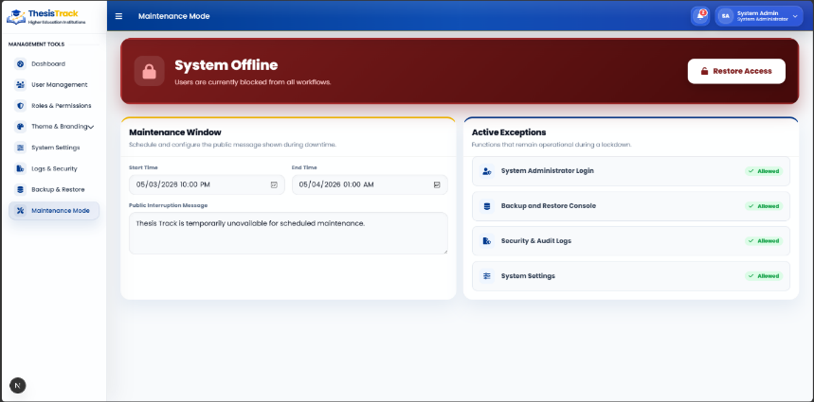
Figure 3.104 – System Admin: Maintenance Mode (System Offline)
Figure 3.104 illustrates the maintenance mode interface within the system administrator module, showing the platform in an active “System Offline” state. It enforces restricted access during critical updates or security patches, allowing administrators to control system availability and ensure uninterrupted maintenance operations.

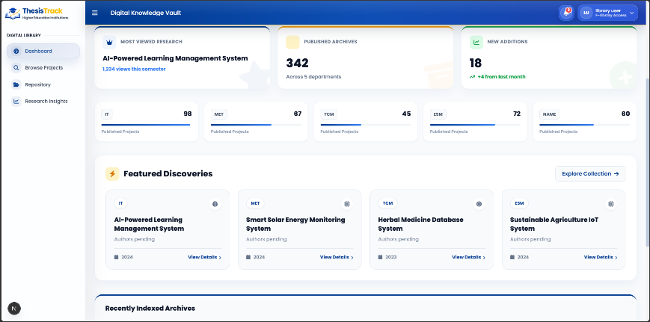
Figure 3.105 – Library: Dashboard

Figure 3.105 illustrates the Library Staff dashboard interface of the ThesisTrack web application. It provides an overview of repository activities through key metrics and allows staff to review submissions, manage document records, and oversee validation and publication processes.

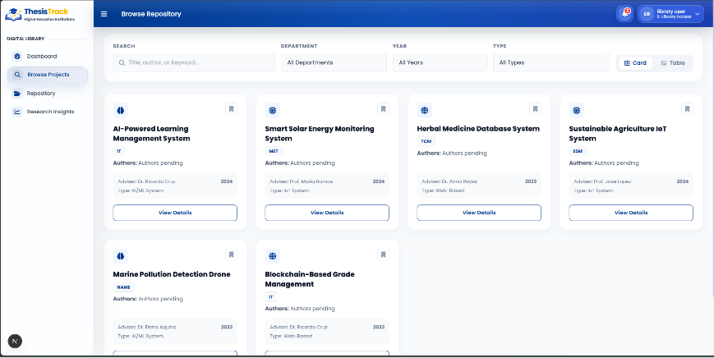
Figure 3.106 – Library: Browse Projects

Figure 3.106 illustrates the Browse Projects interface within the Library Staff module of the ThesisTrack web application. It allows users to search, filter, and browse archived research projects, displaying key details such as project titles, authors, advisers, categories, and publication years.

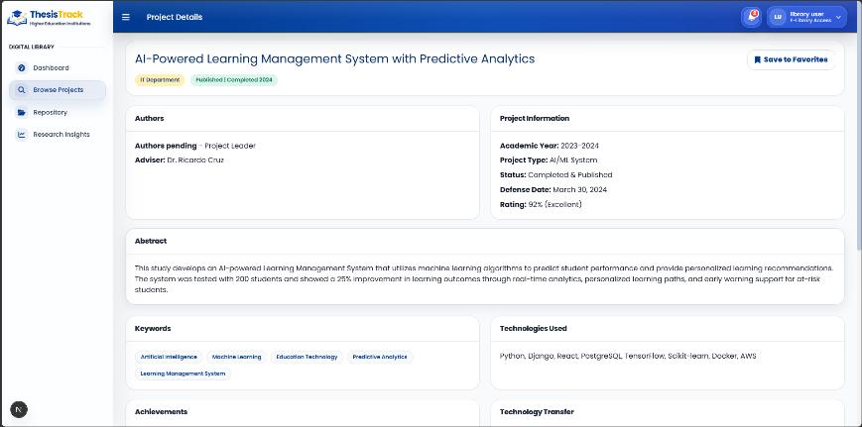
Figure 3.107 – Library: Project Details

Figure 3.107 illustrates the Project Details interface within the Library Staff module of the ThesisTrack web application. It provides detailed project metadata, including author, adviser, department, and abstract information, alongside a document preview panel and administrative tools for verification, correction, download, and repository archiving.

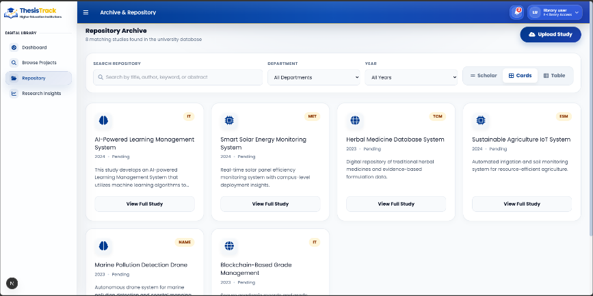
Figure 3.108 – Library: Repository

Figure 3.108 illustrates the Repository interface within the Library Staff module of the ThesisTrack web application. It allows staff to search, filter, and manage archived research projects, providing access to project records, document versions, metadata, and repository visibility settings.

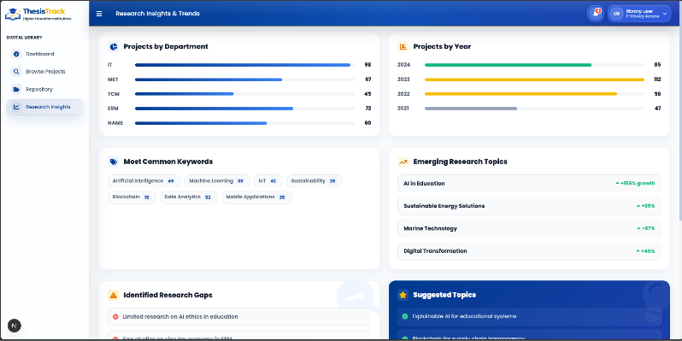
Figure 3.109 – Library: Research Insights

Figure 3.109 illustrates the Research Insights dashboard within the Library Staff module of the ThesisTrack web application. It presents analytics on published research through visual charts and project records, allowing staff to monitor publication trends, research topics, and recent repository activities while supporting data export and reporting.
¶
¶
3.14 Software Requirements Specification (SRS)
¶
¶
Table 3.35 Software Requirements for Development
¶
¶
Platform | Software/Technology | Description
Web Application | Next.js & React | Framework and library used for constructing UI dashboards and tracking views.
 | Tailwind CSS | Utility-first CSS framework utilized for application interface styling.
 | TypeScript | Strongly-typed language used to ensure compile-time code safety.
 | Prisma ORM | Object-relational mapper used to manage data queries and migrations.
 | PostgreSQL | Primary relational database used to store system and evaluation records.
 | Supabase Storage | Cloud object storage service used to securely host project manuscripts.
 | Supabase Auth & Google OAuth | Identity provider services used for role-based access and single sign-on.
 | Nodemailer / SMTP | Email service protocols used to automate system alerts and password resets.
 | Cloudinary | Cloud media service used to store and optimize branding images and logos.
Development Tool | Visual Studio Code & Antigravity | IDE and environment configuration tools used for code authoring and debugging.
 | Git Bash & Github | Terminal tool and cloud platform used for repository hosting and version control.
¶
¶
Table 3.35 illustrates the comprehensive technical stack, operational frameworks, and engineering tools required to develop and deploy the ThesisTrack platform. This formalized baseline ensures configuration consistency across local development environments, preventing cross-platform compatibility issues during software construction. Each technology was deliberately selected to align with the modular architecture, supporting systemic stability, high data integrity, and long-term maintainability for the institutional research tracking lifecycle.
¶
¶
Table 3.36 System Hardware Configuration for Development
¶
¶
Hardware | Specification
Processor | Intel Core i5 / AMD Ryzen 5 (4 Cores, 2.5 GHz or higher)
RAM | 8 GB DDR4 minimum (16 GB recommended for local IDEs and database instances)
Storage | 256 GB SSD (50 GB free space for database storage and dependencies)
Monitor | 1366 x 768 minimum resolution
Internet Connection | Stable Wi-Fi Connection
¶
¶
Table 3.36 illustrates the computing infrastructure benchmarks required to establish a functional engineering workstation for the ThesisTrack system. This formal baseline ensures that the development environment possesses sufficient processing and memory capacity to support localized operations. Standardizing these metrics prevents compilation bottlenecks and interface scaling issues during software construction.
¶
¶
3.15 Research Environment
¶
¶
The study will be conducted at the University of Science and Technology of Southern Philippines (USTP) – Jasaan Campus, which will serve as the primary site for building and testing the proposed system. The institution is an ideal setting for this research as it offers various academic programs, including BS Naval Architecture and Marine Engineering (BSNAME), BS Information Technology (BSIT), BET Manufacturing Engineering Technology (BETMET), BS Energy System and Management (BSESM), and BS Technology Communication Management (BSTCM), all of which require students to complete a thesis or capstone project for graduation. Currently, the campus manages these research outputs through manual or only partially digital methods, involving coordination between students, advisers, panelists, department chairs, and the research head.
¶
¶
The research environment encompasses both physical and digital dimensions to ensure the system is evaluated in a realistic institutional context. Physically, the study will be situated within the university’s research office and the IT department. Digitally, the environment will consist of a web-based system supported by a database server, providing a centralized platform for user access across the different stakeholder groups. This environment is suitable for testing because it allows the researchers to observe how the system simplify messy or outdated manual processes and facilitates technology transfer between the university and its external industry or community partners.
¶
¶
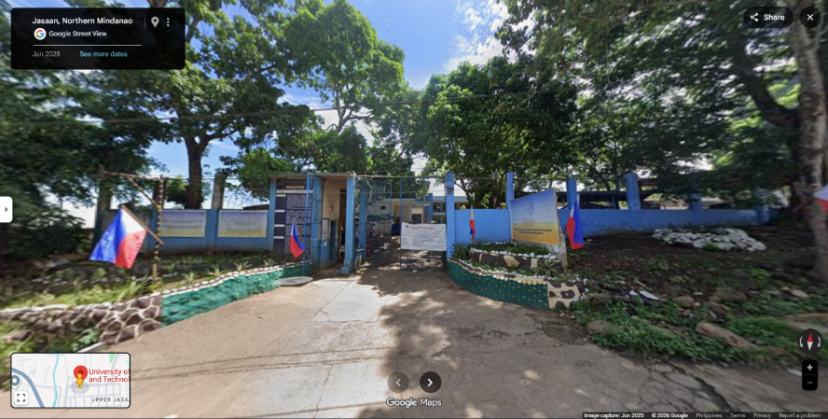
Figure 3.110 – USTP Jasaan Campus Setting
¶
¶
3.16 Unit of Analysis, Respondents and Sampling
¶
¶
3.16.1 Unit of Analysis
¶
¶
The unit of analysis for this study comprises the system users and system performance. Specifically, this focuses on the direct interaction between the institutional stakeholders and the functional modules of the software application. The analysis evaluates these interactive workflows to determine the overall effectiveness, operational stability, and functional suitability of the platform within an institutional higher education setting.
¶
¶
3.16.2 Respondents
¶
¶
The respondents for this study include selected students, faculty advisers, panel members, department chairs, and the research head from the University of Science and Technology of Southern Philippines (USTP) – Jasaan Campus who are directly included in the thesis and capstone process. These specific individuals are selected because of their firsthand experience in developing, supervising, and managing academic research projects. Their institutional insights and evaluative feedback are utilized to test the system's functionality, ease of use, and overall efficacy in resolving existing administrative and tracking gaps.
¶
¶
3.16.3 Sampling Technique
¶
¶
The study employs purposive sampling to select respondents who are directly involved in the thesis and capstone project lifecycles. This non-probability sampling method ensures that only individuals with direct interaction with the research workflow participate in the system evaluation (Etikan et al., 2016). Participants are chosen strictly based on their specific institutional roles to guarantee that the data gathered is methodologically relevant and aligns with the developmental objectives of the study (Patton, 2015).
¶
¶
Under this purposive framework, the selection of participants is designated by the following operational roles:
¶
¶
- Research Head (1) : The campus research head is selected to represent the macro-level administration and overall management of academic research processes within the institution.
- Library Personnel (1) : Library personnel are included to provide targeted feedback related to research documentation, manuscript validation, and digital repository archiving.
- Department Chairs (5) : Department chairs are selected from the active campus programs—specifically Bachelor of Science in Information Technology (BS IT), Bachelor of Engineering Technology in Manufacturing Engineering Technology (BET MET), Bachelor of Science in Energy System and Management (BS ESM), Bachelor of Science in Technology Communication Management (BS TCM), and Bachelor of Science in Naval Architecture and Marine Engineering (BS NAME)—to evaluate departmental monitoring practices and progress tracking needs.
- Faculty Advisers and Panelists (5) : Faculty advisers and panel members representing the distinct academic departments are selected to share their operational experiences in supervising milestone developments and grading student research outputs.
- Industry Partners (1) : An external stakeholder representative, such as a technology transfer officer or an industry partner, is included to ensure the platform effectively supports the transition, matching, and deployment of academic research into the public domain.
- IT Experts (3) : Three external IT professionals, such as software engineers, web developers, or database administrators, are selected to evaluate the technical aspects of the proposed system. They will assess the system's backend infrastructure, database security, system architecture, and overall performance.
- Students (20) : Student respondents are selected from the third-year and fourth-year levels across the active technology and engineering programs (BS IT, BET MET, BS ESM, BS TCM, and BS NAME). These individuals are chosen because they are actively engaged in navigating thesis requirements, tracking milestones, and submitting academic records. Their participation provides direct user insights into the operational challenges and user interface needs of the platform.
- ¶
- ¶
Following their purposive selection, these respondents participate in systematic system testing and platform evaluation. Utilizing purposive sampling in this manner is essential for software evaluations where respondents must possess specific technical or administrative insight to accurately assess a digital solution’s core quality characteristics (Weichbroth, 2024). The evaluation is conducted using a standardized ISO/IEC 25010 quality standards questionnaire, the System Usability Scale (SUS), and User Acceptance Testing (UAT) instruments to assess the comprehensive software quality, workflow integration, and institutional acceptability of the system.
¶
¶
The study will involve a total of 36 respondents. This sample size is supported by Roscoe’s classic Rule of Thumb, which states that a sample size (n) between 30 and 500 is appropriate for technical research studies (Roscoe, 1975). This principle has also been validated in recent system-based research evaluations (Moshood et al., 2025). The respondents are selected from different stakeholder groups to gather feedback from different perspectives and provide a comprehensive evaluation of the proposed system.
¶
¶
3.17 Data Source, Data Gathering Instruments and procedure
¶
¶
3.17.1 Primary and Secondary Data Sources
¶
¶
The study uses two types of data sources to evaluate the platform: primary data and secondary data. The primary data comes directly from the individuals who test and use the system, including students, faculty members, university administrators, and external industry partners. This data includes the scores from their evaluation surveys and their spoken answers during interviews.
¶
¶
The secondary data consists of existing documents and records that provide background information for the project. This includes previous campus thesis records and official university reports. Additionally, the software system itself acts as a source of secondary data by automatically recording user activities, such as real-time progress updates, project document uploads, and milestone completion logs.
¶
¶
3.17.2 Data Gathering Instruments and Procedure
¶
¶
Data will be collected from students, faculty, and administrators at the University of Science and Technology of Southern Philippines, alongside external industry partners. The study will utilize both primary data, such as user evaluation surveys, and secondary data, including existing thesis records and institutional reports. The primary research tool will be a standardized evaluation questionnaire based on the ISO/IEC 25010 framework to gather quantitative data on functional suitability, usability, reliability, and performance efficiency. This instrument will employ a five-point Likert scale ranging from 1 (Strongly Disagree) to 5 (Strongly Agree).
¶
¶
Qualitative data will be obtained through structured interviews specifically with the Research Head and the External Stakeholder Representative. These guided conversations will aim to identify institutional bottlenecks, technology transfer needs, and the specific administrative functionalities required for successful industry-academe collaboration. Additionally, the system itself will serve as a data collection tool, capturing real-time progress reports, milestone tracking, and submission logs.
¶
¶
Ethical standards will be strictly maintained throughout the process. Before participants interact with the research instruments, they will be provided with a formal letter for respondents, an informed consent form, and a data privacy statement. These documents will clearly outline the study's purpose, the voluntary nature of participation, and the guarantee that personal information will remain confidential in compliance with data privacy standards.
¶
¶
The data gathering procedure will be tied directly to the system workflow:
¶
¶
- Secure official authorization from the institution.
- The researchers will develop and deploy the system, followed by the registration of users.
- The users will interact with the various modules, including project uploads, progress monitoring, and partner matching.
- The researchers will distribute the informed consent and data privacy statements, followed by the administration of the system evaluation survey and targeted interviews..
- The procedure will conclude with the organization of all collected data for systematic analysis to ensure it meets the study's objectives.
- ¶
- ¶
3.18 Mode of Analysis, Statistical Instruments Procedure
¶
¶
The quantitative data collected through the standardized evaluation questionnaires will be analyzed using descriptive statistical methods to ensure a rigorous assessment of the system. The researchers will utilize the Weighted Mean to calculate the overall evaluation scores for each quality category defined by the ISO/IEC 25010 standards, including functional suitability, performance efficiency, usability, reliability, and security. Additionally, the Standard Deviation will be calculated to measure the consistency and distribution of the responses among the various user groups. The study will also employ the System Usability Scale (SUS) to measure the overall usability, ease of use, and user satisfaction of the ThesisTrack system. Furthermore, User Acceptance Testing (UAT) will be conducted to evaluate whether the developed system meets the functional requirements and expectations of its intended users within the institutional environment.
¶
¶
To ensure technical accuracy and statistical rigor, all numerical calculations and data processing will be performed using jamovi software. The resulting mean scores will be interpreted using a five-point scale where a range of 4.50–5.00 is considered Excellent, 3.50–4.49 is Very Good, 2.50–3.49 is Satisfactory, 1.50–2.49 is Fair, and 1.00–1.49 is Poor. For the System Usability Scale (SUS), the collected responses will be computed following the standard SUS scoring procedure and interpreted using established usability benchmarks to determine the overall acceptability and usability level of the system. The results from the User Acceptance Testing (UAT) will also be analyzed to determine whether the system satisfies user expectations in terms of functionality, usability, security, and workflow integration.
¶
¶
The qualitative information gathered from the structured interviews with the Research Head and the External Stakeholder Representative will be analyzed using Thematic Analysis. The researchers will review the responses to identify recurring patterns and group them into specific themes, such as institutional requirements, administrative bottlenecks, and technology transfer needs. These qualitative insights will be integrated with the quantitative results to provide a comprehensive evaluation that addresses the overall goals of the study.

REFERENCES
¶
¶
Batoon, J. A., Leonard, J., Ramos, M., Maverick, J., Pineda, M., Miguel, J., Dizon, L., Carlo, L., Reyes, C., Ahmed, M. B. M., Gordon, R., & Santos, S. D. (2022). THESISQUO: Research management system with plagiarism checker and prescriptive analytics. International Journal of Advanced Trends in Computer Science and Engineering, 11(3), 101–107. https://doi.org/10.30534/ijatcse/2022/051132022
¶
¶
Chio, M. E. B., Dal, P. M. M., Garrido, J. L., Baldelovar, A., & Saledaien, J. V. M. (2022). ThesisIT: Web-based university thesis management portal with a defense scheduling system. Science International (Lahore), 34(6), 531–536. https://www.researchgate.net/profile/Jc-Vanny-Mill-Saledaien/publication/374192375_THESISIT_WEB-BASED_UNIVERSITY_THESIS_MANAGEMENT_PORTAL_WITH_A_DEFENSE_SCHEDULING_SYSTEM/links/6517def6321ec5513c225e3d/THESISIT-WEB-BASED-UNIVERSITY-THESIS-MANAGEMENT-PORTAL-WITH-A-DEFENSE-SCHEDULING-SYSTEM.pdf
¶
¶
Doromal, W. G., & Soberano, K. T. (2023). Capstone archiving management system with citation and reference generator. International Journal of Research in Engineering and Science (IJRES), 11(9), 128–133. https://www.ijres.org/papers/Volume-11/Issue-9/1109128133.pdf
¶
¶
Etikan, I., Abubakar, S. A., & Alkassim, R. S. (2016). Comparison of convenience sampling and purposive sampling. American Journal of Theoretical and Applied Statistics, 5(1), 1–4. https://doi.org/10.11648/j.ajtas.20160501.11
¶
¶
Goncharenko, I. (2021). Conceptual model of the hackathon ecosystem of technology transfer in an institution of higher education. Management, 33(1), 74–84. https://doi.org/10.30857/2415-3206.2021.1.7
¶
¶
Hailitik, O., Salim, A., Djaha, A., & Amah, M. (2025). The effectiveness of academic monitoring and evaluation on length of study at Nusa Cendana University. International Journal of Environmental, Sustainability, and Social Science, 6(5), 992–1002. https://doi.org/10.38142/IJESSS.V6I5.1482
¶
¶
Huang, X. (2025). Technology transfer in higher education. https://phd.lib.uni-corvinus.hu/1416/
¶
¶
Lando, A. L., & Wambua, A. W. (2025). Digital solutions for graduate supervision: A critical analysis of thesis management systems. American Journal of STEM Education, 9, 49–64. https://doi.org/10.32674/sbs52z14
¶
¶
Liu, J., Wang, C., & Xiao, X. (2021). Design and application of science and technology project management information system for educational institutes. Mobile Information Systems, 2021(1), 2074495. https://doi.org/10.1155/2021/2074495
¶
¶
Moshood, T. D., Mahmud, F., Nawanir, G., Ahmad, M. H., Mohamad, F., & AbdulGhani, A. (2025). Determinants driving the uptake of biodegradable plastics: A sequential exploratory mixed-methods research approach. Microplastics, 4(1), 7. https://doi.org/10.3390/microplastics4010007
Palavesm, K., & Joorel, J. P. S. (2022). IRINS: Implementing a research information management system in Indian higher education institutions. Procedia Computer Science, 211, 238–245. https://doi.org/10.1016/j.procs.2022.10.197
¶
¶
Patton, M. Q. (2015). Qualitative research & evaluation methods: Integrating theory and practice (4th ed.). SAGE Publications.
¶
¶
Perante, W. J. A., Barnaba, E. O., Jr., Cañete, J. R., & Niegas, M. E. (2024). Design and develop a thesis and capstone project manuscript archiving management system for Eastern Visayas State University Ormoc Campus. International Journal of Recent Advances in Multidisciplinary Research, 11(11), 10417–10422. https://www.researchgate.net/profile/Wilferd-Jude-Perante/publication/387225348_DESIGN_AND_DEVELOP_A_THESIS_AND_CAPSTONE_PROJECT_MANUSCRIPT_ARCHIVING_MANAGEMENT_SYSTEM_FOR_EASTERN_VISAYAS_STATE_UNIVERSITY_ORMOC_CAMPUS/links/6764ceb600aa3770e0ad2320/DESIGN-AND-DEVELOP-A-THESIS-AND-CAPSTONE-PROJECT-MANUSCRIPT-ARCHIVING-MANAGEMENT-SYSTEM-FOR-EASTERN-VISAYAS-STATE-UNIVERSITY-ORMOC-CAMPUS.pdf
¶
¶
Qazdar, A., Hasidi, O., Qassimi, S., & Abdelwahed, E. H. (2023). Newly proposed student performance indicators based on learning analytics for continuous monitoring in learning management systems. International Journal of Online and Biomedical Engineering (iJOE), 19(11), 19–30. https://doi.org/10.3991/ijoe.v19i11.39471
¶
¶
Regla, A. I., & Ballera, M. A. (2023). An enhanced research productivity monitoring system for higher education institutions (HEIs) with natural language processing (NLP). Procedia Computer Science, 230, 316–325. https://doi.org/10.1016/j.procs.2023.12.087
¶
¶
Reyes, E. R., Almonte, R. G., Montano, M. R. F., & Armario, N. O. (2024). Efficiency assessment and design proposal for computerized student record management system in higher education institutions. ACM International Conference Proceeding Series, 24, 154–161. https://doi.org/10.1145/3678726.3678765
¶
Roscoe, J. T. (1975). Fundamental research statistics for the behavioral sciences (2nd ed.). Holt, Rinehart and Winston.
¶
¶
Safdar, M. (2021). Creating institutional repository in libraries: The DSpace experience in Pakistan. Library Philosophy and Practice. https://scholarworks.sjsu.edu/libphilprac/5597
¶
¶
Sarita, V. B. (2025). Technology transfer in higher education institutions: A Philippine state universities and colleges' innovation ecosystem scenario. Discourse and Communication for Sustainable Education, 16(1), 137–149. https://doi.org/10.2478/DCSE-2025-0010
¶
¶
Simard, M. (2021). Project management implementation in a capstone design course. https://doi.org/10.18260/1-2--36313
¶
¶
Weichbroth, P. (2024). Usability of mobile applications: A consolidated model. IEEE Access, 12, 62378–62391. https://doi.org/10.1109/ACCESS.2024.3395528

APPENDIX A: LETTER OF CONSENT
Dear Respondent,
Good day!
You are invited to participate in a research study entitled:
“Development of a Thesis and Capstone Project Inventory, Progress Monitoring, and Technology Transfer Management System for Higher Education Institutions.”
The purpose of this study is to assess the current practices, challenges, and needs related to thesis and capstone project management. Your responses will help determine the feasibility and importance of developing the proposed system.
Your participation is voluntary, and you may choose not to answer any question or withdraw at any time without penalty. The survey will take approximately 5–10 minutes to complete.
All information gathered will be treated with strict confidentiality and will be used solely for academic purposes.
Thank you for your time and valuable contribution to this study.
Respectfully,
Princess Mae Camille N. Achas
Ivy A. Bitos
Kyle Japheth C. Graniten
James Anthony Z. Juntilla
BS Information Technology
USTP Jasaan

INFORMED CONSENT
By answering this survey, you confirm that:
• You have read and understood the purpose of the study
• You voluntarily agree to participate
• You understand that your responses will be kept confidential
• You understand that the data will be used for academic research purposes only
☐ I agree to participate in this survey
☐ I do not agree to participate

DATA PRIVACY STATEMENT
This study complies with applicable data privacy regulations. No personally identifiable information will be collected unless voluntarily provided. All data will be stored securely and accessed only by the researchers.
Collected data will be:
• Used strictly for academic and research purposes
• Reported in aggregated form only
• Stored securely and disposed of properly after the study
If you have any concerns regarding your data, you may ask the researcher.
APPENDIX B: LETTER OF APPROVAL




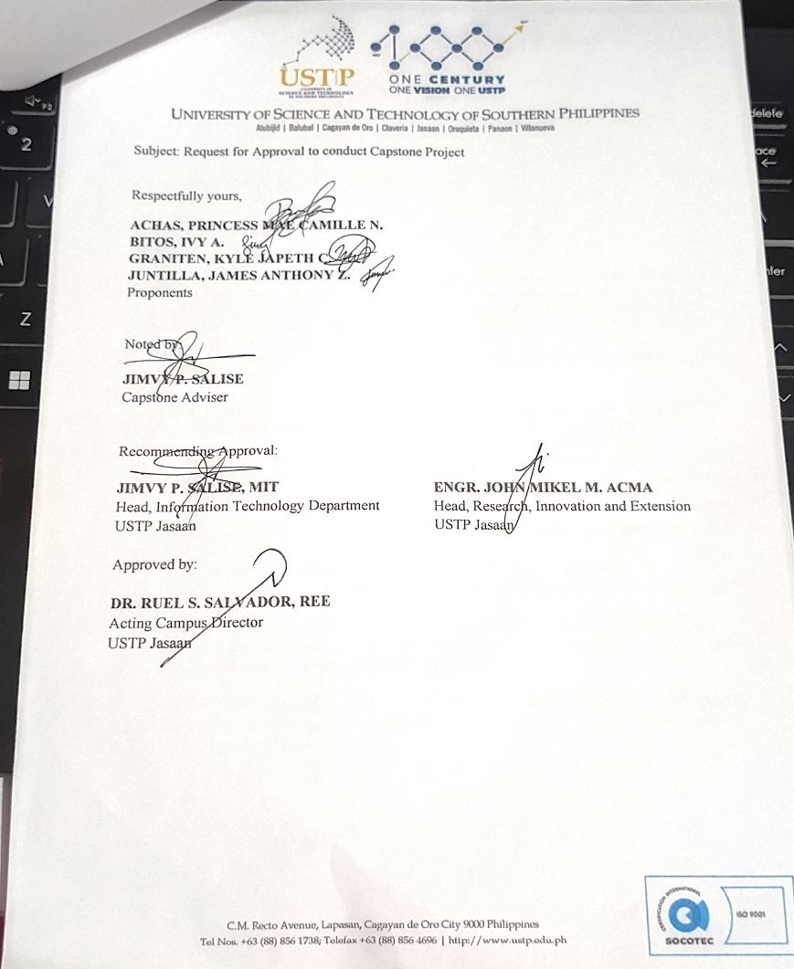
APPENDIX C: NEEDS ANALYSIS SURVEY QUESTIONNAIRE

Needs Analysis Survey Questionnaire
PART 1 : RESPONDENT PROFILE
1. Role:
☐ Student
☐ Faculty/Adviser
☐ Department Chair/Administrator
☐ Industry/Community Partner

2. Department/Program: _______________________

3. Years of Experience:
☐ 1–2 years
☐ 3–5 years
☐ 6+ years

PART 2: CURRENT PRACTICES
4. How are thesis/capstone projects currently managed?
☐ Manual (paper-based)
☐ Spreadsheet (Excel/Google Sheets)
☐ Existing system
☐ Others: _______________________

5. How do you track project progress?
☐ Not systematically tracked
☐ Through meetings only
☐ Using documents/reports
☐ Using a digital system

6. How are completed projects stored?
☐ Physical archive
☐ Digital files (unorganized)
☐ Centralized system
☐ Not properly stored

PART 3: PROBLEMS ENCOUNTERED (RATE 1–5)
 | 1 | 2 | 3 | 4 | 5
Difficulty in tracking student progress | ☐ | ☐ | ☐ | ☐ | ☐
Lack of centralized repository | ☐ | ☐ | ☐ | ☐ | ☐
Duplication of project titles | ☐ | ☐ | ☐ | ☐ | ☐
Delays in submission | ☐ | ☐ | ☐ | ☐ | ☐
Limited communication | ☐ | ☐ | ☐ | ☐ | ☐
Difficulty accessing past projects | ☐ | ☐ | ☐ | ☐ | ☐
Lack of project utilization | ☐ | ☐ | ☐ | ☐ | ☐

PART 4: NEED FOR THE PROPOSED SYSTEM (RATE 1–5)
 | 1 | 2 | 3 | 4 | 5
Need for a unified platform that connects documentation, monitoring, and technology transfer. | ☐ | ☐ | ☐ | ☐ | ☐
Digital monitoring improves completion | ☐ | ☐ | ☐ | ☐ | ☐
Need for real-time visibility into student milestone status to prevent bottlenecks. | ☐ | ☐ | ☐ | ☐ | ☐
Improves communication | ☐ | ☐ | ☐ | ☐ | ☐
Need for a mechanism to prevent research redundancy and topic repetition. | ☐ | ☐ | ☐ | ☐ | ☐
Connect to industry/community | ☐ | ☐ | ☐ | ☐ | ☐
Increase usability of projects | ☐ | ☐ | ☐ | ☐ | ☐

PART 5: DESIRED FEATURES (RATE 1–5)
 | 1 | 2 | 3 | 4 | 5
Cloud-based manuscript archiving with role-based access control | ☐ | ☐ | ☐ | ☐ | ☐
Progress tracking dashboard | ☐ | ☐ | ☐ | ☐ | ☐
Adviser feedback system | ☐ | ☐ | ☐ | ☐ | ☐
Automated email or system alerts for upcoming target dates and overdue milestones. | ☐ | ☐ | ☐ | ☐ | ☐
Search/filter database | ☐ | ☐ | ☐ | ☐ | ☐
Automated title and keyword similarity scanning during proposal submission. | ☐ | ☐ | ☐ | ☐ | ☐
Industry partner access | ☐ | ☐ | ☐ | ☐ | ☐
Deployment tracking | ☐ | ☐ | ☐ | ☐ | ☐
Reports/analytics | ☐ | ☐ | ☐ | ☐ | ☐

PART 6: OPEN-ENDED QUESTIONS
- What is the biggest challenge you experience in the current project management process? Please include any other problems not mentioned in Part 3.
______________________________________________________________________________________________________________________________
- Are there any additional, unique features or functionalities you would like to see in the proposed system that were not listed in Part 5? Please describe them briefly.
______________________________________________________________________________________________________________________________
- In your opinion, how can this system best help bridge the gap between student research projects and actual utilization or commercialization by industry/community partners?
______________________________________________________________________________________________________________________________

APPENDIX D: ISO 25010 EVALUATION QUESTIONNIARE

SOFTWARE QUALITY EVALUATION
Please rate the ThesisTrack system based on your experience using the scale below:
5 – Excellent
4 – Good
3 – Fair
2 – Needs Improvement
1 – Poor

Functional Suitability
Questions | 1 | 2 | 3 | 4 | 5
The system provides the necessary features for managing thesis and capstone project records. | ☐ | ☐ | ☐ | ☐ | ☐
The system allows users to submit, monitor, and manage project requirements properly. | ☐ | ☐ | ☐ | ☐ | ☐
The system supports the required functions for progress tracking and evaluation. | ☐ | ☐ | ☐ | ☐ | ☐
The system provides useful features for repository management and technology transfer. | ☐ | ☐ | ☐ | ☐ | ☐
The system performs its intended functions accurately. | ☐ | ☐ | ☐ | ☐ | ☐

Performance Efficiency
Questions | 1 | 2 | 3 | 4 | 5
The system responds quickly when opening pages and modules. | ☐ | ☐ | ☐ | ☐ | ☐
The system processes submissions, updates, and records within a reasonable time. | ☐ | ☐ | ☐ | ☐ | ☐
The system remains stable while performing different tasks. | ☐ | ☐ | ☐ | ☐ | ☐
The system can handle multiple user actions without noticeable delays. | ☐ | ☐ | ☐ | ☐ | ☐
The system uses its features efficiently without unnecessary loading or interruptions. | ☐ | ☐ | ☐ | ☐ | ☐

Usability
Questions | 1 | 2 | 3 | 4 | 5
The system is easy to understand and use. | ☐ | ☐ | ☐ | ☐ | ☐
The system’s interface is clear, organized, and user-friendly. | ☐ | ☐ | ☐ | ☐ | ☐
The system allows users to complete tasks with minimal difficulty. | ☐ | ☐ | ☐ | ☐ | ☐
The labels, buttons, and navigation are easy to recognize. | ☐ | ☐ | ☐ | ☐ | ☐
Overall, the system provides a smooth and convenient user experience. | ☐ | ☐ | ☐ | ☐ | ☐

Compatibility
Questions | 1 | 2 | 3 | 4 | 5
The system operates properly across different web browsers. | ☐ | ☐ | ☐ | ☐ | ☐
The system functions correctly on different devices and screen sizes | ☐ | ☐ | ☐ | ☐ | ☐
The system works effectively alongside other software and services. | ☐ | ☐ | ☐ | ☐ | ☐
The system maintains consistent performance across different environments. | ☐ | ☐ | ☐ | ☐ | ☐
The system supports data exchange with integrated services without issues. | ☐ | ☐ | ☐ | ☐ | ☐

Reliability
Questions | 1 | 2 | 3 | 4 | 5
The system performs its functions consistently during operation. | ☐ | ☐ | ☐ | ☐ | ☐
The system remains available when needed by users. | ☐ | ☐ | ☐ | ☐ | ☐
The system recovers properly from errors or interruptions. | ☐ | ☐ | ☐ | ☐ | ☐
The system maintains data accuracy during processing and storage. | ☐ | ☐ | ☐ | ☐ | ☐
The system operates without frequent crashes or failures. | ☐ | ☐ | ☐ | ☐ | ☐

Security
Questions | 1 | 2 | 3 | 4 | 5
The system protects user accounts from unauthorized access. | ☐ | ☐ | ☐ | ☐ | ☐
The system safeguards confidential information and records. | ☐ | ☐ | ☐ | ☐ | ☐
The system ensures that only authorized users can access specific functions. | ☐ | ☐ | ☐ | ☐ | ☐
The system provides secure authentication and login mechanisms. | ☐ | ☐ | ☐ | ☐ | ☐
The system protects stored data from unauthorized modification or deletion. | ☐ | ☐ | ☐ | ☐ | ☐

Maintainability
Questions | 1 | 2 | 3 | 4 | 5
The system can be updated without causing major disruptions. | ☐ | ☐ | ☐ | ☐ | ☐
The system structure supports easy identification of issues and errors. | ☐ | ☐ | ☐ | ☐ | ☐
The system allows modifications and enhancements when necessary. | ☐ | ☐ | ☐ | ☐ | ☐
The system is organized in a way that facilitates maintenance activities. | ☐ | ☐ | ☐ | ☐ | ☐
The system supports efficient troubleshooting and correction of defects. | ☐ | ☐ | ☐ | ☐ | ☐

Flexibility
Questions | 1 | 2 | 3 | 4 | 5
The system can adapt to changing user requirements. | ☐ | ☐ | ☐ | ☐ | ☐
The system supports the addition of new features and functionalities. | ☐ | ☐ | ☐ | ☐ | ☐
The system can accommodate changes in institutional processes. | ☐ | ☐ | ☐ | ☐ | ☐
The system can be configured to support different user needs. | ☐ | ☐ | ☐ | ☐ | ☐
The system remains effective under varying operational conditions. | ☐ | ☐ | ☐ | ☐ | ☐

Safety
Questions | 1 | 2 | 3 | 4 | 5
The system minimizes the risk of accidental data loss. | ☐ | ☐ | ☐ | ☐ | ☐
The system prevents actions that may negatively affect system operations. | ☐ | ☐ | ☐ | ☐ | ☐
The system provides warnings or confirmations before critical actions are performed. | ☐ | ☐ | ☐ | ☐ | ☐
The system helps ensure the integrity of stored records and information. | ☐ | ☐ | ☐ | ☐ | ☐
The system reduces the likelihood of user errors causing significant problems. | ☐ | ☐ | ☐ | ☐ | ☐

PART 3: FEEDBACK AND SUGGESTIONS

- What features of the ThesisTrack system did you find useful?
______________________________________________________________________________________________________________________________________________________________________________________________________

- What difficulties did you encounter while using the system?
______________________________________________________________________________________________________________________________________________________________________________________________________

- What improvements would you suggest for the system?
______________________________________________________________________________________________________________________________________________________________________________________________________

Respondent’s Signature: ________________________
Date of Evaluation: ________________________

APPENDIX E: SYSTEM USABILITY SCALE

ThesisTrack: Development of a Thesis and Capstone Project Inventory, Progress Monitoring, and Technology Transfer Management System for Higher Education Institutions

System Usability Scale (SUS)
Please select the option that best describes your experience after using the ThesisTrack system.
 |  | (Strongly Disagree) |  |  |  | (Strongly Agree)
1. | I think that I would like to use this system frequently. | ☐ | ☐ | ☐ | ☐ | ☐
2. | I found the system unnecessarily complex. | ☐ | ☐ | ☐ | ☐ | ☐
3. | I thought the system was easy to use. | ☐ | ☐ | ☐ | ☐ | ☐
4. | I think that I would need the support of a technical person to be able to use this system. | ☐ | ☐ | ☐ | ☐ | ☐
5. | I found the various functions in this system were well integrated. | ☐ | ☐ | ☐ | ☐ | ☐
6. | I thought there was too much inconsistency in this system. | ☐ | ☐ | ☐ | ☐ | ☐
7. | I would imagine that most people would learn to use this system very quickly. | ☐ | ☐ | ☐ | ☐ | ☐
8. | I found the system very inconvenient to use. | ☐ | ☐ | ☐ | ☐ | ☐
9. | I felt very confident using the system. | ☐ | ☐ | ☐ | ☐ | ☐
10. | I needed to learn a lot of things before I could get going with this system. | ☐ | ☐ | ☐ | ☐ | ☐

APPENDIX F: USER ACCEPTANCE TESTING

ThesisTrack: Development of a Thesis and Capstone Project Inventory, Progress Monitoring, and Technology Transfer Management System for Higher Education Institutions

PART 1. RESPONDENT PROFILE
1. Role:
☐ Student
☐ Faculty/Adviser
☐ Department Chair/Administrator
☐ Industry/Community Partner

2. Department/Program: _______________________
3. Date of Testing:_________________________

PART 2. USER ACCEPTANCE EVALUATION
Please evaluate the ThesisTrack system based on your actual experience while performing your assigned tasks. Select the rating that best describes your level of acceptance of the system.

Rating Scale
5 – Highly Acceptable
4 – Acceptable
3 – Moderately Acceptable
2 – Slightly Acceptable
1 – Not Acceptable

Questions | 1 | 2 | 3 | 4 | 5
The system performs the required tasks effectively. | ☐ | ☐ | ☐ | ☐ | ☐
The system provides the necessary features needed by users. | ☐ | ☐ | ☐ | ☐ | ☐
The system is easy to understand and use. | ☐ | ☐ | ☐ | ☐ | ☐
The system interface is clear and organized. | ☐ | ☐ | ☐ | ☐ | ☐
The system responds efficiently during operation. | ☐ | ☐ | ☐ | ☐ | ☐
The system produces accurate and reliable results. | ☐ | ☐ | ☐ | ☐ | ☐
The system helps improve the management of tasks and records. | ☐ | ☐ | ☐ | ☐ | ☐
The system is stable and functions properly during use. | ☐ | ☐ | ☐ | ☐ | ☐
The system meets user expectations and requirements. | ☐ | ☐ | ☐ | ☐ | ☐
Overall, the system is acceptable for implementation. | ☐ | ☐ | ☐ | ☐ | ☐

