# Mediterranean Shipping Company

Swiss international shipping line

**Mediterranean Shipping Company S.A**, branded as **MSC** is an international shipping line founded by [Gianluigi Aponte](https://en.wikipedia.org/wiki/Gianluigi_Aponte" \o "Gianluigi Aponte) in Italy in 1970. The company is owned by the Aponte family with its headquarters in Switzerland since 1978. It is the [world's largest container shipping company](https://en.wikipedia.org/wiki/List_of_largest_container_shipping_companies" \o "List of largest container shipping companies) by both fleet size and cargo capacity, controlling about 19.7 percent of the global container ship fleet.

|  |  |
| --- | --- |
|  | |
| [MSC Astrid departing from Fremantle, Australia, in May 2015](https://en.wikipedia.org/wiki/File:MSC_Zoe_(ship,_2015)_003.jpg) | |
| **Type** | [Private](https://en.wikipedia.org/wiki/Privately_held_company) |
| **Industry** | [Shipping](https://en.wikipedia.org/wiki/Shipping), [air cargo](https://en.wikipedia.org/wiki/Air_cargo" \o "Air cargo), [Rail transport](https://en.wikipedia.org/wiki/Rail_transport" \o "Rail transport) |
| **Founded** | 1970; 53 years ago |
| **Founder** | [Gianluigi Aponte](https://en.wikipedia.org/wiki/Gianluigi_Aponte) |
| **Headquarters** | [Geneva](https://en.wikipedia.org/wiki/Geneva)  ,  [Switzerland](https://en.wikipedia.org/wiki/Switzerland) |
| **Area served** | [Worldwide](https://en.wikipedia.org/wiki/World) |
| **Key people** | Diego Aponte |
| **Services** | Container Shipping and Logistics |
| **Revenue** | Increase $28.19 billion (2015) |
| [**Net income**](https://en.wikipedia.org/wiki/Net_income) | Increase $6.16 billion (2014) |
| **Owner** | [Gianluigi Aponte](https://en.wikipedia.org/wiki/Gianluigi_Aponte) |
| **Number of employees** | Steady 30,000 (2014) |
| [**Subsidiaries**](https://en.wikipedia.org/wiki/Subsidiary) | [MSC Cruises](https://en.wikipedia.org/wiki/MSC_Cruises), [Italo](https://en.wikipedia.org/wiki/Nuovo_Trasporto_Viaggiatori" \o "Nuovo Trasporto Viaggiatori) |
| **Website** | [www.msc.com](http://www.msc.com/) |

Close

[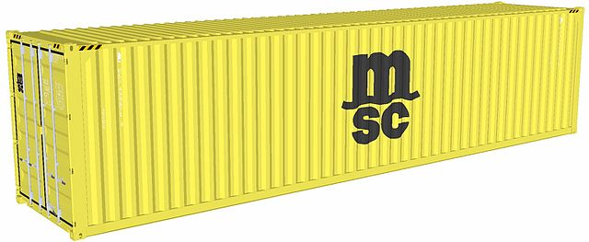](https://en.wikipedia.org/wiki/File:MSC_container.jpeg)

MSC 40' container

As of November 2023, MSC operates over 790 container vessels with an intake capacity of 5,505,417 [twenty-foot equivalent units](https://en.wikipedia.org/wiki/Twenty-foot_equivalent_unit" \o "Twenty-foot equivalent unit) (TEU). In 2022, the company launched a [cargo airline](https://en.wikipedia.org/wiki/Cargo_airline" \o "Cargo airline) under the **MSC Air Cargo** brand.