# Maersk

Danish shipping conglomerate

**A.P. Moller–Maersk Group** (Danish: *A.P. Møller–Mærsk A/S*, Danish pronunciation: [ˈæːˀ ˈpʰeːˀ mølɐˈmæɐ̯sg̊]), also known as **Maersk**, is a Danish [business conglomerate](https://simple.wikipedia.org/wiki/Conglomerate_(company)" \o "Conglomerate (company)). A.P. Møller – Maersk Group has activities in a variety of business sectors, primarily within the [transportation](https://simple.wikipedia.org/wiki/Transport" \o "Transport) and energy sectors. It has been the largest [container ship](https://simple.wikipedia.org/wiki/Container_ship" \o "Container ship) operator and supply vessel operator in the world since 1996.

[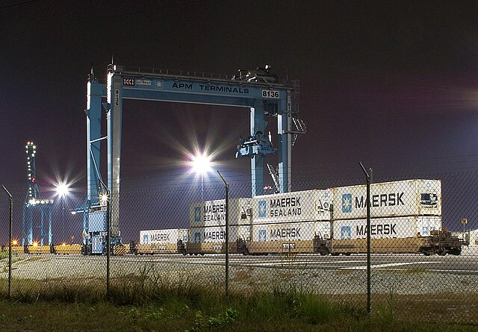](https://simple.wikipedia.org/wiki/File:APM_Terminals_WJ_Grimes.JPG)

A Maersk factory

[](https://simple.wikipedia.org/wiki/File:Maersk_Group_Logo.svg)

The Maersk Group is based in [Copenhagen](https://simple.wikipedia.org/wiki/Copenhagen" \o "Copenhagen), Denmark, with subsidiaries and offices in more than 135 countries worldwide and around 89,000 employees. It ranked 142 on the Forbes Global 2000 list for 2014.