**DECK**

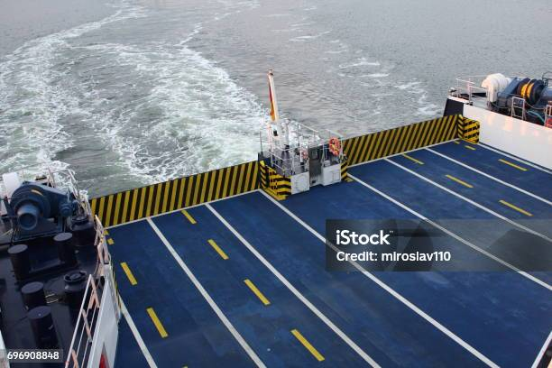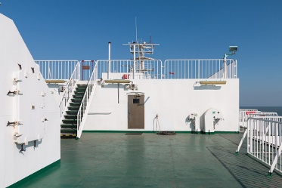The Ship Deck Department, also known as the Deck Department, is responsible for the navigation and safe operation of the ship. This department includes positions such as Captain (Master), Chief Officer (First Mate), Second Officer, Third Officer, and Deck Cadets. The duties of the Deck Department involve navigation, watchkeeping, cargo operations, safety procedures, and maintenance of deck equipment. Deck officers are trained in seamanship, navigation, collision avoidance, ship handling, and emergency response. They play a crucial role in ensuring the safety of the vessel, its crew, and its cargo during voyages. Additionally, deck cadets undergo practical training and education to become licensed deck officers.