1.
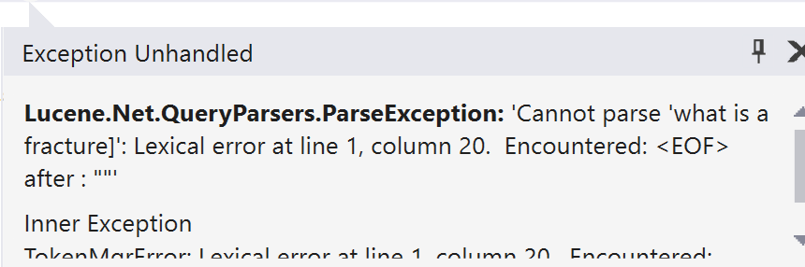

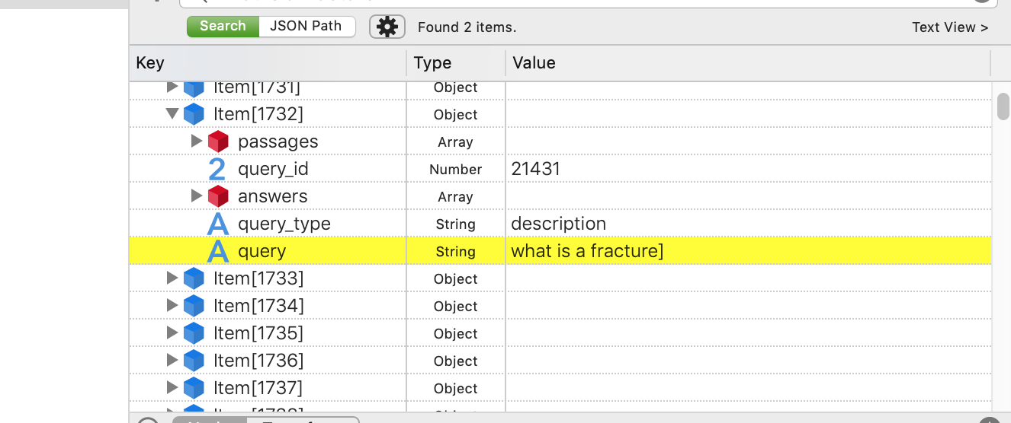

https://stackoverflow.com/questions/10259907/lucene-exception-query-parser-encountered-eof-after-some-word/10259944

Answer: escape special characters

2. when trec_eval the results of the whole collection, --‘Not enough space’

3. how many results should we specify ?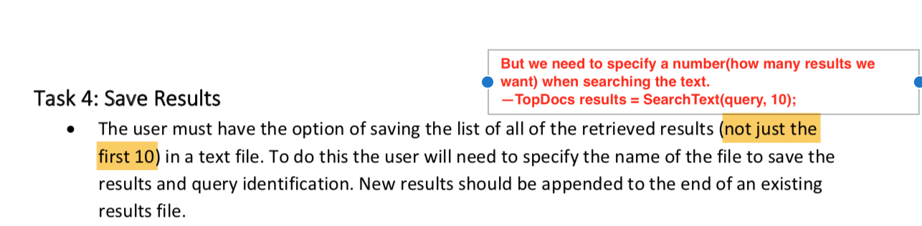

So, basically you can specify as many as you can. (the screenshot is from official document)
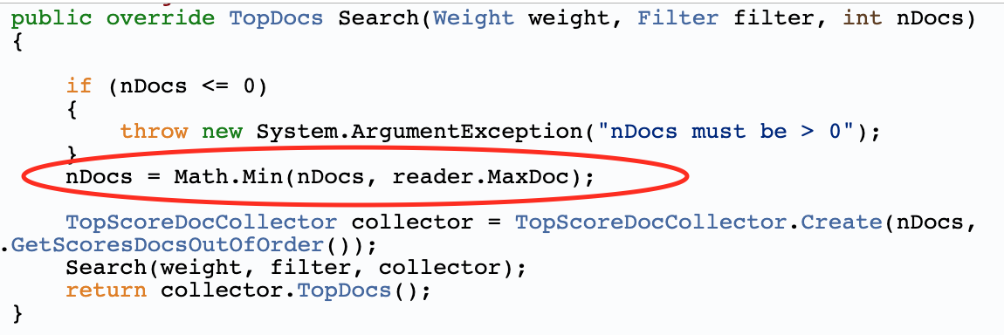

4. Effectiveness of 1000items of collection – Baseline system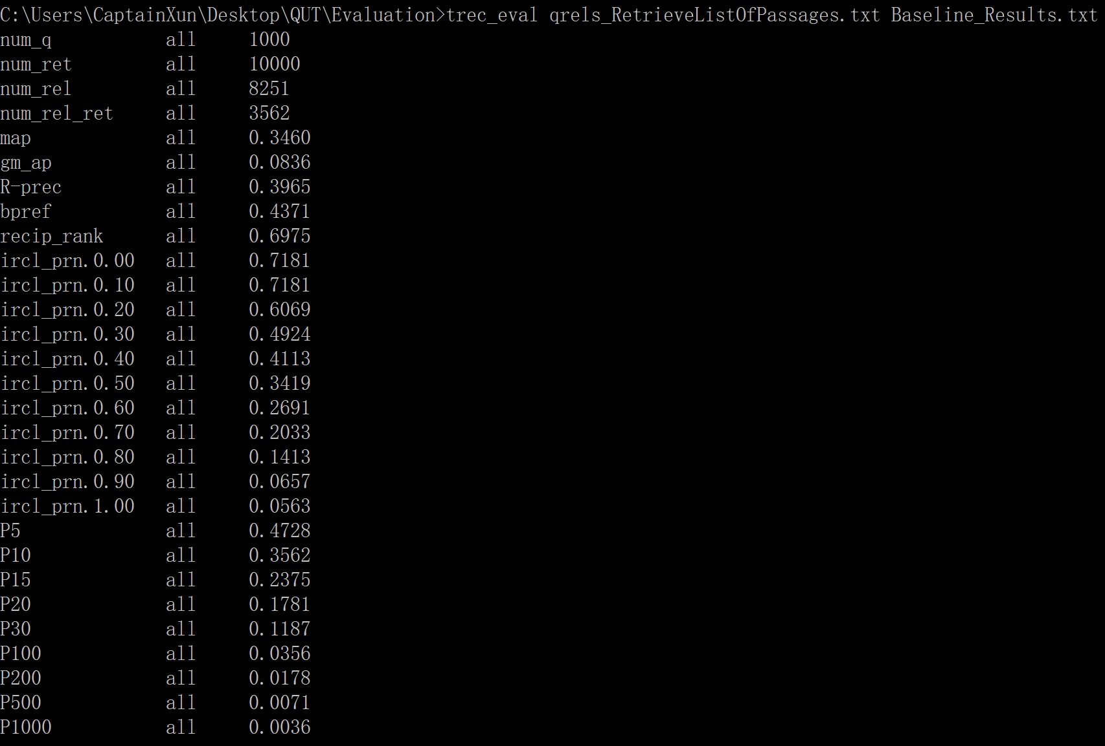

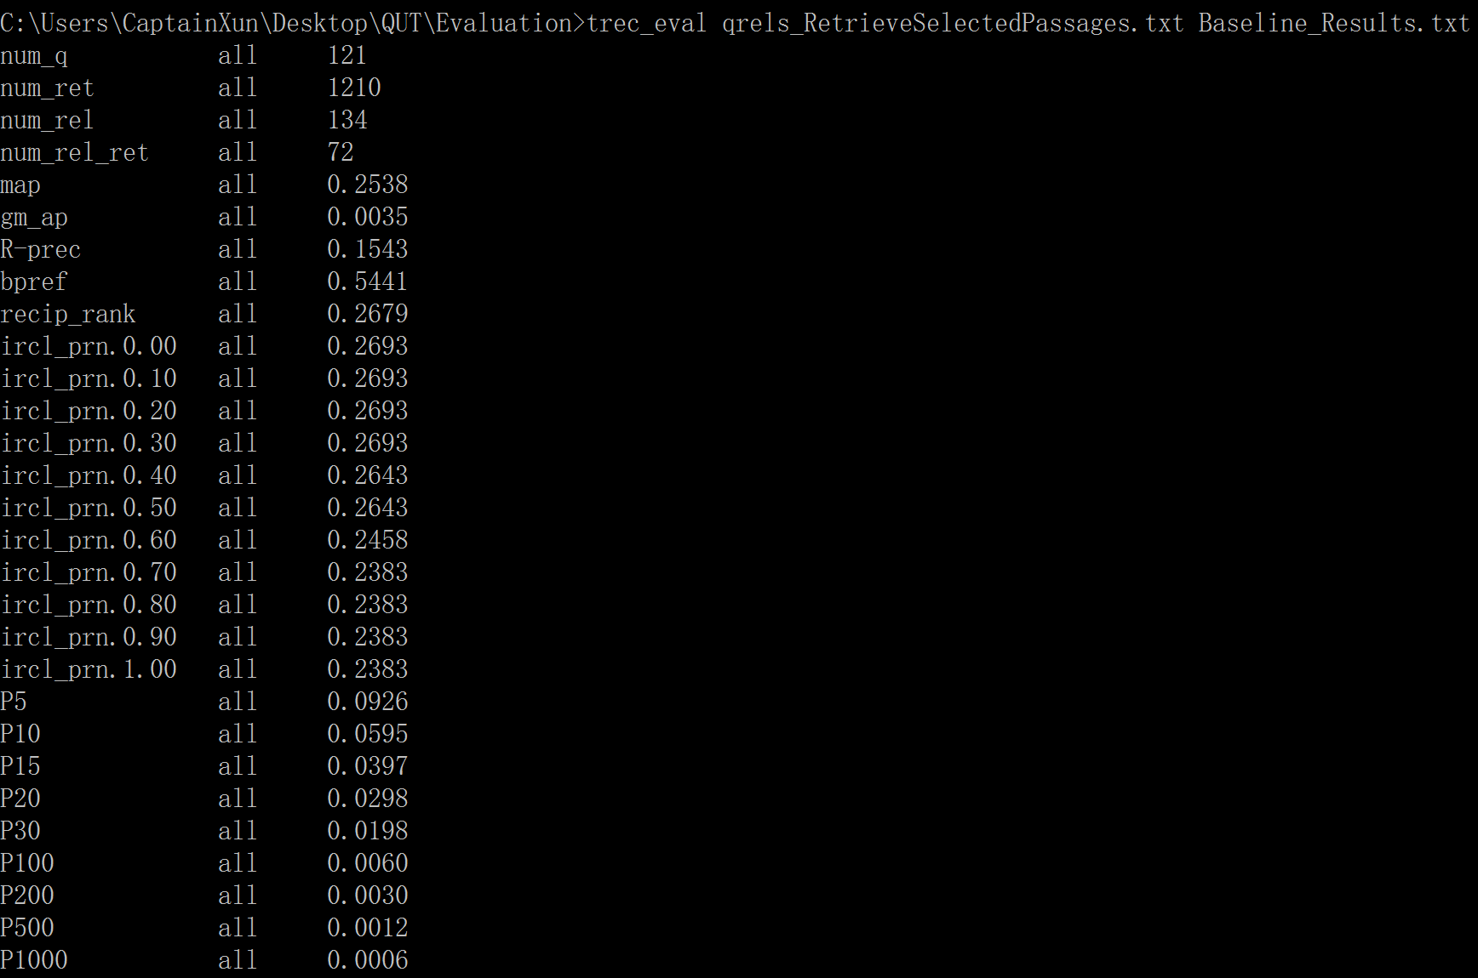

5. For baseline system
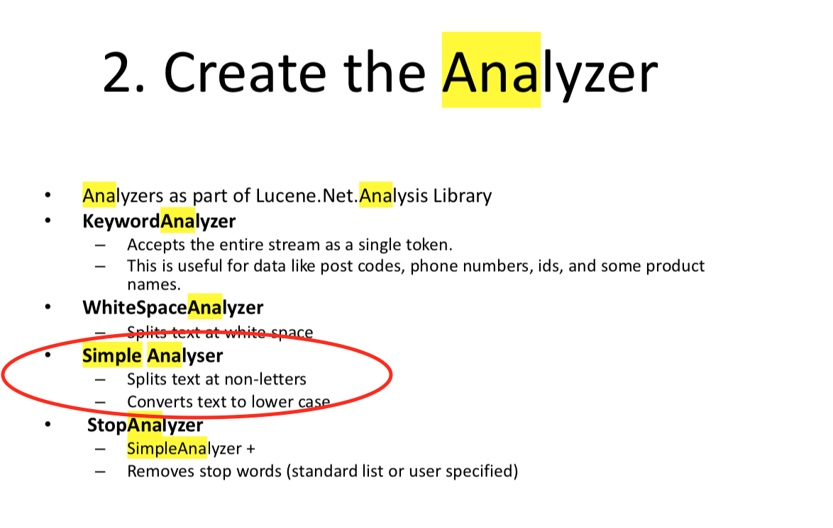
when we use simple analyser, it does not remove stopwords. But is it ok that when we search the query, we remove the stopwords? which is part of pre-processing Natural Language Question. (because I remember the indexing and searching should use the same strategy)

for example, “what is rba” still “what is rba” , not “what rba”

And when I create the simulation to get the baseline results, I use the query in the collection without doing pre-processing.

6. multi-term and multi-phrase?
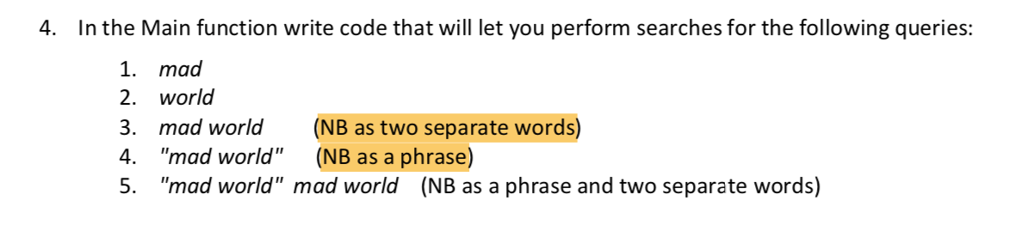

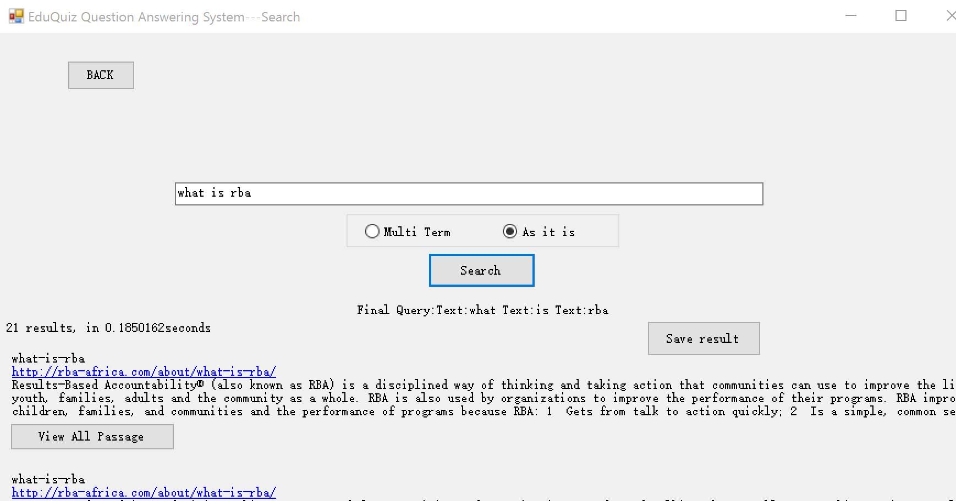

but if we add the following code, it will not tokenize the sentence.
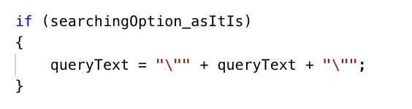
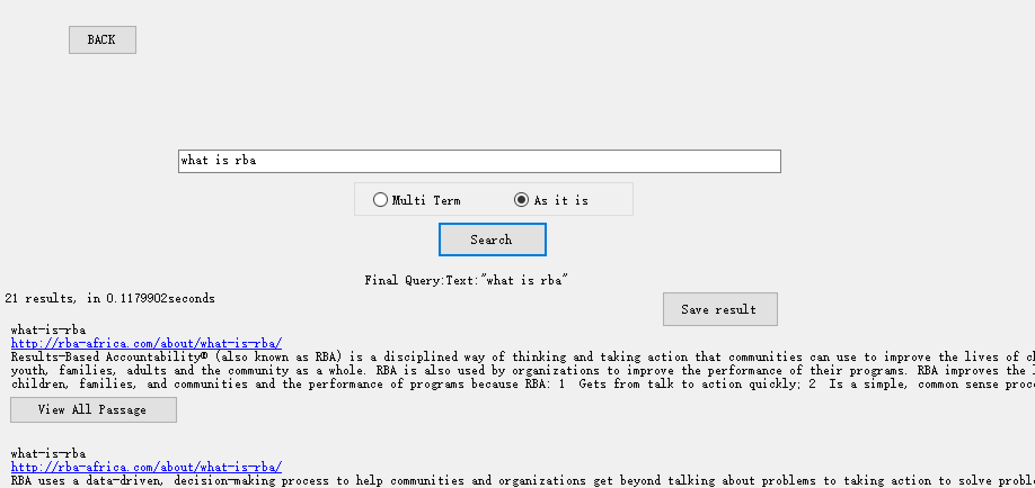

7. in baseline system, I also indexed the passage_ID and query_ID for creating the simulation results, will it affect the searching result? --- Answer: no, because when searching the query, we only use the filed TEXT_FN.

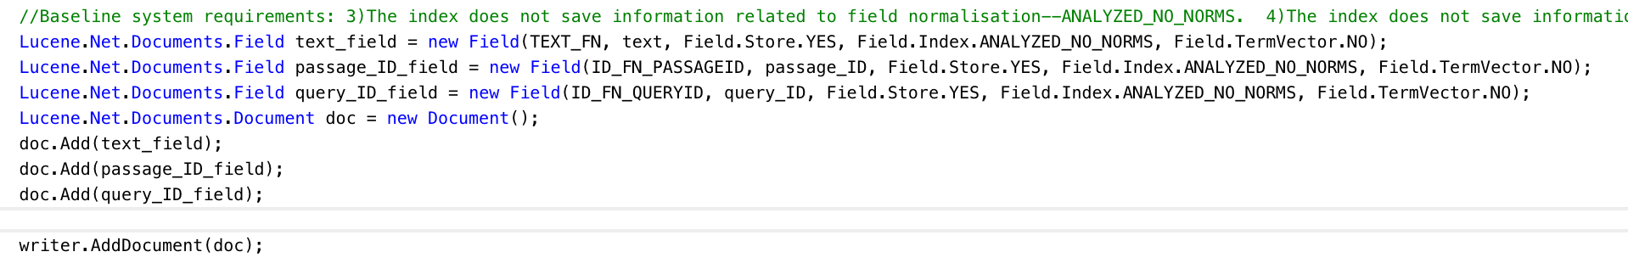

because the calculating the score of query q for document d:
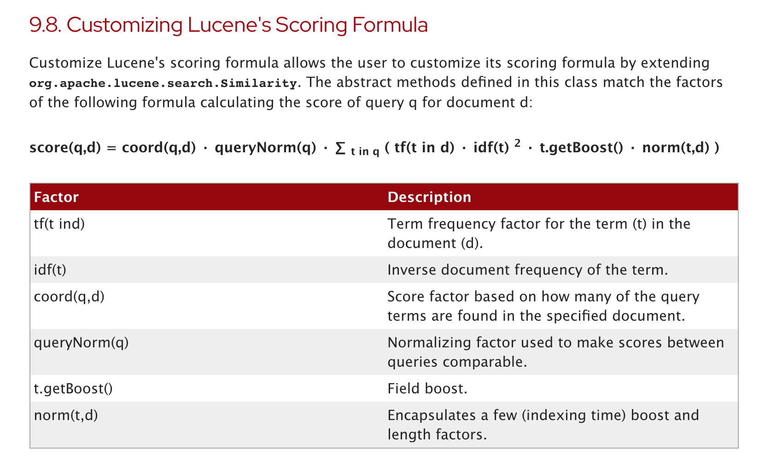

-----------------------------Custom System--------------
1. if I just modify the defaultSimilarity, still using SimpleAnalyzer
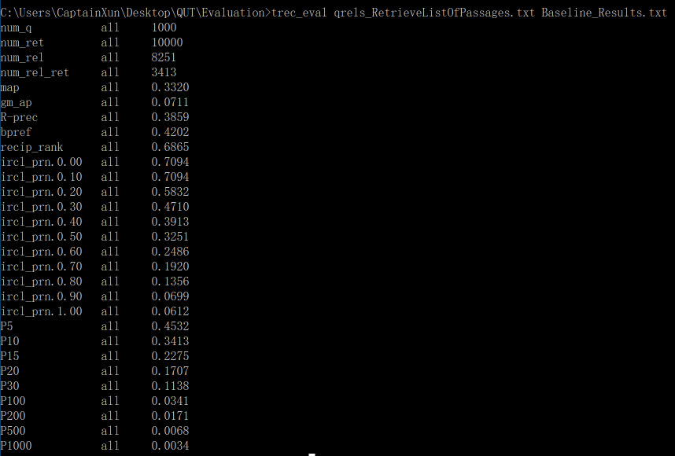
List of relevant passages does not perform well
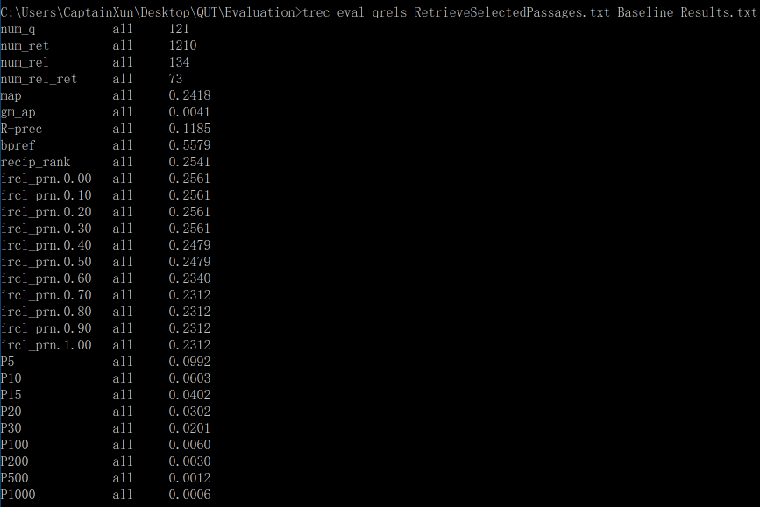
list of selected passages, performs better on P5

2. Table of changes to the baseline system
Change | Baseline system | Custom
Similarity | Default similary | Add boost to tf is low and df is low
Change analyzer(add list of stop words) | SimpleAnalyzer(no stop words) | SnowballAnalyzer with custom stop words
Separate fields for passage_text, title | Single field including passage_text+url(title) | Separate fields for passage_text, title and query. Each field has its own boost. (passage_text.boost=2,  title.boost=5)
Query expansion with WordNet, and boost the original words. | N/A(not applicable) | Connect a lexical database(WordNet) to perform query expansion in your searching operations. Give more weight to the original term.

3. what does multi-term and multi-phrase mean exactly. When using snowball analyzer, it will execute the stopwords removal anyway.

4. As it is , it will still remove stopwords
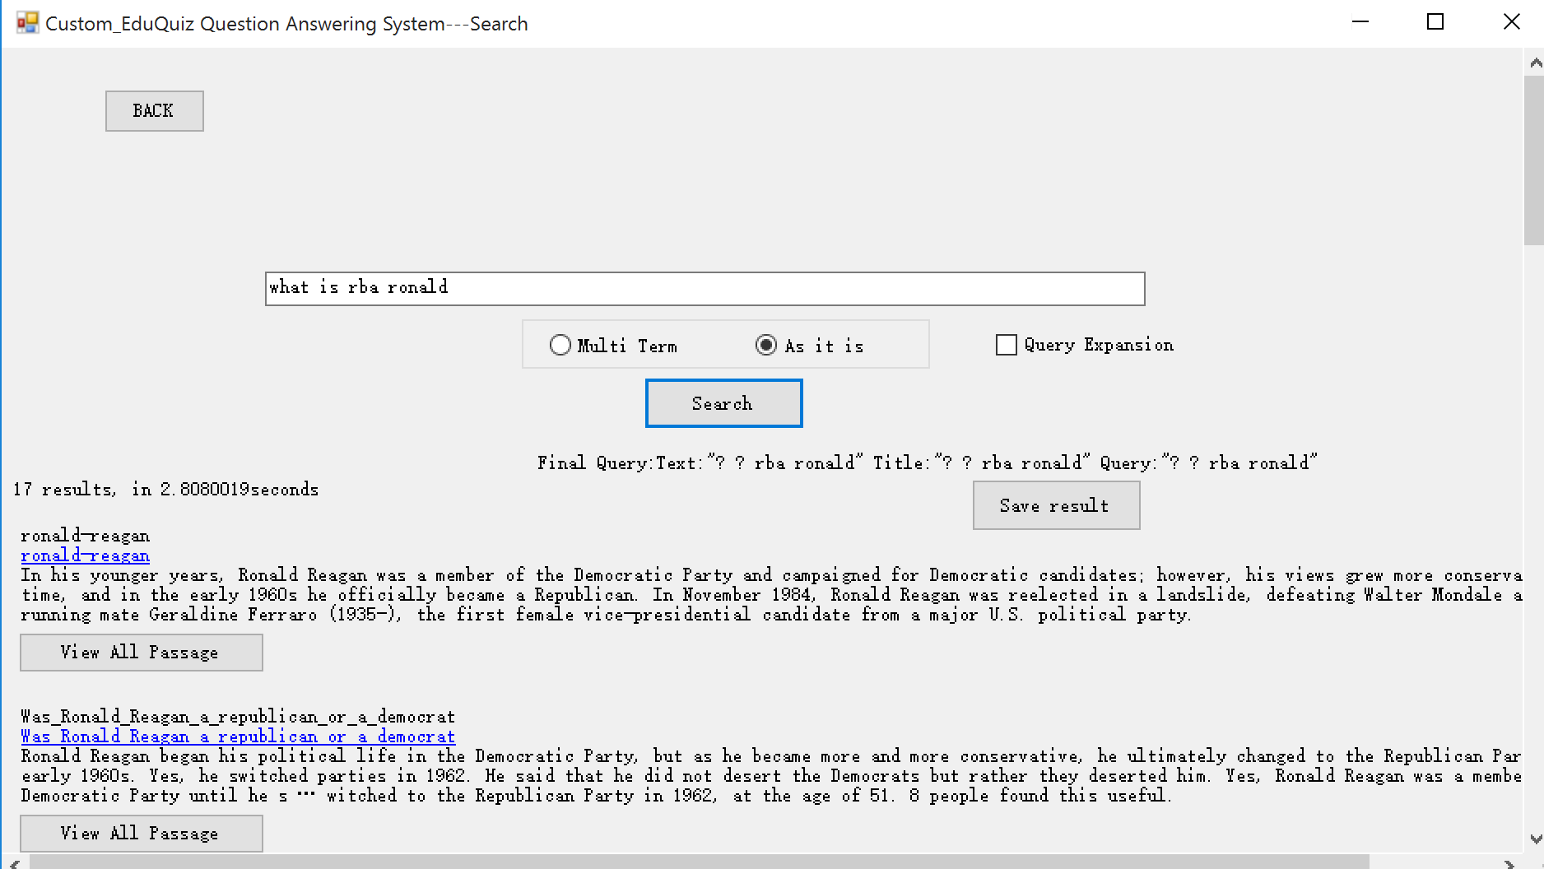

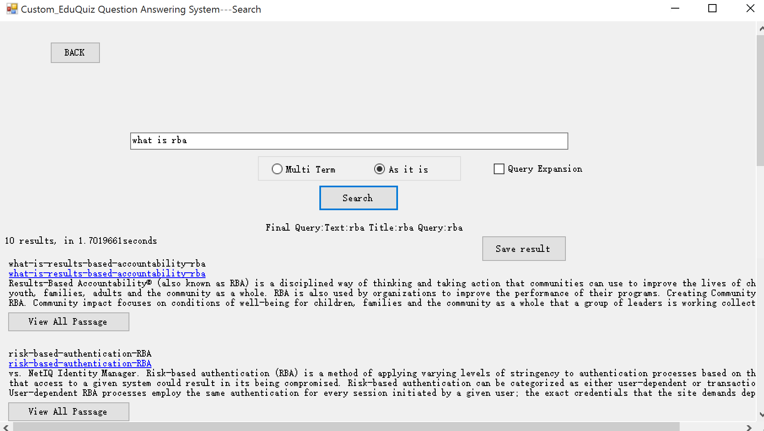

5.

syn.wordnet https://developer.syn.co.in/tutorial/wordnet/index.html
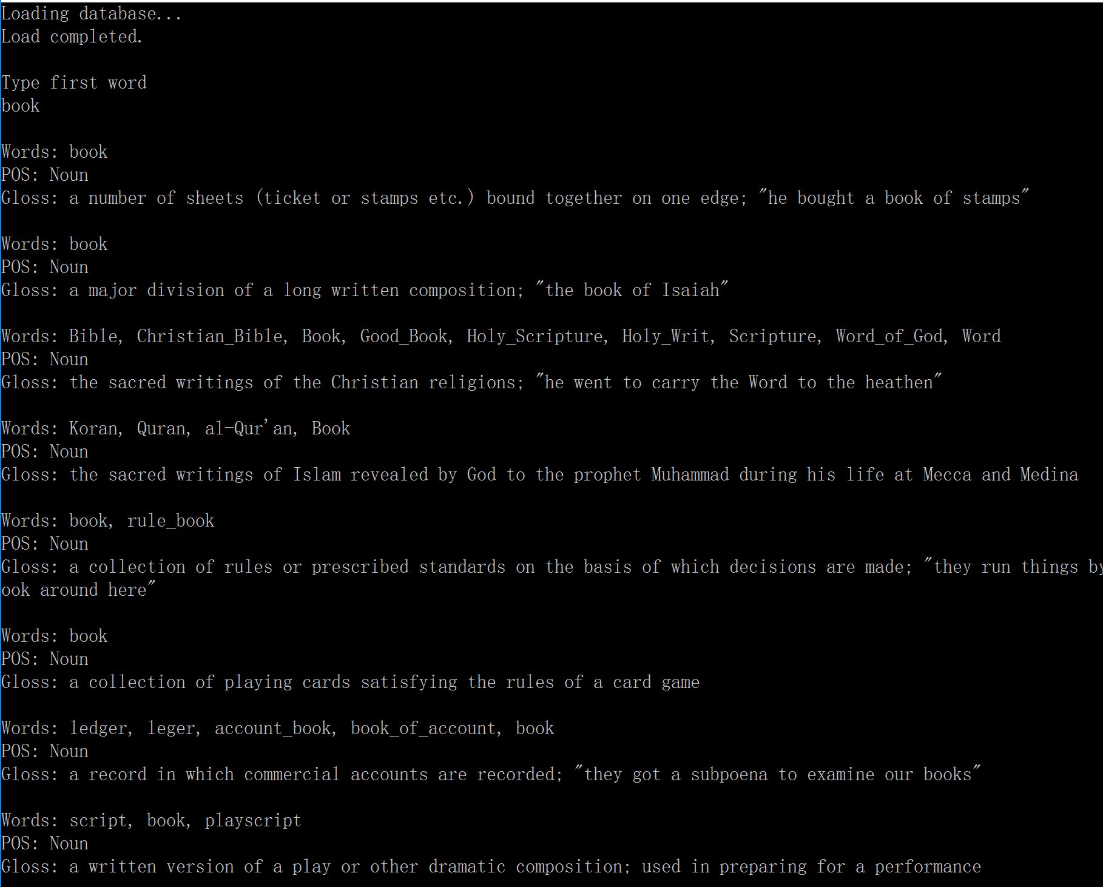

6. if adding boost to original word, cannot get any results
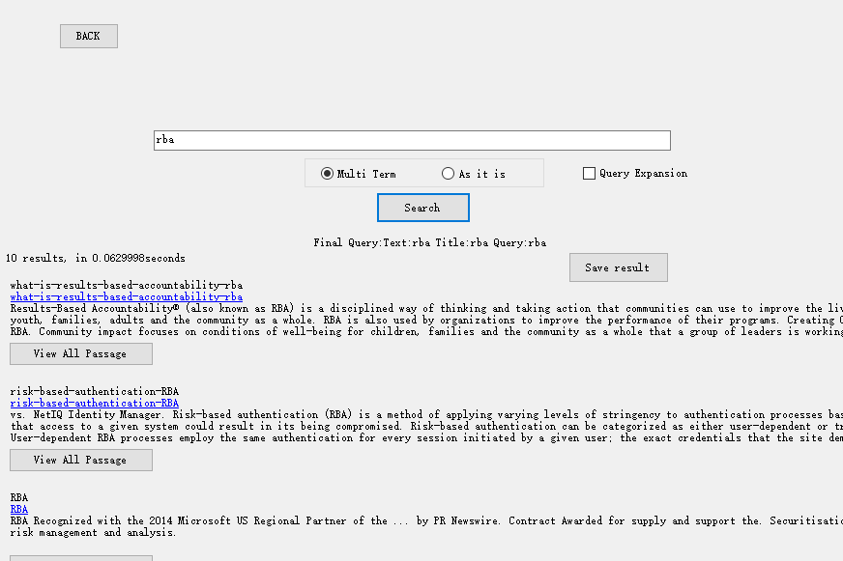

when I choose the query expansion(add boost to original word), shows no results.
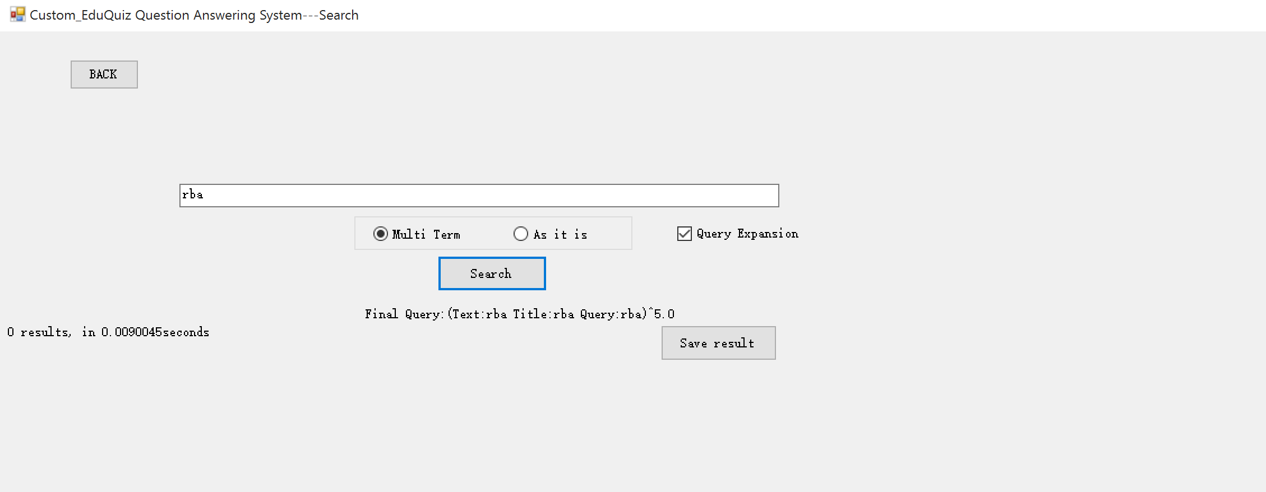

7. if not adding boost to original word, works fine. Recall is higher after query expansion
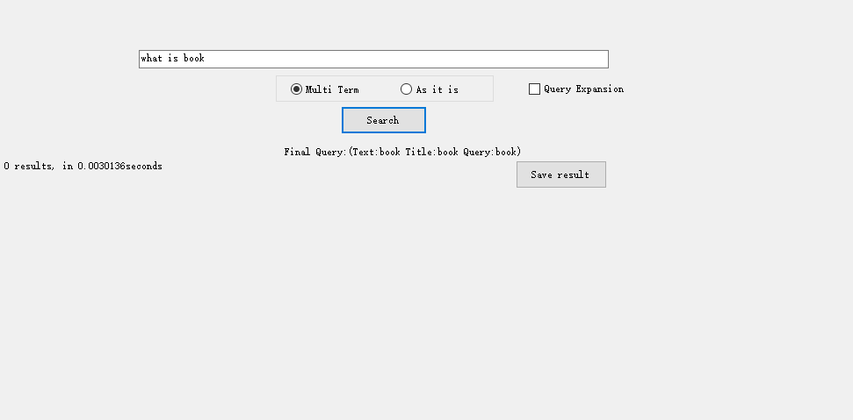
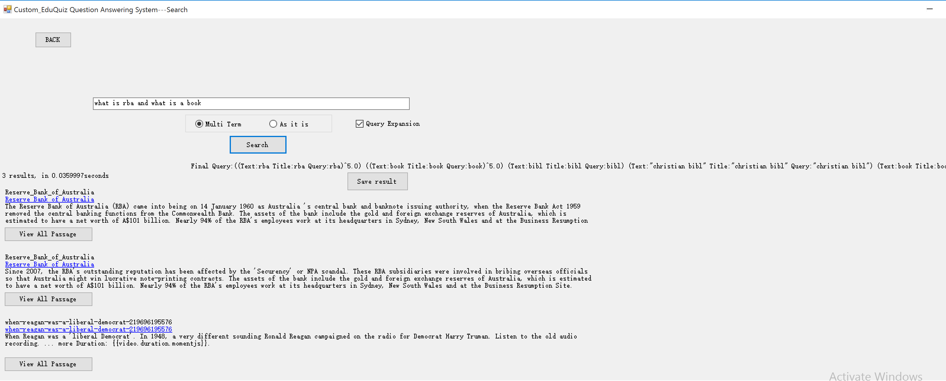

8. the results after implementing the following changes
Change | Baseline system | Custom
Similarity | Default similary | Add boost to tf is low and df is low
Change analyzer(add list of stop words) | SimpleAnalyzer(no stop words) | SnowballAnalyzer with custom stop words
Separate fields for passage_text, title | Single field including passage_text+url(title) | Separate fields for passage_text, title and query. Each field has its own boost. (passage_text.boost=2,  title.boost=5)

Perform better compared to the baseline system.
