ITSP200 – Deliverable 1

Cover page

|  |  |
| --- | --- |
| Group number and name | Group number – ZACSS |
| Group member details | Student number – Chad Phillips (leader)  Student number – Itumeleng Madisha  Student number – Andrew Schwabe  Student number – Shaun Thomson  Student number – Zane Smith |
| Project title | Restaurant Management System |
| Submission date | March |
| Signature of group leader |  |

**Contents**

2.2 Overview 3

2.4 Objectives 3

2.5 User Requirements 4

2.6 Required hardware and software 4

2.7 Schedule 5

2.8 Assumptions and constraints 6

2.9 Feasibility study 7

2.10 Recommendations 8

# Overview

Our first step would be to create a database. This database will be filled with the ingredients required to make each meal on the resturants menu. The database that we will use will be linked with an interface. It will also be able to generate reports, this is for the sole purpose of constructing trends, which would help in ordering stock.

Stock will also be monitored in the Database. This would keep track of the resources the restaurant uses. It will also keep track of wastage, and theft among the staff members. All foods that are used in food will be recorded by the database, and cross referenced with the recipes.

The interface will have a picture of the tables in the restaurant. This would make it possible to make reservations at each table. After the waiter has gotten the order, she will then click on the table. The Table will then open up a menu. When this menu opens up, there will be a picture of the food, and a label with the name on it. This would result in the restaurant having the ability to change the menu and implement it without making a sample to show the waiter. This would give an opportunity to maximize on the report feature, to test what would do the best all year round.

The interface will also have the option to change the specific details in the meal. We will also have specific manager logins that will make more of the system available. The manager will also be able to generate reports using the system. Our system will also produce trends. Every meal ordered will have the waiter’s details.

1. Aim

The aim of the project is to develop an ERP for a small to medium restaurant business. The system will implement software for checking stock making reservations and a billing system for tables.

# Objectives

* Do research on other restaurant ERP’s, focusing on components for stock checking and making reservations.
* Choose a method of development
* Develop and identify the scope of the project
* Identify requirements for the proposed system
* Analyze other restaurant ERP’s
* Design prototypes
* Design the system
* Design the required databases
* Design the UI
* Code the project
* Unit testing and acceptance testing User Requirements

# User Requirements

*Functional Requirements:*

* Admin should be allowed to add, update and delete from databases
* System should be able to produce daily, weekly and monthly sales reports
* Authentication of logins
* Trend tracking for popular choices
* Corrections, adjustments and cancellations to orders
* Authorization to make adjustments to Menu
* Login system and login timeouts for security

*Non-functional requirements:*

* Back-ups for the database
* security
* Database warning system of stock levels are checked every time the database is updated
* User Interface is simple and intuitive
* Data entered into the tables in the database are filtered and restricted to data types.

Technical requirements:

* The system will be client server based, linking the UI from the client to the database on the server
* The system will be developed in Java
* The system will use access for server database/MySQL
* Touch Screens for who? what use?

# Required hardware and software

Two touch screen all in one pc’s, receipt printer, all in one printer, Java environment for user interface, Access database, sales report production.

# Schedule

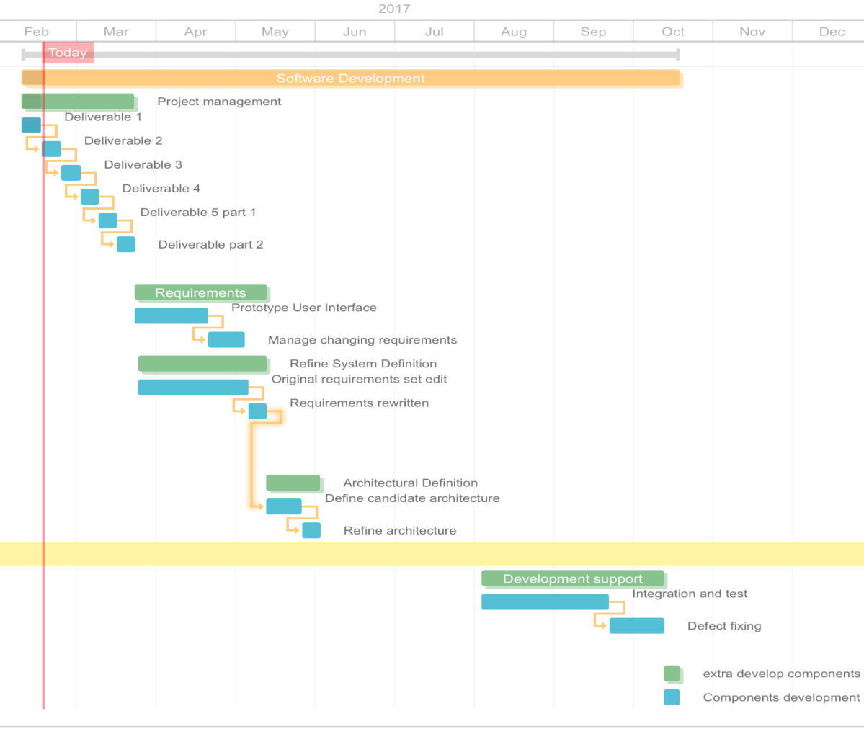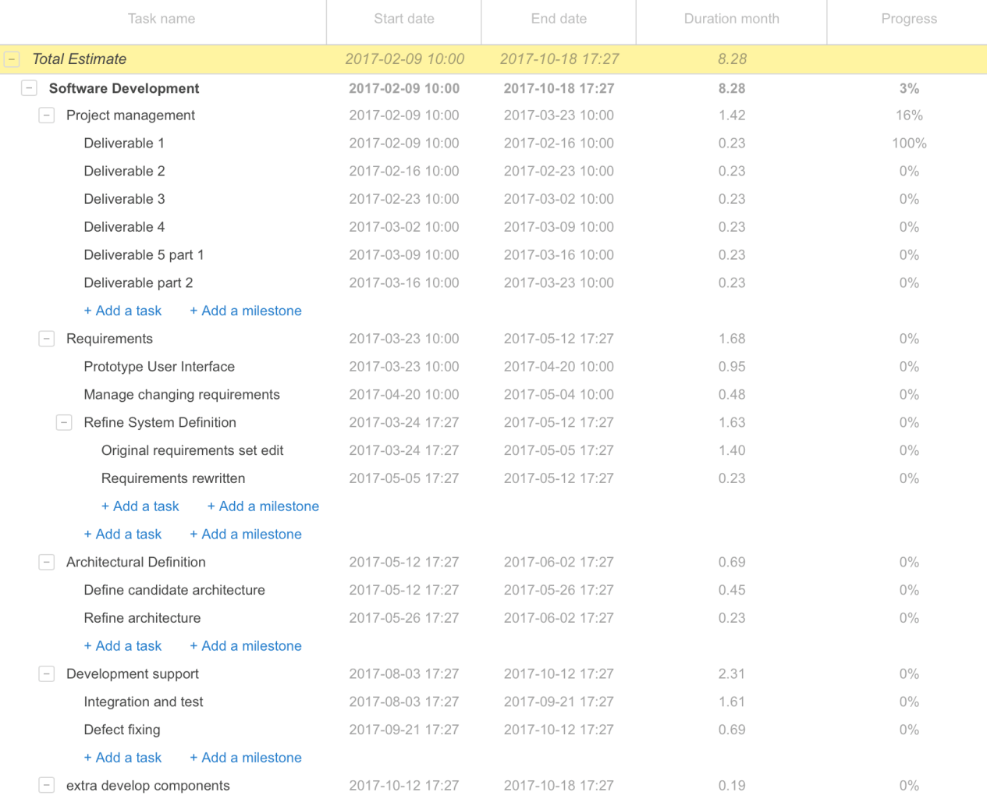

# Assumptions and constraints

* Users have computer skills and understand how to use basic applications.
* How effective the result of the project is if it were to be implemented.
* The features of the project are used efficiently.
* Risks and threats are identified early, and risk analysis takes place.
* Budget of project is taken into consideration
* People and project schedule is made and followed.

# Feasibility study

|  |  |  |  |
| --- | --- | --- | --- |
| **Feasibility criteria** | **Weighting** | **System option 1: Develop system in-house** | **System option 2: Buy system** |
| **Operational feasibility** | 20% | **Functionality:**  The system will replace the existing system whether automated or manual, therefore it will not be new to the company thus it will not affect the day to day operations. They will however need a training period for the new system. As for new employees they would have to have a training period to learn the old system therefore it does not affect training  **Score:** 50 | **Functionality:**  Most restaurants in the industry may already have GAAP as the system, it is a popular system amongst the industry. For those who do not this is an alternative option for them. It’s been around longer therefore has experience in the industry thus aiding the direction of them system giving adequate satisfaction.  **Score:** 20 |
| **Technical feasibility** | 20% | **Technology:**  The technology should be present for companies who already have an existing system. For those companies who don't have a system in place they would need to acquire the technology which in the case is a PC/touch PC and a printer.  **Expertise:**  For those who are already familiar with a point of sales system such as GAAP it will be fairly simple to learn. As for those without a system it would take time to train employees  **Score:** 30 | **Technology:**  Like an in-house system the technology will be similar if not the same. A PC/touch PC and a printer is necessary.  **Expertise:**  Again this will also be similar to an in-house system. For the implementation of the system the staff will have to learn the system, though an individual in-house system has the advantage of being customized whereas GAAP is mass rolled-out.  **Score:** 45 |
| **Economic feasibility** | 40% | **Benefits:**  The benefits are that the system will help streamline the restaurants resource information by keeping track of  inventory, bookings,  waiter actions by logging activity, specials and giving recommendations on  daily operations such as deciding want item on the menus is popular and ones which are less population saving capital on buying ingredients  **Score:** 60 | **Benefits:**  The benefits are that GAAP is already developed and rolled out this means that the system will be more stable and less likely to affect the daily operations thus meaning the likelihood of continuous maintenance is less  **Score:** 90 |
| **Schedule feasibility** | 20% | Maximum of 25 weeks with a optimistic 20 weeks’ timeline.  **Score:** 80 | Because the system has been developed already, the only part of the system development life cycles left is the implementation thus it will be much shorter than developing a new system.  **Score:** 50 |
| **Ranking** | 100% | 56 | 60 |

# Recommendations

* Restaurant owners should insure that the actual inventory of the restaurant  corresponds with that of the inventory of the system
* All wasted products should be correctly recorded in the system to keep an accurate account of ingredients
* Employees should be walked through the system thoroughly to avoid mistakes in busy times
* The customer should workout the average amount of ingredients needed for their various meals on the menu to make the system as efficient as possible
* It is recommended that the customer should contact the manufacturers of the product if any problems occur
* We recommend that the system should be the sole system of the customer to avoid clashes with the database and systems
* All updates and installations should only be done by the manufacturers of the product
* Consumers should use manufacturer recommended hardware