**Task 2: Components**

**Courses page implementation**

Our goal is to create whole page with video courses list. Use ng-cli commands to get it easier.

Please use mocked array of courses implemented as property of courses page components.  
Don’t forget to use Interface of course item created previously (see intro).

You should implement markup + styles + simple logic for components below. Feel free to change components scheme by agreement with your mentor.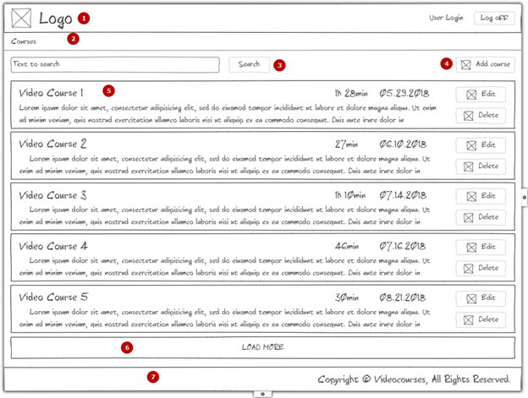

1. Header that includes logo element, user login (text placeholder) and log off button. (fake login text + button log off without handler)
2. Breadcrumbs (only placeholder with static text ‘Courses’)
3. Search control with input and action button.  
   Place input field, button find and add course button.  
   Bind [()] input field with component property.  
   On Find click - console.log input value
4. Add new course button.(placeholder for now)
5. Video Course plate.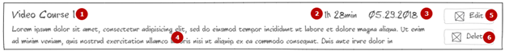
   1. Title
   2. Duration
   3. Date
   4. Description
   5. Edit button
   6. Delete button

Implement @Input for course-item

Use {{object.property}} construction to show all related information (title, duration, date, description)

Edit course - not implemented, markup only

Delete - use @Output to call method on parent component

You should console.log course id in video courses page component

6. Load more button – simple handler with console log

7. Footer (implement sticky footer - should be always at the bottom of the window)

Implement simple routing. Should redirect to courses-page as default route.  
  
Learn ngOnChanges, ngOnInit (and compare to constructor) lifecycle hooks during implementing component.  
Assign fake values on ngOnInit hook.

Place console.log statement in hooks (<https://angular.io/docs/ts/latest/guide/lifecycle-hooks.html>) to understand ordering.

Use ngFor to iterate through your fake items and pass it to the course item component.

Please refer to ng-cli and angular styleguide:

<https://cli.angular.io/>

<https://angular.io/guide/styleguide>

Please find suggested design for this task. It’s not necessary to follow but can be helpful.

<https://epam-my.sharepoint.com/:f:/p/nikita_reshetnikov/EswIvUgc52lOifeSaCceuKEBv-K4LZ_dzwqyY9a4TRL7_w?e=mSpjkg>

Criteria for evaluation

1. Nothing changed
2. Added some simple markup + css without splitting into components. Unable to run app.
3. Partially done with critical issues
4. Added implementations for all components with some major issues
5. Done all above without major issues