UI Component

Estia

Client

Com Component

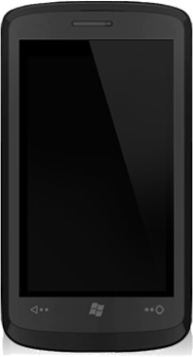

Browser-Based or Native

Browser-Based

Browser-Based

UI Component

Estia

Client

Com Component

UI Component

Estia

Client

Com Component

Estia Web Application

File System

File

File

File

Application Server (Tomcat)

Google Servers

Google Maps Engine

INTERNET

Component A

Component C

Component B

Estia

Server

Domain Component

Spring

Security

Spring Social

Spring Mobile

JSF

JSP

JDBC

Hibernate (as JPA Provider)

Spring JPA

PostgreSQL

Table

Spring MVC

Spring Integration

Spring Framework

Spring Data

REST over HTTPS