**DEFENSIVE DRIVING TECHNIQUES AND THE SAFETY OF HIGH-PROFILE PERSONALITIES**

**A paper presented**

**By**

**JJ Kambai**

Route Commander

**At the Federal Road Safety Corps (FRSC) 2024 Mandatory Training Workshop for Drivers**

**Held at**

**Offa Grammar School Auditorium Hall**

31-10 2024

**Introduction**

Driving high-profile personalities, such as intellectuals, clergy men, government officials, corporate executives, or celebrities, comes with unique challenges and responsibilities. While all lives are equally valued, the safety of these individuals is often critical, not only because of their importance in society but also because their security can directly affect your own well-being. High-profile personalities are frequently targets of criminal activities like kidnappings and armed robberies, which make defensive driving a crucial skill. This paper will outline essential defensive driving techniques and safety precautions that can help ensure their protection and yours.



**The Importance of Defensive Driving for High-Profile Personalities**

Defensive driving is a method of driving that minimizes the risks associated with road hazards and unpredictable events. When transporting high-profile individuals, the stakes are higher because the consequences of an attack or an accident can be severe. Defensive driving is about anticipation, being alert to the actions of other drivers, potential threats, and environmental conditions, all while ensuring a safe and secure ride.

**Key Defensive Driving Techniques**

**1. Situational Awareness**:

- Constant Vigilance: Always remain aware of your surroundings, whether you are on a familiar route or in an unfamiliar location. Be on the lookout for suspicious vehicles, people, or anything unusual in the environment.



- **Scanning the Road**: Continuously scan the road ahead, behind, and to the sides. Use your mirrors frequently, and anticipate the actions of other drivers or road users. This helps in reacting swiftly to sudden changes or threats.

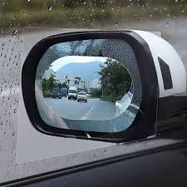

2. **Maintaining a Safe Distance**:

- Keep a reasonable distance between your vehicle and others on the road. The general rule is to maintain a 3-second gap between your vehicle and the one in front, but when driving high-profile personalities, increasing this distance provides more room to maneuver in case of an emergency.

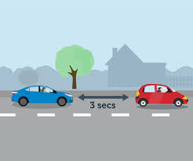

3. **Avoiding Predictable Patterns**:

- Varying Routes and Schedules: One of the most effective ways to protect your passengers from potential threats is to avoid predictable patterns. Criminals often observe the routines of high-profile individuals. Changing your routes and travel times regularly can reduce the risk of ambushes or planned attacks.



- **Avoiding Routine Stops**: When transporting high-profile personalities, avoid making frequent or predictable stops, such as at the same gas station, restaurant, or roadside vendor. Criminals may use such opportunities to attack.



4. **Safe Speed Management**:

- While it is important to follow speed limits, sometimes the safest driving strategy is to match the speed of traffic flow to avoid drawing attention or creating gaps that could be exploited by criminals. In certain situations, it may also be necessary to speed up or slow down strategically to escape potential threats.



- **Avoiding Reckless Speeding**: However, always ensure you are not speeding recklessly, as accidents resulting from such driving could cause more harm than the threat itself.

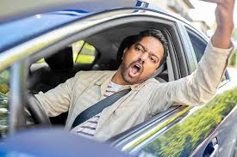

5. **Escape Routes and Evasive Driving:**

- Know Your Exits: Always be aware of potential escape routes in case of emergencies. This is particularly important in high-traffic areas, where options may be limited. Familiarize yourself with the roads, side streets, and exit routes in areas you frequent.



- **Evasive Maneuvers**: In situations where a threat is detected, evasive driving techniques may be required. This could involve making sharp turns, accelerating quickly, or even reversing to avoid danger. However, these techniques should be practiced and mastered beforehand to avoid accidents or worsening the situation.



6. **Avoiding Confrontations**:

- If you notice aggressive drivers or suspicious behavior from other road users, avoid confrontation. Do not engage in arguments or retaliate. Instead, focus on keeping your passenger safe by distancing your vehicle from potential threats.

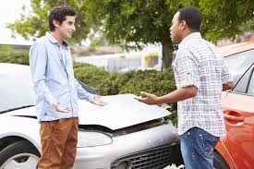

**SAFETY PRECAUTIONS FOR ENHANCING SECURITY**

1. **Pre-Trip Planning**:

- Route Planning: Always plan your routes ahead of time, especially when driving high-profile individuals. Avoid areas with a high risk of criminal activity, traffic congestion, or road construction. Have alternative routes ready in case of emergencies.

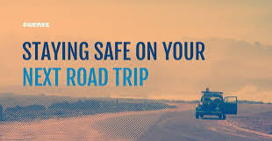

- **Understanding the Area**: If traveling to a new location, research the area’s safety record and traffic conditions. This information helps in making informed decisions if threats arise.



2. **Vehicle Security**:

- **Secure the Vehicle**: Before every trip, ensure that the vehicle is in optimal condition. Check that all doors and windows are properly locked. Ensure that the vehicle’s security systems, such as alarms or bulletproof features (if applicable), are functioning correctly.

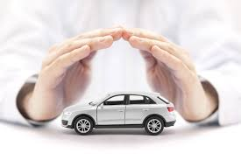

- **Discreet Vehicle**: If possible, use vehicles that do not attract unnecessary attention. High-profile vehicles, such as luxury cars, can sometimes make it easier for criminals to identify your passengers. Using vehicles that blend in with the traffic can add an extra layer of security.



3. **Passenger Safety Measures**:

- **Entry and Exit Protocols**: Ensure that your passenger enters and exits the vehicle in safe, controlled environments. Avoid stopping in open, unsecured areas. When dropping off or picking up high-profile individuals, ensure the area is secure and that there are no visible threats.

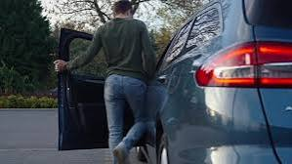

- **Secure Communication**: Keep communication lines open with security personnel or your passenger’s aides. If possible, use encrypted or private communication channels to discuss routes or locations.



4. **Recognizing and Responding to Threats**:

- **Recognize Suspicious Behavior**: Be alert for signs of suspicious vehicles or individuals following you. If you notice that a vehicle has been tailing you for an extended period, take steps to confirm whether it is a threat, such as changing lanes or making unexpected turns.



- **Non-Engagement**: If a threat is detected, your primary focus should be on driving safely and avoiding engagement. Do not stop or exit the vehicle unless it is absolutely necessary and you are in a safe, secure location.



- **Contacting Authorities**: If you feel that your passenger or yourself is in immediate danger, contact law enforcement or security personnel as soon as possible.



5. **First Aid and Emergency Supplies**:

- Ensure that your vehicle is equipped with an emergency first aid kit, fire extinguisher, and any other necessary supplies that may be needed in case of emergencies. These precautions can be vital in ensuring safety during unexpected incidents.

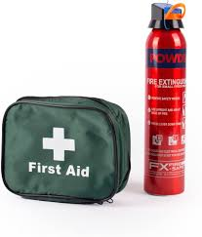

**HANDLING EXTREME SITUATIONS**

In some cases, despite all precautions, you may face an imminent threat such as a kidnapping attempt or armed robbery. Here’s how you can handle such extreme situations:

1**. Keep Calm and Avoid Panic**:

- Keeping a calm demeanor can help you think clearly and make rational decisions under pressure. Panicking can escalate the situation or cause errors in judgment.



2**. Do Not Stop for Unmarked Vehicles**:

- If an unmarked vehicle attempts to stop you and you suspect foul play, do not pull over. Continue driving to the nearest police station or populated area where you can seek help.

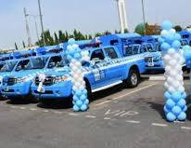

3. **Follow Law Enforcement Instructions**:

- If stopped by legitimate law enforcement officers, always comply with their instructions. Ensure that your passenger remains safe and secure during any encounters with the authorities.



**Conclusion**

The safety of high-profile personalities is a critical responsibility for their drivers. Defensive driving techniques, combined with proper planning and situational awareness, can help protect both the driver and the passenger from potential threats. By being proactive, vigilant, and well-prepared, drivers can minimize the risks associated with criminal activities such as kidnappings and armed robberies. Remember, your passenger’s safety is your safety, and their well-being could determine your own future security. Adopting these techniques and precautions will not only enhance your professional skills but also ensure the safe and secure transportation of high-profile individuals.

**References**

- Smith, R. (2018). **Defensive Driving for VIP Protection**. Security Journal, 23(2), 45-57.

- International Security Drivers Association. (2020). **Protective/Evasive Driving for High-Profile Clients**. Available at: [https://www.securitydrivers.com](<https://www.securitydrivers.com>)

- National Highway Traffic Safety Administration (NHTSA). (2021). **Defensive Driving Techniques and Road Safety**. Available at: [https://www.nhtsa.gov](<https://www.nhtsa.gov>)

- Sun Tzu Security. (2019). **Principles of Route Planning and Risk Avoidance in Executive Protection**. Available at: [https://www.suntzusecurity.com](<https://www.suntzusecurity.com>)

- Federal Road Safety Corps (FRSC). (2020). **Driver’s Handbook: Ensuring Safety on Nigerian Roads**. Available at: [https://www.frsc.gov.ng](<https://www.frsc.gov.ng>)

- **Vehicle Security Operations. (2022). Safe Driving Practices for High-Profile Individuals**. Available at: [https://www.vehiclesecurity.com](<https://www.vehiclesecurity.com>)