**Adherence to Traffic Rules and Transport Business Profitability**

Presented at the

**2024 Federal Road Safety Corps (FRSC) Mandatory Training Workshop for Drivers**

By

**AI Fasina**

Assistant Route Commander

**Introduction**

The transport business, especially in today’s economic climate, faces numerous challenges. Among the most pressing are the rising fuel prices and the increasing costs of goods and services. These economic factors significantly affect the profitability of transport businesses. However, despite these challenges, adhering to traffic rules and adopting effective vehicle maintenance practices can help reduce operational costs and increase profitability. This paper will explore how strict compliance with traffic regulations and maintenance principles can enhance fuel efficiency, prolong vehicle lifespan, and minimize wear and tear.

**THE LINK BETWEEN ADHERENCE TO TRAFFIC RULES AND PROFITABILITY**

The foundation of a successful transport business lies in safe, efficient, and economical driving. Compliance with traffic rules directly impacts the profitability of the business in several ways:

1. **Reduction in Accidents**: Accidents cause damage to vehicles, leading to costly repairs and downtime. Following traffic regulations, such as observing speed limits and road signs, helps avoid accidents, ensuring that vehicles remain on the road, generating revenue.

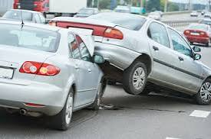

1. **Fuel Efficiency**: Driving within speed limits and avoiding aggressive driving (e.g., sudden acceleration and hard braking) improves fuel efficiency. Research shows that maintaining a steady speed conserves fuel, reducing the overall cost of operations.

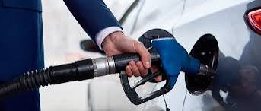

1. **Reduction in Fines and Penalties:** Failure to adhere to traffic rules can result in fines and penalties, which are an unnecessary financial burden on transport businesses. By complying with road regulations, businesses can avoid these costs and invest in other areas of their operations.

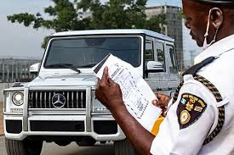

1. **Insurance Premiums**: Companies that consistently adhere to traffic laws tend to have fewer accidents, which lowers insurance claims. As a result, insurers may offer lower premiums to businesses with good safety records.

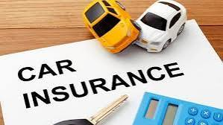

**VEHICLE MAINTENANCE TECHNIQUES TO ENHANCE PROFITABILITY**

While adhering to traffic rules improves safety and efficiency, vehicle maintenance is another critical factor in the profitability of transport businesses. Below are maintenance principles that can help extend engine lifespan, economize fuel consumption, and reduce wear and tear on vehicle parts:

1. **Regular Oil Changes**:

Regular oil changes are essential for keeping the engine in good condition. Oil lubricates the engine, reducing friction between moving parts, which prevents wear and tear. It also helps in keeping the engine cool. Changing oil at recommended intervals prevents engine damage and improves fuel efficiency.

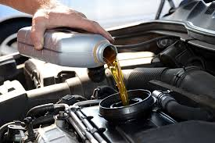

2. **Proper Tire Maintenance**:

Ensuring that tires are properly inflated is vital for fuel efficiency and safety. Underinflated tires increase rolling resistance, which requires the engine to use more fuel. Drivers should regularly check tire pressure and ensure it is at the manufacturer’s recommended level. Additionally, rotating tires periodically ensures even wear and extends the life of the tires.

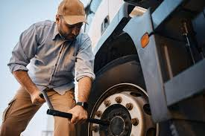

3. **Air Filter Replacement**:

Air filters prevent dirt and debris from entering the engine. A clogged air filter reduces engine performance, causing it to work harder and consume more fuel. Regularly replacing air filters improves engine efficiency and prolongs its lifespan.

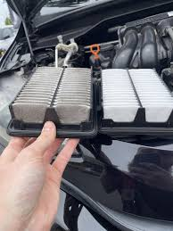

4. **Scheduled Vehicle Servicing**:

Regular servicing is crucial for identifying potential issues before they become serious problems. A comprehensive service includes checking engine components, fluids, belts, and the exhaust system. Regular servicing can prevent breakdowns and ensure vehicles run smoothly, saving costs on expensive repairs.

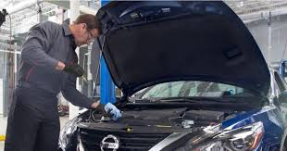

5. **Brake System Maintenance**:

The braking system is one of the most critical safety components of any vehicle. Regular checks and timely replacement of brake pads and fluids not only ensure safety but also prevent more expensive damage to the braking system. Driving with faulty brakes is both dangerous and costly.

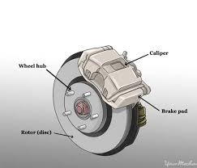

6. **Transmission Fluid Checks**:

Just like the engine, the transmission system requires proper lubrication to function effectively. Low transmission fluid levels or dirty fluid can cause the transmission to overheat, leading to costly repairs. Ensuring the transmission fluid is at the right level and in good condition can extend the life of the vehicle’s transmission system.

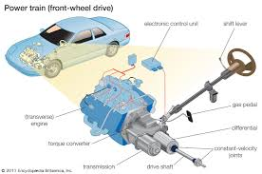

7. **Monitoring Fuel System Components**:

The fuel filter and injectors should be kept clean to ensure proper fuel flow to the engine. Clogged fuel injectors can reduce fuel efficiency, forcing the engine to use more fuel to maintain performance. Regular checks and cleaning of the fuel system can help optimize fuel consumption.

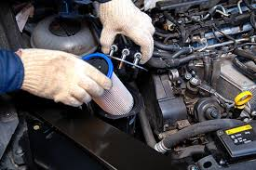

**STRATEGIES FOR ECONOMIZING FUEL CONSUMPTION**

1. **Driving Techniques**:

**Smooth Acceleration and Deceleration**: Gradual acceleration and deceleration reduce the amount of fuel consumed compared to aggressive driving.



**Minimizing Idle Time**: Long periods of idling waste fuel. Drivers should switch off the engine during prolonged stops to save fuel.

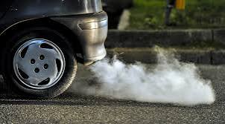

**Using Cruise Control or Speed Limiting Device**: On highways, cruise control helps maintain a consistent speed, which can improve fuel efficiency.

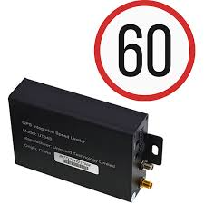

2. **Lightening the Load**:

Carrying unnecessary weight increases fuel consumption. Drivers should remove excess baggage or tools that are not needed for the trip. A lighter vehicle requires less energy to move, saving fuel.



3. **Proper Route Planning**:

Effective route planning helps drivers avoid heavy traffic and take shorter, more efficient routes. Using GPS and traffic apps to avoid congestion can save both time and fuel.

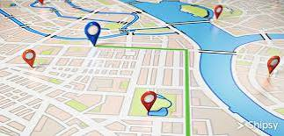

**IMPACT OF RISING FUEL PRICES ON TRANSPORT BUSINESS**

The recent astronomical rise in fuel prices has made it more difficult for transport businesses to maintain profitability. Fuel costs can represent a significant portion of operational expenses, and as these costs rise, the margin for profit narrows. To mitigate these effects, businesses must adopt fuel saving strategies, such as:

* **Investing in Fuel Efficient Vehicles**: Newer vehicle models tend to be more fuel efficient, with advanced technologies that optimize fuel usage. Investing in these vehicles, while expensive up-front, can save on fuel costs in the long term.

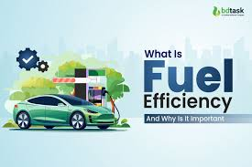

* **Implementing a Fleet Management System**: Fleet management systems can monitor fuel usage, driving behavior, and vehicle health. By analyzing this data, businesses can identify areas where fuel consumption can be reduced and implement corrective actions. Small businesses can come together to implement the system and enjoy same benefits.



**Conclusion**

Adherence to traffic rules and efficient vehicle maintenance are not just about safety; they are key factors that contribute to the profitability of transport businesses. By following traffic regulations, avoiding accidents, and maintaining vehicles properly, businesses can reduce operational costs, extend the lifespan of their vehicles, and increase fuel efficiency. In today’s challenging economic environment, where fuel prices continue to rise, adopting these principles is essential for transport businesses to remain competitive and profitable.

**References**:

Federal Road Safety Corps Nigeria. (2021). **National Road Traffic Regulations**. Available at: [https://www.frsc.gov.ng](<https://www.frsc.gov.ng>)

US Department of Energy. (2022). **Fuel Economy in Driving and Vehicle Maintenance**. Available at: [https://www.fueleconomy.gov](<https://www.fueleconomy.gov>)

AAA Automotive. (2020**). How Proper Vehicle Maintenance Improves Gas Mileage**. Available at: [https://www.aaa.com](<https://www.aaa.com>)

International Energy Agency (IEA). (2023). **Global Oil Market Report: Impact of Rising Oil Prices**. Available at: [https://www.iea.org](<https://www.iea.org>)

World Bank Group. (2022). **Transport Prices and the Oil Price Shocks**. Available at: [https://www.worldbank.org](<https://www.worldbank.org>)

National Highway Traffic Safety Administration (NHTSA). (2022). **The Economic and Societal Impact of Motor Vehicle Crashes**. Available at: [https://www.nhtsa.gov](<https://www.nhtsa.gov>)