Financial Statement Analysis

Multiple Choice Questions
1. A firm has a higher quick (or acid test) ratio than the industry average, which implies.
A. the firm has a higher P/E ratio than other firms in the industry.
B. the firm is more likely to avoid insolvency in short run than other firms in the industry.
C. the firm may be less profitable than other firms in the industry.
D. A and B.
E. B and C.
Current assets earn less than fixed assets; thus, a firm with a relatively high level of current assets may be less profitable than other firms. However, its high level of current assets makes it more liquid.

Difficulty: Easy
2. A firm has a lower quick (or acid test) ratio than the industry average, which implies.
A. the firm has a lower P/E ratio than other firms in the industry.
B. the firm is less likely to avoid insolvency in short run than other firms in the industry.
C. the firm may be more profitable than other firms in the industry.
D. A and B.
E. B and C.
Current assets earn less than fixed assets; thus, a firm with a relatively low level of current assets may be more profitable than other firms. However, its low level of current assets makes it less liquid.

Difficulty: Easy
3. An example of a liquidity ratio is _______.
A. fixed asset turnover
B. current ratio
C. acid test or quick ratio
D. A and C
E. B and C
Both B and C are measures of liquidity; A relates to fixed assets.

Difficulty: Easy
4. __________ a snapshot of the financial condition of the firm at a particular time.
A. The balance sheet provides
B. The income statement provides
C. The statement of cash flows provides
D. All of the above provide
E. None of the above provides
The balance sheet is statement of assets, liabilities, and equity at one point in time.

Difficulty: Easy
5. __________ of the cash flow generated by the firm's operations, investments and financial activities.
A. The balance sheet is a report
B. The income statement is a report
C. The statement of cash flows is a report
D. the auditor's statement of financial condition
E. None of the above is a report
Only statement C is correct; the balance sheet reports assets, liabilities, and equity at a point in time; the income statement is a summary of earnings over a period of time.

Difficulty: Easy
6. A firm has a higher asset turnover ratio than the industry average, which implies
A. the firm has a higher P/E ratio than other firms in the industry.
B. the firm is more likely to avoid insolvency in the short run than other firms in the industry.
C. the firm is more profitable than other firms in the industry.
D. the firm is utilizing assets more efficiently than other firms in the industry.
E. the firm has higher spending on new fixed assets than other firms in the industry.
The higher the asset turnover ratio the more efficiently the firm is using assets.

Difficulty: Easy
7. A firm has a lower asset turnover ratio than the industry average, which implies
A. the firm has a lower P/E ratio than other firms in the industry.
B. the firm is less likely to avoid insolvency in the short run than other firms in the industry.
C. the firm is less profitable than other firms in the industry.
D. the firm is utilizing assets less efficiently than other firms in the industry.
E. the firm has lower spending on new fixed assets than other firms in the industry.
The lower the asset turnover ratio the less efficiently the firm is using assets.

Difficulty: Easy
8. If you wish to compute economic earnings and are trying to decide how to account for inventory, _______.
A. FIFO is better than LIFO
B. LIFO is better than FIFO
C. FIFO and LIFO are equally good
D. FIFO and LIFO are equally bad
E. none of the above
LIFO reflects the current cost of goods sold, and thus is a better determinant of economic earnings.

Difficulty: Easy
9. __________ of the profitability of the firm over a period of time such as a year.
A. The balance sheet is a summary
B. The income statement is a summary
C. That statement of cash flows is a summary
D. The audit report is a summary
E. None of the above is a summary
The income statement summarizes revenues and expenses over a period of time.

Difficulty: Easy
10. Given the results of the study by Clayman, you would __________ the stocks of firms with high ROEs and __________ the stocks of firms with low ROEs.
A. want to buy, want to buy
B. want to buy, not want to buy
C. not want to buy, want to buy
D. not want to buy, not want to buy
E. be unable to buy, want to buy
Clayman found that investing in firms with high ROEs produced results inferior to those obtained by investing in stocks with lower ROEs.

Difficulty: Moderate
11. Over a period of thirty-odd years in managing investment funds, Benjamin Graham used the approach of investing in the stocks of companies where the stocks were trading at less than their working capital value. The average return from using this strategy was approximately ______.
A. 5%
B. 10%
C. 15%
D. 20%
E. none of the above
Although Graham said in 1976 that markets were so efficient that one could not expect to identify undervalued securities consistently as he had done throughout his career, he continued to find this one variable useful.

Difficulty: Moderate
12. A study by Speidell and Bavishi (1992) found that when accounting statements of foreign firms were restated on a common accounting basis,
A. the original and restated P/E ratios were quite similar.
B. the original and restated P/E ratios varied considerably.
C. most variation was explained by tax differences.
D. most firms were consistent in their treatment of goodwill.
E. none of the above.
This study found that restated P/E ratios varied considerably from those originally reported.

Difficulty: Moderate
13. If the interest rate on debt is higher than ROA, then a firm will __________ by increasing the use of debt in the capital structure.
A. increase the ROE
B. not change the ROE
C. decrease the ROE
D. change the ROE in an indeterminable manner
E. none of the above
If ROA is less than the interest rate, then ROE will decline by an amount that depends on the debt to equity ratio.

Difficulty: Moderate
14. If the interest rate on debt is lower than ROA, then a firm will __________ by increasing the use of debt in the capital structure.
A. increase the ROE
B. not change the ROE
C. decrease the ROE
D. change the ROE in an indeterminable manner
E. none of the above
If ROA is higher than the interest rate, then ROE will increase by an amount that depends on the debt to equity ratio.

Difficulty: Moderate
15. A firm has a market to book value ratio that is equivalent to the industry average and an ROE that is less than the industry average, which implies _______.
A. the firm has a higher P/E ratio than other firms in the industry
B. the firm is more likely to avoid insolvency in the short run than other firms in the industry
C. the firm is more profitable than other firms in the industry
D. the firm is utilizing its assets more efficiently than other firms in the industry
E. none of the above
The relationship P/E = (P/B) / ROE indicates that A is possible.

Difficulty: Moderate
16. In periods of inflation, accounting depreciation is __________ relative to replacement cost and real economic income is ________.
A. overstated, overstated
B. overstated, understated
C. understated, overstated
D. understated, understated
E. correctly, correctly
Fixed assets are depreciated based on historical costs and, as a result, are understated relative to replacement costs during periods of inflation; as a result, real economic income is overstated.

Difficulty: Moderate
17. If a firm has a positive tax rate, a positive ROA, and the interest rate on debt is the same as ROA, then ROA will be ________.
A. greater than the ROE
B. equal to the ROE
C. less than the ROE
D. greater than zero but it is impossible to determine how ROA will compare to ROE
E. negative in all cases
If interest rate = ROA; ROE = (1 - tax rate)ROA; ROA > ROE.

Difficulty: Moderate
18. A firm has a P/E ratio of 12 and a ROE of 13% and a market to book value of __________.
A. 0.64
B. 0.92
C. 1.08
D. 1.56
E. none of the above
E/P = ROE / (P/B); 1/12 = (0.13) P/B; 0.0833 = 0.13/(P/B); 0.0833(P/B) = 0.13; P/B = 1.56.

Difficulty: Moderate
The financial statements of Black Barn Company are given below.
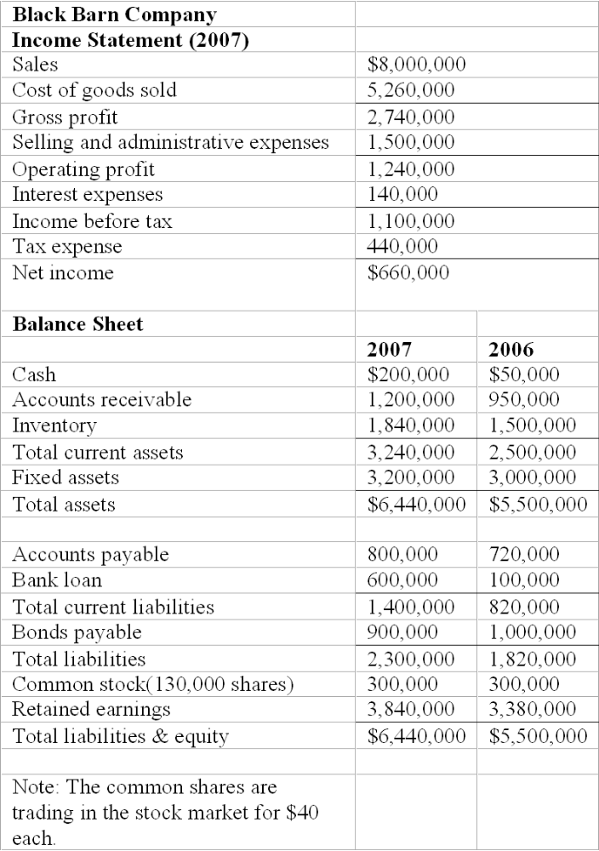

19. Refer to the financial statements of Black Barn Company. The firm's current ratio for 2007 is _____.
A. 2.31
B. 1.87
C. 2.22
D. 2.46
E. none of the above
$3,240,000/$1,400,000 = 2.31.

Difficulty: Moderate
20. Refer to the financial statements of Black Barn Company. The firm's quick ratio for 2007 is _____.
A. 1.69
B. 1.52
C. 1.23
D. 1.07
E. 1.00
($3,240,000 - $1,840,000)/$1,400,000 = 1.00.

Difficulty: Moderate
21. Refer to the financial statements of Black Barn Company. The firm's leverage ratio for 2007 is _____.
A. 1.65
B. 1.89
C. 2.64
D. 1.31
E. 1.56
$6,440,000/$4,140,000 = 1.56.

Difficulty: Moderate
22. Refer to the financial statements of Black Barn Company. The firm's times interest earned ratio for 2007 is _____.
A. 8.86
B. 7.17
C. 9.66
D. 6.86
E. none of the above
$1,240,000/$140,000 = 8.86.

Difficulty: Moderate
23. Refer to the financial statements of Black Barn Company. The firm's average collection period for 2007 is _____.
A. 59.31
B. 55.05
C. 61.31
D. 49.05
E. none of the above
AR Turnover = $8,000,000 / [($1,200,000 + $950,000) / 2] = 7.44; ACP = 365 / 7.44 = 49.05 days

Difficulty: Moderate
24. Refer to the financial statements of Black Barn Company. The firm's inventory turnover ratio for 2007 is _____.
A. 3.15
B. 3.63
C. 3.69
D. 2.58
E. 4.20
$5,260,000/[($1,840,000 + $1,500,000) / 2] = 3.15.

Difficulty: Moderate
25. Refer to the financial statements of Black Barn Company. The firm's fixed asset turnover ratio for 2007 is _____.
A. 2.04
B. 2.58
C. 2.97
D. 1.58
E. none of the above
$8,000,000/[($3,200,000 + $3,000,000) / 2] = 2.58.

Difficulty: Moderate
26. Refer to the financial statements of Black Barn Company. The firm's asset turnover ratio for 2007 is _____.
A. 1.79
B. 1.63
C. 1.34
D. 2.58
E. none of the above
$8,000,000/[($6,440,000 + $5,500,000) / 2] = 1.34.

Difficulty: Moderate
27. Refer to the financial statements of Black Barn Company. The firm's return on sales ratio for 2007 is _____ percent.
A. 15.5
B. 14.6
C. 14.0
D. 15.0
E. 16.5
$1,240,000/$8,000,000 = 0.155 or 15.5%.

Difficulty: Moderate
28. Refer to the financial statements of Black Barn Company. The firm's return on equity ratio for 2007 is _____.
A. 16.90%
B. 15.63%
C. 14.00%
D. 15.00%
E. 16.24%
$660,000/[($4,140,000 + $3,680,000) / 2] = .169.

Difficulty: Moderate
29. Refer to the financial statements of Black Barn Company. The firm's P/E ratio for 2007 is _____.
A. 8.88
B. 7.63
C. 7.88
D. 7.32
E. none of the above
EPS = $660,000/130,000 = $5.08; $40/$5.08 = 7.88.

Difficulty: Moderate
30. Refer to the financial statements of Black Barn Company. The firm's market to book value for 2007 is _____.
A. 1.13
B. 1.62
C. 1.00
D. 1.26
E. none of the above
$40/$31.85 = 1.26.

Difficulty: Moderate
31. A firm has a (net profit / pretax profit ratio) of 0.625, a leverage ratio of 1.2, a (pretax profit / EBIT) of 0.9, an ROE of 17.82%, a current ratio of 8, and a return on sales ratio of 8%. The firm's asset turnover is _________.
A. 0.3
B. 1.3
C. 2.3
D. 3.3
E. none of the above
17.82% = 0.625 X 0.9 X 8% X asset turnover X 1.2; asset turnover = 3.3.

Difficulty: Difficult
32. A firm has an ROA of 14%, a debt/equity ratio of 0.8, a tax rate of 35%, and the interest rate on the debt is 10%. The firm's ROE is _________.
A. 11.18%
B. 8.97%
C. 11.54%
D. 12.62%
E. none of the above
ROE = (1 - 0.35)[14% + (14% - 10%)0.8] = 11.18%.

Difficulty: Difficult
33. A firm has an ROE of -2%, a debt/equity ratio of 1.0, a tax rate of 0%, and an interest rate on debt of 10%. The firm's ROA is ________.
A. 2%
B. 4%
C. 6%
D. 8%
E. none of the above
-2% = (1)[ROA + (ROA - 10%)1] = 4%.

Difficulty: Difficult
34. A firm has a (net profit/pretax profit) ratio of 0.6, a leverage ratio of 2, a (pretax profit/EBIT) of 0.6, an asset turnover ratio of 2.5, a current ratio of 1.5, and a return on sales ratio of 4%. The firm's ROE is _________.
A. 4.2%
B. 5.2%
C. 6.2%
D. 7.2%
E. none of the above
ROE = 0.6 X 0.6 X 4% X 2.5 X 2 = 7.2%.

Difficulty: Difficult
35. A measure of asset utilization is ________.
A. sales divided by working capital
B. return on total assets
C. return on equity capital
D. operating profit divided by sales
E. none of the above
B measures how efficiently the firm is utilizing assets to generate returns.

Difficulty: Easy
36. During periods of inflation, the use of FIFO (rather than LIFO) as the method of accounting for inventories causes ________.
A. higher inventory turnover
B. higher incomes taxes
C. lower ending inventory
D. higher reported sales
E. none of the above
In inflationary periods, the use of FIFO causes overstated earnings, which result in higher taxes.

Difficulty: Moderate
37. Return on total assets is a function of _______.
A. interest rates and pre-tax profits
B. the debt-equity ratio
C. the after-tax profit margin and the asset turnover ratio
D. sales and fixed assets
E. none of the above
ROA = Net profit margin X Total asset turnover.

Difficulty: Moderate
38. FOX Company has a ratio of (total debt/total assets) that is above the industry average, and a ratio of (long term debt/equity) that is below the industry average. These ratios suggest that the firm _________.
A. utilizes assets effectively
B. has too much equity in the capital structure
C. has relatively high current liabilities
D. has a relatively low dividend payout ratio
E. none of the above
Total debt includes both current and long term debt; the above relationships could occur only if FOX Company has a higher than average level of current liabilities.

Difficulty: Moderate
39. A firm's current ratio is above the industry average; however, the firm's quick ratio is below the industry average. These ratios suggest that the firm _________.
A. has relatively more total current assets and even more inventory than other firms in the industry
B. is very efficient at managing inventories
C. has liquidity that is superior to the average firm in the industry
D. is near technical insolvency
E. none of the above
A is the only possible answer; total current assets are high, and inventory is a very large portion of total current assets, relative to other firms in the industry.

Difficulty: Moderate
40. Which of the following ratios gives information on the amount of profits reinvested in the firm over the years:
A. Sales/total assets
B. Debt/total assets
C. Debt/equity
D. Retained earnings/total assets
E. None of the above
Only retained earnings reflect profits reinvested over the years.

Difficulty: Moderate
41. Ferris Corp. wants to increase its current ratio from the present level of 1.5 when it closes the books next week. The action of __________ will have the desired effect.
A. payment of current payables from cash
B. sales of current marketable securities for cash
C. write down of impaired assets
D. delay of next payroll
E. none of the above
Example: CA = $150; CL = $100; current ratio = 1.5; Pay $50 of CL with cash; CA = $100; CL = $50; current ratio = 2. B has no effect on ratio (CA remain same); C does not affect current account; D would decrease ratio.

Difficulty: Moderate
42. Assuming continued inflation, a firm that uses LIFO will tend to have a(n) ________ current ratio than a firm using FIFO, and the difference will tend to __________ as time passes.
A. higher, increase
B. higher, decrease
C. lower, decrease
D. lower, increase
E. identical, remain the same
A firm using LIFO will have lower priced inventory, thus resulting in a lower current ratio. If inflation continues, these differences will increase over time.

Difficulty: Moderate
43. Fundamental analysis uses __________.
A. earnings and dividends prospects
B. relative strength
C. price momentum
D. A and B
E. A and C
Relative strength and price momentum are technical, not fundamental, tools.

Difficulty: Easy
44. __________ is a true statement.
A. During periods of inflation, LIFO makes the balance sheet less representative of the actual inventory values than if FIFO were used
B. During periods of inflation, FIFO makes the balance sheet less representative of actual inventory values than if LIFO were used
C. After inflation ends, distortion due to LIFO will disappear as inventory is sold
D. During periods of inflation, LIFO overstates earnings relative to FIFO
E. None of the above
During periods of inflation, the use of LIFO results in lower priced inventory remaining in stock; thus the balance sheet understates the actual inventory values.

Difficulty: Moderate
45. __________ is a false statement.
A. During periods of inflation, LIFO makes the balance sheet less representative of the actual inventory values than if FIFO were used
B. During periods of inflation, FIFO makes the balance sheet less representative of actual inventory values than if LIFO were used
C. After inflation ends, distortion due to LIFO will disappear as inventory is sold
D. During periods of inflation, LIFO overstates earnings relative to FIFO
E. B, C, and D
During periods of inflation, the use of LIFO results in lower priced inventory remaining in stock; thus the balance sheet understates the actual inventory values.

Difficulty: Moderate
46. The level of real income of a firm can be distorted by the reporting of depreciation and interest expense. During periods of high inflation, the level of reported depreciation tends to __________ income, and the level of interest expense reported tends to __________ income.
A. understate, overstate
B. understate, understate
C. overstate, understate
D. overstate, overstate
E. There is no discernable pattern.
Depreciation is based on historic costs; thus during periods of inflation depreciation is understated, which results in the overstatement of income. In periods of inflation, interest rates are high, and thus result in the understatement of the firm's long term earning capacity.

Difficulty: Moderate
47. Which of the following would best explain a situation where the ratio of (net income/total equity) of a firm is higher than the industry average, while the ratio of (net income/total assets) is lower than the industry average?
A. The firm's net profit margin is higher than the industry average.
B. The firm's asset turnover is higher than the industry average.
C. The firm's equity multiplier must be lower than the industry average.
D. The firm's debt ratio is higher than the industry average.
E. None of the above.
Assets are financed either by debt or equity. The situation described above could occur only if the firm is financing more assets with debt than are industry competitors.

Difficulty: Moderate
48. If a firm's ratio of (total liabilities/total assets) is higher than the industry average while the total capitalization of the firm's stockholders' equity) is lower than the industry average, the most likely assumption is that the firm ________.
A. has more current liabilities than the industry average
B. has more leased assets than the industry average
C. will be more profitable than the industry average
D. has more current assets than the industry average
E. none of the above
The total capitalization of the firm reflects long-term capital; which is used to purchase fixed assets, not current assets. Thus, the firm appears to have more current liabilities than the industry average.

Difficulty: Moderate
49. What best explains why a firm's ratio of (long-term debt/total capital) is lower than the industry average, while the ratio of (income before interest and taxes/debt interest charges) is lower than the industry average.
A. The firm pays lower interest on long-term debt than the average firm
B. The firm has more short-term debt than average
C. The firm has a high ratio of (current assets/current liabilities)
D. The firm has a high ratio of (total cash flow/long term debt)
E. none of the above
The firm is using more short-term debt, possibly to finance fixed assets, than the average firm. The coverage ratio includes only interest on long-term debt.

Difficulty: Moderate
50. __________ best explains a ratio of (sales/average net fixed assets) that exceeds the industry average.
A. The firm expanded plant and equipment in the past few years
B. The firm makes less efficient use of assets than competing firms
C. The firm has a substantial amount of old plant and equipment.
D. The firm uses straight-line depreciation
E. None of the above
If the firm has more old plant and equipment than competing firms, the denominator is deflated thus producing a higher than average ratio.

Difficulty: Moderate
51. Given the following firm and market information, determine the value of the firm.
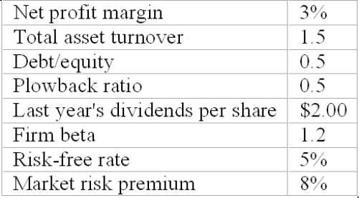
A. $28.42
B. $18.42
C. $8.42
D. $38.42
E. none of the above
ROE = 3 X 1.5 X 1.5 = 6.75%; g = 0.5 X 6.75% = 3.375%; k = 5% + 1.2(8%) = 14.6%; 2 (1.03375) / (.146 - .03375) = $18.42

Difficulty: Difficult
52. Firms will not have both relatively high profit margins and total asset turnover for long periods of time because
A. if both variables are relatively high, more firms will be attracted into the industry, which will result in lower profit margins.
B. excess economic profits will result (until equilibrium is restored).
C. high profit margins result in inefficiency.
D. A and B.
E. A and C.
The excess profits will attract more firms into the industry, which will eliminate excess profits.

Difficulty: Moderate
53. Comparability problems arise because
A. firms may use different generally accepted accounting principles.
B. inflation may affect firms differently due to accounting conventions used.
C. financial analysts do not know how to compare financial statements.
D. A and B.
E. A and C.
Firms often select specific generally accepted accounting principles for the desired effect on the financial statements. The analyst must make adjustments in order to compare firms using different account techniques. Often firms adopt specific techniques to offset the negative effects of inflation on the firm.

Difficulty: Moderate
54. One problem with comparing financial ratios prepared by different reporting agencies is
A. some agencies receive financial information later than others.
B. agencies vary in their policies as to what is included in specific calculations.
C. some agencies are careless in their reporting.
D. some firms are more conservative in their accounting practices.
E. none of the above.
One problem with comparing financial ratios prepared by different reporting agencies is agencies vary in their policies as to what is included in specific calculations.

Difficulty: Easy
55. One reason that capital markets are not truly global is
A. exchange rates are too volatile.
B. investors are too timid.
C. some firms are not allowed to sell their shares in other countries.
D. there is not a global standard for international financial reporting.
E. both C and D are true.
One reason that capital markets are not truly global is some firms are not allowed to sell their shares in other countries.

Difficulty: Moderate
The financial statements of Midwest Tours are given below.
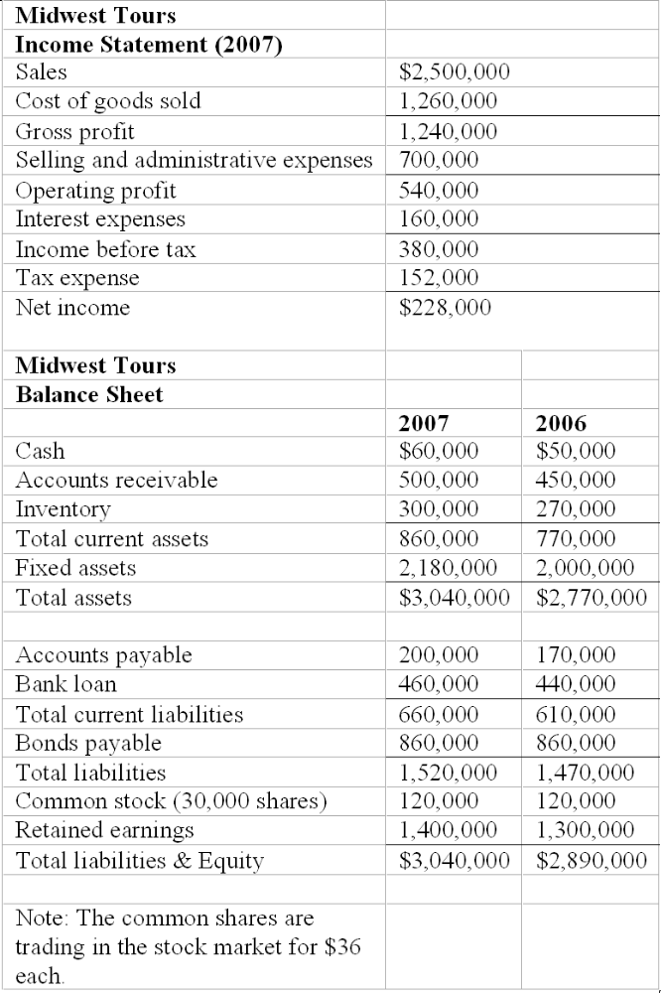

56. Refer to the financial statements of Midwest Tours. The firm's current ratio for 2007 is _____.
A. 1.82
B. 1.03
C. 1.30
D. 1.65
E. none of the above
$860,000/$660,000 = 1.30.

Difficulty: Moderate
57. Refer to the financial statements of Midwest Tours. The firm's quick ratio for 2007 is __________.
A. 1.71
B. 0.78
C. 0.85
D. 1.56
E. none of the above
($860,000 - $300,000)/$660,000 = 0.85.

Difficulty: Moderate
58. Refer to the financial statements of Midwest Tours. The firm's leverage ratio for 2007 is __________.
A. 1.62
B. 1.56
C. 2.00
D. 2.42
E. 2.17
$3,040,000/$1,520,000 = 2.00.

Difficulty: Moderate
59. Refer to the financial statements of Midwest Tours. The firm's times interest earned ratio for 2007 is __________.
A. 2.897
B. 2.719
C. 3.375
D. 3.462
E. none of the above
$540,000 / 160,000 = 3.375.

Difficulty: Moderate
60. Refer to the financial statements of Midwest Tours. The firm's average collection period for 2007 is __________.
A. 69.35
B. 69.73
C. 68.53
D. 67.77
E. 68.52
AR Turnover = $2,500,000 / [($500,000 + $450,000)) 2] = 5.26; ACP = 365 / 5.26 = 69.35 days

Difficulty: Moderate
61. Refer to the financial statements of Midwest Tours. The firm's inventory turnover ratio for 2007 is __________.
A. 2.86
B. 1.23
C. 5.96
D. 4.42
E. 4.86
$1,260,000/[($300,000 + $270,000)) 2] = 4.42.

Difficulty: Moderate
62. Refer to the financial statements of Midwest Tours. The firm's fixed asset turnover ratio for 2007 is __________.
A. 1.45
B. 1.63
C. 1.20
D. 1.58
E. none of the above
$2,500,000/[($2,180,000 + $2,000,000)) 2] = 1.20.

Difficulty: Moderate
63. Refer to the financial statements of Midwest Tours. The firm's asset turnover ratio for 2007 is __________.
A. 1.86
B. 0.63
C. 0.86
D. 1.63
E. none of the above
$2,500,000/[($3,040,000 + $2,770,000)) 2] = 0.86.

Difficulty: Moderate
64. Refer to the financial statements of Midwest Tours. The firm's return on sales ratio for 2007 is __________ percent.
A. 20.2
B. 21.6
C. 22.4
D. 18.0
E. none of the above
$540,000/$2,500,000 = 0.216 or 21.6%.

Difficulty: Moderate
65. Refer to the financial statements of Midwest Tours. The firm's return on equity ratio for 2007 is __________.
A. 12.24%
B. 14.63%
C. 15.50%
D. 14.50%
E. 16.9%
$228,000/[($1,520,000 + $1,420,000)) 2] = .155.

Difficulty: Moderate
66. Refer to the financial statements of Midwest Tours. The firm's P/E ratio for 2007 is __________.
A. 4.74
B. 6.63
C. 5.21
D. 5.00
E. none of the above
EPS = $228,000/30,000 = $7.60; $36/$7.60 = 4.74.

Difficulty: Moderate
67. Refer to the financial statements of Midwest Tours. The firm's market to book value for 2007 is __________.
A. 0.24
B. 0.95
C. 0.71
D. 1.12
E. none of the above
$36/[$1,520,000/30,000] = 0.71.

Difficulty: Moderate
The financial statements of Snapit Company are given below.
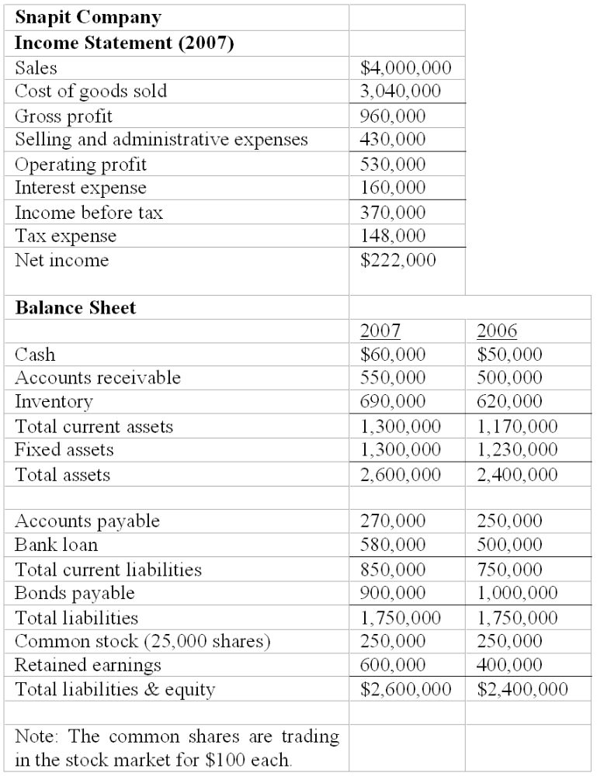

68. Refer to the financial statements for Snapit Company. The firm's current ratio for 2007 is ___________.
A. 1.98
B. 2.47
C. 0.65
D. 1.53
E. none of the above
$1,300,000/$850,000 = 1.53.

Difficulty: Easy
69. Refer to the financial statements of Snapit Company. The firm's quick ratio for 2007 is _______.
A. 1.68
B. 1.12
C. 0.72
D. 1.92
E. none of the above
($1,300,000 - $690,000)/$850,000 = 0.72.

Difficulty: Moderate
70. Refer to the financial statements of Snapit Company. The firm's leverage ratio for 2007 is _________.
A. 2.25
B. 3.53
C. 2.61
D. 3.06
E. none of the above
$2,600,000/$850,000 = 3.06.

Difficulty: Moderate
71. Refer to the financial statements of Snapit Company. The firm's times interest earned ratio for 2007 is __________.
A. 2.26
B. 3.16
C. 3.84
D. 3.31
E. none of the above
$530,000/$160,000 = 3.31.

Difficulty: Moderate
72. Refer to the financial statements of Snapit Company. The firm's average collection period for 2007 is _______ days.
A. 47.90
B. 48.53
C. 46.06
D. 47.65
E. none of the above
(525,000 / 4,000,000) (365) = 47.90.

Difficulty: Moderate
73. Refer to the financial statements of Snapit Company. The firm's inventory turnover ratio for 2007 is ________.
A. 4.64
B. 4.16
C. 4.41
D. 4.87
E. none of the above
$3,040,000/[($620,000 + $690,000) / 2] = 4.64.

Difficulty: Moderate
74. Refer to the financial statements of Snapit Company. The firm's fixed asset turnover ratio for 2007 is _____.
A. 4.60
B. 3.61
C. 3.16
D. 5.46
E. none of the above
$4,000,000/[($1,300,000 + $1,230,000) / 2] = 3.16.

Difficulty: Moderate
75. Refer to the financial statements of Snapit Company. The firm's asset turnover ratio for 2007 is _____.
A. 1.60
B. 3.16
C. 3.31
D. 4.64
E. none of the above
$4,000,000/[($2,600,000 + $2,400,000) / 2] = 1.60.

76. Refer to the financial statements of Snapit Company. The firm's return on sales ratio for 2007 is ________.
A. 0.0133
B. 0.1325
C. 1.325
D. 1.260
E. none of the above
$530,000/$4,000,000 = 0.1325.

Difficulty: Moderate
77. Refer to the financial statements of Snapit Company. The firm's return on equity ratio for 2007 is ________.
A. 0.1235
B. 0.0296
C. 0.2960
D. 2.2960
E. none of the above
$222,000/[($850,000 + $650,000) / 2] = 0.2960.

Difficulty: Moderate
78. Refer to the financial statements of Snapit Company. The firm's market to book value for 2007 is _____.
A. 0.7256
B. 1.5294
C. 2.9400
D. 3.6142
E. none of the above
$100/[($850,000 / 25,000)] = 2.9400.

Difficulty: Moderate
79. ______ is a measure of what the firm would have earned if it didn't have any obligations to creditors or tax authorities.
A. Net Sales
B. Operating Income
C. Net Income
D. Non-operating Income
E. Earnings Before Interest and Taxes
Taxes and interest expense are subtracted from EBIT to find Net Income. If there are no taxes and no interest expense EBIT would equal Net Income.

Difficulty: Easy
80. Proceeds from a company's sale of stock to the public are included in ________.
A. par value
B. additional paid-in capital
C. retained earnings
D. A and B
E. A, B, and C
When a stock is sold, the par value goes into the Par account and any amount above the par value goes into the Additional Paid-in Capital account.

Difficulty: Easy
81. Which of the financial statements recognizes only transactions in which cash changes hands?
A. Balance Sheet
B. Income Statement
C. Statement of Cash Flows
D. A and B
E. A, B, and C
The Balance Sheet and Income Statement are based on accrual accounting methods. Revenues and expenses are recognized when they are incurred regardless of whether cash is involved.

Difficulty: Easy
82. Suppose that Chicken Express, Inc. has a ROA of 7% and pays a 6% coupon on its debt. Chicken Express has a capital structure that is 70% equity and 30% debt. Relative to a firm that is 100% equity-financed, Chicken Express's Net Profit will be ________ and its ROE will be ________.
A. lower, lower
B. higher, higher
C. higher, lower
D. lower, higher
E. It is impossible to predict.
Chicken Express's Net Profit will be lower because it has to pay interest expense. But as long as Chicken Express's ROA exceeds the cost of its debt, leverage will have a positive impact on its ROE.

Difficulty: Difficult
83. The P/E ratio that is based on a firm's financial statements and reported in the newspaper stock listings is different from the P/E ratio derived from the dividend discount model (DDM) because
A. the DDM uses a different price in the numerator.
B. the DDM uses different earnings measures in the denominator.
C. the prices reported are not accurate.
D. the people who construct the ratio from financial statements have inside information.
E. They are not different - this is a "trick" question.
Both ratios use the same numerator - the market price of the stock. But P/Es from financial statements use the most recent past accounting earnings, while the DDM uses expected future economic earnings.

Difficulty: Moderate
84. The dollar value of a firm's return in excess of its opportunity costs is called its
A. profitability measure.
B. excess return.
C. economic value added.
D. prospective capacity.
E. return margin.
Economic value added measures the success of the firm relative to its return on projects vs. the rate investors could earn themselves in the capital markets. EVA = ROA - k*Capital Invested.

Difficulty: Moderate
85. Economic value added (EVA) is also known as
A. excess capacity.
B. excess income.
C. value of assets.
D. accounting value added.
E. residual income
Stern Stewart, a consulting firm that works extensively with EVA, introduced this term.

Difficulty: Easy
86. Which of the following are issues when dealing with the financial statements of international firms?
I) Many countries allow firms to set aside larger contingency reserves than the amounts allowed for U.S. firms.
II) Many firms outside the U.S. use accelerated depreciation methods for reporting purposes, whereas most U.S. firms use straight-line depreciation for reporting purposes.
III) Intangibles such as goodwill may be amortized over different periods or may be expensed rather than capitalized.
IV) There is no way to reconcile the financial statements of non-U.S. firms to GAAP.
A. I and II
B. II and IV
C. I, II, and III
D. I, III, and IV
E. I, II, III, and IV
The first three items are concerns. The fourth is not a factor because it is possible to reconcile the financial statements to GAAP.

Difficulty: Moderate
87. To create a common size income statement ____________ all items on the income statement by ____________.
A. multiply; net income
B. multiply; total revenue
C. divide; net income
D. divide; total revenue
E. multiply; COGS
To create a common size income statement divide all items on the income statement by total revenue.

Difficulty: Moderate
88. To create a common size balance sheet ____________ all items on the balance sheet by ____________.
A. multiply; owners equity
B. multiply; total assets
C. divide; owners equity
D. divide; total assets
E. multiply; debt
To create a common size balance sheet divide all items on the balance sheet by total assets.

Difficulty: Moderate
89. Common size financial statements make it easier to compare firms ____________.
A. of different sizes
B. in different industries
C. with different degree of leverage
D. that use different inventory valuation methods (FIFO vs. LIFO)
E. none of the above
Common size financial statements make it easier to compare firms of different sizes.

Difficulty: Easy
90. Common size income statements make it easier to compare firms ____________.
A. that use different inventory valuation methods (FIFO vs. LIFO)
B. in different industries
C. with different degree of leverage
D. of different sizes
E. none of the above
Common size income statements make it easier to compare firms of different sizes.

Difficulty: Easy
91. Common size balance sheets make it easier to compare firms ____________.
A. with different degree of leverage
B. of different sizes
C. in different industries
D. that use different inventory valuation methods (FIFO vs. LIFO)
E. none of the above
Common balance sheets statements make it easier to compare firms of different sizes.

Difficulty: Easy
92. If a firm has "goodwill" recorded on its balance sheet it must have ____________.
A. donated to charity
B. participated in a benefit for a charitable cause
C. participated in a company-wide fund raising drive for a charity
D. acquired another firm
E. none of the above
If a firm has "goodwill" recorded on its balance sheet it must have acquired another firm.

Difficulty: Easy

Short Answer Questions
93. Publicly traded firms must prepare audited financial statements according to generally accepted accounting principles (GAAP). How do comparability problems arise?
Many accounts may be valued by more than one generally accepted accounting principle. As a result, firms often select the GAAP that presents the firm in the most attractive position. Thus, the analyst trying to compare firms using different GAAPs must be aware of these differences and make his or her own adjustments of the financial statements in order to determine which firm is the more attractive investment alternative. Generally accepted accounting principles for inventory valuation and depreciation are two of the more common areas where comparability problems may arise.
Feedback: This question is designed to ascertain whether or not the student understands whether the analyst merely takes financial statements at "face value" or whether the analyst must perform considerable additional work with the financial statements in order to value the firms.

Difficulty: Easy
94. In an increasingly globalized investment environment, comparability problems become even greater. Discuss some of the problems for the investor who wishes to have an internationally diversified portfolio.
Firms in other countries are not required to prepare financial statement according to U.S. generally accepted accounting principles. Accounting practices in other countries vary from those of the U.S. In some countries, accounting standards may be very lax or virtually nonexistent. Some of the major differences are: reserve practices, many countries allow more discretion in setting aside reserves for future contingencies than is typical in the U.S.; depreciation practices, in the U.S., firms often use accelerated depreciation for tax purposes, and straight line depreciation for accounting purposes, while most other countries do not allow such dual accounts, and finally, the treatment of intangibles varies considerably across countries.
Finally, the problem of obtaining financial information may be considerable for some international investments, varying currency exchange rates present additional complications, translation of statements into English is another complication; potential government expropriation of assets and political unrest may be problems in some countries. In general, for the individual investor, investing in global or international mutual funds is a less risky way to add diversification to the portfolio than is attempting to value individual international securities.
Feedback: This question is designed to insure that the student understands the comparability problems and additional risks of international investing.

Difficulty: Easy
95. Many different debt, or financial leverage, ratios are reported. Explain the relationship between total assets/equity and debt/equity.
Total assets/equity is the ratio used in computing the ROE in the "duPont breakout formula". Assets may be purchased with either debt or equity or some combination thereof. Thus, the sum of debt and equity financing equals total assets. If one is given the debt/equity ratio and needs the total assets/equity ratio (for example, for the above cited calculation), one merely adds the amounts of debt and equity in the capital structure in order to obtain the amount of total assets. For example:
Debt = $50,000;
Equity = $50,000;
Debt/equity = 1;
$50,000 + $50,000 = $100,000 (total assets);
Total assets/Equity = $100,000/$50,000 = 2; or 1 + 1 = 2.
Feedback: This question is designed to see if the student understands the relationship between basic balance sheet financial ratios.

Difficulty: Easy
96. Discuss the differences between economic earnings and accounting earnings. Which is preferred in financial analysis? Which is most widely used, and why?
Economic earnings consist of the sustainable cash flow that can be paid out to stockholders without impairing the productive capacity of the firm. The focus is on the present value of expected cash flows. Accounting earnings are based on accrual methods and can be manipulated to a certain extent. They are subject to the firm's decisions about its accounting methods such as inventory valuation and amortization of capital expenditures. Net Income will be different in each case. Financial analysis is based on economic earnings, which are often difficult to measure, whereas accounting earnings are widely available. Annual and quarterly reports contain a firm's financial statements. They do provide important information about the health and prospects of the firm. Accounting earnings are therefore most frequently used for analysis.
Feedback: This question tests whether the student understands the differences between the two types of earnings, why they differ, and how the difference influences the choice of earnings used in financial analysis.

Difficulty: Easy
97. The DuPont system decomposes ROE into the following components:
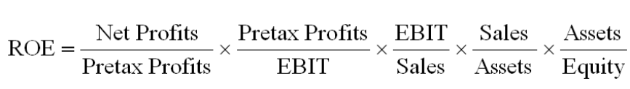
Enter the formula that corresponds to the description of each ratio into the second column of the table. The third column gives a value for each ratio. Use the fourth column to describe the meaning of the ratio's value.
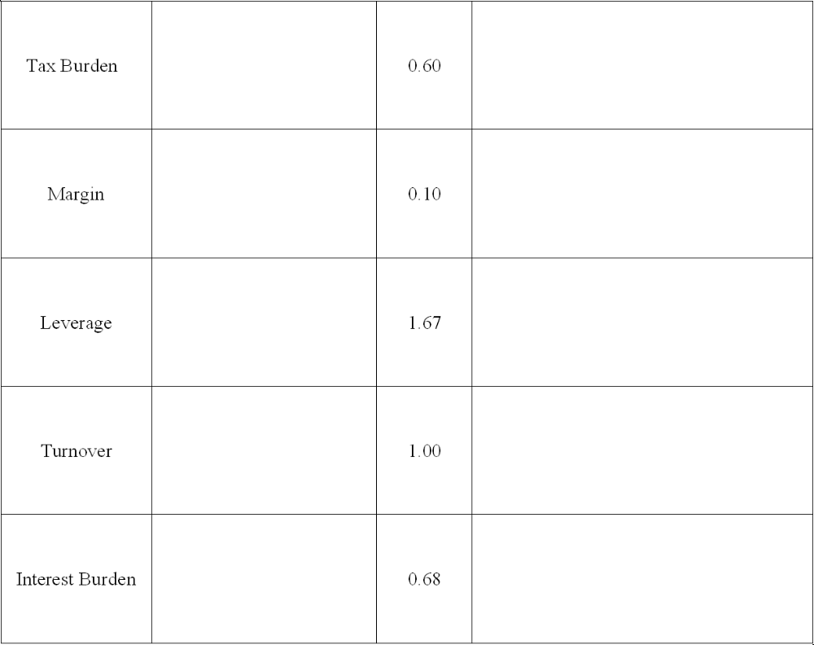
Answers are shown in the table below.
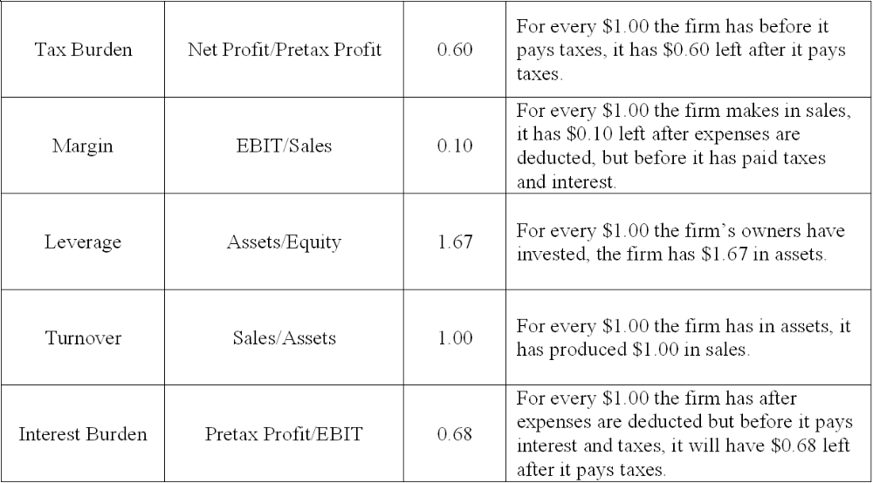
Feedback: This question tests the students' understanding of various financial ratios and whether they can identify the ratios by their descriptive terms.

Difficulty: Difficult

