**Aim:**

Set up emulators to run FreeDOS.

**Description:**

Virtualization is creation of Virtual Machines which can emulate hardware in software or in other words it is the creation of virtual version of something such as a hardware platform, operating system, storage device, or network resources.

QEMU is a generic and open source machine emulator and virtualizer. When used as a machine emulator, QEMU can run OSes and programs made for one machine (e.g. an ARM board) on a different machine (e.g. your own PC). By using dynamic translation, it achieves very good performance. When used as a virtualizer, QEMU achieves near native performances by executing the guest code directly on the host CPU.

FreeDOS (formerly Free-DOS and PD-DOS) is an operating system for IBM PC compatible computers. FreeDOS is made up of many different, separate programs that act as "packages" to the overall FreeDOS Project.

COMMANDS:

|  |  |  |
| --- | --- | --- |
| Sl. No. | COMMAND | DESCRIPTION |
| 1. | sudo apt-get | To install |
| 2. | qemu-system --version | To see version number |
| 3. | cd | To navigate |
| 4. | create | To make the statement executable |
| 5. | boot | Boot the GUI |
| 6. | cdrom | Access bits in the CD |
| 7. | hda | Hard drive A |
| 8. | sudo | To give user permission |

**PROCEDURE:**

1. Installing qemu.
2. Install Freedos.
3. Move the files to common location.
4. Create image in qemu.
5. Boot freeDOS on qemu.

**Outputs:**

1. Installing qemu

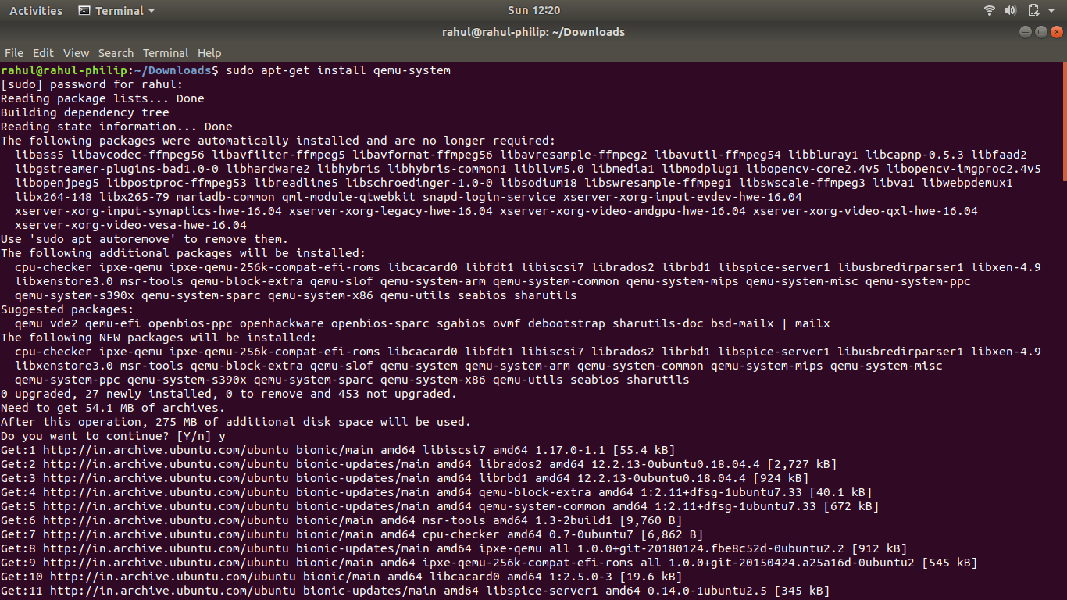

1. QEMU version

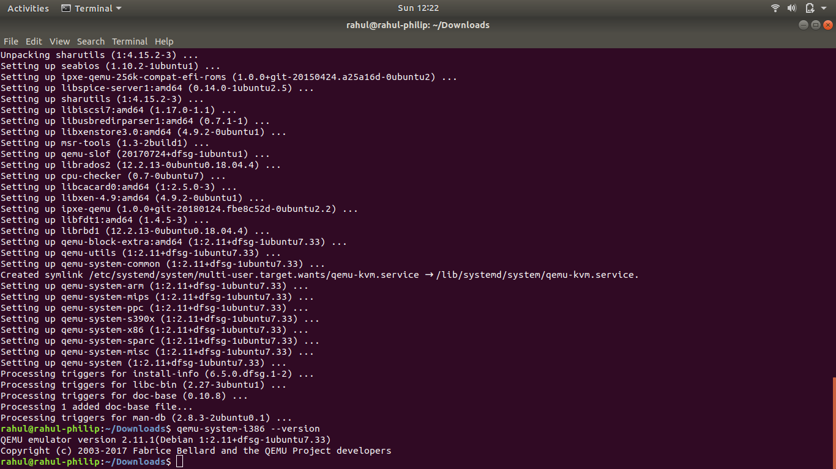

1. Downloading freeDOS

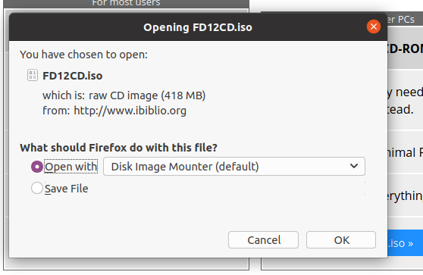

1. Making directory
2. Moving file

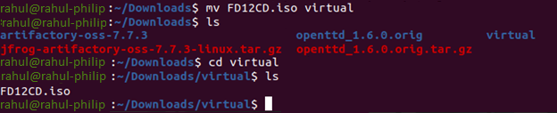

1. Creating image

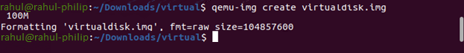

1. Booting freeDOS on qemu

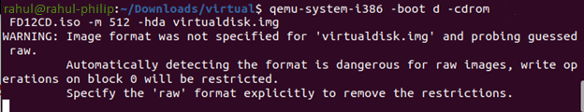

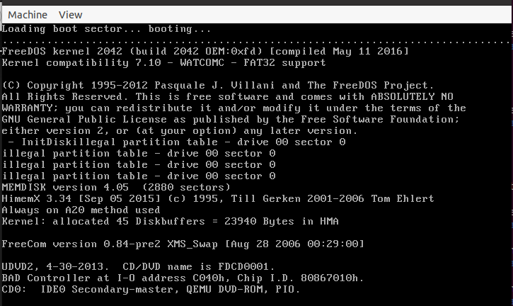

1. Setting up freeDOS

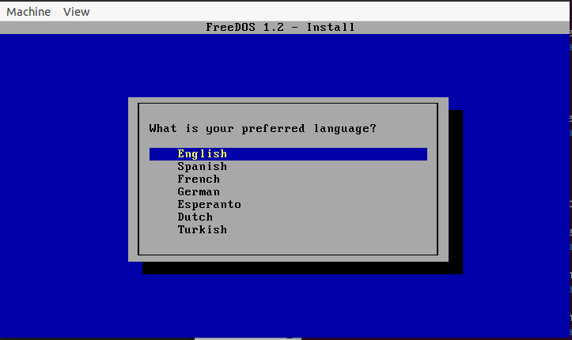

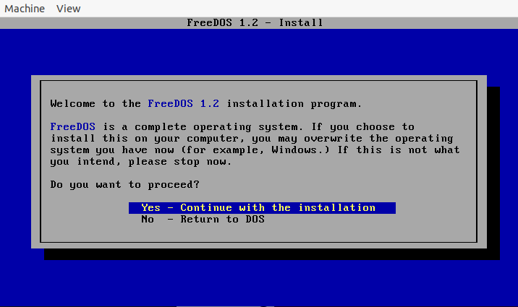

Video Link: <https://youtu.be/V-Qs69NpJnA>

RESULT:

FreeDOS is being run on an emulator.