**Aim:**

To execute basic Perl programs

**Description:**

ARRAYS IN PERL:

An array is a variable that stores an ordered list of scalar values. Array variables are preceded by an "at" (@) sign. To refer to a single element of an array, you will use the dollar sign ($) with the variable name followed by the index of the element in square brackets.

@ages = (25, 30, 40);

@names = ("John Paul", "Lisa", "Kumar");

print "\$ages[0] = $ages[0]\n";

print "\$ages[1] = $ages[1]\n";

print "\$ages[2] = $ages[2]\n";

print "\$names[0] = $names[0]\n";

print "\$names[1] = $names[1]\n";

print "\$names[2] = $names[2]\n";

ARITHEMATIC OPERATIONS OF PERL:

|  |  |
| --- | --- |
| **Sl.No.** | **Operator & Descriptio** |
| 1 | **+ ( Addition )**  **Example** − $a + $b will give 30 |
| 2 | **- (Subtraction)**  **Example** − $a - $b will give -10 |
| 3 | **\* (Multiplication)**  **Example** − $a * $b will give 200 |
| 4 | **/ (Division)**  **Example** − $b / $a will give 2 |
| 5 | **% (Modulus)**  **Example** − $b % $a will give 0 |
| 6 | **\*\* (Exponent)**  **Example** − $a**$b will give 10 to the power 20 |

**QUESTION 1: Demonstrate various operators in perl.**

**PROCEDURE:**

1. Get choice from user for arithmetic, comparison, string, bitwise operation
2. If arithmetic operation then choice operation
3. Perform operation and print the value
4. If comparison operation
5. Enter 2 values
6. Check if values are equal or greater than or less than
7. Print the output
8. If string operation then enter two strings
9. Perform concatenation operation and print the result
10. If bitwise operation then enter two values
11. Perform bitwise &,|, <<, >> and print the value

**Source code:**

# Perl operators

print("Choose an option: \n 1.Arithmetic operation \n 2.Comparision operation\n 3.String Operation \n 4.Bitwise Operation\n");

$c = <STDIN>;

if ($c == 1)

{

print("ARITHMETIC OPERATIONS\n");

print("Enter two values\n");

$a = <STDIN>;

$b = <STDIN>;

print("Choose an option: \n 1.Addition \n 2.Subtraction\n 3.multiplication \n 4.Division \n 5.Modulus\n");

$op = <STDIN>;

if($op == 1)

{

$tot = $a+$b;

print("Sum of numbers: $tot\n");

}

elsif ($op ==2)

{

$tot = $a-$b;

print("Difference between both values: $tot\n");

}

elsif ($op == 3)

{

$tot = $a*$b;

print("Product of both the numbers: $tot\n");

}

elsif ($op == 4)

{

$tot = $a/$b;

print("Qoutinent of both the numbers: $tot\n");

}

elsif ($op == 5)

{

$tot = $a%$b;

print("Modulus of both the numbers: $tot\n");

}

else

{

print ("Invalid Option\n");

}

}

elsif ($c == 2)

{

print("COMPARISION OPERATION\n");

print("Enter two values\n");

$a = <STDIN>;

$b = <STDIN>;

if($a == $b)

{

print("The values are equal\n");

}

elsif($a >$b)

{

print ("Greater value: $a\n");

print ("Lower values: $b\n");

}

else

{

print("Lower value: $a\n");

print("Greater value: $b\n")

}

if($a != $b)

{

print("Both values are not equal\n");

}

}

elsif ($c == 3)

{

print("STRING OPERATION\n");

print("Enter two strings\n");

$x = <STDIN>;

$y =<STDIN>;

$z = $x.$y;

print("Conactenated String: $z");

}

elsif ($c == 4)

{

print("BITWISE OPERATOR\n");

print("Enter two values\n");

$a = <STDIN>;

$b = <STDIN>;

$and = $a &$b;

print("Performing bitwise AND: $and\n");

$or = $a|$b;

print("Printing bitwise OR: $or");

$left = $a<<2;

print("Performing left shift: $left");

$right = $a>>2;

print("Performing right shift: $right");

}

else

{

print("Invalid Operation");

}

**Output:**

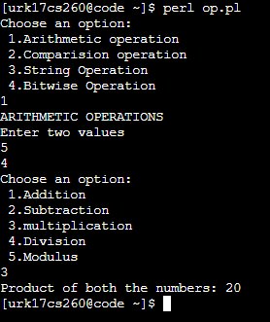

**QUESTION 2: Print 10 inputs received from the user.**

**PROCEDURE:**

1. Create a for loop that executes from 0 to 9
2. Input values into an array
3. Print the array

**Source code :**

print ("Enter 10 values\n");

for ($i =0; $i<10;$i++)

{

$arr[$i]=<STDIN>;

}

print("THE VALUES:\n");

for ($i =0; $i<10;$i++)

{

print $arr[$i];

}

**Output:**

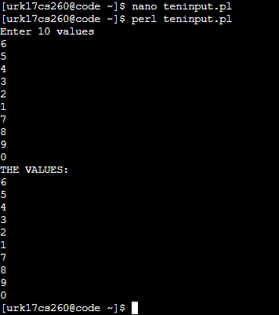

Video Link:

RESULT:

Basic perl programs are successfully executed.