Ex 7 BASIC PYTHON PROGRAMMING
Date: 06.10.20

Aim:
To study and implement the basic python programming.

Exercise:
1. Design and implement a basic calculator.
Source Code
def add(num1, num2):
return num1 + num2

def subtract(num1, num2):
return num1 - num2

def multiply(num1, num2):
return num1 * num2

def divide(num1, num2):
return num1 / num2

print("Please select operation :-\n 1. Add\n 2. Subtract\n 3. Multiply\n 4. Divide")

select = int(input("Select operations form above noumber: "))

number_1 = int(input("Enter first number: "))
number_2 = int(input("Enter second number: "))

if select == 1:
print(number_1,"+",number_2,"=", add(number_1, number_2))

elif select == 2:
print(number_1,"-",number_2,"=",subtract(number_1, number_2))
elif select == 3:
print(number_1,"*",number_2,"=",multiply(number_1, number_2))

elif select == 4:
print(number_1,"/",number_2,"=",divide(number_1, number_2))
else:
print("Invalid input")

Output
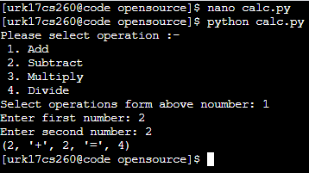

2. Find whether the given number is perfect or not.
Source Code
num = int(input(" Please Enter any Number: "))
summ = 0
for i in range(1, num):
if(num % i == 0):
summ = summ + i
if (summ == num):
print("It is a Perfect Number")
else:
print("It is not a Perfect Number")

Output
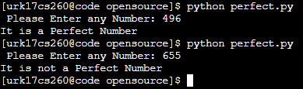
3. Find whether the given number is Adam’s number or not.
Source Code
def isAdam(num):
n = num
rev = 0
while n != 0:
rev = rev * 10 + n % 10
n = n // 10
sn = num ** 2
sr = rev ** 2
n = sr
rev = 0
while n != 0:
rev = rev * 10 + n % 10
n = n // 10
return sn == rev
num = int(input("Enter the number: "))
if isAdam(num):
print(str(num) + " is an Adam Number.")
else:
print(str(num) + " is NOT an Adam Number.")
Output
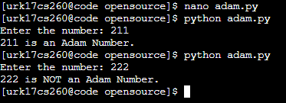
4. Find whether the given number is Armstrong or not.
Source Code
num = int(input("Enter a number: "))
summ = 0
temp = num
while temp > 0:
digit = temp % 10
summ += digit ** 3
temp //= 10
if num == summ:
print(num,"is an Armstrong number")
else:
print(num,"is not an Armstrong number")

Output
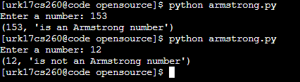

Results:
The study and implementation of the basic python programming are studied and executed.
Video Link: https://youtu.be/g2viuAl41SE

