Name: Vedika Goliwar UID: 2022201007

Identify

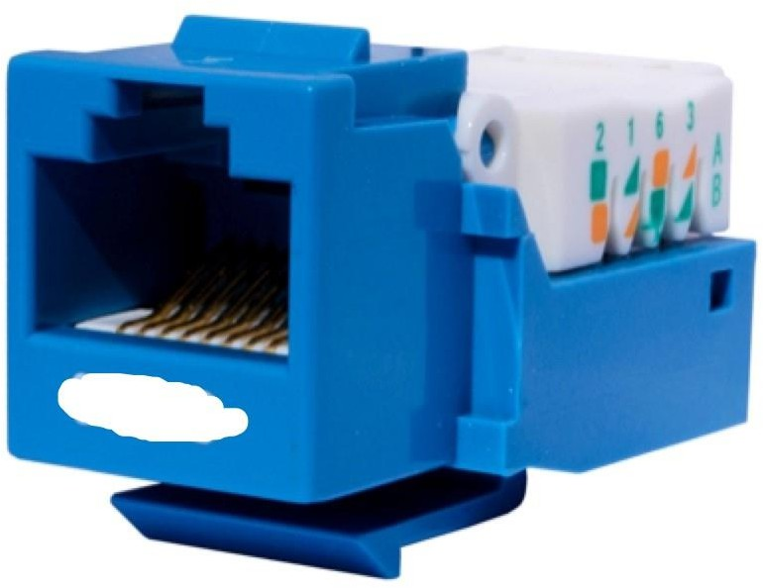 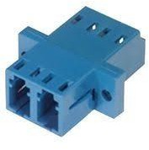

RJ-45 connector RJ-11 connector

RJ- Register Jack

Crimper Tool

Wire Striper

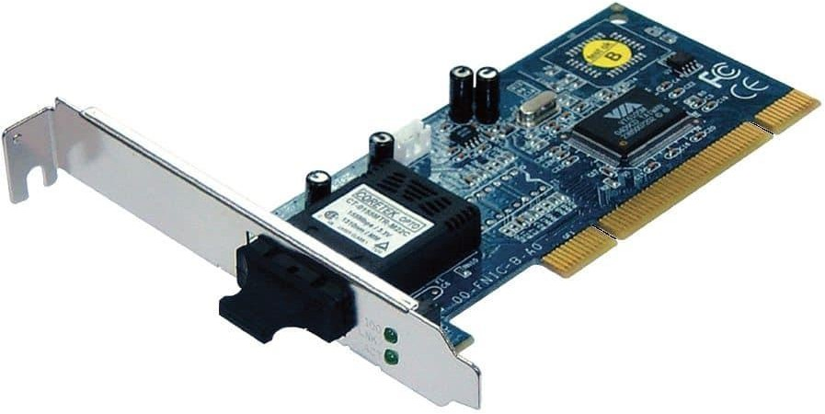 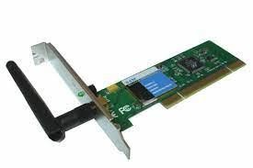

Modem NIC(Network Interface

Card)

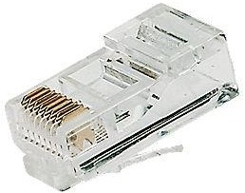

Rj-45 Male Connector

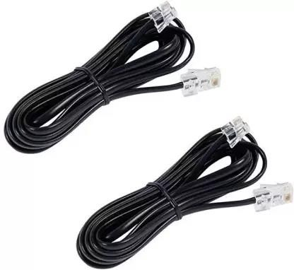

RJ-45 Cabel

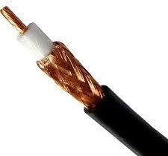 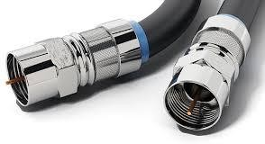

Coaxial BNC Connector

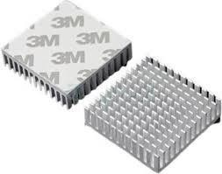Heat Shrink

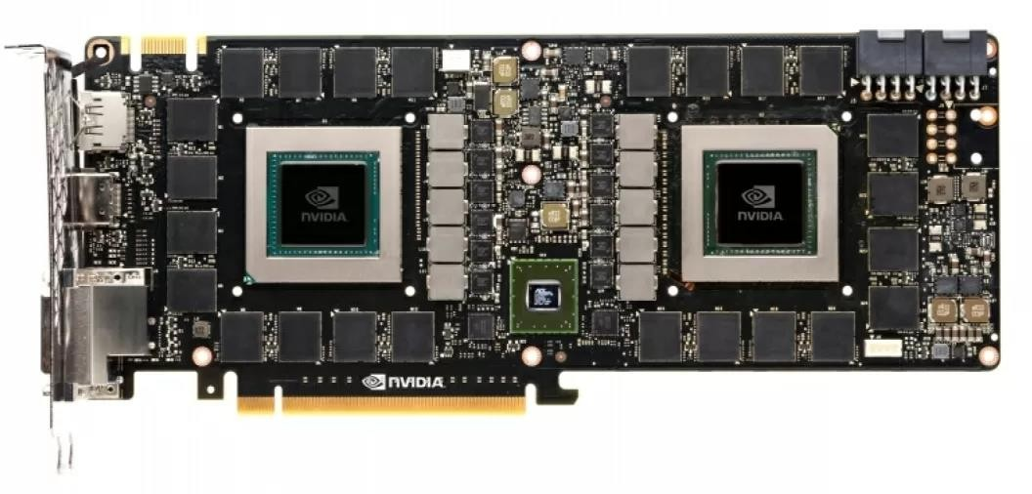

Graphics Card

* IEEE
* LAN
* WAN
* MAN
* GAN
* 802.11
* 802.3

Institute of electrical and electronics engineering

Local area Network Wide Area Network

Metropolitan Area Network Global Area Network IEEE Wireless Standard

IEEE Wired Standard

* 2.4 GHz - ISM Band
* 5 GHz – ISM Band
* ISM – Industrial Scientific Medical Band
* Wireless IEEE standard-802.11
* Wired IEEE standard-802.3
* OSI-ISO – Open System Interconnection
* Wi-Fi - Wireless-Fidelity

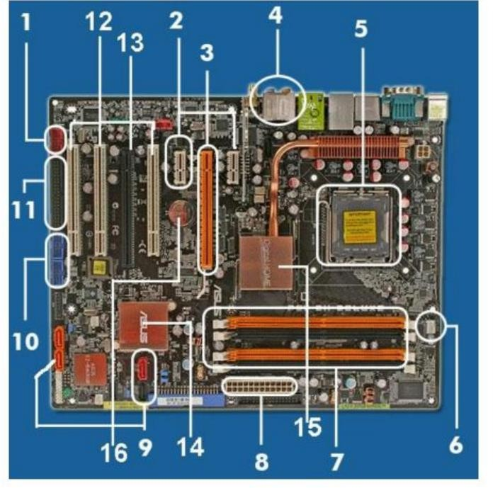

1. Port firewire
2. PCI x1
3. PCI express X16
4. Port Audio
5. Socket Processor
6. Fan headers
7. Socket RAM
8. Socket ATX Power
9. Serial ATA(SATA)
10. Header USB
11. Slot IDE
12. Slot PCI
13. Slot AGP
14. BIOS
15. Chipset
16. CMOS baterai

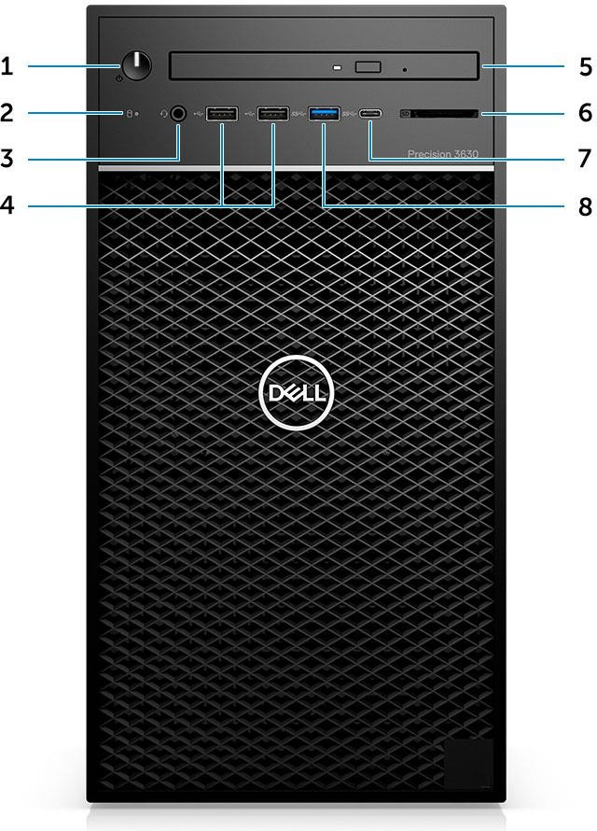TASK-1

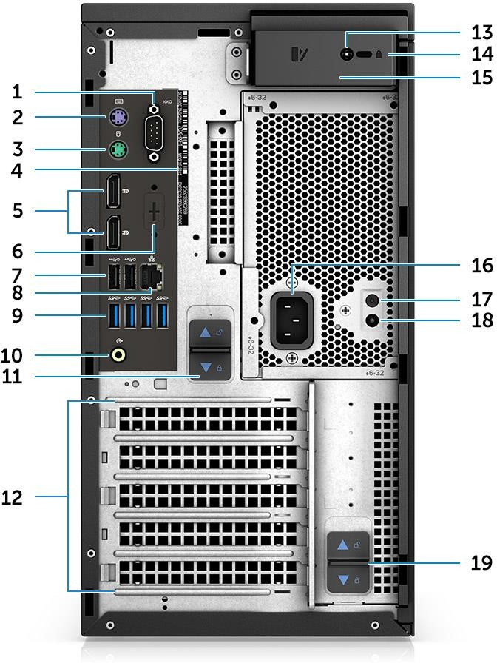

ANSWERS OF SLIDE 13

* + 1. Power button/Diagnostics indicator
  + 2. Drive activity LED indicator
  + 3. 3.5 mm Headphone port
  + 4. USB 2.0 Type-A port \*2
  + 5. DVD-RW Slim Optical drive
  + USB 3.1 Type-C port
  + 7. USB 3.0 Type-A port

1. Service tag
2. Serial port
3. PS2 port (Keyboard)
4. PS2 port (Mouse)
5. Display Port\*2
6. NIC port
7. USB 2.0 Type-A with SmartPower \*2
8. USB 3.0 Type-A ports \*4

6. Audio line-out port

1. Expansion card slots \*4
2. Kensington/padlock slot
3. System cover release latch
4. Power Supply Unit (PSU)
5. Power connector port
6. Power Supply Unit (PSU) Built-in Self Test (BIST) button
7. Power Supply Unit (PSU) Built-in Self Test (BIST) LED
8. PSU hinge release latch