Temple Inn & Suites

TEMPLEINN.COM

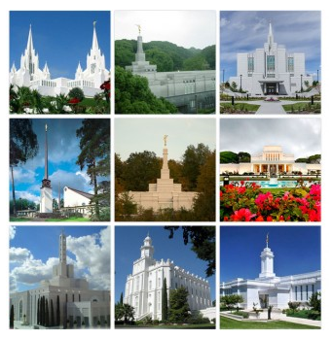

Rick Holmstead CIT 230

**Overview**

# Site Purpose

The **Temple Inn & Suites**is a hotel chain headquartered in Bethesda, MD that builds and manages specialized hotel accommodations near temple locations of The Church of Jesus Christ of Latter-day Saints around the world. The owner-operated company caters to temple workers, patrons, and their families by providing specialized services and accommodations that meet the needs of those patrons. The overall goal of the website project is to promote and provide information about the specialized services that this hotel chain offers.

# Target Audience

The hotel accommodations and services are available to anyone willing to abide by the terms and policies outlined by the company. A few of the anticipated groups are participate in events such as:

* Sealings
* Weddings
* Receptions
* Youth trips

**Site Map**

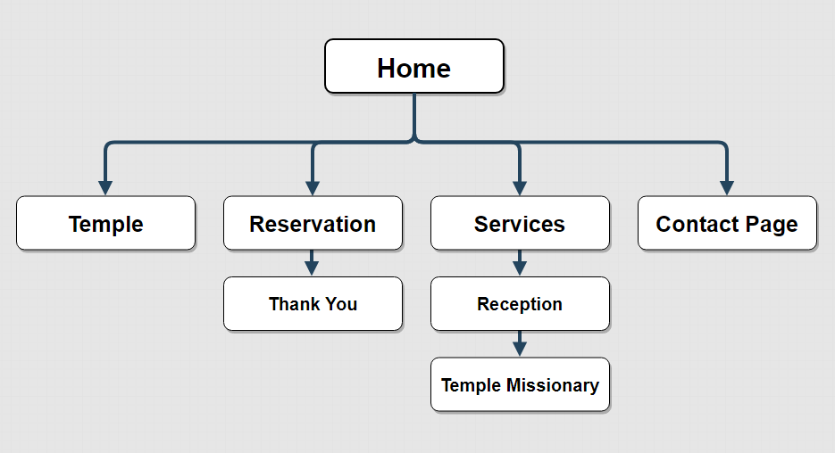

**Color Palette**



|  |  |  |  |  |  |
| --- | --- | --- | --- | --- | --- |
| **Primary** |  | **Accent** | **Accent** | **Accent** | **Secondary** |
| #FFD700 |  | #2A1200 | #F5F5DC | #769E7B | #0E62A3 |

**Typography**

|  |  |  |  |  |
| --- | --- | --- | --- | --- |
| Site Header | 'Kaushan Script | 48px | # FFD700 | Sample |
| Primary Navigation | Courgette | 20px | #000000 | Sample |
| Headers | Marck Script | 20Px | #000000 |  |
| Footer Navigation | Courgette | 16px | #000000 | Sample |
| Paragraph Text (p) | Kalam | 12px | #000000 | Sample |

**Wireframe**

Full Screen View

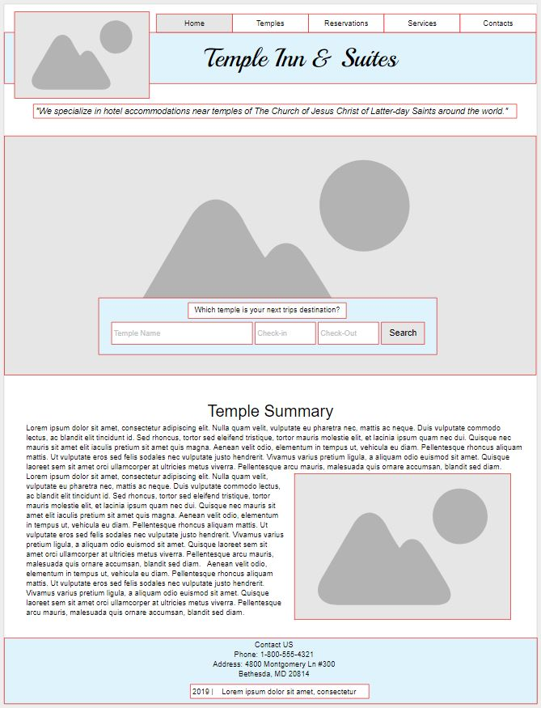

Mobile View

