CS7637: Knowledge-Based AI: Cognitive Systems  
Summer 2015 Syllabus

Last Revised: 05/10/2015

All course documents can be found in [this](https://drive.google.com/folderview?id=0B-XdVjMuNV2GfnRnMG5xaFAtNmdXd3lQZ3FNVTRtaXRUT0pLOHJxLUU0QV93dGhRRFF4c0E&usp=sharing) Google folder.

# Table of Contents

Class Information

Teaching Team

Course Description

Competency

Learning Goals

Learning Strategies

Learning Outcomes

Class Materials

Course Schedule

Reading List

Class Assessments

Grade Categories

Grading Policies

Projects

Assignments

Peer Feedback

Final Exam

Class Policies

Course Communication

Office Hours

Late Work

Collaboration & Academic Honesty

Feedback

Comparison to a Full-Length Semester

# Class Information

## Teaching Team

David Joyner, Instructor

[david.joyner@gatech.edu](mailto:david.joyner@gatech.edu); [www.davidjoyner.net](http://www.davidjoyner.net)

Wade Ashby, Teaching Assistant

Liam Irish, Teaching Assistant

Eling Lam, Teaching Assistant

Jacob Langston, Teaching Assistant

Isabel Lupiani, Teaching Assistant

Mike Lustig, Teaching Assistant

Paige Pettoruto, Teaching Assistant

Dana Sheahen, Teaching Assistant

Angela Smiley, Teaching Assistant

Bryan Wiltgen, Head Teaching Assistant

## Course Description

This is a core course in artificial intelligence. It is designed to be a challenging course, involving significant independent work, readings, assignments, and projects. It covers structured knowledge representations, as well as knowledge-based methods of problem solving, planning, decision-making, and learning. For additional information on the course, we invite you to watch our [talk to the GVU Brown Bag](https://www.youtube.com/watch?v=N56ghCGmWWQ) from last December.

## Competency

To succeed in this course, you should be able to answer 'Yes' to the following questions:

* Are you confident with computer programming in either Java or Python?
* Are you familiar with basic concepts of data structures and object-oriented programming, such as inheritance and polymorphism?
* Are you familiar with basic concepts of algorithm design, such as algorithms for sorting, searching, and matching?
* Are you comfortable with writing essays, totaling approximately 10,000 words (across seven essays) throughout the semester?

If your answer is “No” to any of these questions, this course may not be appropriate for you.

## Learning Goals

The class is organized around three primary learning goals. First, this class teaches the **concepts, methods, and prominent issues** in knowledge-based artificial intelligence. Second, it teaches the **specific skills and abilities** needed to apply those concepts to the design of knowledge-based AI agents. Third, it teaches the **relationship** between knowledge-based artificial intelligence and the study of human cognition.

## Learning Strategies

This structure of this course is driven by several pedagogical motivations:

* **Learning by example:** Each topic is taught through examples of the way in which humans and artificial intelligence agents approach certain problems, often building from human thought toward AI agents and subsequently referring back to human cognition.
* **Learning by doing:** you will participate in the reasoning within each particular lesson, and subsequently tie the topic back to a broader problem.
* **Project-Based Learning:** This class has three projects, each of which build on the previous one, and the overall goals and motivations of KBAI are presented through these projects.
* **Personalization:** Individualized feedback will be given on your performance on the exercises, assignments, projects, and tests. Additionally, you are welcome and encouraged to proceed at your own pace throughout the lessons, including viewing them outside of the designed order to better align with your interests.
* **Collaborative Learning:** We encourage collaboration and the development of communities of practice surrounding the course material and projects. We are excited to see you borrow one another’s ideas and build on them, as well as spin off your own study groups.
* **Peer-to-Peer Learning:** During this class you will give your peers feedback on their work on the same assignments you complete. This lets you see additional approaches to the problems, provides you extra feedback, and puts you in the position of a teacher, which [has been shown to be a pedagogically useful](http://link.springer.com/article/10.1007%2Fs11251-011-9177-2) role reversal.
* **Self-Reflection:** At the conclusion of each lesson, we ask each student to reflect on what they learned in the class. Each design project requires the writing of a project reflection that explains and critiques, and reflects on the student’s work on the project.
* **Authenticity:** The project that you will explore in this class is an open research question in the AI and Cognitive Systems research communities. Two students from our lab have completed dissertations working on these questions in the past two years, and we have had papers published on these topics within the past several months.

## Learning Outcomes

At the conclusion of this class, you will be able to accomplish three primary tasks. First, you will be able to **design and implement a knowledge-based artificial intelligence agent** that can address a complex task using the methods discussed in the course. Second, you will be able to **use this agent to reflect on the process of human cognition**. Third, you will be able to **use both these practices to address practical problems in multiple domains**.

# Class Materials

## Course Schedule

CS7637: Knowledge-Based AI is typically run as a 16-week class. For the shorter summer semester, more lectures are assigned per week. All assignments are due at the end of the week, on Sunday at midnight UTC-12 ([Anywhere On Earth](https://www.timeanddate.com/time/zones/aoe) time). This translates to an early-morning Monday deadline in the Americas, a midday Monday deadline in Europe, etc. For example, Assignment 1 is due on May 24th at midnight UTC-12, which translates to Monday, May 25th at 8AM Eastern time, 5AM Pacific time.

Precise due dates and times can be found in T-Square on each assignment page. Make sure to [set T-Square to your local time zone](https://docs.google.com/document/d/1VDlW5n3EzNie1U-r5r70E2_GvsGDU26YP4iC_5bNG4s/edit?usp=sharing) to see due dates in your time.

The following is a short version of the course calendar; the full version, with links to the various assignments and T-Square submission pages, can be found [here](https://docs.google.com/document/d/1hd65NUtG9gVEh6ygHPDhlAZJ_dMK9rltlj_uyk4UTX8/edit?usp=sharing). Numbers in parentheses below are the estimated amounts of time (in minutes) each lesson should take, including exercises. Your experience may vary, especially if you watch the videos at an increased speed (highly recommended!).

|  |  |  |  |
| --- | --- | --- | --- |
| Week | Week Of | Lessons | Assignment |
| 1 | May 11 | [Introduction to KBAI](https://www.udacity.com/course/viewer#!/c-ud037/l-1209999811) (45); [Introduction to CS7637](https://www.udacity.com/course/viewer#!/c-ud037/l-1453218650) (60); [Semantic Nets](https://www.udacity.com/course/viewer#!/c-ud037/l-1471018574) (60) | [Survey & Introduction](https://docs.google.com/document/d/190tigPyW5yukbXkX2Irf0VsMvKuq4bRNDDbUsc14TQM/edit?usp=sharing) |
| 2 | May 18 | [Generate & Test](https://www.udacity.com/course/viewer#!/c-ud037/l-1565569443) (30); [Means-Ends Analysis](https://www.udacity.com/course/viewer#!/c-ud037/l-1572839229) (60); [Production Systems](https://www.udacity.com/course/viewer#!/c-ud037/l-1614208648) (60) | [Assignment 1](https://docs.google.com/document/d/1UD6HjYMSkvxP70mZ0MZgiZB1s00HMd1dCF0kECEa2j4/edit?usp=sharing) |
| 3 | May 25 | [Frames](https://www.udacity.com/course/viewer#!/c-ud037/l-1778648600) (45); [Learning by Recording Cases](https://www.udacity.com/course/viewer#!/c-ud037/l-1938369005) (30); [Case-Based Reasoning](https://www.udacity.com/course/viewer#!/c-ud037/l-2129908564) (60) | [Assignment 2](https://docs.google.com/document/d/1Y1i6Z4eMZTAFJm-ASgsU7tpIufLcH2Y0r9QmZwe8pg4/edit?usp=sharing) |
| 4 | June 1 | [Incremental Concept Learning](https://www.udacity.com/course/viewer#!/c-ud037/l-1623408676) (60); [Classification](https://www.udacity.com/course/viewer#!/c-ud037/l-1649018590) (45) | [Project 1](https://docs.google.com/document/d/1ULlFP6bsnDKNJUNJDu7DdwOxAk1CM0m3R8HSYNh9FZ4/edit?usp=sharing) |
| 5 | June 8 | [Logic](https://www.udacity.com/course/viewer#!/c-ud037/l-1924148987) (90); [Planning](https://www.udacity.com/course/viewer#!/c-ud037/l-1922019281) (75) | [Assignment 3](https://docs.google.com/document/d/1KrA5nF0nwwL8Lhqj-YdYJQQmmOOwwa6FoHq5whFAmm8/edit?usp=sharing) |
| 6 | June 15 | [Understanding](https://www.udacity.com/course/viewer#!/c-ud037/l-1965358577) (30); [Common Sense Reasoning](https://www.udacity.com/course/viewer#!/c-ud037/l-1992128593) (60); [Scripts](https://www.udacity.com/course/viewer#!/c-ud037/l-1968808670) (30) | [Assignment 4](https://docs.google.com/document/d/1NT1z_YDu3R56AZ-KHee9YF2dFLUPA3h5Ll864O6ixIc/edit?usp=sharing) |
| 7 | June 22 | [Explanation-Based Learning](https://www.udacity.com/course/viewer#!/c-ud037/l-1958328606) (45); [Analogical Reasoning](https://www.udacity.com/course/viewer#!/c-ud037/l-2256588560) (60) | [Project 2](https://docs.google.com/document/d/1oA4r11n7NYNMaYOZlfUYC8u9_W37jzB5ZnGwJbusYHk/edit?usp=sharing) |
| 8 | June 29 | [Version Spaces](https://www.udacity.com/course/viewer#!/c-ud037/l-1938340059) (60); [Constraint Propagation](https://www.udacity.com/course/viewer#!/c-ud037/l-1969578631) (45); [Configuration](https://www.udacity.com/course/viewer#!/c-ud037/l-1934948585) (45) | [Assignment 5](https://docs.google.com/document/d/1dfM2wix0iqkff-AgRRDz6T6AW0zlYpWz76bHHhW9IlY/edit?usp=sharing) |
| 9 | July 6 | [Diagnosis](https://www.udacity.com/course/viewer#!/c-ud037/l-1951908693) (45); [Learning by Correcting Mistakes](https://www.udacity.com/course/viewer#!/c-ud037/l-2245488560) (45); [Meta-Reasoning](https://www.udacity.com/course/viewer#!/c-ud037/l-2259968553) (30) | [Assignment 6](https://docs.google.com/document/d/1pFhpqd87nxger4pK7U_5bz3lMIYSU7WM-t0cPTwPGm0/edit?usp=sharing) |
| 10 | July 13 | [Advanced Topics](https://www.udacity.com/course/viewer#!/c-ud037/l-2244438544) (60); [Wrap-Up](https://www.udacity.com/course/viewer#!/c-ud037/l-2248828579) (30) | [Project 3](https://docs.google.com/document/d/1PRnkj9X5lioYFTH6VjeaJugZnEmFKIprhlNBD6vBcYw/edit?usp=sharing) |
| 11 | July 20 | -- | [Final Exam](https://docs.google.com/document/d/1ox1xIEyqTnglGmCzae8G0EQt59xEPNUGDdFPhco6z7o/edit?usp=sharing) |
| 12 | July 27 | -- | [CIOS](http://gatech.smartevals.com/) & [KBAI Surveys](https://t-square.gatech.edu/samigo-app/servlet/Login?id=42581ed2-c1c4-4de4-0089-6be5c23196871431052799253) |

This schedule of the lessons is merely provided as a guide. In practice, you are free and encouraged to watch the lessons in any order and at any pace you choose. Note only that you are responsible for all lecture material for the final exam, and that each assignment is based on some of the immediately preceding lesson topics.

Make sure to consult the full schedule [here](https://docs.google.com/document/d/1hd65NUtG9gVEh6ygHPDhlAZJ_dMK9rltlj_uyk4UTX8/edit?usp=sharing) for additional assignments (Peer Feedback reminders, survey reminders) and links to T-Square submission pages.

## Reading List

This offering of CS7637 has no required readings. However, accompanying each lesson are a set of optional readings for students interested in delving deeper into the material. These readings can be found in the [optional reading list](https://docs.google.com/spreadsheets/d/1huu9XzMLBOT4FoqgVeTfEbJqLh02AOlCSAe6RY6UX_k/edit?usp=sharing). Readings will either be publicly available online or will be provided to you in the T-Square Resources section for this class.

# Class Assessments

## Grade Categories

Your final grade in this class will be based on four components.

|  |  |  |
| --- | --- | --- |
| **Category** | **%** | **Description** |
| Assignments | 20% | 3 written assignments (~1000 words each). |
| Projects | 45% | 3 programming projects with accompanying project reflections (~1500 words each). |
| Exam | 20% | 1 unproctored final exam (~1500 words). |
| Peer Feedback | 15% | ~30 peer feedback activities based on written assignments and project project reflections. |

It is important to note that this course does *not* follow the normal grading buckets (90 or above for A, 80 to 90 for B, etc.). Last semester, for example, one student out of 220 received above a 90 on one of the projects. Make sure to pay attention to the announcements after each assignment and project is graded to understand where your grade sits in the big picture; otherwise, you’re likely to think you’re doing *much* worse than you actually are. Although we understand the importance of grades, we encourage you to focus first on doing the best you can on all assignments; if you do, your grade should take care of itself.

## Grading Policies

After submission, all written work (assignments and project reflections) will go through a round of peer feedback. During peer feedback, your peers will score your assignment according to the same rubric used by the graders, as well as leave you written feedback. Your peers will have one week to submit this peer feedback. *After* peer feedback is done, the graders will have one week to grade your assignments. Thus, you will always get your assignment grades by **two weeks** after the original submission deadline. The structure of the class assignments and projects also means that you can always receive a grade before the next time a similar assignment is due (for example, Project Reflections are due three weeks apart, so you’re guaranteed to receive a score on your Project Reflection a week before the next Reflection is due).

Note that the grades assigned by your peers have *no* direct effect on the grades you receive from the graders. All actual grades are assigned by the graders and the graders alone. The primary purpose of supplying the graders with the results of the peer feedback process is to help the graders ensure every student gets useful feedback, as well as to ensure that the peer feedback received is accurate.

Grades will generally be delivered via both T-Square and Peer Feedback. Written feedback from the graders, however, will only be delivered via Peer Feedback. For Projects, sub-scores for your agent’s performance on the problems and for your project reflection will be returned via the assignment submission page, and the overall project score will be posted to the gradebook. Checkmarks for Peer Feedback participation will be provided throughout the semester via the assignment submission pages for those tasks, and a final Peer Feedback score (based both on completion and quality of participation) will be assigned at the end of the semester.

Note that grades on Project 3 and the final exam will be posted very close to the final grade submission deadline. Make sure to allocate time during the final weekend of the course (the final weekend of July) to check your grades and make sure everything, especially these final two, are as you expected.

Lastly, remember: this class is effectively graded on a curve. A 90% is certainly not the threshold for an A in the class. Last semester’s class average was 81%, and only 10% of the class ended with a raw score over 90; well over half the class still received an A, though. If you try to interpret your grade according to the traditional categories, you will likely think you are doing *far* worse in the class than you actually are. Make sure to pay attention to the stats posts at the end of each assignment for the context necessary to interpret your grade and evaluate your performance.

## Projects

The course consists of three design and programming projects, each of which build on the previous one. We will post exemplary solutions to each project at the end of each project to give others a chance to learn from the best submissions. For complete information on the projects, consult the [Overall Project Description](https://docs.google.com/document/d/1GkXYf6xG-jGzxM_Z5pwE2GkhCUvq369t7lmOI9YUVnQ/edit?usp=sharing) and the documents for [Project 1](https://docs.google.com/document/d/1ULlFP6bsnDKNJUNJDu7DdwOxAk1CM0m3R8HSYNh9FZ4/edit?usp=sharing), [Project 2](https://docs.google.com/document/d/1oA4r11n7NYNMaYOZlfUYC8u9_W37jzB5ZnGwJbusYHk/edit?usp=sharing), and [Project 3](https://docs.google.com/document/d/1PRnkj9X5lioYFTH6VjeaJugZnEmFKIprhlNBD6vBcYw/edit?usp=sharing).

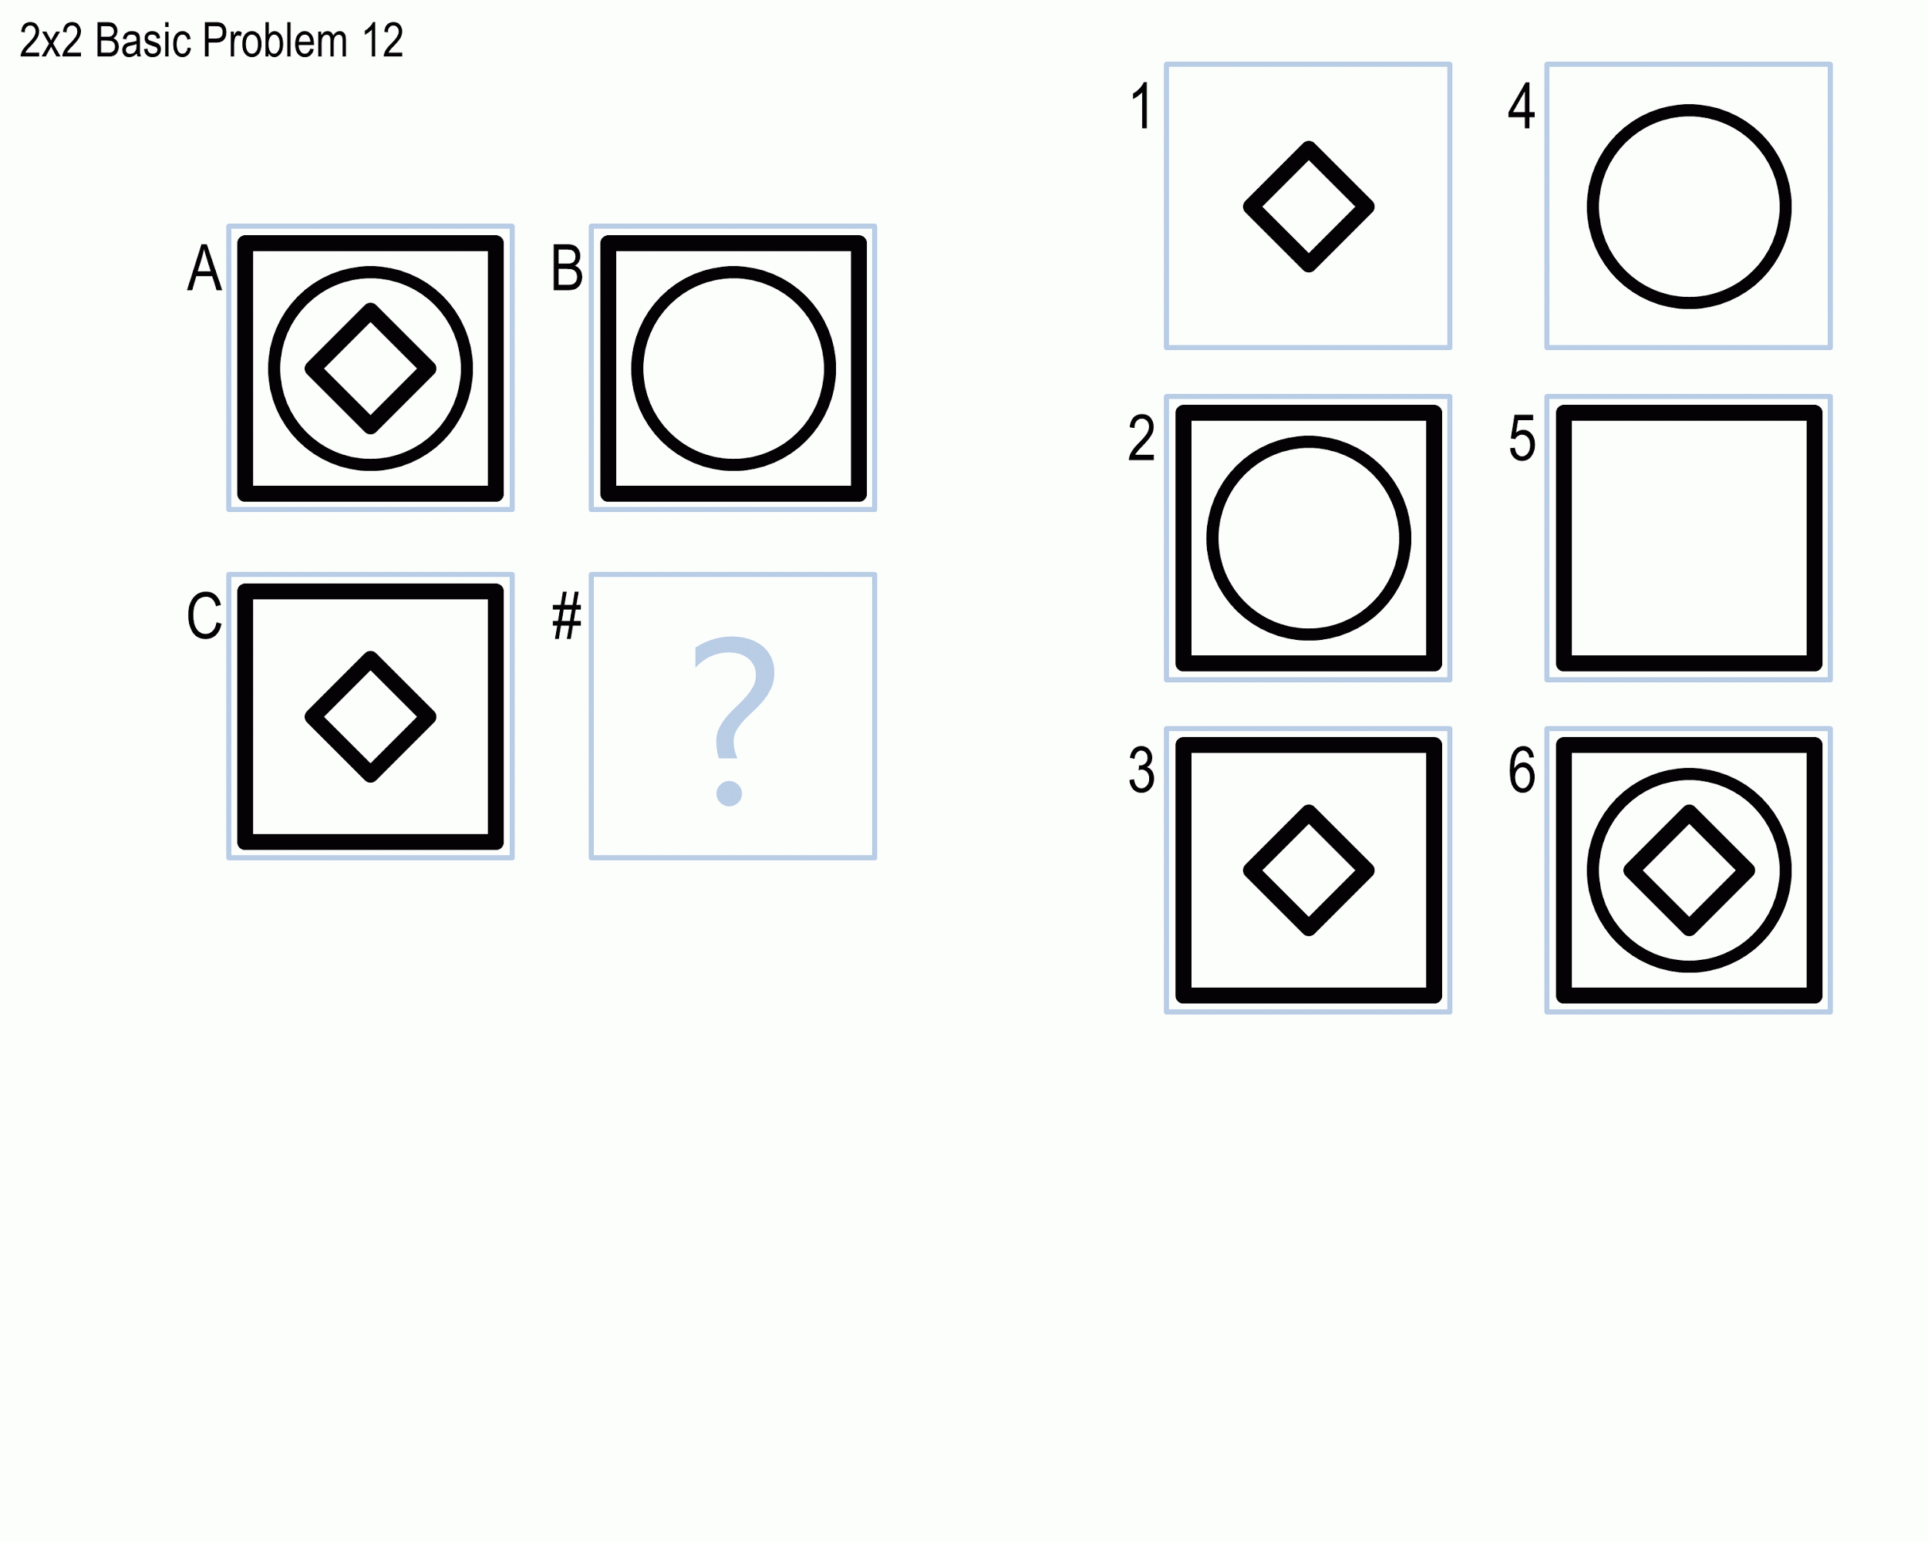

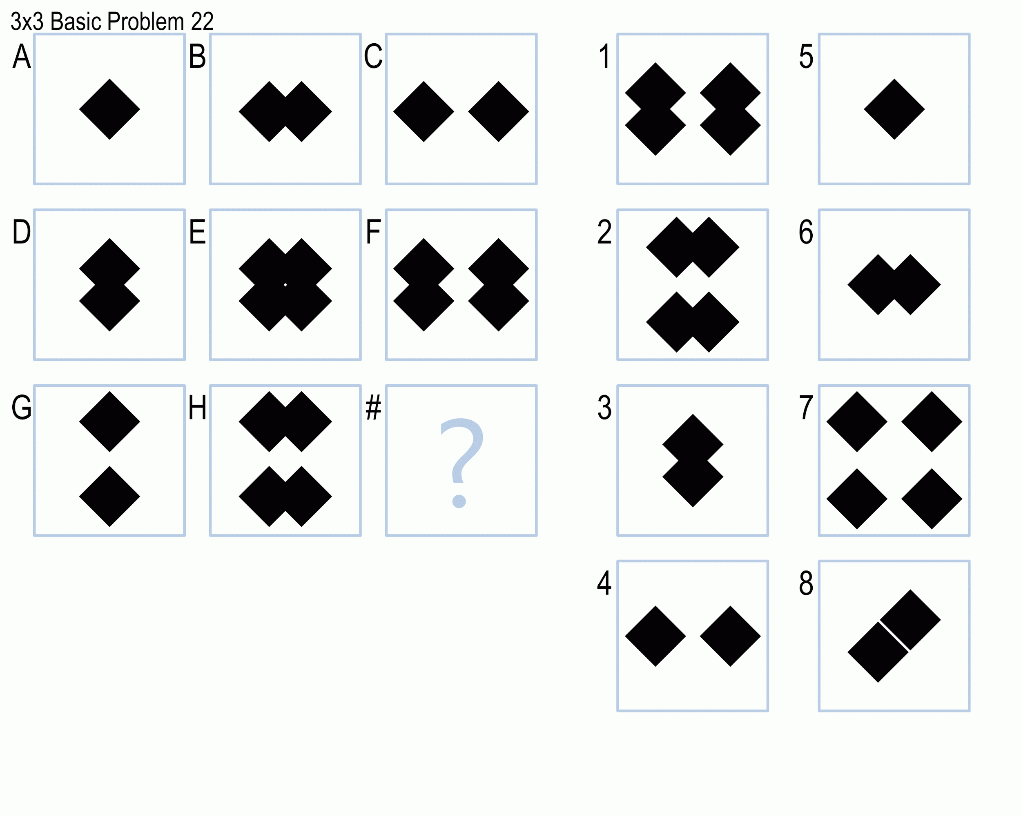

In all three projects, you will design agents that solve intelligence test problems like the two shown above. These problems are broken into four sets of roughly ascending difficulty: set B, set C, set D, and set E. Set B consists of 2x2 problems, while sets C, D, and E consist of 3x3 problems. In some projects, your agents will be able to operate on both verbal and visual representations of these problems. Visual representations are images themselves, while verbal representations are words expressing parameters and relationships. For example, a verbal representation of figure G above might specify that the figure has two shapes, both shapes are filled diamonds, and one diamond is above the other.

The three projects ascend as follows:

* Project 1: Solve Set B (both visual and verbal).
* Project 2: Solve Sets B and C (both visual and verbal).
* Project 3: Solve Sets B, C, D, and E (visual only for D and E).

Generally speaking, verbal representations are easier to work with than visual representations because some human reasoning has already simplified the problem. So, verbal representations are supplied for the first couple projects to scaffold your agent’s reasoning. However, we also provide the visual representations from the beginning so that you can shift to using visual representations as early as you’d like.

The best humans struggle to get all these problems correct. The current state of the art in computer algorithms to solve these problems currently gets roughly 80% of these problems correct. You’re encouraged to try to design the smartest agent you can, but please make sure you’re not holding yourself to the usual standard of “90% or above is an A”. Think about how humans solve these problems, try to design an agent that solves these problems, and use the agent’s performance to reflect on how humans solve these problems. The goal of this project is to explore the relationship between AI and human cognition; the number of problems your agent gets correct is merely a barometer to measure how much you’ve explored that relationship.

More information about the projects and their learning goals can be found on the individual project assignment pages. Note that unlike previous semesters, no external libraries like OpenCV are permitted for use on any of these projects, excepting the Python image processing library Pillow. Each project should also be accompanied by a ~1500 word project reflection describing the mechanics, strengths, and weaknesses of the agent as well as what it tells us about human cognition.

## Assignments

There are six assignments in this class; you must complete three of them. You must complete either [Assignment 1](https://docs.google.com/document/d/1UD6HjYMSkvxP70mZ0MZgiZB1s00HMd1dCF0kECEa2j4/edit?usp=sharing) **or** [Assignment 2](https://docs.google.com/document/d/1Y1i6Z4eMZTAFJm-ASgsU7tpIufLcH2Y0r9QmZwe8pg4/edit?usp=sharing); either [Assignment 3](https://docs.google.com/document/d/1KrA5nF0nwwL8Lhqj-YdYJQQmmOOwwa6FoHq5whFAmm8/edit?usp=sharing) **or** [Assignment 4](https://docs.google.com/document/d/1NT1z_YDu3R56AZ-KHee9YF2dFLUPA3h5Ll864O6ixIc/edit?usp=sharing); and either [Assignment 5](https://docs.google.com/document/d/1dfM2wix0iqkff-AgRRDz6T6AW0zlYpWz76bHHhW9IlY/edit?usp=sharing) **or** [Assignment 6](https://drive.google.com/open?id=1pFhpqd87nxger4pK7U_5bz3lMIYSU7WM-t0cPTwPGm0&authuser=0). Put differently, you must complete one assignment before each project. The assignments will connect to the projects as well, so completing the earlier assignments will get you feedback on your ideas for the project sooner.

Each assignment should be approximately 1,000 words (neither a minimum nor a maximum, just a heuristic), and should relate a certain topic or set of topics in the course material to some problem. For Assignments 1 and 2, the problem should be the class project. For Assignments 3 and 4, we will provide a list of problems that you can choose from. For Assignments 5 and 6, you may choose from that same list, or you may select a problem of your own.

## Peer Feedback

We will use a tool called Peer Feedback -- peerfeedback.gatech.edu -- to give peer-to-peer feedback in this class. Peer-to-peer feedback provides a number of opportunities: it gives you the opportunity to see your classmates’ work, it gets you more feedback on your work than you would otherwise receive, and it puts you in the position of critiquing and analyzing course material. You will give peer-to-peer feedback to your classmates on all six assignments (including the three you do not personally complete) and on all three project reflections.

Peers will evaluate one another on the same rubric that graders will use; however, the scores you assign to your peers will *not* factor into their actual grades on the assignment. All grades will be assigned by TAs. TAs will see the feedback you give to your peers in order to ensure that all students receive adequate feedback.

Completing peer feedback exercises is 15% of your average. Your peer feedback average will be determined not only based on whether or not you completed all assigned peer feedback exercises, but also based on the quality of the feedback you provided as evaluated by the TAs and by the recipients of the feedback.

## Final Exam

At the end of the course, there will be a final exam. The final exam will be an unproctored, untimed exam. It will be posted on Monday of the last regular week of the class (July 20th), and it will be due the following Sunday (July 26th) at the regular time. It will consist of a number of different questions asking you to synthesize multiple parts of the course material. Your total submission for the final exam should be approximately the same length as the project reflections, 1500 words.

# Class Policies

## Course Communication

Any new class information that you are responsible for knowing (such as changing due dates or changes to assignment requirements) will be sent in two ways:

* A T-Square announcement with an email notification.
* A pinned Piazza announcement in the ‘announcements’ folder with an email notification.

Thus, any new information you are required to know will arrive in your inbox twice, as well as be visible on the T-Square page and Piazza forum for the class.

If we have any questions for you, such as your assignment could not be opened or your project would not run, we will email you. Georgia Tech generally asks that you check your GT email at least once every 24 hours on weekdays. While there should not be anything in this course that requires an answer that fast, we ask that you check your GT email with that level of regularity to make sure you see any important announcements in plenty of time and respond to any TA questions quickly. If we contact you and do not hear back, your grade may be affected (and we don’t want that!).

Note that assignments are due on Sunday nights based on popular request among OMS students. However, remember that for the instructors and TAs of this class, this is a job, and we may not check Piazza on weekends. Please make sure to start the projects and assignments early enough to ask questions in advance.

## Office Hours

Generally speaking, questions should be posed first to Piazza. This opens up the question to input from everyone in the class and creates a self-documenting history of the answer to the question. However, there are certain questions that are better-suited for office hours, like more conversational discussions on course material and discussions about individuals’ grades. For these things, we will have weekly synchronous office hours sessions run via Webex, one with the instructor and one with the head TA. These sessions will be accessible via the following link: <https://gatech.webex.com/meet/gth815k>

Clicking that link should allow you to set up Webex and participate in the teleconference. If you have any difficulty, please contact the TAs and let us know. Note that generally, these office hours will not be recorded. Synchronous office hours are intended for conversations about individual projects, discussions about course material, etc. rather than straightforward question-and-answer; because they are more personal to the individual attendees, they are not as useful when recorded and posted. Additionally, the pressure of knowing 400 people may watch a private chat tends to dampen natural conversation. If anything comes up in these office hours that is relevant to the rest of the class, it will be recorded or posted on Piazza. In the event that synchronous office hours are not offered during a time that you can make, let us know and we’ll try to add times to the schedule.

If your question is about a private issue, such as a grade on an examination, you should post a private Piazza message (visible only to instructors). Please remember, however, that the instructor and TAs are together responsible for a class of 400 students in addition to in-person classes and other responsibilities, so please be patient in awaiting responses and, whenever possible, post your questions publicly on the forum first.

## Late Work

Running such a large class involves a detailed workflow for assigning assignments to graders, grading those assignments, and returning those grades. As such, work that does not enter into that workflow presents a major delay. Thus, we cannot accept any late work in this class. All assignments must be submitted by the posted deadlines. If you have technical difficulties submitting the assignment to T-Square, post privately to Piazza **immediately** and attach your submission.

If you have an emergency and absolutely cannot submit an assignment by the posted deadlines, we ask you to go through the Dean of Students' office regarding class absences. The Dean of Students is equipped to address emergencies that we lack the resources to address. Additionally, the Dean of Students office can coordinate with you and alert all your classes together instead of requiring you to contact each professor individually. You may find information on contacting the Dean of Students with regard to personal emergencies here: <http://www.deanofstudents.gatech.edu/content/25/absences>

The Dean of Students is there to be an advocate and partner for you when you’re in a crisis; we wholeheartedly recommend taking advantage of this resource if you are in need. Justifiable excuses here would involve any major unforeseen disruption to your classwork, such as illnesses, injuries, deaths, and births, all for either you or your family. Note that for foreseen but unavoidable conflicts, like weddings, business trips, and conferences, you should complete your work in advance; this is why we have made sure to provide all assignment and project resources in advance. If you have such a conflict specifically with the final exam, let us know and we’ll try to work with you.

## Collaboration & Academic Honesty

In general, we strongly encourage collaboration in this class. You are encouraged to discuss the course material, the exercises, the written assignments, and the projects with your classmates, both before and after assignments and projects are due. Similarly, we will be posting the best projects for public viewing so you may learn from the success of others' designs.

However, in collaborating, we draw the line at the following:

* You may not copy any code directly from anyone else. Again, you may use others' ideas to inform your own designs, but your project must be your own work.
* You may not directly copy any text from anyone else's written assignments. This includes directly paraphrasing. Again, you may use others' ideas to inform your own writing, but your assignments must be your own work.
* You may not collaborate at all on the final. Do not discuss the questions and answers with your classmates until after the tests are due.

We have mechanisms in place to prevent plagiarism, and we have caught instances of it each semester that we’ve delivered this course. Please don’t be the next person to do this; I assure you that the consequences for a poor grade on a project or assignment are far, far less than the consequences for plagiarism. It isn’t worth the risk. Any instances of violation of this policy will be referred to the Dean of Students. If you are unsure of whether a certain type of collaboration is acceptable, please ask first, preferably on Piazza. The full Georgia Tech honor code is available at: <http://www.catalog.gatech.edu/rules/18b.php>

## Feedback

Every semester is a learning experience for us as we administer this course. We made many changes to the Spring offering of this course based on the Fall offering, and we have continued to make changes based on the Spring offering. There are still bound to be things we can (and will) improve. First, we ask that you be patient and understanding with anything that might go wrong; we promise that we, too, will be fair and understanding, especially with anything that might impact your grade or performance in the class. Second, we ask you to give us feedback on anything that we could be doing better, as well as feedback on anything you are particularly enjoying. You may take advantage of the feedback box on Piazza, as well as the surveys we will send out over the course of the semester.

## Comparison to a Full-Length Semester

The Summer session of the course covers all the same content as the Spring and Fall sessions of the course in a condensed time period. As such, more lecture content is covered each week (2.5 lessons per week on average instead of 1.5 lessons per week). We have kept the pace of one deliverable per week, but in order to compensate for the shorter semester, the scope of the deliverables has changed a bit. Where previously each assignment would cover three topics, each assignment this summer will cover four. Where previously each assignment was ~750 words, each assignment this summer will be ~1000 words. With regard to projects, we have effectively merged the last two projects together, so the projects altogether will have the same overall scope. Finally, the final exam will contain questions that typically would appear on the midterm. Thus, the overall scope of the work involved in the class remains unchanged, but it is divided amongst fewer assignments.