SUMMER.GG | 1/10
I built my kid an OS for his summer break
No cloud. No subscription. Just AI.

It runs entirely on home network — private, fast, and free. Can be accessed from anywhere (Free Tailscale private VPN setup required).
Built using Python . Flask . SQLite . Ollama . Qwen3.5:9b . yfinance . Tailscale
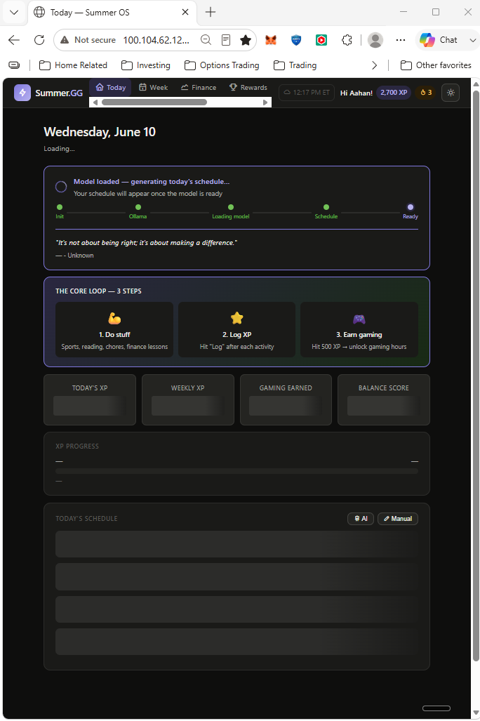
THE PROBLEM IT SOLVES |  | 2/10
Endless gaming. No structure. No growth.

Summer break shouldn't mean 12 weeks of unchecked screen time.
Kids need balance. Parents need leverage.

Summer.GG gives both
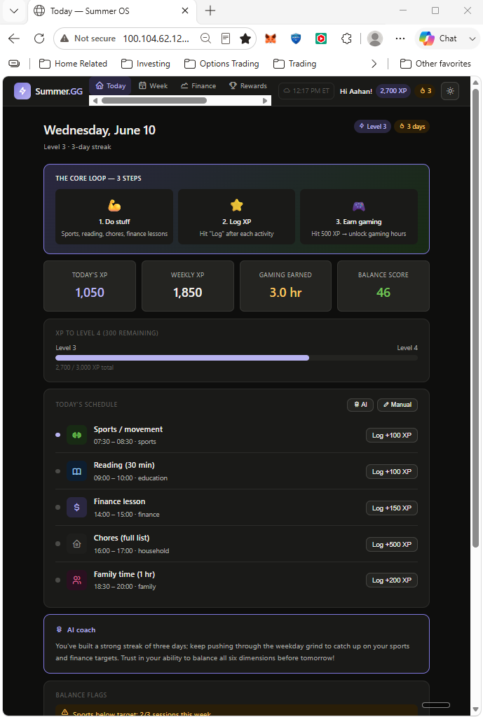

INTRODUCING | 3/10
Summer.GG
An AI-powered summer planner that runs entirely on your home network.

0 ☁️  Cloud dependency | $0/mo  Subscription cost | 11  SQLite tables

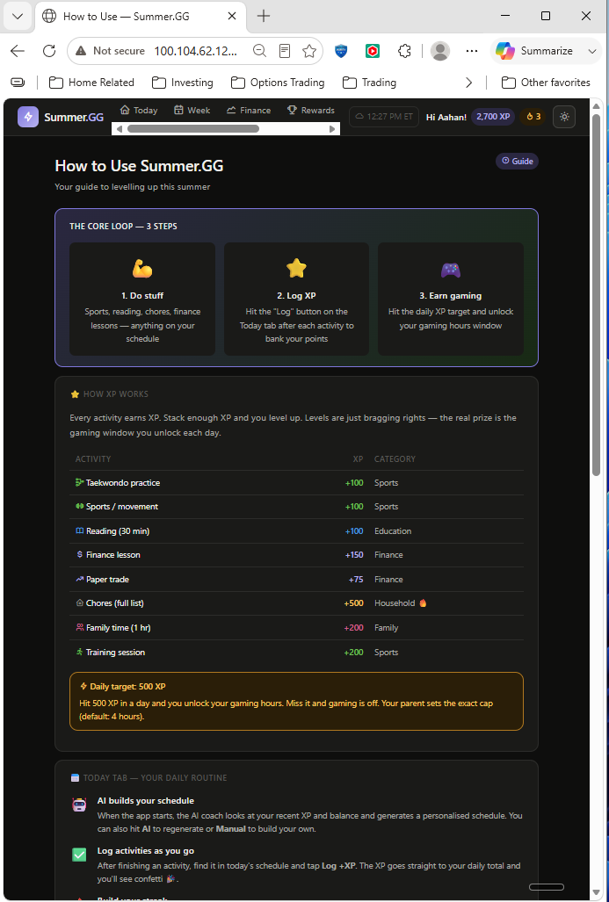

THE XP ENGINE | 4/10
Gaming hours are earned, not given

Complete chores, Taekwondo, reading, family time → earn XP → unlock screen time.

0 XP | 0 hrs gaming
500 XP | 1.5 hrs unlocked
800 XP | 2.5 hrs unlocked
1000 XP | 4.0 hrs unlocked

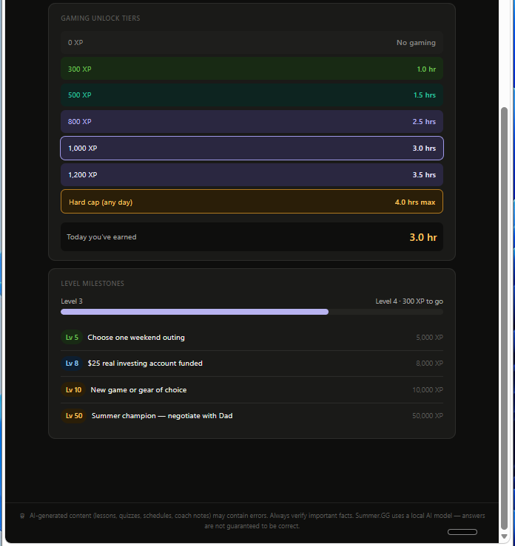

LOCAL AI SCHEDULER | 5/10
A new personalized plan every morning

Powered by Ollama (local LLM). Adapts based on XP, streaks, and balance flags. No data leaves your machine.
Detects imbalances . Auto-rebalances . Streak tracking . Gaming overrun alerts

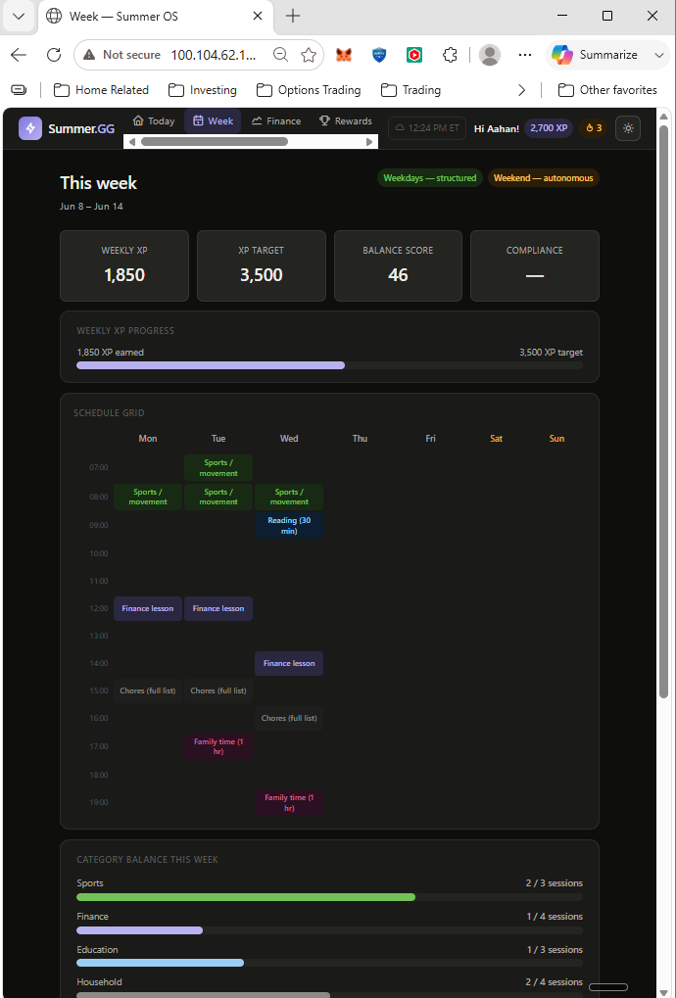

FINANCE MODULE | 6/10
Financial Learning
3-tier financial literacy track with AI-generated lessons, quiz gates, and live paper trading via yfinance.

Tier 1 | Budgeting · Savings · Compound Interest · Credit
Tier 2 | Stocks · P/E Ratio · Chart Reading · Stop-Loss
Tier 3 | Screeners · Technical Signals · Options Intro

 | 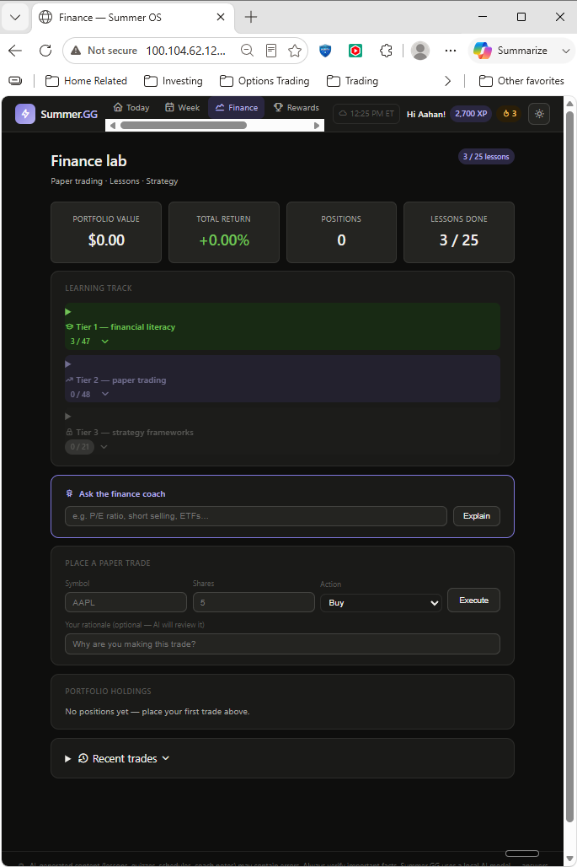
PARENT DASHBOARD |  | 7/10
Parents get full visibility and full control

🔐 PIN-gated — kids can't tamper
📈 XP → real pocket money conversion
🤖 AI weekly balance & flag reviews
⚙️ Override gaming caps & XP rates
🗑️ Selective reset — wipe only what you choose

 | 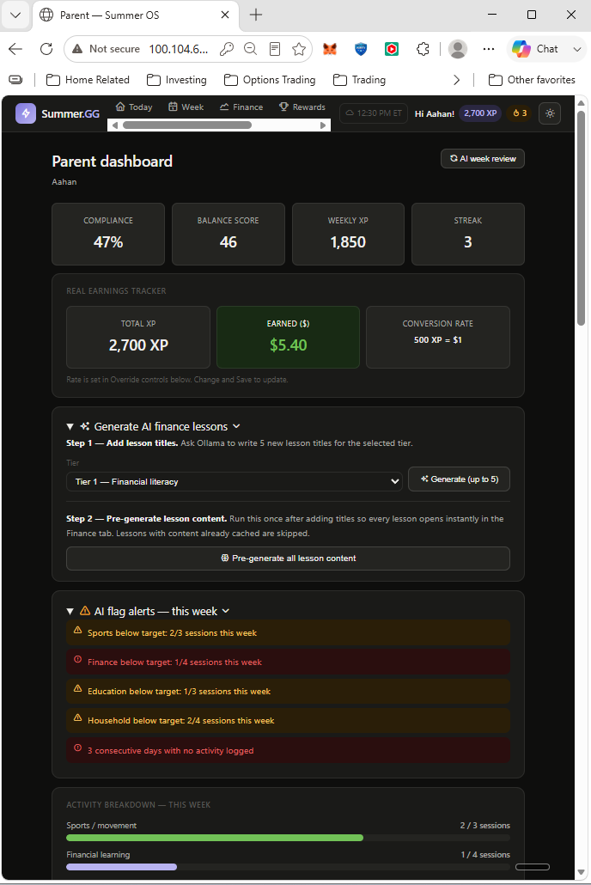
IN ACTION |  | 8/10
Dashboard & Daily Schedule



IN ACTION | 9/10
Paper Trading

Not real money. Real financial learning. Pulls live quotes from Yahoo Finance to simulate trades. AI coach reviews and opines on your investment thesis.



SUMMER.GG | 10/10
Attempts to solve a real-life problem every parent faces.

Drop a comment if you want to check out the GitHub repo.

Built by Pranay

#BuildInPublic #AI #LocalLLM #Parenting #Python

Follow for more builds like this →

