**GAME DESIGN DOCUMENT**

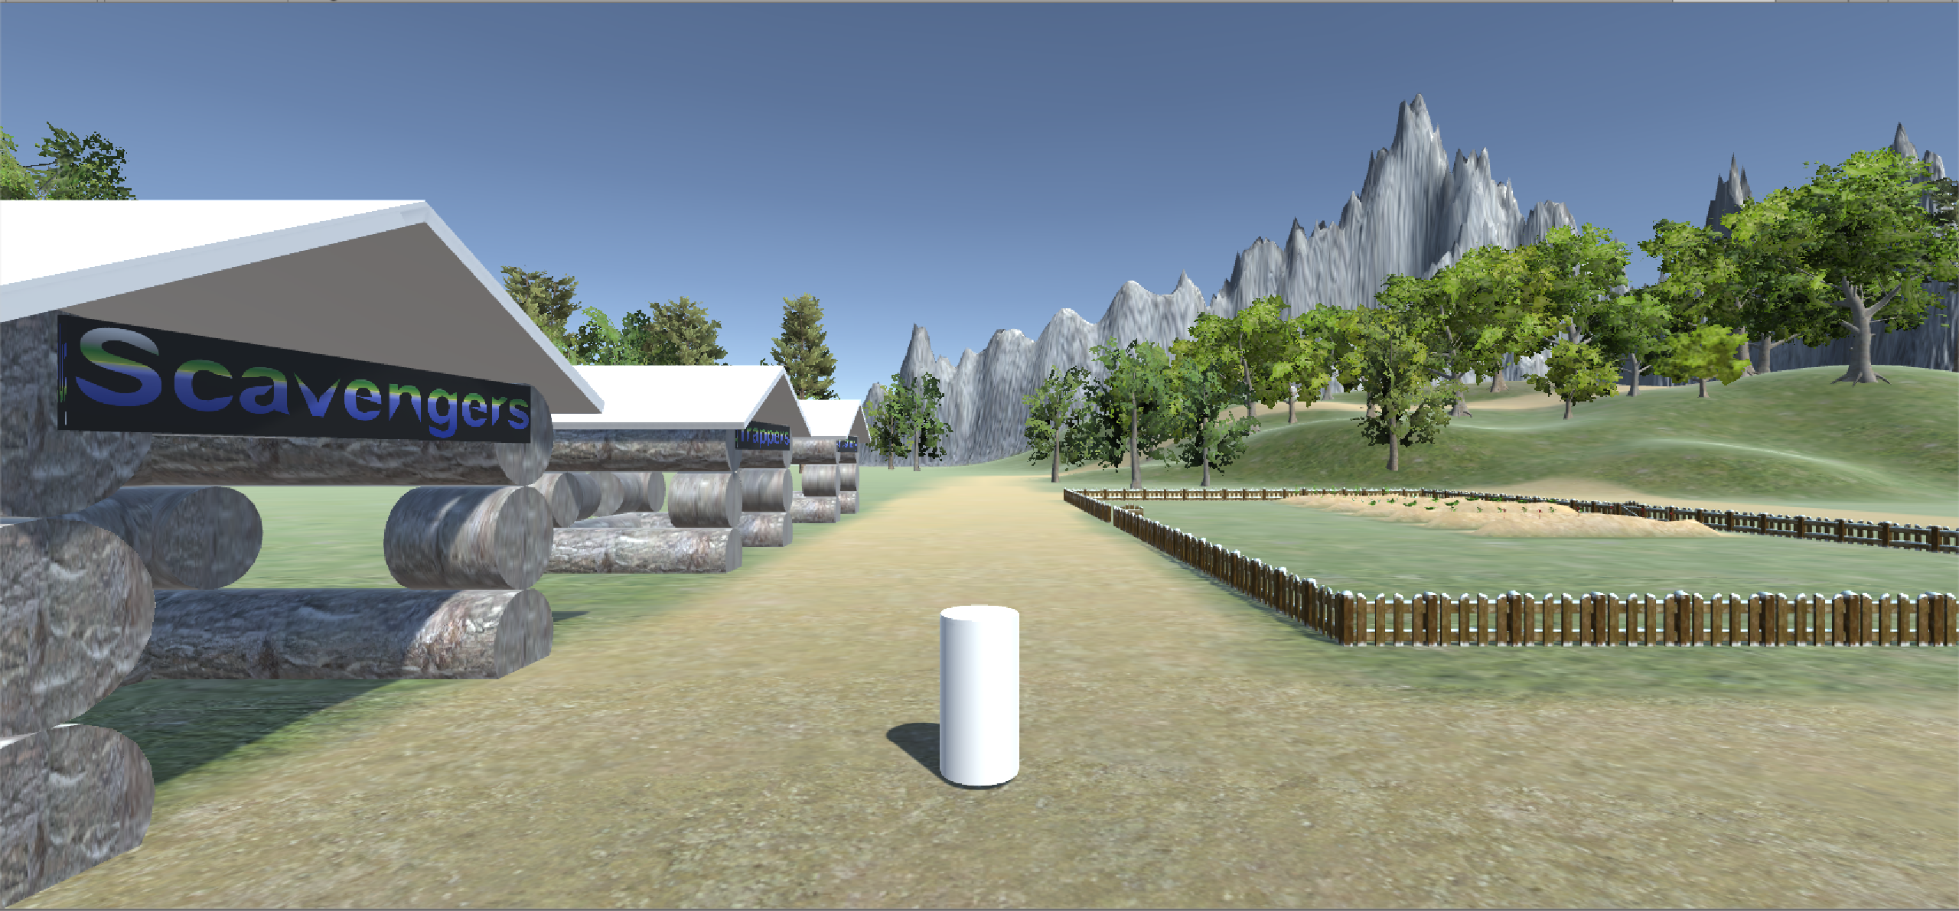

HappyVillageGoFunTime

Happy Village

**Last Updated:**

11/23/2018

**Prepared By:**

Josh Cove

Curtis Beesley

**TABLE OF CONTENTS**

Game Analysis 3

Mission Statement 2

Genre 2

Platforms 2

Target Audience 2

Control Scheme 2

# Mission Statement

Happy Village is an open world RPG on which the player will have to keep a small village alive. The Player will select a villager activating that villager’s Tasks.

# Tasks

Tasks are daily chores the player will have to complete.

Tasks include – fishing, hunting.

# Stretch Tasks

- Gathering water for each home

- Boating

- Chop wood for each home

# Genre

RPG.

# Platforms

Pc only. (possibly a smaller version for mobile)

# Target Audience

This game will target a wide range of players. The game will be simple keeping it unrealistic leaving it open to kids and young adults.

**Control Scheme**

Hunter:

F – throw spear

WASD – movement

Right click – camera movement

Space – Jump

Fisher Man:

WASD – movement

Left Shift – Stab Fish

Space – Jump

Right Click – Camera Movement