**GAME DESIGN DOCUMENT**

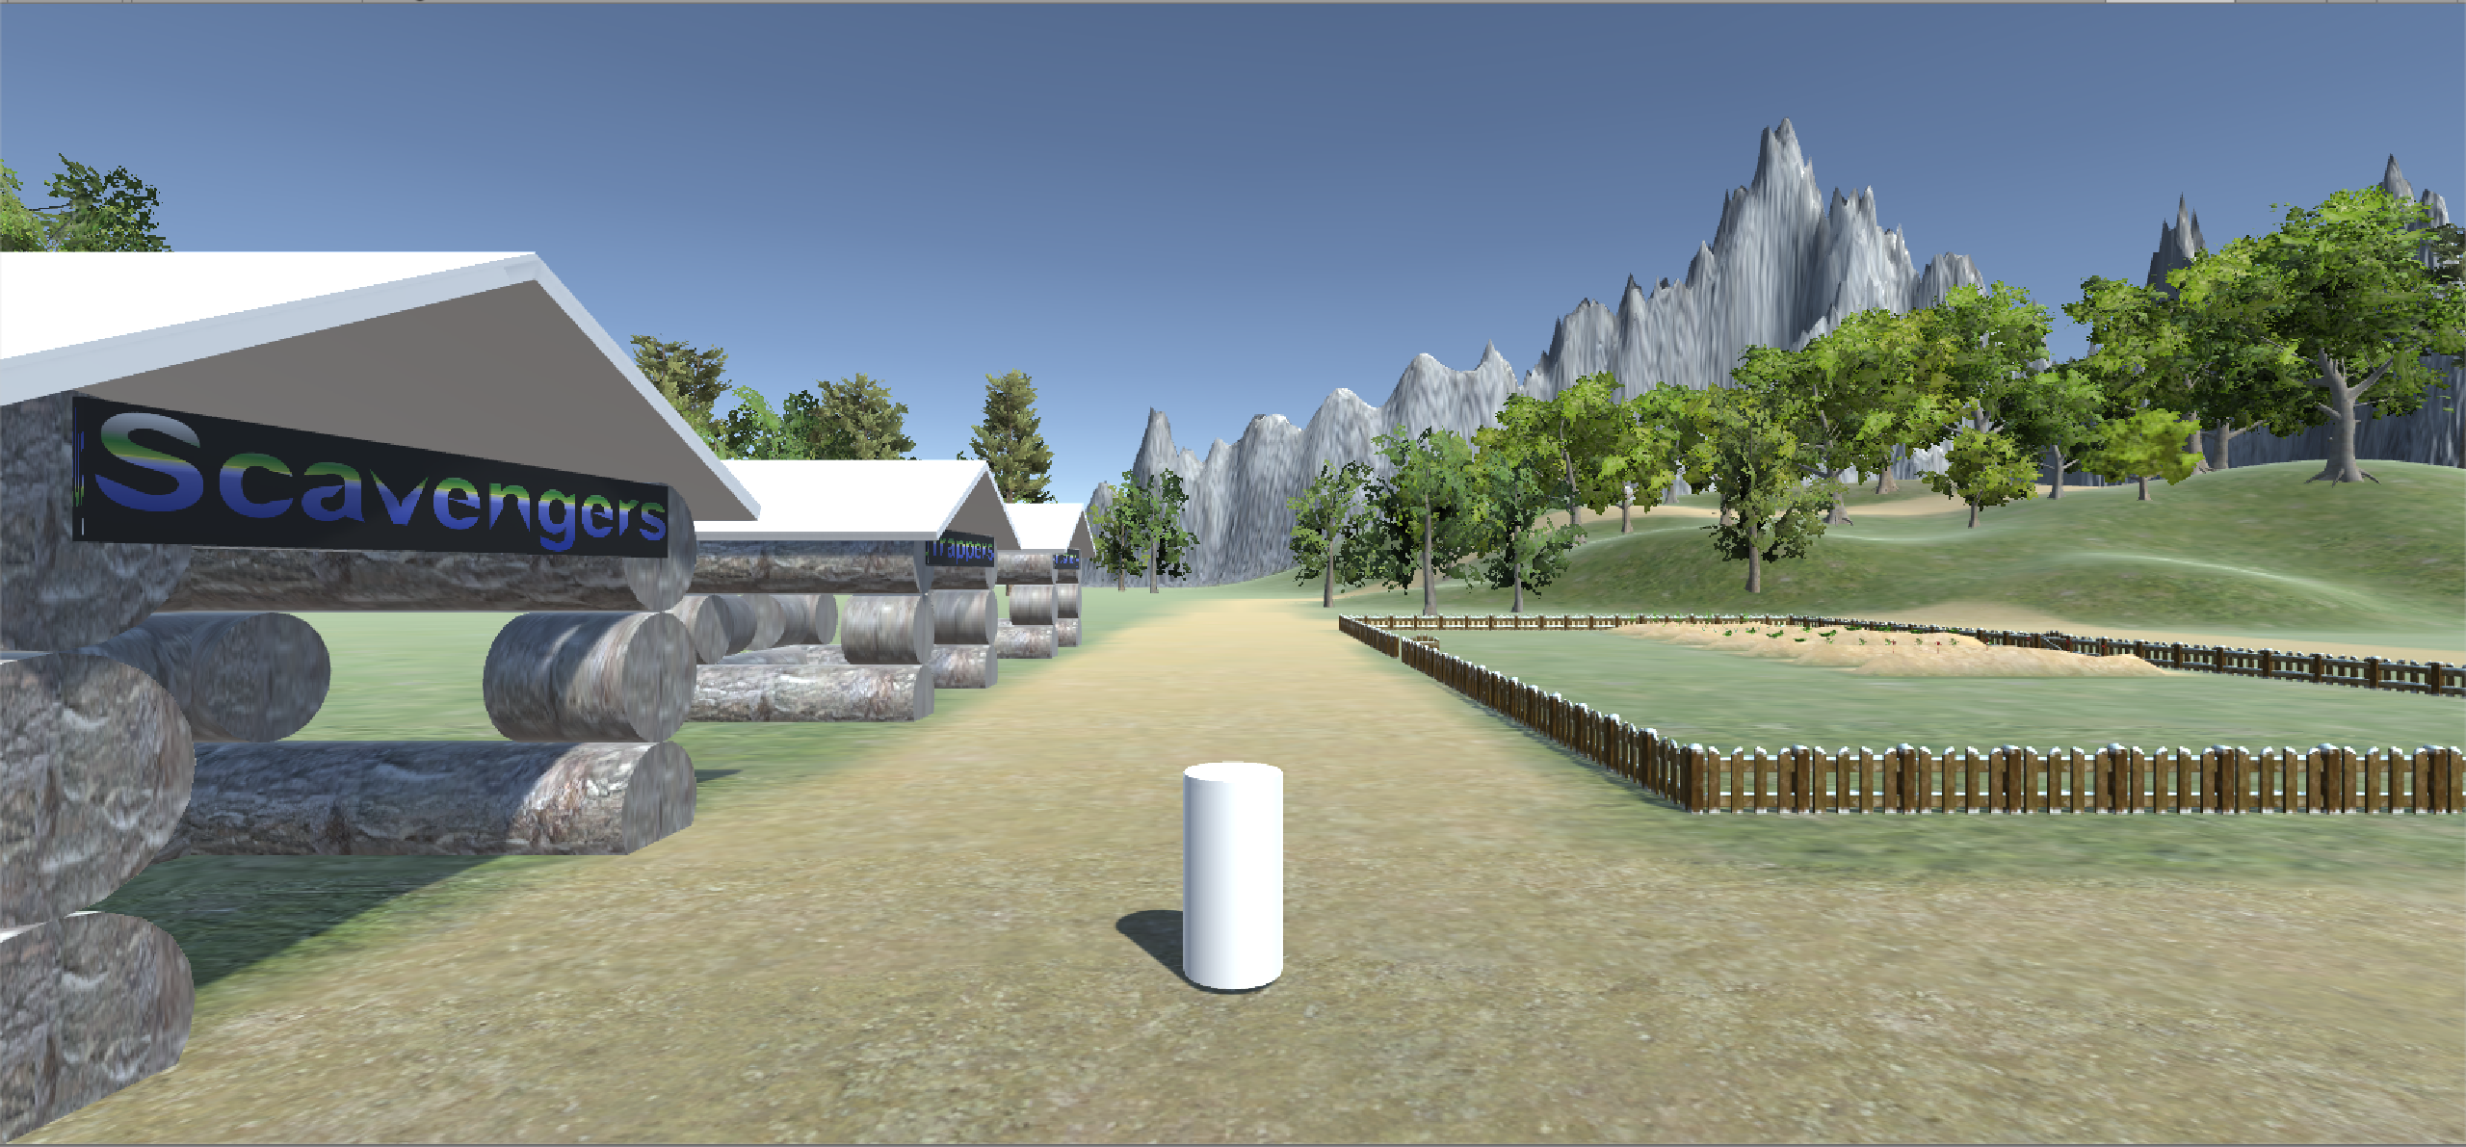

Happy Village

**Last Updated:**

11/23/2018

**Prepared By:**

Josh Cove

Curtis Beesley

**TABLE OF CONTENTS**

Game Analysis 3

Mission Statement 3

Genre 3

Platforms 3

Target Audience 3

Control Scheme 4

PLAYABle Characters 5

Level layout 6

# Mission Statement

Happy Village is an open world RPG on which the player will have to keep a small village alive. The Player will select a villager activating that villager’s Tasks. The village homes will consume food and fire wood on a daily basis. The player will need take control of each playable villager each day to supply every home with the resources required. If the homes are not maintained villagers can die if forgotten for too long.

# Tasks

Tasks are daily chores the player will have to complete.

Tasks include – fishing, hunting, chop trees, plant trees, mine stone.

# Stretch Tasks

- Gathering water for each home

- Boating

# Genre

RPG.

# Platforms

Pc only. (possibly a smaller version for mobile)

# Target Audience

This game will target a wide range of players. The game will be simple keeping it unrealistic leaving it open to kids and young adults.

**Control Scheme**

Hunter:

F – throw spear

WASD – movement

Right click – camera movement

Space – Jump

Fisher Man:

WASD – movement

Left Shift – Stab Fish

Space – Jump

Right Click – Camera Movement

Minor:

WASD – movement

Left Shift – swing pick axe

Space – Jump

Right Click – Camera Movement

Tree Harvester:

WASD – movement

Left Shift – swing axe

Space – Jump

Right Click – Camera Movement

Resource collector:

WASD – movement

F Key – Pick-up Materials

Space – Jump

Right Click – Camera Movement

# Playable Characters

Hunter:

The Hunter’s Task in happy village is to venture into the woods and hunt whatever prey he wishes. The hunter will need to supply the homes with the meats he collects.

Fisher Man:

The fisherman’s main task in Happy Village is to spear fish at local ponds and streams. He will then place the fish in barrels outside of local homes.

Minor:

The Minor’s main task in Happy Village is to travel to the mine and collect stone for the villages future upgrade ability (building new homes). The resource collector will be responsible for taking stone in to town each day

Tree Harvester:

The tree harvester’s responsibilities include cutting down trees and dispersing wood to all the village homes for the cold nights.

Resource Collector:

The resource collector will wander around from mine to woods in search of supplies such as wood and stone. The resource collector has a large inventory and will make dispersing wood to homes faster and easier.

# Level Layout

Pond:

Woods:

Village:

Mine: