**NCP Project Review 0**

**GROUP NUMBER: 4**

|  |  |  |
| --- | --- | --- |
| S.No | Name | Roll Number |
| 1 | Ajay Pranav | CB.EN.U4CSE17606 |
| 2 | Mathana Kumar S | CB.EN.U4CSE17635 |
| 3 | Mithila M | CB.EN.U4CSE17638 |
| 4 | Janardhana Reddy | CB.EN.U4CSE17639 |
| 5 | Muthu Kumaran SK | CB.EN.U4CSE17641 |
| 6 | Sai Sanjay S | CB.EN.U4CSE17654 |

Project title : **Higher Studies/Competitive Exams**

**ABSTRACT**

This project aims to develop an application that helps to ease the process of information attainment regarding higher education. The importance of higher education is something that is very apparent. It paves a way to a prosperous career and innately improves the quality of life. A proper higher education shapes one’s career and there are many factors regarding this. Deciding the ideal university will normally involve a lot of hassle owing to multiple factors. This web application helps to reduce the hassle by reducing the effort required to gain information regarding it by including an amalgam of specifications in a single webpage.

There are multiple, sequential modules. A login-register feature for the user(student in this case) to get a more personalized blend of information. Evidently, the user has to log in every time to access the application. The user can then go on to select a stream of their interest(Science, Finance, etc.) and the country of their choice. Based on the respective choices, the user has the option to select examinations or universities based on their choices. They can then select an examination/university and gain basic information about it. There are additional features that involve a rank/college predictor which returns the possible university based on the marks obtained. A reminder feature which reminds the user regarding upcoming opportunities based on their interests and much more. The basic static information display along with dynamic support establishes an easy and efficient way to make decisions regarding the career-defining component that is Higher Education.

**WEB DESIGNING COMPONENTS**

Front-end technologies involved:

1. HTML
2. CSS
   * Framework: Bulma CSS
3. Vanilla JavaScript

Back-end technologies involved:

1. JSP
2. MySQL DB

**HTML**: HTML (HyperText Markup Language) is the most basic building block of the Web. It defines the meaning and structure of web content. They can include writing, links, pictures, and even sound and video. HTML is used to mark and describe each of these kinds of content so the web browser can display them correctly.

**CSS**: Cascading Style Sheets (CSS) is a simple mechanism for adding style (e.g., fonts, colors, spacing) to Web documents. CSS is designed to enable the separation of presentation and content, including layout,colour and fonts. This separation can improve content accessibility, provide more flexibility and control in the specification of presentation characteristics.

**JS**: JavaScript (JS) is a full-fledged dynamic programming language that can add interactivity to a website. JavaScript is also commonly used in server-side programming through platforms like Node.js, or "embedded" in non-JavaScript applications where the base programming language lacks the high-level functionality that JavaScript offers.

**JSP**: Java Server Pages (JSP) is a server-side programming technology that enables the creation of dynamic, platform-independent methods for building Web-based applications. JSP has access to the entire family of Java APIs, including the JDBC API to access enterprise databases.

**DESIGN DIAGRAM**

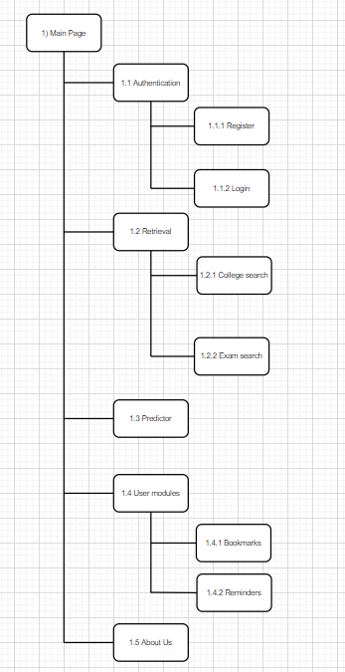

**IMPLEMENTATION**

**Screenshots**

1. **Register Screen**

* Serves as a user data collection point for receiving reminders.

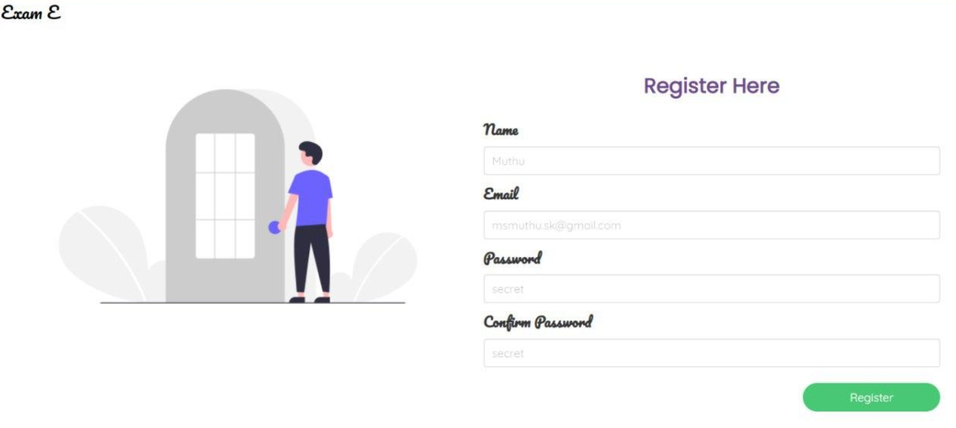

1. **Login Screen**

* Credentials checked and user entry allowed.

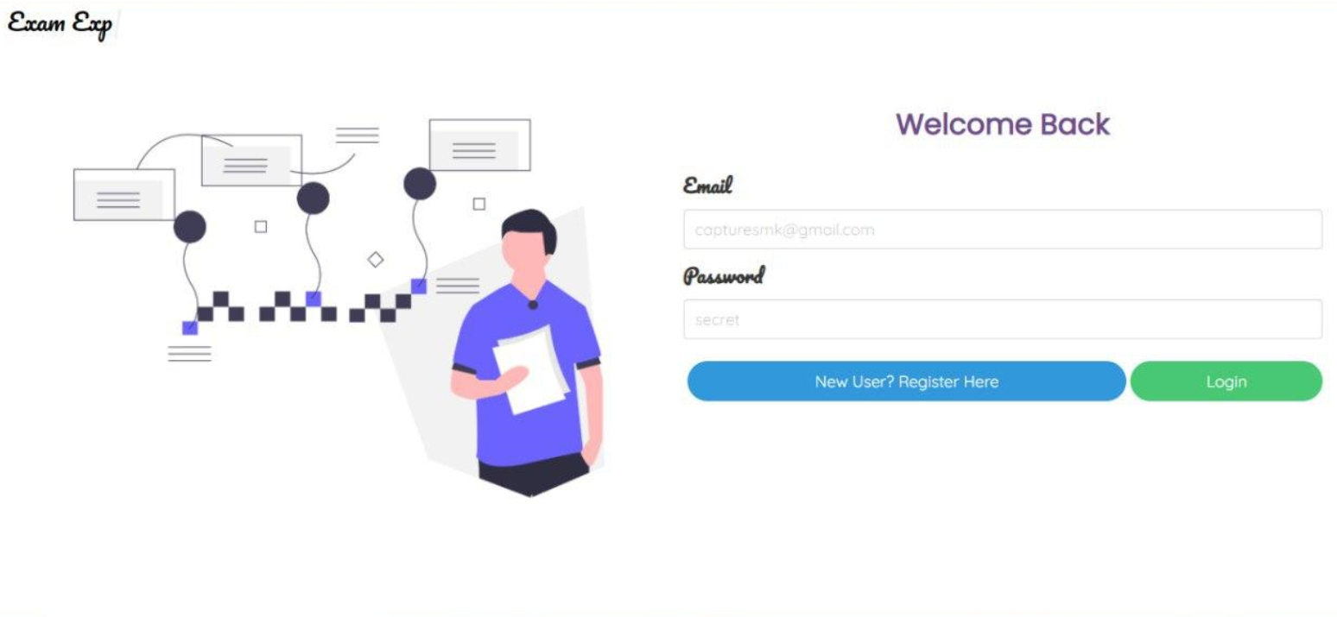

1. **Dashboard Screen**

* Contains 4 main components of the WEB APP: Bookmarks, Searching courses, exams and rank predictor.

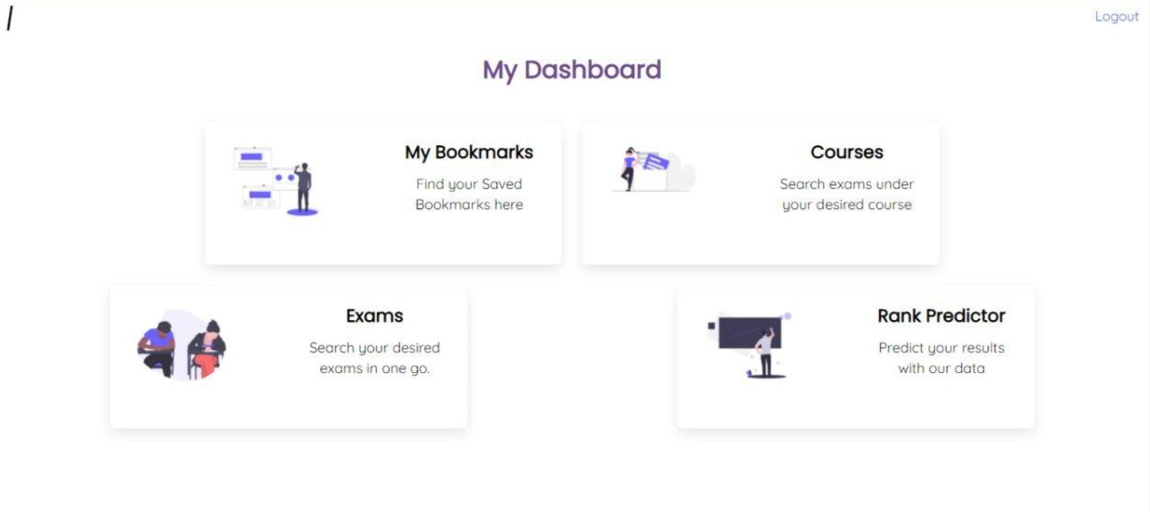

**Code Snippets: Dashboard Segment**

<body>

<nav class="navbar is-transparent is-fixed-top" role="navigation" aria-label="main navigation" id="navbar">

<div class="navbar-menu is-active">

<div class="navbar-start">

<!-- navbar items -->

<div class="navbar-item" id="navtext"></div>

</div>

<div class="navbar-end">

<div class="navbar-item">

<a href="" id="logout">Logout</a>

</div>

</div>

</div>

</nav>

<section class="section">

<div class="mainhead has-text-centered">

My Dashboard

</div>

<div class="columns">

<div class="column is-4 is-offset-2">

<div class="box">

<div class="columns">

<div class="column is-6">

<figure class="image is-128x128">

<img src="../assets/bookmark.png">

</figure>

</div>

<div class="column has-text-centered col-head">

My Bookmarks

<div class="col-text">

Find your Saved Bookmarks here

</div>

</div>

</div>

</div>

</div>

<div class="column is-4">

<div class="box">

<div class="columns">

<div class="column is-6">

<figure class="image is-128x128">

<img src="../assets/course.png">

</figure>

</div>

<div class="column has-text-centered col-head">

Courses

<div class="col-text">

Search exams under your desired course

</div>

</div>

</div>

</div>

</div>

</div>

<div class="columns">

<div class="column is-4 is-offset-1">

<div class="box">

<div class="columns">

<div class="column is-6">

<figure class="image is-128x128">

<img src="../assets/exam.png">

</figure>

</div>

<div class="column has-text-centered col-head">

Exams

<div class="col-text">

Search your desired exams in one go.

</div>

</div>

</div>

</div>

</div>

<div class="column is-4 is-offset-2">

<div class="box">

<div class="columns">

<div class="column is-6">

<figure class="image is-128x128">

<img src="../assets/prediction.png">

</figure>

</div>

<div class="column has-text-centered col-head">

Rank Predictor

<div class="col-text">

Predict your results with our data

</div>

</div>

</div>

</div>

</div>

</div>

</section>

<!--Scripts ARENA-->

<script src="https://unpkg.com/typewriter-effect@latest/dist/core.js"></script>

<script>

var app = document.getElementById('navtext');

var typewriter = new Typewriter(app, {

loop: true

});

typewriter.typeString('Exam Experts')

.start();

</script>

<!--Scripts ARENA Ends-->

</body>