# Final Project Report

## Project Title: Trending Video Classifier using YouTube Public Datasets

### 1. Features Implemented in Trending Video Classifier

- Cleaned dataset by removing missing data  
- Created a new column 'trending' based on view count  
- Selected key features: views, likes, comment count  
- Trained a machine learning model to classify videos  
- Evaluated the model using accuracy score  
- Performed basic visual analysis for trends

### 2. Tech Stack Used

• Language: Python  
• Platform: Jupyter Notebook  
• Libraries: Pandas, NumPy, Matplotlib, Scikit-learn  
• Dataset: trending_videos.csv (from Kaggle)

### 3. Project-Related Diagrams

Below are the visual diagrams used in this project:

🔸 Flowchart

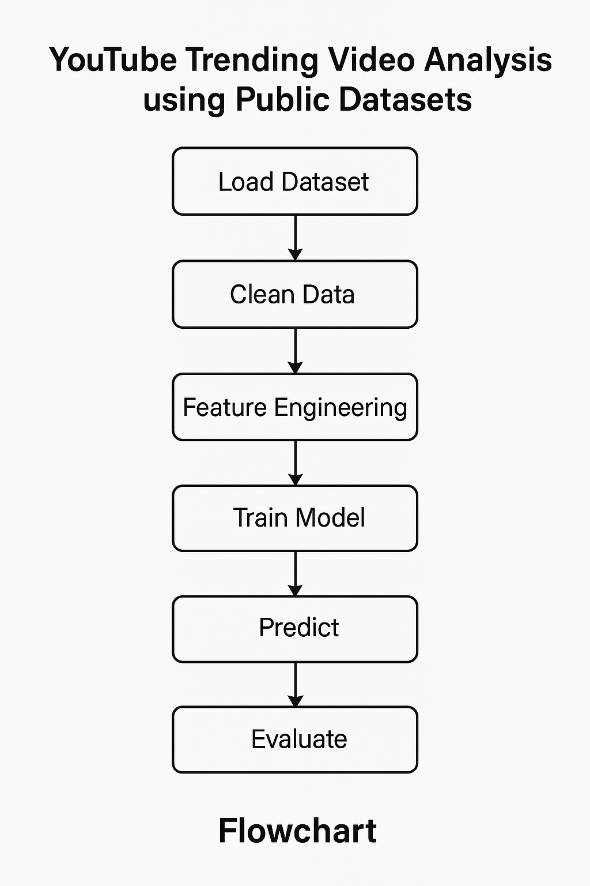

🔸 System Architecture

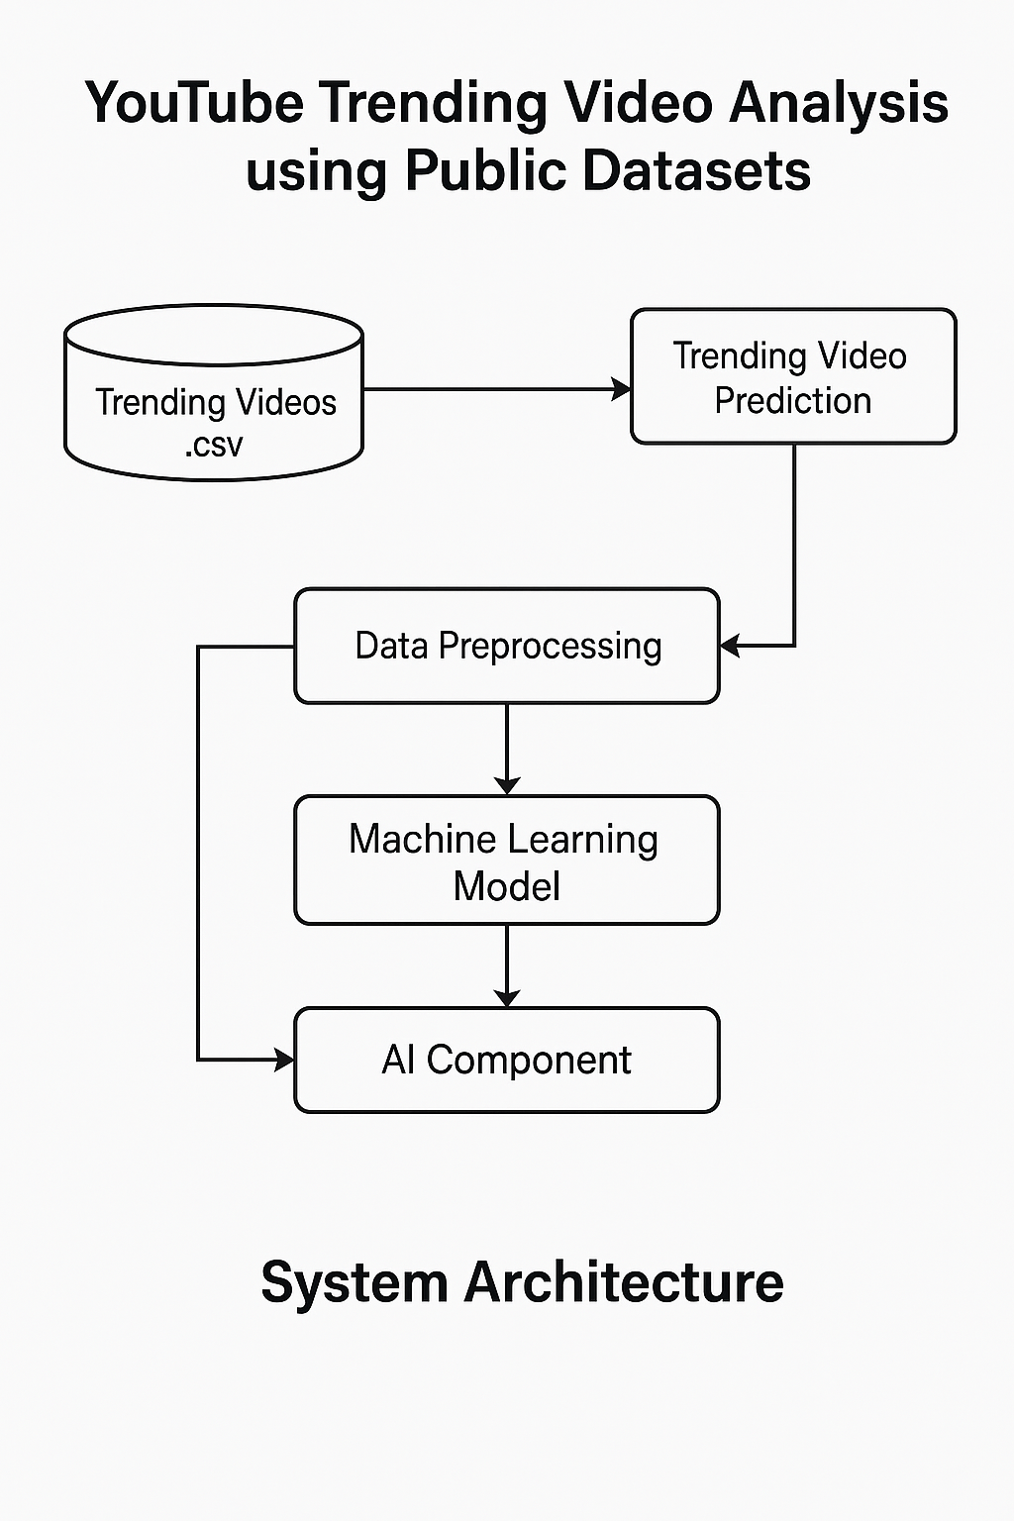

### 4. AI Module Details

• AI was used in this project.  
• A Random Forest Classifier was trained to predict whether a video is trending.  
• The model used 'views', 'likes', and 'comment_count' as input features.  
• This helped in identifying important trends from the dataset.

### 5. Insights and Outcomes

This project showed how machine learning can predict trending videos using public YouTube data. The model gave accurate results and highlighted key factors like views, likes, and comments that influence trends.