Jayson Boubin

July 2017

Feel free to contact me about this program here:

[boubinjg@miamioh.edu](mailto:boubinjg@miamioh.edu)

[boubin.2@osu.edu](mailto:boubin.2@osu.edu)

Fault Injector Documentation

Fault Injector is a program which triggers fail safes in fixed wing ardupilot mega aircraft in SITL using dronekit, mavproxy, and mavlink. It can be easily modified to inject failures into other craft that can be simulated in SITL, or to change any variables in the vehicle or simulation over mavlink.

Fault Injector is a python program which runs in python 2.7, due to the versions of dronekit and pymavlink. To run Fault Injector, you must have the following libraries installed: dronekit, pymavlink, and Tkinter. Dronekit and pymavlink handle communication with the vehicle and interaction with the simulated environment. Tkinter handles the Graphical User Interface.

You can run this program in any environment that supports the above libraries. It was developed on Linux, but will work in a Windows or Mac environment, given you have all necessary programs installed.

The fault injector interface is broken into three parts:

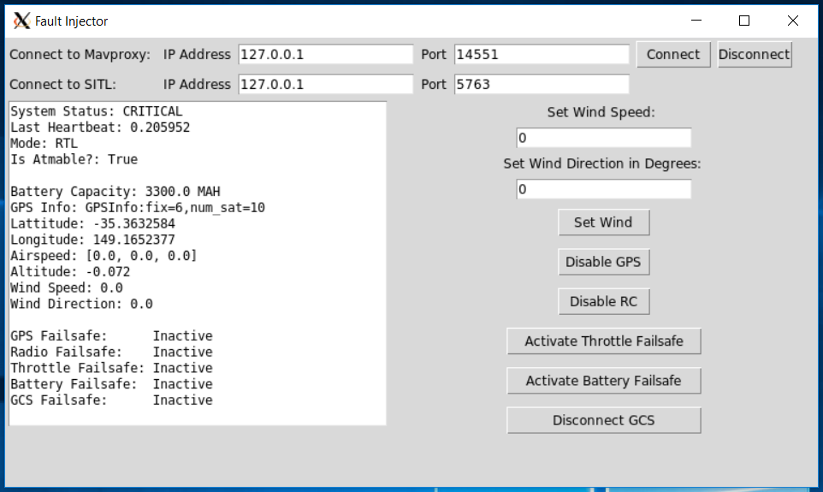

Connection interface: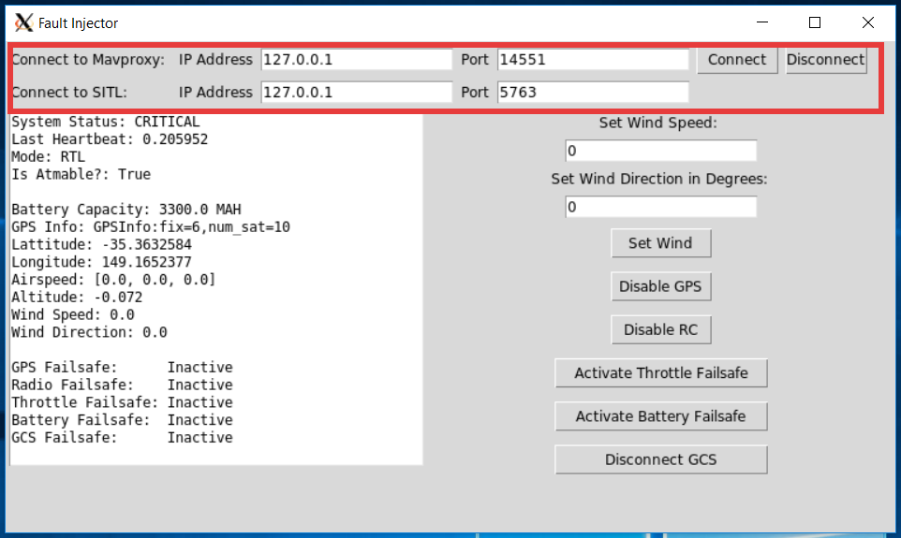

To connect to a vehicle, you must provide the vehicle’s SITL ip address and port number, as well as a Mavproxy ip address and port connected to the same SITL instance. The default values are shown above. These values are valid if you are running SITL and Mavproxy on the same machine as Fault Injector, and are using a Mavproxy port for a ground station, and a SITL port for Mavproxy. By hitting the connect button, connections to Mavproxy and SITL are initiated. After successful connections, your readout window should start displaying information about your vehicle. To disconnect from your vehicle, simply hit the disconnect button. This terminates the connections.

Fault Buttons

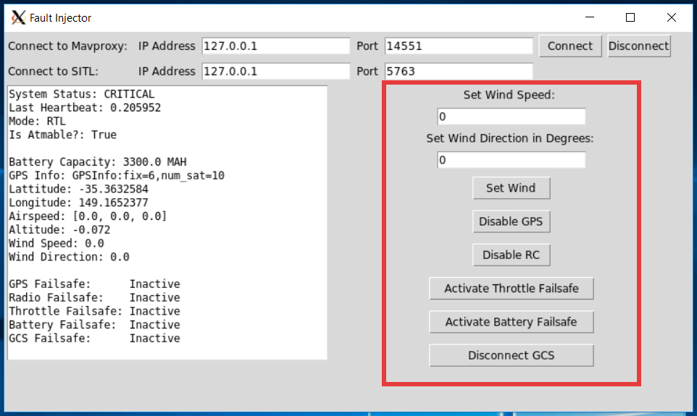

The fault buttons have a number of capabilities. You can inject wind into your simulation, or activate certain fail safes at the click of a button. The fault buttons have these functions:

Wind injection:

You can set the wind in the simulation by providing Fault Injector with wind direction and wind speed. Wind direction is in degrees from north in the direction the wind is blowing. For example, a 0 degree wind direction will cause the wind to blow directly north. A 10 degree wind direction will cause the wind to blow slightly to the right of north. The wind speed box takes a number representing the wind speed in meters per second.

GPS malfunction:

SITL allows for the simulation of GPS failure. To simulate GPS failure using SITL simulation variables, you can use the GPS fault button. This will initiate a GPS failsafe, and should result in considerable drift of your aircraft.

RC disconnection:

SITL also allows for the simulation of complete disconnection of RC. SITL simulates RC disconnection itself using one of its internal environment variables, set by Fault Injector. This will activate the RC failsafe.

Throttle malfunction:

Fault Injector can emulate throttle malfunction by changing the vehicle’s internal throttle PWM failsafe value. Pressing this button should trigger a throttle PWM failsafe.

Battery drain:

Fault Injector can emulate a battery failure by changing the vehicle’s battery capacity failsafe value. Your SITL instance may or may not incorporate battery burndown depending on configuration. This failsafe will trigger even so, by setting the battery failsafe value above the max MAH of the configured battery.

Ground Control Station disconnection:

Fault Injector can disconnect vehicles from their ground stations, while still allowing the ground stations to communicate with the vehicle. By changing the vehicle’s ground station ID number, Fault Injector limits the vehicle’s ability to communicate with a ground station, while still allowing the ground station to communicate in the simulated environment.

All fail safe buttons are toggles, meaning you can turn the failsafes on and off.

Readout Pane

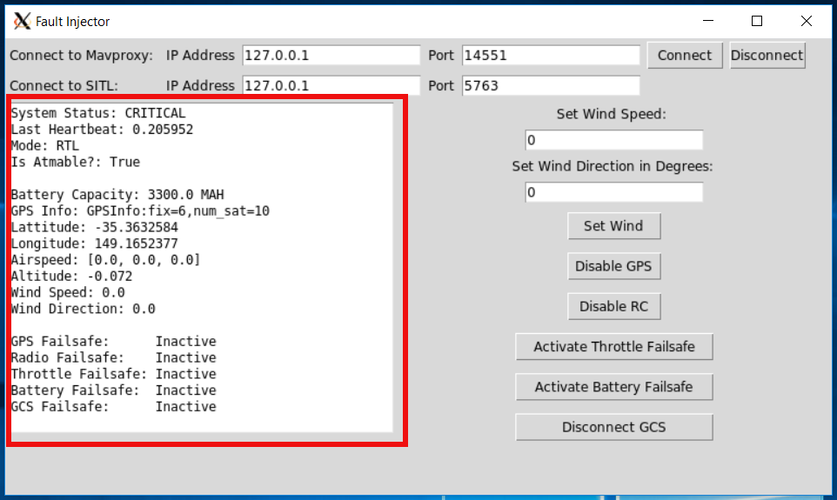

The readout pane provides information about the vehicle in SITL. As seen above, the pane includes information on the system, such as it’s current status, last heartbeat, and mode. There is also information about the system’s current battery, gps status, location, speed, altitude, and wind conditions.

The lower section of the pane denotes whether certain failsafes are active.