- Data visualizations are important tools for communication and convincing; we need to be able to evaluate the ways that data are presented in visual form to be critical consumers of information
- To test your evaluation skills, locate two public data visualizations online, one good and one bad
  - You can find data visualizations at https://public.tableau.com/app/discover or https://datavizproject.com/, or anywhere else you like!
- For each visualization (good and bad):
  - Explain (with reference to material covered up to date, along with readings and other scholarly sources, as needed) why you classified that visualization the way you did.
- How could this data visualization have been improved?

- Word count should not exceed (as a maximum) 500 words for each visualization (i.e. 300 words for your good example and 500 for your bad example)
Bad Data Viz: (Admittedly nonsensical) UFO sightings on Tableau
https://public.tableau.com/app/profile/caroline.swiger/viz/Unidentified30YearsofUFOSightings/Unidentified
Reported UFO Sightings are on the Rise Figure 2: “By Year”
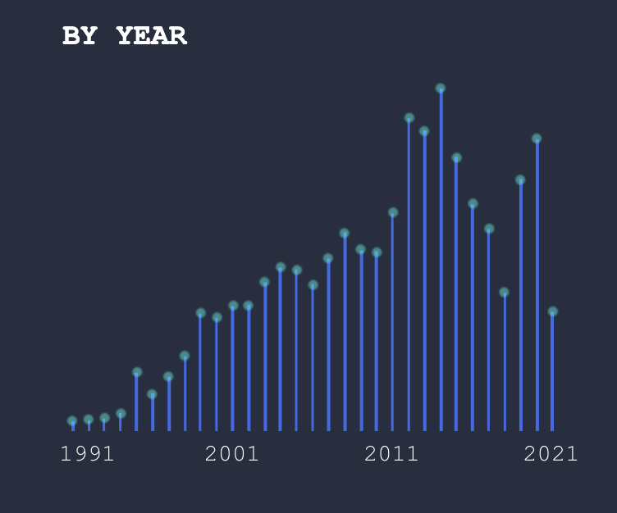
I decided to have some fun with this assignment and chose a data visualization on a topic that I know is outlandish (UFO sightings). Below are my assessments of this visualization, based on the criteria discussed in class.
The visualization has some nice features:
Aesthetic: I do actually think this visualization is pretty. The colors evoke the night sky, which is a nice touch given the topic.
Additionally, the clean layout, geometric shapes and lines, and 2D image increases perceived the factual basis of this image. However, the lack of a cited reference at the bottom reduces it.
The choice of a simple bar plot helps minimize the cognitive load of this visualization.
However, I think the visualization has several problems:
Perceptual: The intended point that UFO sightings are on the rise is not a clear trend across all 30 years. The numbers increase steadily until the mid-2010s, and then there is a more varied patter.
Substantive: I think the data is presented in a way that can be difficult to understand. Problems include:
- No clear y-axis labels. If a reader wants to figure out what the y axis scale is, they can hover over the graph to get the information, but having to do so and remember those values increases the cognitive load for this visualization.
- I also think the lack of y-axis labels detracts from the credibility of this visualization, especially given that the nearby graphs use completely different y-axis scales.
- Reference information is not given. A single reference is provided at the end of the entire Tableau presentation, but data for each figure would be preferable.
- Recalling the Gestalt principles, it would be nice if the figure author used lines or grouping to help make a point. (For example, encircling or labelling the years where they intend to show a steady upward trend in UFO sightings). The chart contains no grouping of objects or lines.

Good Data Viz. Figure 2 on p. 15: https://www.toronto.ca/wp-content/uploads/2024/12/949f-TorontosCurrentandFutureClimate-REPORT-Final.pdf
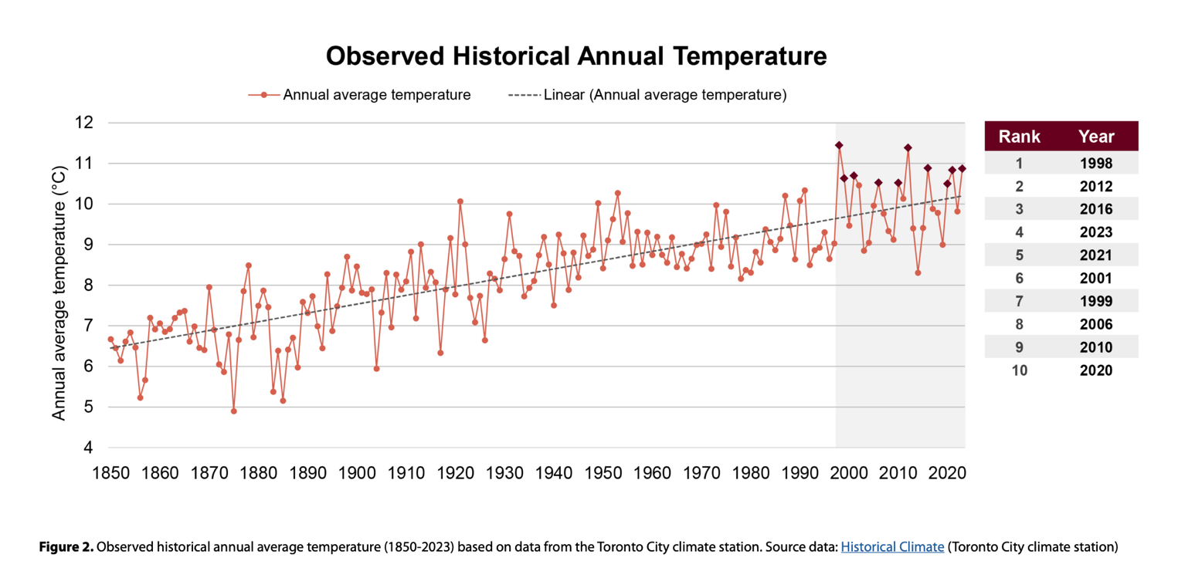
Below are my assessments of this visualization, based on the criteria discussed in class.
Aesthetic: The graph is a little busy, but mostly easy to understand and interpret.
Substantive: Yes, the figure shows clear increase in average temperature over time.
The clean layout, geometric shapes and lines, 2D image, and reference at bottom increase perceived factual basis.
Perceptual: I wish the authors had labeled the x-axis on the plot, but it is pretty easy to infer that the x-axis is years, especially given the plots title. The table on the right side is a nice touch, but adding temperatures to table (in addition to rank and year) would help further illustrate their point.
Gestalt principles: The trend line helps illustrate upward trend over time.Grouping of years 2000 to 2020 further emphasizes high temperatures in recent years.
Cognitive Load: I think the cognitive load of this figure is reasonable. Line plots are common. It did take a little extra mental work to figure out that dark diamonds on plot correspond to the top 10 temperatures and are also the points in the table. Overall, though, this graph makes a clear point very quickly and shows that the average annual temperature in Toronto has been on the rise for over the past ~170 years, as explained in the report text that precedes the figure.

