Workflow to access data on Abyssio server via Research Cloud
Created by: Cara Nissen, Berend Wijers
Latest update: March 13, 2026

Part 1: Accessing and using Research Cloud

- Accept invitation to join Research Cloud team ‘analysing-ocean-model-uva’ which you should have received via email (check your spam folder!)

Landing page after you have logged in (www.sram.surf.nl):
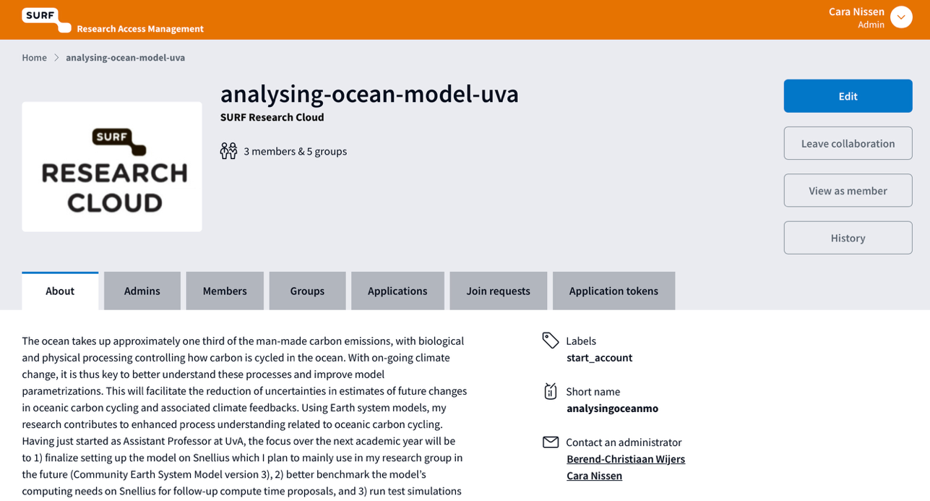

View under ‘Members’ tab:
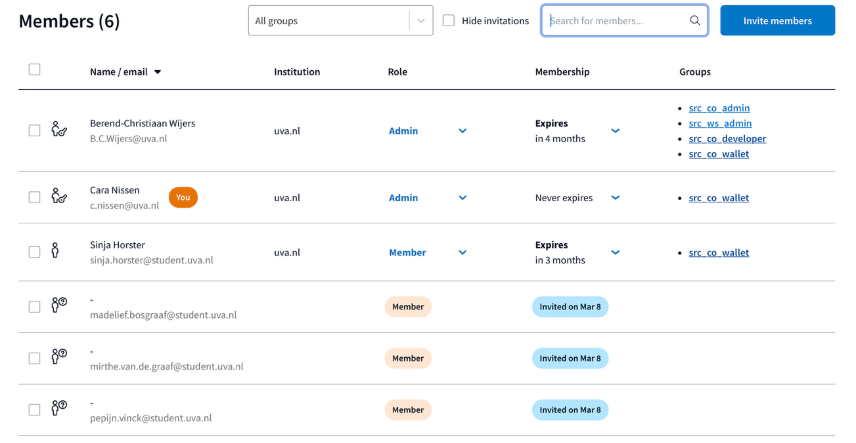

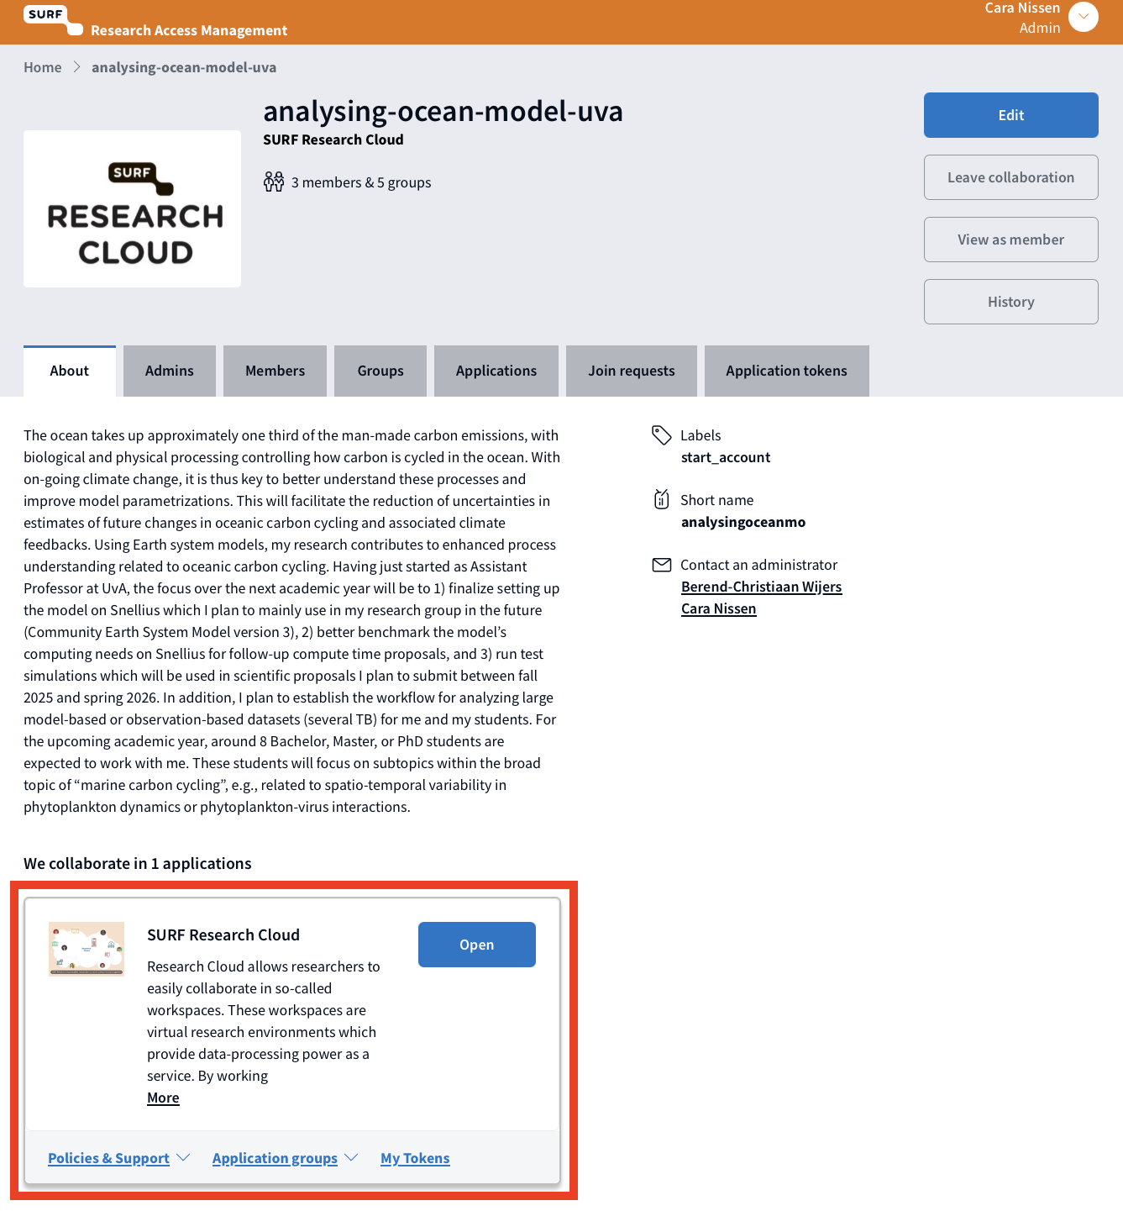
- Access research cloud via button at the bottom of the landing page:

Landing page of Research Cloud:

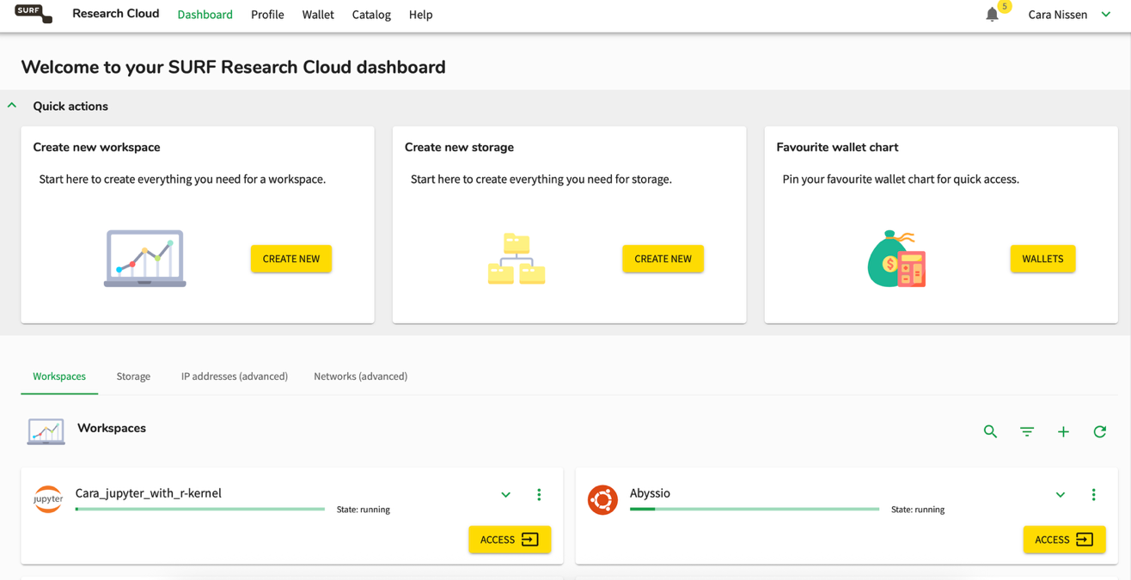
Research Cloud works with virtual machines (so-called “workspaces”) that you can configure according to your needs, e.g., in terms of power/memory, installed software, or attached storage (so-called “storage volumes”).
You will configure your own storage volume and workspace, see steps below.

When being added to Cara’s project, you are automatically added to her wallet. This corresponds to the total budget of computing resources and storage that she has available for the current academic year. These resources were acquired for projects like yours, so feel free to use them. But please be mindful with your resource use as this is a resource shared by all members of her research group.

- Create a storage volume on Research Cloud

A storage volume is where your data and codes can be stored. Be mindful with how much storage you ask for, as this will not be available to other team members. The total project currently has 2TB of storage available. If you are in doubt about how much storage you need, reach out to Cara for guidance.

To get started, a workspace with Ubuntu 22.04 / 1 Core - 8 GB RAM with Jupyter and a storage volume of 50 or 100 GB is all you need.

Naming convention: Please add your first name somewhere in the name of the storage volume

- Create a Research Cloud workspace and start it

When creating a workspace, you need to specify an expiration date. For a start, you could set it to the expected end of your project but note that you can adjust that date at any time. Each workspace comes with some storage, which is meant to be used for the operating system etc. In principle, you can also store your data in this storage, but importantly, when your workspace is deleted, all data stored in the storage coming with the workspace is deleted. This is why every workspace should have a storage volume attached (see step above). Think of this as kept separately from the workspace. You are asked which storage volume you want to attach to the current workspace while creating it, but you can also change that at a later stage. Data and codes stored in storage volumes will survive the deletion of a given workspace and can be re-attached to a new workspace that you create. For example, this could become necessary if you notice half-way through your analysis that you need a more powerful virtual machine than you initially thought.

After creating the workspace, you can start/resume it from your Dashboard. This is when you start using resources from the budget. If you are done with your work (including for longer breaks!), it is important to remember to pause the workspace. Only when you pause the workspace will you stop using resources!

Naming convention: Please add your first name somewhere in the name of the storage volume

For working with R in your project: Choose Jupyter Notebook (not ‘Jupyter Notebook with R-Kernel’)
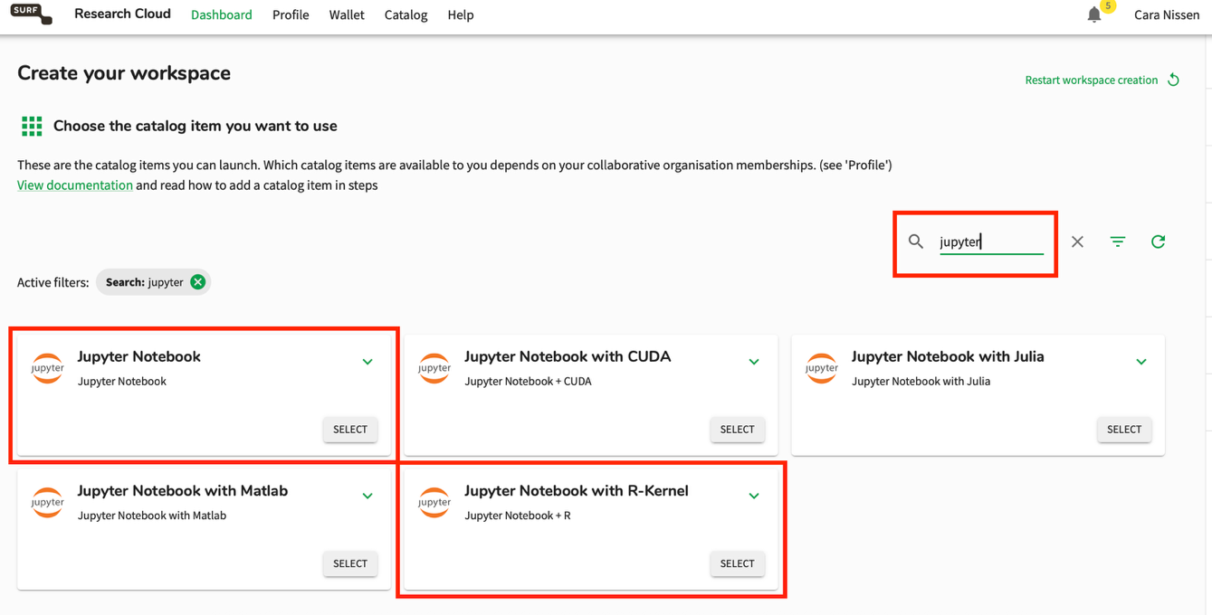

You can pause your workspace and see information about your workspace when clicking on the symbols. This is also where you can edit the expiration date of your workspace:

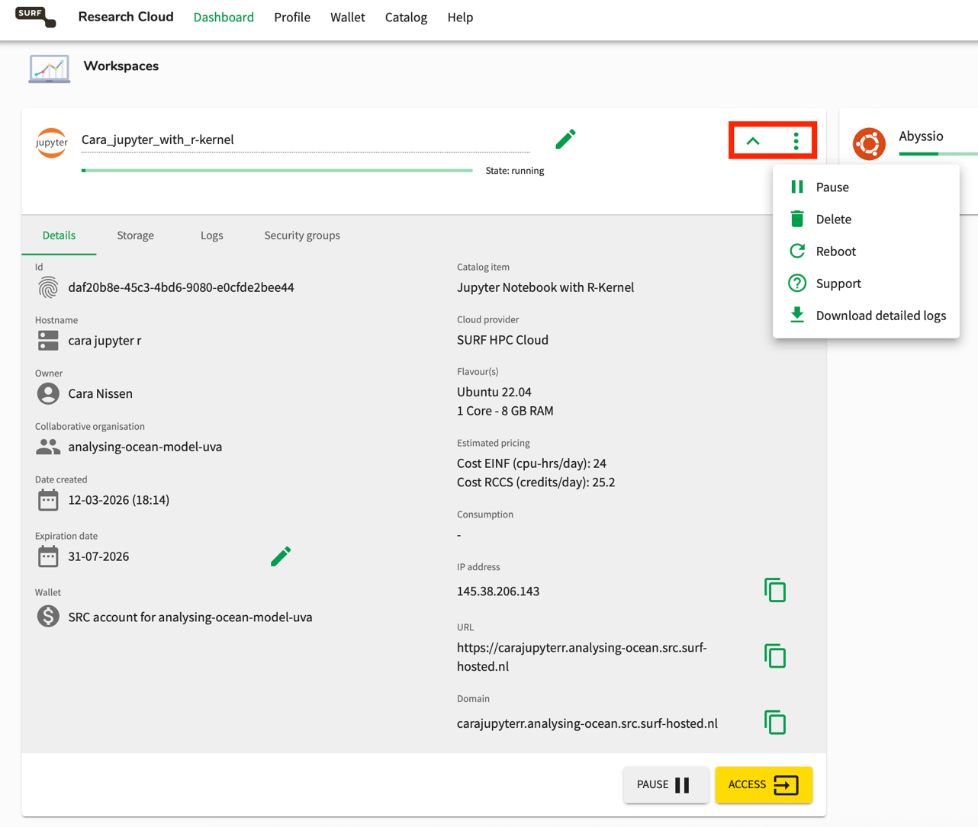

- Once your workspace has been created, click ‘Access’. Jupyter will open in a new window.

Part 2: Connecting to Abyssio server from Research Cloud

Background: One way to work with many people on Research Cloud could simply be that every team member creates their own workspaces and storage volumes. This works well if everybody works on different datasets and as long as the individual datasets are small. However, if some team members work with the same (large) dataset, this approach would mean that duplicates of the same dataset have to be created, as a storage volume can only ever be attached to a single workspace a time. As an alternative approach, Berend has set up the Abyssio server, where the dataset for your projects is stored. This server can be accessed by multiple people at the same time, making it an ideal configuration for your projects. The steps below explain how to interact with the Abyssio server through R on Research Cloud.

- Create a custom kernel to install some R libraries that are needed

A kernel is the engine that will execute your code. So, if you have specific packages you want to use, it makes sense to create your own kernel.
Below is the list of commands. Execute these commands in a terminal (bash). It takes a few minutes before the jupyter launcher recognizes the updates kernels. Give it a few minutes (2-5) for it to update.
If you are still on the landing page of your workspace, click on ‘Terminal’. If you have already opened a notebook, click on the ‘+’ next to the notebook name at the top to re-open the landing page in an additional tab. Run the following commands:
/etc/miniconda/bin/conda init

Close terminal and reopen.

conda create -n rocean -c conda-forge r-essentials
conda activate rocean [start from here if you want to install other packages later on]
conda install -c conda-forge r-ncdf4 libnetcdf [this is only needed once]
R
install.packages(c('aws.s3','IRkernel','getPass', 'ini'))
IRkernel::installspec(name = 'rocean', displayname = 'R-Ocean')
q()

conda deactivate

After waiting a few minutes, your new kernel should appear as a new tile on the landing page. Click on it to start Jupyter with your newly created R kernel.

If you ever wanted to install more packages, you’d follow the above instructions again, with the exception of “conda create…”. Since your rocean kernel already exists, you can start from activating it.

- Create and run the notebook to set up the connection between Abyssio and your Research Cloud Workspace

The Jupyter notebook you need to run can be found here:
https://github.com/cara-nissen/abyssio_notebooks/blob/main/abyssio_r.ipynb

For now, it might be the easiest to copy the different cells one by one.

To run the cell that sets the Abyssio configuration, you need the username (‘access_key’) and password (‘secret_key’) Cara has hopefully sent you via email. Important: Note that the link to the password only works once. Make sure to copy your password to somewhere safe on your laptop!

Now you should be all set!

Browser address of Abyssio server to get an overview of what data is there (you will need the same access_key and secret_key to log in):
http://145.38.204.177:9001/browser/input

The different folders:

Input: has AIGD-PFT data

Personal: After you have logged in, a folder for you has hopefully been created. You can save any plots here. You can also upload your analysis scripts to this folder from Research Cloud to have everything in one place. See sections on ‘upload’ in the setup notebook (step 7).
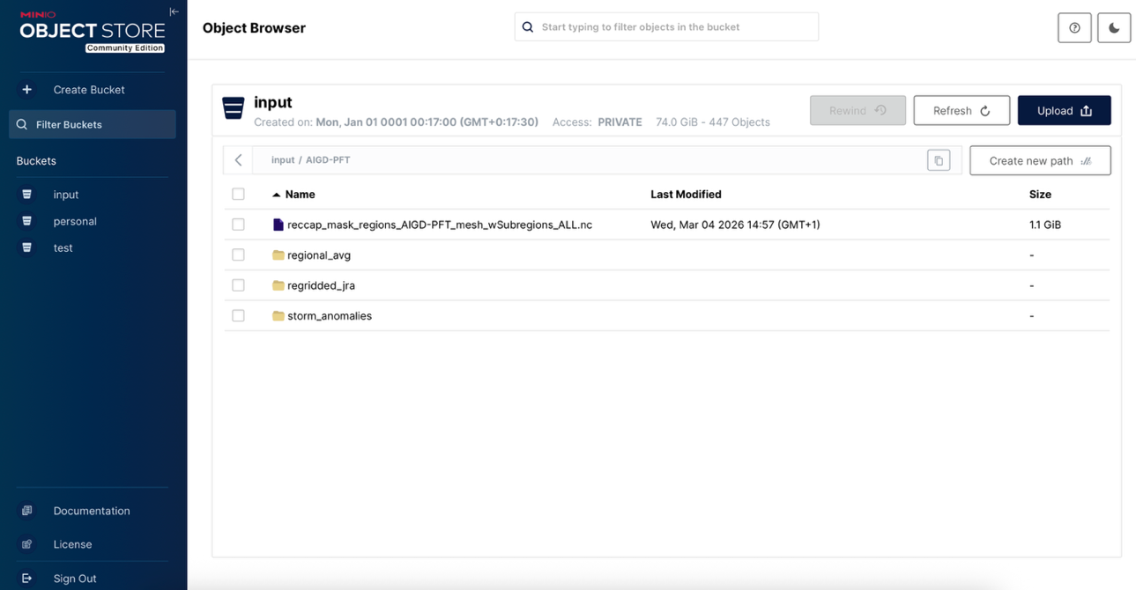

Useful commands for working in the terminal:
https://www.digitalocean.com/community/tutorials/linux-commands
https://ubuntu.com/tutorials/command-line-for-beginners#1-overview

cd another_folder (“change directory”)

mkdir new_folder (make a new directory)

ls (list all files in a directory)
ls -la (list all files in a directory and show access rights etc.)

du -sh * (show size of each file in the current folder in a human-readable format)

cp file1 file2 (copy file 1 to file 2)
cp file1 new_path/file1 (copy file1 to another directory, keeping the same filename)

mv file1 file2 (move file1 to file2 this is effectively just renaming the file if you stay within the same directory)
mv file1 new_path/file1 (move file1 to another directory, keeping the same filename)

rm filename (delete a file)
rm -r folder_name (delete a folder and its contents; note that “rm folder_name” will not work)
rm * (delete all files; Be CAREFUL with this command to not accidentally delete files you wanted to keep!)

The “*” is interpreted as a placeholder. For example, “mv data_* another_folder/” moves all data starting with “data” to the new folder.

