日本語のページはこちら

Sparkling Jell-o

Ingredients:  2 C sparkling wine（or apple/ white grape juice）  1/4 C seaweed gelatin flakes  2 T sugar  2/3 C fruit of choice (except kiwi or pineapple)  6 champagne glasses, small tea cups or jell-o molds | 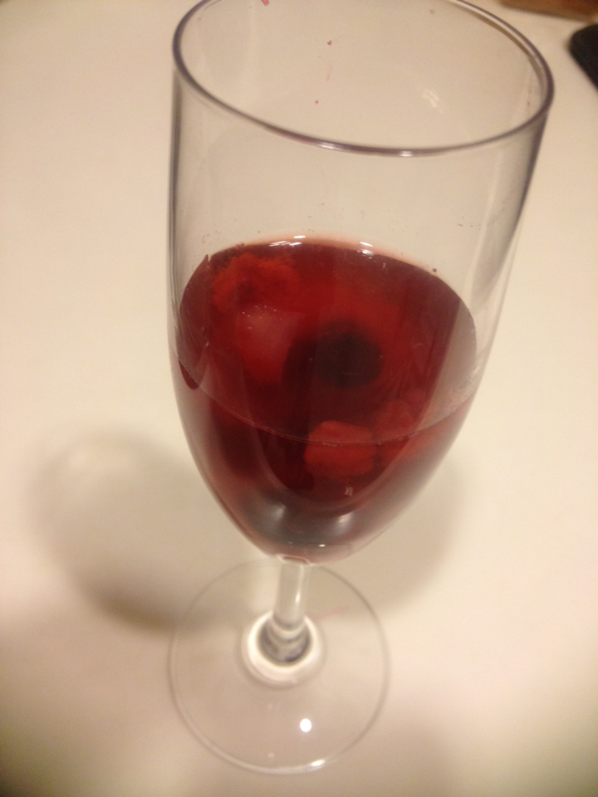
Directions：

- Cut the fruit into small pieces and distribute equally into the glasses or molds.
- Finely shred 1/4 cup of gelatin.
- Heat the wine or juice in a medium-sized pot.
- Once heated, put in the gelatin and sugar, and bring to a boil while stirring with a spoon.
- Stir until the gelatin and sugar are melted (about 5 minutes).
- Pour into the glasses or molds, and put them in the refrigerator. Chill about 1-2 hours, then serve.

