The Artwork of
Cara Blythe Phillips

About
the
Artist
Art, specifically painting, has been my lifelong hobby. I have been painting since the age of ten, sometimes with acrylics and watercolours, but primarily with oil on canvas. I typically choose to paint in Realism, but have dabbled in some Impressionism, abstract, and non-objective work, as well. I attended Virginia Tech during my freshman year of college to study architecture, but by the end of that year I decided to further explore her interest in foreign languages and changed my major to Japanese studies. Nevertheless, I would still one day like to work in an art-related field or at least continue to paint while teaching English abroad.
I designed the following website to display work I have done in the past and show prospective buyers what I am capable of if they want to commission a painting: http://www.geocities.com/aoibonsai/artwork/artmenu.htm
(The site needs a lot of work, but...)

If you would like to buy a piece labeled "For Sale", commission a piece, or order a print of any of Cara’s artwork, please contact the artist: aoibonsai@yahoo.com
(Note: Depending on the size and type of painting, please allow up to 3 months for commissioned works.)
Landscapes and
Nature
“Day Lily”
January 1997
Acrylic on Canvas

Given to my mother, Donna Phillips, who would not let me continue beyond the under-painting, saying “It’s beautiful! I love it just like that! Don’t do anything else to it.”
“Peaches”
May 1997
Oil on Canvas

On permanent display at the Frederick County Building, 107 N. Kent St., Winchester, Virginia, U.S.A. since June 1997.
“Mediterranean Coast”
August 1997
Oil on Canvas

Commissioned by Ms. Cindy Acree of Aurora, Colorado, U.S.A.

Cara with Mediterranean Coast
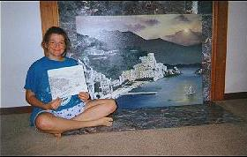

“Spout's Run”
May 1998
Oil on Canvas

Bought in an art auction by Ms. MaryAnn Vaughn of Winchester, Virginia, U.S.A. (my high school art teacher) in June 1998.

Photo after which the painting was patterned (of Spout’s Run waterfall, Millwood, Virginia, U.S.A.):
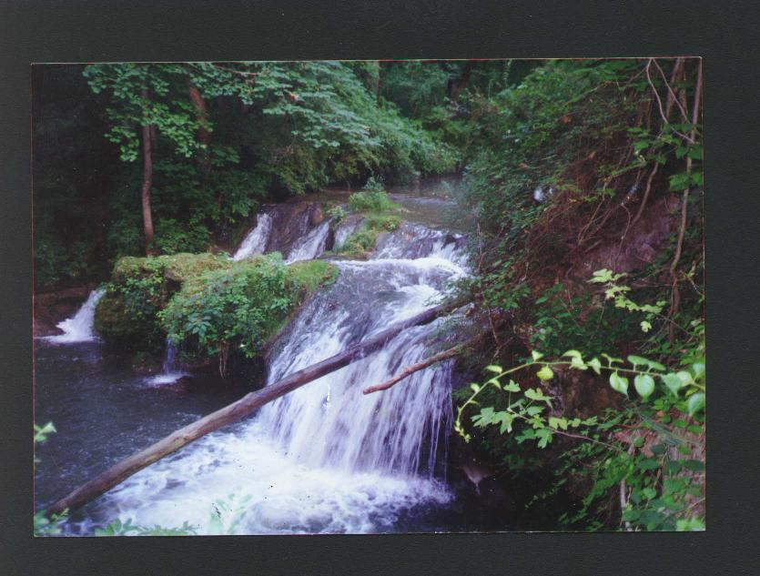
“Monet's ‘Water Lilies’ Study”
May 1999
Oil on Canvas

Commissioned by Ms. Donna Myers of El Paso, Texas, U.S.A.
“Spout's Run II”
June 2002
Oil on Canvas
5’x3’

Given to Mr. Jason Heustis of Denver, Colorado, U.S.A. as a birthday present July 2002.

Photo after which the painting was patterned (of Spout’s Run waterfall, Millwood, Virginia, U.S.A.):
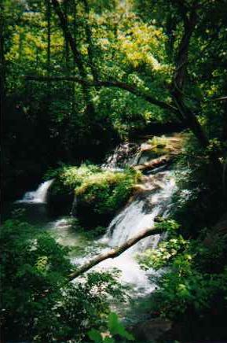
Close-up of “Spout’s Run II”
“Gloxinia”
June 2004
Oil on Canvas
16 5"x7" canvases

Given to Ryan and Elizabeth Elder of Los Angeles, California, U.S.A. as a wedding present in July 2004.

Portraits
“Laurel, Cara, and Olivia Phillips”
December 1997
Oil on Canvas

Given to my parents, Samuel and Donna Phillips, for Christmas 1997.
“Portrait of Steven”
October 1998
Oil on Canvas
24"x36"
An assignment for my painting class at the University of Pittsburgh, Pittsburgh, Pennsylvania, U.S.A.

For Sale:$300.00 U.S.+ shipping and handling
If interested, contact: aoibonsai@yahoo.com
“Nude”

November 1998
Oil on Canvas
24"x30"

An assignment for my painting class at the University of Pittsburgh, Pittsburgh, Pennsylvania, U.S.A. Most of my paintings are created from looking at photographs, but this one I painted of a live nude in at the studio.

For Sale: $100.00 U.S.+ shipping and handling
If interested, contact: aoibonsai@yahoo.com
“Jen and Darren”

November 1998
Oil on Canvas

Commissioned by my college friend, Jen, as a gift for her boyfriend.
“Little Cara”
May 1999
Oil on Canvas

A self-portrait, and yet another under-painting that was wanted, as is, by mother.
“Sebastian”
May 1999
Oil on Canvas

Commissioned by my neighbour at the time, Ingrid Romero, as a gift for her sister. (Sebastian is her nephew.)
“Grandchildren II”

August 2000
Oil on Canvas

Commissioned by Ms. Donna Myers of El Paso, Texas, U.S.A.

“Self-Portrait”
July 2003
Oil on Canvas (black & white)
18"x20"

For Sale:$300.00 U.S.+ shipping and handling
If interested, contact: aoibonsai@yahoo.com

Architectural Pieces
“Alphabet Exploration”
October 1997
Pen & Ink on Poster Board
24"x30"
For Sale:$75.00 U.S.+ shipping and handling (frame included)
If interested, contact: aoibonsai@yahoo.com

“Taj Mahal”
April 1998
Watercolour

An assignment for my watercolour class in the Architecture Department at Virginia Tech, Blacksburg, Virginia, U.S.A.

Given to my mother, Donna Phillips, for Mother’s Day 1998.

Collages
"Autobiography"
November 1996
Conté on Conté paper

An assignment for my advanced drawing class, Sherando High School, Stephens City, Virginia, U.S.A.

Purchased by Ms. Cindy Acree of Aurora, Colorado, U.S.A. the following year.
“Japan”
December 1998
Oil on Canvas

An assignment for my painting class at the University of Pittsburgh, Pittsburgh, Pennsylvania, U.S.A.

Given to my parents, Samuel and Donna Phillips, of Winchester, Virginia, U.S.A. for Christmas 1998.

Still-Lifes

“Pear and Apple”

September 1996
Coloured Pencil

An assignment for my advanced drawing class, Sherando High School, Stephens City, Virginia, U.S.A.

For Sale:$35.00 U.S.+ shipping and handling (matting, which is pictured, is included)
If interested, contact: aoibonsai@yahoo.com
“La Mesa”

March 1997
Silk Screen Print (1/5)

An assignment for my advanced design class, Sherando High School, Stephens City, Virginia, U.S.A.

For Sale:$40.00 U.S.+ shipping and handling (matting, which is pictured, is included)
If interested, contact: aoibonsai@yahoo.com

“Still-life”
November 1998
Oil on Canvas

An assignment for my painting class at the University of Pittsburgh, Pittsburgh, Pennsylvania, U.S.A.

Given to my sister, Olivia Phillips, of Alexandria, Virginia, U.S.A.

I Take Commissions
!!!

“La Tour Eiffel”

November 2005
Oil on canvas, 12 5”x7” canvases

By: Cara Blythe Phillips

For Sale:
$350.00 U.S.
+ shipping and handling (or arrange pick-up)

