MediTrace v2026.3: A Longitudinal, Interactive and Visual Medical Record for Patient Empowerment, Pharmacovigilance and Clinical Decision Support
Pierre-Henri Giraud & Claude (Anthropic)
Independent researcher, Atzeneta del Maestrat, Spain — Anthropic, San Francisco, USA
DOI: 10.5281/zenodo.19973451 — Version 3 (v2026.3) — May 2026 — CC BY 4.0
Abstract
MediTrace is an open-source longitudinal medical tracking tool designed to centralise, visualise and analyse a patient's medical history from heterogeneous PDF documents. Version 2026.3 introduces: client-side OCR via Tesseract.js for scanned documents, a bacteriology module for culture results and antibiograms, radar charts for normalised parameter overview, Progressive Web App (PWA) architecture for offline use, an extensible parameter system with source memory, and a streamlined workflow for Claude.ai integration without API key. Applied to a real clinical case covering 2016-2026 (29+ documents, 50+ biological parameters), the tool identified critical findings including an unreported drug interaction (Haloperidol + Donepezil double QTc prolongation), chronic vitamin D deficiency, complete left ICA occlusion, and insufficient renal monitoring under Dabigatran. Implemented as a single-file PWA in pure HTML5/JavaScript, running 100% client-side. GNU GPL v3.
Keywords: longitudinal medical record, pharmacovigilance, OCR, PWA, patient empowerment, clinical decision support, open source, LLM-assisted extraction

1. Introduction
The fragmentation of medical records across multiple healthcare providers remains a critical barrier to effective longitudinal patient care. MediTrace addresses this gap with a radically simple architecture: a single HTML file, running entirely in the browser, requiring no server, no account, no installation.

2. New Features in v2026.3

2.1 Client-Side OCR (Tesseract.js)
MediTrace integrates Tesseract.js v4 for client-side OCR, supporting Spanish with English fallback. For scanned PDFs, pdf.js renders each page to high-resolution canvas before OCR. An "OCR-only" mode allows text extraction without an API key.

2.2 Claude.ai Workflow Without API Key
After OCR, "Copy for Claude" prepares the text with the extraction prompt. The user pastes into claude.ai, copies the JSON, and uses "Paste and import" for one-click integration.

2.3 Bacteriology Module
Tracks culture results and antibiograms: specimen type, organism, colony count, and S/I/R classification per antibiotic.

2.4 Radar Chart
Normalised overview of all biological parameters. Each axis = parameter normalised to reference range (100% = middle of normal). Multiple dates superimposed. Eight parameter groups.

2.5 Progressive Web App
Installable on mobile/desktop. Service worker caches all assets for offline use.

2.6 Extensible Parameters
Users create custom parameters and sources are memorised for rapid re-selection.

2.7 Accessibility
High-contrast light theme with increased font sizes (18px base). Driven by feedback from the caregiver (age 83).

4. Clinical Findings
• Complete left ICA occlusion (MRI March 2026) — correlated with PET/CT December 2021.
• QTc prolongation risk — Haloperidol + Donepezil identified. Haloperidol discontinued.
• Anticoagulation abandonment — Dabigatran stopped (Feb 2025) with recurrent PE.
• Chronic vitamin D deficiency — 27.10 to 12.33 ng/mL.
• Cognitive decline — MMSE: 25 to 16. Vascular/frontotemporal pattern.
• Renal decline — GFR: 83 to 70.8 mL/min.

5. Discussion
MediTrace embodies: "Why do what the computer can do?" Every manual step eliminated. Designed for elderly caregivers. All data processed locally. Co-developed through iterative conversation between caregiver and Claude (LLM).

6. Future Work
• Batch OCR
• Global search
• Print optimisation
• Encrypted backups
• Enriched bacteriology
• Active alert badges
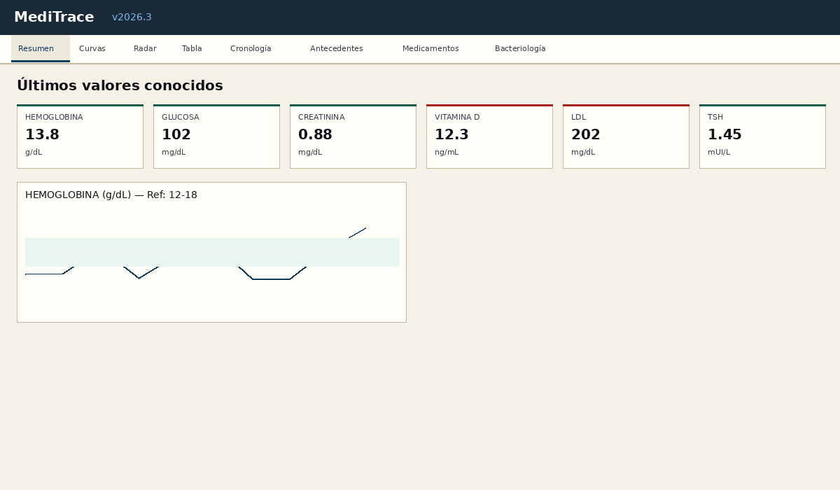
Figure 1: Summary view with KPI cards and evolution chart.
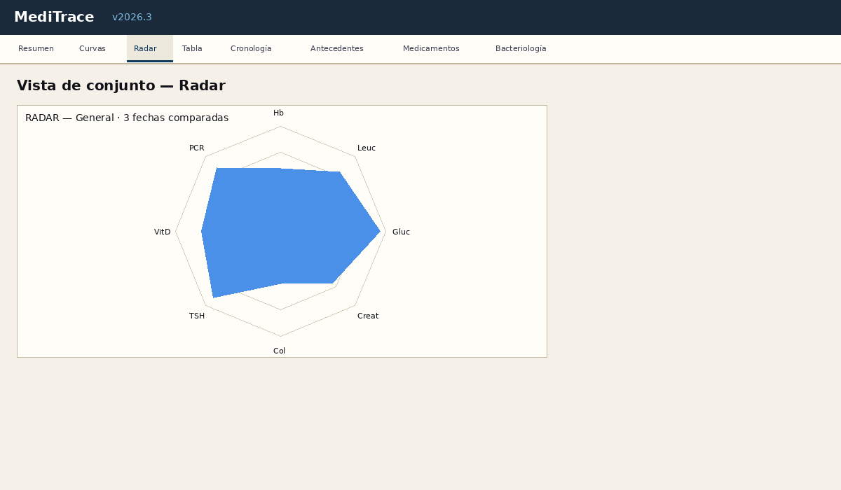
Figure 2: Radar chart with normalised parameters.
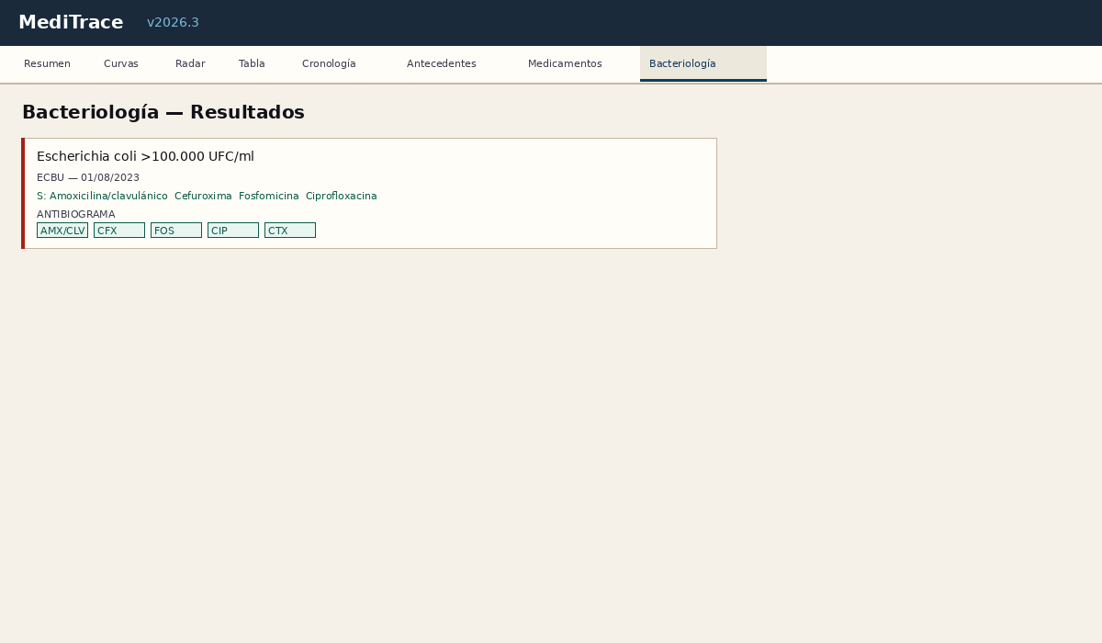
Figure 3: Bacteriology module with antibiogram.

7. Version History
Version | Date | Changes
v2026.1 | May 2026 | Initial release
v2026.2 | May 2026 | Medications, observance, correlations
v2026.3 | May 2026 | OCR, bacteriology, radar, PWA, light theme, guide
MediTrace v2026.3 — Pierre-Henri Giraud x Claude (Anthropic) — DOI: 10.5281/zenodo.19973451 — CC BY 4.0

