Measuring the efficiency of Portuguese and Spanish Airports: A two-stage DEA analysis
Gonçalo Valente Monteiro da Silva
goncalovalentesilva@tecnico.ulisboa.pt
Instituto Superior Técnico, Lisboa, Portugal
October 2025

Introduction
The air transport market has suffered significant transformations over the last decades, driven by the liberalization of the industry, which started in 1978 when the United States of America (USA) deregulated its domestic airline market, meaning airlines were free to set their own fares and routes, without federal control. This new regulatory framework without market entry barriers and market restrictions, marked the beginning of an era of unprecedented air traffic growth, where the number of passengers in the world increased from 310 million in 1970 to 4.5 billion in 2019 (World Bank Data 2025).
Central to this evolution was the emergence and expansion of Low-Cost Carriers (LCCs). Around 2002, a steep growth of LCCs started, reaching 30.3% of the market share in 2018, 10 times more than in 2002 (Eurocontrol 2025). Initially operating mostly from secondary or regional airports, LCCs gradually expanded their operations to larger airports, and are now competing directly with legacy airlines at major airports (Jimenez and Suau-Sanchez 2020). This strategic shift of LCCs towards larger airports highlights the dynamic nature of the air transport market and the consequent need of constant benchmarking to evaluate the performance of airports and adapt accordingly to the changing market conditions. This need for performance analysis is further intensified by the increasing trend towards business models such as privatization and the use of concessions for airport management, as regulation by public entities and stakeholders requires transparent and objective performance metrics.
Benchmarking has become a fundamental tool to evaluate the performance across a wide range of industries and represents a systematic comparison of the performance of different entities, which usually transform the same kind of inputs into similar outputs (Bogetoft and Otto 2011). There are two main benchmarking methodologies: Stochastic Frontier Analysis (SFA), a parametric approach, meaning it requires a predefined functional form for the production function, and the Data Envelopment Analysis (DEA), a non-parametric approach.. A thorough review of the existing literature on airport benchmarking was conducted to identify the most common methodology and employed variables in this type of analysis.
Motivated by the decision of the development of a new airport in Lisbon, the present work aims to benchmark the efficiency of 41 Iberian airports (5 Portuguese and 36 Spanish) from 2016 to 2023 and identify exogenous factors that influence airport efficiency, such as rail intermodal terminals.
In the next section, a literature review is presented. Then, the methodology used in this work is described, followed by the presentation and discussion of the results. Finally, the main conclusions are drawn and public policy reflections are provided.

Literature review
In this section a review of the previous literature on airport efficiency is conducted.
Spain, having one of the largest airport operator (Aena), is one of the most frequently analyzed countries in the literature. Thus, a special focus is given to works analyzing Spanish airports, representing 10 of the 22 studies relevant studies reviewed.
Examining the literature, it was possible to identify that DEA is the most common methodology used to assess airport efficiency, being used in 19 of the 22 studies reviewed. Nevertheless, SFA has also been applied in relevant Iberian studies, such as (C. P. Barros 2008a), (Tovar and Martín-Cejas 2010), (J. C. Martín, Román, and Voltes-Dorta 2011). The DEA’s non-parametric nature, meaning it does not require a predefined functional form for the production function, makes it the preferred method.
From the 19 DEA studies, 11 combined the first-stage DEA with a second-stage analysis to identify exogenous factors influencing airport efficiency. Some articles applied the Tobit regression ((Coto-Millán et al. 2014), (Fragoudaki and Giokas 2016), (Coto-Millán et al. 2016)) but the truncated regression proposed by (Simar 2007) was deemed more appropriate and was used in 7 of the 11 studies ((C. Pestana Barros and Dieke 2008), (C. P. Barros 2008b), (Tsekeris 2011), (Chang, Yu, and Chen 2013), (Adler, Ülkü, and Yazhemsky 2013), (Fernández, Gundelfinger, and Coto-Millán 2022), (Cifuentes-Faura and Faura-Martínez 2023)). Also, the static DEA scores were complemented with a dynamic analysis using the Malmquist Productivity Index (MPI) in 4 of the 13 studies that analyzed more than one year ((Fung et al. 2008), (Tovar and Martín-Cejas 2010), (Coto-Millán et al. 2014), (Inglada, Coto-Millan, and Inglada-Pérez 2018)).
Regarding the input variables used, some studies used only financial inputs, such as capital or operating costs ((J. Martín and Román 2001), (C. P. Barros 2008a), (C. Pestana Barros and Dieke 2008), (Coto-Millán et al. 2014), (Coto-Millán et al. 2016), (Inglada, Coto-Millan, and Inglada-Pérez 2018)), but due to the common lack of financial data, most studies used physical inputs, such as the runway area/length or apron area, that are more related to the areonautical capacity of the airport ((Lin and Hong 2006), (C. P. Barros 2008b), (Tsekeris 2011), (Lozano, Gutiérrez, and Moreno 2013), (Fragoudaki and Giokas 2016), (Gutiérrez and Lozano 2016)) or logistic inputs, such as the number of boarding gates, number of employees or the terminal area ((Fung et al. 2008), (Tovar and Martín-Cejas 2010), (J. C. Martín, Román, and Voltes-Dorta 2011)). Other variables such as the airport area and number of baggage belts, check-in counters, airlines and routes were also identified but less frequently employed ((Lozano, Gutiérrez, and Moreno 2013), (Gutiérrez and Lozano 2016), (Cifuentes-Faura and Faura-Martínez 2023)).
For output variables, the literature clearly converges on passenger volume, aircraft movements, and cargo as the most common output variables, with 18 studies presenting them in their analysis.
A review of the explanatory variables used in the second-stage analysis was also performed. The selection of these variables depends on the scope of each study, but common variables include location, working load unit, military presence and hub status ((C. Pestana Barros and Dieke 2008), (C. P. Barros 2008b), (Tsekeris 2011), (Adler, Ülkü, and Yazhemsky 2013), (Fragoudaki and Giokas 2016)).
Accordingly, the present study will employ a two-stage DEA approach with a truncated regression, complemented by a Malmquist Productivity Index analysis, to evaluate the efficiency of 41 Iberian airports, from 2016 to 2023, and identify exogenous factors influencing their performance. This study contributes to the Iberian airport efficiency literature, by analyzing for the first time Portuguese and Spanish airports simultaneously. Additionally, it will be one of the few studies incorporating data after the partial privatization of Aena (Spanish airport operator) in 2014.

Methodology

Data Envelopment Analysis (DEA)
DEA is a non-parametric method used to evaluate the efficiency of Decision Making Units (DMUs) that convert inputs into outputs, by comparing each DMU to a best-practice frontier. The calculated efficiency is relative and is measured by the distance to the frontier, meaning a DMU is efficient if it lies on the frontier, and inefficient if it lies below it (Charnes et al. 1994).
DEA models can be oriented in two ways: input or output oriented. In an input-oriented model the focus is on how much the inputs of a DMU can be proportionally reduced, without affecting the outputs produced. On the other hand, an output-oriented model focuses on increasing output quantities proportionally, while maintaining the same level of inputs (Charnes et al. 1994).
Another important aspect of DEA is the assumption on returns to scale. In this regard there are two main formulations, the CCR model (Charnes, Cooper, Rhodes) and the BCC model (Banker, Charnes, Cooper). The first assumes constant returns to scale (CRS), meaning that an increase in inputs will lead to a proportional increase in outputs. The second assumes variable returns to scale (VRS), meaning it separates the inefficiencies due to scale from those due to pure technical inefficiency, and therefore compares DMUs of similar size (Banker, Charnes, and Cooper 1984). Even though the CCR model is a valuable measure of overall efficiency, as airports cannot easily adjust their scale, the BCC model is often more appropriate in real world contexts and will, therefore, be the model applied in this work.
Eq.([output_dea]) presents the formulation for the output-oriented BCC model. Eq.([eq:bcc_constraints_output]) represent the respective constraints. The main difference between the CCR and BCC models is the inclusion of the convexity constraint ( j​λj=1), which ensures that an inefficient DMU is only benchmarked against similar sized DMUs. To obtain the input-oriented version, the function of Eq.([output_dea]) is replaced by $min_{θ,λ} θ$, and the two first inequations are reversed, keeping the rest the same (Banker, Charnes, and Cooper 1984).
Output-oriented BCC Model
$$max_{ϕ,λ} ϕ$$
subject to
j​yr,jλj≥ϕyr,o for r=1,…,sj​xi,jλj≤xi,o for i=1,…,mj​λj=1λj≥0
Having obtained the efficiency scores using both the CCR and BCC models, it is possible to obtain the scale efficiency (SE) of an airport. SE measures the loss that a DMU suffers for not operating at optimal scale, and it is calculated as the ratio between the efficiency scores obtained using CRS and VRS. The value of SE, is always between 0 and 1, since the efficiency score obtained using the CCR model is always less than or equal to that obtained using the BCC model. An SE value of 1 indicates that the DMU is operating at optimal scale, while a value less than 1 indicates that it is not (Bogetoft and Otto 2011).
Analyzing the value of SE does not provide information on the type of scale inefficiency, i.e., whether the DMU is operating at increasing (IRS) or decreasing returns to scale (DRS). To identify the nature of the returns to scale, an additional model is needed: the non-increasing returns to scale (NIRS) model, which is derived from the BCC model by replacing the j​λj=1 restriction with j​λj≤1. Eq.([eq:rts_definition]) summarizes the classification criteria for the different RTS that can be identified by comparing the models explained above (Huguenin 2012).
$$RTS=\left\{\begin{matrix}IRS, & \text{if }E_{NIRS}≠E_{VRS} \\ CRS, & \text{if }E_{NIRS}=E_{VRS}=E_{CRS} \\ DRS, & \text{if }E_{NIRS}=E_{VRS}≠E_{CRS}\end{matrix}\right.$$
DEA efficiency scores can be influenced not only by management decisions and scale operation conditions, but also by exogenous factors. Second-stage regressions are usually applied to identify the effect of these factors, in which the DEA scores obtained in the first stage are regressed against a set of potential explanatory variables. In this study, a truncated regression is going to be applied.

Truncated Regression
Following (Simar 2007), a second-stage truncated regression is applied:
$$θ_{i}=α+βZ_{i}+ε_{i}, i=1,…,n$$
where
$$ε_{i}∼N\left(0,σ_{ε}^{2}\right), \text{such that} ε_{i}≥1−α−Z_{i}β$$
which is estimated by maximizing the corresponding likelihood function.
$θ_{i}$ represents the efficiency value of the $n$ DMUs, $α$ a constant term, $β$ the vector of regression coefficients, $Z_{i}$ a set of explanatory variables used to evaluate the efficiency scores and $ε_{i}$ a random variable accounting for statistical noise.
Since the DEA efficiency scores are relative and not absolute, there is a strong statistical depen- dency between each observation. Therefore, using them directly in a second-stage regression may violate fundamental assumptions of regression analysis, such as the independence of the dependent variable (Simar 2007). To overcome the above problems, the bootstrap technique is applied. The double bootstrap approach proposed by (Simar 2007) enables consistent inference in the second stage regression, by addressing the dependency problem, while simultaneously correcting for bias and estimating variance and confidence intervals. Fig.1 provides a flowchart detailing the 7-step procedure of algorithm 2 of (Simar 2007).
Algorithm 2 flowchart based on (Simar 2007).
Although the DEA methodology provides an accurate static measure of efficiency for each year, it does not fully capture how productivity evolves over time. To address this limitation, the Malmquist Productivity Index (MPI) is also applied, to provide a dynamic perspective on efficiency changes.

Malmquist Productivity Index (MPI)
MPI evaluates the productivity change of a DMU, in our case an airport, by calculating the ratio of the distance to the frontier in two different time periods, t and t + 1, relative to a common reference technology. Initially, (Caves, Christensen, and Diewert 1982) defined the MPI as follows:
$$MPI_{o}=\frac{D_{o}^{t}\left(x_{t+1},y_{t+1}\right)}{D_{o}^{t}\left(x_{t},y_{t}\right)}$$
where $\left(x^{t+1},y^{t+1}\right)$ represents the input/output combination for the $t+1$ period, and $\left(x^{t},y^{t}\right)$ for the $t$ period. $D_{o}^{t}\left(x^{t+1},y^{t+1}\right)$ and $D_{o}^{t}\left(x^{t},y^{t}\right)$ would then be the distance between the DMU observation in $t+1$ and $t$ periods, respectively, and the best practice frontier in the $t$ period, for airport $o$.
If one wants to consider the technology from the t + 1 period as the reference, the distance would be measured to the frontier in t + 1 period, meaning $D_{o}^{t}$ would be replaced by $D_{o}^{t+1}$, in the functions of Eq.([eq:MI1]).
In order to avoid the arbitrary selection of a reference technology, (Färe et al. 1994) specified the output-based MPI as the geometric mean of the index from Eq.([eq:MI1]), using both reference technologies, given by:
$$\begin{matrix}MPI_{o} & =\left[\left(\frac{D_{o}^{t}\left(x_{t+1},y_{t+1}\right)}{D_{o}^{t}\left(x_{t},y_{t}\right)}\right)\right. \\ & {\left.\left(\frac{D_{o}^{t+1}\left(x_{t+1},y_{t+1}\right)}{D_{o}^{t+1}\left(x_{t},y_{t}\right)}\right)\right]}^{1/2}\end{matrix}$$
According to (Färe et al. 1994), an equivalent way of writing the index of Eq.([eq:MI3]) is:
$$\begin{matrix}MPI_{o} & =\underset{\text{Efficiency Change (EC)}}{\underset{⏟}{\frac{D_{o}^{t+1}\left(x_{t+1},y_{t+1}\right)}{D_{o}^{t}\left(x_{t},y_{t}\right)}}} \\ & ×\underset{\text{Technological Change (TC)}}{\underset{⏟}{{\left[\frac{D_{o}^{t}\left(x_{t+1},y_{t+1}\right)}{D_{o}^{t+1}\left(x_{t+1},y_{t+1}\right)}×\frac{D_{o}^{t}\left(x_{t},y_{t}\right)}{D_{o}^{t+1}\left(x_{t},y_{t}\right)}\right]}^{1/2}}}\end{matrix}$$
This formulation decomposes Eq.([eq:MI3]) into two different components: Efficiency change (EC) and Technological change (TC). The former evaluates if the airport’s efficiency is getting closer or further away from the best practice frontier (catching-up effect). The latter captures shifts in the frontier itself, indicating whether there has been technological progress or regress over time.
So far, the analysis has been conducted under constant returns to scale (CRS). However, the first term (EC) can be further decomposed into Pure Efficiency Change (PEC), associated with VRS, and Scale Efficiency Change (SEC). To obtain this full decomposition, two additional programming problems are required, namely the calculation of $D_{o}^{t+1}\left(x_{t+1},y_{t+1}\right)$ and $D_{o}^{t}\left(x_{t},y_{t}\right)$ under VRS, which provides the value of PEC and allows the calculation of SEC.
A $MPI_{o}$ greater than one indicates an improvement in efficiency between periods t and t + 1. The same interpretation applies to the other all the other components of the MPI. Conversely, a value less than one indicates a decline in efficiency

Results
In this section, the dataset used is described and the results obtained are presented. First, the descriptive statistics are provided, then the DEA scores are obtained, followed by the truncated regression analysis, and finally the Malmquist index results.

Descriptive Statistics
Our dataset includes 41 Iberian airports, including 5 in Portugal and 36 in Spain, over a period of eight years (2016-2023). Following the airport size definition from (Ripoll-Zarraga and Mar-Molinero 2020), Fig.2 displays a map with the geographical location of the airports and their respective sizes.
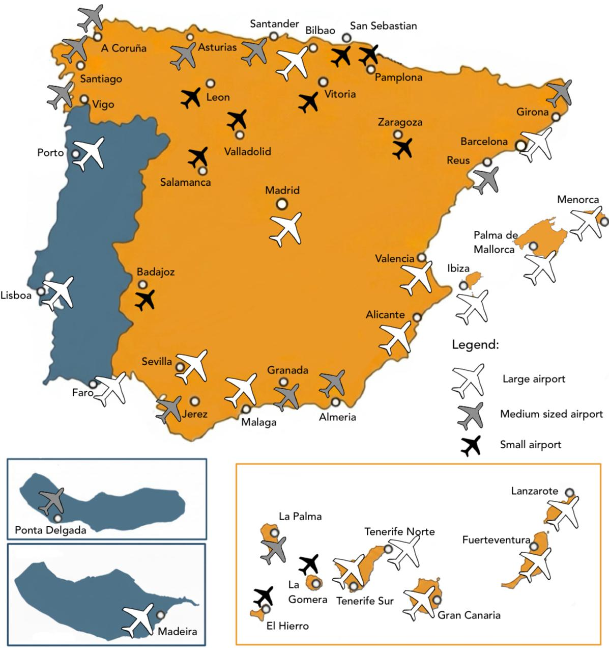
Location and size classification of the 41 Iberian airports
DEA models require the identification of the inputs and outputs of the analysis. As DEA is not a statistical technique, there is no systematic approach for the selection of inputs and outputs, thus the first practical criterion for selecting these variables is data availability. Tab.[tab:variables] lists these variables and summarizes their main descriptive statistics, namely the minimum (Min.), maximum (Max.), mean, and standard deviation (St. Dev.) values.
Even though this selection of input variables does not fully represent the most common variables in the literature review conducted in [sec:backg], due to data availability constraints, it is still in line with the previous literature. It is important to highlight that only physical measures of capital were considered in this analysis, since airport-level financial data stopped being published, following Aena’s partial privatization in 2014.
Regarding the second-stage regression, Tab.[tab:exp_statistics] lists the explanatory variables used in the second-stage regression to explain DEA efficiency scores.
Island is a binary variable indicating whether an airport is located on an island (Island=1) or the mainland (Mainland=0). The inclusion of this variable is justified, as 13 out of the 41 airports in the dataset operate on an island. Military is another binary variable indicating whether there are military operations at the airport. In the considered dataset, 11 out of the 41 airports operate as mixed civil-military airports. Share of cargo represents the percentage of cargo in the total WLU and Share of LCC passengers the percentage of low-cost carrier (LCC) passengers in the total number of passengers. Additionally, a novel input in Iberian airport efficiency studies was included: the existence of a railway connection inside the airport. This variable was included to capture the impact of intermodal connectivity on airport efficiency.

First-stage: Static DEA scores
The first stage of the analysis involved calculating the efficiency scores for each airport across the different years considered. For that, an output oriented DEA model under Variable Returns to Scale (VRS) was applied.
The choice of output orientation is particularly appropriate in the context of Iberian airports, since most of the Spanish airports operate with overcapacity, meaning the existing infrastructure is underutilized (Nerja 2021). As some of the airport inputs are considered fixed in the short and medium term, airport managers have limited capacity to adjust input levels, and should, therefore, focus on maximizing their utilization (J. Martín and Román 2001). Regarding the returns to scale, VRS was assumed due to the size differences between the airports considered, as shown in Fig.2. Nonetheless, the CRS scores were also determined for the calculation of Scale efficiencies.
Tab.[tab:crs,vrs,scale] presents the DEA bootstrapped results obtained for each airport. It includes the average efficiency scores for Constant Returns to Scale (CRS), Variable Returns to Scale (VRS), and Scale efficiency (Scale) for each airport. It should be noted that the biased scores were also calculated for comparison, even though they are not presented for brevity. Following the definition in Eq.([eq:rts_definition]), the last column indicates the type of returns to scale (RTS) each airport is operating, which can be either Increasing Returns to Scale (IRS), Decreasing Returns to Scale (DRS), or Constant Returns to Scale (CRS). As this study analyzes a period of 8 years, different classifications can be obtained in different years. In Tab.[tab:crs,vrs,scale], the most common classification will be displayed. In cases where the two most common classifications are observed the same number of times across the eight-year period, both classifications are presented.
Analyzing Tab.[tab:crs,vrs,scale], it is possible to observe that Iberian airports present low values of efficiency, averaging 0.480 for the bootstrapped VRS model, in the years under analysis. When excluding the years 2020 and 2021, due to the COVID-19 pandemic, the average bootstrapped VRS efficiency increases to 0.522, while the CRS model increases to 0.436. It is also possible to note that there is no average efficiency score of 1, with a maximum observed value of 0.823 for Madrid-Barajas airport, meaning none of the considered airports operates in the frontier. Regarding scale efficiency, the average bootstrapped scale efficiency is 0.854, indicating that Iberian airports are not operating at their optimal scale.
Regarding the returns to scale (RTS) classification, out of the 41 airports considered, 21 operate under IRS. This result further confirms the fact that a majority of airports in the Spanish centralized system are underutilized and have the potential to increase their efficiency by expanding their operation, as argued by (Nerja 2021). On the other hand, a smaller set of 9 airports operate under DRS, meaning they could improve their efficiency by reducing their operations. Out of the 41 airports, 7 of them obtained more than one classification. Only 4 airports were classified with CRS, meaning they operate at their optimal scale. Analyzing the Portuguese airports, it can be observed that all operate under IRS.

For a better comparison of the performance of the considered airports, Fig.3 presents a boxplot graph displaying the minimum, first quartile, median, third quartile and maximum values of the boot- strapped VRS efficiency scores, for each airport, over the years considered. For easier interpretation of the results, a dotted line was added to indicate the average efficiency score of 0.522. Also, the data for the COVID years (2020 and 2021) was excluded from the boxplot, as they are not representative of the airports’ normal operation. However, they are still included in the graph and marked by red dots.
Analyzing Fig.3, and considering the median value of each box, it is possible to observe that, from the 41 airports, 24 present above average efficiencies, with Madrid-Barajas, Barcelona and Zaragoza obtaining the highest efficiency scores, while San Sebastian, Valladolid and Vigo being the least efficient airports. Following the airport size definition presented in Fig.2, 16 of the 24 airports with above average efficiency are large, while 14 of the 17 below average airports are small or medium sized. This result suggests that larger airports tend to be more efficient.
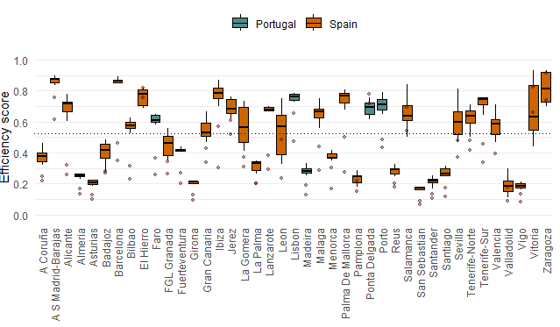
Boxplots of the bootstrapped VRS efficiency scores, for each airport.
Considering the Portuguese airports, only Madeira airport is considered inefficient, with Lisbon being the most efficient, followed by Porto, Ponta Delgada and Faro. The average efficiency for Portuguese airports is 0.613, indicating that, over the period and sample considered, they are approximately 20% more efficient than the Spanish ones that obtained an average efficiency of 0.510.

Second-stage: Truncated regression
After computing the DEA efficiency scores in the first stage, a second-stage truncated regression was conducted to address DEA’s main limitation, which is its inability to explain the effect of some determinants in the efficiency scores. The regression was applied to the bootstrapped DEA scores, using the explanatory variables described in Tab.[tab:exp_statistics], under the following model:
$$\begin{matrix}θ_{i,t} & =α+β_{1}{\text{Island}}_{i}+β_{2}{\text{Military}}_{i}+β_{3}{\text{Rail}}_{i} \\ & +β_{4}{\text{ShareCargo}}_{i,t}+β_{5}{\text{ShareLCC}}_{i,t}+ε_{i,t}\end{matrix}$$
Tab.[tab:regression_results] reports the coefficients and p-values for the variables considered in both the biased and bootstrapped models. For binary variables, the coefficient represents the estimated change in the effi- ciency score when the specific variable applies, while for continuous variables, the coefficient reflects the marginal effect on the efficiency score of a one-unit increase in the corresponding variable (Simar 2007).
Analyzing the results, it is possible to observe that the coefficients of the variables are similar across both models, with the bootstrapped model presenting consistently lower values. Starting by the Island variable, its coefficient is positive and statistically significant at the 1% significance level in both models, indicating that airports located on islands are, on average, 18.58% and 16.90% more efficient than those located on the mainland, respectively. It can also be concluded that the presence of Military operations in the airport contributes positively on the efficiency, with a coefficient of 8.22% in the biased model and 6.44% in the bootstrapped one, with the former being statistically significant at the 10% significance level and the latter at the 5% significance level.
Note: Statistically significant at 1% $​^{***}$, 5% $​^{**}$, or 10% $​^{*}$ level.
Regarding the novel explanatory variable in Iberian airport studies, Rail existence, it achieved the highest coefficient, from all variables and revealed to be statistically significant at the 1% level, in both models. An Iberian airport with a conventional rail connection is, on average, 48.95% more efficient in the biased model and 38.28% in the bootstrapped one, respectively, than one without such a connection. Focusing on the effect the share of cargo transport has on airport efficiency, it is possible to observe that the coefficient is positive and statistically significant at the 1% significance level in both models, indicating that a 1% increase in the share of cargo, in the total WLU, results in an increase in the efficiency score of 1.08%, for the biased model, and 0.65%, for the bootstrapped one. As for the share of LCC passengers, the results were inconclusive. In the biased model, the coefficient was negative and statistically significant at the 5% significance level, suggesting that a 1% increase in the share of LCC passengers would lead to a 0.16% decrease in the efficiency score. In contrast, in the bootstrapped model, the coefficient became positive (0.07%) but was not statistically significant.

Dynamic Evolution: Malmquist index
To complement the obtained static DEA scores, the Malmquist Productivity Index (MPI) was applied to analyze how the productivity of each Iberian airport evolved over the considered period (2016-2023). The dynamic evaluation that this methodology offers becomes especially important for a period that includes an external shock as the COVID-19 pandemic, since it allows for a better understanding of the impact of such events in airport performance, not only in the affected years (in this case, 2020 and 2021), but also in the subsequent recovery years.
Tab.[tab:malmquist_summary] presents the geometric means of the MPI for the Iberian airports, as well as the four components it can be decomposed into: Technological Change (TECHC), Efficiency Change (EC), which is further divided into Pure Efficiency Change (PEC) and Scale Efficiency Change (SEC). Two additional notes must be done: first, the MPI calculations were made without accounting for the bias present in the DEA scores, i.e., no bootstrapping technique was applied, as no function in the softwares used (RStudio and Stata) is readily available. Second, 4 of the initial 41 airports do not present the results of the decomposition of EC, due to failure in the estimation of PEC (that is obtained by conducting a MPI analysis under VRS), namely the airports of El Hierro, La Gomera, Leon and Ponta Delgada.
Analyzing Tab.[tab:malmquist_summary], it is possible to observe that, on average, Iberian airports experienced a productivity growth of 3.82% over the period considered, with 37 out of the 41 airports showing improvement (MPI $>$ 1). The main driver of this productivity growth was Efficiency Change (EC), which increased by 3.27%, while Technological Change (TECHC) contributed with a smaller increase of 0.58%. This result indicates that most of the productivity growth was due to improvements in how efficiently airports utilized their resources, rather than advancements in technology or infrastructure. An expected result is that the highest values of Technological Change (TECHC) are concentrated in the largest airports as Madrid-Barajas, Barcelona, Lisbon, Porto and Valencia, with values ranging from 1.0367 to 1.0848. When analyzing the decomposition of EC, it is possible to observe that the average Pure Efficiency Change (PEC) increased by 2.96%, while Scale Efficiency Change (SEC) slightly decreased by 0.24%. This suggests that most of the efficiency improvements were due to better management and operational practices, rather than changes in the scale of operations.
The best performing airports in the considered period were Badajoz, Leon and Valencia. The latter achieved the highest MPI, with a value of 1.1265, indicating a significant productivity growth of 12.65%. This growth was mainly driven by a strong increase in EC (8.66%), with both PEC and SEC contributing positively to the efficiency change. Leon and Badajoz also showed strong performance, with MPIs of 1.1234 and 1.1119, respectively, driven by improvements in efficiency rather than advancements of the frontier. Unfortunately, for Leon the decomposition of EC cannot be analyzed but for Badajoz, unlike Valencia a decrease of 7.97% in the scale efficiency was registered.
As already mentioned, 4 of the 41 airports presented a decrease in efficiency, namely Faro, FGL Granada, Salamanca and Tenerife-Sur. Faro had the lowest MPI, with a value of 0.9550, indicating a productivity decline of 4.50%. This result is explained by a decrease in TECHC (0.80%) and EC (3.73%), with both PEC and SEC contributing negatively to the EC result. FGL Granada also experienced a slight decline in productivity, with an MPI of 0.9974, driven by a decrease in TECHC (2.42%) despite the increase in EC (2.21%). Salamanca and Tenerife-Sur had similar MPI results, with values of 0.9863 and 0.9818, respectively. Both airports experienced declines in TECHC (1.71% and 0.12%, respectively) while for EC, Salamanca had a slight increase (0.34%) and Tenerife-Sur a decrease (1.70%). Also, both airports presented an improvement in scale.
To better understand how the MPI changed and what caused its variations along the years, Fig.4 displays the evolution of the average MPI and its components for each year. The score of each year represents the change in relation to the previous year. To provide the starting point representation, the first year 2016, was also added, so all the components under study have a value equal to one in this year.
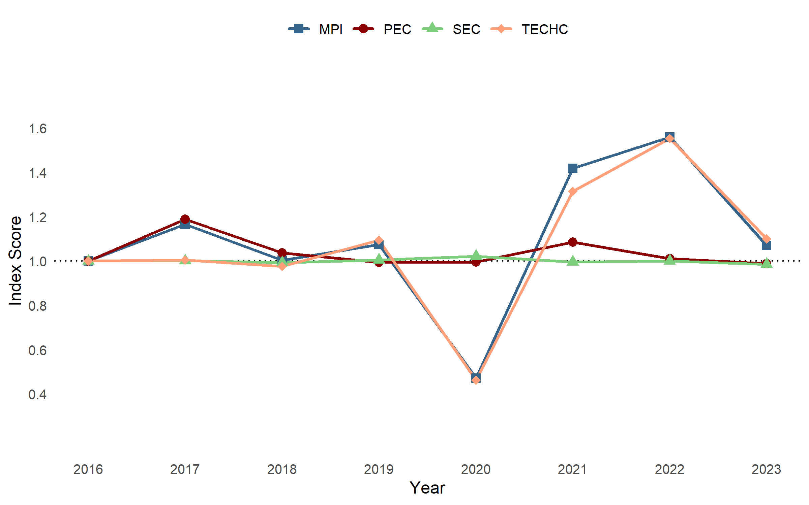
Average of Malmquist Productivity Index (MPI) and its components for each year
Analyzing Fig.4, it is possible to observe that the average MPI was above 1 in all years, except for 2020. The overall trend for each component of the MPI can also be examined. TECHC represented the principal contributor for MPI fluctuations, while PEC and SEC showed a more constant evolution, with SEC remaining almost unchanged through the whole period and being the only component with an average value below 1. In the first years, the MPI had two years with different growth patterns. In 2017, the MPI reached a value of 1.1657 associated with an improvement in PEC, while TECHC remained practically constant. However in 2019, MPI growth, with a value of 1.0748, was mainly driven by an increase in TECHC. From 2019 to 2020, an expected decline in TECHC caused the MPI to drop to a value of 0.4719, the lowest in the period. However, observing the subsequent years it can be concluded that the Iberian airports managed to recover well from the severe impact caused by the COVID-19, which lead to a positive average of the MPI in the considered time period. It is important to note that, in 2021 both TECHC and PEC increased, with PEC achieving its second highest score of 1.0852. A rise in TECHC was expected, but this result in PEC indicates that, despite the challenging circumstances, airports were able to improve their efficiency through better management of their resources.

Conclusions
In this section, the main achievements of this work are summarized, followed by public policy reflections, and finally the main limitations and suggestions for future work are presented.

Achievements
The first-stage DEA analysis revealed that, on average, Iberian airports present relatively low effi- ciency values in the considered period, with an average bootstrapped VRS efficiency score of 0.480, which increases to 0.522 when excluding the years affected by the COVID-19 pandemic (2020 and 2021). The results also indicated that most airports are not operating at optimal scale, with a significant number presenting increasing returns to scale, confirming that several airports operate with overcapacity. Lastly, the Portuguese airports were found to be approximately 20% more efficient than the Spanish ones.
The second-stage truncated regression provided insights into the exogenous factors influencing Iberian airport efficiency. It demonstrated that airports located on islands, with military operations and with a rail connection generally achieved higher efficiency scores. A higher share of cargo was also as- sociated with increased efficiency, while the effect of the share of low-cost carrier (LCC) passengers was inconclusive.
Lastly, the Malmquist Productivity Index (MPI) analysis showed that, over the period considered, there was a modest improvement in MPI among the airports, with a value of 1.0382. This improvement was primarily driven by efficiency change, while technological change had a smaller, but still positive, impact.

Public Policy Reflections
The Iberian airport network, mainly due to the Spanish network, is characterized by a large number of underutilized airports, which negatively impacts the overall efficiency of the system. This centralized management model in Spain, strongly relies on cross subsidies from large airports to smaller ones, meaning that the profits from the larger airports are used to cover the losses of the smaller ones. (Nerja 2021) and (Cifuentes-Faura and Faura-Martínez 2023) defended that this system further intensifies inefficiencies in the Spanish airport network. Conversely, a different perspective defends that the actual system promotes equity and solidarity between Spanish regions.
Prior studies, especially those published immediately before Aena’s privatization, identified persis- tent sources of inefficiency and proposed different scenarios to mitigate them. The results obtained in this dissertation invite policy makers and airport managers to reassess the current state of network management model, taking those earlier proposals into account, namely, regionalize the management of underperforming airports; reallocate cargo traffic from airports operating under decreasing returns to scale (DRS) to those operating under increasing returns to scale (IRS); and consider closing or merging airports that share catchment areas ((J. Martín and Román 2001), (J. C. Martín, Román, and Voltes-Dorta 2011), (Ripoll-Zarraga and Mar-Molinero 2020), (Nerja 2021), (Cifuentes-Faura and Faura-Martínez 2023)).
Portugal has a much smaller airport network, especially on the mainland, so the above suggestions for Spain are not directly transferable, since they can be more relevant for smaller to medium airports. However, one main reflection should be done. Portugal’s network is centered around 3 main airports, Lisbon, Porto and Faro, but none of them has an intermodal rail connection inside the terminal. In Spain, by contrast, the largest mainland airports such as Madrid Barajas, Barcelona El Prat, and Malaga, as well as a medium sized airport like Jerez with a direct link to Seville, do have rail inside the terminal. The absence of rail connections in the main Portuguese airports limits the catchment area of those airports, and consequently their potential passengers, efficiency and growth (Fernández, Gundelfinger, and Coto-Millán 2022). One can argue that the central train stations of those cities are relatively close to the airports and only one transfer away. However, this indirect connectivity introduces inconveniences that not only increase travel time but also reshape passenger behaviour. Passengers relying on indirect connections, driven by the higher degree of uncertainty, tend to arrive earlier at the airport to avoid the risk of delays during the transfer, which can contribute for a higher concentration of passengers and consequently the need for larger terminal facilities (Jiang et al., n.d.). Moreover, the inconvenience of indirect connections can discourage passengers from using rail or public transport entirely, particularly when traveling with luggage. Instead, passengers may opt for private cars, which requires better and larger parking infrastructures (Pasha, Hickman, and Prato 2020).
The plan for the implementation of the new high-speed rail (HSR) line in Portugal, already contem- plates the integration of Lisbon and Porto airports with future HSR stations (Infraestruturas de Portugal, 2025). The present study serves as evidence of the importance of this type of intermodal connections for airport efficiency, and supports the decision of including those connections in the HSR Portugal’s project.
Portugal operates its 10 main airports through ANA - Aeroportos de Portugal, a private company owned by VINCI Airports, while the Spanish airport network comprises 46 airports managed by Aena, a publicly owned company. Even though the Spanish airport network is much larger than Portugal’s, due to the countries proximity and as both operate under centralized management models, it is important to continuously benchmark the performance of Portuguese airports against the Spanish ones and follow the evolution of the Spanish network closely.
Portugal’s concession agreement includes a 75 km exclusivity radius, within which new airports cannot be developed without ANA’s consent. Outside this radius, airports may be developed indepen- dently of the concession framework. This specific context makes Castellón Airport a particularly relevant case study. Located about one hour north of Valencia, approximately 100 km away, Castellón airport is managed by the Valencian regional government, outside the Aena network. Monitoring cases like Castellón Airport can provide insights into how airports outside the centralized network perform and how they affect the efficiency of airports in the network, as certain developments can be analogous to the Portuguese context.

Main Limitations and Future Work
As any research work, this dissertation has some limitations that should be acknowledged by the readers. Firstly, the DEA methodology, being a measure of relative efficiency, depends on the sample of DMUs under analysis. Also, the choice of inputs and outputs can significantly influence the results, since the efficiency scores are based only on the selected variables. Lack of availability of financial data poses one of the main limitations of this study, since only technical efficiency could be assessed. For the Portuguese airports, only data regarding the 5 of the 10 ANA airports was available, which limits the conclusions that can be drawn about the efficiency of the entire Portuguese airport network. Regarding the explanatory variables, the share of LCC passengers was limited to the LCCs ranked among the top 10 airlines at each airport, which may not fully capture the impact of LCCs on airport efficiency.
Building on the present work, the following suggestions are made: As DEA measures relative efficiency, increasing the sample size by including more airports, especially the remaining Portuguese airports managed by ANA, would improve the robustness of the results and provide a wider benchmark comparison. Additionally, future Iberian studies could aim to include financial data, to assess cost efficiency in addition to technical efficiency. As a continuation of the present work, the same methodology can be applied for the subsequent years, i.e, from 2024 onwards.
Adler, N., T. Ülkü, and E. Yazhemsky. 2013. “Small Regional Airport Sustainability: Lessons from Benchmarking.” Journal of Air Transport Management, October. https://doi.org/10.1016/j.jairtraman.2013.06.007.
Banker, R. D., A. Charnes, and W. W. Cooper. 1984. “Some Models for Estimating Technical and Scale Inefficiencies in Data Envelopment Analysis.” Management Science 30 (9): 1078–92. https://www.jstor.org/stable/2631725.
Barros, C. P. 2008a. “Technical Change and Productivity Growth in Airports: A Case Study.” Transportation Research Part A: Policy and Practice 42 (5): 818–32. https://doi.org/10.1016/j.tra.2008.01.029.
———. 2008b. “Airports in Argentina: Technical Efficiency in the Context of an Economic Crisis.” Journal of Air Transport Management, November. https://doi.org/10.1016/j.jairtraman.2008.08.005.
Barros, C. Pestana, and P. U. C. Dieke. 2008. “Measuring the Economic Efficiency of Airports: A Simar–Wilson Methodology Analysis.” Transportation Research Part E: Logistics and Transportation Review 44 (6): 1039–51. https://doi.org/10.1016/j.tre.2008.01.001.
Bogetoft, P., and L. Otto. 2011. Benchmarking with DEA, SFA, and R. https://doi.org/10.1007/978-1-4419-7961-2.
Caves, D. W., L. R. Christensen, and W. E. Diewert. 1982. “The Economic Theory of Index Numbers and the Measurement of Input, Output, and Productivity.” Econometrica. https://doi.org/10.2307/1913388.
Chang, Y. C., M. M. Yu, and P. C. Chen. 2013. “Evaluating the Performance of Chinese Airports.” Journal of Air Transport Management, August. https://doi.org/10.1016/j.jairtraman.2012.11.002.
Charnes, A., W. W. Cooper, A. Y. Lewin, and L. M. Seiford. 1994. Data Envelopment Analysis: Theory, Methodology, and Applications. Dordrecht. https://doi.org/10.1007/978-94-011-0637-5.
Cifuentes-Faura, J., and U. Faura-Martínez. 2023. “Measuring Spanish Airport Performance: A Bootstrap Data Envelopment Analysis of Efficiency.” Utilities Policy 80 (February): 101457. https://doi.org/10.1016/j.jup.2022.101457.
Coto-Millán, P., P. Casares-Hontañón, V. Inglada, M. Agüeros, M. Ángel Pesquera, and A. Badiola. 2014. “Small Is Beautiful? The Impact of Economic Crisis, Low Cost Carriers, and Size on Efficiency in Spanish Airports.” Journal of Air Transport Management, August. https://doi.org/10.1016/j.jairtraman.2014.05.006.
Coto-Millán, P., V. Inglada, X. L. Fernández, L. Inglada-Pérez, and M. Ángel Pesquera. 2016. “The ‘Effect Procargo’ on Technical and Scale Efficiency at Airports: The Case of Spanish Airports.” Utilities Policy, April. https://doi.org/10.1016/j.jup.2016.01.004.
Eurocontrol. 2025. “EUROCONTROL Data Snapshot on the Rise of Low Cost Carriers in Europe.” 2025. https://www.eurocontrol.int/publication/eurocontrol-data-snapshot-34-rise-low-cost-carriers-europe.
Färe, R., S. Grosskopf, M. Norris, and Z. Zhang. 1994. “Productivity Growth, Technical Progress, and Efficiency Change in Industrialized Countries.” The American Economic Review. https://www.jstor.org/stable/2117971.
Fernández, X., J. Gundelfinger, and P. Coto-Millán. 2022. “Impact of Logistics and Intermodality on Airport Efficiency.” Transport Policy, August. https://doi.org/10.1016/j.tranpol.2021.05.008.
Fragoudaki, A., and D. Giokas. 2016. “Airport Performance in a Tourism Receiving Country: Evidence from Greece.” Journal of Air Transport Management, April. https://doi.org/10.1016/j.jairtraman.2015.12.010.
Fung, M., K. Wan, Y. Hui, and J. Law. 2008. “Productivity Changes in Chinese Airports 1995–2004.” Transportation Research Part E: Logistics and Transportation Review, May. https://doi.org/10.1016/j.tre.2007.01.003.
Gutiérrez, E., and S. Lozano. 2016. “Efficiency Assessment and Output Maximization Possibilities of European Small and Medium Sized Airports.” Research in Transportation Economics 56 (August): 3–14. https://doi.org/10.1016/j.retrec.2016.07.001.
Huguenin, J. 2012. (DEA) a Pedagogical Guide for Decision Makers in the Public Sector. Lausanne.
Inglada, V., P. Coto-Millan, and L. Inglada-Pérez. 2018. “Evaluación de la eficiencia en los aeropuertos españoles después de la liberalización del transporte aéreo.” Revista de Evaluación de Programas y Políticas Públicas, January. https://doi.org/10.5944/reppp.9.2017.17686.
Jiang, Y., S. Yu, W. Guan, S. Gao, and T. Feng. n.d. “Ground Access Behaviour of Air-Rail Passengers: A Case Study of Dalian ARIS.” https://doi.org/10.1016/j.tbs.2021.03.006.
Jimenez, E., and P. Suau-Sanchez. 2020. “Reinterpreting the Role of Primary and Secondary Airports in Low-Cost Carrier Expansion in Europe.” Journal of Transport Geography 88 (October): 102847. https://doi.org/10.1016/j.jtrangeo.2020.102847.
Lin, L. C., and C. H. Hong. 2006. “Operational Performance Evaluation of International Major Airports: An Application of Data Envelopment Analysis.” Journal of Air Transport Management 12 (6): 342–51. https://doi.org/10.1016/j.jairtraman.2006.08.002.
Lozano, S., E. Gutiérrez, and P. Moreno. 2013. “Network DEA Approach to Airports Performance Assessment Considering Undesirable Outputs.” Applied Mathematical Modelling, February. https://doi.org/10.1016/j.apm.2012.04.041.
Martín, J. C., C. Román, and A. Voltes-Dorta. 2011. “Scale Economies and Marginal Costs in Spanish Airports.” Transportation Research Part E: Logistics and Transportation Review, March. https://doi.org/10.1016/j.tre.2010.09.007.
Martín, J., and C. Román. 2001. “An Application of DEA to Measure the Efficiency of Spanish Airports Prior to Privatization.” Journal of Air Transport Management, May. https://doi.org/10.1016/S0969-6997(00)00044-2.
Nerja, A. 2021. “An Efficiency Analysis of Spanish Airports.” International Journal of Transport Economics. https://doi.org/10.19272/202106701002.
Pasha, M., M. D. Hickman, and C. G. Prato. 2020. “Modeling Mode Choice of Air Passengers’ Ground Access to Brisbane Airport,” November. https://doi.org/10.1177/0361198120949534.
Ripoll-Zarraga, and Mar-Molinero. 2020. “Exploring the Reasons for Efficiency in Spanish Airports.” Transport Policy 99 (December): 186–202. https://doi.org/10.1016/j.tranpol.2020.08.021.
Simar, P., L. Wilson. 2007. “Estimation and Inference in Two-Stage, Semi-Parametric Models of Production Processes.” Journal of Econometrics, January. https://doi.org/10.1016/j.jeconom.2005.07.009.
Tovar, B., and R. R. Martín-Cejas. 2010. “Technical Efficiency and Productivity Changes in Spanish Airports: A Parametric Distance Functions Approach.” Transportation Research Part E: Logistics and Transportation Review, March. https://doi.org/10.1016/j.tre.2009.08.007.
Tsekeris, T. 2011. “Greek Airports: Efficiency Measurement and Analysis of Determinants.” Journal of Air Transport Management 17 (2): 140–42. https://doi.org/10.1016/j.jairtraman.2010.06.002.
World Bank Data. 2025. “World Air Passenger Traffic Evolution, 1970-2020 – Charts – Data & Statistics.” 2025. https://data.worldbank.org/indicator/IS.AIR.PSGR?end=2019&locations=1W&start=1970.

