EYELECTURE
Accounts, roles and access
The first piece of the product is built: deciding who is allowed in and who vouched for them. There are no lectures, questions or analytics yet. This is what exists and how to try it.
August 2026 · test build

Sign in
Open https://eyelecture-d.next2.ai and sign in with a username — not an email address. These all share one password.
Sign in as | Username | Password
Medical student, in automatically | ana.demo | EyeDemo2026!
Medical student, approved by a person | sofia.demo | EyeDemo2026!
Medical student, still waiting | mateo.demo | EyeDemo2026!
Residency administrator | diego.demo | EyeDemo2026!
Administrator | admin | EyeDemo2026!
Every account also has a recovery address on file. It does not sign anybody in — it is there so the account stays reachable once the institution closes the main mailbox.

1. Signing up takes two steps
First a name, a username and a password — nothing else. The account exists from that point, but the only screen it can reach is the second step, which asks for the rank and the two addresses. Nothing is decided until then, because nothing can be.
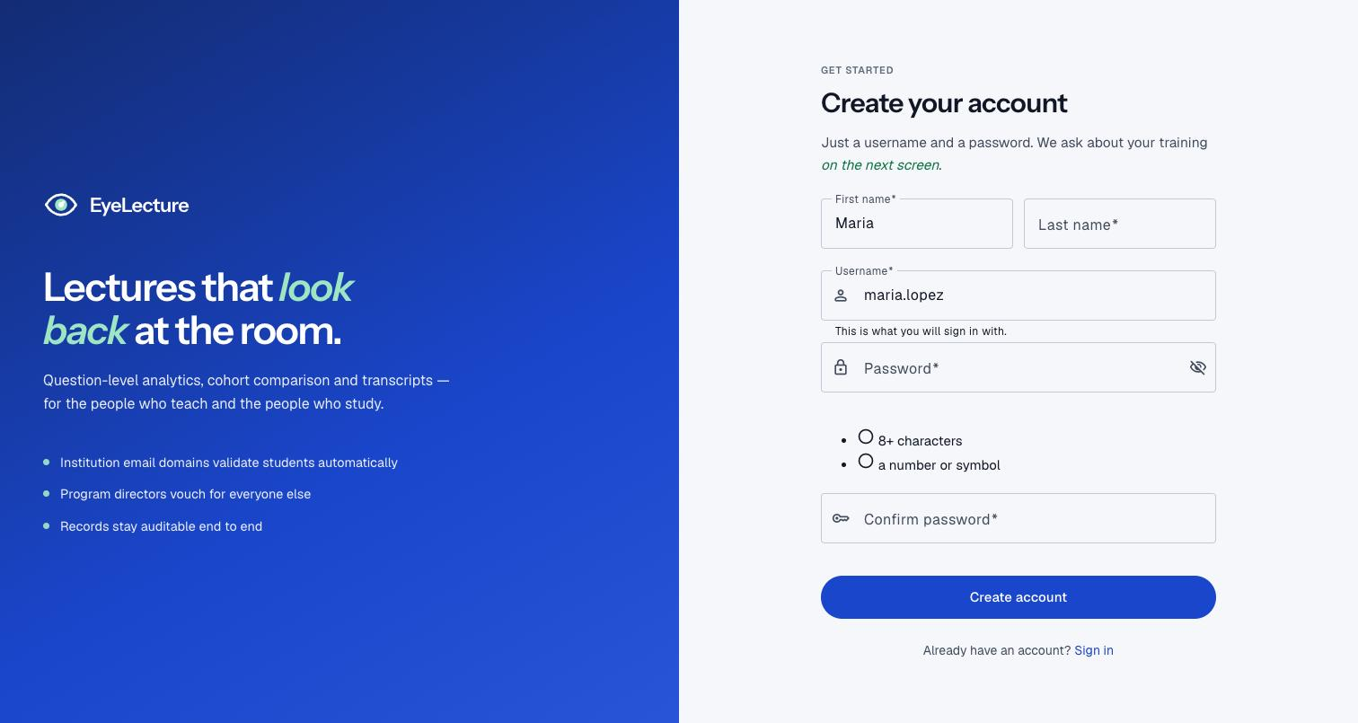
Step one. The username is what signs them in from then on.

2. The one rule
An institution owns one or more email domains. That fact, together with the rank, decides who confirms a new account.
Rank | With an address on | What happens
Medical student, resident, fellow | a domain an institution owns | In immediately. Nobody reviews them.
Medical student, resident, fellow | anything else, naming an institution | A residency administrator there reviews them.
Attending physician | anything at all | An administrator reviews them. Always.
Residency administrator | anything at all | An administrator reviews them. Always.
Only the three training ranks can be let in by an address alone. An attending physician is expected to use a personal one, and a residency administrator vouches for other people — neither is something a matching domain can establish.
One institution exists today: Stanford University School of Medicine, owning stanford.edu and med.stanford.edu. Every other domain is unrecognised.

3. The review queue
Same screen for both roles, different scope. A residency administrator sees only trainees who named their own institution. An administrator sees everyone waiting anywhere, including attending physicians and people applying to be residency administrators — which only an administrator can approve.
Either way the decision is Validate or Turn down, with an optional note that stays on the record.

4. Recovery addresses
Every account carries a second, personal address alongside the institutional one. The reason is what happens after graduation: the university closes the institutional mailbox, and without another address the account becomes unreachable.
- It does not sign anybody in. The username does that, which is why neither address changing matters.
- It has to be genuinely personal. A second institutional address is rejected — it disappears at the same time as the first.
- It never grants membership. Only the institutional address decides which institution someone belongs to.

5. What administrators can do
Institutions and their domains, the reference lists, every account, every pending request, and creating other administrators. Adding a domain is the highest-leverage action in the app: from that moment, every trainee signing up on it skips review entirely.
Reference lists are the specialties, residency programmes and fellowship programmes people pick from. Editing one changes every signup form at once, so retiring an entry is usually the right move — it stays readable on the profiles that already use it, while dropping out of the pickers.
On any row: change someone’s role, suspend them, or delete the account. Suspending is reversible and is the right answer to almost everything; deleting is not, and asks twice.
There is also Activate account, which stands in for the confirmation email when somebody cannot receive it. It marks the address confirmed and lets them sign in.

6. Not built yet
Email works: confirmation messages are sent for real, so a new signup gets a link and does not need an administrator to let them in. These are the gaps that remain.
Missing | What that means for you
Password reset | No "forgot password" link. An administrator hands out a temporary one instead.
Lectures, questions, analytics | None of the actual product. The dashboards are deliberately close to empty.
Bulk actions and invitations | People are approved one at a time. There is no way to invite a cohort.
Specialty and training on the profile | Attending physicians will pick a specialty, residency and fellowship. The lists exist and are editable; the step that asks for them does not yet.
If something looks broken, three things account for most surprises: an account that never finished step two, which is pinned to the profile screen; an account on a temporary password, pinned to the change-password screen; and a browser still signed in as somebody else. Roles change what renders, so sign out fully before switching.

