Assignment Report

# Literature Review

*A brief description of the problem area and how you problem (the shipping records) fits in. A less brief description of the technical issues involved (with sources).*

*At Masters level your report should not only describe your work but show an awareness of similar projects how your solution fits into a wider context. In this case the context is using databases for historical research. You need to describe other solutions to similar problems and how your work compares. Finding other similar works are a matter of your own research. Google Scholar is a good place to start.*

# Methodology

*A technical description of your solution with an explanation of the choices involved.*

# Results

*An analysis of your project from a technical standpoint. This should be evidence based.*

# Discussion

*An overall analysis of your project, this should summarise evidence from your results section, it can also be more subjective (but still evidence based).*

# Self-reflection

*Although it is not normally part of a peer-reviewed paper, it is university policy that you include a reflection section here. Reflection on your work has been shown to improve your learning in the long term. You should consult the marking schema and position your own work on it. You should also reflect on how you would do it differently if you were to repeat the exercise.*

**Running a container with mongo**

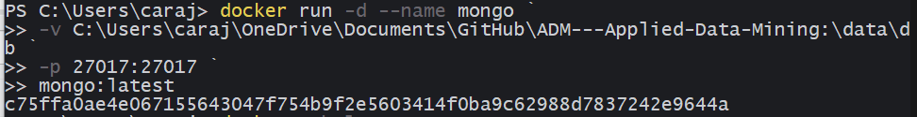

**Entering the bash terminal within the container and then executing the mongo command to be able to perform mongo operations**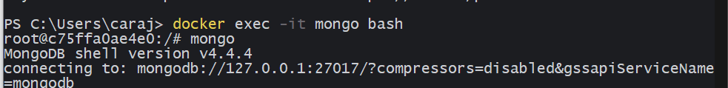

**Executing mongo operations**

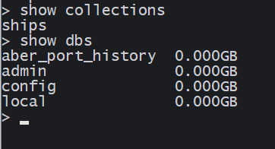

**GUI Interface to quickly visualise mongo operations**

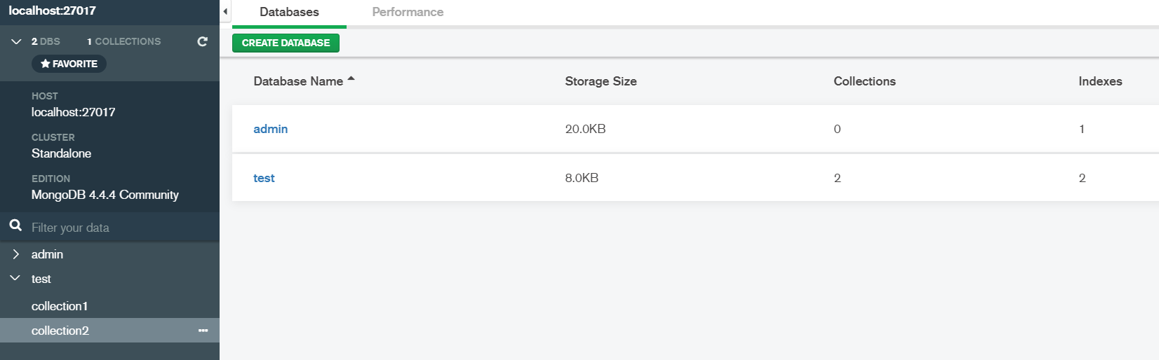

**Example of GUI interface visualising mongo operations**

