**To the attention of the Department of Human Management:**

I have been working as a Customer Service Agent for different companies for over 10 years now and 2 years as an assistant, and have developed impeccable phone manners, and an ability to deal with agitated or distressed customer. I am accustomed to work on multiples tasks simultaneously, and can offer new ideas to help your company grow.

I meet the requirements, since I have a Bachelor's degree in Business Administration, a good academic record and a high level of English. I believe that my skills, experience and reputation for excellence can greatly improve the already impressive performance of your company.

I have a proven track record of responsibility, integrity, and commitment to the company's goals. I feel comfortable working independently or as part of a team, and I firmly believe that your needs and my skills would be an excellent combination. In addition to all this I have impeccable personal and work references that I can present to you.

I invite you to review my attached resume, which will show you that I am a professional person who is able to perform to the highest standards in the areas of administration and human resources. The basis of my achievements to date lies in my ability to organize my time effectively, prioritize tasks and use my initiative to find solutions to problems.

I am available for an interview at any time, and in case you need any additional information, please do not hesitate to contact me. In the meantime I thank you sincerely for taking the time to read my request, and look forward with much interest to the opportunity to speak to you, in detail, regarding this position.

Receive a warm greeting,

**Juan Alcides Cabreja Rodríguez**

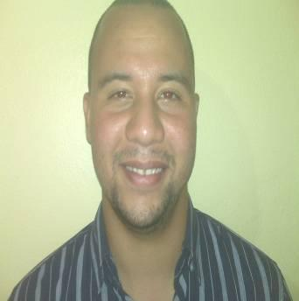

***Home: 809-535-1680 Cel: 809-309-3369***

***E-mail: mmjuancabreja@gmail.com***

***Calle 3 #5, Urb. Enriquillo Km 9 ½ Ave Independencia, Distrito Nacional.***



***ID: 001-1788122-7***



**Personal Information**

* **Status : *Single***
* **Nationality: *Dominican***
* **Age: *33***
* **Place Of Birth: *Santo Domingo, República Dominicana***



**Studies**

* **Primary Studies:**  **Colegio Infantil Átala**
* **Secondary Studies: Colegio San Gabriel de la Dolorosa**
* **University Studies:** **Universidad Católica Santo Domingo**

(Bachelor of Business Administration)

* **Technical Studies:** **INFOTEP**

(Computer Accounting Manager)

**UASD Y ATRIRD** (Diploma In Accounting and Tax Management)

**SIGMATEC**

(Diploma In Process Improvement)

**Language**

* **English Universidad O&M** (Advanced)

**Computer Skills**

* **Full Windows and Microsoft Office package.**
* **PC Maintenance and Configuration**
* **DacEasy Accounting System**

**Work Experiences**

**08/2005 – 05/2007 Teleservices**

Sales Agent.

Tel. 809-682-8797

**10/2007 – 08/2008 Data Vimenca**

Customer Service Agent.

Tel. 809-535-0516

**9/2008 – 3/2011 Stream Global Services**

Tech Support Agent

Tel. 809-476-1615

**4/2011 – 01/2020 Media Monitors RD**

Global Monitoring Operations Assistant

Tel. 809-472-2681

**Courses Completed**

1. **Biblioteca República Dominicana**

Etiquette and Protocol

**2003 Centro de Tecnología Universal (CENTU)**

Digitization and Hardware

**2012 INFOTEP**

Computerized Accounting

**2015 ATRIRD**

Accounting and Tax Management

**References**

**Dra. Jennie Adorno**

Cel. 849-353-3915

**Lic. Juan Luis Reyes**

Cel. 809-849-5456

Email: juan_reyes@bhd.com.do

**Ing. Luis Mejia**

Cel. (809) 820-6773

**Wellington Duran**

Cel. 849-854-4689

