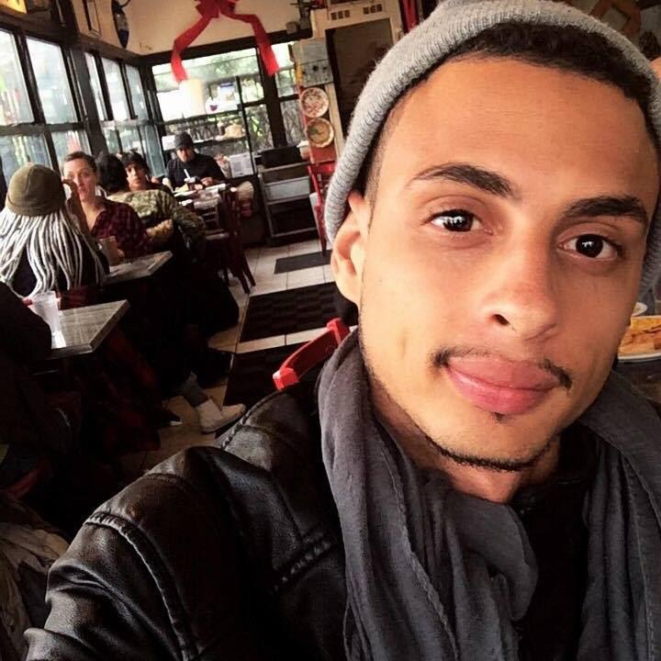2

**PROFESSIONAL EXPERIENCE**

**Supervisor**

**Frainy**

**Francisco S.**

Visionappoint.INC (2016/2019)

Call center

Puerto plata village(2014/2015)

**Recepcionist**



63

**PERSONAL DATA**

**AWARDS AND RECOGNITIONS**

**>HIPPA**

**> CUSTOMER SERVICE,**

**>INFOTEP**

**>ONLINE COURSES**

**Name**

Frainy Francisco Suero

Visionexpo East 2018 NY

**Birthday**

12 December 1994

Invitacion a participar como oyente y reconocimiento digital estampado.

**Civil Status**

Single

**Nationality**

Dominican

**Languages**

English, French.





**CONTACTO**

**PROFESSIONAL STUDIES**

Avenida Bartolome colon, Santiago

**Address**

**UTESA**

Administration(2014)

Currently studying

**Phone**

809. 972. 6876

**Bachelor**

facebook.com/frainy.francisco

**Mail**

franciscofrainy@gmail.com

**Website**

ANTERA MOTA (2009-2013)



8

**HABILIDADES**

**REFERENCIAS**

PC

Design

**Carlos Baquero**

Illustrator

Dreamweaver

HTML&CSS

Leadership

829 693 3748

**Independent**