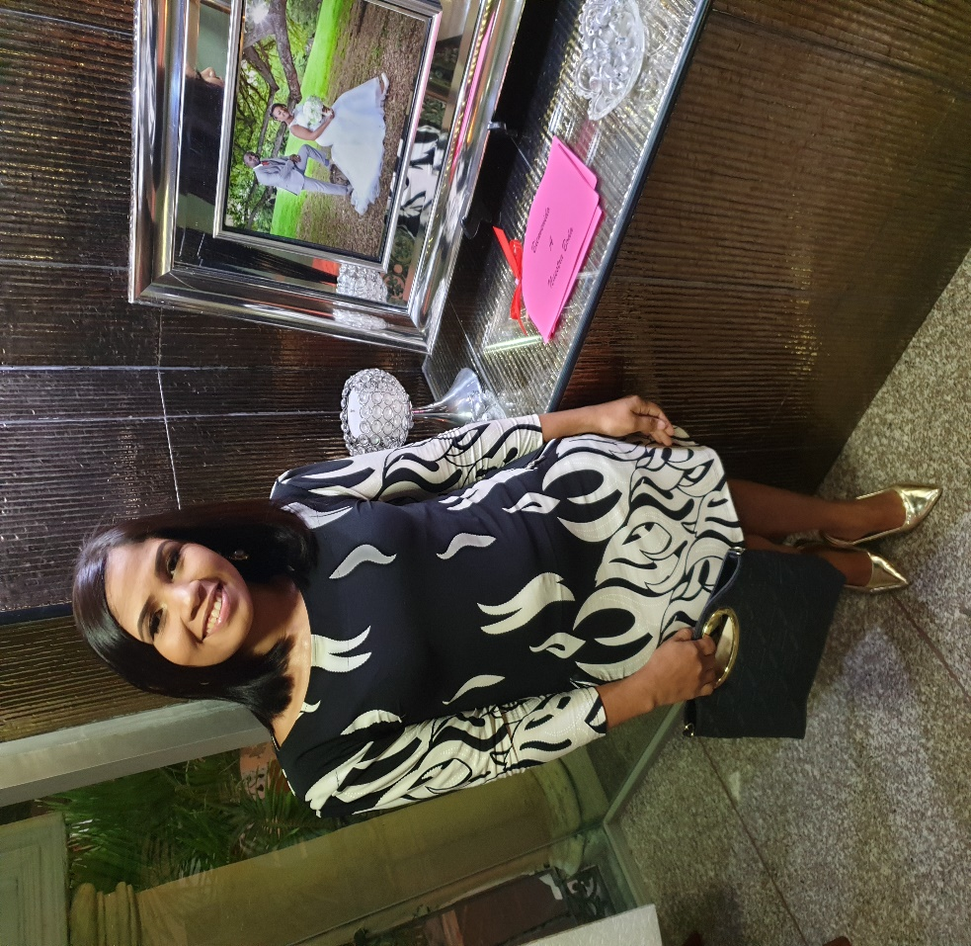

Francy E. Camacho de Torres

C/4 #5 Maz. 21, Caña Linda, Santo Domingo Este.

Email: lyabner22@gmail.com

Cell: (849) 402-4477

BD15058_ Goals:

I look forward to being able to grow within a company that acknowledges an employee’s dedication, consistency and desire to excel, notwithstanding getting the opportunity to endure in different areas of the corporation, allowing me the advantage of being capacitated in multiple fields.

BD15058_ Expectations:

It is very important to know that I work for a company that has no boundaries and that values my work and commitment. A corporation that understands that there are no barriers of an employee that considers herself an asset. I want to be able to forecast my accomplishment in a satisfying manner.

* **Professional Experience:**
  + **Telemarketing Agent:** USA (Cybernetic Park 2005)
  + **CSR Postmedia CANADA** (Laurus 2010-2012) Tel: (829) 687-1717

Postmedia Newspapers (Calgary/Edmonton)

* + **ACS-Xerox** (2012-2019) Quality analyst Tel: (809) 338-0201
  + **Concentrix** (2019) Asociante Tel: (809) 215-0584

**Education:**

**Third Semester:** UAPA (currently active)

**Business English:** Instituto Tecnologico las Americas **“**ITLA”

**IT technician:** CENTU

**Leadership, Coaching Cash and The Art Of Managing Stress:** Infotep.

**Typing Skills:** Self-study at home.

**Languages:**

English: BD21301_Written BD21301_ Read BD21301_ Comprehension BD21301_ Spoken

Spanish: BD21301_Written BD21301_ Read BD21301_ Comprehension BD21301_ Spoken

Reference:

* Miguel German Cell: 829-840-3894
* Ing. Don Carrion Cell: 829-903-4477