Pending times

Carlos Ram?rez

December 5, 2017

# Abstract

Pending times are very important for customer experience and fidelity. Hence, in this EDA report we analyze pending times for bussiness step processes in order to monitore and evaluate businness steps performance. In this report we focuses in Pareto categories, that is, top categories that accounts for more than eighty percent of the total GMV in the year 2017.

# Results

## Pending times across ifix steps

The following figure shows the pending times for diverse ifix steps.

The logarithm of the pending times are shown in the next figure, it can be seen that the process from visit to quote pdf attachment to ifix platform has the biggest mean pending time (267 hours ~ 11 days) of all the process steps in 2017. However, all steps have much variation (from 3 to 124, taking exponents). The time from payment to the initiation of the custom project has the lower mean values (142 hours ~ 6 days).

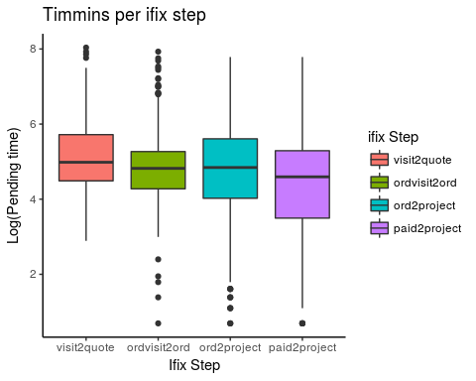

## ordvisit2ord.sum ord2project.sum visit2quote.sum paid2project.sum  
## Min. -346.0000 -22.0000 -702.0000 -23.0000  
## 1st Qu. 66.0000 32.0000 69.5000 28.0000  
## Median 122.0000 102.0000 140.0000 78.0000  
## Mean 232.4138 190.7275 267.0162 144.1753  
## 3rd Qu. 233.5000 242.0000 333.0000 168.0000  
## Max. 2777.0000 2406.0000 3093.0000 2406.0000

## Pending times across categories

In the following figure pending times (logs) by categories are shown. It can be seen that Limpieza (cleanning) has low pending times and also a lot of variation in time values. At the other hand Plomero (plumbing) has low pending time. These two categories distributions differs in a unpaired t-test with a p-value = 4.496e-08 statistical test.

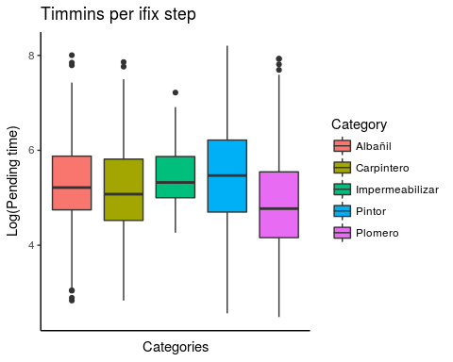

##   
## Welch Two Sample t-test  
##   
## data: timmings.mx[timmings.mx$category == "Pintor", "visit2quote"] and timmings.mx[timmings.mx$category == "Plomero", "visit2quote"]  
## t = 6.1617, df = 400.27, p-value = 1.756e-09  
## alternative hypothesis: true difference in means is not equal to 0  
## 95 percent confidence interval:  
## 142.2898 275.6265  
## sample estimates:  
## mean of x mean of y   
## 425.3421 216.3840

## Conclusions

In this report we analyzed pending times for several ifix bussinnes steps. We could observe that Mexico has lower mean time for quote definition. However, Argentina has lower mean pending time rate for quotes by job. In the case of Mexico, when analyzing pending times for different bussinness ifix steps and observed that quote definition has the high mean pending time value. At the other hand, the process from paid to project realization of custom projects had the lowest mean pending time. Finally, when mean pending times are evaluated it can be seen that Plomero (plumbing) and Limpieza (cleanning) has low and high mean times, respectively. These two categories had also different distributions when tested by a statistical t-test. Therefore, the next step is to evaluate how mean pending times affect sales conversion.