Pending times

Ifix BI Mexico

December 5, 2017

# Abstract

Pending times are very important for customer experience and fidelity. Hence, in this EDA report we analyze pending times for business steps processes in order to monitor and evaluate business steps performance.

# Results

## Mexico has a lower mean quote pending time

We started by focusing at the analysis of pending quotes. The next plot shows the time from the first visit to the when the quote is attached to the ifix platform. Distributions are given for the three countries Argentina (ARG), Brazil (BRZ) and Mexico (MXN) on year 2017. From the mean values shown it can be seen that Mexico has the low pending time for quote definition (140 hours ~ 6 days). However, it should be considered the fact that Mexico has the lower number of jobs of all the three countries.

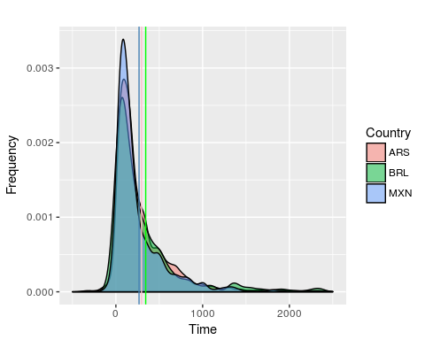

A summary table that includes mean pending times for all countries in the current year is given in the next table.

## ARGENTINA BRAZIL MEXICO  
## Min. -2792.0000 -318.0000 -702.0000  
## 1st Qu. 88.0000 64.0000 69.5000  
## Median 180.5000 164.5000 140.0000  
## Mean 295.7868 343.8474 267.0162  
## 3rd Qu. 375.7500 399.2500 333.0000  
## Max. 4968.0000 4335.0000 3093.0000

## Argentina has a better quote pending time rate by job

However, as the number of processed orders differs between countries we considered the corrected quote pending time rate as the pending time divided by the number of group by week. The distribution of the quote pending time rate is shown in the next image.

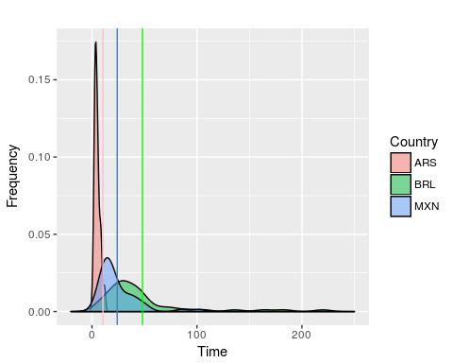

From the figure it can be seen that Argentina processes has lower mean quote pending times rates (5 hours per job). That is, lower pending time by job that the rest of the countries. The correc­ted means are shown in the next table.

## ARGENTINA BRAZIL MEXICO  
## Min. 0.700000 5.857143 2.809524  
## 1st Qu. 3.124521 23.625000 11.658497  
## Median 4.563636 33.982143 18.500000  
## Mean 10.436020 48.101710 24.072350  
## 3rd Qu. 6.280128 48.607143 31.633929  
## Max. 285.000000 220.000000 102.000000

A possible interpretation for quote pending rates is that Argentina performs approximately 6 and 10 times faster quotes per job than Mexico and Brazil, respectively.

## Pending time across process steps

We went further and examined pending times for different steps of the ifix process. The logarithm of the pending times are shown in the next figure, it can be seen that the process from visit to quote pdf attachment to ifix platform has the biggest mean pending time (267 hours ~ 11 days) of all the process steps in 2017. However, all steps have much variation (from 3 to 124, taking exponents). The time from payment to the initiation of the custom project has the lower mean values (142 hours ~ 6 days).

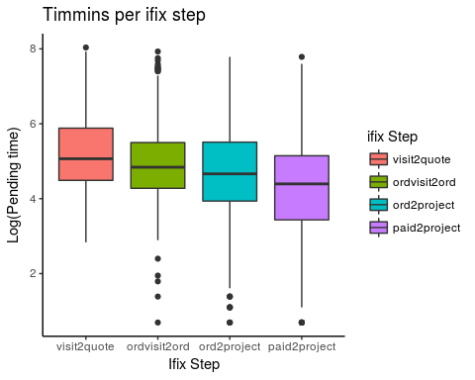

## ordvisit2ord.sum ord2project.sum visit2quote.sum paid2project.sum  
## Min. -346.0000 -22.0000 -702.0000 -23.0000  
## 1st Qu. 66.0000 32.0000 69.5000 28.0000  
## Median 122.0000 102.0000 140.0000 78.0000  
## Mean 232.4138 190.7275 267.0162 144.1753  
## 3rd Qu. 233.5000 242.0000 333.0000 168.0000  
## Max. 2777.0000 2406.0000 3093.0000 2406.0000

## Pending times across categories

In the following figure pending times (logs) by categories are shown. It can be seen that Limpieza (cleanning) has low pending times and also a lot of variation in time values. At the other hand Plomero (plumbing) has low pending time. These two categories distributions differs in a unpaired t-test with a p-value = 4.496e-08.

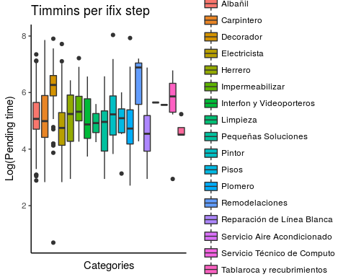

##   
## Welch Two Sample t-test  
##   
## data: timmings.mx[timmings.mx$category == "Decorador", "visit2quote"] and timmings.mx[timmings.mx$category == "Plomero", "visit2quote"]  
## t = 6.5564, df = 69.551, p-value = 8.148e-09  
## alternative hypothesis: true difference in means is not equal to 0  
## 95 percent confidence interval:  
## 308.0876 577.5169  
## sample estimates:  
## mean of x mean of y   
## 630.4426 187.6404

## Conclusions

In this report we analyzed pending times for several ifix bussinnes steps. We could observe that Mexico has lower mean time for quote definition. However, Argentina has lower mean pending time rate for quotes by job. In the case of Mexico, when analyzing pending times for different bussinness ifix steps and observed that quote definition has the high mean pending time value. At the other hand, the process from paid to project realization of custom projects had the lowest mean pending time. Finally, when mean pending times are evaluated it can be seen that Plomero (plumbing) and Limpieza (cleaning) has low and high mean times, respectively. These two categories had also different distributions when tested by a statistical t-test. Therefore, the next step is to evaluate how mean pending times affect sales conversion. Another perspective is to focus on categories that accounts for the vast majority of the GMV, since considering all categories can add more variability and confusors to the analysis.