P56817_20220518005400_top_scores_XGBClassifier_f1_weighted_rf0

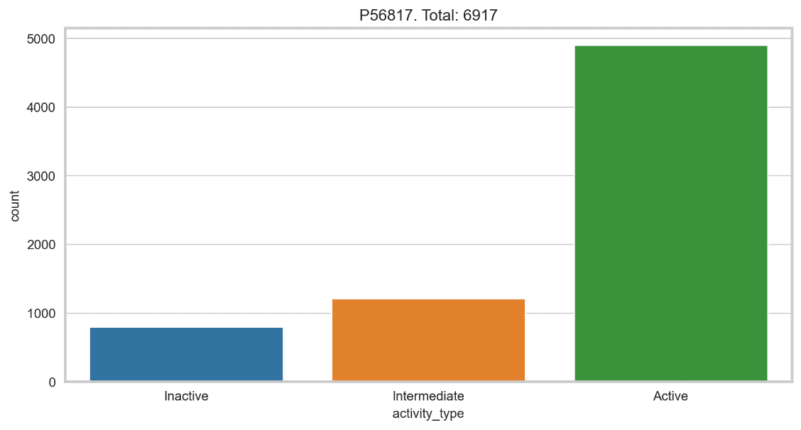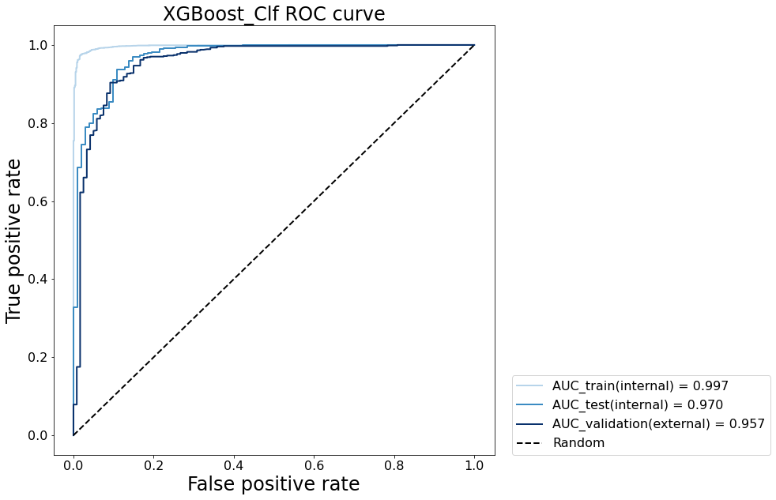

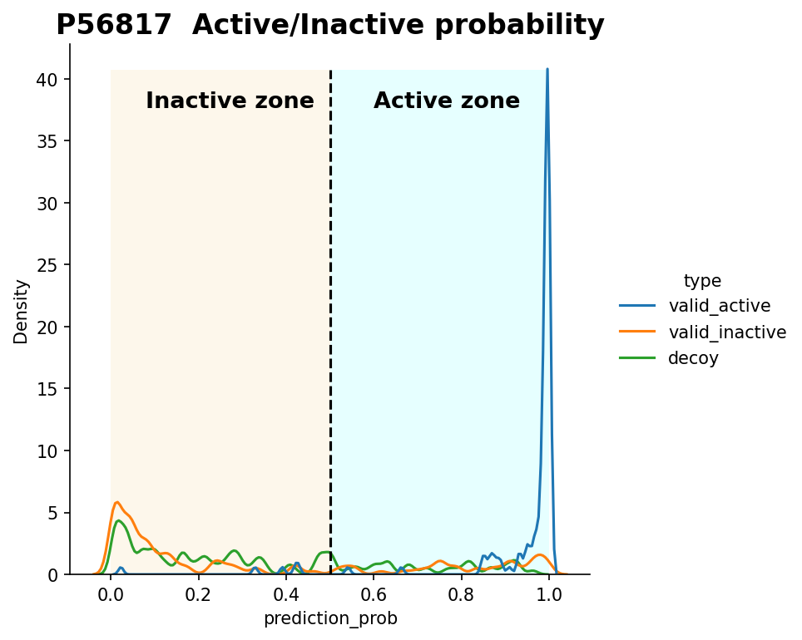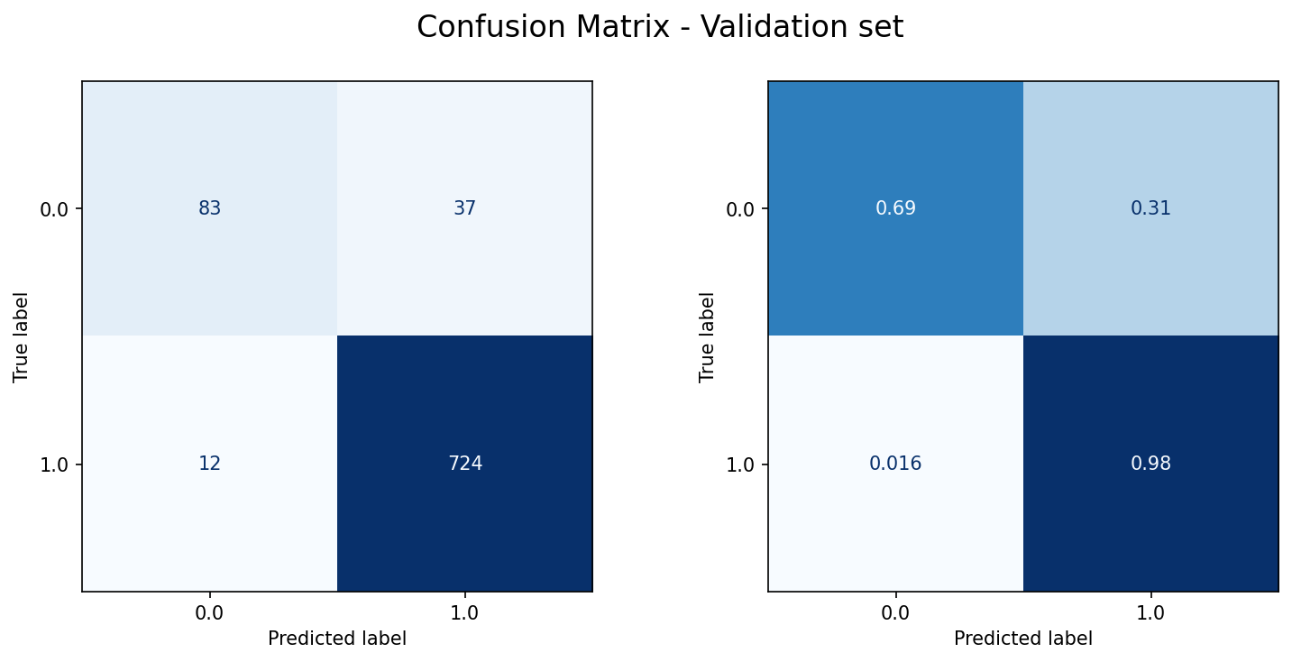

P56817_20220524175737_top_scores_XGBClassifier_jaccard_rf0

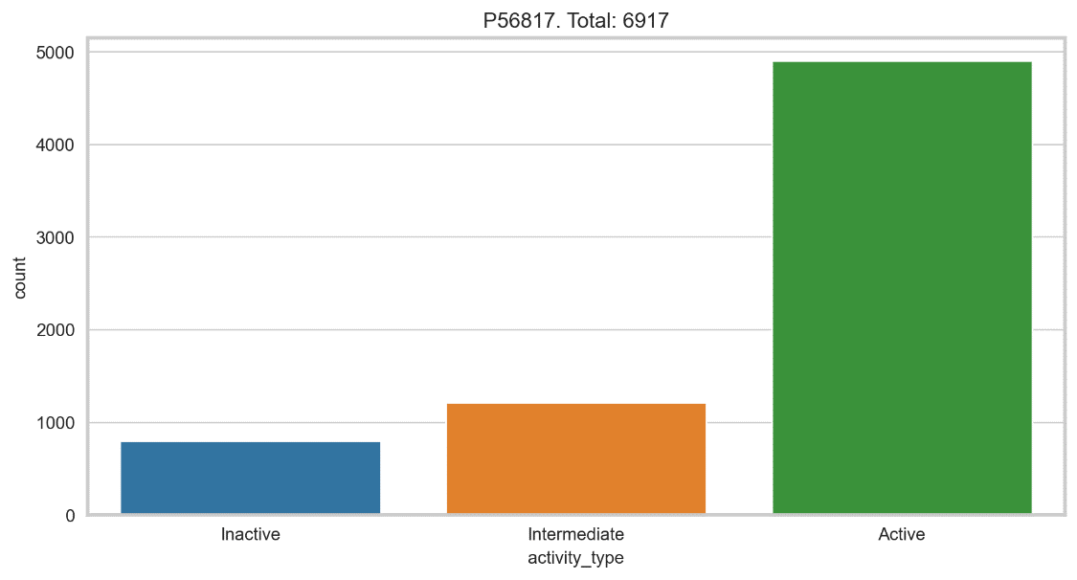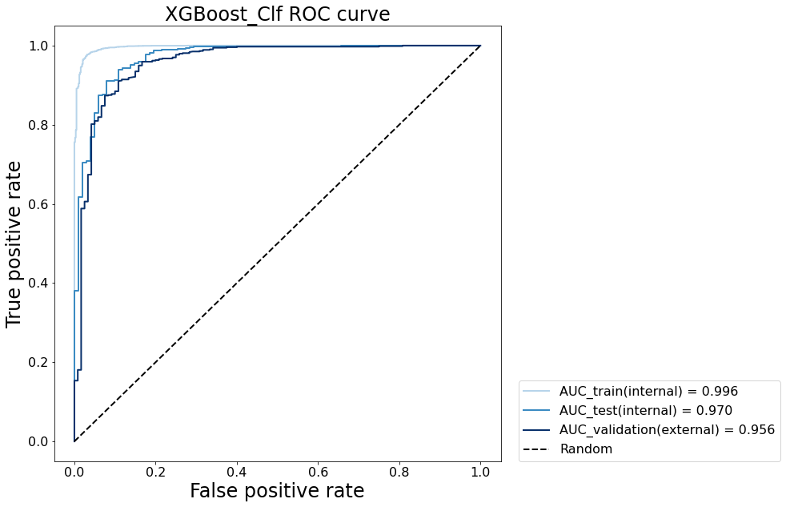

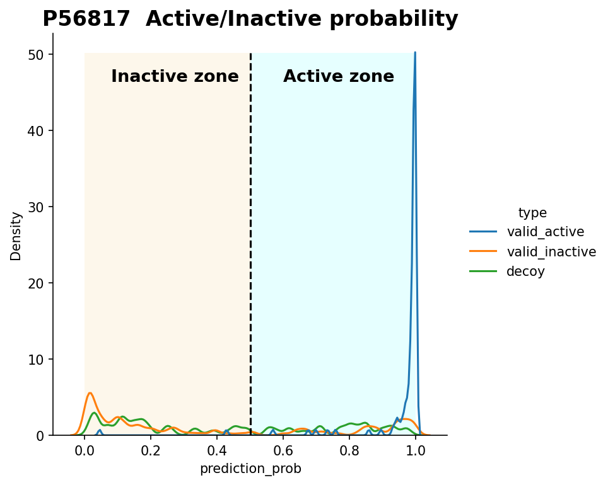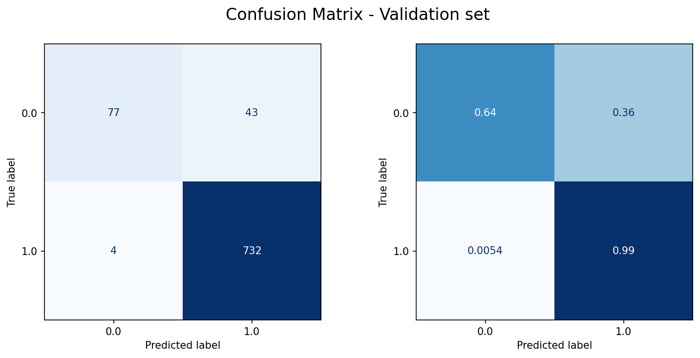

P56817_20220524182502_top_scores_XGBClassifier_accuracy_rf0

P56817_20220524184556_top_scores_XGBClassifier_balanced_accuracy_rf0

P56817_20220525141431_top_scores_XGBClassifier_precision_rf0

56817_20220603101021_top_scores_XGBClassifier_accuracy_rf4

P56817_20220603102130_top_scores_XGBClassifier_balanced_accuracy_rf4

P56817_20220603112114_top_scores_XGBClassifier_f1_weighted_rf4

P56817_20220603115019_top_scores_XGBClassifier_precision_rf4

P56817_20220603091603_BayesSearchCV_XGBoots_jaccard_rf4

