P49841_20220628112515_top_scores_XGBClassifier_balanced_accuracy_rf0

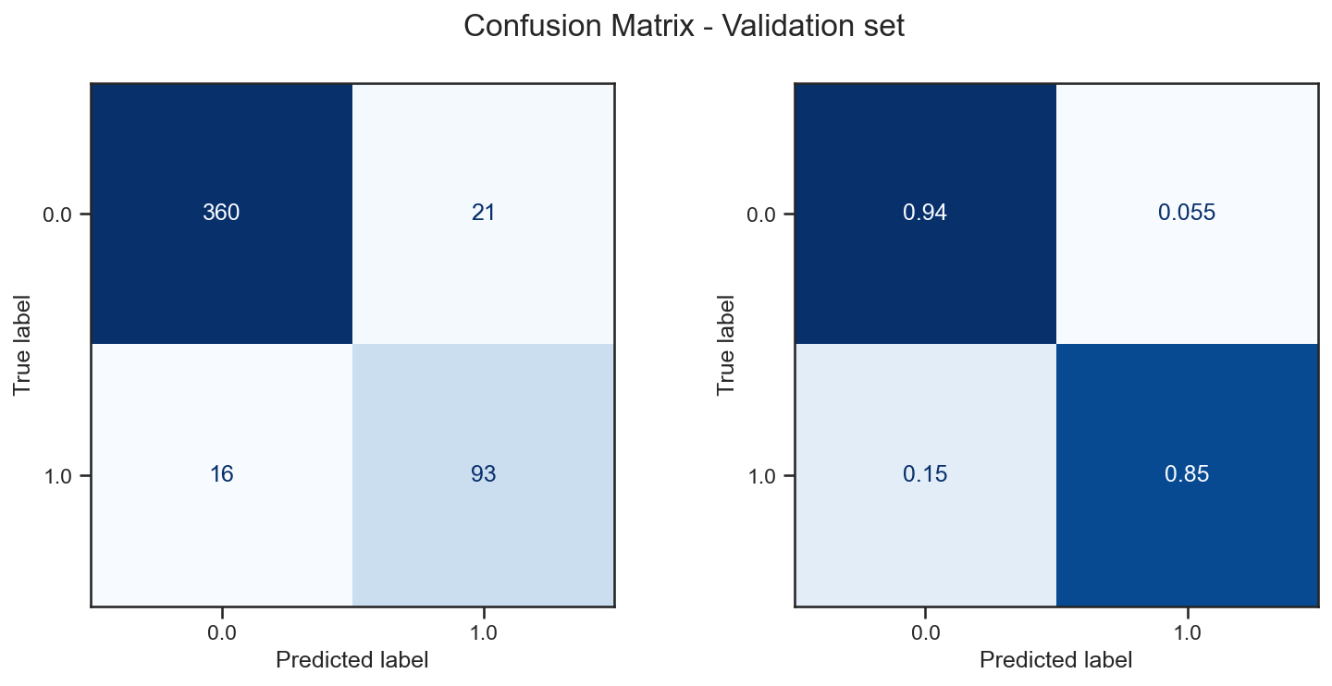

P49841_20220628123407_top_scores_XGBClassifier_f1_weighted_rf0

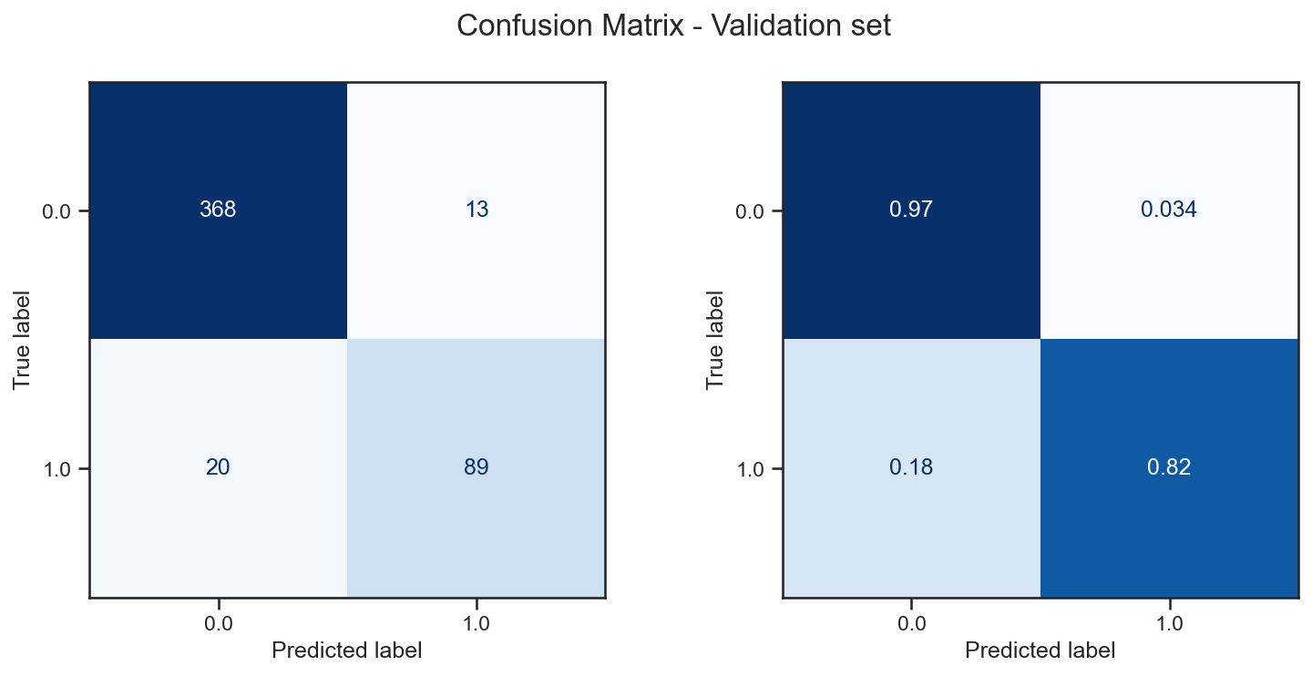

P49841_20220628131508_top_scores_XGBClassifier_precision_rf0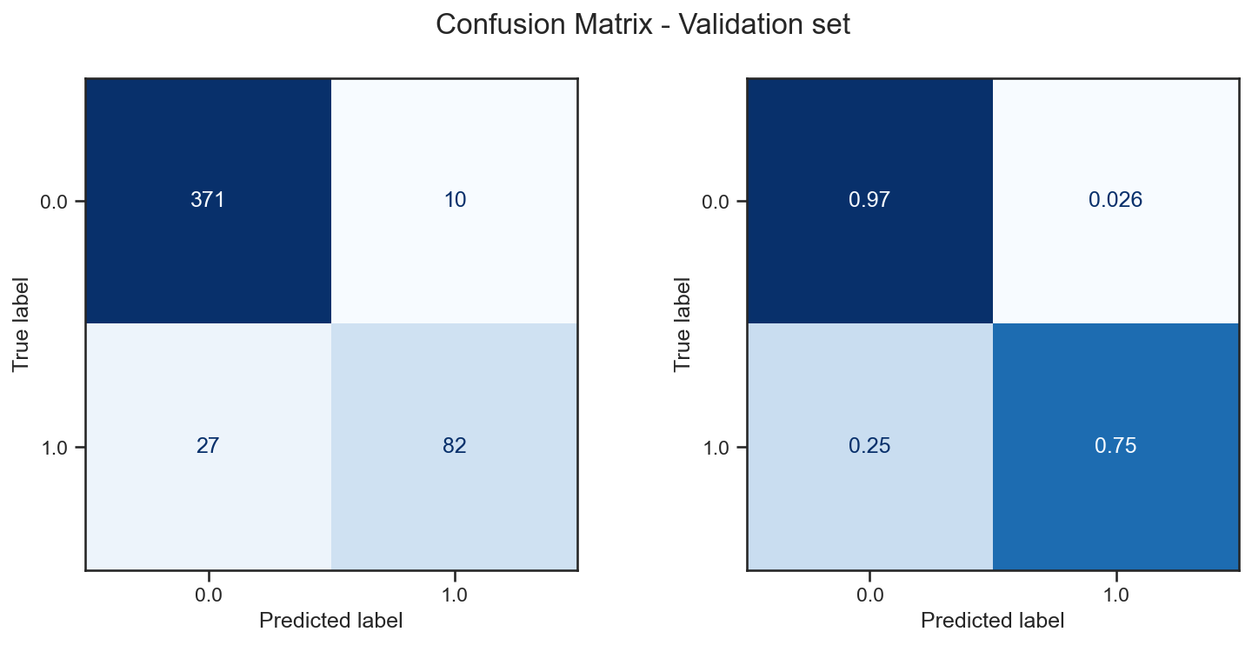

P49841_20220628140741_top_scores_XGBClassifier_accuracy_rf0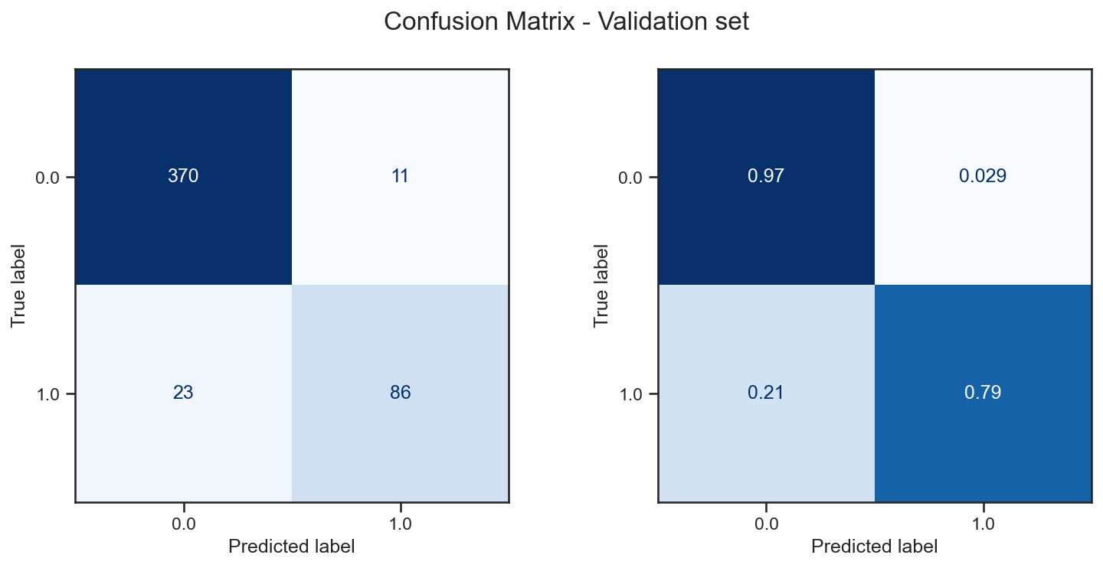

P49841_20220628141316_top_scores_XGBClassifier_jaccard_rf0

