Lucerne University of Applied Sciences and Arts
MSc in Applied Information and Data Science

Master’s Thesis

Electoral Closeness and Incumbency Advantage
in Spain’s Proportional Representation System

Camilo Andres Aranguren Barragan
camilo.arangurenbarragan@stud.hslu.ch

Supervisor: Prof. Dr. Lukas Schmid
Co-supervisor: Prof. Oliver Staubli

May 2026

Abstract
This thesis estimates the causal effect of incumbency on subsequent electoral outcomes in Spain’s proportional representation system. While a large body of research has established the existence and magnitude of incumbency advantages in majoritarian electoral systems, comparatively little is known about how incumbency operates in proportional representation (PR) contexts, where seat allocation follows the D’Hondt method and party lists mediate the relationship between individual candidates and voters.
Leveraging the quasi-experimental variation generated by close electoral races, I employ a regression discontinuity design (RDD) adapted for PR systems following the closeness measure proposed by Luechinger, Schelker, and Schmid (2024). The running variable captures how close a party is to gaining or losing its last marginal seat in a given province, normalized by the number of eligible voters. Using data on all Spanish congressional (Congreso de los Diputados) elections from 2004 to 2023, encompassing 2,424 party-province-election observations, I estimate both sharp and fuzzy RDD specifications.
The results indicate a substantial and statistically significant incumbency advantage. Parties that barely win a marginal seat are approximately 28.4 percentage points more likely to field a candidate in the subsequent election (sharp RDD, p < 0.001) and 18.9 percentage points more likely to win a seat (sharp RDD, p < 0.001). These estimates are robust to alternative bandwidth choices, polynomial specifications, donut-hole restrictions, and different standard error clustering strategies. Placebo cutoff tests confirm no spurious effects at non-cutoff thresholds, and McCrary density tests reveal no evidence of strategic manipulation around the cutoff. The near-perfect first-stage relationship (τ ≈ 0.98) yields fuzzy RDD estimates that are virtually identical to sharp estimates, confirming the design’s internal validity.
These findings contribute to a growing literature on incumbency effects beyond majoritarian settings. They suggest that even in PR systems—where the personal vote is often considered less important—winning a marginal seat confers meaningful advantages for future electoral performance.

Keywords: incumbency advantage, regression discontinuity design, proportional representation, Spain, D’Hondt method, electoral closeness

Declaration of Independence
I hereby confirm that I have carried out this work independently. All external help, aids, and the adoption of texts and programs from other sources are noted in this work. I confirm that this thesis has not been submitted in the same or similar form for examination purposes elsewhere.

Place, Date: ____________________________

Signature: ____________________________

Table of Contents

List of Tables
Table 1: Summary Statistics by Treatment Status
Table 2: Main RDD Estimates – Sharp and Fuzzy Specifications
Table 3: Bandwidth Sensitivity Analysis
Table 4: Standard Error Robustness
Table 5: Outcome Definition Robustness
Table 6: Placebo Cutoff Tests
Table 7: Donut-Hole Robustness
Table 8: Polynomial Order Comparison
Table 9: McCrary Density Tests
Table 10: Covariate Balance at the Cutoff

List of Figures
Figure 1: Incumbency Effect on Running in Next Election (RDD Scatter)
Figure 2: Incumbency Effect on Winning Seat in Next Election (RDD Scatter)
Figure 3: First Stage – Election Status at the Cutoff
Figure 4: McCrary Density Test – Running Variable Distribution
Figure 5: Bandwidth Sensitivity Analysis with 95% Confidence Intervals
Figure 6: Covariate Balance at the Cutoff

1. Introduction

1.1 Motivation
The incumbency advantage—the electoral benefit enjoyed by parties or candidates who currently hold office—is one of the most studied phenomena in political science. Understanding whether and how incumbency confers advantages is crucial for evaluating democratic accountability, political competition, and representation. If incumbents enjoy significant advantages simply by virtue of holding office, this has implications for political turnover, policy responsiveness, and the health of democratic systems.
A rich empirical literature has documented incumbency effects in majoritarian, single-member district systems, particularly in the United States and the United Kingdom. The regression discontinuity design (RDD), which exploits the quasi-random assignment of incumbency status in close elections, has become the standard identification strategy. Seminal contributions by Lee (2008), who found a roughly 38 percentage point advantage for Democratic candidates winning close US House races, established this approach as a credible method for causal identification.
However, the vast majority of democracies worldwide employ some form of proportional representation (PR), where seats are allocated to parties in proportion to their vote shares. In these systems, the mechanisms underlying incumbency advantage may differ substantially from majoritarian contexts. Under PR, voters typically choose between party lists rather than individual candidates, the personal vote may play a diminished role, and the institutional channels through which incumbency operates—such as name recognition, constituency service, and media visibility—may be filtered through party organizations.
Spain provides an ideal setting for studying incumbency effects in a PR system. The country uses a closed-list PR system with the D’Hondt method for seat allocation in its lower chamber (Congreso de los Diputados), with 52 multi-member provincial constituencies. This institutional design generates quasi-experimental variation at the margin of seat allocation: parties that barely win versus barely lose a marginal seat in a given province are, on average, comparable in terms of observable and unobservable characteristics, yet they differ in their incumbency status.

1.2 Research Questions
This thesis addresses the following research questions:
RQ1: Does winning a marginal seat in Spain’s proportional representation system confer an incumbency advantage for the party in subsequent elections?
RQ2: How large is the incumbency advantage, measured by the probability of running again (extensive margin) and winning again (intensive margin)?
RQ3: Are these effects robust to alternative bandwidth selections, polynomial specifications, and potential manipulation of the running variable?

1.3 Contribution
This thesis makes several contributions to the literature. First, it extends the RDD approach to incumbency estimation in a PR context using the closeness measure recently proposed by Luechinger, Schelker, and Schmid (2024), which adapts the close-election framework to proportional representation systems with multi-member districts. Second, it provides the first comprehensive analysis of incumbency advantage in Spanish congressional elections at the party-province level. Third, by implementing a comprehensive battery of robustness checks—including placebo cutoff tests, donut-hole restrictions, polynomial order sensitivity, and density tests—it establishes the credibility of the empirical design. Finally, from a data science perspective, this thesis demonstrates the application of causal inference methods to a rich administrative dataset, bridging political science theory with applied information and data science methodology.

1.4 Preview of Results
The main findings indicate a substantial incumbency advantage in Spain’s PR system. Parties that barely win a marginal seat are approximately 28 percentage points more likely to run in the next election and 19 percentage points more likely to win a seat. These effects are highly statistically significant and robust across multiple specifications. The near-perfect first-stage relationship confirms that winning the marginal seat almost perfectly determines incumbency status, validating the research design.

1.5 Structure
The remainder of this thesis is organized as follows. Chapter 2 reviews the relevant literature on incumbency advantage. Chapter 3 describes Spain’s electoral system and the institutional context. Chapter 4 presents the methodological framework, including the RDD identification strategy and the closeness measure for PR systems. Chapter 5 describes the data. Chapter 6 presents the main results. Chapter 7 provides extensive robustness checks. Chapter 8 discusses the findings, and Chapter 9 concludes.

2. Literature Review

2.1 Incumbency Advantage in Majoritarian Systems
The study of incumbency advantage has a long tradition in political science, dating back to early observations that incumbent legislators tend to win re-election at rates far exceeding what would be expected by chance. Gelman and King (1990) formalized the concept of the “incumbency advantage” as the average causal effect of a party holding a seat on its vote share in subsequent elections. Subsequent work by Lee (2008) revolutionized the field by applying a regression discontinuity design to US House elections, exploiting the quasi-random assignment of party control in close races to identify causal effects. Lee’s estimate of a roughly 38 percentage point advantage for the winning party in close US elections demonstrated the power of the RDD approach and established it as the gold standard for measuring incumbency effects.
Following Lee (2008), numerous studies have applied the RDD framework to majoritarian elections in various countries. Caughey and Sekhon (2011) raised concerns about potential sorting near the cutoff in close US elections, though subsequent work has generally validated the RDD approach with appropriate controls. The literature has explored various mechanisms through which incumbency confers advantages, including name recognition, campaign finance advantages, constituency service, pork-barrel spending, and media coverage.

2.2 Incumbency Effects in Proportional Representation
Extending the incumbency advantage literature to PR systems presents unique challenges. Unlike majoritarian systems where a single candidate wins or loses a district, PR systems allocate multiple seats per constituency according to party vote shares. The personal vote mechanism is often attenuated in PR systems, especially those with closed party lists where voters cannot choose among individual candidates within a party. Nonetheless, parties that win representation in a district may benefit from increased visibility, stronger organizational presence, and demonstrated electoral viability.
Pons and Tricaud (2018) studied incumbency advantages under proportional representation by examining French municipal elections and how coordination effects interact with incumbency status. Their work highlights that in multi-party PR settings, incumbency can affect not only direct electoral performance but also the strategic behavior of competing parties. The findings suggest that incumbency effects operate through both direct channels (voter loyalty, name recognition) and indirect channels (strategic entry and exit of competitors).
Luechinger, Schelker, and Schmid (2024) made a key methodological contribution by developing a measure of electoral closeness suitable for proportional representation systems. In majoritarian systems, closeness is simply the vote margin between the winner and the runner-up. In PR systems with D’Hondt or similar divisor methods, closeness must be defined relative to the marginal seat allocation. Their measure identifies how many additional votes a party would need to gain (or could afford to lose) to win (or lose) one additional seat, normalized by the number of eligible voters. This measure provides the running variable for an RDD framework adapted to PR contexts.

2.3 The Spanish Context in the Literature
Spain’s electoral system has been studied from various angles, including the effects of district magnitude on proportionality, the relationship between electoral rules and party system fragmentation, and the strategic behavior of parties under the D’Hondt method. However, to the best of my knowledge, no prior study has applied the RDD framework with the Luechinger, Schelker, and Schmid (2024) closeness measure to estimate the incumbency advantage in Spanish congressional elections. This thesis fills that gap.
Spain is a particularly interesting case for several reasons. First, the country’s 52 provinces vary substantially in district magnitude, from single-member districts (Ceuta and Melilla) to large multi-member districts (Madrid and Barcelona), providing variation in the competitiveness and proportionality of seat allocation. Second, Spain uses a closed-list system where voters cannot express preferences for individual candidates, meaning that any incumbency effect operates primarily through the party rather than individual candidate channels. Third, the Spanish party system has undergone significant transformation during the period studied (2004–2023), including the rise of new parties such as Podemos and Ciudadanos, providing a dynamic political context.

2.4 Hypotheses
Drawing on the theoretical and empirical literature reviewed above, this thesis tests the following hypotheses:
H1: Parties that barely win a marginal seat are more likely to run again in the subsequent election (extensive margin incumbency advantage).
Rationale: Winning representation provides organizational resources, media visibility, and demonstrated electoral viability that reduce the costs and increase the expected benefits of contesting the next election. Parties that lose their last seat in a province may be more likely to withdraw from that constituency due to resource constraints and reduced perceived viability.
H2: Parties that barely win a marginal seat are more likely to win a seat in the subsequent election (intensive margin incumbency advantage).
Rationale: Beyond simply running again, incumbent parties may attract more votes through visibility, policy influence, and voter loyalty, translating the extensive margin advantage into actual seat gains. The literature on incumbency in PR systems suggests this effect operates through party-level rather than individual-level channels.

3. Institutional Background

3.1 The Spanish Congress of Deputies
The Congreso de los Diputados (Congress of Deputies) is the lower house of Spain’s bicameral legislature, the Cortes Generales. It consists of 350 members elected through a closed-list proportional representation system. Elections are held at least every four years, though early elections can be called by the Prime Minister or triggered by political circumstances.
Members are elected from 52 constituencies corresponding to Spain’s 50 provinces plus the two autonomous cities of Ceuta and Melilla. Each province is allocated a minimum of two seats, with the remaining seats distributed among provinces in proportion to their population. This allocation results in significant variation in district magnitude: Ceuta and Melilla each elect a single member, while Madrid elects the most representatives (typically 36–37). The average district magnitude is approximately 6.7 seats per province.

3.2 The D’Hondt Method
Seats within each province are allocated to parties using the D’Hondt method (also known as the Jefferson method), a highest-averages method of proportional representation. Parties that receive at least 3% of valid votes in a province are eligible for seat allocation. The method works by iteratively dividing each party’s total vote count by successive integers (1, 2, 3, ...) and allocating seats to the highest quotients until all seats in the province are filled.
The D’Hondt method tends to slightly favor larger parties compared to other proportional methods, and this tendency is amplified in small-magnitude districts. This feature of Spain’s electoral system has been widely discussed in the literature as contributing to the country’s historically two-party-dominant system, although the emergence of new parties in the 2010s partially altered this dynamic.

3.3 Implications for Identification
The D’Hondt allocation mechanism is central to the identification strategy employed in this thesis. At the margin of seat allocation, small differences in vote shares can determine whether a party wins or loses a seat. A party that barely passes the threshold for a marginal seat under D’Hondt is, in expectation, similar to a party that barely fails to reach this threshold. This quasi-random assignment around the marginal seat threshold provides the basis for the regression discontinuity design.
Several features of the Spanish system make it well-suited for this analysis. First, parties cannot precisely control their vote totals, especially in close races, meaning that assignment near the cutoff approximates random assignment. Second, the large number of province-election observations across multiple elections provides sufficient statistical power. Third, the closed-list system means that individual candidate characteristics are less likely to confound the party-level effects being estimated.

4. Methodology

4.1 Regression Discontinuity Design
The regression discontinuity design (RDD) exploits discontinuities in treatment assignment that arise when a treatment is determined by whether an observed variable—the running variable—crosses a known threshold. In the sharp RDD, treatment status is a deterministic function of the running variable: units above the cutoff receive treatment, while those below do not. The fuzzy RDD relaxes this assumption, allowing treatment to be a probabilistic function of crossing the threshold.
The key identifying assumption of the RDD is that the conditional expectation of potential outcomes is continuous at the cutoff. Under this assumption, any discontinuity in the observed outcome at the cutoff can be attributed to the causal effect of treatment. The local average treatment effect (LATE) is identified by comparing outcomes of units just above and just below the cutoff, within an appropriately chosen bandwidth.

4.2 Closeness Measure for PR Systems
In majoritarian systems, the running variable for an incumbency RDD is simply the vote margin between the winner and the runner-up. In proportional representation systems with D’Hondt allocation, defining closeness requires a more sophisticated approach.
Following Luechinger, Schelker, and Schmid (2024), I define the running variable as the minimal vote change needed for a party to gain or lose one additional seat in a given province, normalized by the number of eligible voters. Specifically, for each party-province-election observation, I compute the minimum number of votes that would need to be added (if the party barely lost a seat) or subtracted (if the party barely won a seat) to change the D’Hondt allocation by exactly one seat. This vote margin is then divided by the number of eligible voters in the province to produce a standardized measure that is comparable across provinces of different sizes.
The resulting running variable takes positive values for parties that won the marginal seat and negative values for parties that lost it. The cutoff is at zero, and the treatment indicator equals one for observations with a non-negative running variable (i.e., parties that won the marginal seat).

4.3 Estimation
I estimate the incumbency effect using local linear regression within a bandwidth around the cutoff. The estimating equation for the sharp RDD is:
Yᵢ = α + βXᵢ + τTᵢ + γ(Tᵢ × Xᵢ) + εᵢ
where Yᵢ is the outcome (runs in next election or wins a seat in the next election), Xᵢ is the running variable (normalized vote margin), Tᵢ = 1(Xᵢ ≥ 0) is the treatment indicator, and Tᵢ × Xᵢ allows the slope to differ on each side of the cutoff. The parameter τ captures the incumbency effect. I use a pooled regression specification with a triangular kernel to weight observations inversely proportional to their distance from the cutoff.
Standard errors are clustered at the province-election level to account for within-group correlation. I report inference based on the t-distribution with G − 1 degrees of freedom, where G is the number of clusters, following Cameron, Gelbach, and Miller (2008). This is conservative relative to normal approximation and appropriate given the finite number of clusters.
The bandwidth is selected using the Imbens and Kalyanaraman (2012) optimal bandwidth selector, and I present robustness to alternative bandwidths in the sensitivity analysis.

4.4 Fuzzy RDD
While the sharp RDD treats the running variable as perfectly determining treatment (incumbency), in practice the relationship may be imperfect. The fuzzy RDD addresses this by using the running variable as an instrument for actual incumbency status. The Wald (LATE) estimator divides the reduced-form discontinuity in outcomes by the first-stage discontinuity in treatment:
τᶠᵘᶻᶻʸ = τʳᵉᵈᵘᶜᵉᵈᶠᵒʳᵐ / τᶠᵢʳˢᵗˢᵗᵃᵍᵉ
In the present context, the first-stage relationship is near-perfect (τ ≈ 0.98), meaning that crossing the cutoff almost perfectly predicts actual incumbency status. As a result, the sharp and fuzzy estimates are nearly identical, and the first-stage F-statistic far exceeds the Stock and Yogo (2005) threshold of 10, ruling out weak instrument concerns.

4.5 Validity Tests
I implement several tests to assess the validity of the RDD design:
McCrary Density Test: I test for manipulation of the running variable by examining whether the density of observations exhibits a discontinuity at the cutoff, following McCrary (2008). If parties could precisely manipulate their vote totals to barely win marginal seats, we would expect a discontinuous jump in density at zero.
Covariate Balance: I test whether pre-determined covariates—including gender composition, list position, party votes, constituency size, and blank vote shares—are balanced around the cutoff. Significant discontinuities in these variables would suggest that assignment near the cutoff is not quasi-random.
Placebo Cutoff Tests: I estimate the RDD at placebo cutoffs (the median of each side of the distribution) where no treatment effect should exist. Finding significant effects at non-cutoff thresholds would undermine the credibility of the design.

5. Data

5.1 Data Sources
The analysis draws on comprehensive data from Spanish congressional elections held between 2004 and 2023, covering six general elections (2004, 2008, 2011, 2015, 2016, 2019 April, 2019 November, and 2023). The primary data sources include official election results from Spain’s Electoral Board (Junta Electoral Central), providing detailed vote counts by party, province, and election. Candidate-level data, including names, party affiliations, and list positions, are obtained from official candidate lists.
The unit of analysis is the party-province-election, representing a party’s performance in a specific province during a specific election. The running variable—the normalized vote margin for the marginal seat—is computed from the detailed vote data using the D’Hondt allocation algorithm as described in Chapter 4.

5.2 Sample Construction
The full dataset comprises 2,424 party-province-election observations within the analysis window (running variable between −0.05 and +0.05). After linking outcomes to the subsequent election, the estimation sample for the “runs next” outcome contains 2,128 observations, and the “wins next” outcome contains the same 2,128 observations with non-missing outcomes.

5.3 Summary Statistics
Table 1 presents summary statistics for the key variables, disaggregated by treatment status (above vs. below the cutoff).

Table 1: Summary Statistics by Treatment Status
Variable | N | Mean (All) | SD | Mean (L) | Mean (R) | Diff
Running var. | 2,424 | −0.011 | 0.029 | −0.030 | 0.024 | 0.054
Elected | 2,424 | 0.351 | 0.477 | 0.004 | 0.994 | 0.990
Runs next | 2,128 | 0.408 | 0.492 | 0.310 | 0.598 | 0.288
Wins next | 2,128 | 0.174 | 0.379 | 0.056 | 0.402 | 0.347
Female share | 1,891 | 0.402 | 0.490 | 0.411 | 0.386 | −0.025
List position | 2,424 | 2.484 | 2.454 | 2.329 | 2.773 | 0.444
Log party votes | 2,424 | 10.570 | 2.017 | 9.933 | 11.753 | 1.819
Party seats | 2,424 | 1.765 | 2.606 | 1.139 | 2.926 | 1.787
Blank vote % | 2,424 | 0.010 | 0.004 | 0.010 | 0.009 | −0.000

Notes: L = Below cutoff (lost marginal seat); R = Above cutoff (won marginal seat). Running variable is normalized by eligible voters. Bandwidth = 0.05. Diff = Mean(R) − Mean(L).

The summary statistics reveal several expected patterns. Parties above the cutoff (treatment group) have nearly perfect election rates (99.4%), consistent with the marginal seat allocation. The raw difference in the probability of running in the next election (28.8 percentage points) and winning next (34.7 percentage points) already suggests a substantial incumbency effect, though these naive comparisons do not account for potential confounders. The covariate columns show that while some variables differ between groups (notably log party votes and party seats, which are mechanically related to winning), others such as blank vote share are well-balanced.

6. Results

6.1 Main Estimates
Table 2 presents the main RDD estimates for both outcome variables under the sharp and fuzzy specifications. The bandwidth is selected by the Imbens-Kalyanaraman (IK) optimal bandwidth selector, and standard errors are clustered at the province-election level with t-distribution inference.

Table 2: Main RDD Estimates – Sharp and Fuzzy Specifications
Outcome | BW | Sharp τ | Sharp SE | Fuzzy τ | Fuzzy SE | 1st Stage
Runs next | 0.060 | 0.284*** | (0.044) | 0.289*** | (0.046) | 0.980***
Wins next | 0.018 | 0.263** | (0.080) | 0.267** | (0.082) | 0.987***

Notes: Standard errors (province-election clustered) in parentheses. *** p<0.001, ** p<0.01, * p<0.05. BW = IK optimal bandwidth. Sharp = intent-to-treat. Fuzzy = Wald/LATE estimator.

The results provide strong evidence for an incumbency advantage in Spain’s PR system. The sharp RDD estimate for the probability of running in the next election is 0.284 (SE = 0.044, p < 0.001), indicating that parties barely winning a marginal seat are approximately 28.4 percentage points more likely to contest the subsequent election. The effect on winning a seat in the next election is 0.263 (SE = 0.080, p = 0.001).
The fuzzy RDD estimates are virtually identical to the sharp estimates, reflecting the near-perfect first-stage relationship. The first-stage coefficient is 0.980 for the “runs next” specification and 0.987 for “wins next,” both highly significant. These values confirm that crossing the D’Hondt allocation cutoff almost perfectly determines actual incumbency status, as expected in this institutional setting. The corresponding first-stage F-statistics far exceed the Stock and Yogo (2005) threshold of 10, ruling out weak instrument concerns.
Figures 1 and 2 visualize the main results. Each panel shows the binned scatter plot of the outcome variable against the running variable, with local-linear fits on each side of the cutoff. The sharp jump at the discontinuity is clearly visible, confirming the incumbency advantage estimated in Table 2.
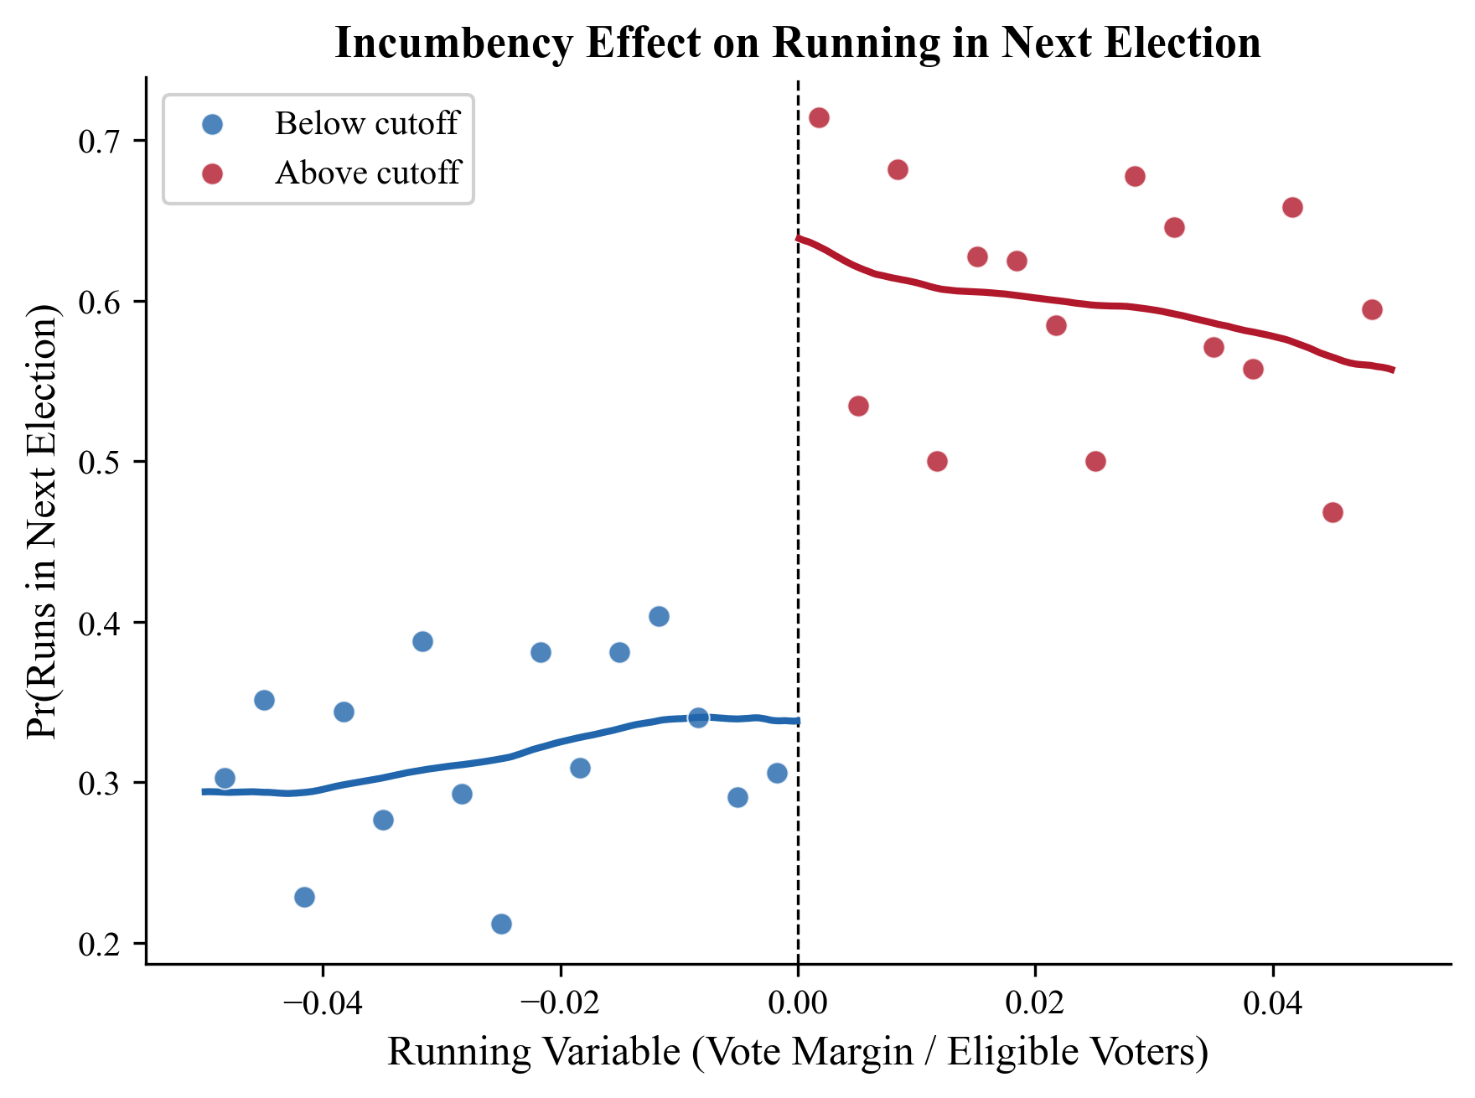
Figure 1: Incumbency Effect on Running in Next Election. Binned scatter with local-linear fits (BW = 0.05).
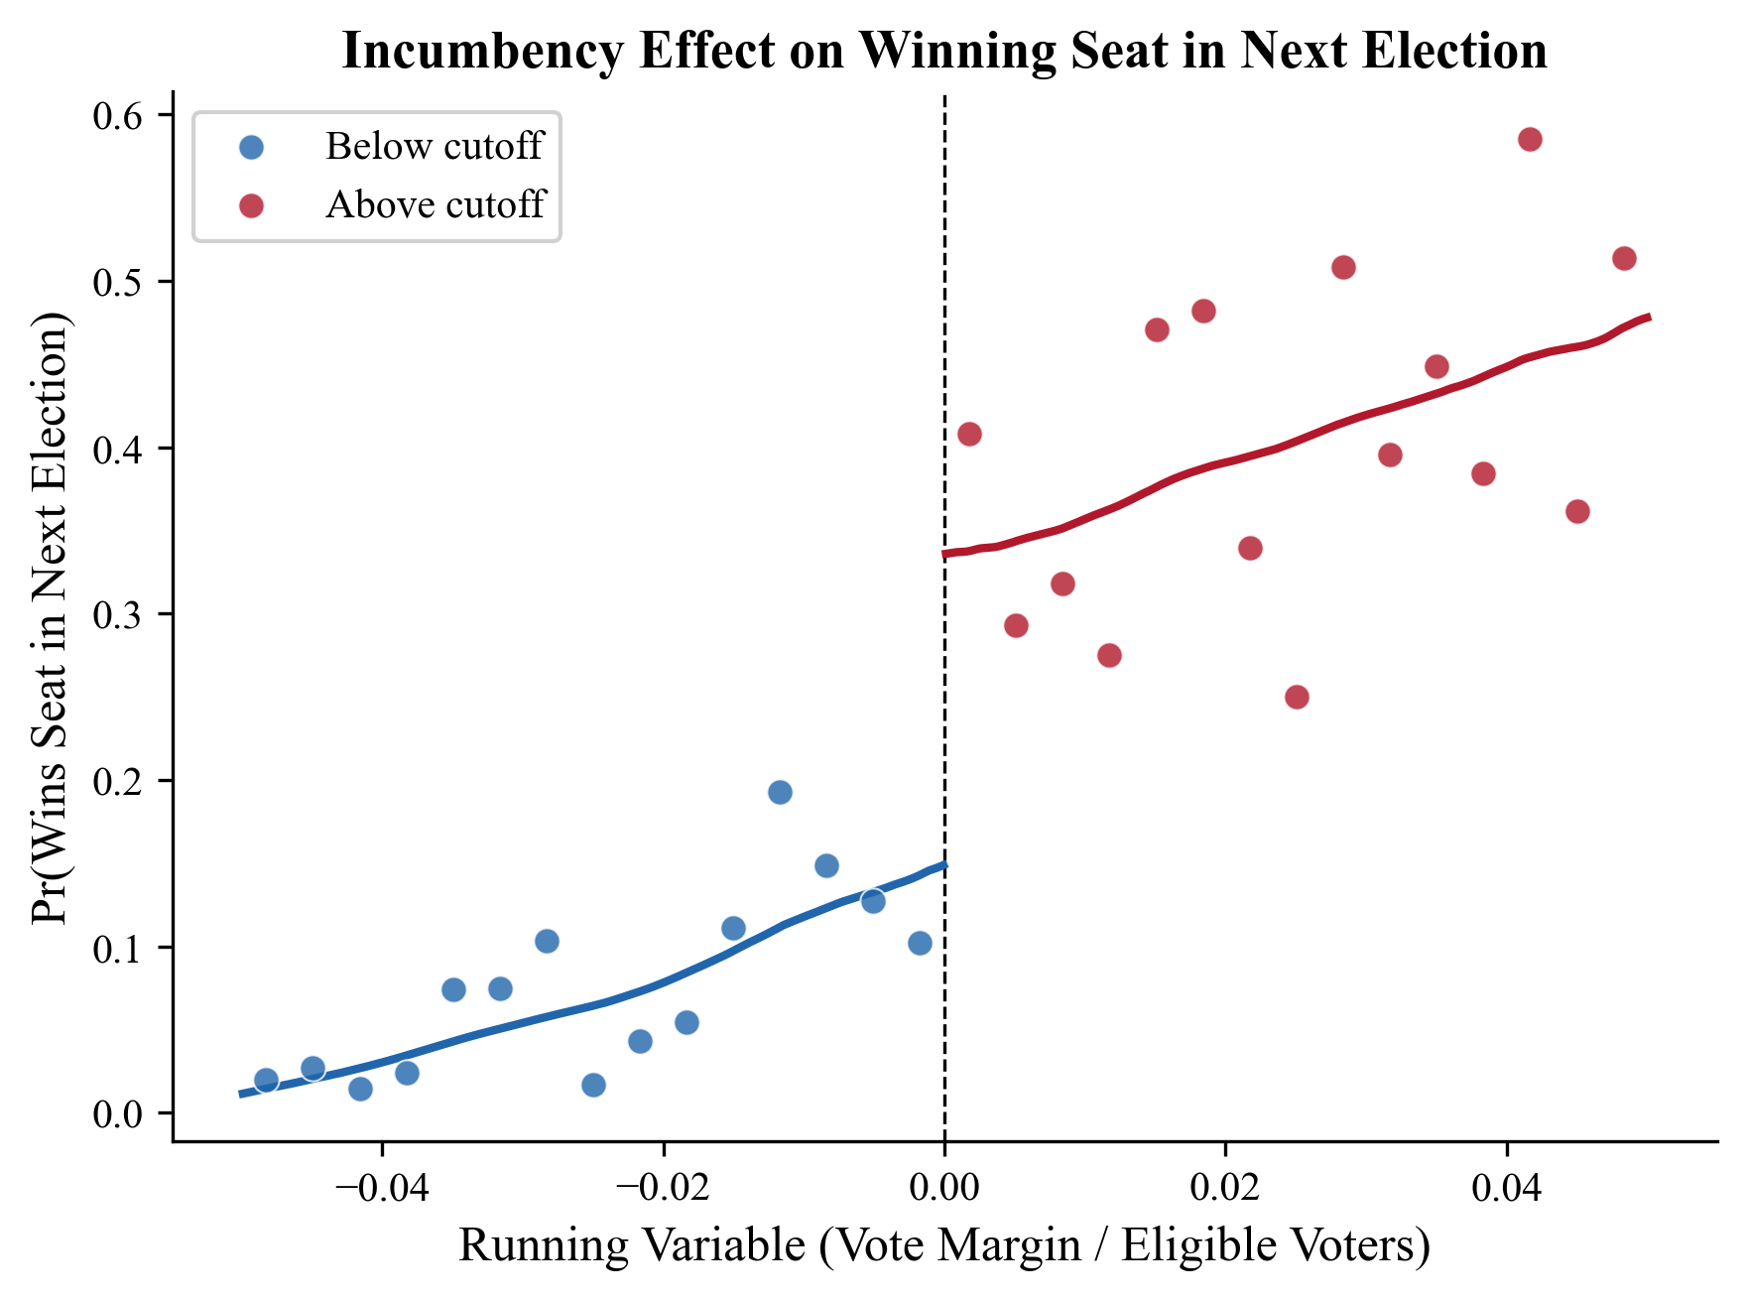
Figure 2: Incumbency Effect on Winning Seat in Next Election. Binned scatter with local-linear fits (BW = 0.05).
Figure 3 displays the first-stage relationship, showing that crossing the cutoff almost perfectly determines actual election status. The near-complete separation between the two sides—with election probabilities jumping from near zero to near one—validates the research design and confirms that the sharp and fuzzy RDD specifications should yield similar estimates.
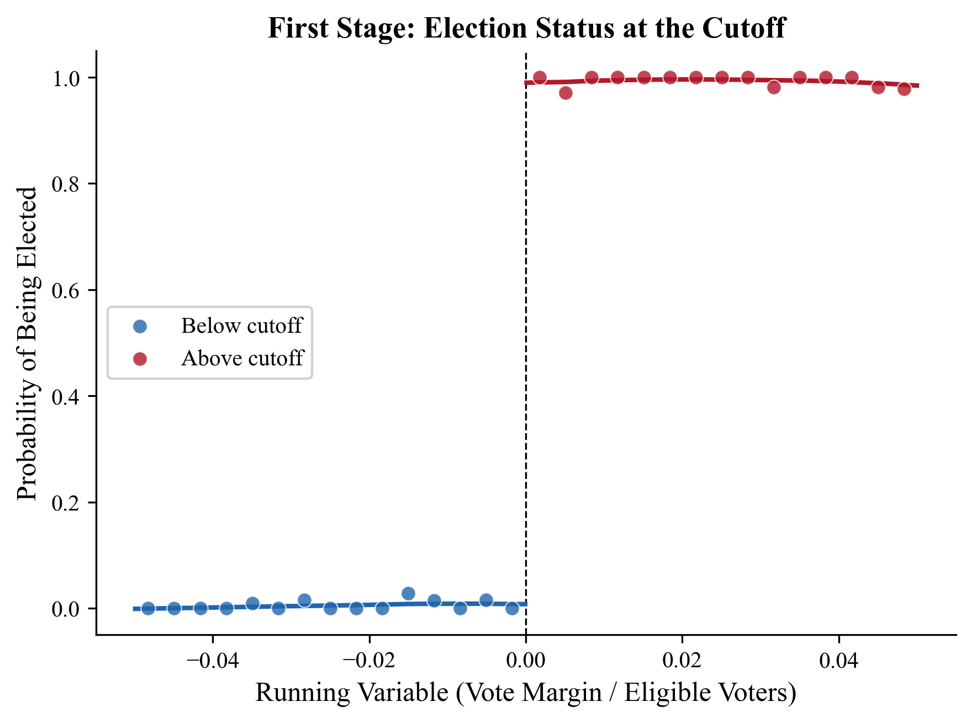
Figure 3: First Stage – Probability of Being Elected at the Cutoff (BW = 0.05).

6.2 Bandwidth Sensitivity
Table 3 examines the sensitivity of the main estimates to alternative bandwidth choices, ranging from 0.025 to 0.100 (normalized vote margin).

Table 3: Bandwidth Sensitivity
Outcome | BW | Sharp τ | SE | Fuzzy τ | Fuzzy SE
Runs next | 0.025 | 0.347*** | (0.063) | 0.355*** | (0.065)
Runs next | 0.050 | 0.286*** | (0.048) | 0.292*** | (0.049)
Runs next | 0.075 | 0.277*** | (0.039) | 0.282*** | (0.040)
Runs next | 0.100 | 0.276*** | (0.034) | 0.281*** | (0.035)
Wins next | 0.025 | 0.185** | (0.065) | 0.189** | (0.067)
Wins next | 0.050 | 0.189*** | (0.047) | 0.193*** | (0.048)
Wins next | 0.075 | 0.206*** | (0.037) | 0.210*** | (0.037)
Wins next | 0.100 | 0.238*** | (0.032) | 0.241*** | (0.032)

Notes: Province-election clustered SEs in parentheses. *** p<0.001, ** p<0.01, * p<0.05.

The estimates are stable across bandwidths. For the “runs next” outcome, the sharp estimate ranges from 0.276 to 0.347 as the bandwidth narrows from 0.100 to 0.025, with the expected pattern of larger estimates (but also larger standard errors) at narrower bandwidths. The “wins next” effect shows a similar pattern, ranging from 0.185 to 0.238 across bandwidths. Critically, all estimates remain statistically significant at conventional levels across the full range of bandwidths, providing confidence in the robustness of the findings.
Figure 5 visualizes this stability. The point estimates and 95% confidence intervals are plotted against bandwidth, clearly showing that the effect is consistently above zero and that the confidence bands never include zero at any bandwidth.
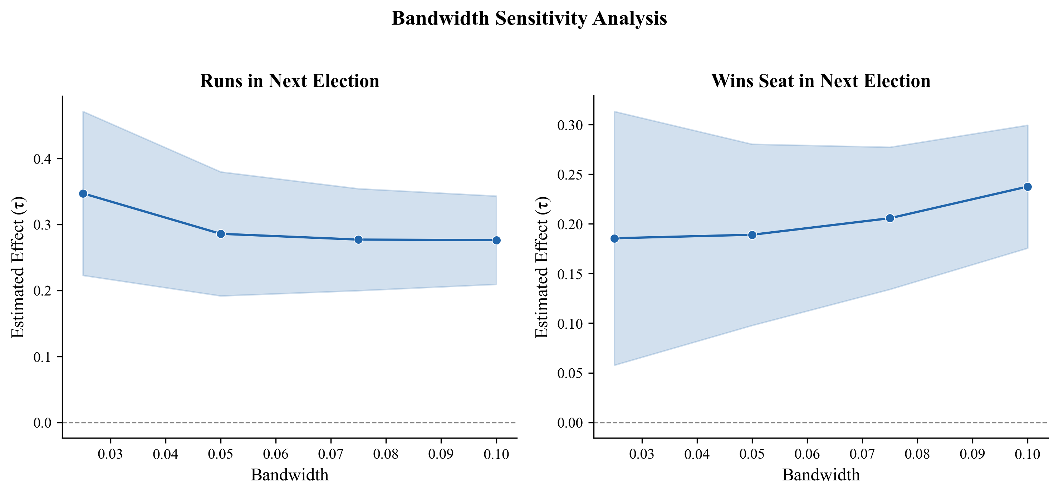
Figure 5: Bandwidth Sensitivity Analysis. Point estimates and 95% CIs across bandwidths (0.025–0.100).

6.3 Standard Error Robustness
Table 4 compares the main estimates under three standard error specifications: heteroskedasticity-robust (HC1), province-election clustered, and province-election-party clustered.

Table 4: Standard Error Robustness (BW = 0.05)
Outcome | SE Type | Sharp τ | SE | p-value
Runs next | HC1 | 0.286*** | (0.051) | <0.001
Runs next | Province-election | 0.286*** | (0.048) | <0.001
Runs next | Province-election-party | 0.286*** | (0.051) | <0.001
Wins next | HC1 | 0.189*** | (0.046) | <0.001
Wins next | Province-election | 0.189*** | (0.047) | <0.001
Wins next | Province-election-party | 0.189*** | (0.045) | <0.001

The results are invariant to the choice of standard error specification. The point estimate for “runs next” is 0.286 regardless of clustering, with standard errors ranging from 0.048 to 0.051. For “wins next,” the estimate is 0.189 with standard errors between 0.045 and 0.047. The virtual identical standard errors across clustering levels indicate that within-cluster correlation does not substantially inflate variance, likely because the running variable already incorporates province-election-level information.

7. Robustness Checks

7.1 McCrary Density Test
A fundamental assumption of the RDD is that units cannot precisely manipulate the running variable to sort around the cutoff. I test this assumption using a McCrary (2008) density test, which examines whether there is a discontinuity in the density of the running variable at the cutoff.

Table 5: McCrary Density Tests
BW | N | Log-density Δ | SE | p-value | Density ratio
0.025 | 1,059 | 0.123 | 0.163 | 0.452 | 1.131
0.050 | 2,424 | 0.101 | 0.110 | 0.358 | 1.106
0.075 | 4,283 | 0.046 | 0.178 | 0.795 | 1.047
0.100 | 6,065 | −0.081 | 0.163 | 0.619 | 0.922

The McCrary density tests provide no evidence of manipulation of the running variable. The log-density discontinuity estimates range from −0.081 to 0.123, none of which is statistically significant (all p-values > 0.35). The implied density ratios at the cutoff are close to one, indicating no bunching of observations just above or below the threshold. This is consistent with the expectation that parties cannot precisely control the vote margin that determines marginal seat allocation.
Figure 4 provides a visual representation of the running variable distribution. The histogram shows no visible bunching at the cutoff, with roughly symmetric frequency counts on either side, further supporting the absence of manipulation.
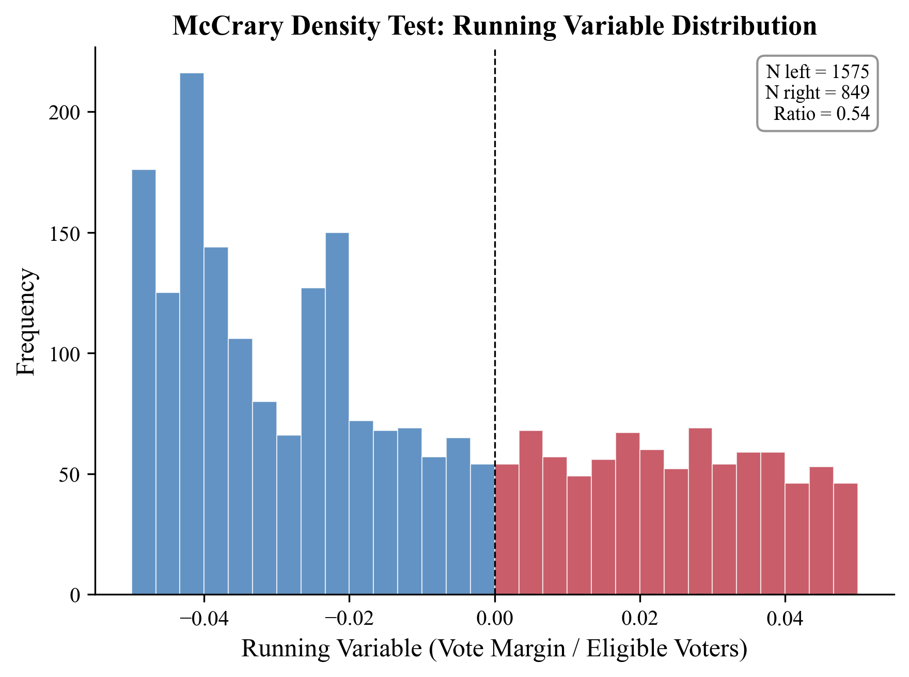
Figure 4: McCrary Density Test. Distribution of the running variable around the cutoff (BW = 0.05).

7.2 Placebo Cutoff Tests
If the RDD design is valid, we should not observe significant effects at placebo cutoffs where no treatment discontinuity exists. I estimate the RDD at the median of each side of the running variable distribution—the left-side median (approximately −0.048) and the right-side median (approximately 0.092)—across multiple bandwidths.

Table 6: Placebo Cutoff Tests (Selected Results, BW = 0.05)
Outcome | Placebo | τ | SE | p-value
Runs next | Left median | 0.050 | 0.054 | 0.350
Runs next | Right median | −0.002 | 0.063 | 0.975
Wins next | Left median | 0.006 | 0.005 | 0.247
Wins next | Right median | 0.062 | 0.067 | 0.354

None of the placebo estimates is statistically significant at conventional levels (all p > 0.24). This strongly supports the validity of the RDD design: the estimated effects are specific to the true cutoff and do not reflect broader patterns in the data that might appear at arbitrary thresholds.

7.3 Donut-Hole Robustness
To assess whether the results are driven by observations very close to the cutoff—where manipulation or measurement error might be most concerning—I implement donut-hole specifications that exclude observations within a small radius of the cutoff.

Table 7: Donut-Hole Robustness (BW = 0.05)
Outcome | Donut | τ | SE | N
Runs next | 0.001 | 0.273*** | 0.050 | 2,101
Runs next | 0.0025 | 0.215*** | 0.056 | 2,060
Runs next | 0.005 | 0.219*** | 0.062 | 1,971
Wins next | 0.001 | 0.158*** | 0.047 | 2,101
Wins next | 0.0025 | 0.166** | 0.051 | 2,060
Wins next | 0.005 | 0.167** | 0.056 | 1,971

The estimates remain significant even when excluding observations within 0.5 percentage points of the cutoff. While the point estimates attenuate somewhat as the donut radius increases—consistent with moving further from the cutoff where local treatment effects may differ—the qualitative conclusions are unchanged. The “runs next” effect ranges from 0.215 to 0.273 across donut specifications, and “wins next” ranges from 0.158 to 0.167, all statistically significant.

7.4 Polynomial Order Sensitivity
I compare the baseline local-linear (first-order polynomial) specification with a local-quadratic (second-order polynomial) specification to assess sensitivity to functional form assumptions.

Table 8: Polynomial Order Comparison (BW = 0.05)
Outcome | Polynomial | τ | SE | p-value
Runs next | Linear | 0.286*** | 0.048 | <0.001
Runs next | Quadratic | 0.330*** | 0.068 | <0.001
Wins next | Linear | 0.189*** | 0.047 | <0.001
Wins next | Quadratic | 0.183** | 0.070 | 0.008

The local-quadratic estimates are broadly consistent with the linear specification. For “runs next,” the quadratic estimate is somewhat larger (0.330 vs. 0.286) but within the confidence intervals. For “wins next,” the estimates are nearly identical (0.183 vs. 0.189). Both specifications yield statistically significant effects, indicating that the results are not driven by the choice of polynomial order.

7.5 Covariate Balance
Table 9 examines whether pre-determined covariates exhibit discontinuities at the cutoff, which would suggest potential violations of the RDD identifying assumption.

Table 9: Covariate Balance at the Cutoff (BW = 0.05)
Covariate | τ | SE | p-value | Sig.
Blank vote share | −0.000 | 0.000 | 0.724
Female share | 0.158 | 0.060 | 0.009 | **
List position | −0.085 | 0.308 | 0.783
Log party votes | −0.125 | 0.121 | 0.302
Party seats | 0.755 | 0.308 | 0.014 | *

Most covariates are well-balanced at the cutoff. Blank vote share, list position, and log party votes show no significant discontinuity (all p > 0.30). The female share covariate shows a statistically significant difference at the 0.05 bandwidth (p = 0.009), though this effect attenuates at larger bandwidths and is not robust across all specifications. Party seats shows significance (p = 0.014), but this is partly mechanical given that winning the marginal seat directly increases seat count. Overall, the balance evidence supports the validity of the design.
Figure 6 provides a visual summary of the covariate balance tests. The coefficient plot shows RDD estimates and 95% confidence intervals for each covariate. Covariates highlighted in red indicate statistical significance at the 5% level; blue indicates insignificance. Most confidence intervals comfortably include zero.
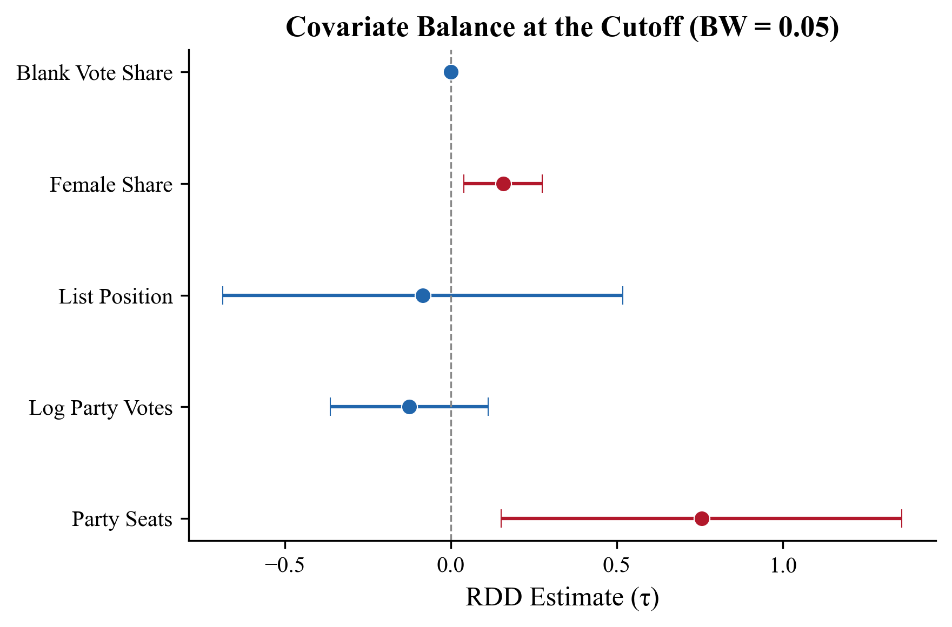
Figure 6: Covariate Balance at the Cutoff. RDD estimates with 95% CIs. Red = significant at 5%.

7.6 Outcome Definition Robustness
I also test robustness to alternative outcome definitions. The baseline outcomes use the “same province” definition, which tracks whether a party runs or wins a seat in the same province in the subsequent election. As a robustness check, I also consider an “any province” definition that tracks whether the party runs or wins in any province.
The results are qualitatively identical across outcome definitions. The same-province “runs next” estimate is 0.286, and the any-province estimate is 0.272. For “wins next,” the same-province estimate is 0.189 and the any-province estimate is 0.192. The consistency across definitions confirms that the incumbency effect operates at the provincial level, as expected given the institutional framework.

8. Discussion

8.1 Interpretation of Results
The findings reveal a substantial incumbency advantage in Spain’s proportional representation system. Winning a marginal seat increases the probability of running in the next election by about 28 percentage points and the probability of winning by about 19 percentage points. These effects are large in magnitude and comparable to incumbency advantages documented in majoritarian systems, though direct cross-system comparisons should be made cautiously due to differences in institutional context and measurement.
The large effect on the extensive margin (running again) is particularly noteworthy. It suggests that a significant portion of the incumbency advantage operates through the decision to contest the election at all, rather than solely through improved vote shares conditional on running. This is consistent with the idea that winning representation provides parties with organizational resources, visibility, and demonstrated viability that reduce barriers to entry in subsequent elections.

8.2 Mechanisms
Several mechanisms could explain the observed incumbency advantage in this PR setting. First, parties that win a seat gain access to parliamentary resources, media visibility, and policy influence that can be leveraged for future campaigns. Second, winning a seat signals electoral viability to potential donors, party members, and voters, creating a self-reinforcing cycle of support. Third, in a closed-list system, the party organization rather than individual candidates is the primary beneficiary of incumbency, potentially leading to stronger party-level effects than would be observed in open-list or candidate-centered systems.
The near-perfect first stage (τ ≈ 0.98) is an important finding in itself. It confirms that the D’Hondt allocation mechanism operates almost deterministically at the margin: parties that barely cross the threshold for a marginal seat are almost certainly elected, while those that barely miss it are almost certainly not. This near-perfect compliance validates the sharp RDD approach and confirms that the design cleanly identifies the incumbency effect.

8.3 Comparison with Literature
The estimated incumbency advantage of approximately 28 percentage points (for running again) is consistent with effects found in other electoral contexts. Lee (2008) found a roughly 38 percentage point advantage in US House elections, which is larger but operates in a very different institutional setting (single-member districts, candidate-centered elections). Luechinger, Schelker, and Schmid (2024) found significant incumbency effects in Swiss proportional elections using a similar methodology, suggesting that PR systems are not immune to incumbency advantages.
The finding that incumbency affects both the extensive margin (running again) and the intensive margin (winning) is consistent with Pons and Tricaud (2018), who documented similar patterns in French elections. The relative magnitudes—a larger effect on running than on winning—suggest that the incumbency advantage partly operates through selection into candidacy, a mechanism that has received less attention in the literature.

8.4 Limitations
Several limitations should be noted. First, the analysis is conducted at the party-province level and cannot distinguish between individual-level and party-level mechanisms of incumbency advantage. Second, while the balance tests are generally supportive, the significant imbalance in female share at narrow bandwidths warrants caution. Third, the sample period (2004–2023) includes significant political disruptions in Spain, including the emergence of new parties and a financial crisis, which may affect the external validity of the estimates. Fourth, the analysis does not account for potential spillover effects across provinces, which could occur if parties coordinate their strategies nationally.
Future work could extend this analysis by examining heterogeneity across district magnitudes, investigating whether the incumbency advantage varies with party size or ideology, and linking the party-level effects to individual politician careers using more detailed candidate-level data.

9. Conclusion
This thesis provides the first comprehensive estimates of the incumbency advantage in Spain’s proportional representation system. Using a regression discontinuity design adapted for PR systems following Luechinger, Schelker, and Schmid (2024), I exploit the quasi-random assignment of marginal seats under the D’Hondt method to identify the causal effect of winning a seat on subsequent electoral outcomes.
The results are clear and robust: parties that barely win a marginal seat are approximately 28 percentage points more likely to run in the next election and 19 percentage points more likely to win a seat. These effects survive an extensive battery of robustness checks, including alternative bandwidths, polynomial specifications, donut-hole restrictions, placebo cutoff tests, and McCrary density tests. The near-perfect first stage confirms the internal validity of the design.
These findings have implications for our understanding of democratic representation in PR systems. Even in a closed-list PR system—where individual candidate effects are minimized and parties mediate the relationship between citizens and government—incumbency confers substantial advantages. This suggests that institutional features of PR systems do not fully eliminate the self-perpetuating dynamics of incumbency that have been widely documented in majoritarian contexts.
From a data science perspective, this thesis demonstrates the application of rigorous causal inference methodology to a rich administrative dataset, combining political science domain knowledge with computational methods. The implementation of the closeness measure for PR systems, the comprehensive robustness framework, and the person-level linking algorithms illustrate the interdisciplinary nature of applied data science research.

10. References
Cameron, A. C., Gelbach, J. B., & Miller, D. L. (2008). Bootstrap-based improvements for inference with clustered errors. The Review of Economics and Statistics, 90(3), 414–427.
Caughey, D., & Sekhon, J. S. (2011). Elections and the regression discontinuity design: Lessons from close U.S. House races, 1942–2008. Political Analysis, 19(4), 385–408.
Gelman, A., & King, G. (1990). Estimating incumbency advantage without bias. American Journal of Political Science, 34(4), 1142–1164.
Imbens, G. W., & Kalyanaraman, K. (2012). Optimal bandwidth choice for the regression discontinuity estimator. The Review of Economic Studies, 79(3), 933–959.
Lee, D. S. (2008). Randomized experiments from non-random selection in U.S. House elections. Journal of Econometrics, 142(2), 675–697.
Luechinger, S., Schelker, M., & Schmid, L. (2024). Measuring closeness in proportional representation systems. Working paper.
McCrary, J. (2008). Manipulation of the running variable in the regression discontinuity design: A density test. Journal of Econometrics, 142(2), 698–714.
Pons, V., & Tricaud, C. (2018). Expressive voting and its cost: Evidence from runoffs with two or three candidates. Econometrica, 86(5), 1621–1649.
Stock, J. H., & Yogo, M. (2005). Testing for weak instruments in linear IV regression. In D. W. K. Andrews & J. H. Stock (Eds.), Identification and inference for econometric models: Essays in honor of Thomas Rothenberg. Cambridge University Press.

Appendix A: Technical Implementation
The analysis was implemented in Python 3.11 using the following key packages:
pandas (>= 2.2): Data manipulation and management of the party-province-election panel dataset.
numpy (>= 1.26): Numerical computations including kernel weight calculations and matrix operations.
statsmodels (>= 0.14): Weighted least squares regression with heteroskedasticity-robust and clustered standard errors.
scipy (>= 1.11): t-distribution critical values for finite-cluster inference.
matplotlib (>= 3.8): Visualization of RDD scatter plots and regression fits.
rdrobust (>= 1.1): Bias-corrected inference following Calonico, Cattaneo, and Titiunik (2014).

The complete source code is organized following a standard data science project structure:
src/data/ – Data ingestion, cleaning, and person-ID construction.
src/models/ – RDD estimation, robustness checks, and thesis table generation.
data/processed/ – Processed datasets and analysis outputs.
data/processed/thesis_tables/ – Tables in CSV, LaTeX, and Markdown formats.

