CARATLOGIC

CaratLogic KYC Product Guide
Client feature and workflow manual
This manual explains each major CaratLogic KYC feature using a short description followed by the corresponding product screen. It is designed to help clients understand where each feature is located and how it supports the KYC process.

Prepared for client understanding
Product environment reviewed September 2026

Contents

1 Dashboard
2 Review Submissions
3 Forms Management
4 Settings
5 Email Template Configuration
Every subsection follows the same layout: feature name, a brief explanation, and the application screenshot. Screen content shown in this guide comes from the development environment and may change as the product evolves.

1 Dashboard

The Dashboard is the main operational workspace for contacts and KYC activity. It combines status counts, search and filters, contact records, notifications, and contact-level actions in one place.

Dashboard Overview
The Dashboard gives users a single view of KYC activity and business contacts. It shows status totals at the top and a searchable contact list below, allowing teams to understand the current workload quickly.
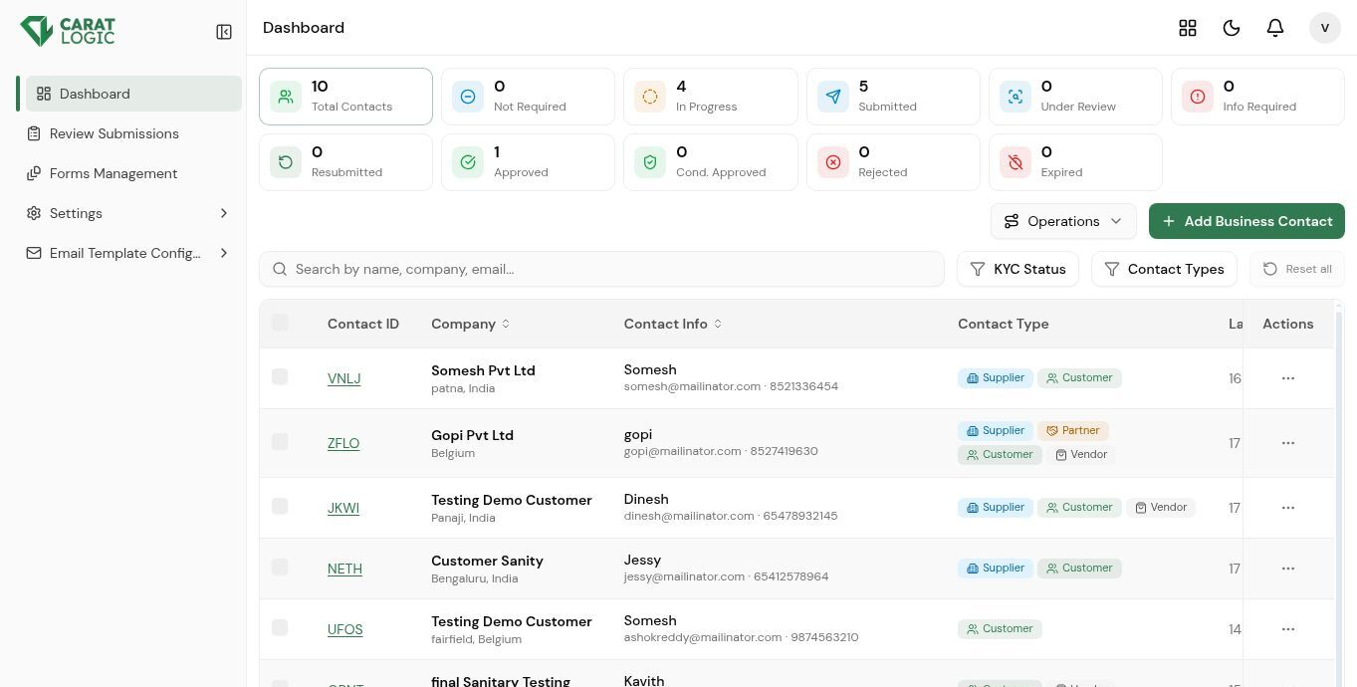
Dashboard Overview screen

KYC Status Summary
The summary cards display totals for Not Required, In Progress, Submitted, Under Review, Information Required, Resubmitted, Approved, Conditionally Approved, Rejected, and Expired. Selecting a status helps users focus on contacts that need the next action.
KYC Status Summary screen

Search and Filters
Users can search by contact name, company, or email and narrow the list by KYC status or contact type. Multiple status choices are available, and Reset all clears the active filters.
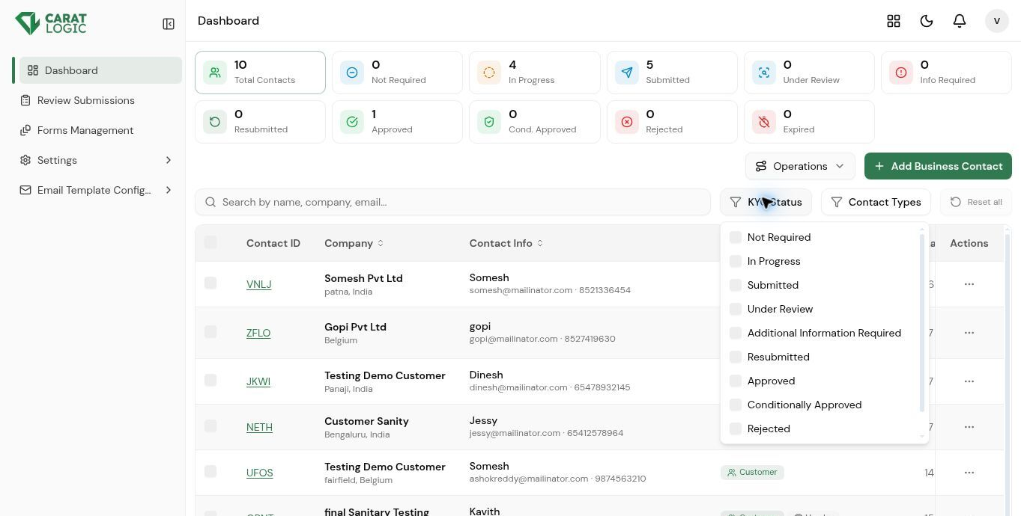
Search and Filters screen

Notifications
The notification panel shows recent KYC events, such as a business contact submitting a form for review. Each notification identifies the related contact and helps the user open the appropriate review activity.
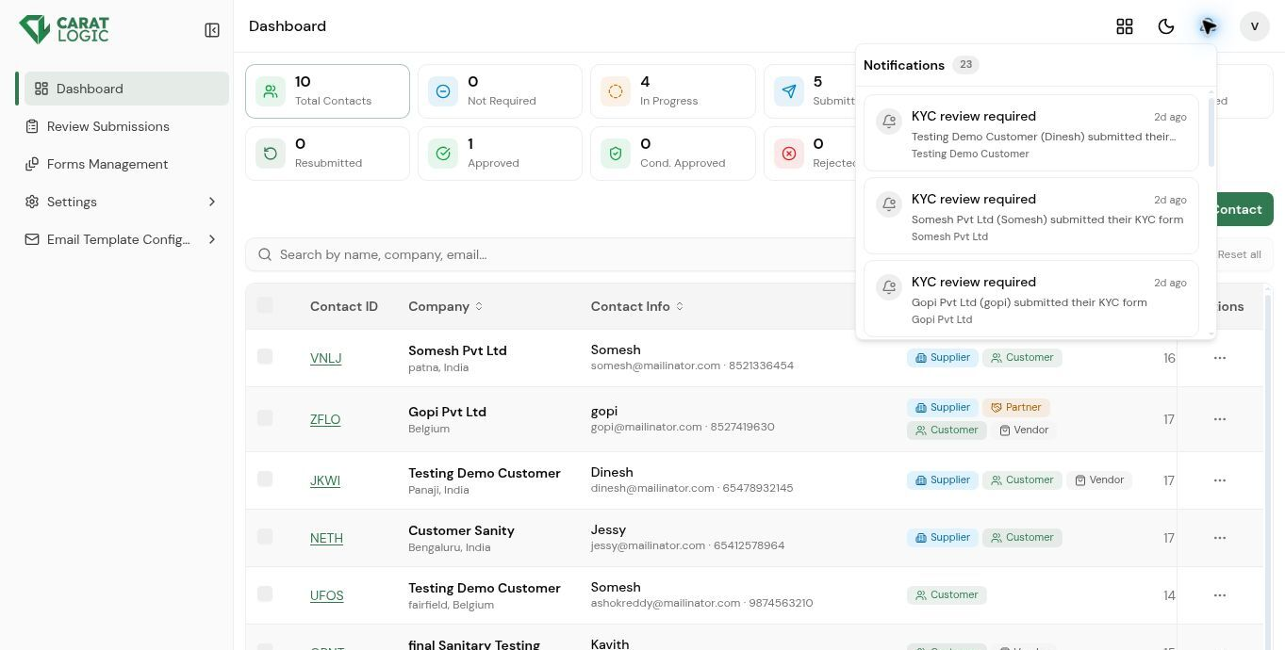
Notifications screen

Add Business Contact
Add Business Contact captures address, company, tax, currency, contact, relationship, and initial KYC information. Required fields ensure that the minimum details are collected before the contact is saved.
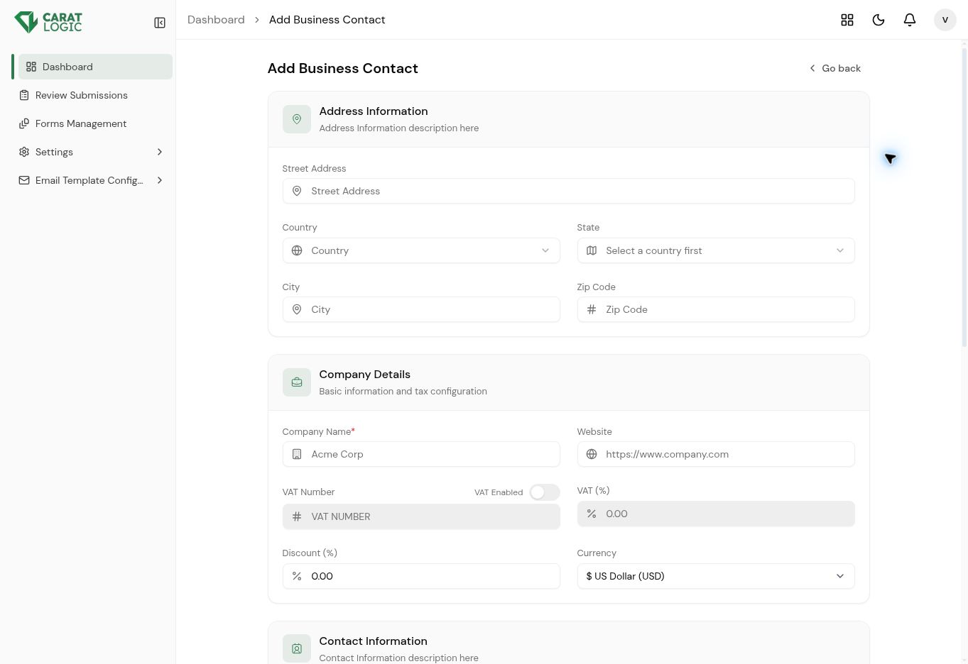
Add Business Contact screen

Contact Actions and Form Assignment
The row action menu provides access to View, Edit, Fill KYC, Review KYC, Assign Form, and Delete. Assign Form connects the correct published KYC form and version to the selected business contact.
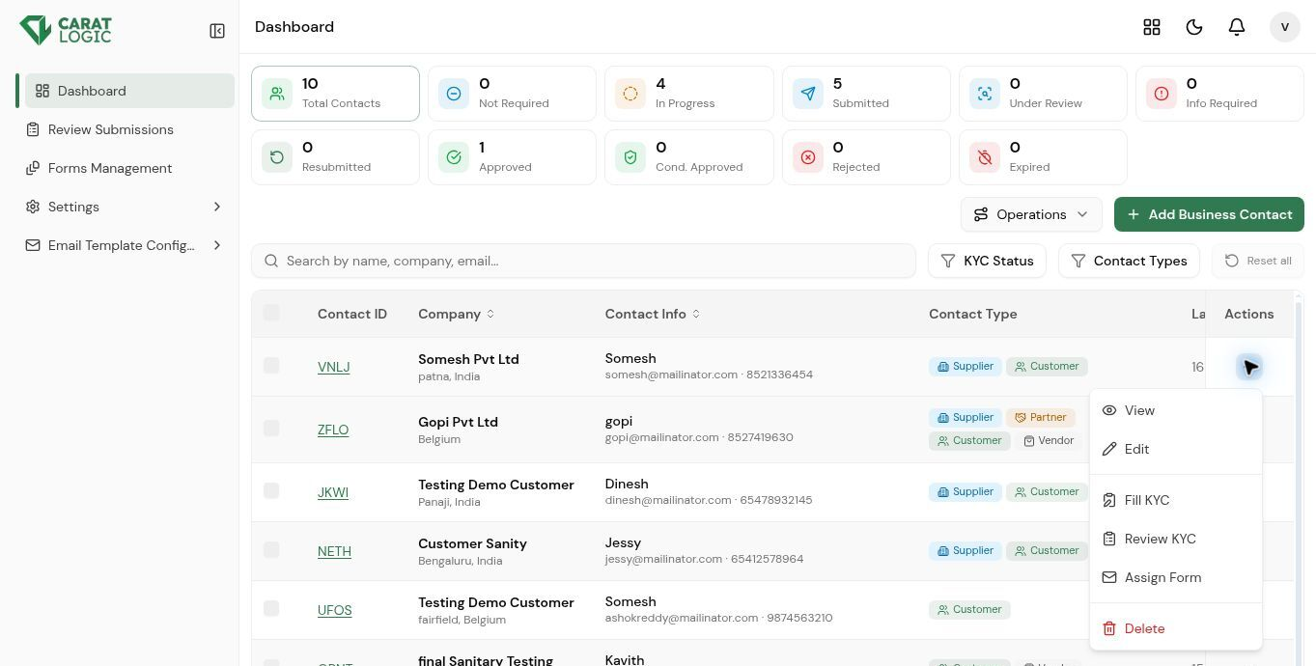
Contact Actions and Form Assignment screen

Select Multiple Customers
The checkbox beside each contact supports bulk selection. After selecting two or more customers, the selection count appears below the table and Operations can apply the same action to all selected records.
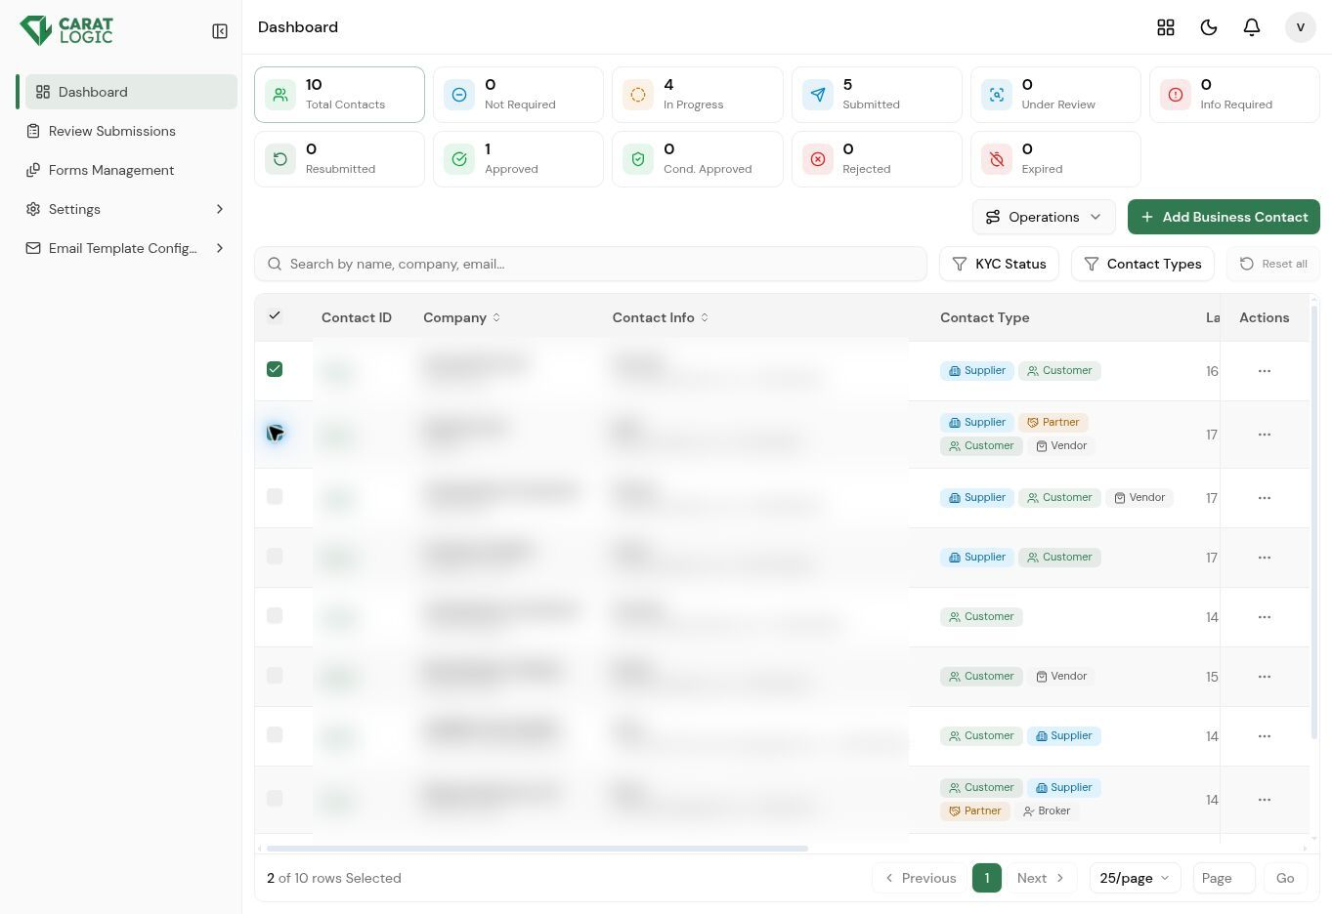
Select Multiple Customers screen

Bulk Assign Form Operation
Open Operations and choose Assign Form to start one assignment for all selected customers. The number shown beside Assign Form confirms how many recipients will receive the selected form and version.
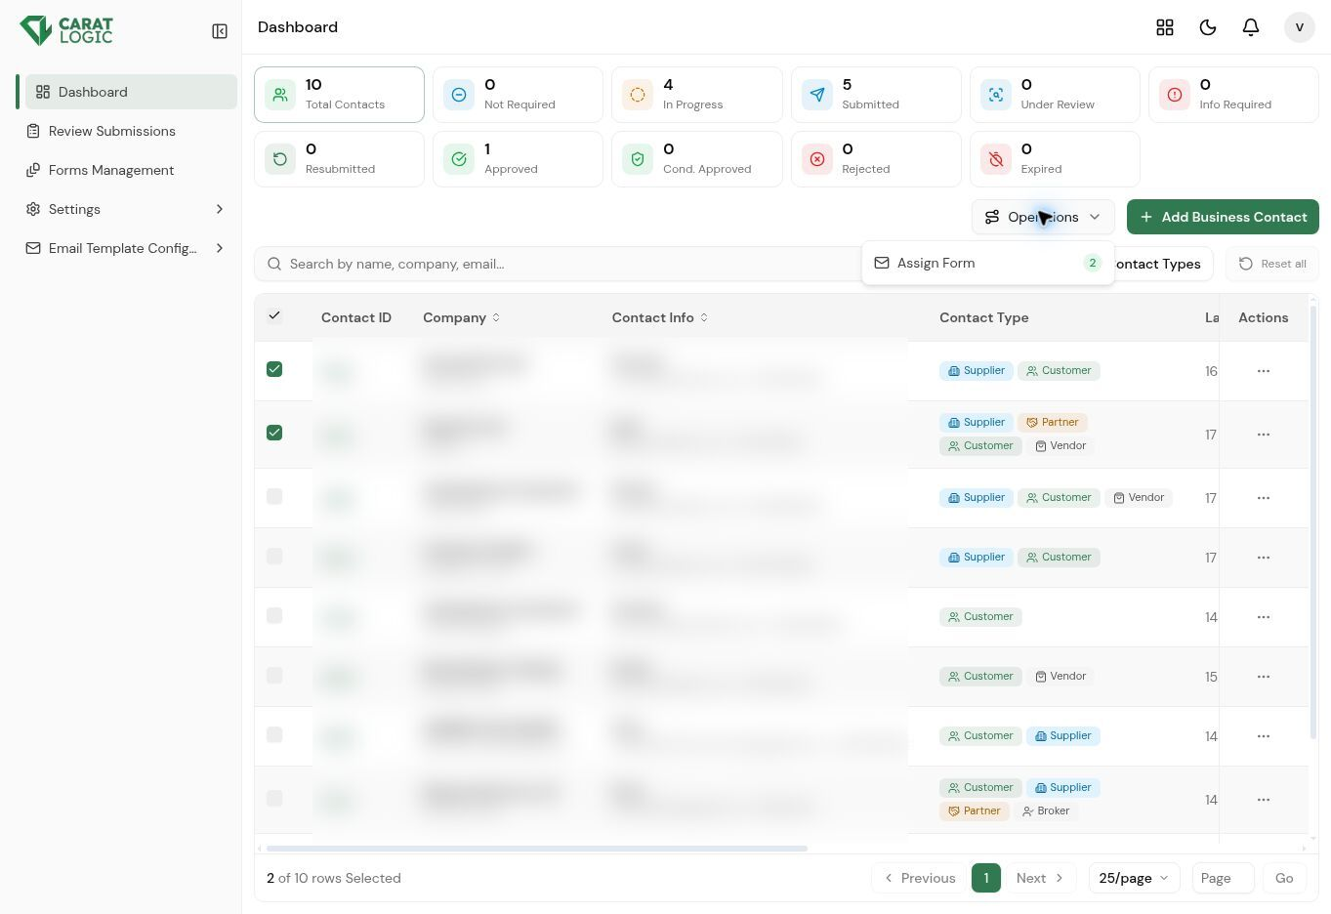
Bulk Assign Form Operation screen

Assign Form Popup
The popup applies one published form and version to every selected contact, while giving each recipient an individual verification link. Users can choose the default form, control customer email notification, review recipients, and confirm the verification and access periods before sending.
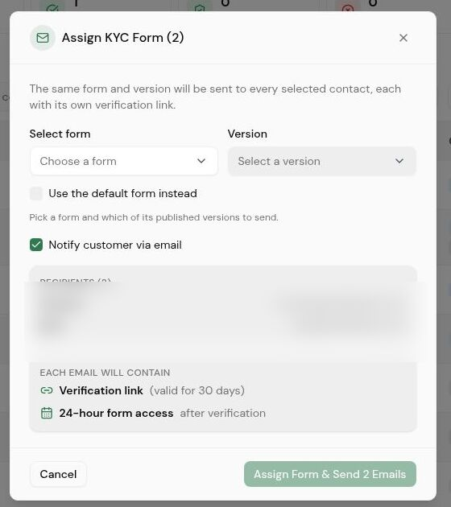
Assign Form Popup screen

2 Review Submissions

Review Submissions is the compliance work queue. It allows reviewers to find completed submissions, inspect the collected data, check submission history, and record the final review action.

Submission Listing and Search
The listing displays the company, contact details, relationship types, KYC form and version, submission date, status, and Review action. The search field can find a record using the contact, company, email, phone number, or contact ID.
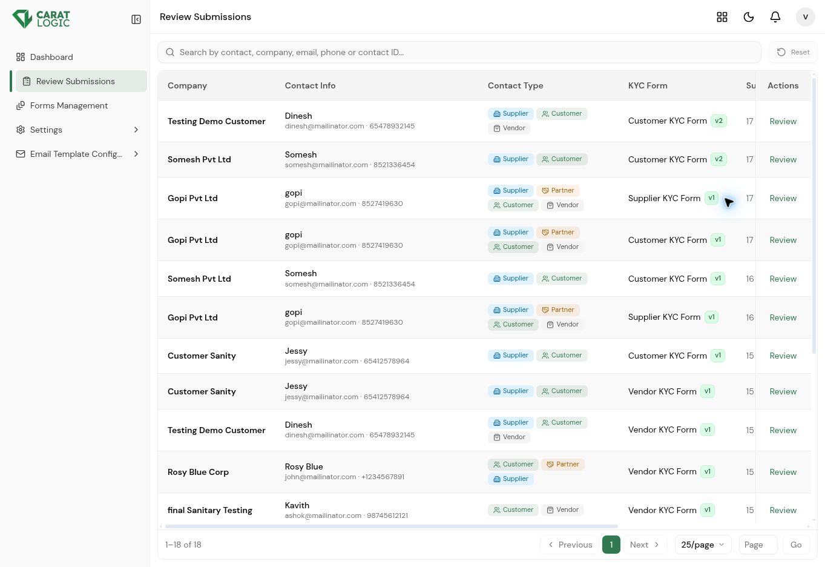
Submission Listing and Search screen

Review Submission Details
The review screen confirms the company, current status, assigned form, submission date, and number of completed pages. Each submitted section can be expanded so the reviewer can inspect field values and uploaded evidence.
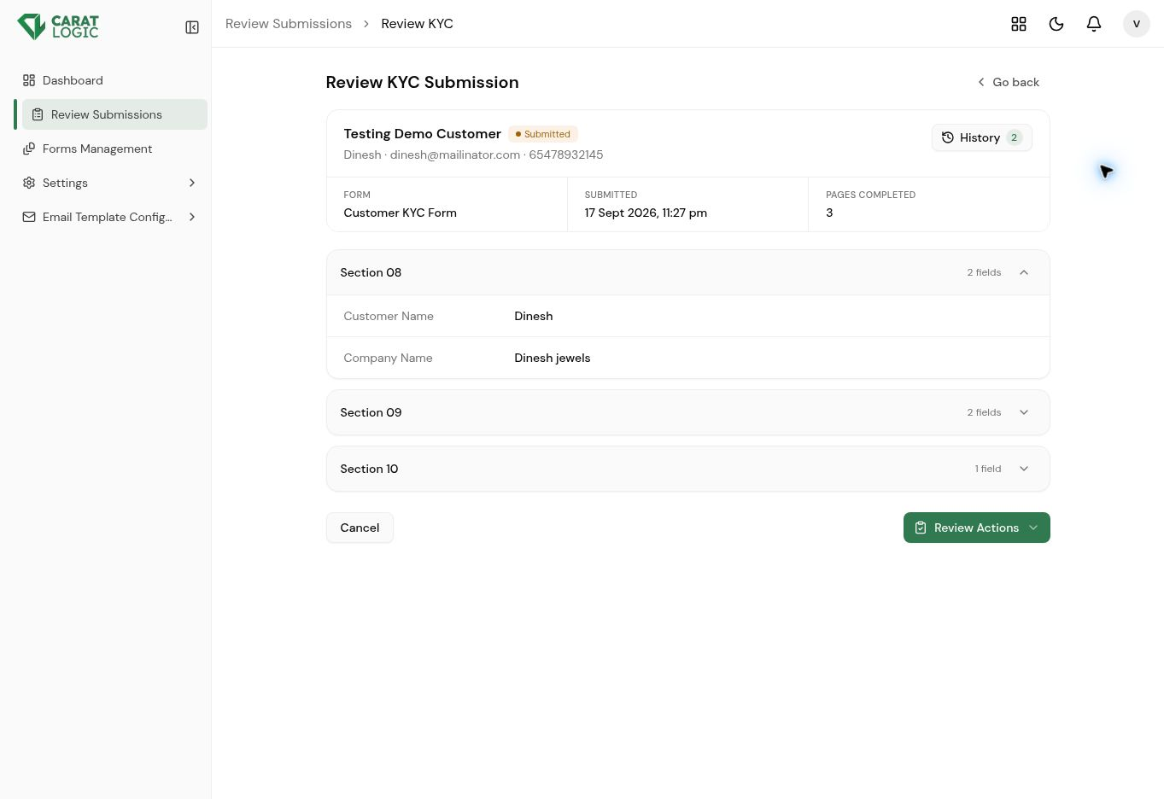
Review Submission Details screen

Submission History
History shows all submissions for the selected contact, with the newest submission first. The Current label identifies the active record and helps reviewers distinguish it from earlier form versions or previous submissions.
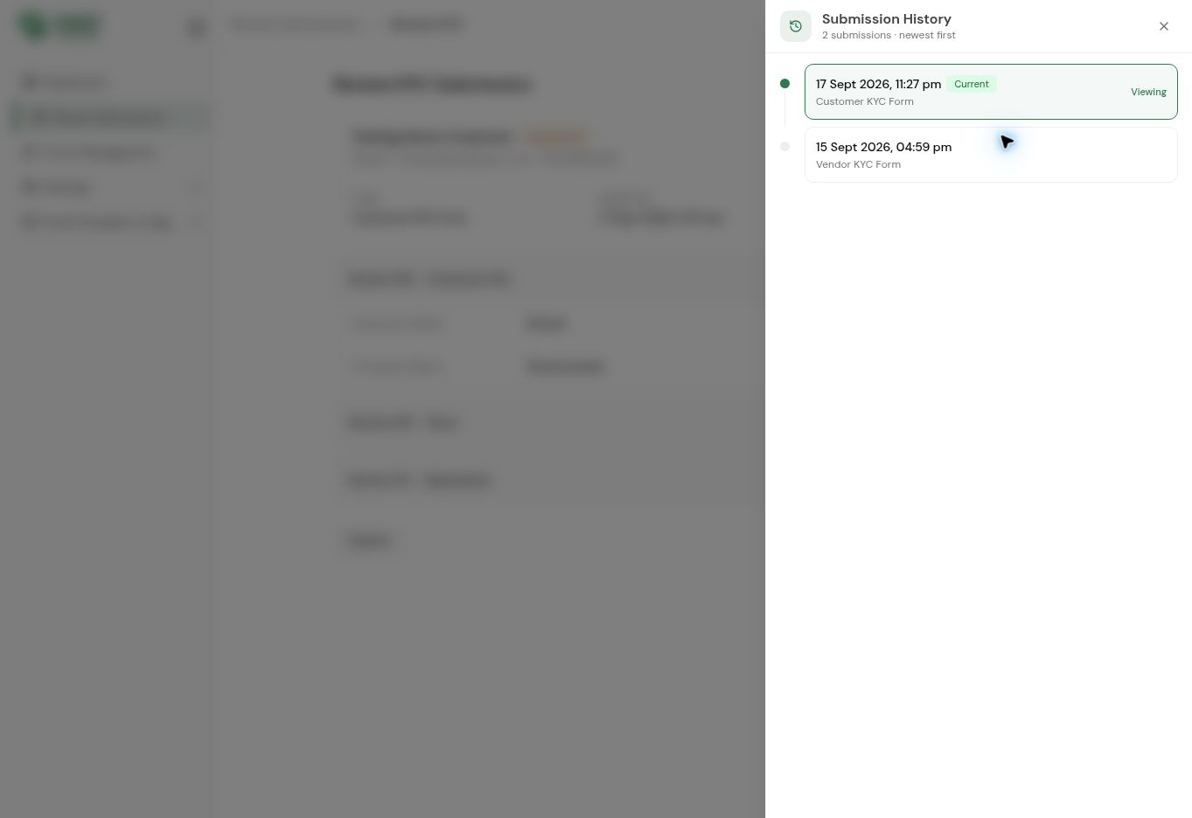
Submission History screen

Review Actions
After checking the submission, the reviewer can Approve, Conditionally Approve, Request Information, or Reject. The selected action updates the KYC workflow and can trigger the matching email communication.
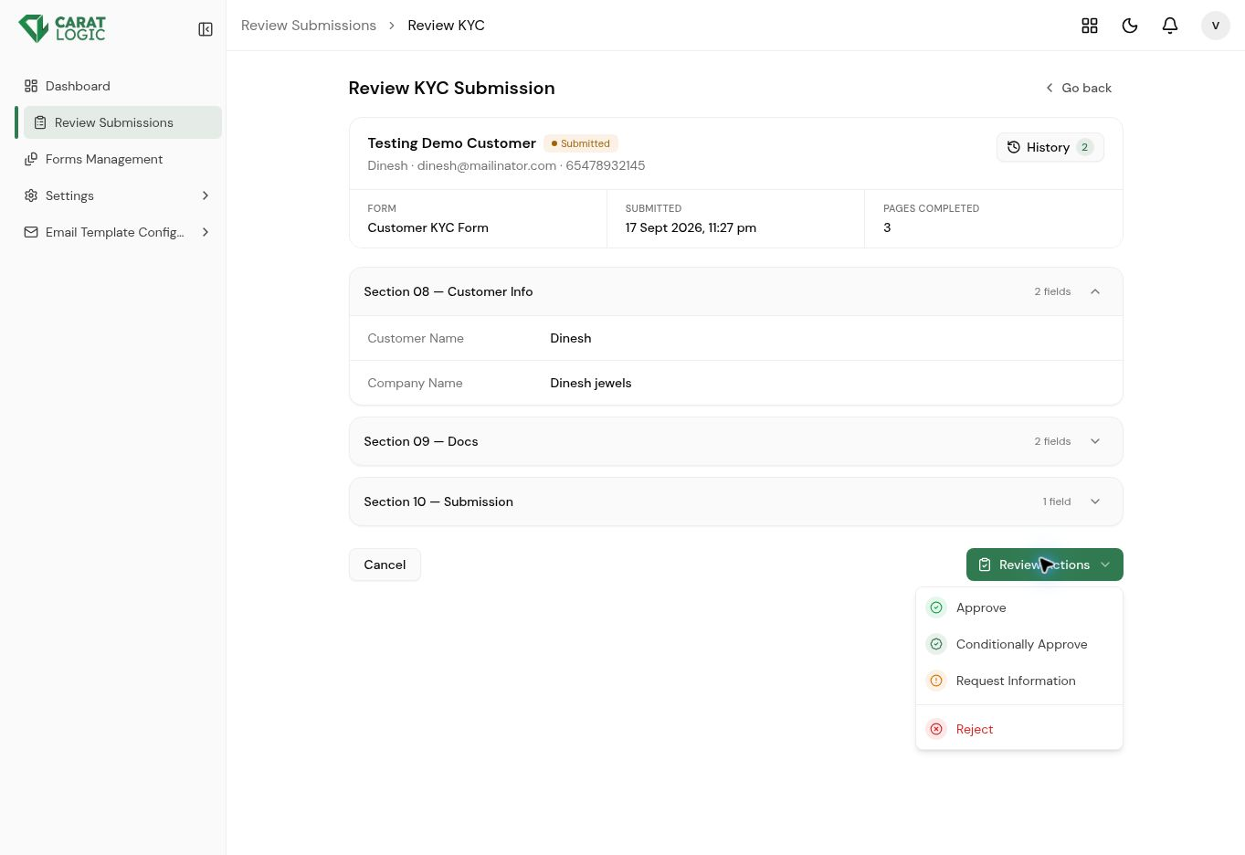
Review Actions screen

3 Forms Management

Forms Management controls the questionnaires used for customers, suppliers, vendors, and other business relationships. Administrators can create forms, configure pages and fields, manage versions, preview the customer experience, and select the default version.

Form Listing and Search
The form list shows every KYC form, its latest version, creator, and last updated time. The search bar helps administrators locate a form quickly, while the Default label identifies the version used for new contacts.
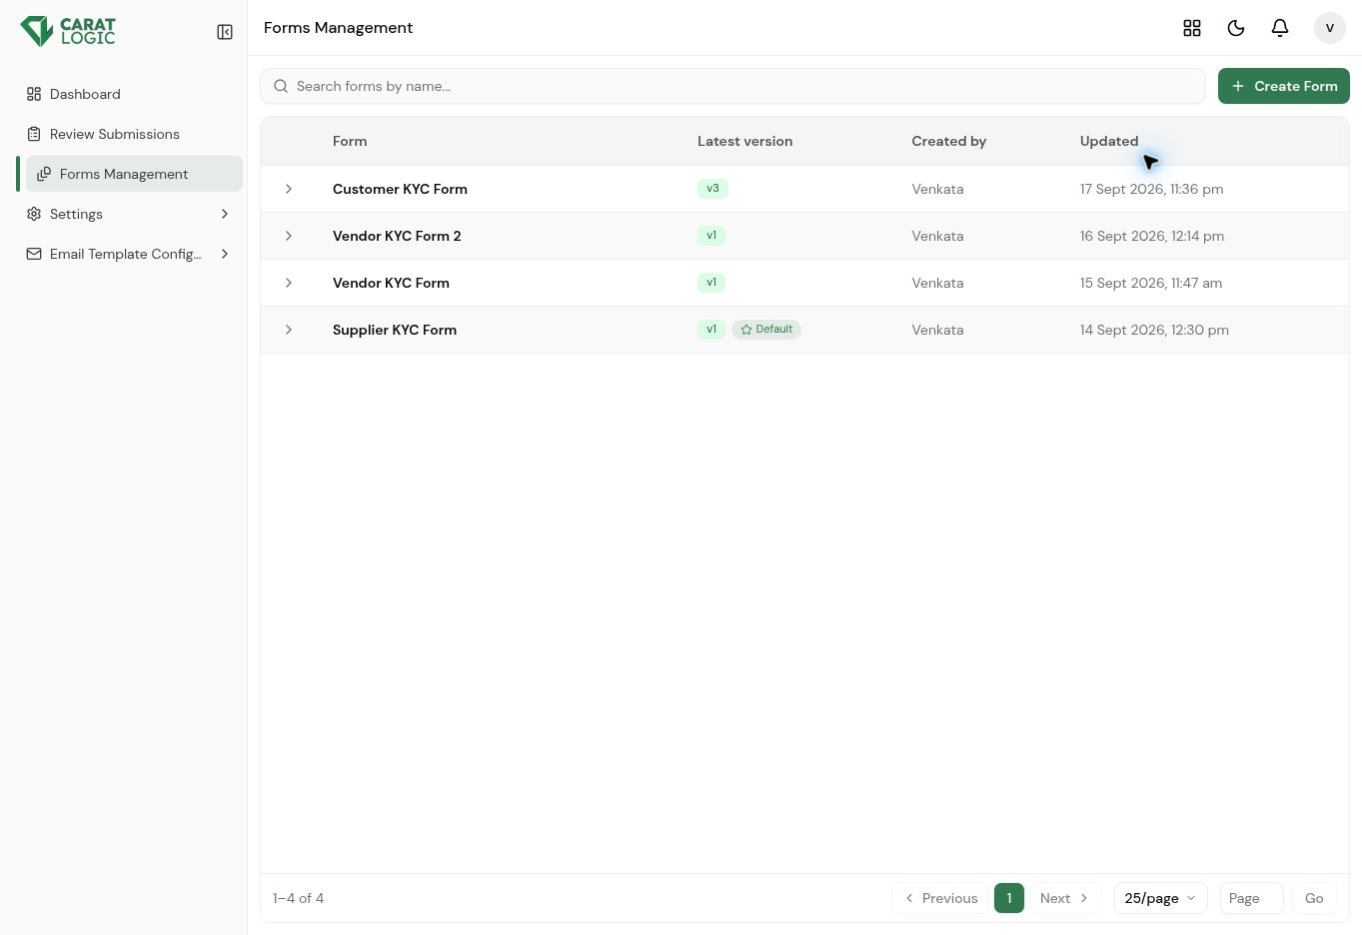
Form Listing and Search screen

Create Form
Create Form starts a new questionnaire using a form name and optional description. The system creates a version 1 draft, which can then be configured with pages and fields before publication.
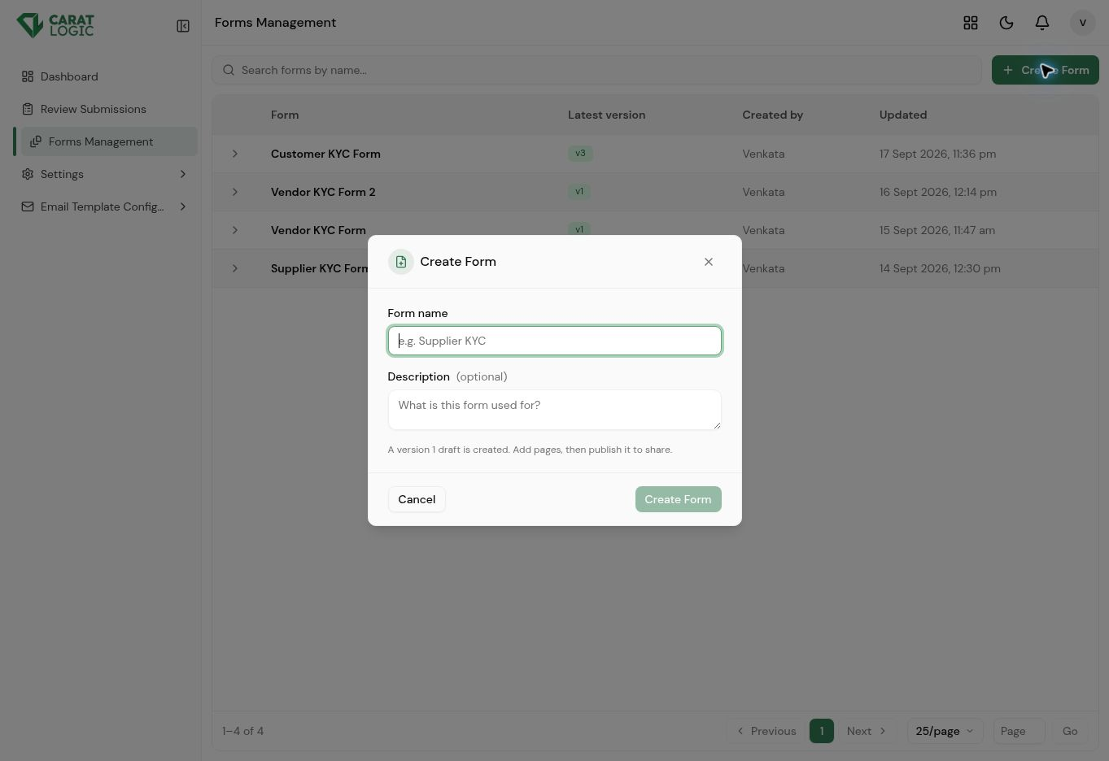
Create Form screen

Form Editor Workspace
After the form name is entered, the version 1 draft opens in the form editor. The workspace provides Save changes, Publish, form actions, page tabs, Add page, page actions, and Add Field controls; Publish becomes available after the draft has been saved and is ready for use.
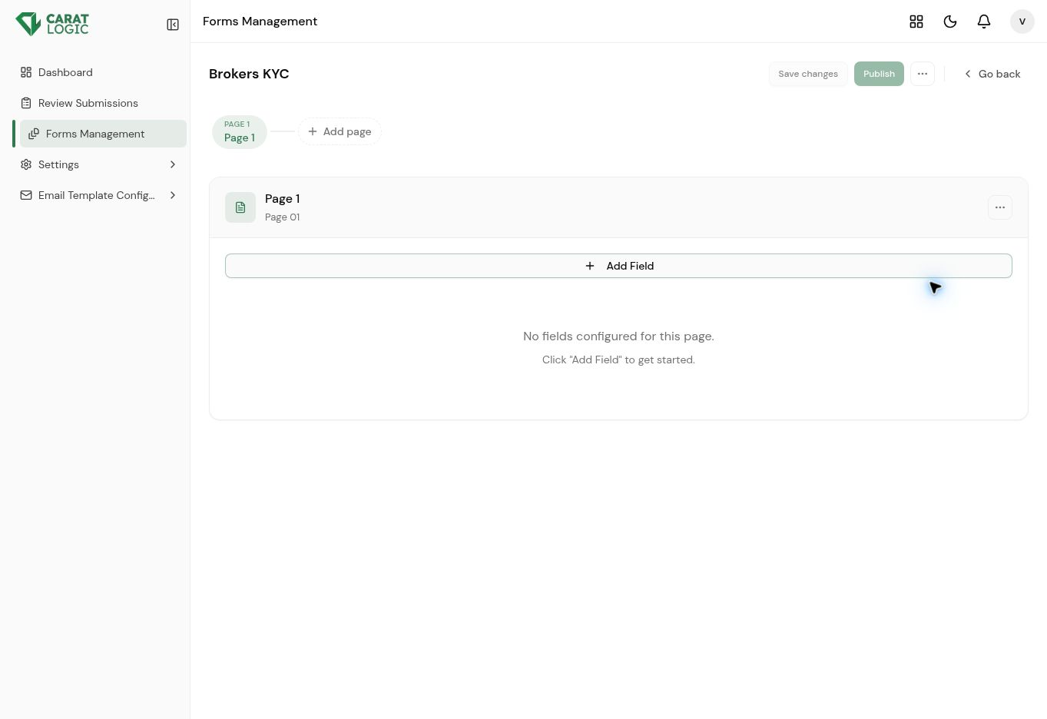
Form Editor Workspace screen

Form Level Menu
The menu beside Publish provides Rename form and Reset form to default. Rename changes the form title, while Reset form to default restores the editor to its default structure and should be used carefully when draft content already exists.
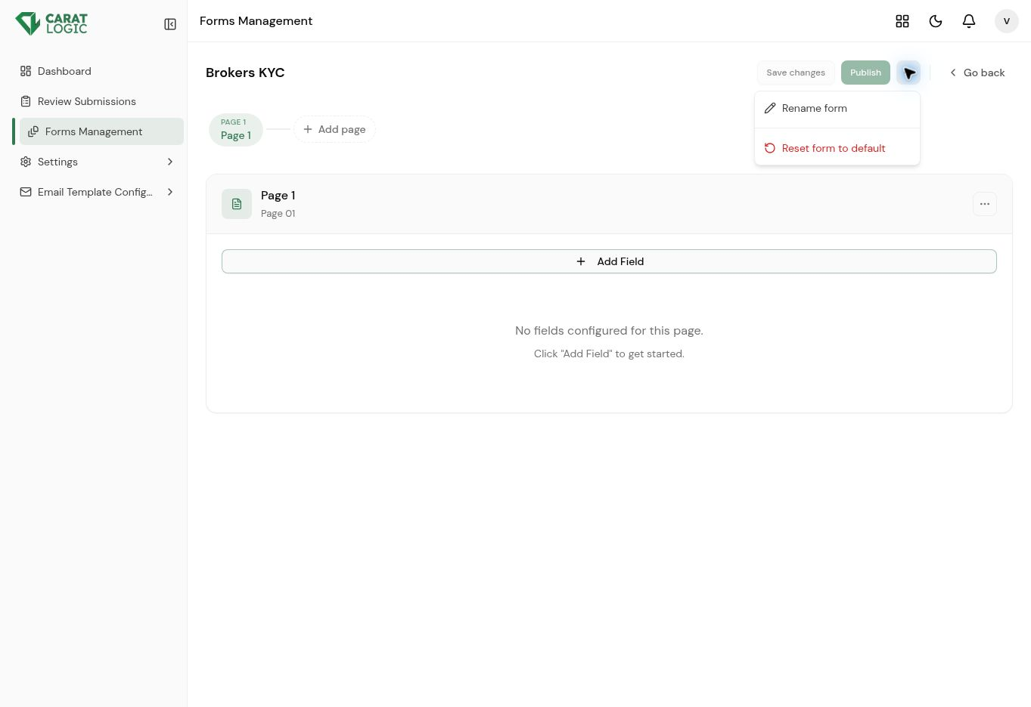
Form Level Menu screen

Page Management Menu
Every page has a menu for Rename page, Clear all fields, and Delete page. Clear and Delete are enabled only when valid, and the product prevents deletion when the form must retain at least one page.
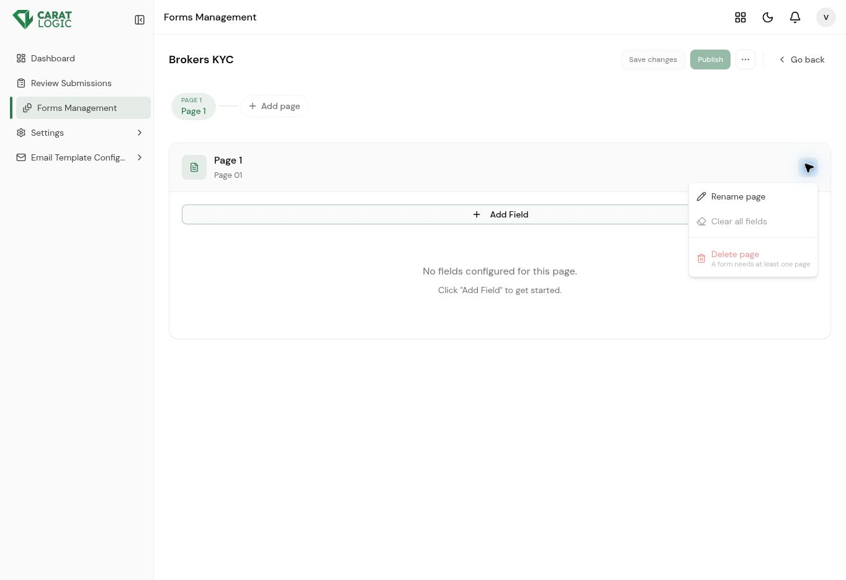
Page Management Menu screen

Add and Configure Fields
Add Field captures the field label, type, placeholder, and formatted help description. Supported types include Text, Text Area, Email, Phone, Number, Date, Time, Dropdown, Radio Group, Checkbox, Multi Select, Toggle, Image, File, and Docs with Expiry; Required, Visible, and Editable switches control field behavior.
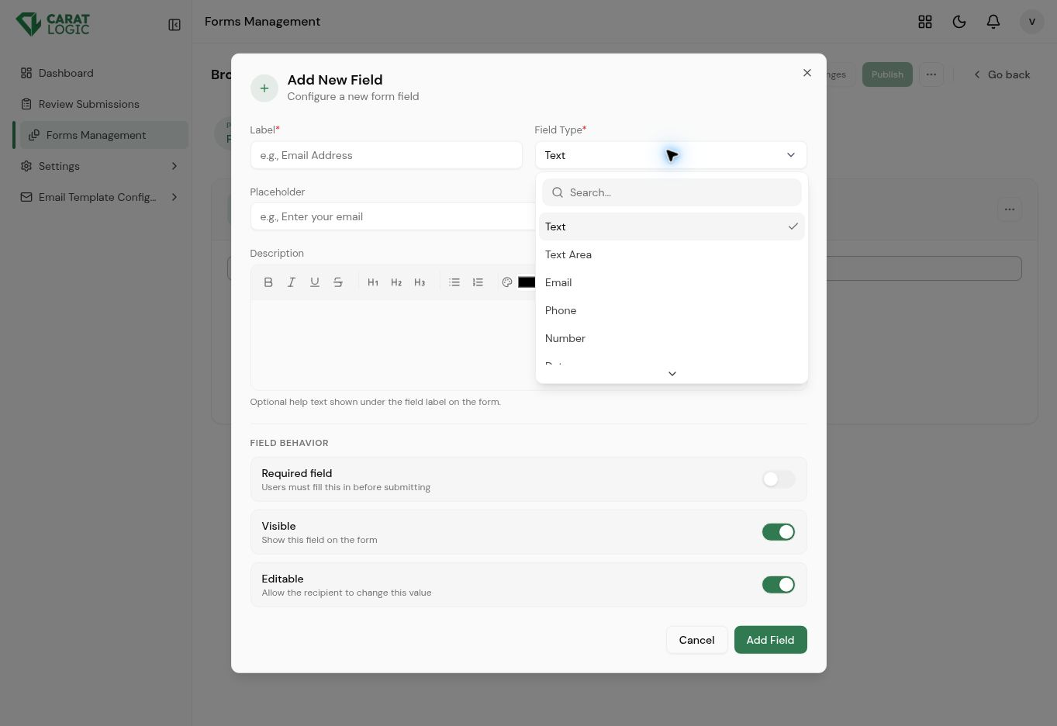
Add and Configure Fields screen

Field Level Controls
Each field card includes a Required switch and controls to show or hide, edit, or delete the field. Save changes stores the draft updates, Discard removes the current unsaved changes, and Publish makes the completed version available for assignment.
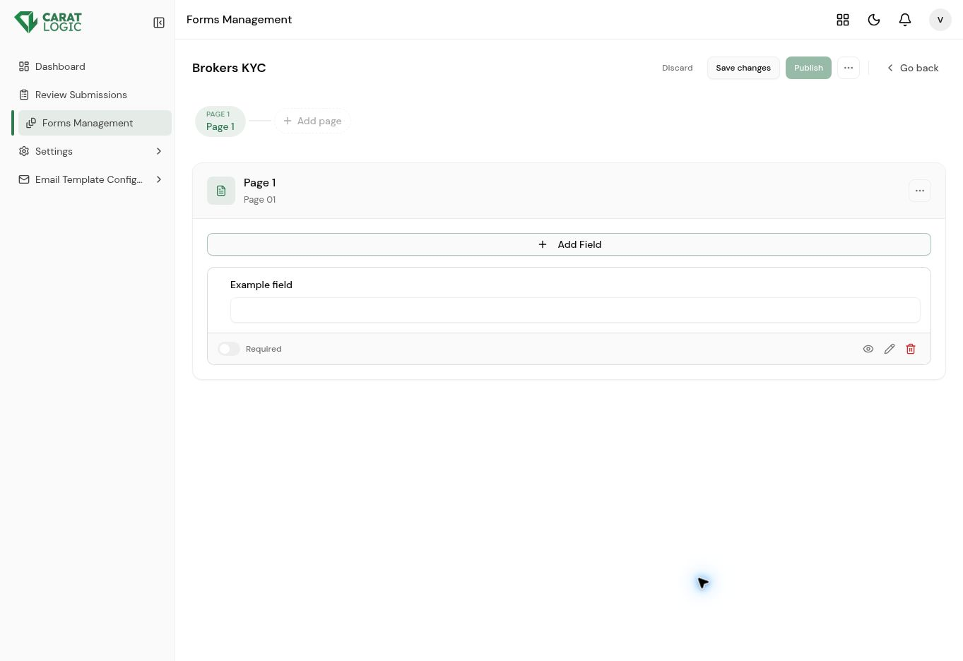
Field Level Controls screen

Form Version History
Expanding a form displays every published version with its version number and publication time. The Latest and Default indicators make it clear which version is newest and which version is assigned by default.
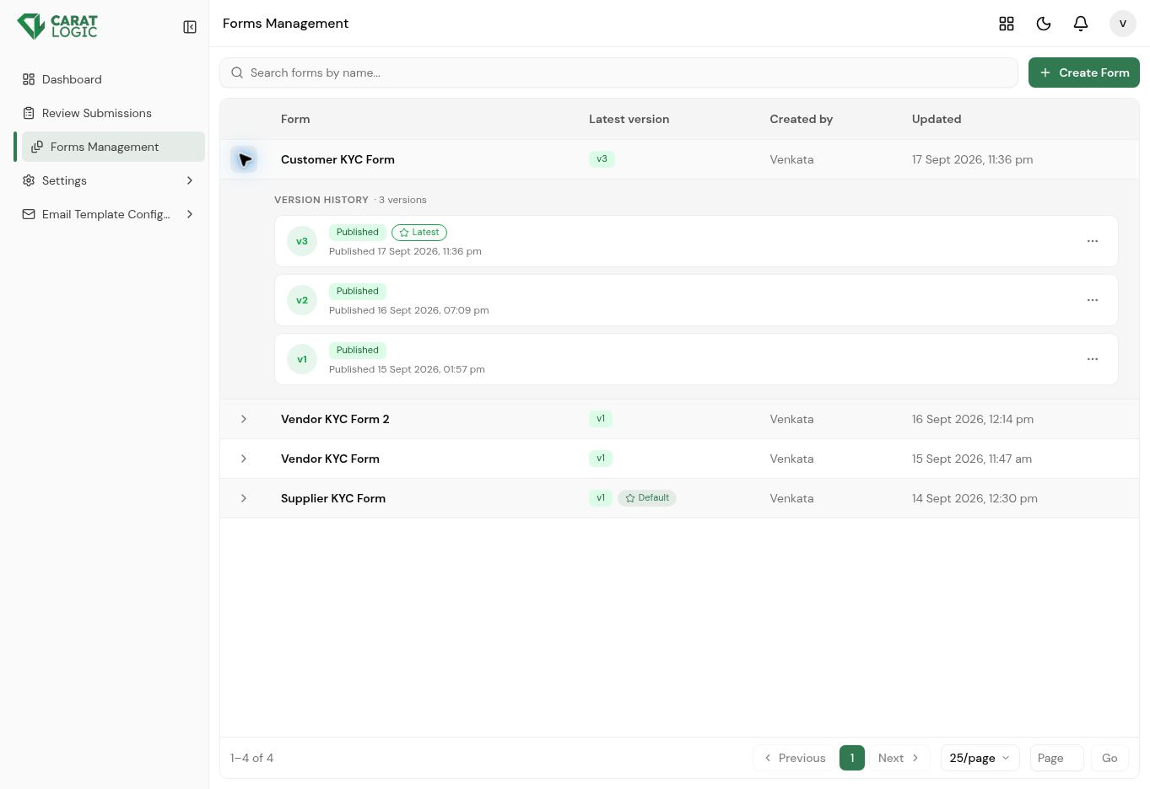
Form Version History screen

Form Version Actions
Each version provides actions to Preview, Edit, Duplicate, Set as default, or Deactivate. These controls support safe form updates while retaining earlier versions and their related submissions.
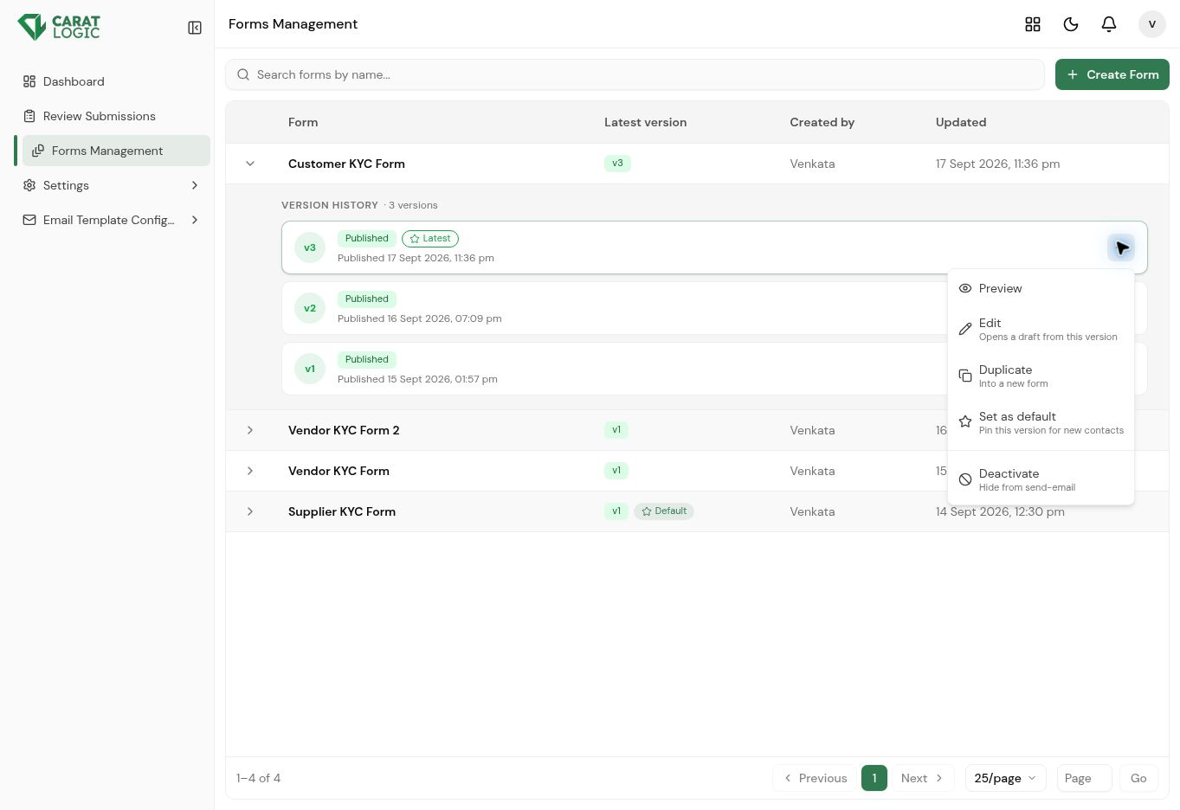
Form Version Actions screen

Form Preview
Preview displays the form as the business contact will see it without saving any entered information. Administrators can verify the page order, field labels, required indicators, and Previous and Next navigation before using the form.
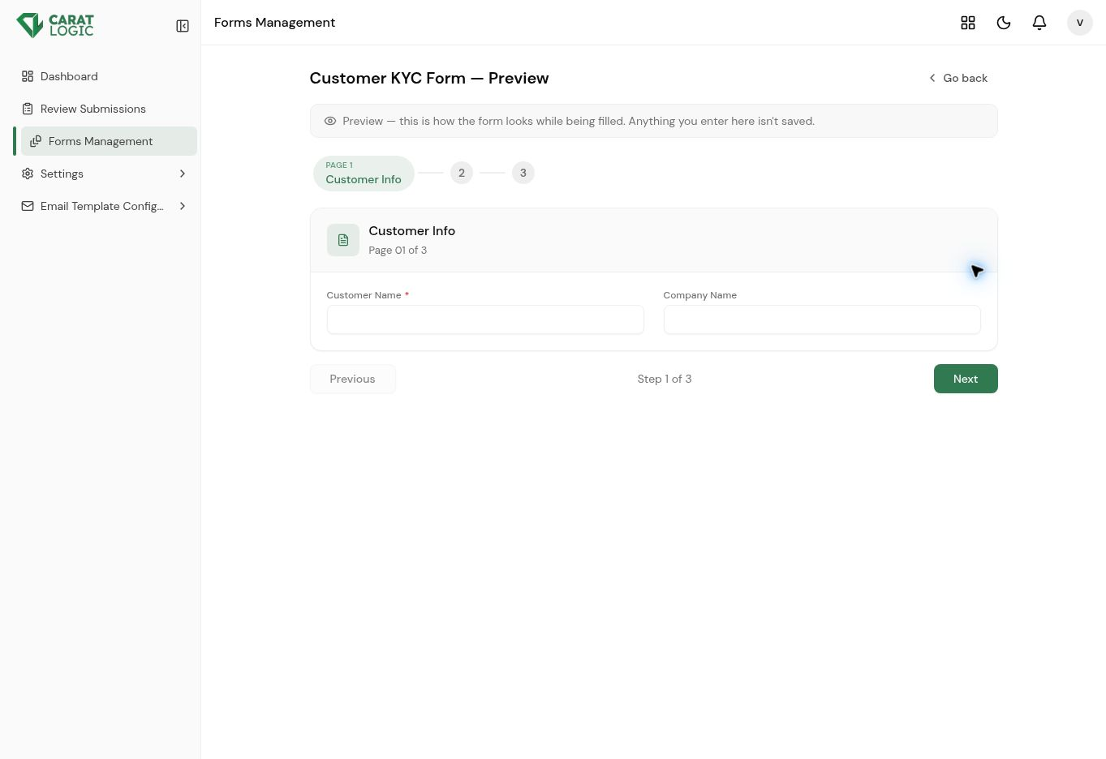
Form Preview screen

4 Settings

Settings controls automated reminders, KYC renewal timing, outgoing email delivery, and the internal recipients who are notified when a submission is received.

Reminder Settings
Reminder Settings defines how frequently KYC reminder emails are sent and when an approved KYC record should be renewed. Auto Reminders can be enabled or disabled, and Reset to defaults restores the standard configuration.
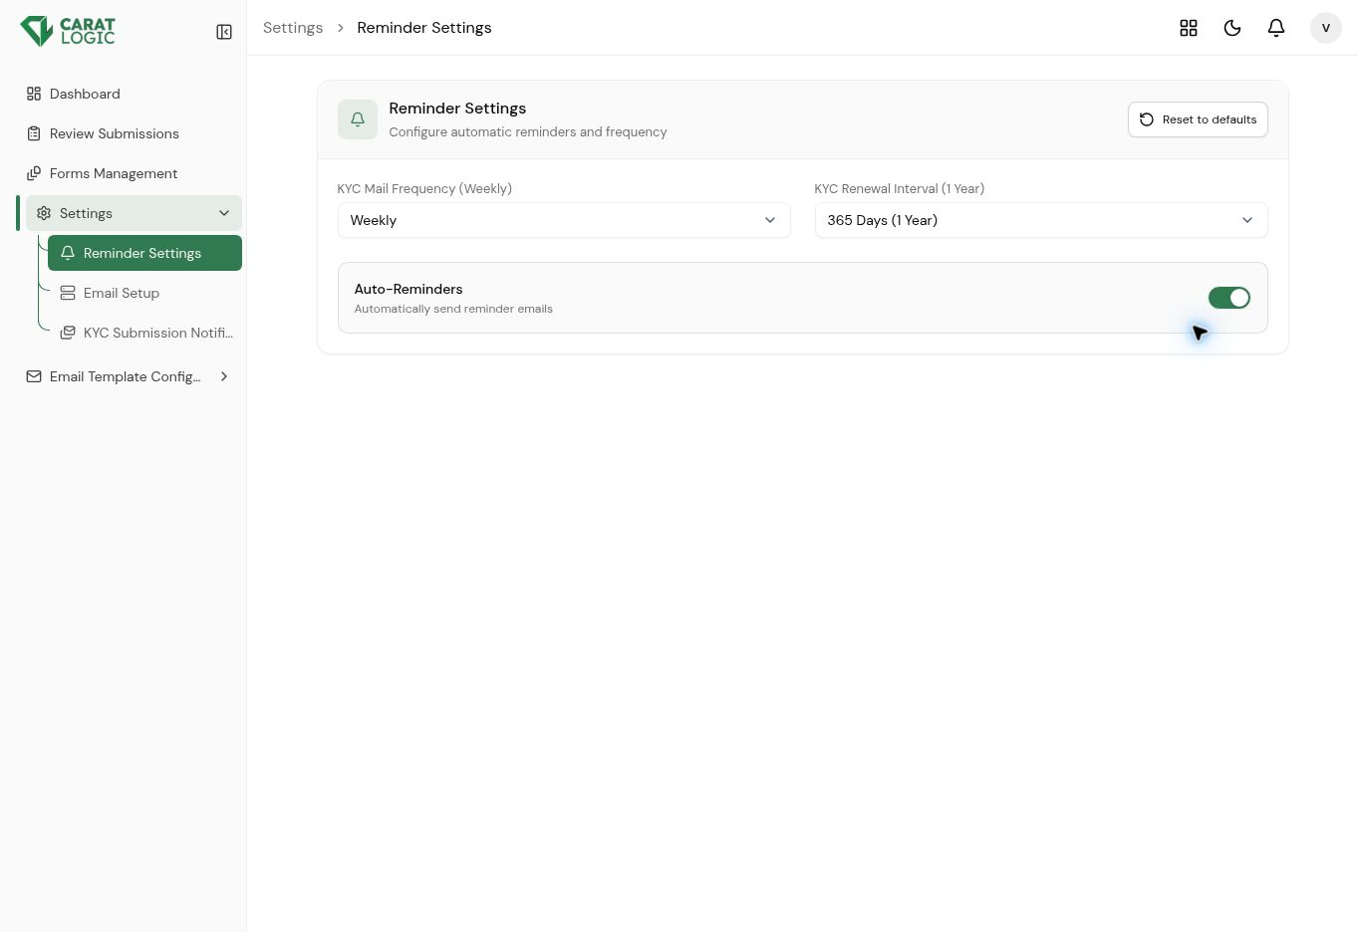
Reminder Settings screen

Email Setup
Email Setup connects the KYC product to the organization’s SMTP service. Administrators provide the SMTP server, port, username, password, sender email address, and sender name used for outgoing notifications.
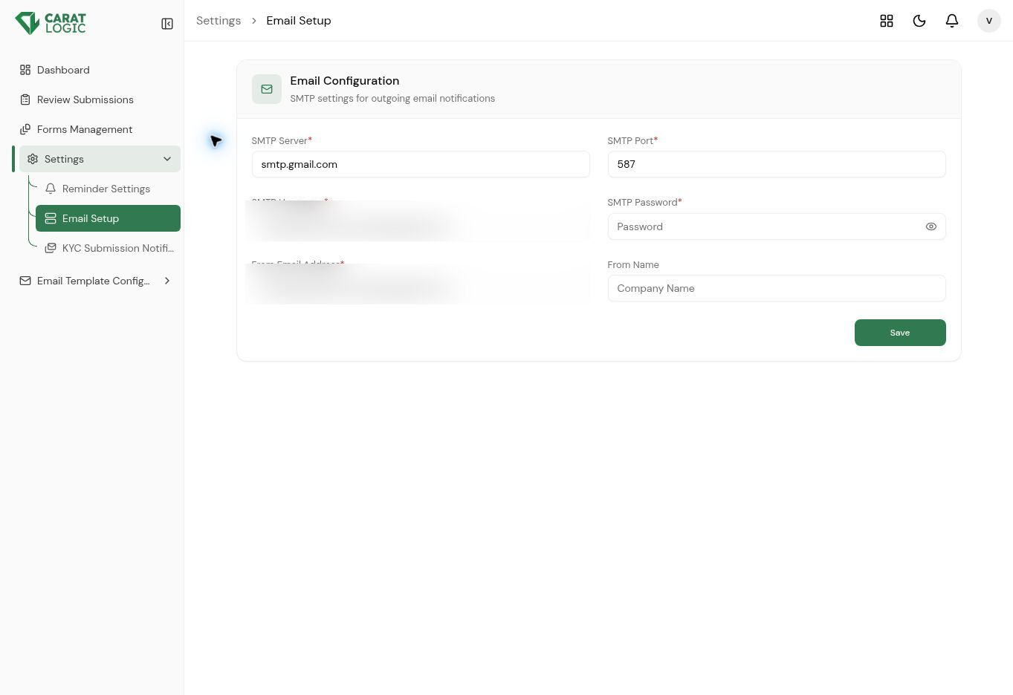
Email Setup screen

KYC Submission Notification Recipients
This setting defines the internal email addresses that receive an alert when a contact submits KYC for review. Recipients can be added, edited, or removed; leaving the list empty disables submission emails.
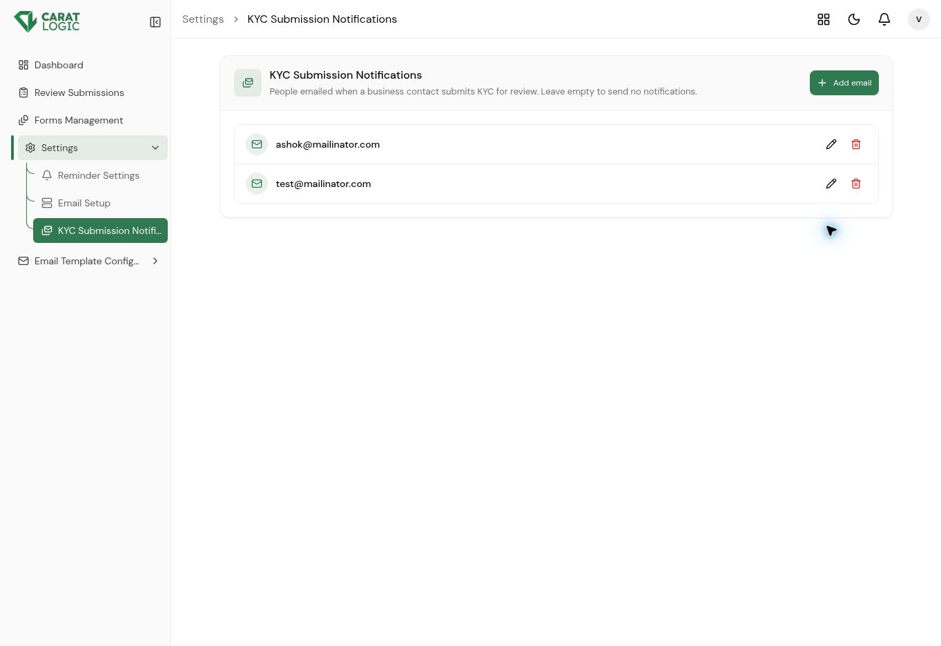
KYC Submission Notification Recipients screen

5 Email Template Configuration

Email Template Configuration allows administrators to control the messages sent during each stage of the KYC lifecycle. The available templates are KYC Invitation, Submitted, Additional Information Required, Approved, Rejected, and Conditionally Approved.

Lifecycle Email Templates
The left menu provides a separate template for every major customer communication. This allows the organization to keep invitation, confirmation, follow-up, approval, conditional approval, and rejection messages consistent.
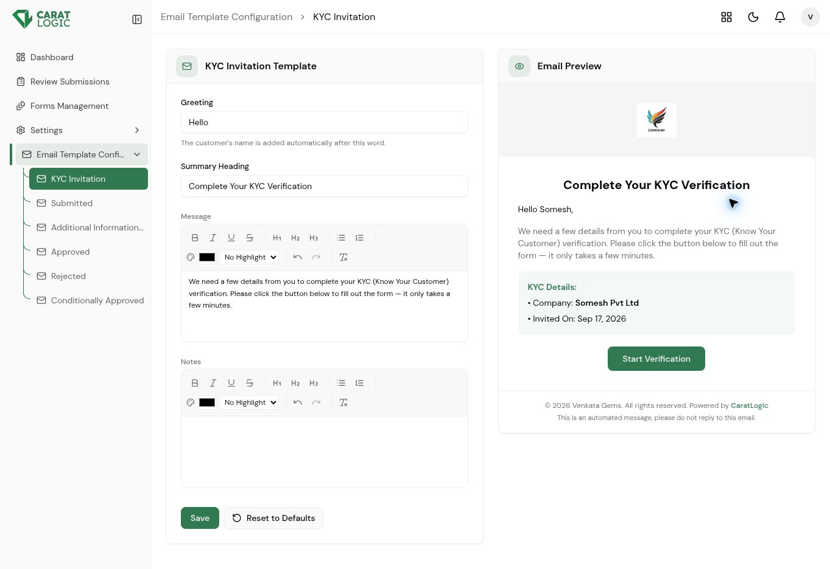
Lifecycle Email Templates screen

Template Editor and Email Preview
The editor supports a greeting, summary heading, formatted message, notes, and common rich-text tools. The preview displays how the email will look to the recipient, including branding, KYC details, the action button, and footer text.
Template Editor and Email Preview screen

