***MUHAMMAD FAISAL AMIR***

***6706160014***

***D3IF-40-02***

**SOAL JURNAL MODUL 5 ROUTING STATIS**

1. Gambar topologi:

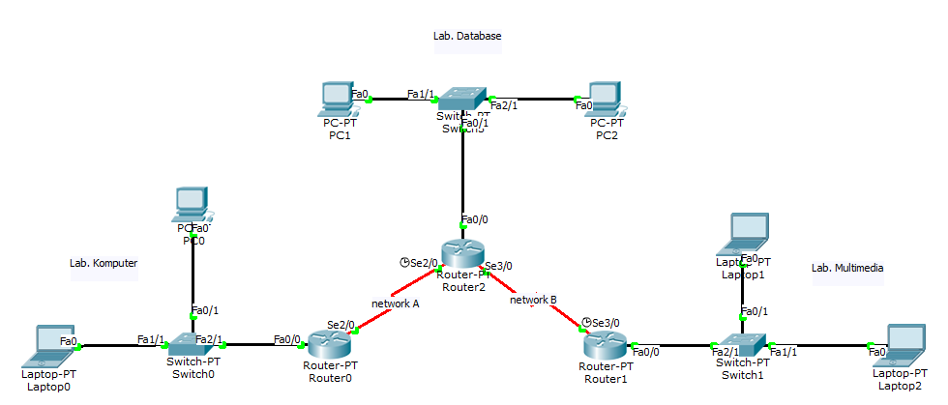

Diberikan IP Address 172.16.0.0/19, maka:

1. Tentukan Network ID, IP First, IP Last, IP Broadcast, Subnetmask, dan Prefix tiap host dibawah (subnetting VLSM):

* Lab. Komputer: 132 Host
* Lab. Database: 112 Host
* Lab. Multimedia: 60 Host
* Network A: 2 Host
* Network B: 2 Host

1. Buat topologi seperti diatas dan Lakukan konfigurasi routing statis agar tiap host diatas dapat terhubung. ***Sertakan screenshot konfigurasi routing di CLI!***
2. Cek apakah seluruh host telah terhubung. ***Sertakan screenshot dicmd!***

Jawab :

1. Network ID 172.16.0.0/19

* 132 host (Lab Komputer)

IP range

255.255.255.255

255.255.255.0

-----------------------------------

0 0 0.255

Network : 172.16.0.0

First Host : 172.16.0.1

Last Host : 172.16.0.254

Broadcast : 172.16.0.255

Subnet Mask : 255.255.255.0

* 112 host (Lab Database)

IP range

255.255.255.255

255.255.255.128

-----------------------------------

0 0 0.127

Network : 172.16.1.0

First Host : 172.16.1.1

Last Host : 172.16.1.126

Broadcast : 172.16.1.127

Subnet Mask : 255.255.255.128

* 60 host (Lab Multimedia)

IP range

255.255.255.255

255.255.255.192

-----------------------------------

0 0 0.63

Network : 172.16.1.128

First Host : 172.16.1.129

Last Host : 172.16.1.190

Broadcast : 172.16.1.191

Subnet Mask : 255.255.255.192

* 2 host (Network A)

IP range

255.255.255.255

255.255.255.252

-----------------------------------

0 0 0.3

Network : 172.16.1.192

First Host : 172.16.1.193

Last Host : 172.16.1.194

Broadcast : 172.16.1.195

Subnet Mask : 255.255.255.252

* 2 host (Network B)

IP range

255.255.255.255

255.255.255.252

-----------------------------------

0 0 0.3

Network : 172.16.1.196

First Host : 172.16.1.197

Last Host : 172.16.1.198

Broadcast : 172.16.1.199

Subnet Mask : 255.255.255.252

1. 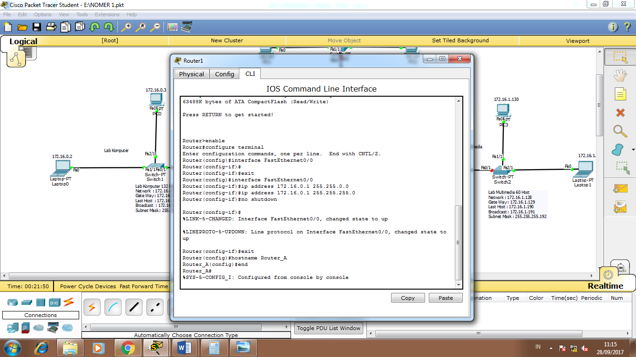 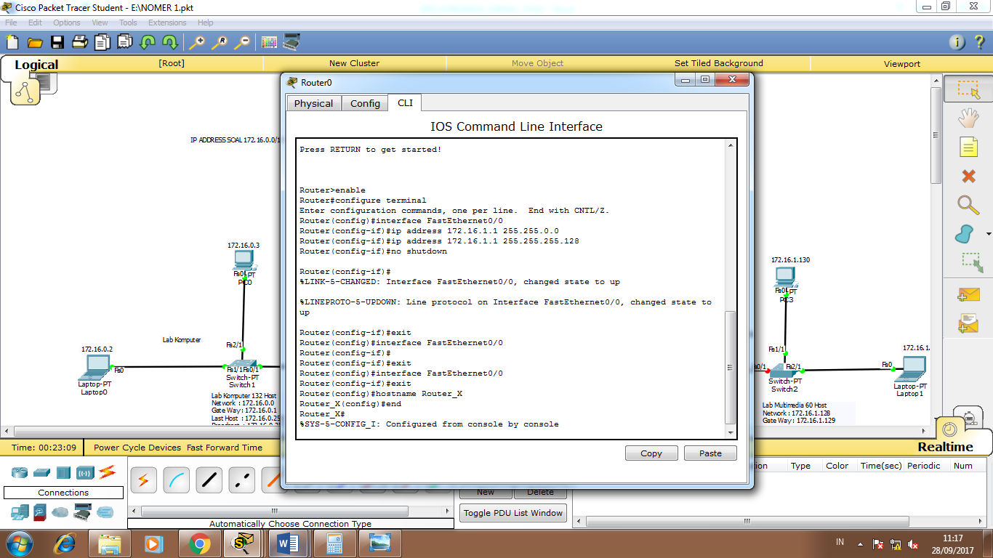 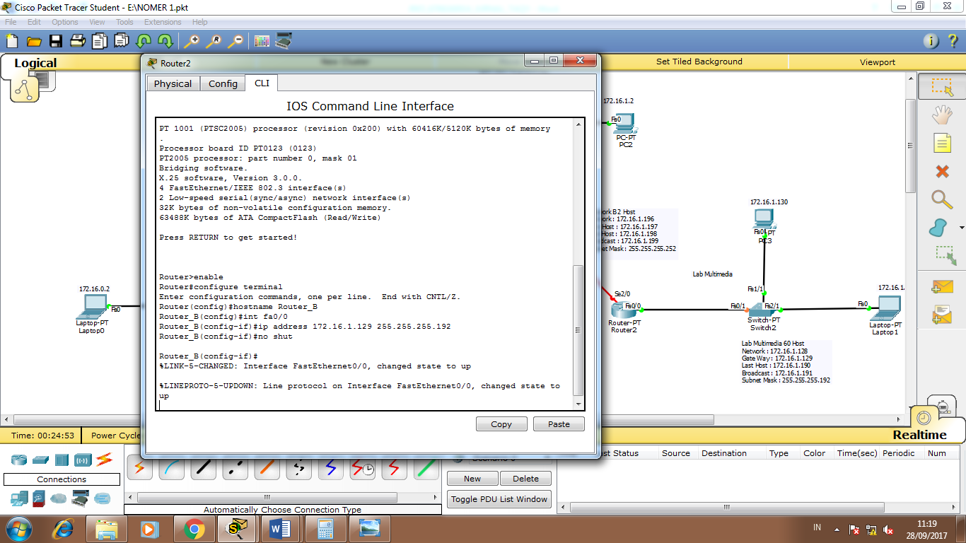 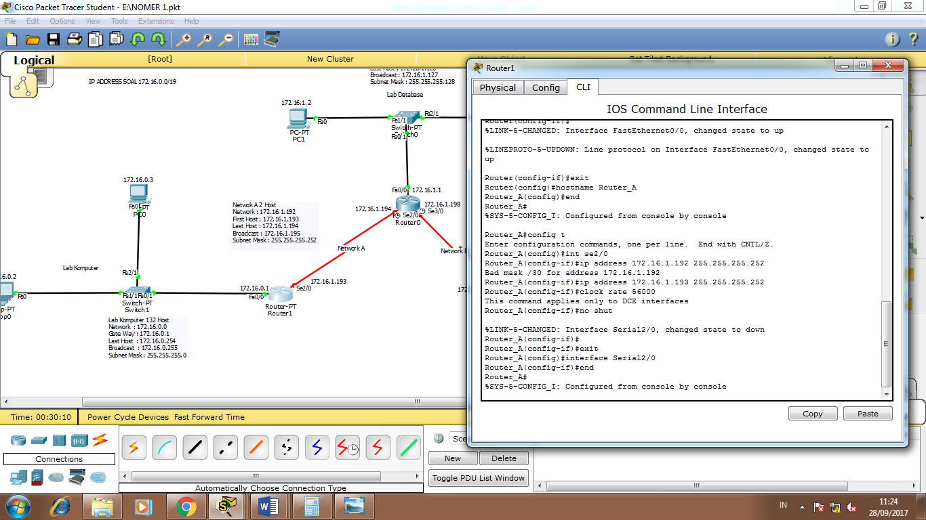 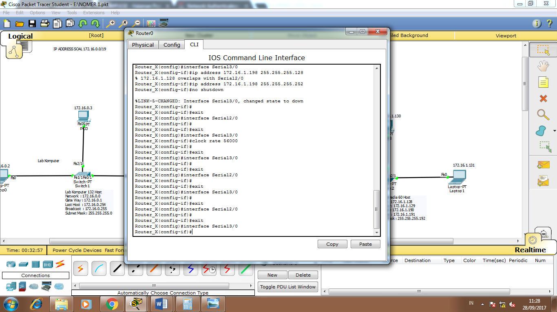 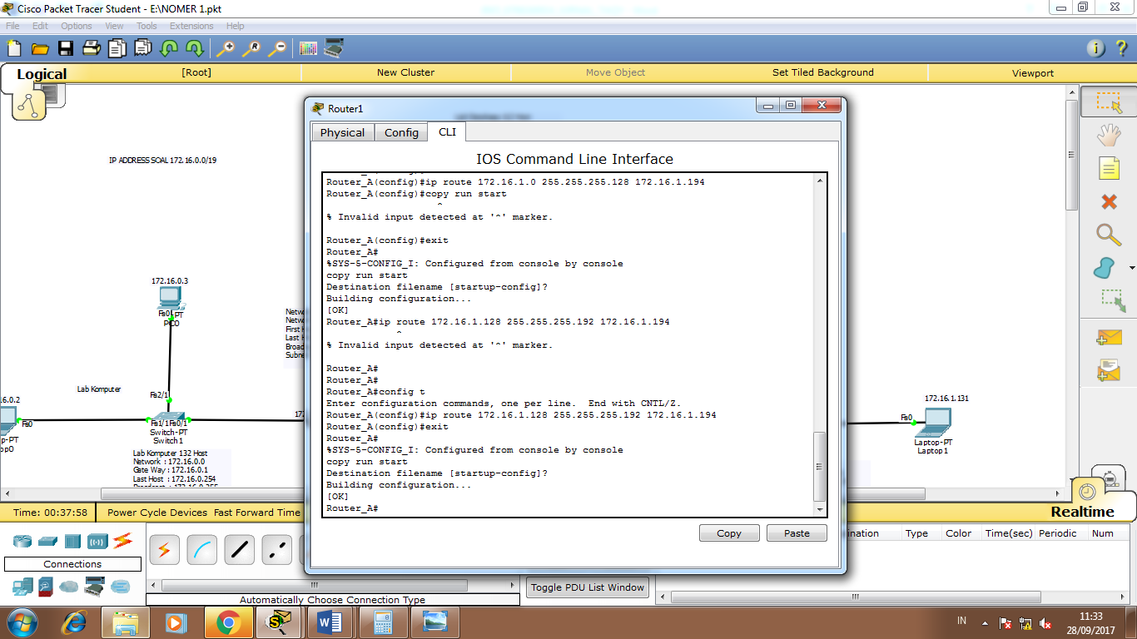 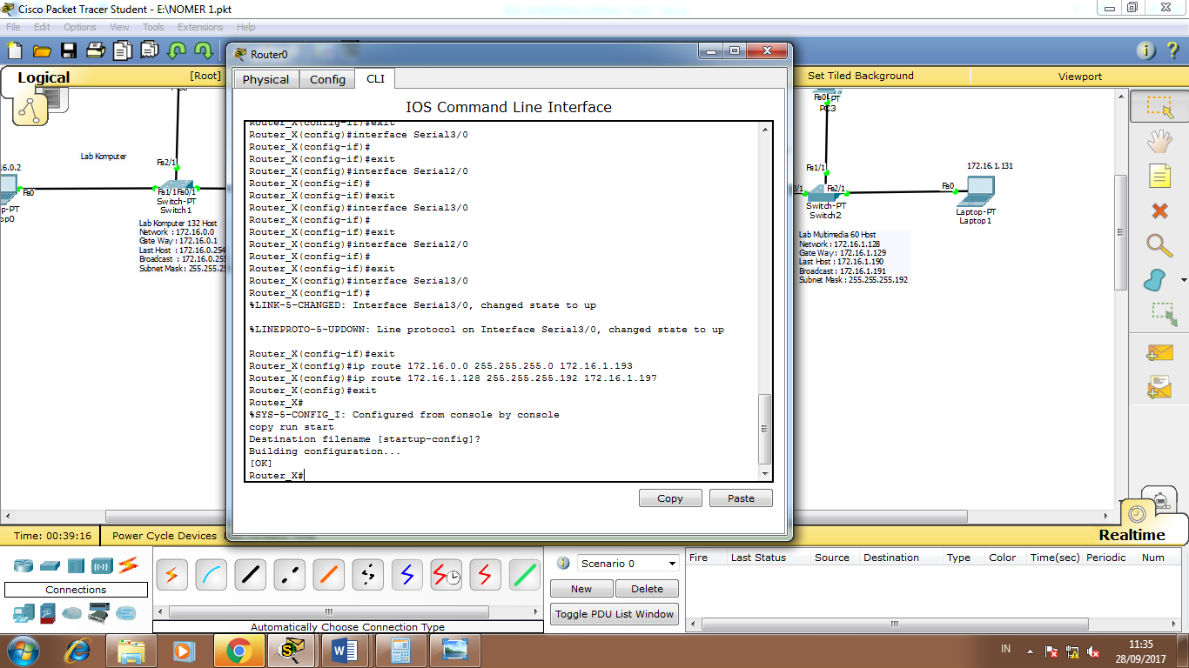 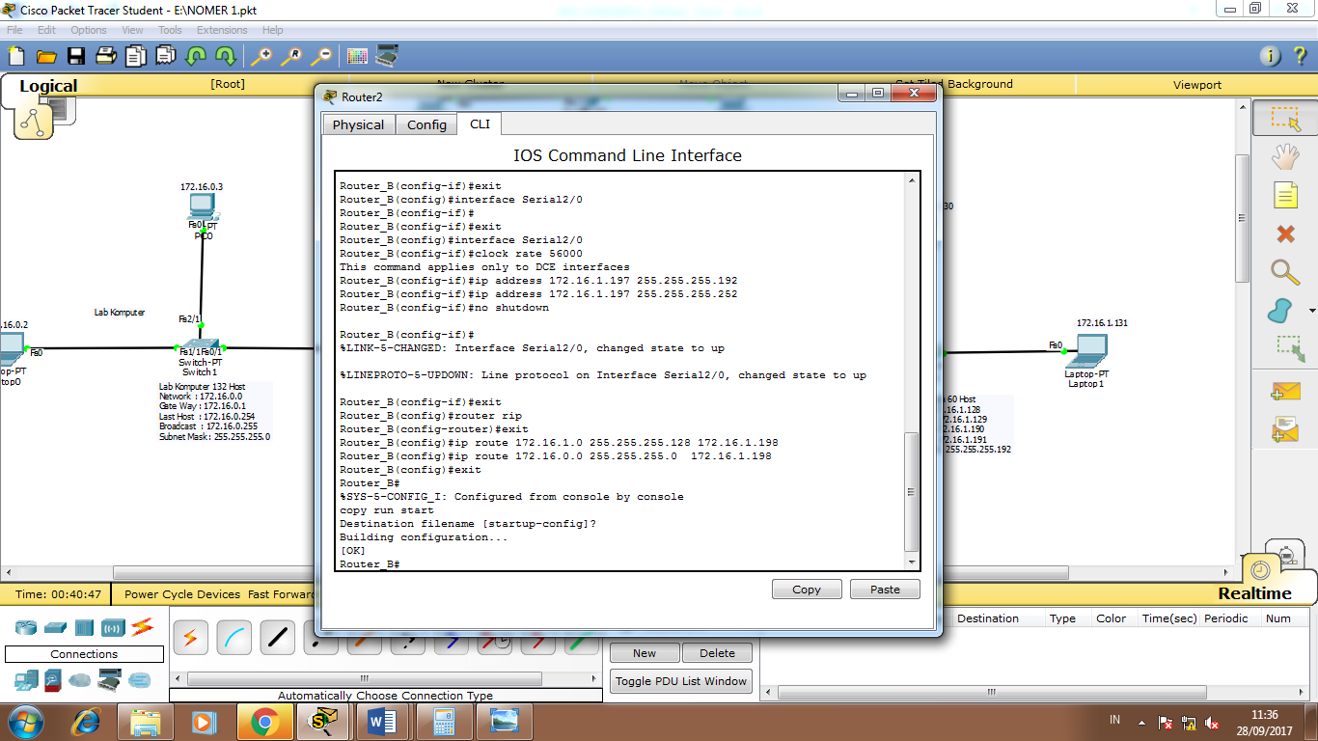

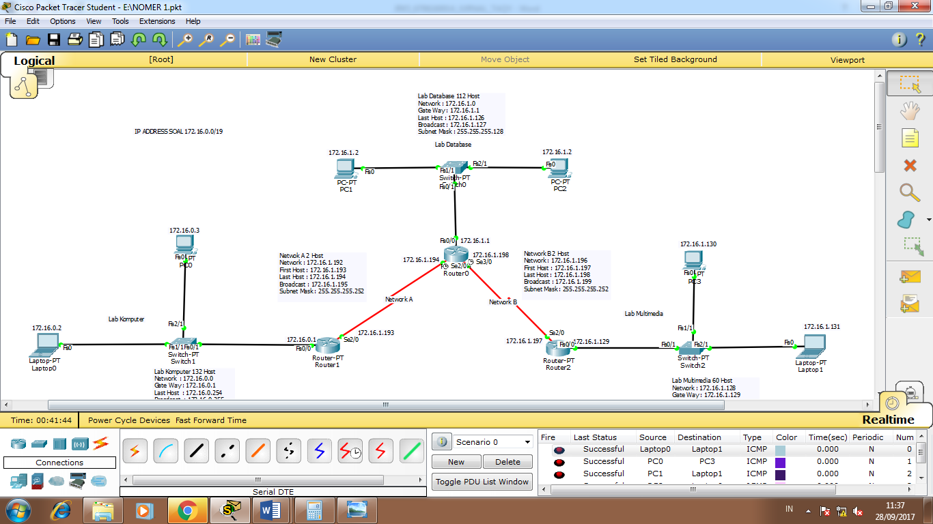

1. 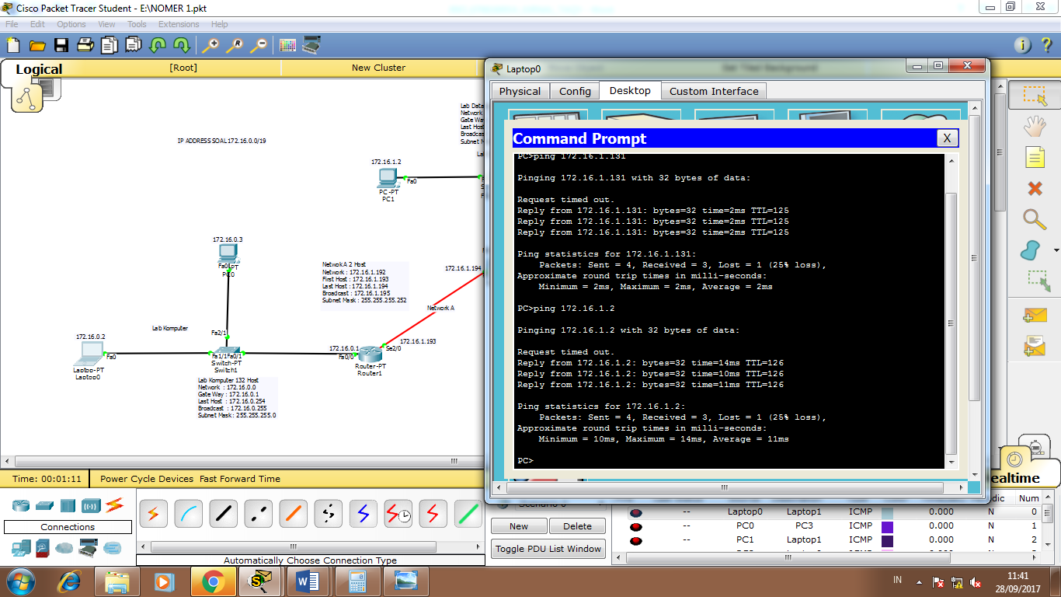
2. Gambar topologi:

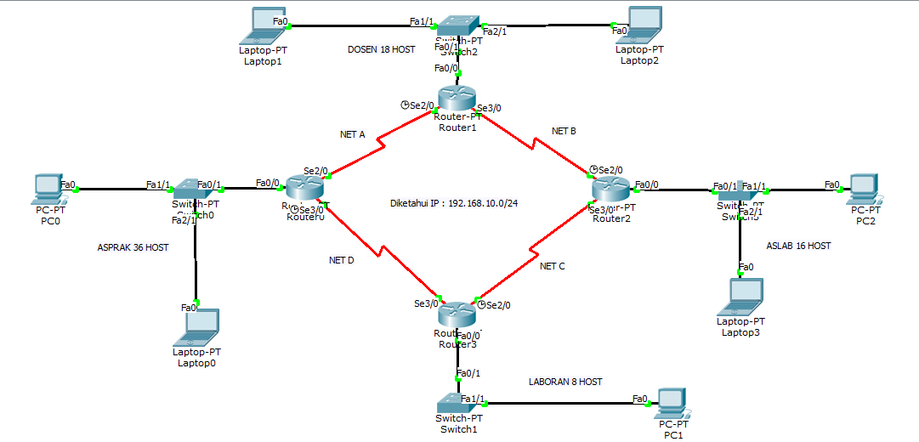

Diberikan IP Address 192.168.10.0/24. Maka:

* 1. Tentukan Network ID, IP First, IP Last, Broadcast, Subnet Mask dan Prefix dari tiap network dibawah (Subnetting VLSM)
* ASPRAK : 36 Host
* DOSEN : 18 Host
* ASLAB : 16 Host
* LABORAN : 8 Host
  1. Buat topologi seperti diatas dan Lakukan konfigurasi routing statis agar tiap host diatas dapat terhubung. ***Sertakan screenshot konfigurasi routing di CLI!***
  2. Cek apakah seluruh host telah terhubung. ***Sertakan screenshot dicmd!***

Jawab :

1. Network ID 192.168.10.0/24

* 36 host (Asprak)

IP range

255.255.255.255

255.255.255.192

-----------------------------------

0 0 0.63

Network : 192.168.10.0

First Host : 192.168.10.1

Last Host : 192.168.10.62

Broadcast : 192.168.10.63

Subnet Mask : 255.255.255.192

* 18 host (Dosen)

IP range

255.255.255.255

255.255.255.224

-----------------------------------

0 0 0.31

Network : 192.168.10.64

First Host : 192.168.10.65

Last Host : 192.168.10.94

Broadcast : 192.168.10.95

Subnet Mask : 255.255.255.224

* 16 host (Aslab)

IP range

255.255.255.255

255.255.255.224

-----------------------------------

0 0 0.31

Network : 192.168.10.96

First Host : 192.168.10.97

Last Host : 192.168.10.126

Broadcast : 192.168.10.127

Subnet Mask : 255.255.255.224

* 8 host (Laboran)

IP range

255.255.255.255

255.255.255.240

-----------------------------------

0 0 0.15

Network : 192.168.10.128

First Host : 192.168.10.129

Last Host : 192.168.10.142

Broadcast : 192.168.10.143

Subnet Mask : 255.255.255.240

* 2 host (NET A)

IP range

255.255.255.255

255.255.255.252

-----------------------------------

0 0 0.3

Network : 192.168.10.144

First Host : 192.168.10.145

Last Host : 192.168.10.146

Broadcast : 192.168.10.147

Subnet Mask : 255.255.255.252

* 2 host (NET B)

IP range

255.255.255.255

255.255.255.252

-----------------------------------

0 0 0.3

Network : 192.168.10.148

First Host : 192.168.10.149

Last Host : 192.168.10.150

Broadcast : 192.168.10.151

Subnet Mask : 255.255.255.252

* 2 host (NET C)

IP range

255.255.255.255

255.255.255.252

-----------------------------------

0 0 0.3

Network : 192.168.10.152

First Host : 192.168.10.153

Last Host : 192.168.10.154

Broadcast : 192.168.10.155

Subnet Mask : 255.255.255.252

* 2 host (NET D)

IP range

255.255.255.255

255.255.255.252

-----------------------------------

0 0 0.3

Network : 192.168.10.156

First Host : 192.168.10.157

Last Host : 192.168.10.158

Broadcast : 192.168.10.159

Subnet Mask : 255.255.255.252

1. 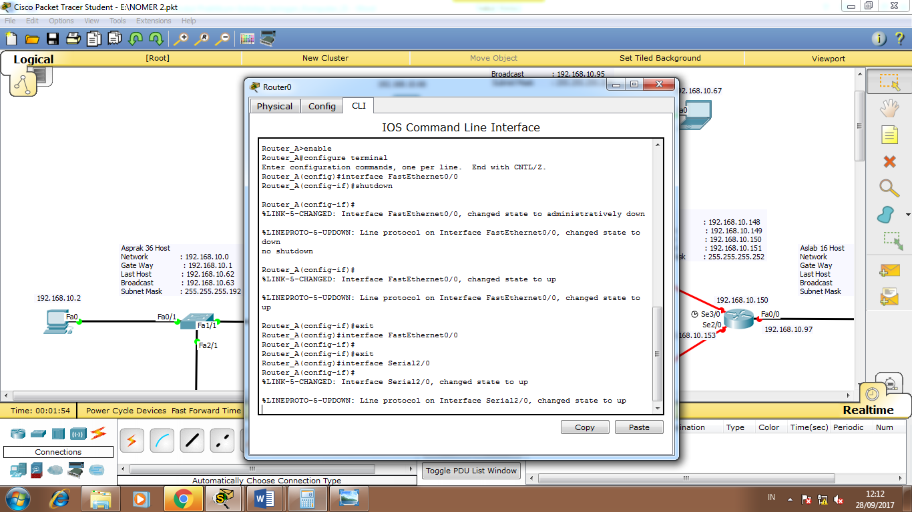 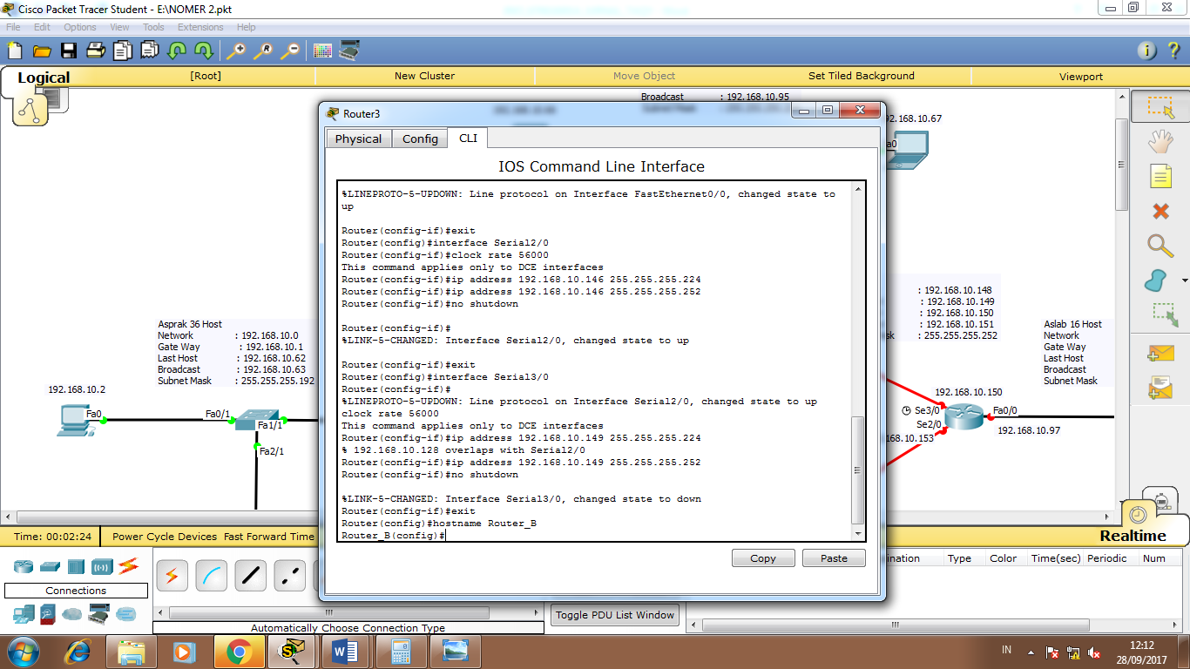 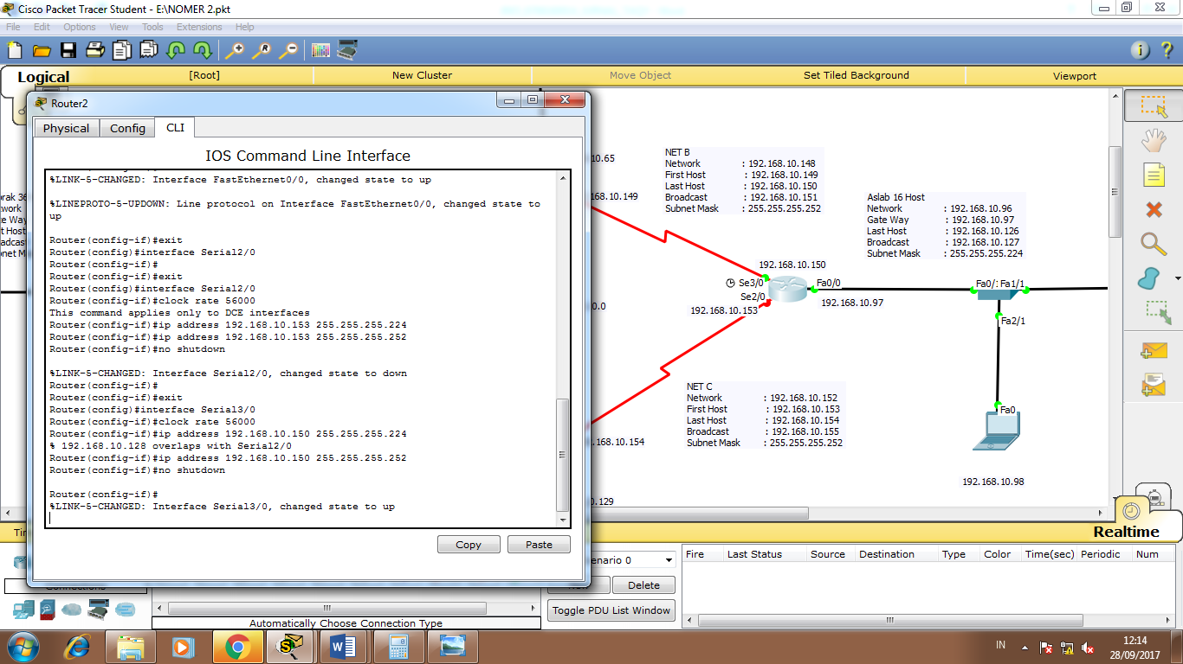 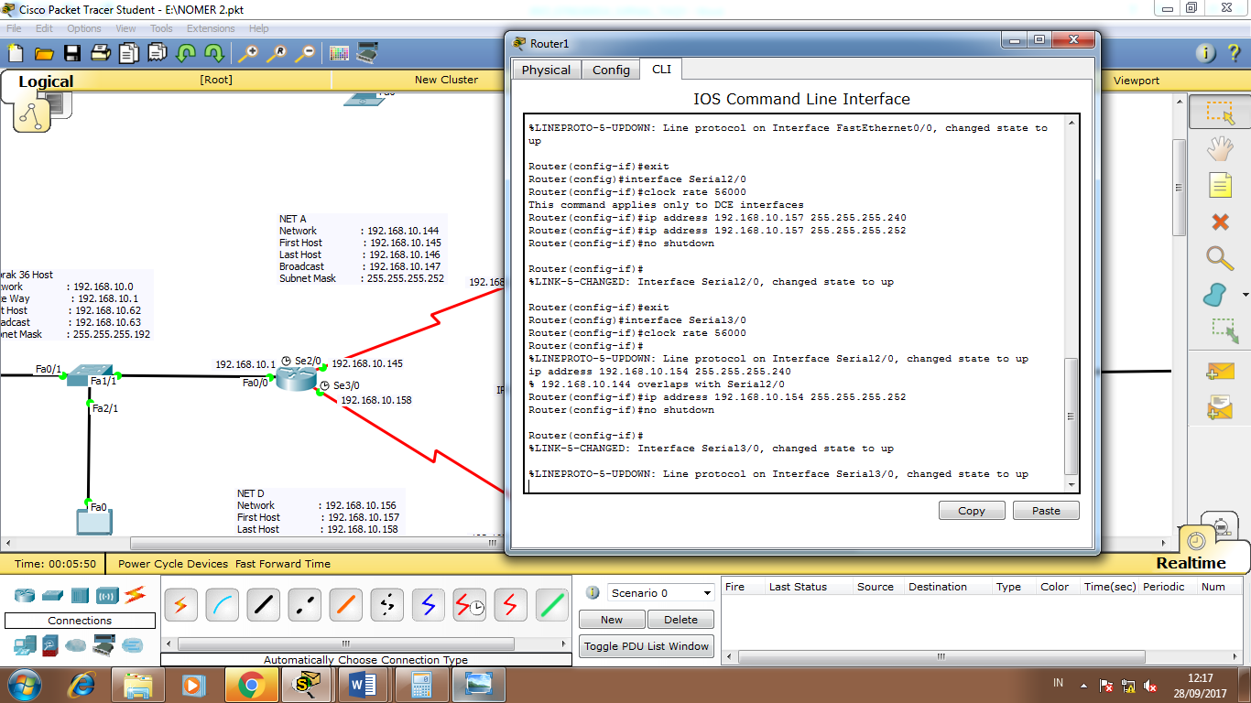

Router0 Gate Way 192.168.10.146

ip route 192.168.10.64 255.255.255.224 192.168.10.146

ip route 192.168.10.96 255.255.255.224 192.168.10.146

ip route 192.168.10.128 255.255.255.240 192.168.10.146

Router0 Gate Way 192.168.10.157

ip route 192.168.10.64 255.255.255.224 192.168.10.157

ip route 192.168.10.96 255.255.255.224 192.168.10.157

ip route 192.168.10.128 255.255.255.240 192.168.10.157

Router1 Gate Way 192.168.10.158

ip route 192.168.10.0 255.255.255.192 192.168.158

ip route 192.168.10.64 255.255.255.224 192.168.10.158

ip route 192.168.10.96 255.255.255.224 192.168.10.158

Router1 Gate Way 192.168.10.153

ip route 192.168.10.0 255.255.255.192 192.168.153

ip route 192.168.10.64 255.255.255.224 192.168.10.153

ip route 192.168.10.96 255.255.255.224 192.168.10.153

Router2 Gate Way 192.168.10.154

ip route 192.168.10.0 255.255.255.192 192.168.154

ip route 192.168.10.64 255.255.255.224 192.168.10.154

ip route 192.168.10.128 255.255.255.240 192.168.10.154

Router2 Gate Way 192.168.10.149

ip route 192.168.10.0 255.255.255.192 192.168.149

ip route 192.168.10.64 255.255.255.224 192.168.10.149

ip route 192.168.10.128 255.255.255.240 192.168.10.149

Router3 Gate Way 192.168.10.145

ip route 192.168.10.0 255.255.255.192 192.168.145

ip route 192.168.10.96 255.255.255.224 192.168.10.145

ip route 192.168.10.128 255.255.255.240 192.168.10.145

Router3 Gate Way 192.168.10.150

ip route 192.168.10.0 255.255.255.192 192.168.150

ip route 192.168.10.96 255.255.255.224 192.168.10.150

ip route 192.168.10.128 255.255.255.240 192.168.10.150