**SOAL JURNAL MODUL 6**

**MUHAMMAD FAISAL AMIR**

**6706160014**

**D3IF-40-02**

1. Diberikan alamat jaringan : 175.33.20.0/17 (poin 25)

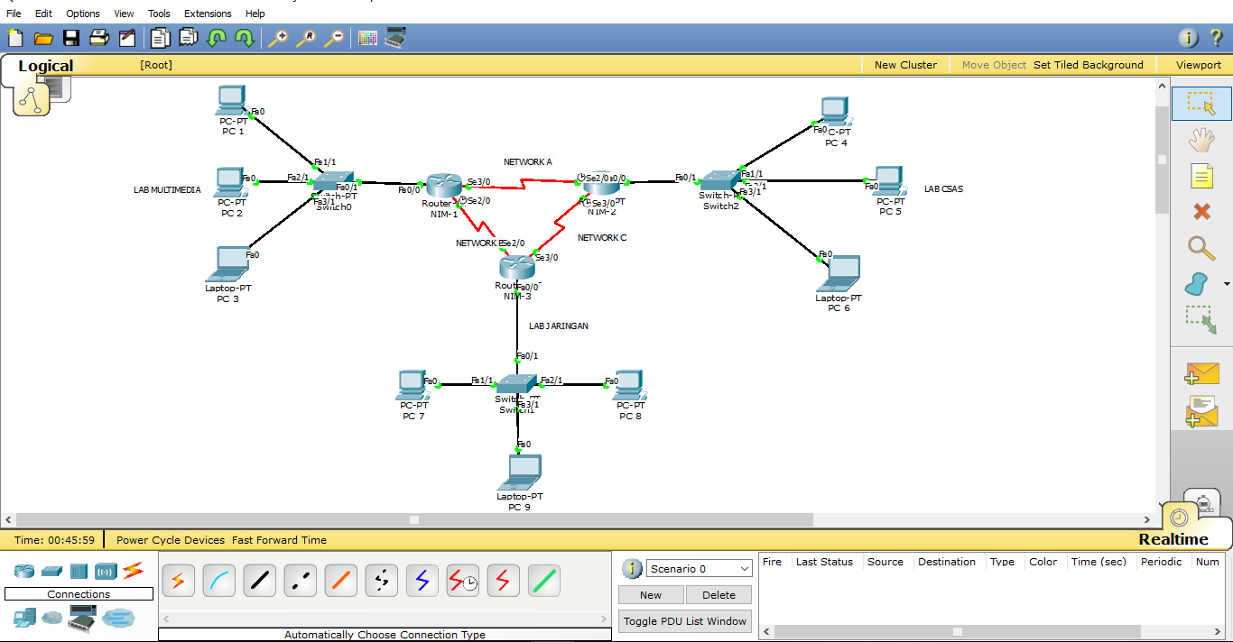

1. Lakukan subnetting VLSM , Tentukan Network, FH, LH, Broadcast, Subnet Mask, dan Prefix tiap host

* LAB MULTIMEDIA 100 host
* LAB CSAS 120 host
* LAB JARINGAN 50 host
* Network A 2 host
* Network B 2 host
* Network C 2 host

1. Network ID 175.33.20.0/17

* LAB CSAS

IP range

255.255.255.255

255.255.255.128

-----------------------------------

0 0 0.127

120 Host (LAB CSAS)

Network : 175.33.20.0

First Host (GW) : 175.33.20.1

Last Host : 175.33.20.126

Broadcast : 175.33.20.127

Subnet Mask : 255.255.255.128

* LAB MULTIMEDIA

IP range

255.255.255.255

255.255.255.128

-----------------------------------

0 0 0.127

100 Host (LAB MULTIMEDIA)

Network : 175.33.20.128

First Host (GW) : 175.33.20.129

Last Host : 175.33.20.254

Broadcast : 175.33.20.255

Subnet Mask : 255.255.255.128

* LAB JARINGAN

IP range

255.255.255.255

255.255.255.192

-----------------------------------

0 0 0.63

50 Host (LAB JARINGAN)

Network : 175.33.21.0

First Host (GW) : 175.33.21.1

Last Host : 175.33.21.62

Broadcast : 175.33.21.63

Subnet Mask : 255.255.255.192

* NET A

IP range

255.255.255.255

255.255.255.252

-----------------------------------

0 0 0.3

2 Host (NET A)

Network : 175.33.21.64

First Host (GW) : 175.33.21.65

Last Host : 175.33.21.66

Broadcast : 175.33.21.67

Subnet Mask : 255.255.255.252

* NET B

IP range

255.255.255.255

255.255.255.252

-----------------------------------

0 0 0.3

2 Host (NET B)

Network : 175.33.21.68

First Host (GW) : 175.33.21.69

Last Host : 175.33.21.70

Broadcast : 175.33.21.71

Subnet Mask : 255.255.255.252

* NET C

IP range

255.255.255.255

255.255.255.252

-----------------------------------

0 0 0.3

2 Host (NET C)

Network : 175.33.21.72

First Host (GW) : 175.33.21.73

Last Host : 175.33.21.74

Broadcast : 175.33.21.75

Subnet Mask : 255.255.255.252

1. Buat topologi seperti pada contoh dan lakukan konfigurasi dinamis dengan menggunakan RIPv2. Screenshoot dengan watermark NAMA dan NIM

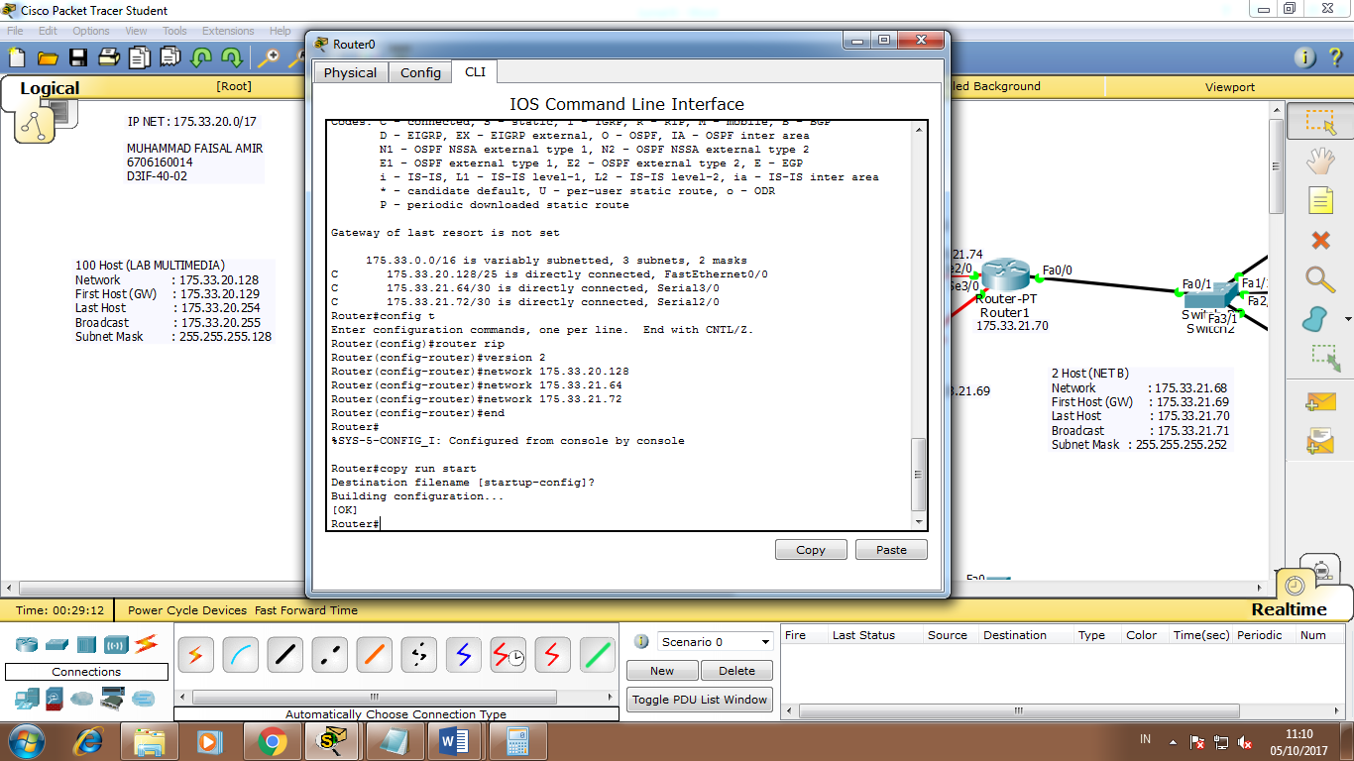

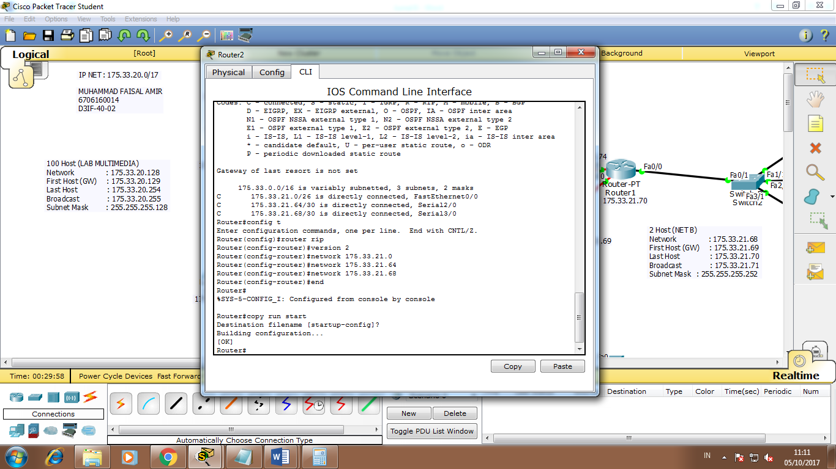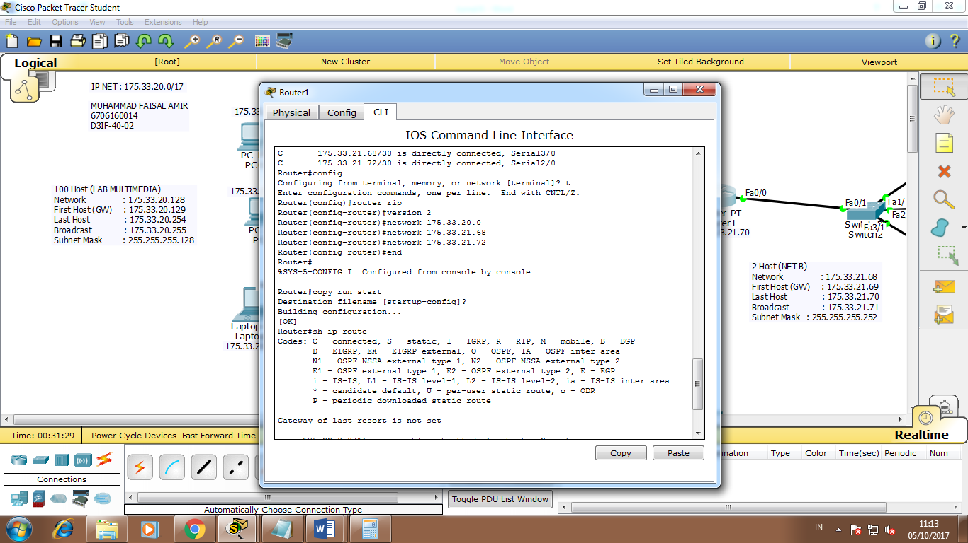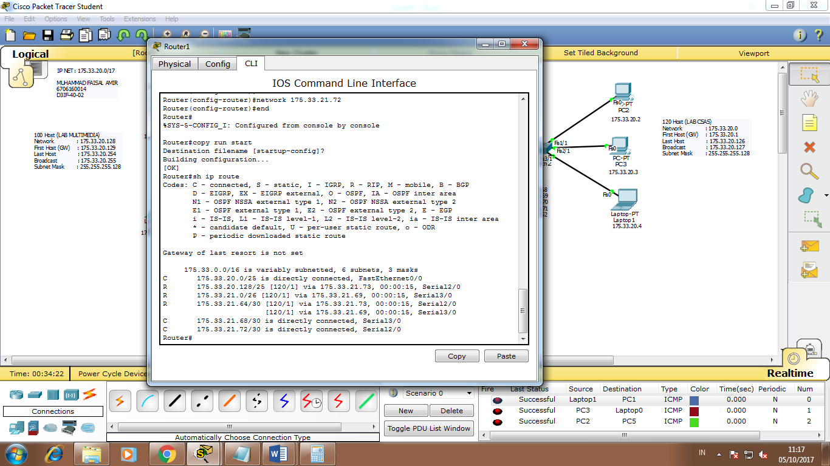

1. Cek apakah seluruh host telah terhubung. Sertakan screenshoot di cmd dengan watermark NAMA dan NIM

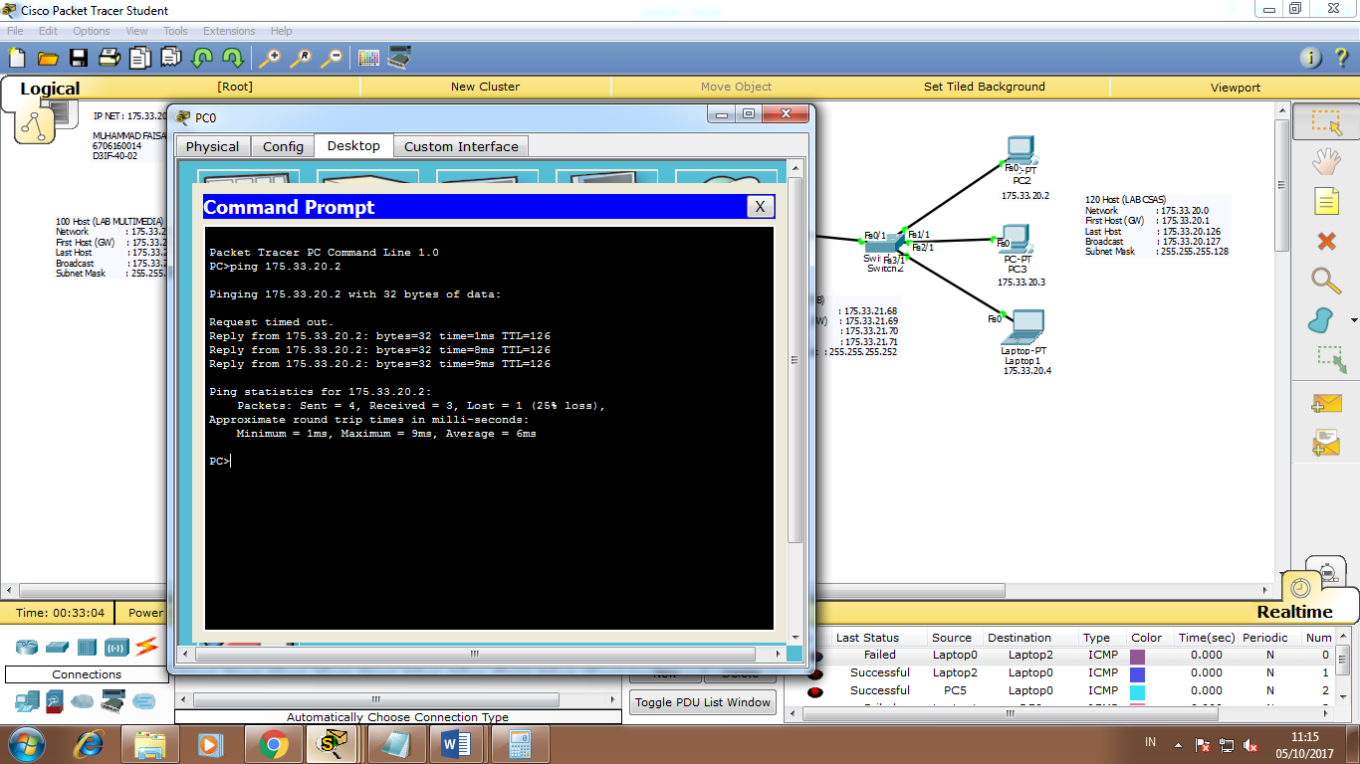

1. jika Network A diputus, Lab multimedia masih bisa ping ke lab jaringan, begitupun jika Network C yang diputus, lab multimedia masih bisa ping ke lab jaringan. Lakukan juga terhadap host yang lain. (CLOSE ASPRAK)

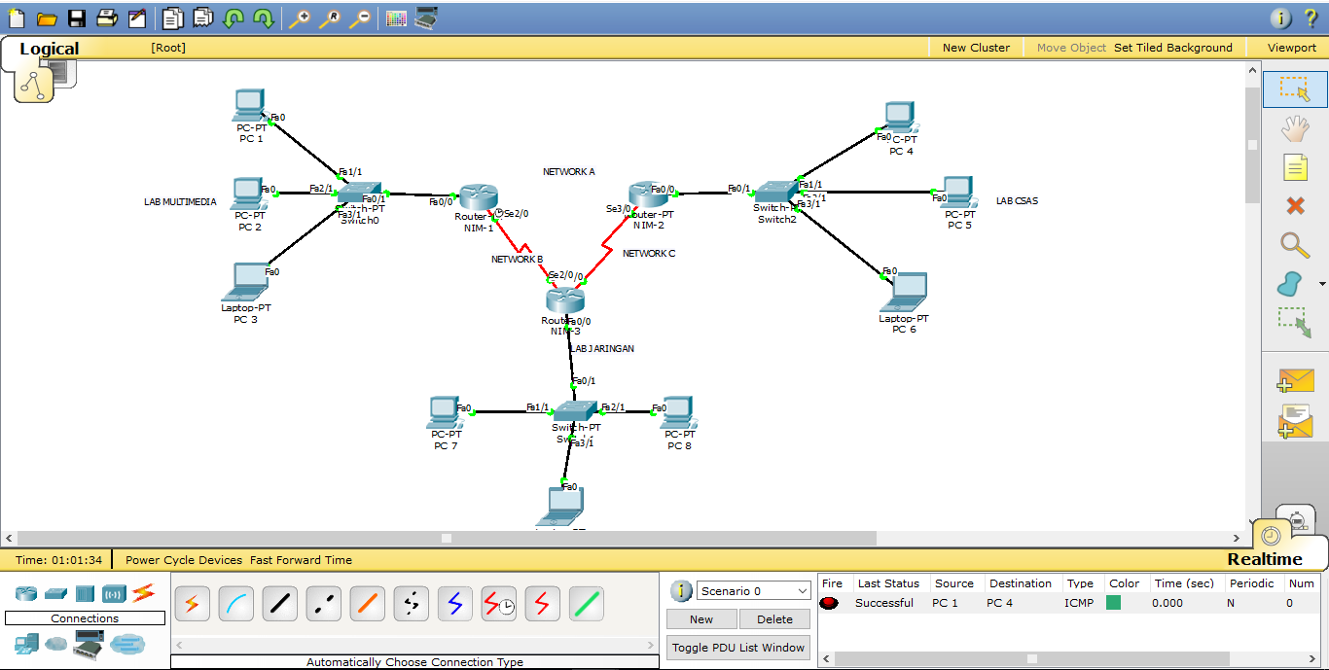

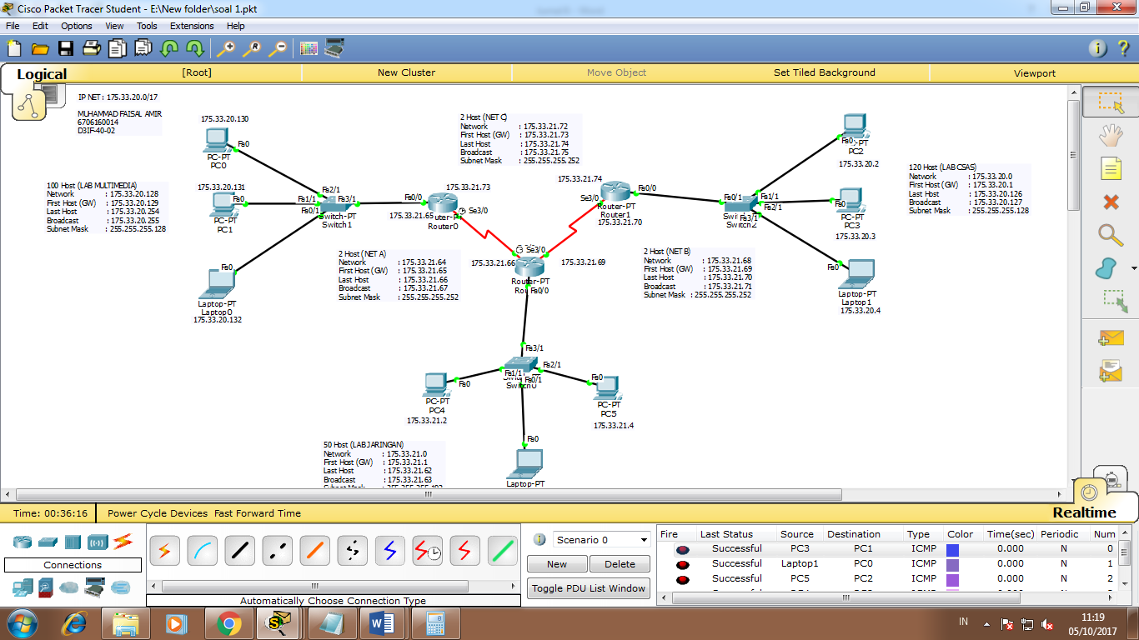

1. Diberikan alamat jaringan : 192.168.11.0/25 (poin 40)

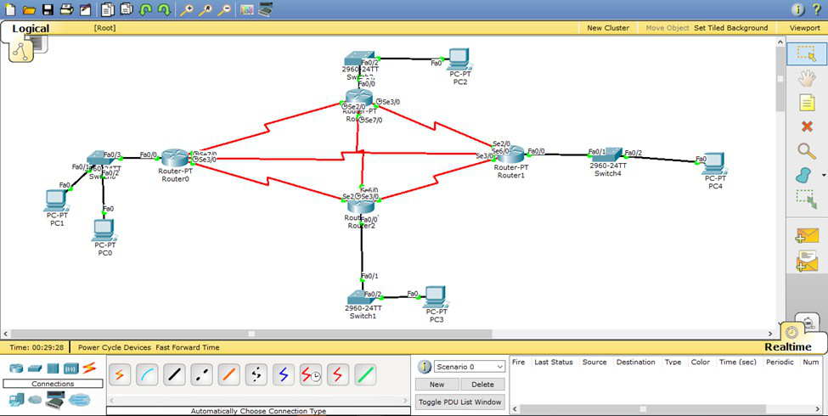

1. Lakukan subnetting VLSM , Tentukan Network, FH, LH, Broadcast, Subnet Mask, dan Prefix tiap host. Tiap host dinamakan sama seperti dibawah ini.

* Shingeki No Kyojin 56 host
* Boku no Pico 110 host
* Rem Ram 130
* Kuroko no Basket 80 host
* Net A 2 host
* Net B 2 host
* Net C 2 host
* Net D 2 host
* Net E 2 host
* Net F 2 host

NET ID 192.168.11.0

* REM RAM

IP range

255.255.255.255

255.255.255.0

-----------------------------------

0 0 0.255

130 Host (REM RAM)

Network : 192.168.11.0

First Host (GW) : 192.168.11.1

Last Host : 192.168.11.254

Broadcast : 192.168.11.255

Subnet Mask : 255.255.255.0

* BOKU NO PICO

IP range

255.255.255.255

255.255.255.128

-----------------------------------

0 0 0.127

110 Host (BOKU NO PICO)

Network : 192.168.12.0

First Host (GW) : 192.168.12.1

Last Host : 192.168.12.126

Broadcast : 192.168.12.127

Subnet Mask : 255.255.255.128

* KUROKO NO BASKET

IP range

255.255.255.255

255.255.255.128

-----------------------------------

0 0 0.127

80 Host (KUROKO NO BASKET)

Network : 192.168.12.128

First Host (GW) : 192.168.12.129

Last Host : 192.168.12.254

Broadcast : 192.168.12.255

Subnet Mask : 255.255.255.128

* SHINGEKI NO KYOJIN

IP range

255.255.255.255

255.255.255.192

-----------------------------------

0 0 0.63

56 Host (SHINGEKI NO KYOJIN)

Network : 192.168.13.0

First Host (GW) : 192.168.13.1

Last Host : 192.168.13.62

Broadcast : 192.168.13.63

Subnet Mask : 255.255.255.192

* NET A

IP range

255.255.255.255

255.255.255.252

-----------------------------------

0 0 0.3

2 Host (NET A)

Network : 192.168.13.64

First Host (GW) : 192.168.13.65

Last Host : 192.168.13.66

Broadcast : 192.168.13.67

Subnet Mask : 255.255.255.252

* NET B

IP range

255.255.255.255

255.255.255.252

-----------------------------------

0 0 0.3

2 Host (NET B)

Network : 192.168.13.68

First Host (GW) : 192.168.13.69

Last Host : 192.168.13.70

Broadcast : 192.168.13.71

Subnet Mask : 255.255.255.252

* NET C

IP range

255.255.255.255

255.255.255.252

-----------------------------------

0 0 0.3

2 Host (NET C)

Network : 192.168.13.72

First Host (GW) : 192.168.13.73

Last Host : 192.168.13.74

Broadcast : 192.168.13.75

Subnet Mask : 255.255.255.252

* NET D

IP range

255.255.255.255

255.255.255.252

-----------------------------------

0 0 0.3

2 Host (NET D)

Network : 192.168.13.76

First Host (GW) : 192.168.13.77

Last Host : 192.168.13.78

Broadcast : 192.168.13.79

Subnet Mask : 255.255.255.252

* NET E

IP range

255.255.255.255

255.255.255.252

-----------------------------------

0 0 0.3

2 Host (NET E)

Network : 192.168.13.80

First Host (GW) : 192.168.13.81

Last Host : 192.168.13.82

Broadcast : 192.168.13.83

Subnet Mask : 255.255.255.252

* NET F

IP range

255.255.255.255

255.255.255.252

-----------------------------------

0 0 0.3

2 Host (NET F)

Network : 192.168.13.84

First Host (GW) : 192.168.13.85

Last Host : 192.168.13.86

Broadcast : 192.168.13.87

Subnet Mask : 255.255.255.252

1. Buat topologi seperti pada contoh dan lakukan konfigurasi dinamis dengan menggunakan OSPF pada area 0. Screenshoot dengan watermark NAMA dan NIM.

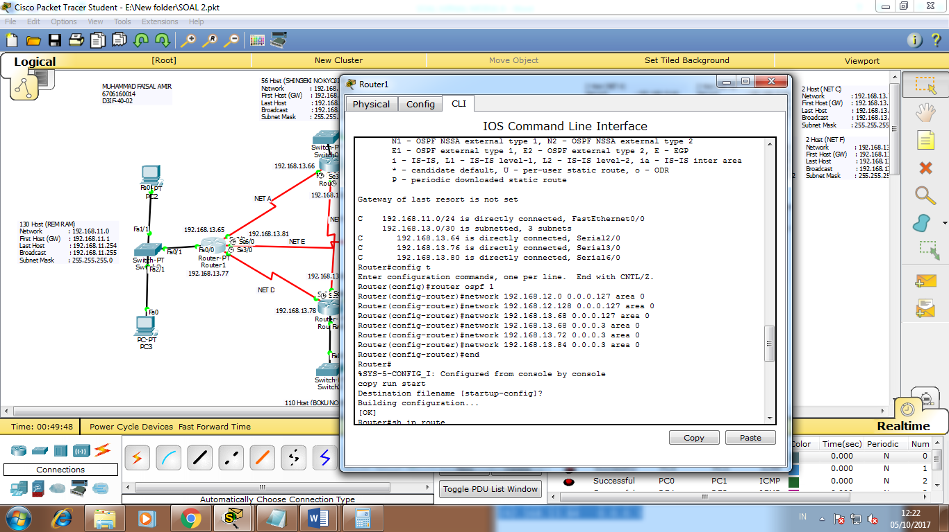

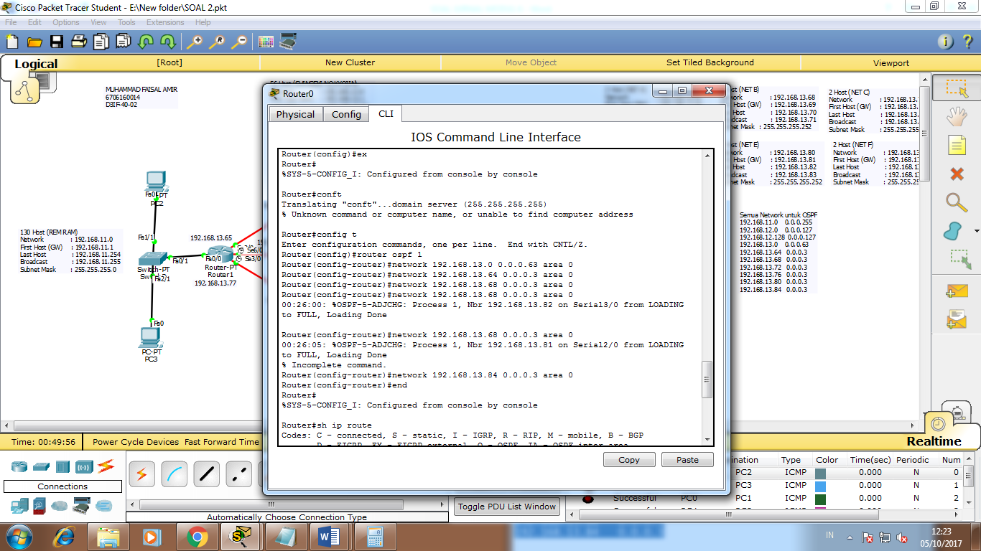

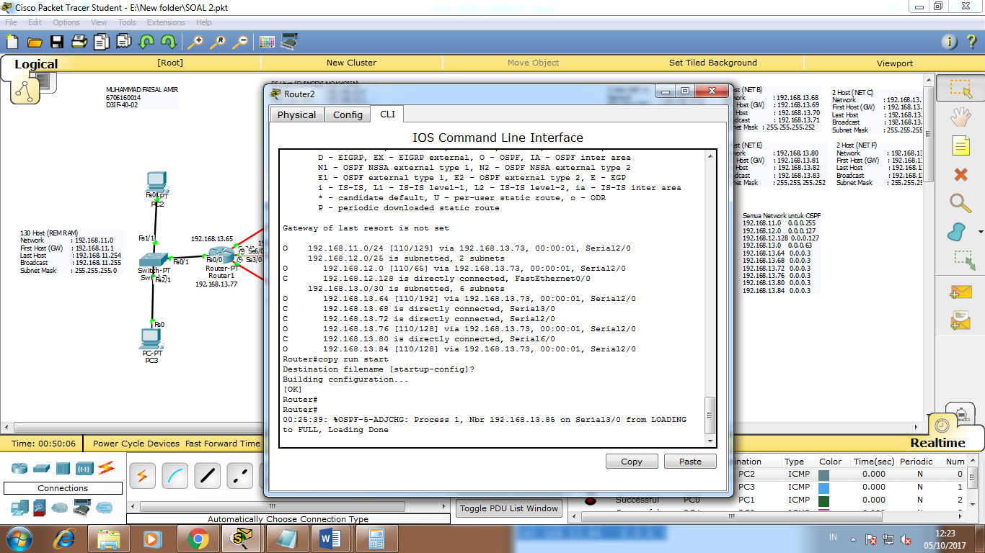

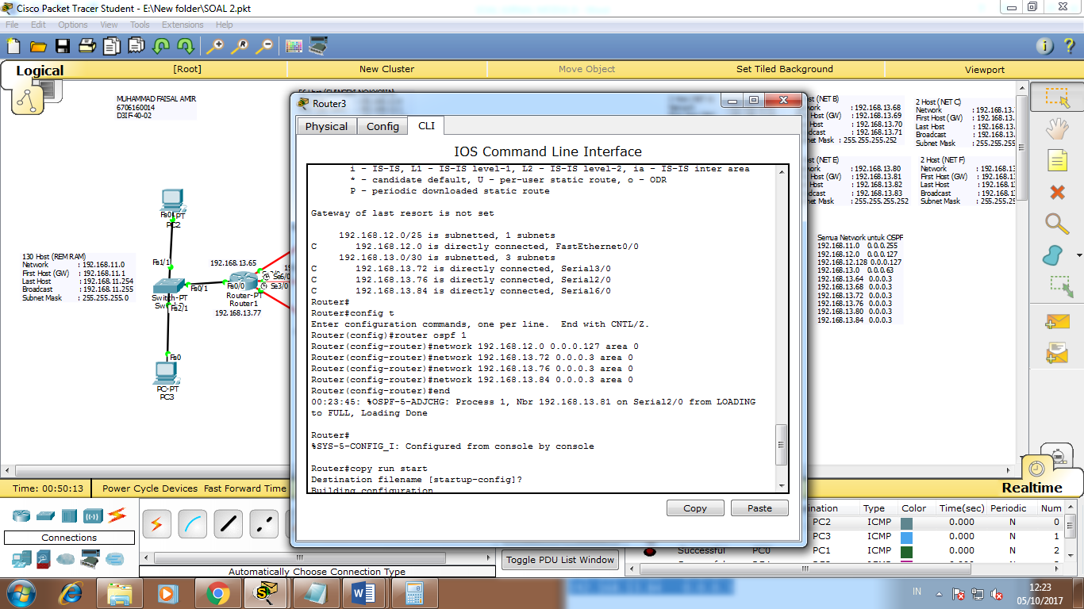

1. Cek apakah seluruh host telah terhubung. Sertakan screenshoot di cmd dengan watermark NAMA dan NIM.

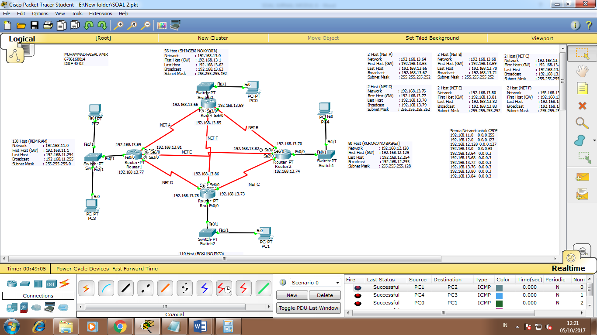

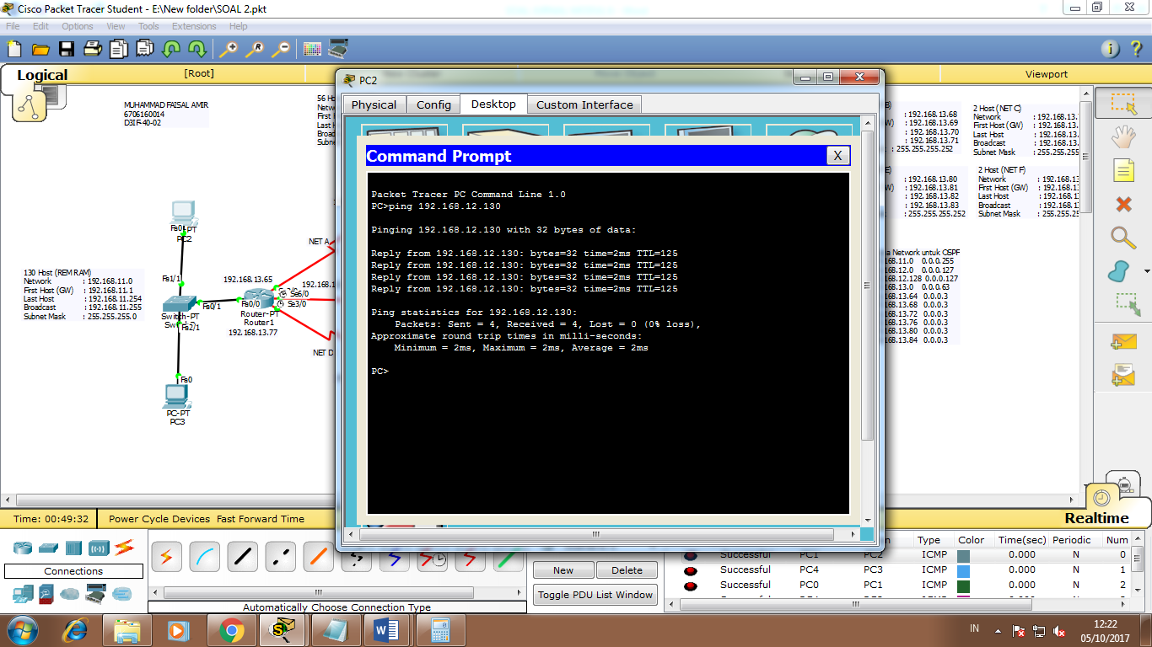

1. jika Network A diputus, antar host masih bisa ping, begitupun jika Network C yang diputus, antar host masih bisa melakukan ping. Lakukan juga terhadap host yang lain. (CLOSE ASPRAK)

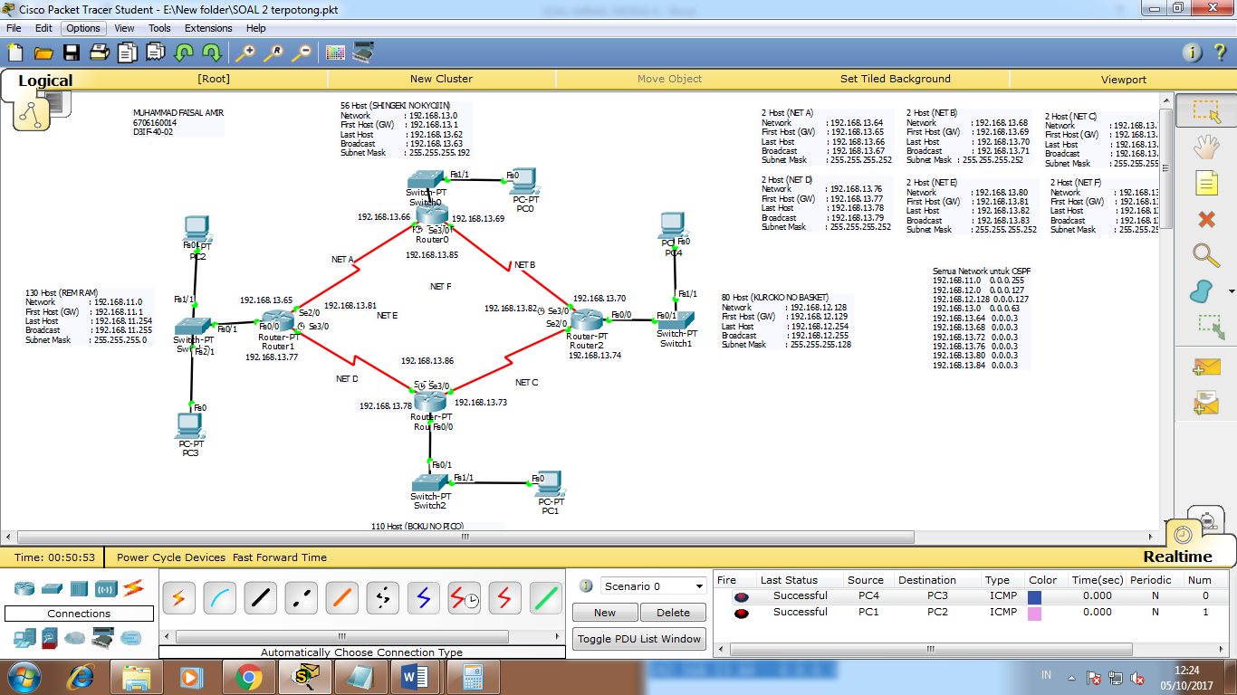

1. (SOAL BONUS)(POIN MAKS 50)(CLOSE ASPRAK)

Diberikan alamat jaringan : 200.168.1.0/21

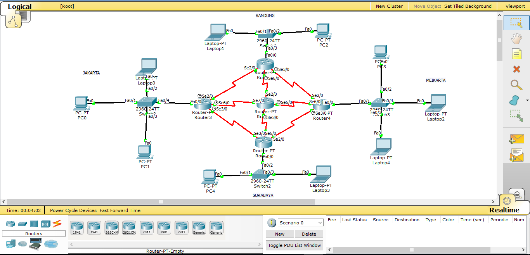

1. Lakukan subnetting VLSM , Tentukan Network, FH, LH, Broadcast, Subnet Mask, dan Prefix tiap host

* JAKARTA 100 host
* MEIKARTA 120 host
* BANDUNG 50 host
* SURABAYA 200 host
* Network A 2 host
* Network B 2 host
* Network C 2 host
* Network D 2 host
* Network E 2 host
* Network F 2 host
* Network G 2 host
* Network H 2 host
* MEIKARTA

IP range

255.255.255.255

255.255.255.192

-----------------------------------

0 0 0.63

120 Host (MEIKARTA)

Network : 192.168.13.0

First Host (GW) : 192.168.13.1

Last Host : 192.168.13.62

Broadcast : 192.168.13.63

Subnet Mask : 255.255.255.192

* NET A

IP range

255.255.255.255

255.255.255.252

-----------------------------------

0 0 0.3

2 Host (NET A)

Network : 192.168.13.64

First Host (GW) : 192.168.13.65

Last Host : 192.168.13.66

Broadcast : 192.168.13.67

Subnet Mask : 255.255.255.252

1. Buat topologi seperti pada contoh dan lakukan konfigurasi dinamis dengan menggunakan EIGRP. Screenshoot dengan watermark NAMA dan NIM.
2. Cek apakah seluruh host telah terhubung. Sertakan screenshoot di cmd dengan watermark NAMA dan NIM.
3. jika Network A diputus, antar host masih bisa ping, begitupun jika Network C yang diputus, antar host masih bisa melakukan ping. Lakukan juga terhadap host yang lain. (CLOSE ASPRAK)

BERBAHAGIALAH YANG DAPAT MENGERJAKAN SEMUA SOAL