**Data Visualization Project Proposal**

By Jason Caravella, Franchesca Rivas, Maria Fe

**Inspiration**

Over the past decade we have seen a major increase in cannabis drugs, in particular marijuana. It has gained a lot of popularity for both recreational and medicinal uses. Data analysts can gather information and determine positive and negative trends on and how that varies from state to state over the nation. Furthermore we can analyze if the legal status of marijuana has any effects on the opioid overdose epidemic. Also if this has a direct correlation with roadway fatalities, if so, how would that vary state by state.

**Goal**

To create a web visualization dashboard:

1. that has a landing page with USA map visualization of the marijuana legal status of every state
2. Plots that represent and compare yearly data over the course of three years where we show OD deaths by state, total death percentage by MVA or OD by state, as well as a gauge tool that shows an OD percentage rate against total deaths by state.

**Data Source**

<https://worldpopulationreview.com/states/marijuana-laws-by-state/>

<https://injuryfacts.nsc.org/state-data/motor-vehicle-deaths-by-state/>

<https://www.cdc.gov/nchs/nvss/vsrr/drug-overdose-data.htm>l

<https://www.kaggle.com/shree97/marijuana-legal-status-in-usa#marijuana.json>

Kaggle.com was the Data source for this project. We chose a json dataset named “Marijuana Legal Status in the USA”. This dataset included data over the course of 7 years however we focused on a course of 3 years from 2015-2017 as this had the same data info on multiple datasets. We also found CSV tables on the CDC.gov website for overdose data and motor vehicle deaths by state on NSC.org.

**Extraction**

Data was extracted from various CSV files and possibly web scraping then displayed on a relation database server webpage.

**Transformation**

1. CSV files will be cleaned and read into the dataframe and transformed also a few were transformed to json files. Most of our datasets were to be read by D3.csv method or D3.json.
2. Data in some columns had to be dropped to try to align similar factors in all datasets to have relevant arguments.
3. CSV files also had to be created in JSON files as we had a better success when working with JS libraries.

**Loading**

Data frame will be loaded into the relational database – Postgres or Heroku.

**HTML pages**

2 or more HTML pages will be created that will have access the JavaScript file in order to display the dashboard features on the browser including all graphs displaying the .

**JavaScript file**

D3.js, Plotly and Leaflet libraries will provide the basic framework for building the web dashboard and information on the map and the different types of charts/plots.

**User-driven interaction**

1. The web page / dashboard will be designed to contain a navigation bar with dropdown menu for the user to choose different state views and show the charts display the data. The tabs will allow direct access to our interactive map showing legal states through the country and all of our charts to show MV deaths.

**Challenges**

Initially we explored trying to find datasets that would compare marijuana legalization use with other natural/herbal supplements and the effect that had on individuals with chronic conditions where it was easier to attribute the legalization status with “Mixed” and “Fully Legal” and define if this is indeed a positive or negative trend.

We also did not have sufficient time to incorporate a JS library that was not discussed in class. We had a difficult adjustment to virtual learning and group work and had continuous breaking in our codes.

**Screen Shots**

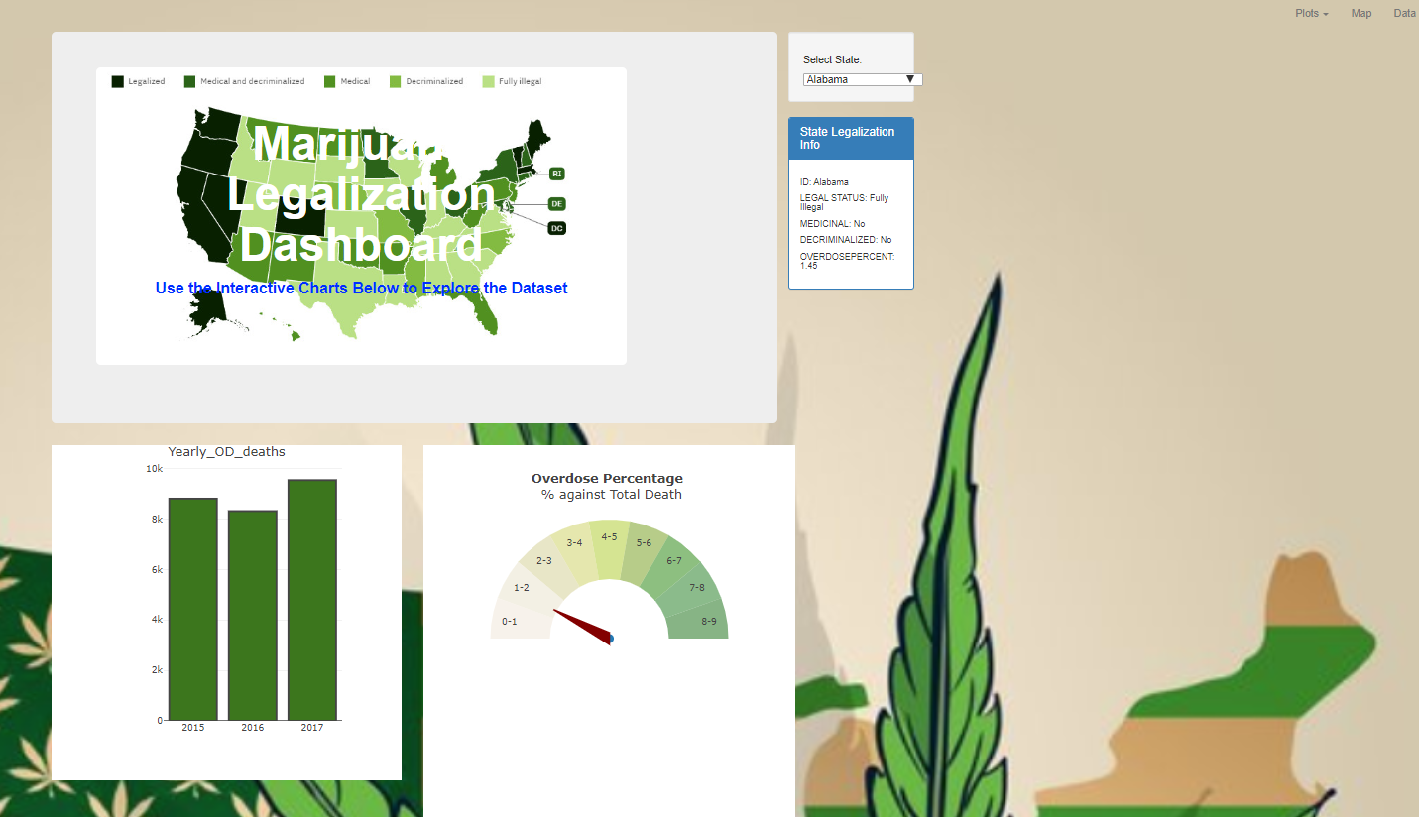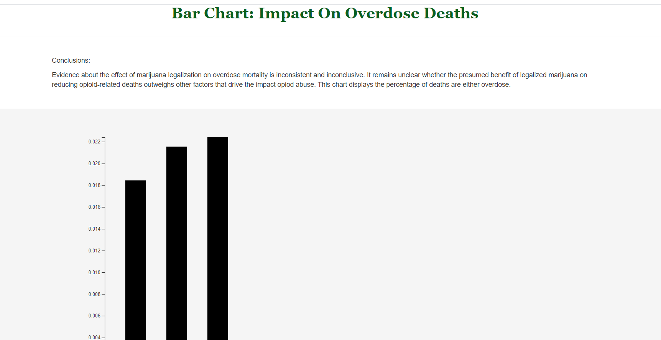

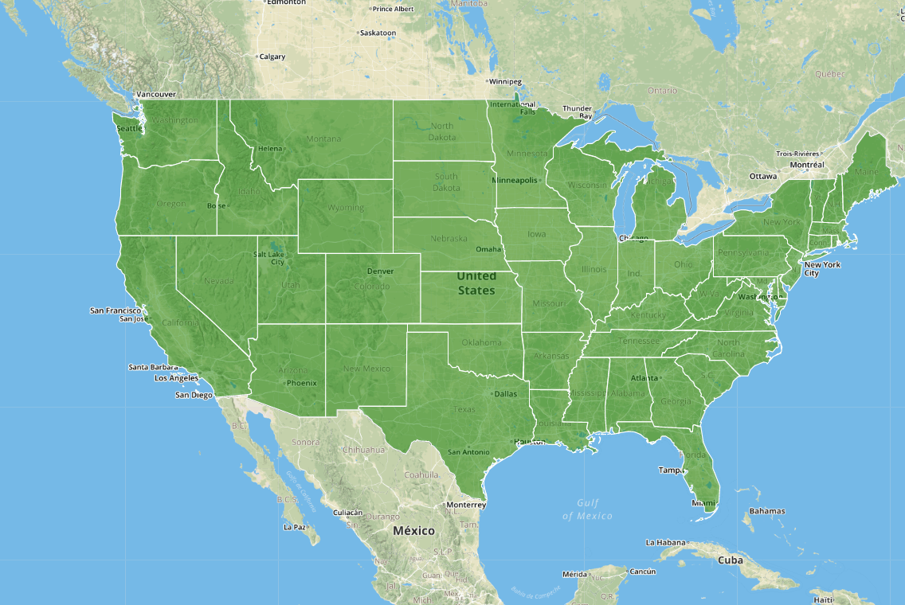

**Conclusions**

Evidence on the effect of marijuana legalization on overdose mortality is pretty inconsistent and inconclusive. There is no direct correlation that shows that marijuana legalization has a direct effect on overdose mortality or increases motor vehicle deaths. It remains unclear whether the presumed benefits of legalizing marijuana is reducing opioid related harms outweighs the policy’s externalities, such as its effect on the productivity of its users. Ultimately it is difficult to conclude that marijuana legalization contributes to any of the factors that were analyzed due to the limitations on information and the underlying reasons by state that would also contribute to OD and MV deaths such as weather related or depression/anxiety rates.