**Training Report**

for **NEXT Academy FullStack**

**Supervised by: Eng. Omnia**

Table 1 Version History

|  |  |  |
| --- | --- | --- |
| **Version** | **Date** | **Reason for Change** |
| 1.0 | 17-Aug-23 | Layout |

**17 August 2023**

|  |  |
| --- | --- |
| **Mohamed Hossam Abdelalim** | **21P0254** |

Table 2 Names and IDs

GitHub Repository: <https://github.com/caraxesmsc/Training-NEXT-Fullstack>

Table of Contents

1. Introduction 3

2. Functional Requirements 3

3. Non-functional Requirements 3

4 Conclusion 4

5 UML Class Diagram 4

5.1 Diagram: 4

5.2 Classes used: 4

5.3 Initial testing for the main class 5

6 Initial Diagram For GUI 6

6.1 Main 6

6.2 Admin Options 7

6.3 Book Options 8

Table of Tables

Table 1 Version History 1

Table 2 Names and IDs 1

Table of Figures

Figure 1 UML Class Diagram for Library management system 4

Figure 2 Initial testing for the main class (NOT FINAL) 5

# Introduction

# The Fullstack Bootcamp was a transformative experience that propelled me from a coding enthusiast to a proficient fullstack developer. I dived deep into HTML, CSS, and JavaScript, and then into backend development with PHP, MySQL, and Laravel.

# The backend trio of PHP, MySQL, and Laravel revolutionized my understanding of web development. I learned to create dynamic web applications, exploring server-side scripting, databases, and seamless frontend-backend interaction.

# Engaging with industry mentors enriched my understanding of practical development. Overcoming coding challenges fostered resilience and creative problem-solving. This journey has equipped me not only with technical skills but also with teamwork, adaptability, and effective communication.

# In conclusion, the Fullstack Bootcamp has been a launchpad for my aspirations as a fullstack developer, armed with expertise in PHP, MySQL, and Laravel. This report encapsulates my evolution and sets the stage for a dynamic career in the tech world.

# Content

# 2.1 Frontend

|  |  |
| --- | --- |
| Lecture # | Content |
| 1 and 2 | Basics of HTML and CSS |
| 3 and 4 | JavaScript Basics & Advanced |
| 5 | jQuery |
| 6, 7, 8 & 9 | Bootstrap & UI/UX |

# Backend

|  |  |
| --- | --- |
| Lecture # | Content |
| 10 | PHP |
| 11 | MySQL |
| 12, 13, 14 & 15 | Laravel |

# Non-functional Requirements

* Security:
  + For each user, there exists a unique ID and password to prevent unauthorized access to information.
* User-friendly interface:
  + The system should have a user-friendly interface that is easy to use and understand.
* Scalability:
  + The system should be able to handle a large number of books and members.
* Performance:
  + The system should be fast and responsive to user requests.

# Conclusion

The Library Management System is a JAVA program that allows librarians and readers to manage a library in a simple and comfortable way. The system supports various actions such as addition/removal of books and members, member and book searches, addition/removal of users from Book- Order list, blocking of users who return books late, and renting of books. The system also has various non-functional requirements such as security, user-friendly interface, scalability, and performance.

# UML Class Diagram

## 5.1 Diagram:

Figure 1 UML Class Diagram for Library management system

## 5.2 Classes used:

## 5.3 Initial testing for the main class

Figure 2 Initial testing for the main class (NOT FINAL)

# Initial Diagram For GUI

## Main

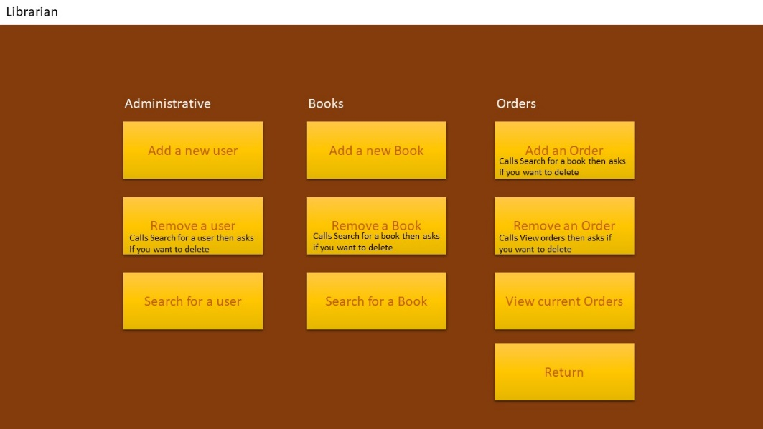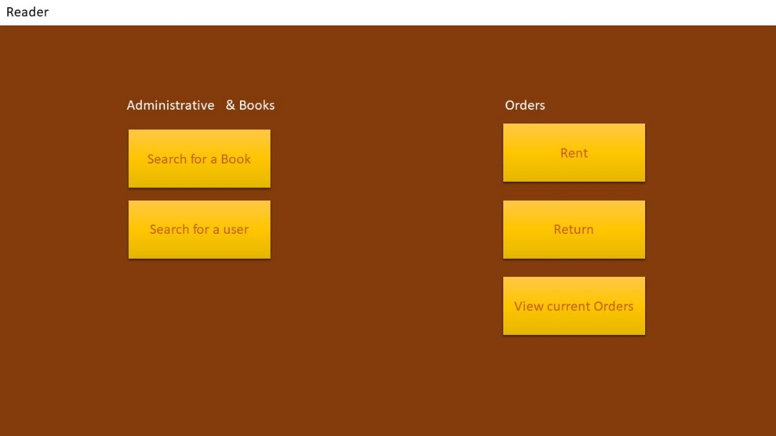

## Admin Options

## Book Options

