 | BICOL UNIVERSITY POLANGUI  Polangui, Albay  IT 123 – System Administration and Maintenance  1st Semester 2025-2026 | 

Week 7 Laboratory – Configuring and Securing Network Services
John Omar C. Clutario
Simone Andreas M. Mannhuel M. Nate
Joshua A. Obstaculo
BSIT – 4B

Guillermo V. Red, DIT
Instructor

09-28-2025

By the end of this lab, students will be able to:
- Configure essential network services (DNS, DHCP, HTTP, FTP) in Ubuntu Server.
- Verify service functionality using command-line tools.
- Apply basic security measures (restricting access, enabling encryption where possible).
- Understand the importance of service management in real-world IT infrastructure.
Prerequisites
- Ubuntu Server VM with static IP (from Week 6).
- Admin privileges on the server.
- Basic understanding of network protocols (DNS, DHCP, HTTP, FTP).
- (Optional) Windows Server VM can be used for comparison.

Part 1 – DNS Configuration (Ubuntu Server)
1. Install BIND9
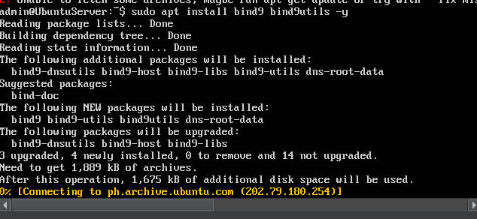
2. Configure a Zone File
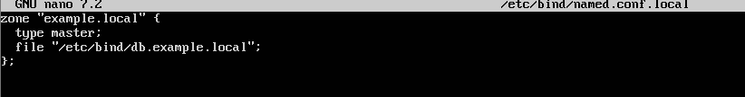
3. Create a Zone File Database
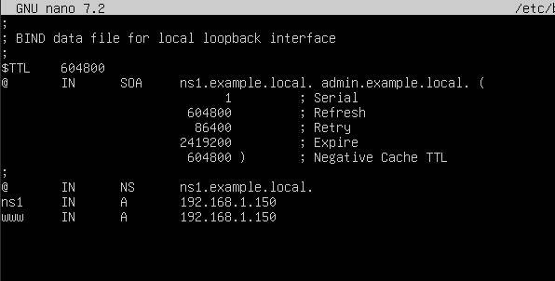

4. Restart Service
5. Test
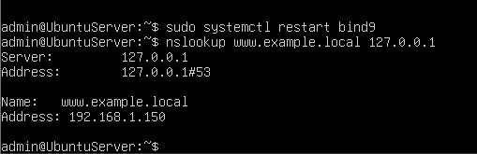
✅ Expected Result: The DNS server should return the IP address 192.168.1.150 for www.example.local.
Part 2 – DHCP Configuration (Ubuntu Server)
1. Install DHCP Server
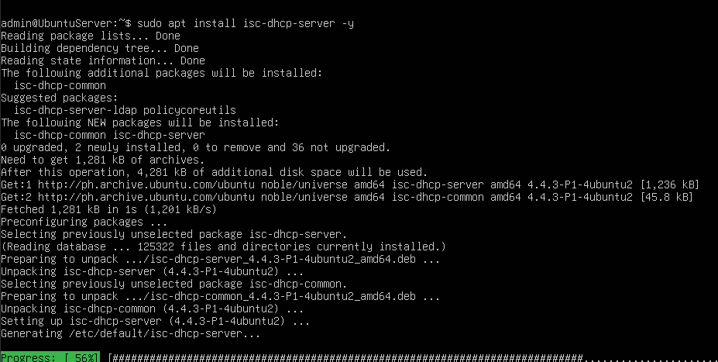

2. Configure
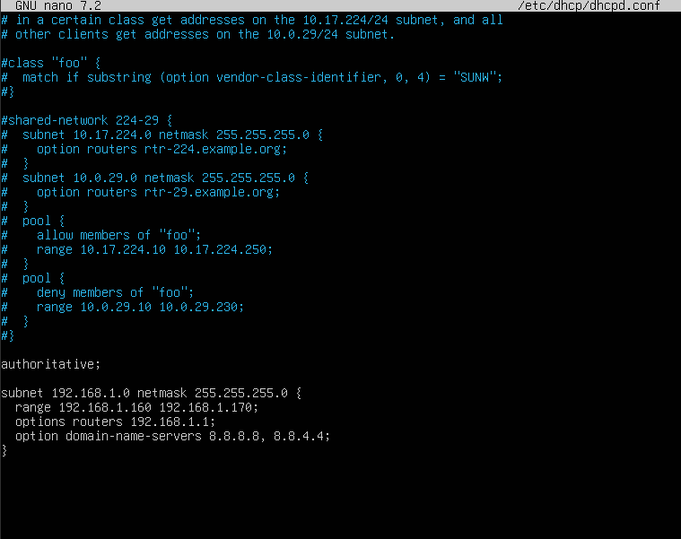
3. Start Service
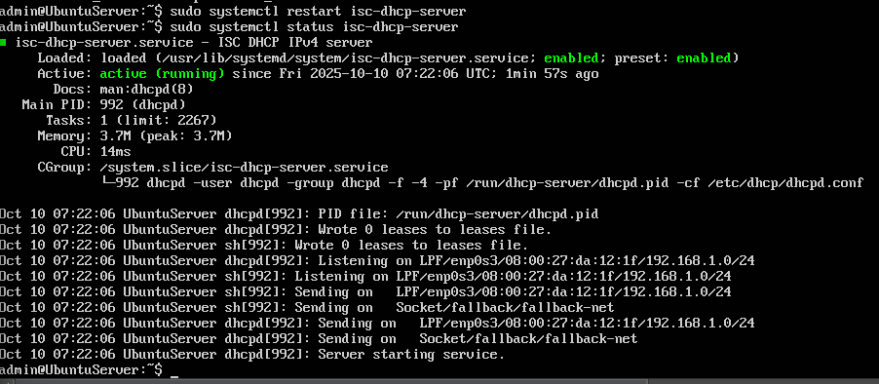
✅ Expected Result: No syntax errors; DHCP service starts successfully.
Part 3 – HTTP Service (Apache)
1. Install Apache
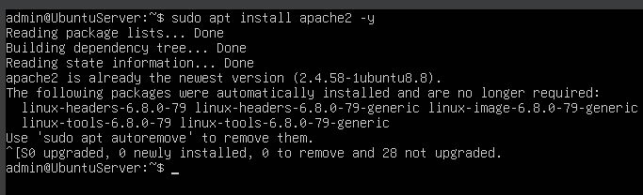
2. Test
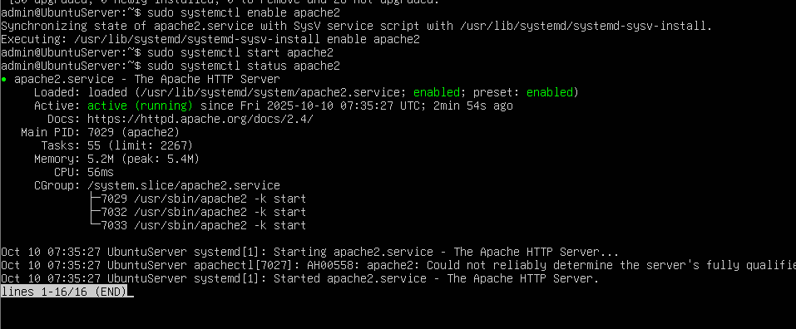
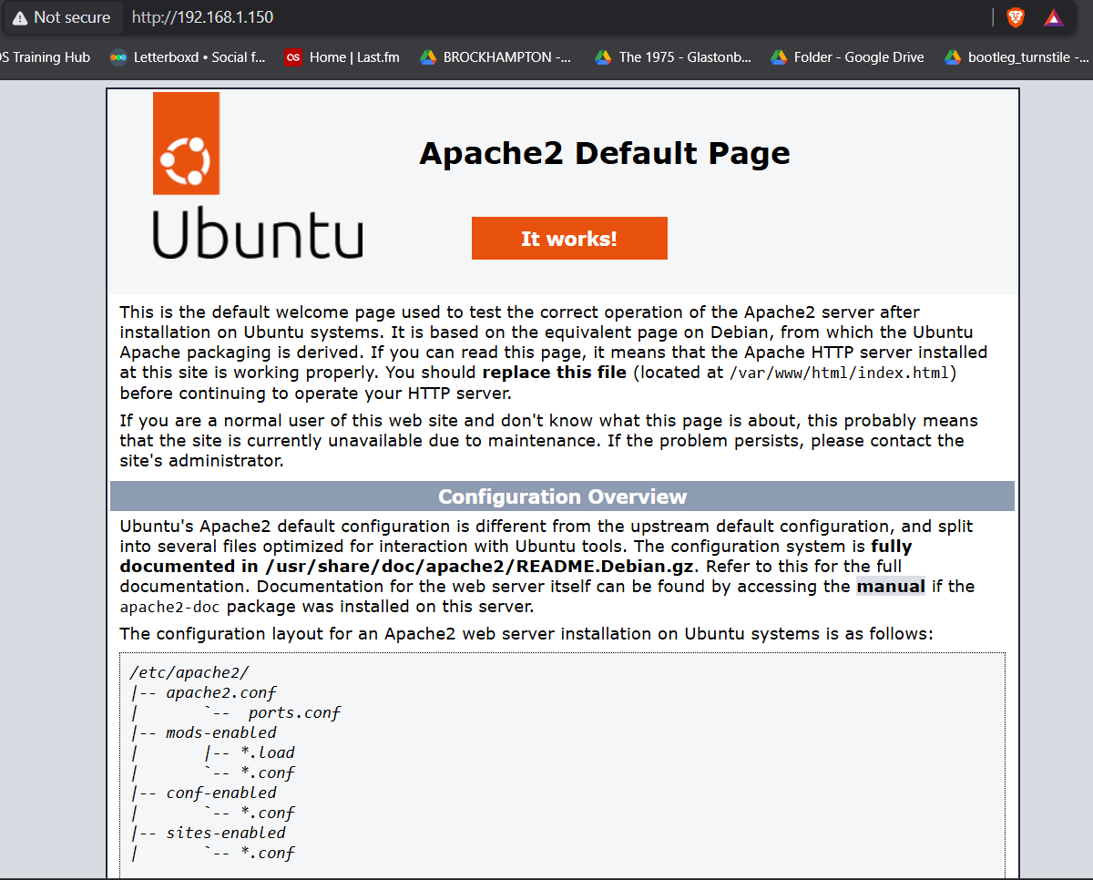
✅ Expected Result: The default Apache welcome page “It works!” should be displayed.

Discussion (Part 1-3)
After successful configuration, the server provided name resolution through BIND9, dynamic IP allocation through DHCP, and web hosting through Apache.
All services were verified to be functional both locally and from the host machine.
This setup demonstrates fundamental LAN service management and network integration under Ubuntu Server.

⚙️ Part 4 – FTP Service
Step 1: Install vsftpd
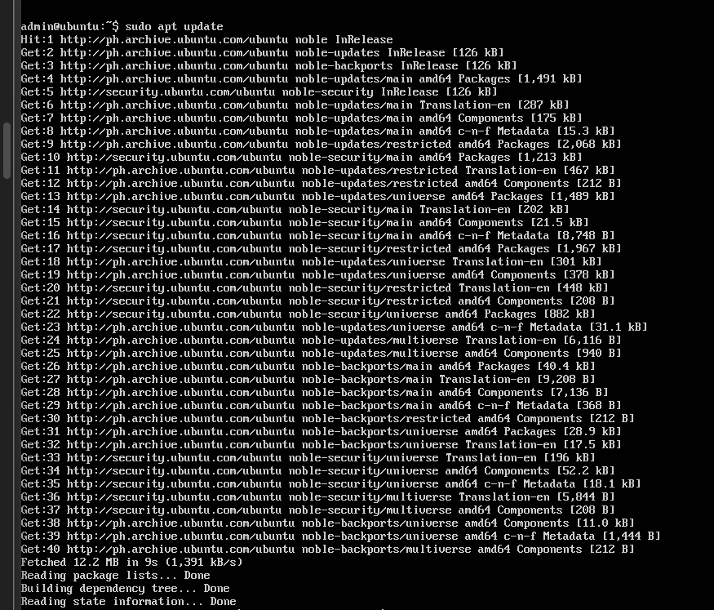

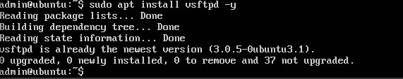

Step 2: Configure FTP
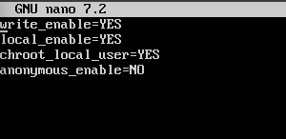

Step 3: Restart and Test FTP
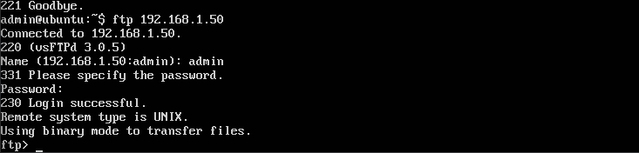

🔐 Part 5 – Securing Services
Restrict FTP to Local Network
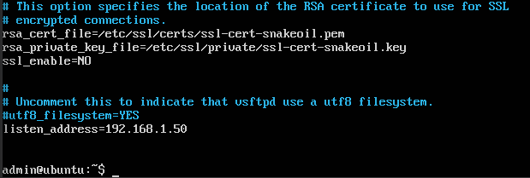

Enable and Configure UFW Firewall
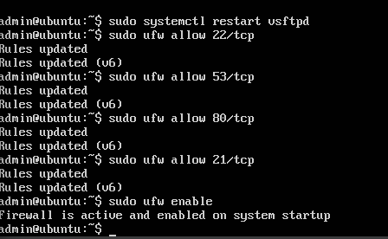

🧩 Part 6 – Student Exercise
Scenario
You are the system administrator of a small office network. Configure the server so that:
- Employees get their IP addresses automatically (DHCP).
- The internal website (company.local) is hosted internally (DNS + Apache).
- File sharing via FTP is enabled only for local network users.

Task 1: DHCP Configuration
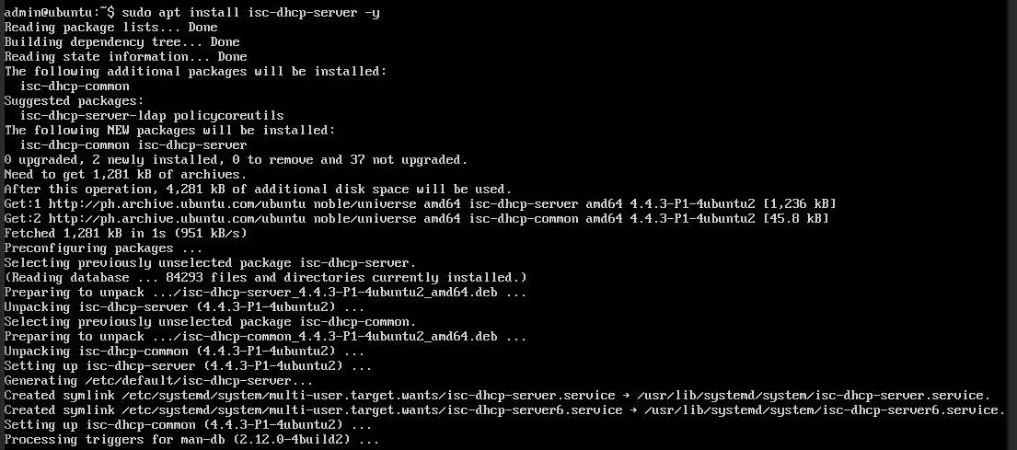

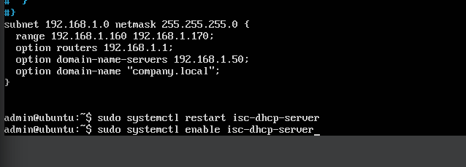

Task 2: DNS Configuration
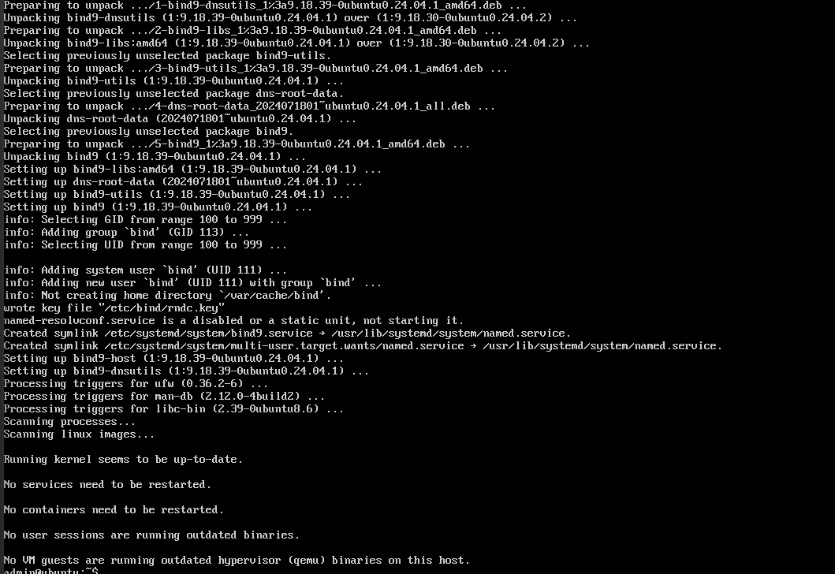
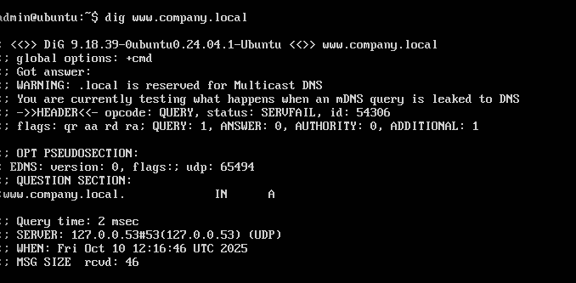
Task 3: Apache Configuration
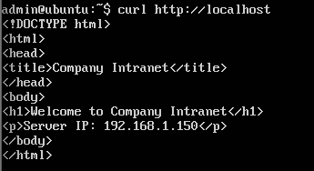

Task 4: FTP Access (LAN Only)
