 | BICOL UNIVERSITY POLANGUI  Polangui, Albay  IT 123 – System Administration and Maintenance  1st Semester 2025-2026 | 

Week 6 Laboratory – Network Configuration and Management

John Omar C. Clutario
Simone Andreas M. Mannhuel M. Nate
Joshua A. Obstaculo
BSIT – 4B

Guillermo V. Red, DIT
Instructor

09-28-2025

Lab Objectives
- Configure static and dynamic IP addresses in Linux (Ubuntu Server).
- Verify network connectivity and troubleshoot using CLI tools.
- Understand basic network configuration in Windows (optional).
- Apply security practices by testing connectivity and limiting access.
Prerequisites
- Ubuntu Server VM installed and running.
- Admin access to the VM.
- Familiarity with CLI from Weeks 3–5.
- (Optional) Windows Server VM for parallel practice.

Part 1 – Checking Current Network Configuration (Ubuntu Server)

1. Show Active Interfaces
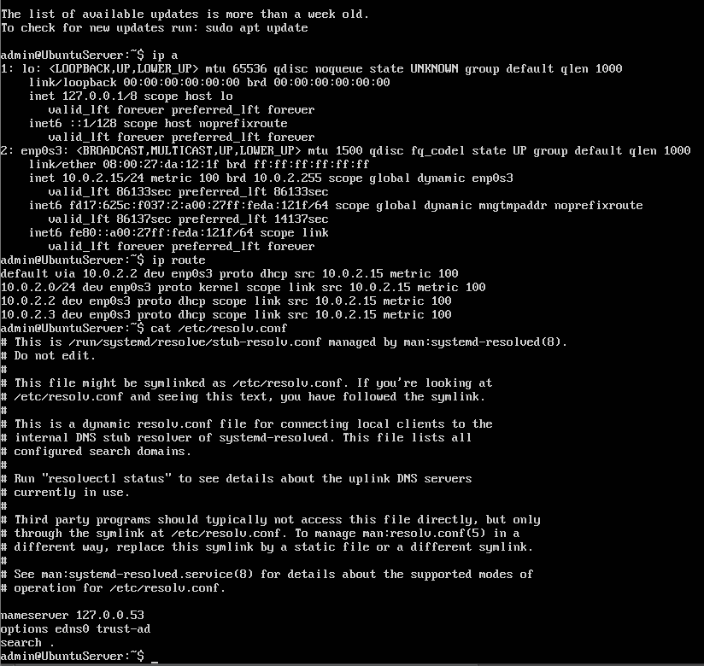

2. Check default routing and DNS:

Part 2 – Configuring a Static IP Address (Ubuntu Server)

1. Open the netplan config file:
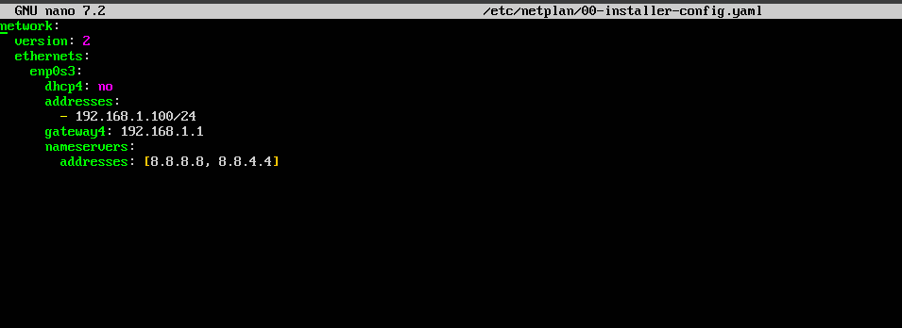
2. Configuration

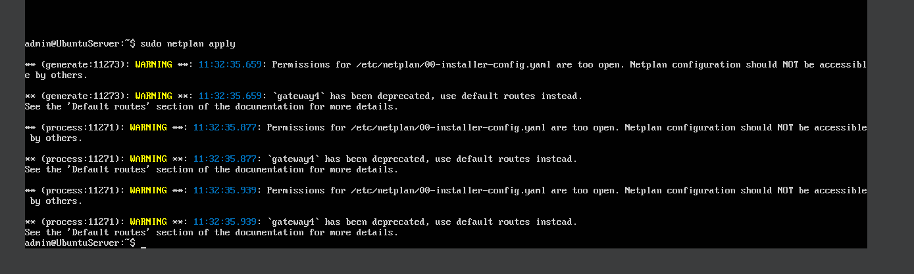
3. Apply changes:

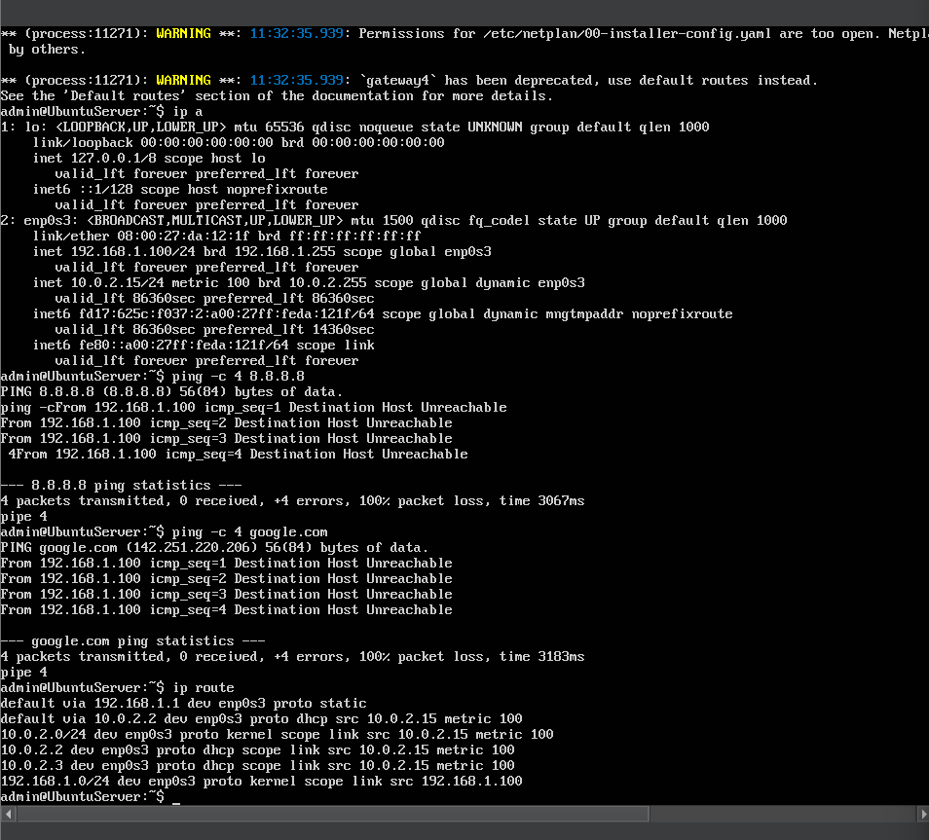
4. Verify

Discussion:
The static IP configuration using Netplan was successfully applied and verified using the commands ip a and ip route. The system now uses the assigned IP address 192.168.1.100/24. Connectivity testing resulted in ‘Host Unreachable’ due to multiple routes.

Part 3: Switching Back to DHCP (Ubuntu Server)
1. Edit the netplan config file again:
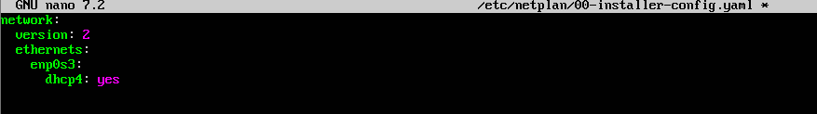

2. Apply changes
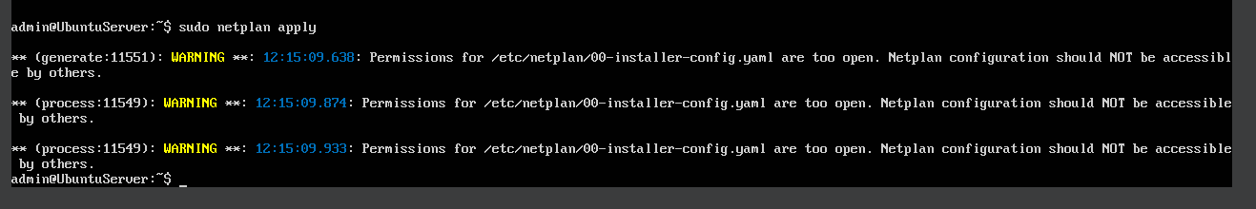
3. Verify:
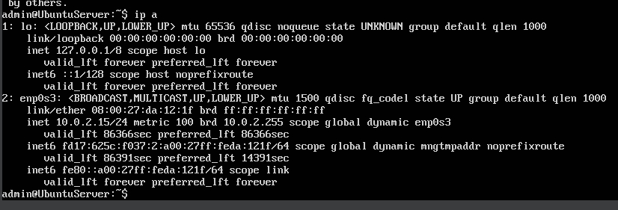

Discussion:
By switching from a static IP configuration to DHCP, the server now relies on the DHCP server to automatically assign its IP address. This is beneficial in networks where IP addresses are frequently reassigned, reducing the need for manual reconfiguration. The key indicator of success was the presence of the dynamic flag in the assigned IP.
The Ubuntu Server was successfully reconfigured to use DHCP only. Verification confirmed that the server now receives its IP address (10.0.2.15) dynamically from the DHCP server, with no static IP addresses configured.
Part 4 – Troubleshooting with CLI Tools
Commands to show:
ping -c 4 192.168.1.1
traceroute google.com
nslookup google.com
ss -tuln
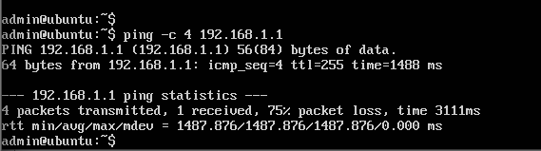
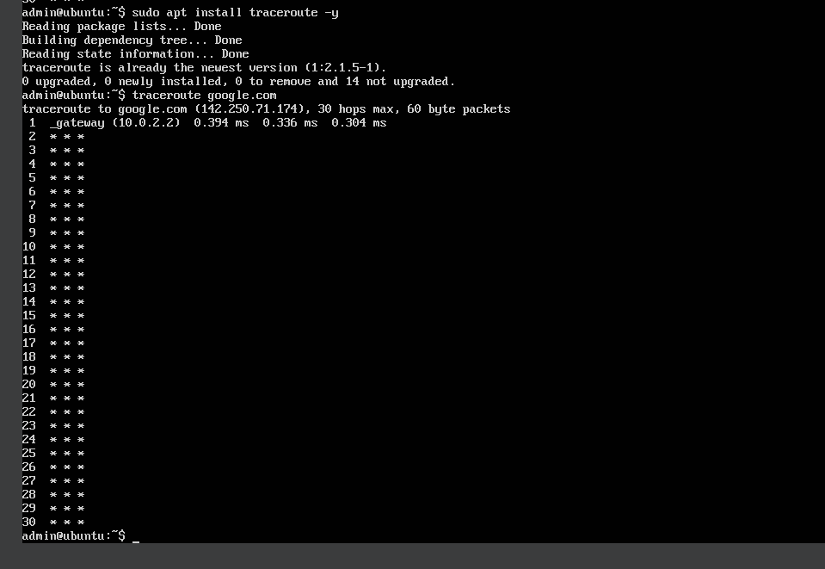

Part 6 – Student Exercise (Static vs DHCP Servers)
Verification Tests:
On Server A:
ping -c 4 192.168.1.150
ping -c 4 <Server B IP>
ping -c 4 google.com
On Server B:
ping -c 4 192.168.1.150
ping -c 4 google.com
Server A (Self Ping, Ping Server B and Google.com)
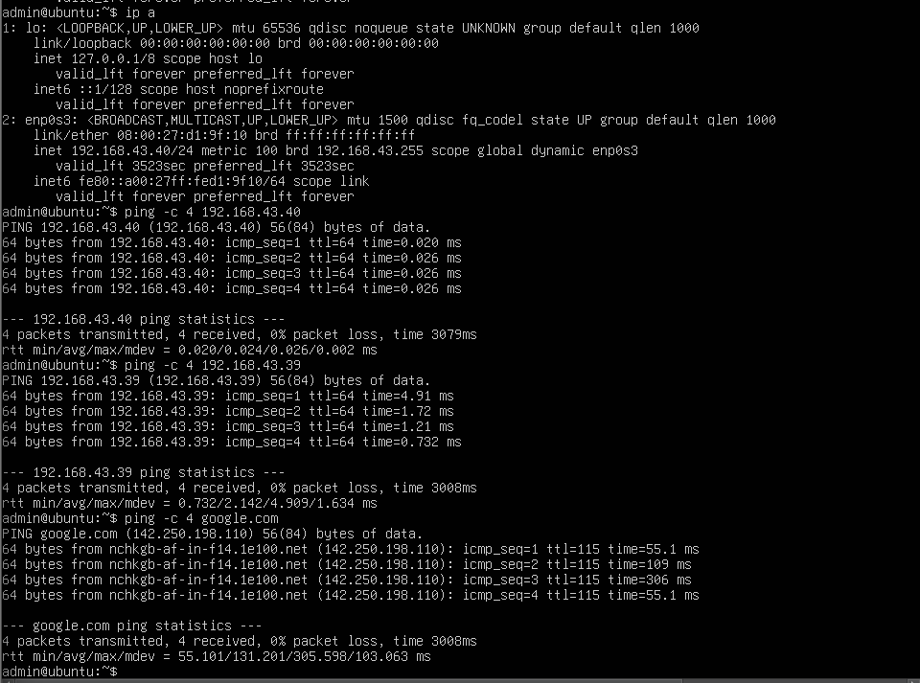

Server B (Ping Server A and Google.com)
